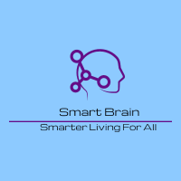

Project Management and Research Methods

Project Initiation Document (PID)
Electronics Engineering Course @ UWTSD
By Krzysztof Matela
Student ID: 1804424

Page Index:
Page 3 …………………………………………………………………………………………………… Introduction
Page 3 ………………………………………………………………………………………………………. Objectives
Page 4 ………………………………………………………………………………………………………….…. Scope
Page 5 …………………………………………………………………………………………………….. Constraints
Page 6 ……………………………………………………………………………………………………….. Authority
Page 6 ……………………………………………………………………………………………………. Gannt Chart
Page 7 …………………………………………………………………………………………… Network Diagram
Page 6 ………………………………………………………………………………………………………. Resources
Page 6 ……………………………………………………………………………………………………… References

Introduction:
This document contains details of ‘Brain Smart’ project initiation which is run by a group of 3 people. Dementia is an issue that continues to grow reaching billions in costs and cure is still far from being developed⁽¹⁾. The goal for the team is to improve the quality of life of a person suffering from Dementia by developing an app and custom hearing aid. The app and the device will be designed to monitor life functions of an individual as well as provide him/her with reminders of events, tasks, and other essentials in everyday life. The team really hopes to provide an affordable option for everyone who needs its – not only for Dementia patients.
Objectives:
This section describes the steps that are required for the company to achieve success.
- Research
- Team will arrange meetings with NHS or other medical companies to discover the symptoms of Dementia and how they can be overcome.
- Each individual member will perform his own research to save on time.
- Team meeting
- Team must meet and share their individual research with each other.
- Agree on what functionality to be implement in finished product.
- Agree on what technology to use for an app and prototype to communicate together.
- Share general team-working requirements and expectations.
- Resources
- Team must agree on and produce a sheet of resources that will be required.
- Software required for app development, database design, circuitry simulation and design.
- Hardware required for production, testing and 3D printing of hearing aid prototype.
- Confirm project fits within the budget.
- Development
- Person to develop and manage database.
- Another to design and develop the android application.
- Lastly to design and produce a working prototype.
- Testing
- Confirm project met its requirements
- If not, fix the bugs or add functionality
- Product release
- Analyse costs and potential profits
- Improve product awareness by advertising campaign
- Release functional product for public

Scope:
The boundaries for this project were organised using MOSCOW mnemonic which includes but is not limited to:
Must Have | Should Have | Could Have | Won’t Have
Software Application | Automated features / AI | Customers Medical Records stored locally | Online Web Site
Database | Customers Contact Details | Customers Medical Records stored on server
Hearing Aid | Standard Functionality | Bluetooth Module, Accelerometer, Temperature sensor
Connection to internet | No Data Charges
DPR | Description of what Customer Data is Being Stored and Used | Option for Customers to Refuse Their Data Being Used for Further Development
Feedback options | Feedback in Form of a Survey or a Message | Option to Give Anonymous Feedback
Research and Development Team | Contact with Existing Medical Branches and Team Members |  | Actual Designated Team

Constraints:
The following list contains essential points that must be taken into consideration because they can affect the project and/ or its delivery date.
- Human Error – Everybody makes mistakes but it mustn’t affect overall deadline
- Un-foreseen circumstances – Such as power loss, internet connectivity issues, loss of mobile service and so on.
- Involved costs – Since project will be fully funded by team members, fact is, their individual finances are fairly limited.
- Customers’ expectations – Some customers might be picky and refuse to use our product for any reason.
- Testing issues – Product might not meet given requirements and must be returned to developers for improvements.
- Natural Disasters – They are not common in Wales but, they shouldn’t be ignored.

Authority:
This section explains who has the ultimate authority and control over the Brain Smart project using Stakeholder Register:
Name | Position | Internal/ External | Project Role | Contact
Matthew Howells | Team Leader | Internal | Group Management, Database Requirements, Design, and Development | 1702520@student.uwtsd.ac.uk
Ryan Williams | Team Member | Internal | App Requirements, Design, and Development | 1708310@student.uwtsd.ac.uk
Krzysztof Matela | Team Member | Internal | Hearing Aid Requirements, Design, and Development | 1804424@student.uwtsd.ac.uk
Sue Maw | Lecturer | External | Project Management and Research Methods | Sure.Maw@uwtsd.ac.uk
James Williams | Lecturer | External | Enterprise and Innovation Group Projects | James.Williams@uwtsd.ac.uk
University of Wales Trinity Saint David | Education Centre | External | Potential Funding | n/a
NHS and Local Organisations | Caretakers | External | Key study and Support | n/a
Government | Oversight | External | Ensure all legal matters are met | n/a

Gannt Chart:
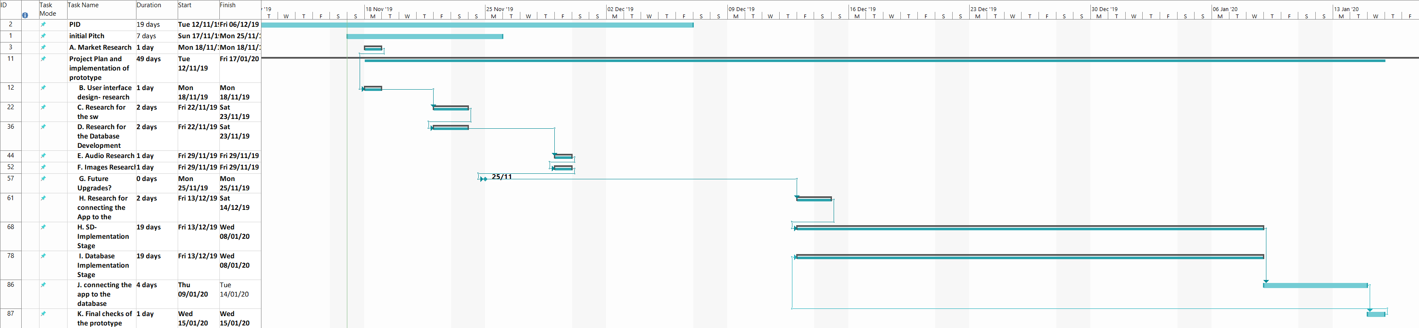

Network Diagram:
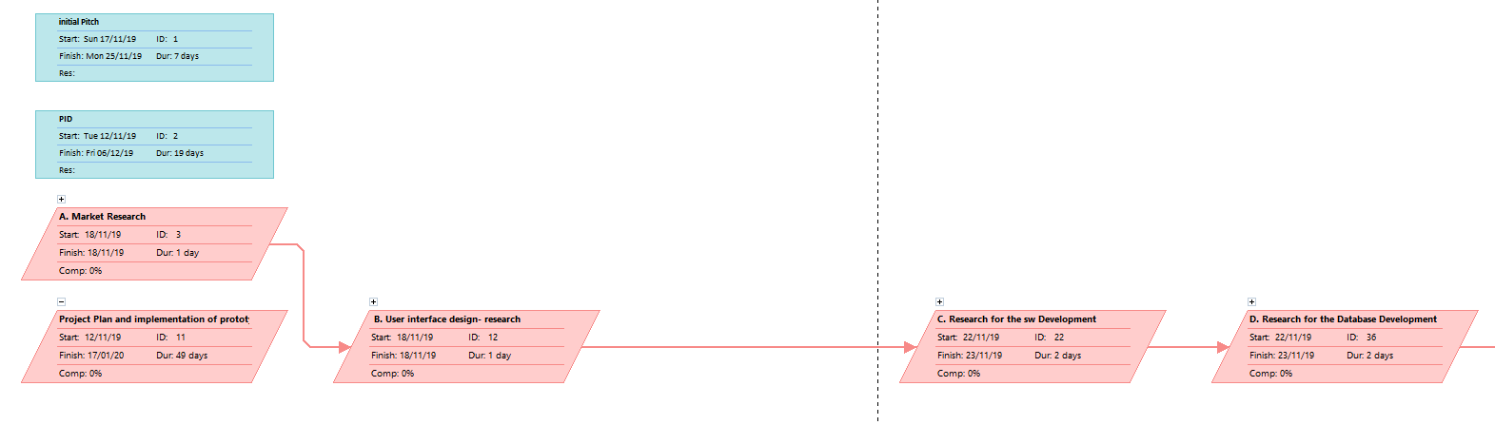
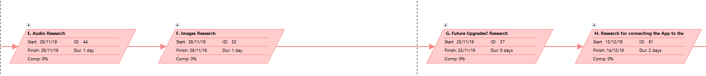
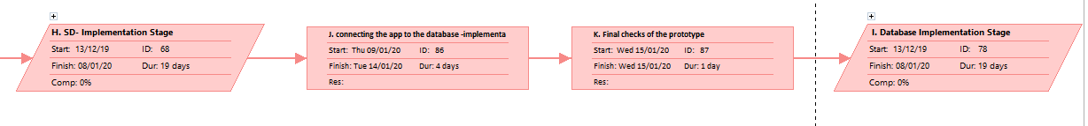
Resources:
Each team member requires software and/ or hardware to do their job effectively which is listed below:
Name | Software | Hardware | Task
Matthew Howells | AutoCAD | 3D Printer | 3D Printing
Matthew Howells | UWTSD Cloud | UWTSD Cloud | Database
Matthew Howells | MS Office | - | Team Management
Ryan Williams | Visual Studio | - | App Production
Ryan Williams | - | - | -
Krzysztof Matela | Proteus, Easy-PC | - | Hearing Aid Simulation
Krzysztof Matela | MPLAB / Visual Studio | Workstation, IC components | Hearing Aid Prototype

References:
- https://www.alzheimers.org.uk/about-us/policy-and-influencing/dementia-uk-report
- Remaining information sourced from moodle.uwtsd.ac.uk

