
BA International Hotel Management
Module: Foreign Languages & Cultural Awareness
Module code: BMIH5003
Intercultural Competence Report


June 7, 2024
Lecturer: Giulia Chifari
Student: Olga Brinza 2242685

EXECUTIVE SUMMARY
This report had presented an evaluative overview from a manager’s perspective about the cultural differences in between England and Germany, including culture and customs. The discussion had assessed and compared both countries by using the Globe project for the study of leadership and culture in these countries. Along with that, this report had also integrated the challenges of intercultural leadership within the hospitality industry. Several recommendations are outlined in order to avoid cultural conflicts and misunderstandings.

Table of Contents
EXECUTIVE SUMMARY 1
INTRODUCTION 3
Key differences between England and Germany 3
Using GLOBE Project’s culture and leadership study to analyse and compare two countries 4
Challenges of intercultural leadership in the hospitality industry 5
RECOMMENDATIONS………………………………………………………………………….7
CONCLUSION 7
REFERENCES 8

INTRODUCTION
Foreign Languages & Cultural Awareness can be seen as the capability to communicate effectively and understand the different values, principles, beliefs, and customs of different cultures around the world (Makhmudov, 2020). The following report will provide an understanding of Foreign Languages & Cultural Awareness in the context of Multicultural Hotel & Spa which is looking to expand in Germany. In the beginning, the report will provide key differences between England and Germany, mainly focusing on culture and customs, etc. Further, the report will analyse and compare the two countries using the GLOBE Project’s culture and leadership study. The last part of the report will present the challenges of intercultural leadership in the hospitality industry with some relevant examples.

Key differences between England and Germany
While the success of businesses in the hospitality sector is completely dependent on the type of customer service they provide, still there are different factors that hospitality businesses have to consider while expanding into different countries. In the case of the 5-star Multicultural Hotel & Spa which is expanding in Germany several differences should be considered. In this aspect, the major differences between the United Kingdom and Germany will include:
Language- One of the major key differences that can be outlined is the language because in England, the most used language is English while in Germany German is the language predominant in business and hospitality. As professionals in hospitality have to understand and communicate with the guests effectively in order to provide the best customer service, the hotel staff needs to understand and learn the local language. English speakers will have more role opportunities when joining the team in London, but everyone will be encouraged to learn and improve their English knowledge.
Cultural norms and etiquettes – There are differences in cultural norms also which is evident because in England, people mainly appreciate and show politeness, reliability, openness, and are positive. On the other hand, German cultural norms can be seen to put more importance on straightforwardness, and openness which helps in creating strong relations (Jdetawy, 2020). Comparing both countries' cultural norms, it is critically important for the Multicultural Hotel & Spa employees to understand the differences and approach guests suitably and professionally, showing respect and knowledge to the country.
Food and dining customs – Food and dining customs can be said as one of the most important differences as both countries have their customs. It is well known that guests in England prefer fish and chips, bacon, and baked beans while German food and dining customs are different as the main traditional dishes include schnitzel, pretzels, frankfurters, sausages, etc. These customs are extremely important for Multicultural Hotel & Spa so that employees can easily serve and provide their best service according to the local culture (Guptill, 2022).

Analysis of the English and German culture and leadership Using GLOBE Project

GLOBE Project’s culture and leadership study helps identifying different cultural dimensions that act as a driving force for organisational behaviour and leadership practices in different countries (Areiqata, 2020). Different cultural dimensions will be analysed and compared with the help of GLOBE Project’s culture and leadership study for England and Germany. This analysis is aimed at helping local and foreign employees understand the cultural differences between them and do their best to congregate and work for the best of the guests.
Performance orientation – performance orientation can be seen as an important dimension because England puts a big emphasis on high-performance orientation including accomplishments, achievements, and improvement in the hospitality sector. This approach of England helps deliver the best customer service while ensuring customer and employee satisfaction. On the other hand, Germany also is oriented toward performance but the approach chosen by them is mainly focused on increasing efficiency and effectiveness in delivering services. Business in the German hospitality sector looks for innovation and creativity to enhance service satisfaction. Fig.1 is showing Cultural practices and values in Germany, which include a high level of performance orientation, future orientation, and in-group-collectivism. In England these aspect are higher alongside with gender collectivism, uncertainty avoidance, human orientation and institutional collectivism.
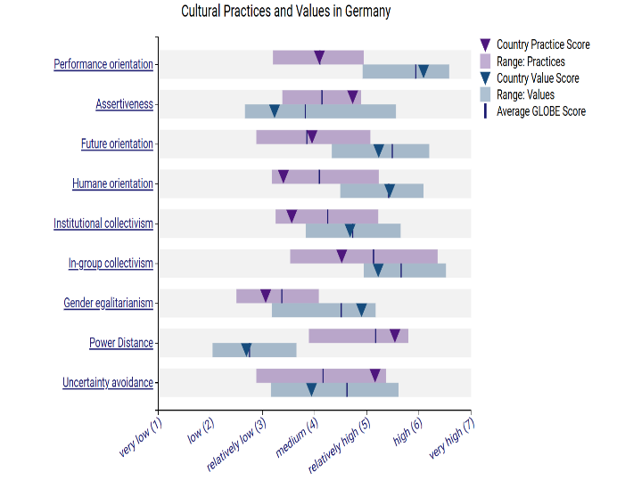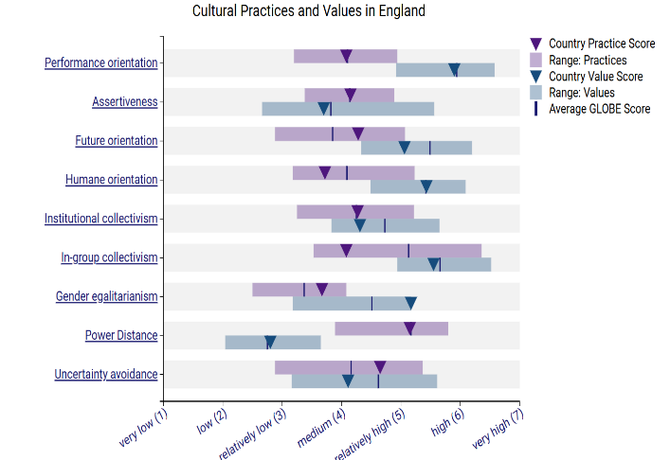fig1.
Uncertainty avoidance – Comparing both countries it can be said that businesses in the hospitality sector of England have lower uncertainty avoidance as they are risk takes and are keen to take risks and make changes in the processes. This often increases flexibility and opens doors for innovation and creativity. On the other hand, the hospitality sector of Germany has higher uncertainty avoidance where they prefer to stick with defined rules and regulations, business also ensures that they are not taking risks in their business procedures and providing a consistent level of business service.
Future orientation – One of the major dimensions that is mainly emphasised by both England and Germany is future orientation under which businesses in the hospitality sector put in efforts for future planning, investing in sustainability initiatives, and focusing on innovation which help them to ensure the best levels of customer service and ensuring long term viability for the business.

Challenges of intercultural leadership in the hospitality industry
Intercultural leadership in hospitality can be seen as one of the complex tasks that bring in several challenges for the leaders managing teams in an intercultural context. Some of the major challenges can be highlighted as -
Communication barriers – Managing teams in the intercultural context is directly connected with communication barriers and considering effective communication is essential for the hospitality industry, communication challenges can critically impact business performance (Huertas-Valdivia, 2022). For example, managers from Eastern culture may find it challenging for the with open communication approach in Western culture. In England, managers have the same rights and obligations as other employees, and they usually jump into different departments to support their teams. Foreigners usually can’t understand the relaxed approach managers from England have. They are not so strict, and they are flexible in their work and with employees. The communication process between managers and employees is a positive and professional one. As a manager, it is important to remember the communication differences between cultures and be ready to manage any possible communication misunderstandings.
Work ethics and expectations – Working in different cultures is directly connected with distinguishing work ethics and expectations. For example, employees from western culture mainly prioritise their work-life balance rather than spending long working hours on their jobs on the other hand employees form Eastern culture are committed towards their job and prioritise high dedication towards their jobs which clearly shows the challenge of managing the employees from different cultures. In these aspect, as shown on fig.2 both countries focus on team-oriented, charismatic and participative characteristics which have a great impact on team work and employees satisfaction.
Apart from these, there are several challenges including cultural sensitivity and respect, differing customer service standards, etc. All these challenges can critically impact the business processes and operations. Considering this situation leaders have to implement different strategies that can help them overcome these challenges.
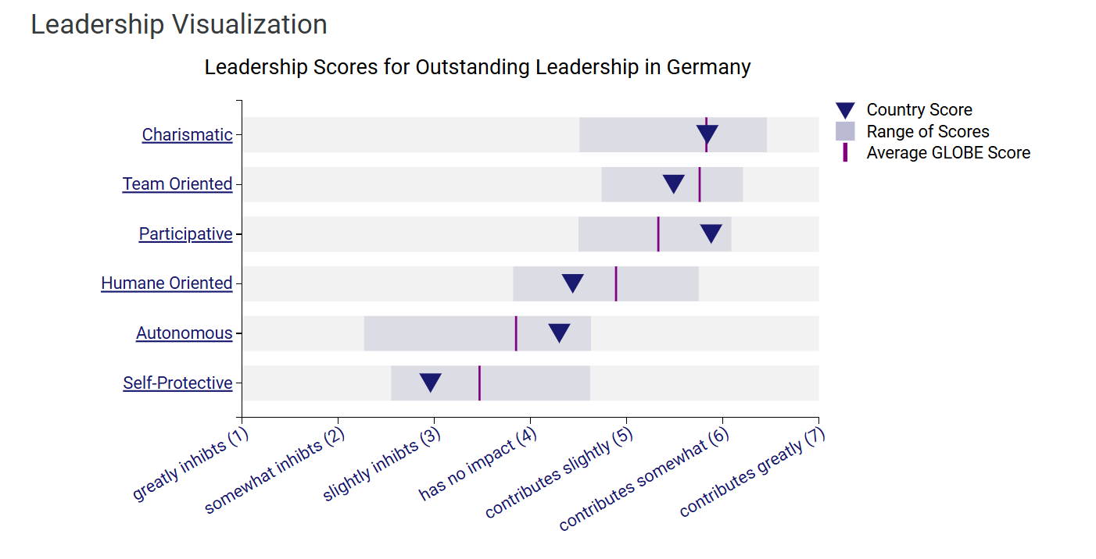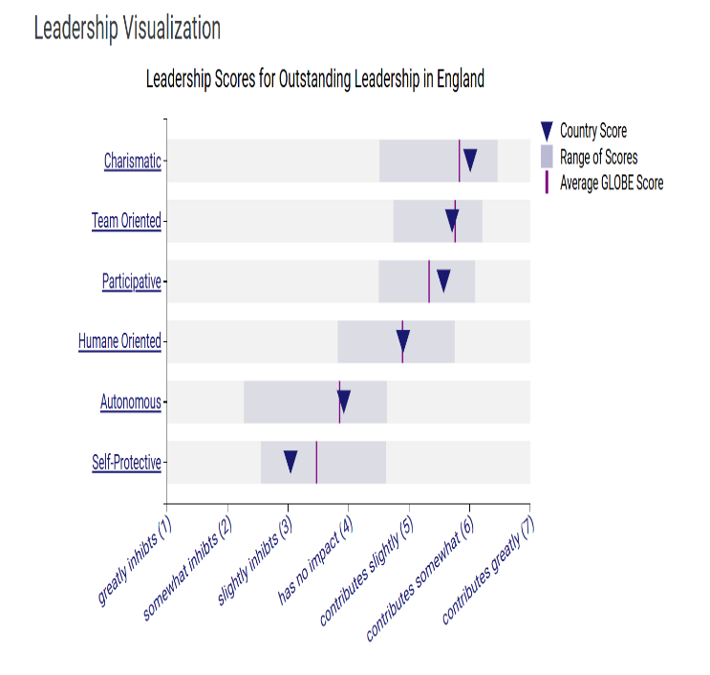fig.2

RECOMMENDATIONS

Based on the report findings, I would recommend trainings for employees from both countries on such subjects as cultural differences, acceptance, communication barriers, team-work games, language courses. For business I would recommend, often exchange of employees in order to reduce the cultural differences and to be open to any changes in order to satisfy guests and employees.

CONCLUSION
The above report has provided an understanding on Foreign Languages & Cultural Awareness in the context of Multicultural Hotel & Spa which is looking to expand in Germany. In the beginning, the report has provided with the key differences between England and Germany by taking in consideration culture and customs, etc. Further, the report has analysed and compared the two countries using the GLOBE Project’s culture and leadership study. The last part of the report has discussed the challenges of intercultural leadership in the hospitality industry with the help of concrete examples. Recommendations have been provided in aspect of cultural differences and avoiding cultural and communication misunderstandings.

REFERENCES
Areiqata, and.et.al, (2020). Culture and leadership are simply two sides of the same coin. Culture, 13(4), 123-147.
Guptill, and.et.al, (2022). Food & society: Principles and paradoxes. John Wiley & Sons.
Huertas-Valdivia, and.et.al, (2022). Contemporary leadership in hospitality: a review and research agenda. International Journal of Contemporary Hospitality Management, 34(6), 2399-2422.
Jdetawy, and.et.al, (2020). Linguistic etiquette: a review from a pragmatic perspective. Technium Soc. Sci. J., 14, 695.
Makhmudov, K. (2020). Ways of forming intercultural communication in foreign language teaching. Science and Education, 1(4), 84-89.

