DS2: Business Digital Task

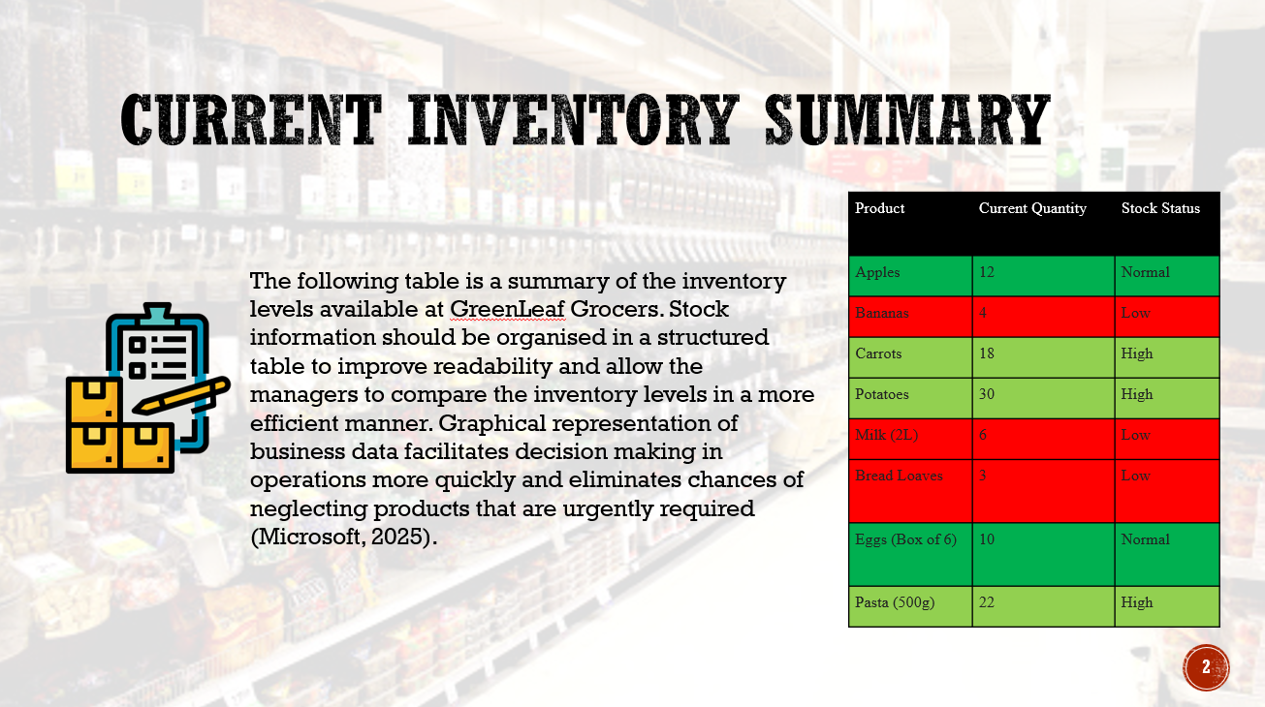

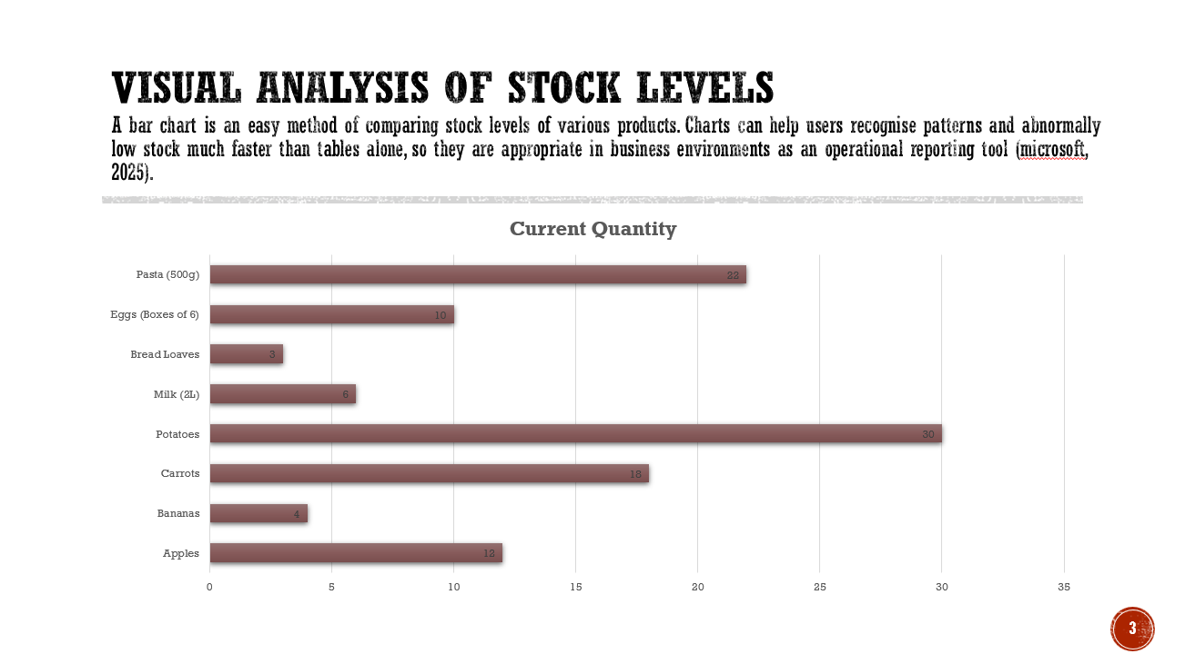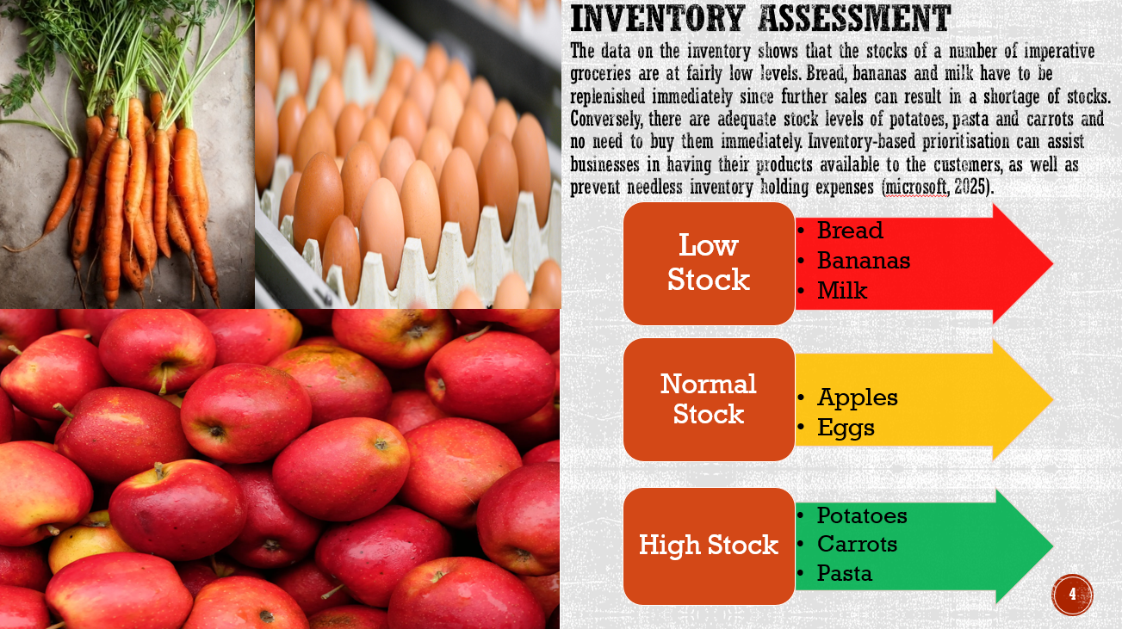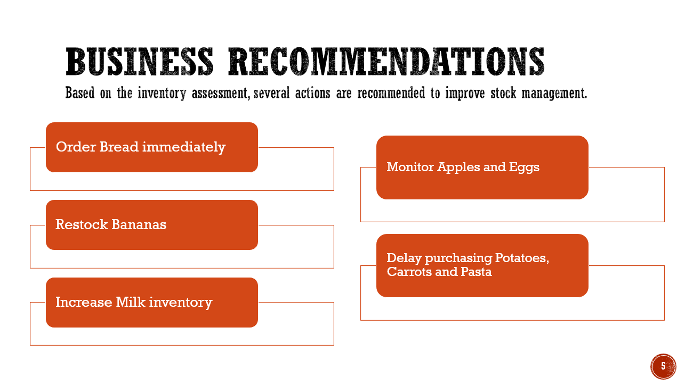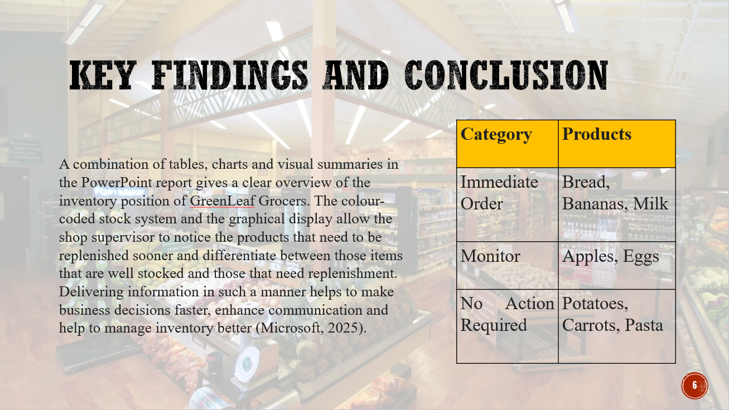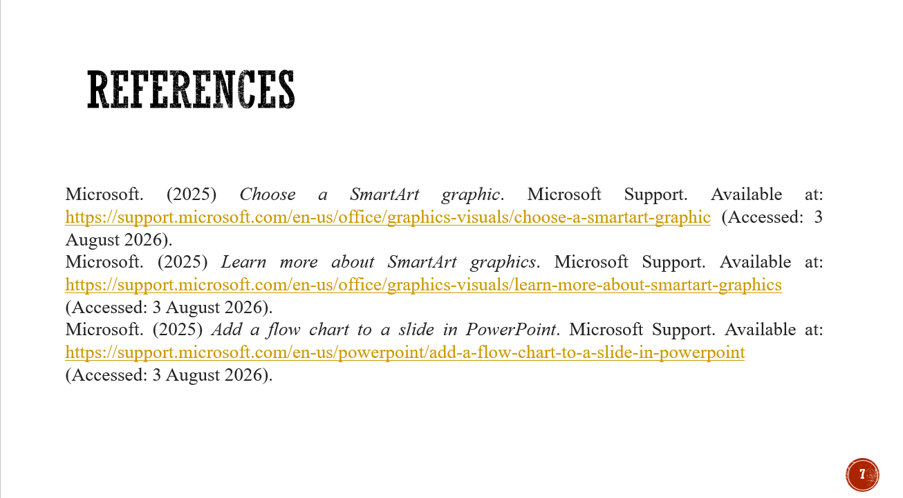
Log
Scenario 1 – GreenLeaf Grocers
1. Why I elected PowerPoint.
To undertake this evaluation, I chose Microsoft PowerPoint to prepare a stock summary presentation of GreenLeaf Grocers. Though the task is a numerical one, I felt PowerPoint to be the most appropriate tool since the business owner needs a concise chart, not a spreadsheet with lots of information. PowerPoint helps to arrange the information in professional slides based on tables, charts, icons and colour coding and easy to understand the stock levels in business meetings and day to day decision making process.
Other features that are in PowerPoint include, SmartArt, charts, standard themes and slide layouts, that enhance readability and communication. Microsoft suggests the clear slide titles, readable colours and clear layouts to enhance the accessibility and understanding, and I adhered to these guidelines to create my presentation. This served to make sure that the information was presented in a professional and user-friendly way and not in a set of untamed numbers.
2. Information Used
The information used in my presentation came directly from the GreenLeaf Grocers business scenario. The stock list included eight products and their current quantities:
- Apples – 12
- Bananas – 4
- Carrots – 18
- Potatoes – 30
- Milk – 6
- Bread – 3
- Eggs – 10
- Pasta – 22
Based on this information I was able to classify the products into three categories namely low stock, normal stock and high stock. I also drew a bar graph so as to compare stock quantities visually. This has enabled the shop supervisor to know the goods that need urgent replenishment as well as know the goods that were stocked up. The grouping of the data in such a manner turned raw numerical data into useful business data to make operational decisions.
3. The Process of making my Digital Artefact.
My first step was to plan how the presentation is going to look and then I added some content. First, I made a title slide that presented the aim of the report. I followed it by inserting a table that shows the information on all products and the amounts of stocks. I made use of uniform fonts, headings and spacing throughout the presentation to enhance readability.
Once I had the table, I typed in a bar graph which displays the number of stocks of all products. A chart is easier to compare than individual numbers as it is possible to notice the difference between the stocks at a glance. To enhance comprehensibility, Microsoft suggests clear chart titles, labels and contrasting colours which informed the design of my chart.
I then prepared an analysis slide that showed the products that needed attention and those products that had sufficient inventory. Lastly, I included a recommendation slide which proposed some practical steps that the shop supervisor can take, after which I included a conclusion summarising the findings.
4. Improvements and alterations done.
Throughout the developmental process, I also improved a number of aspects that enhanced the quality and professionalism of my presentation.
The table at the beginning had only the names of the products and quantities. Nevertheless, I understood that the manager would require recognising urgent products fast. Thus, I also added colour coding red (low stock), amber (normal stock and green (high stock). This presentation style simplifies the interpretation process as the reader would not need to go through each figure.
I have also redesigned the chart. In my initial version I had a few colours that captured the attention away from the data. Having read about presentation design and accessibility in Microsoft documentation, I updated the chart with uniform colours, bigger labels and more specific titles. These refinements made the chart more comprehensible and fit a professional business job.
An additional enhancement was on the slide layout, which was made simpler. I minimised redundant text, made all objects consistent and of the same design theme that was spread to all slides. This made it look cleaner and more readable.
5. Feedback and Reflection
I viewed my presentation and then I viewed it as a business user and thought about some ways I could enhance it. I realised that certain labels were too small at first, and I changed the font size and made elements spacing better. I also made sure that all the slides had meaningful titles thus ensuring that people could easily navigate the presentation.
Besides this, I also examined Microsoft directions on available presentations. This prompted me to apply clear headings, readable colour contrast and logical organisation of slides such that information could be easily comprehended by various users. By following these suggestions, my end presentation was made better and more professional.
6. Final Artefact Evaluation.
Generally, I think my digital artefact effectively addresses the business needs of the scenario. The presentation does not only come up with stock figures but conveys effective business information that can help in making decisions. The table presents the correct stock information whereas the chart shows the discrepancies of products in a short time. Colour codes and recommendations can make the supervisor know the priority items without analysing each quantity separately.
PowerPoint also enhances communication since the presentation can easily be distributed during meetings or it can be utilised as a visual management report. The last artefact shows that digital presentation software can be used to systematise business information in professional ways and enable prompt decisions on operations.
To enhance this further, should I ever undertake this again I would add automatic stock limits connected to an Excel sheet so that the presentation would automatically update as the stock levels altered. This would render the report even more helpful in future business operations.
Conclusion
The development of this digital artefact enhanced my knowledge of the role of presentation software in business communication. I also understood that good presentations are not only about good design but also about good organisation, visual correspondence and proper business suggestions. Planning, reviewing and improving my work helped me create a professional presentation that helps GreenLeaf Grocers to monitor stock level and make informed decisions about restocking.

References
Microsoft (2025) Make your PowerPoint presentations accessible to people with disabilities. Microsoft Support. Available at: https://support.microsoft.com/en-us/accessibility/powerpoint/make-your-powerpoint-presentations-accessible-to-people-with-disabilities (Accessed: 4 August 2026).
Microsoft (2025) Accessibility best practices with Excel spreadsheets. Microsoft Support. Available at: https://support.microsoft.com/en-us/accessibility/excel/accessibility-best-practices-with-excel-spreadsheets (Accessed: 4 August 2026).

