
MODULE CODE/ COD Y MODIWL: BMSK5004
MANAGING PROJECTS IN THE ORGANISATION

Café Gusto Project

Name: William Fernandez
Student Number: 1707878
Date: 9 May 2019

Lecturer: Dr Rexon Nting
Executive Summary
The project is about launching a coffee shop business, Café Gusto, at Walthamstow. Location has been selected strategically to lure many potential customers. The cost of the project is £50,000 and the starting date is 3rd of June 2019 up to 12th of August 2019. PRINCE2 is the project management method used from initiating stage up to closing stage. Payback period is 4 years, and the cost-benefit ratio is around 1.2. Potential risks have been identified and contingency plans to minimise its effect are evaluated. Lastly, personal assessment on project management are done on the latter part to improve my project management skills.
Table of Contents
Introduction 2
Project Management Methodologies 3
Agile PM 3
Scrum 3
PRINCE2 4
Work Breakdown Structure (WBS) and The Project Life Cycle 6
Initiating and Planning Stage 6
Project Scope 6
Business Case of Coffee Shop at Walthamstow 7
Business Objectives 7
Identify Stakeholders 7
Executing Stage 10
Stage 1: Legal requirements 10
Stage 2: Constructing and Renovating a Coffee Shop 10
Stage 3: Acquiring Right Suppliers 12
Stage 4: Marketing Coffee Shop 12
Stage 5: Hire and Train Employees 13
Stage 6: Opening Event 13
Timetable for the Project 13
Organisation Structure to Implement the Project 15
Cost of the Project 16
Monitoring and Controlling 17
Risk Management Plan 18
Financial Feasibility of the Project 19
Closure of the Project 20
Self-development Plan to be an Effective Project Manager 20
Conclusion 22
References 23
Appendix 24
Questionnaire on Project Management Skills Assessment 24

Introduction
The success of a project is not a simple task. The challenges manifest in time delays, working within a budget, unsatisfied clients, stressed workers and other undesirable results. The progress and sustainability of business organisations are dependent immensely on the management of projects. Project management comprises of the creation of working environment and situations in which to attain an objective or goal in a controlled manner with a group of people working together. Innovations on new ventures of doing things, launching of new products and business expansion require timetables, budgets and a team working together toward an objective on delivering the project. (Buttrick, 2009). The objective of project management is to produce an end product that is beneficial to the business organisation. Recently, many business organisations have begun to grasp the importance of project management as a key for opportunities on managing change to enhance efficiency and performance of the organisation. However, in every new endeavour, there are always risks that need to be managed properly to ensure realisation of the project within a time frame (Boddy, 2017).
The objective of this report is to show the practicality and valuableness of putting up coffee shop which specializes on freshly baked pastries and cakes at Hoe Street, Walthamstow, London. Moreover, implementation of the project that includes tools and technique of project management is to be critically assessed. Consequently, detailed planning, project scope and risk assessments are going to be discussed. Stakeholders in the project need to be identified and inform how they may be affected on implementing the project. Furthermore, a personal assessment on managing a project is to be critically evaluated. In addition to this, a self-development plan on enhancing my capabilities and skills on project management is going to be included on this report.

Project Management Methodologies
The selection among many project management methodologies has been debated by many professional practitioners on which is the best method suited for a project. There is a battle between Agile Pm vs Scrum vs PRINCE2 by many project managers even if many argue that there is no strict need to select only one methodology of project management. The project management processes are different on each methodology to facilitate the project on increasing the chances to become successful. The success rate is important due to most of the projects are extremely costly and choosing a method to apply is considered priority and essential. AgilePM, Scrum and PRINCE2 are the biggest names on the methodology of project management (Verzuh, 2017).

Agile PM
The AgilePM project management methodology has become widely used over recent years. Due to the demand of innovation and creativity of products and services, many project manager or professionals are utilising its flexibility so that the products can remain competitive in the market. Changes can be made during the execution process of the project. The benefits of Agile PM are adaptable to changes. Nevertheless, it is not focused on product quality and may suffer working beyond the project boundaries (Verzuh, 2017).

Scrum
Nicholas and Gezinus (2014) argue that Scrum management methods are moving away from the conservative agile project management roles. It has only three roles which are product owner, team and Scrum master to execute the processes of project management. It is normally applied on software development or any project that involves innovation and dynamic procedures. The priority of the project is to identify what matters most and divide into manageable portions. Determining what the customers want and ensuring to deliver is the main objective of Scrum. The advantages of scrum are changes are executed without difficulty and huge projects can be divided into chunks for effective management. However, there is no clear project definition, frequent changes are normal and usually results from working outside the project scope.

PRINCE2
PRINCE2 is from the contraction of PRojects IN Controlled Environments (version 2) and it was intended originally for the development of IT projects. The PRINCE2 project management methods offers a well-structured approach. It is scalable, flexible and practical on any type of project. It has been refined for many years by experienced project managers. There are seven key principles on utilising PRINCE2 method which are continued justification; learn from experience; defined roles and responsibilities; manage by stages; manage by extension; focus on products; and tailor to suit the project environment as shown in figure 1. If a project is successful, there are six performance variables to be manage which are cost, time, quality, scope, benefits and risk. Prince2 renders a set of processes that provide a controlled beginning, controlled development and controlled termination of the project. Prince2 has an approach which is processed-based describing different themes within the process which are business case, organisation, progress, plans, risk, quality and change as shown in figure 2. PRINCE2 has the potential benefits on focusing on product quality and can be tailored to suit any project. However, working product availability in only available at a product conclusion and the decision-making takes time to process (Bentley, 2010).

PRINCE2 Key Principles
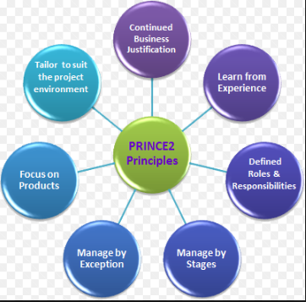
Figure 1
PRINCE2 Themes
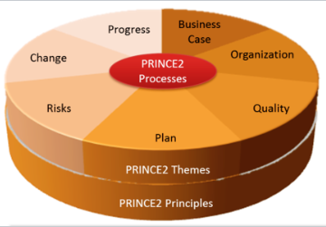
Figure 2

The Italian coffee shop project has a definite objective that is not changing frequently over time. It needs a methodology which has well-defined structure as not to go beyond project specification to manage the initiating stage, planning stage, executing stage, monitoring and controlling stage and closing the project. The most appropriate methodology for the ‘Café Gusto’ project is PRINCE2.

Work Breakdown Structure (WBS) and The Project Life Cycle
Work breakdown structure means breaking down the project into chunks to make it more manageable tasks. Whereas the project life cycle represents the process of execution of the project on different stages in order to be implemented. Nevertheless, while dealing about structures, project life cycle is primary project structure and it is subdivided into structures (Bruce and Langdon, 2018). The project life cycle is shown in figure 3 below.
Project Life Cycle of ‘Café Gusto’ Project

Figure 3

Initiating and Planning Stage

Project Scope
The part of the project that comprises identifying the project goals, features, time frame, limitations and cost of the project is called project scope (Roberts, 2011). The description of the project is vital to determine the cost and the impact of schedule on delivering the project. The subsequent paragraph is the project scope of ‘Café Gusto’.
The project is putting an Italian coffee shop called ‘Café Gusto’ which specialises on quality Italian coffee, pastries, rolls and sandwiches in the busy street of Walthamstow. The coffee shop project is about 50 square meters floor area with small kitchen, coffee bar, satisfactory space for seating, coffee machine and toilets. The coffee shop is intended to be a magnificent meeting place for friends, families and commuters. Moreover, the establishment can host up to 18 customers. The coffee shop will also offer Wi-Fi and relaxing music. Six workers would be necessary for morning and evening shift. The location should be near on Walthamstow train stations and a walking distance to Wathamstow mall. The project has an initial estimated budget of no more than £50000. The time frame to launch the business is 10 weeks and it will begin on 3rd of June 2019. The coffee shop project will be successful if the launching will be on 5th of August 2019 and it will be fully operational on 12th of August 2019.

Business Case of Coffee Shop at Walthamstow
Café Gusto is a relaxing place for those who love quality coffee and artisan pastries and sandwiches at the heart of Walthamstow. The vacant former retail clothing shop is available for lease and it offers opportunity to open a coffee shop. The main objective is to serve the best cup of coffee in town. Moreover, this will give families and friends a quality bonding time with each other. Although, for people ‘on the go’, clients can purchase a cup of coffee for takeaway. At present situation, there are only a small number of coffee shops at Walthamstow. This may fill in the gap on coffee shop that serves authentic Italian coffee. Cafe Gusto will offer the need of demanding clients and be the market leader at Walthamstow.
.

Business Objectives
The aim of the business is to be ranked high regard in website, social media, foodies and forum. Moreover, the company targets to build a profitable business and generate a great employment workplace. Furthermore, the company targets to keep a sustainable enterprise, which offers a quality products and services that stands out to competitors.

Identify Stakeholders
The objective is to involve stakeholder at an early stage. Stakeholder is anybody or group of people who are affected by the project. Not all stakeholders are equally significant, so determine those who have vital influence on the project. Creating a good rapport to the main stakeholders are essential to the success of the project (Bruce and Langdon, 2010). The organisational stockholders of ‘Café Gusto’ are project manager, employees, customers, social and political groups, competitors, trade and industry associations, government, media, suppliers, communities and unions. The level of importance can be determined using the figure below.

Stakeholder Analysis Table

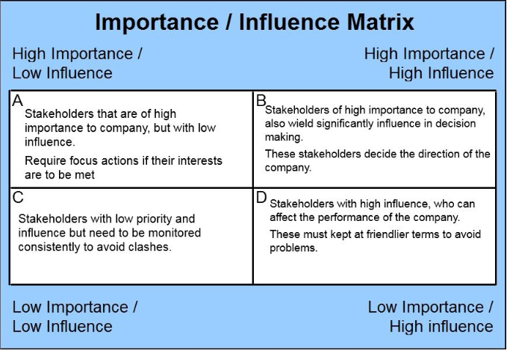
Figure 4
Source: Bruce and Langdon (2010)
High importance and high influence signify that the stakeholder is important, and it has a huge impact on the project such as project manager and key team member. This quadrant holds key roles and regular communication is necessary for the success of the project. While the high important and low influence like government and suppliers are significant but the engagement or participation is low. When it comes to low important but high influence like media, it means that engagement is little or none at all however, there is a huge influence on the outcome of the project. On the other hand, the low important sand low influence has a minimal influence and the degree of importance is low like competitors and environmental group. Thus, by understanding the importance and influence of stakeholders, project manager can act accordingly within the requirement of the project.
The better the communication, the smoother the ‘Café Gusto’ project will flow. It is important to ensure that everyone who needs a project information has an easy access on it. Moreover, a two-way communication by listening and asking feedback should be encourage and make the most of new technology to improve communication. The stakeholder analysis for project communication is shown on figure 5. It has the key stakeholders, document name, document format, contact person and due date on communicating.

Stakeholder Analysis for Project Communication
Stakeholders | Document Name | Document Format | Contact Person | Due
Project Manager | Weekly Status Report | Hard Copy | William Fernandez | Every Friday
Store Manager | Training plan | Hard Copy e-mail | Raihan Miah | 14th of June 2019
Renovation Contractor | Weekly Status Report | Hard Copy | Phil Collins | Every Friday
Electrician | Store Electrical Plan Layout | Hard Copy | Shariff Udin | 14th of June 2019
Government | Official License to Operate | Hard Copy | Immon Suffian, Muhammed Islam | 10th of June 2019
POS system provider | Software Implementation Plan | e-mail | Ancuta Chirita | 21st of June 2019
Suppliers | Price Lists | Hard copy/e-mail | Wafa Nasaar and Siraje Sekawunde | 28th of June 2019
Coffee Shop Equipment Provider | Price Lists/ Delivery date | Hard copy/e-mail | Muhammed Jamal | 17th of June
Furniture Company | Price Lists/ Delivery date | Hard Copy/e-mail | Adella Ness | 10th of June

Figure 5

Executing Stage

Stage 1: Legal requirements
After the preparation of a solid business plan and a strong desire to open a coffee shop, it is required to obtain a public liability insurance. It is necessary to acquire a license to Waltham Forest Council as an officially registered company. It would take one week to process the license (GovUK, 2019). This stage is important because the business cannot operate legally without it. There should be an assurance that the government will give a license to operate. If not due to some reasons or issues, the project will not push through before investing a huge amount of money. Furthermore, there should be an approval of the landlord in writing before initialising construction on coffee shop business.

Stage 2: Constructing and Renovating a Coffee Shop
- Select and order flooring to be worked out by a construction company according to the design which is illustrated in a business plan. Toilet flooring is by tiles and the rest is luxury vinyl tile. It has a taste of elegance, but it is a lot cheaper than porcelain or marble.

Floor Plan of Coffee Shop
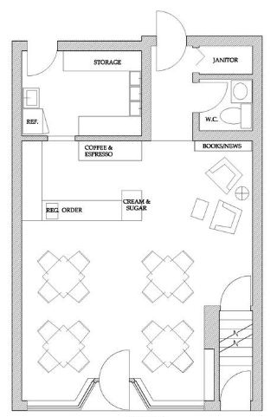
Figure 6
- After the flooring is done, build a cabinet where to put the coffee machine, cream sugar stand, book newsstand, food display cabinet and storage cabinet in a minikitchen.
- The next thing to do when the flooring is done is installing electrical wirings, plugs and connections. Make sure to hire professional workers to ensure abiding health and safety regulations from the government.
- Purchase and set-up the coffee machine, dishwashing machine, refrigerator, freezer, microwave oven, salamander grill, toaster, sandwich toaster, heating system and blender. The project manager should concentrate on a good espresso machine due to the fact that it is the heart of the business. However, it is not necessarily the most expensive coffee machines, but it depends to the anticipation of potential customers during peak hours. With these factors, right model can be purchased.
- Furnitures and fixtures need to be set on its proper place. Chairs should be comfortable and cosy. Furthermore, tables and chairs should look elegant but not exorbitant on its prices.
- A coffee shop POS (Point of Sale) system needs to be installed. It is designed to assist on managing efficiently the counter, delivery order, seat numbers and overall general business needs. Moreover, POS system is not just a tool for coffee shop business, but it can ease the administration burdens such as cashing up, calculating tax and monitoring sales and inventories, and help serve customer faster. Thus, it can act like another key member of the staff.
- Design the cafeteria that makes its ambience an authentic Italian coffee shop. Signposts outside should be visible and attractive to potential clients who are passing by.

Stage 3: Acquiring Right Suppliers
Ensuring on finding the right supplier of the coffee business is crucial. The connections that the project manager or owner of the coffee shop to its suppliers are one of the most essential part of the success of the business. However, it requires a lot of face-to-face communication and business negotiations. Hence, the business owner needs to rely on its suppliers for smooth operation.
There are some criteria on looking for the right suppliers of ‘Café Gusto’. When searching for suppliers, it is not necessarily the cheapest price is the best deal. Although it is tempting, consistent quality products and services need to be considered. Furthermore, suppliers have a vast knowledge on current trends in coffee. A fringe advantage of communicating properly with suppliers is to utilise for professional networking and grabbing a business offer on other field such as information for new offers of other products or newly modified rules and regulations.

Stage 4: Marketing Coffee Shop
Constructing a coffee shop and acquiring suppliers are not the only important things to start a coffee business but attracting potential customers to go inside your shop is another one entirely. The attractiveness of freshly baked goods and the tantalising smell of freshly roasted coffee should be considered significantly to retain and attract customers. Once the coffee shop has been set-up, it is vital to advertise it online. There are many advertising services at no extra cost to offer geotargeting option such as Facebook and Twitter. Creating a company website would let the customers know the opening times and specialties through browsing the internet (Nautiyal, 2016).

Stage 5: Hire and Train Employees
Hiring right people is a huge task, specifically when the business is just starting up. The project manager/owner needs to hire a manager, 2 full-time supervisors, 2 full-time baristas and 2 part-time baristas on launching the coffee shop. The company need an experienced manager who has a work experience on coffee shop and has a managerial experience. All employees should undergo first-aid training, food handling training and trained to use the coffee machine and other equipment prior to utilising it.

Stage 6: Opening Event
After working hard to launch a coffee shop, it now ready for a grand opening as it welcomes the community that the new business is ready to send a message that the coffee shop is ready to serve the most delicious coffee within the vicinity. The aim of the grand opening is to create loyal and repeat customers. Before setting the date of grand opening, it is a good strategy to collaborate with other neighbouring business establishments by posting and distributing promotional materials. Although not everyone will be attending the event, it is vital that friends, relatives and passer-by have a good chance to attend and enjoy a great customer experience as a part of ‘word-of-mouth’ advertising. It is also a good time to train all employees on actual scenario on how to utilise coffee shop POS system. Moreover, there should be coffee discounts, food treats and souvenirs to market the business.

Timetable for the Project
The timetable for the execution of the project is vital to check the duration and the detailed plan when to act on it. It has been subdivided into different stages and some stages can not be done without completing the prior stage. Flooring should be done first before installing the electrical wiring. Setting up coffee machine and equipment can not push through before the installation of electrical wiring. However, there is a floater or allowance for 7 days depending on the availability of technician. For the grand opening, designing, installing POS, hiring and training of employees are all set before the grand opening day. Afterwards, adjustment is necessary before the closure of the project. Furthermore, marketing and monitoring could be done from the second week up to closure of the project. Thus, the timetable is vital as a guide on completing the project on time and monitoring its progress
Project Schedules
Start Date | End date |  | Description | Duration/ No. of days | Float/ No. of days
03-Jun | 10-Jun | Acquiring public liability insurance and business license |  | 7 | 0
10-Jun | 17-Jun | Flooring construction |  | 7 | 0
17-Jun | 24-Jun | Install electrical wiring |  | 7 | 7
17-Jun | 01-Jul | Building cabinets |  | 14 | 0
01-Jul | 08-Jul | Setting up coffee machine and equipment |  | 7 | 0
01-Jul | 08-Jul | Putting tables and chairs |  | 7 | 0
08-Jul | 15-Jul | Installing POS system |  | 7 | 7
08-Jul | 15-Jul | Designing cafeteria |  | 7 | 7
08-Jul | 22-Jul | Hire and train employees |  | 14 | 0
22-Jul | 05-Aug | Preparation for grand opening |  | 14 | 0
05-Aug | 06-Aug | Grand opening |  | 1 | 0
06-Aug | 12-Aug | Final preparations and closure |  | 6 | 0
Figure 7

Gantt Chart for ‘Café Gusto’ Project

Figure 8

Organisation Structure to Implement the Project
Berkun (2008) argues that having a definite organisational structure would beneficial to avoid confusion and going beyond the project scope. The project is not a large scale on its size. The project manager is held accountable to the success of the project. Store manager, staff of the project manager, renovation contractor, coffee shop equipment provider and the agent of furniture company need to report on him about updates and progress of the project. Roles and responsibilities are different. For instance, the store manager is responsible to contact supplier, hire and train employees and communicate with the POS system provider.

Organisational Structure of ‘Café Gusto’ Project

Figure 9

Cost of the Project
The important part of launching a business in on the concept of returning investment. Hence, the expenditure should be on the right thing focusing only on the need of the project. The estimated cost of the project is broken down on the following:
Cost of the ‘Café Gusto’ Project
Materials/Equipment Services | Costs
Leasing (Quarterly) | £4,500.00
Utility Bills | £600.00
Legal Requirements  (Public liability insurance, solicitor, business permit and many more) | £4,000.00
Flooring | £1,500.00
Fixtures and Fittings | £5,000.00
Tables and Chairs | £2,000.00
Coffee Machines and other Equipment | £15,000.00
Marketing | £400.00
Staffing (Hiring and Training) | £4,000.00
Inventory | £2,000.00
Initial Operating Cost | £2,000.00
Others | £1,000.00
Contingency Budget | £8,000.00
Total | £50,000.00
Figure 10
According to (Morland, 2017) , it is recommended to have a contingency plan and an initial operating cost when it begins on operation. The company is going to pay a lot of VAT and it might take a while to reclaim this. Furthermore, the business may start slowly at first until it will reach a point where potential clients would come regularly to the coffee shop. It takes time to build confidence and trust from customers.

Monitoring and Controlling
Effective monitoring keeps a project on track when it comes on performance, time and cost. The challenge is to focus according to plan and to act fast tackling issues and changes to stay on course. It is crucial to have an early monitoring system. Moreover, it is vital to keep comparing schedules from the Gantt chart above and budget against the original plan. Every stage of execution and milestone must be documented and reported by the project manager (Cole and Kelly, 2011).
For the ‘Café Gusto’ project, it needs a weekly report and meeting from the general manager, owner and project manager. The stakeholder analysis for project communication on figure 5 has a vital information about the document needed, due date and contact person. The project manager needs to check if it is implemented accordingly. The Gantt chart on figure 8 contains a strict schedule on executing smoothly the project. However, the project manager needs to assess the activities if it is done correctly according to time, quality and budget. If there are some necessary adjustment, it needs to be done quickly and manage the risk involve on it.

Risk Management Plan
There is no perfect project even if it is carefully planned. There are always unexpected issues that may come out of the project. It paves way to the importance of project risk management. It is defined as the science of determining and responding appropriately to meet project objectives. The first objective is to identify the potential issues and analyse how most likely it may occur. The next thing is to provide the negative risks that can be avoided and minimise the impact for those it cannot be avoided (Boyer and Shields, 2017). The table below is the risk assessment of ‘Café Gusto’.
Risk Management Plan

Legend:
L – low
M – Medium
H - High
Risk | Possibility | Impact | Priority | Preventing and Mitigating the Risk | Contingency Plan
Fire damage | L | H | H | Fire extinguishers, smoke alarms are regularly check and tested. Staff training must be provided in case for a fire situation. Moreover, life and property must be insured. | After the damage caused by fire, the shop must be immediately rebuilt while waiting for the insurance.
Suppliers change the condition or prices of the agreed deal | M | M | M | Establish a sustainable business relationship to the supplier. There should be always a contingency plan if business may be negatively affected. | Look for other suppliers using contingency budget
Food Poisoning | L | H | H | Staff should be trained on food handling. All staff must rotate the products and be aware on expiry date. | Investigate the source of the food poisoning and take good care of the affected customer. Follow the company policy on handling complaint.
Delay on delivering equipment | M | M | H | It is a good practice to order ahead of time to give allowance for delay and monitor the order regularly. | Communicate to the company to deliver it as soon as possible or look for alternative company who can deliver it on time
Figure 11

Financial Feasibility of the Project
It is important to identify if the coffee shop project is profitable and sustainable. The necessity of justification of investment can be determined using payback method and cost-benefit analysis which are the two most preferred methods (Berkun, 2008).
Payback denotes to the period of time to return the investment. Shorter paybacks are preferable compared to longer paybacks. It is a tool that is easy to apply and understand by investors. The amount of time it takes to recover the investment is 4 years from figure 12 below which means that the business is profitable but it would take 4 years to recover the investment (Sanchez, 2017).

Payback Table of ‘Café Gusto’ Project
 | Cash Flow (£) | Cumulative (£)
Year 0 | (50,000) | (50000)
Year 1 | 5000 | (45,000)
Year 2 | 10000 | (35000)
Year 3 | 15000 | (20000)
Year 4 | 20000 | 0
Year 5 | 30000 | 30000
Figure 12
On the other hand, cost-benefit analysis determines the profitability of the business in a given period of time. It is the ratio of revenues all over cost of operation. The ideal scenario is having a ratio of greater than one to be profitable. The higher the ratio, the better the performance of the business in terms of profit making (Sanchez, 2017). For instance, the operational cost of monthly operation is £20,000 and the revenue is £24,000. Hence, the Cost-Benefit ratio = £24,000/£20000 = 1.2. Thus, the ratio of 1.2 means that the project is feasible.

Closure of the Project
The ‘Café Gusto’ project will be closed on 12th of August 2019. On this date, the project manager will turnover the coffee shop to the store manager to manage its daily operation.

Self-development Plan to be an Effective Project Manager
It is necessary to create and reflect on my development plan to be a good project manager. It is essential that it should be SMART. The acronym SMART stands for Specific, Measurable, Achievable, Realistic and Time Bound. Moreover, I need to determine my strengths and weaknesses from the point of view of my colleagues in the workplace on managing and implementing a project. My strengths are being result-oriented, organised, good communication skills, work well in a team, leadership skills and flexible to my work schedules. However, I have weaknesses such as stubborn, procrastinating on my career progression and lack of experience on managing projects.

Self-Development Plan
Objective | Action Required | Resources or Support Needed | Success Criteria | Target Date for Review and Completion
Effective Project Manager | - Find a mentor who has many years of experience on managing project  -Develop my project management skills  -Attend trainings and seminars on project management | -Support from a management team  - Professional Networking  - More exposure on managing a project | Successful projects as a project manager | 31st of December 2020
Figure 13

On my self-development plan on how to be a good project manager, resources are needed such as experience, support from a management team and professional networking. The actions required are finding a mentor, more training and develop my project management skills. I need to improve or minimise skills gap on the ten attributes of a good project manager which are effective communication skills, strong leadership skills, good decision maker, technical knowledge of the given project, inspired a shared vision, work well under pressure, good negotiation skills, empathetic and competence (Maund, 2018) . I also answered questionnaire to assess my project management skills on Appendix 1. My score is 91 which is reasonably effective manager, but I need to address some weak points such as procrastinating to address my sponsor, trusting new member to fit in the project, regular contacts with key stakeholders and many more. There is lot to improve my performance managing project. However, knowing my weaknesses and strengths, I am able to focus on it in a given time frame.

Conclusion
PRINCE2 has been chosen as the most appropriate project methodology because ‘Café Gusto’ project needs a definite and organised structure to focus on delivering within the project scope. There are five stages on the project life cycle which are initiating stage, planning stage, executing stage, monitoring and controlling stage and closing the project. The project scope, business objectives, stakeholder analysis are vital parts of the initiating stage prior to starting a project. Moreover, a timetable on executing a project utilising Gantt chart to a smooth flow of operation is beneficial for monitoring and controlling. There is a well-defined organisational structure to avoid confusion on communication, roles and responsibilities. The project has been assessed to be financially feasible by using payback period and cost-benefit analysis. Potential risks such as fire damage, price increase of materials, food poisoning and delays on delivery have been identified to mitigate or minimise its negative impact. Lastly, a self-development plan on project management with a questionnaire is assessed to enhance my performance as a project manager. The ability to manage a project properly improve the chances of achieving the desired result, ensure its efficient use and avoid unnecessary expenses.

References
Bentley, C. (2010) PRINCE2: A practical handbook. 3rd edn. Oxford: Elsevier Ltd.
Berkun, S. (2008) Making Things Happen: Matering project management. California: O'Reilly Media, Inc..
Boddy, D (2017) An Introduction yo Management. 7th edn. Harlow: Pearson Education Limited.
Boyer, K. and Shields, K. (2017) 'Strategic planning characteristics applied to project management' International Journal of Project Management, 35(2), pp. 169-179.
Bruce, L. and Langdon, K. (2018) Project Management. London: Dorling Kindersley Publishing.
Buttrick, R. (2009) The Project Workout. 4th edn. Harlow: Pearson Education Limited.
Cole, G. and Kelly, P. (2011) Management Theory and Practice. 7th edn. Hampshire: Cengage Learning EMEA.
GovUK (2019) 'Business License'.
https://www.gov.uk/licence/sectors?utf8=%E2%9C%93&sectors=380&q=coffee+shop&button= [Accessed: 2nd May 2019].
Joshua, P. (2019) 'How Much Does it Costs to Open a Coffee Shop'. https://www.noblypos.com/cost-to-open-a-coffee-shop [Accessed: 6th May 2019].
Maund, A. (2018) BA in Leadership and Management. London: Sage Publications Ltd.
Morland, L. (2017) ' Rounton Coffee and Bedford Street' International Journal of Enterpreneurs and Innovation, 18(4), pp. 256-257.
Nautiyal, J. (2016) 'Experiences in Opening Coffee Shops' Education and Culture Journal, 32(2), pp. 99-118.
Nicholas, J. and Gezinus, H. (2014) ' Management Principles Associated with IT project success' International Journal of Management and Information Systems, 14(5), pp. 1-4.
Roberts, P. (2011) Effective Project Management. Norfolk: Kogan Page Ltd.
Sanchez, O. (2017) 'Cost and Time Project Management' International Journal of Project Management, 35(8), pp. 1608-1626.
Verzuh, E. (2017) Project Management. 4th edn. New Jersey: John Wiley and Sons.

Appendix

Questionnaire on Project Management Skills Assessment

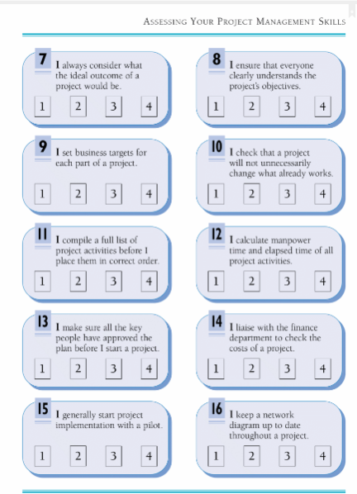

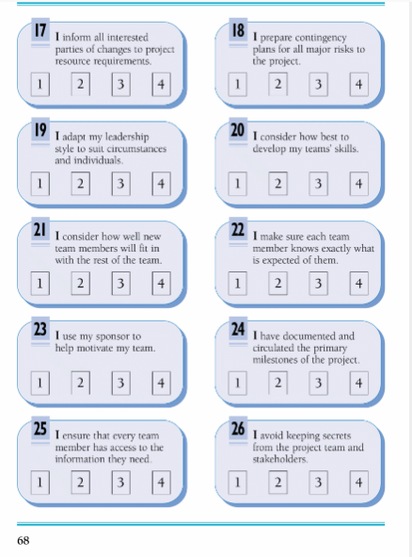
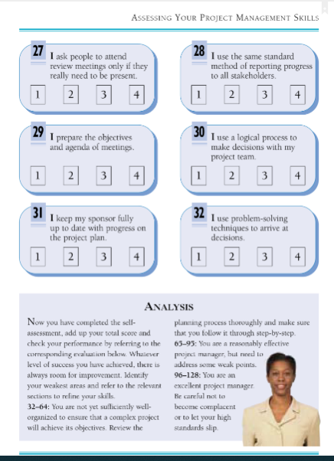
Source: (Bruce and Langdon, 2018)
My Score: 91 points

