Table of Contents
0. Abstract 1
1. Introduction 1
2. Validation 1
3. Assembly and Materials 2
4. Initial Simulation 3
4.1. Rigid Dynamics 3
4.2. Steady-State Thermal 3
4.3. Static Structural 4
5. Evaluation and Iteration 5
5.1. 6061-T1 Aluminium 5
5.2. GRANTA Cast steel 6
5.3. GRANTA Titanium 7
5.4. Material Evaluation 8
6. References 8

0. Abstract
This report presents the results of a computer simulation of a crankshaft assembly with a focus on the effects of different material properties on the deformation and stress experienced by the piston. The simulation software was validated using a known example from the Dlubal verification database, demonstrating its accuracy. The material used in the initial simulation was then swapped out and evaluated against other materials. The results show that the material has a significant impact on the deformation and stress experienced by the piston, with some materials performing better under the simulated conditions.

1. Introduction
This report covers the use of computer simulation software to evaluate different material properties on the piston of a crankshaft assembly. This is first verified by the use of a validation model to test that the simulation properties match those of real-world conditions. From this, an initial simulation is developed covering rigid dynamics, steady-state thermal, and static structural models to give the end total deformation and total stress on the piston head as the crankshaft rotates at 4000 RPM. The material used is then swapped out and evaluated against the other materials in the study.

2. Validation
For the accuracy of the model, a validation should be produced to evaluate the accuracy of the software used before using it to simulate a full complex analysis of an assembly. This is done by using the Dlubal verification examples database to select an example to be modelled and tested in the Ansys software.
For the validation test, the Elastic Bending – Continuous Load (000016) was selected (Dlubal, 2022), which is a thin plate fully fixed on the left side, with a uniform pressure applied to the top surface of the model. The specifications of the Material, Geometry, and Load have been taken from the verification example sheet and placed into this report for ease of use, with units converted from meters (m) to millimetres (mm).
Material | Elastic-Plastic | Modulus of Elasticity | E | 210000.000 | MPa
Material | Elastic-Plastic | Poisson’s Ratio | v | 0.000
Material | Elastic-Plastic | Shear Modulus | G | 105000.000 | MPa
Geometry | Plate | Length | L | 1000.000 | Mm
Geometry | Plate | Width | w | 50.000 | Mm
Geometry | Plate | Thickness | t | 5.000 | Mm
Load | Plate | Pressure | p | 2750.000 | Pa
Table 1 – Specifications of the Elastic Bending – Continuous Load verification example.
To do this, the specifications of the plate from Table 1 were modelled using Solidworks, to create a plate which was then saved to be used in Ansys as the geometry portion of the simulation. In Ansys, the data from the Material section of Table 1 was then inputted into a new Engineering Data node, which was then connected to a Static Structural node with the geometry from Solidworks imported also into the Static Structural node. Then by opening the Model portion of the node, Ansys Mechanical is used to setup and simulate the model, firstly by applying the correct Elastic-Plastic material from the Engineering Data to the geometry. Next the mesh was generated using 2.5mm increments, giving a large mesh of 2.5x2.5x2.5mm mesh cubes, and then the left-hand surface was set as a fixed position, meaning that it will not deform or move like the rest of the model. Lastly, a total deformation was applied to the top surface of the model and the simulation was run. It gave the output shown in Figure 1.
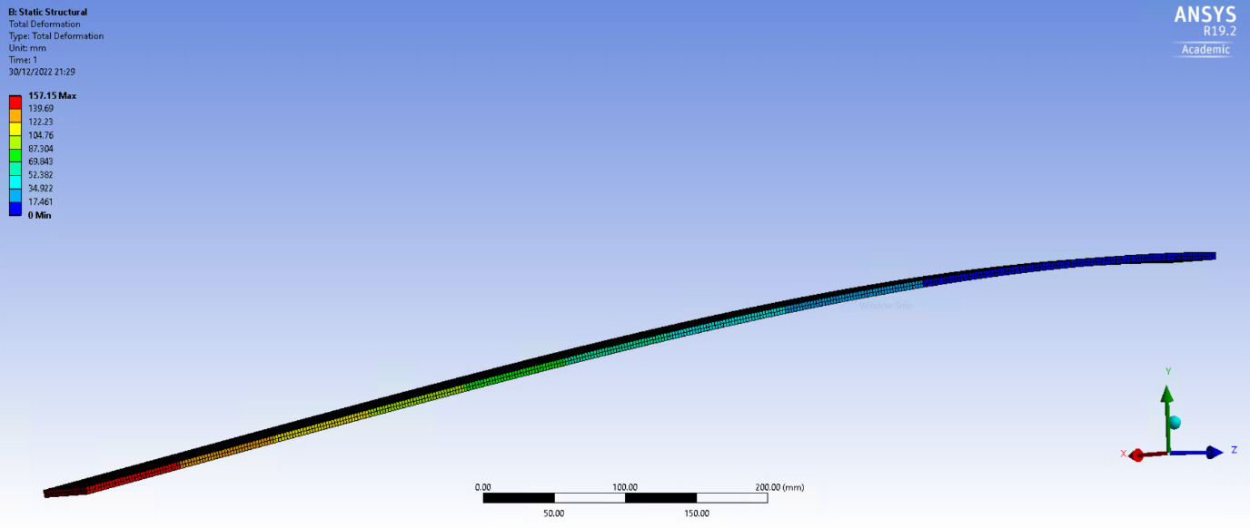
Figure 1 – A rendering of the complete total deformation model of the Elastic Bending Continuous Load verification example.
Once the simulate was complete, the data from the original verification example PDF (Dlubal, 2022) was taken and compared to the actual simulation data. This can be seen as 157.15 in the upper left, compared to the original analytical solution results which show 157.143. From this, there is some margin of error however it is so small that it is almost completely negligible meaning that we can conclude that the simulation software is accurate in comparison to the Dlubal verification examples, and accurate for other simulations.

3. Assembly and Materials
The assembly used is a model of a crankshaft, assembled in Solidworks and then exported into the specific STEP file format so that it is compatible with Ansys Workbench.
For the material 6061-T6 Aluminium is used, from which the properties were added to an Engineering Data from the study data provided, which has been written here for convenience. For the material, the Poisson’s ratio is 0.33, the coefficient thermal expansion at 22°C is 2.36E-05 1/°C, the thermal conductivity is 167 W/m-K, and the specific heat capacity is 0.896 J/g-°C. Once all the data was added to the engineering data, it can then be used in each study with the material properties imported, however, checking the data is imported correctly at each study is important.
Young’s Modulus
Temperature (°C) | Value (GPa) | Value (MPa)
22 | 67 | 67000
100 | 70 | 70000
150 | 68 | 68000
200 | 64 | 64000
250 | 56 | 56000
300 | 48 | 48000
350 | 41 | 41000
400 | 32 | 32000
450 | 21 | 21000
500 | 12 | 12000
Table 2 – List of Young’s Modulus values for 6061-T6 and their MPa conversions.

4. Initial Simulation

4.1. Rigid Dynamics
For the rigid dynamics, when adding it into the project schematic portion of ANSYS Workbench, make sure that the engineering data added previously connects to the engineering data in the rigid dynamics. This sharing of data is an important part of the simulation allowing for the data from each study to be used in the next, and save the repeating of work. Next, the assembly is added to the geometry section, which needs to be in a format suitable for use with Workbench, for example a ‘STEP’ file if the assembly was made using Solidworks. For this study, an assembly of a crankshaft is used with the focus being on the piston part of the model, with different materials used to understand what could happen to the piston head.
Next the model section of the rigid dynamics is opened, with ANSYS Mechanical opened with contacts generated by the software which need to be replaced with specific joints. First, delete the pre-existing connections and disable the automatic generation, and add a joint between each section: crankshaft and connecting rod, connecting rod and gudgeon pin, and gudgeon pin and piston head with all of them being revolute. Then two special joints need to be made, with one connecting the crankshaft to the ground and again being a revolute joint, then a general joint needs to be made allowing the piston to only move on the Z axis (up and down) as in a full engine the piston would be in a shaft.
Lastly, the solution parameters can be setup, by using a rotational velocity on the crankshaft to ground joint at 4000 RPM. Then a joint probe on the gudgeon pin to piston can be used to gather the total forces acting on the joint via graph generated. By taking the data from the peak of the total joint force, this can then be exported for use in the static structural part of the study.

4.2. Steady-State Thermal
For the thermal study, the existing rigid dynamics model data is once again used, with the engineering data and geometry taken and inserted into the steady state thermal section. The static structural section is also added at this stage but is left for later use. The model is then opened in ANSYS Mechanical, with the material property checked and changed over to the 6061-T6 if not already on that property.
From there, the other parts of the study are suppressed as they are not used in this portion, as the steady-state thermal is only looking at the piston. A mesh is then created, in this case 4mm was used as the sizing as a balance of size and accuracy, by the software so that the thermal properties can be calculated. However, regions must be selected via the use of Convections, that allow for the specific heat transfer coefficient and temperature of the region to be inputted for the analysis. For this, there are 6 sections (Top and Middle grooves are combined) with all the specifications inputted from the table below.
Thermal Study Boundary Conditions
Piston Part | Heat Transfer Coefficient Avg. | Temperature (°C) Avg.
Crown Top | 497.5 | 928.5
Crown Side | 447.5 | 425
Top Groove | 437.5 | 190
Middle Groove | 437.5 | 190
Oil Groove | 338.75 | 163.75
Underside | 675 | 91.25
Skirt | 462.5 | 107.5
Table 3 – List of thermal study boundary conditions, with the raw values omitted, showing only the average values for each section of the piston head – aka the values used.
Once this is completed, the Solution section has a Thermal Temperature part added, allowing for the minimum, maximum and average results to be collected for use in the static structural section of the report. This is then solved, to give us the results seen in figure 2.
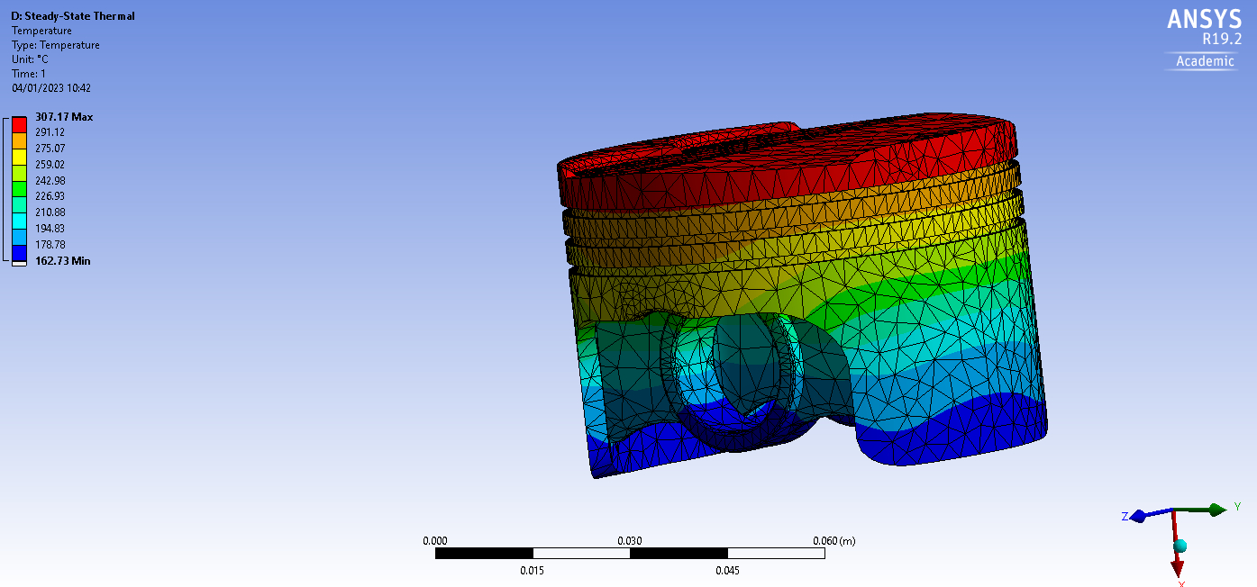
Figure 2 – A rendering of the complete steady-state thermal load, with the minimum (162.73C) and the maximum (307.17C) values shown, with the average being 249.63C.

4.3. Static Structural
Going back to the static structural, the solution from the thermal study is used in the setup section of the static structural study. This is done by just dragging the Solution section of the steady-state thermal into the setup portion of the static structural. As well as this, the engineering data, geometry, and model are all taken from the rigid dynamics study and used again here. When opening the setup of the static structural, all of the data from the other studies will need to be regenerated due to the changes made in the thermal study, so that it can be used here.
With the setup open, the mesh will need to be remade with the same size as before, 4mm, with the use of mesh sizing we can make specific sections have a smaller mesh to have more detailed areas for analysis, but for now we will leave this. Under the analysis section, the weak springs need to be turned on so that the piston head can deform correctly, allowing for the tiniest bit of resistance for deformation.
For the final solution an analysis, a total deformation and equivalent stress solutions need to be setup in the solution section. The results of these can be seen in Figure 3 and 4 below, giving accurate results using real world data and simulation as proven with the validation before this crankshaft assembly and piston were completed.

5. Evaluation and Iteration

5.1. 6061-T1 Aluminium
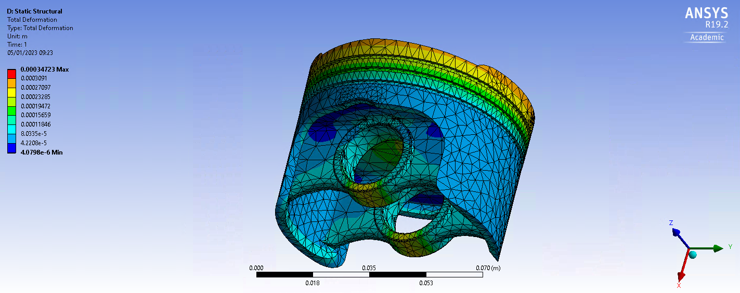
Figure 3 – A rendering of the complete static structural total deformation across the piston head using 6061-T aluminium.
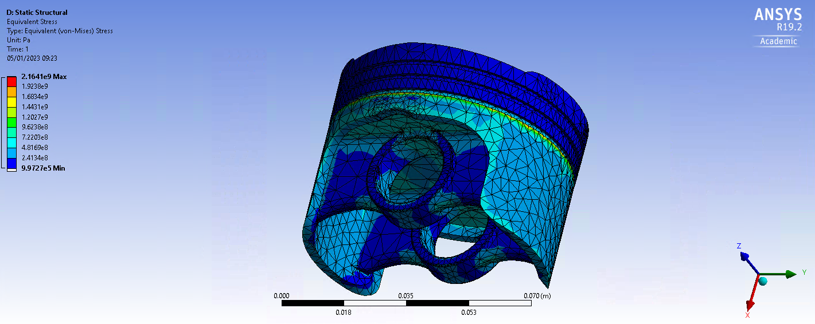
Figure 4 – A rendering of the complete static structural equivalent stress across the piston head using 6061-T1 aluminium.
For the initial simulation and for use through the setup portion, 6061-T1 Aluminium is used as the first material as well as the baseline for comparison against the other materials selected. You can see the total deformation max is at 0.000347 and the minimum is 0.0000040798.

5.2. GRANTA Cast steel
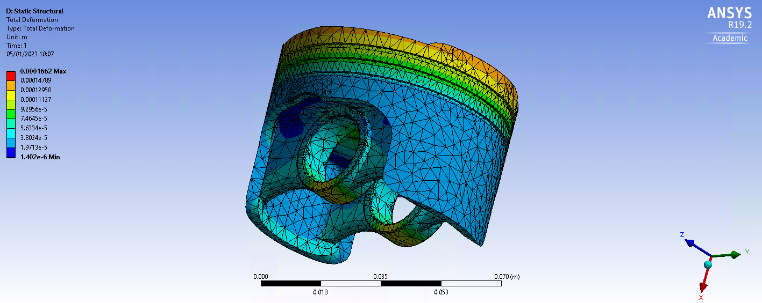
Figure 5 – A rendering of the complete static structural total deformation across the piston head using GRANTA cast steel.
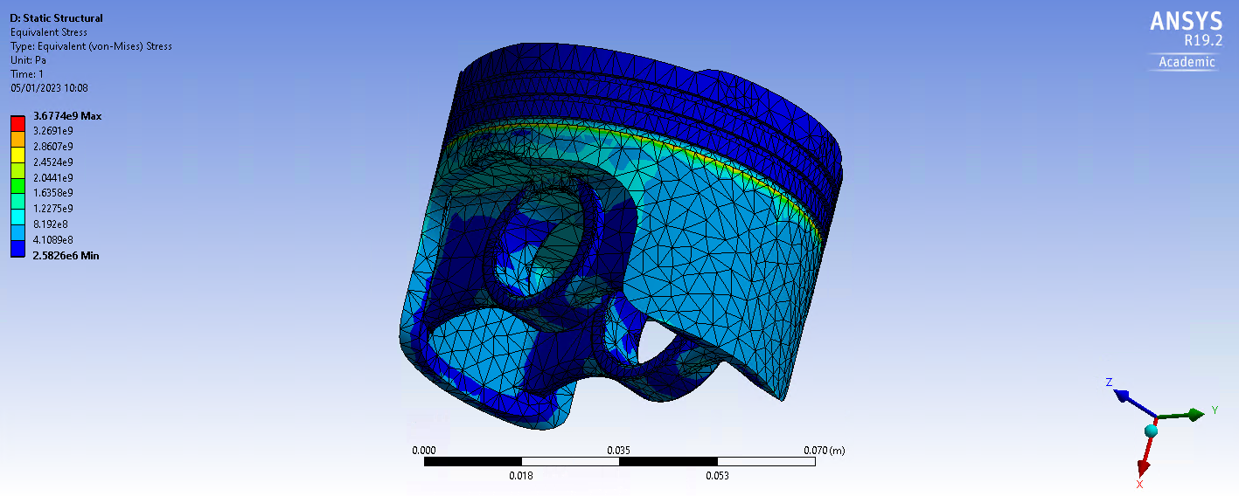
Figure 6 – A rendering of the complete static structural equivalent stress across the piston head using GRANTA cast steel.
For the second simulation, GRANTA cast steel (ANSYS, 2023) is used as the second material where can see the total deformation max is at 0.0001662 and the minimum 0.000001402. Compared to the aluminium the total deformation max is at 0.000347 and the minimum is 0.0000040798.
It appears that the steel has a lower maximum and minimum total deformation compared to the aluminium. The maximum total deformation of the steel is 70.46% lower than that of the aluminium, and the minimum total deformation of the steel is 97.70% lower than that of the aluminium. This suggests that the steel may be more resistant to deformation than the aluminium under the conditions of the simulation.

5.3. GRANTA Titanium
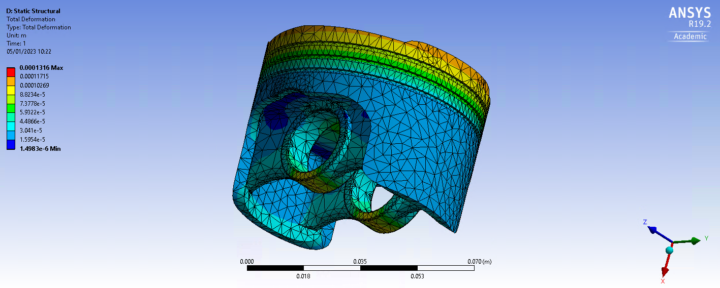
Figure 7 – A rendering of the complete static structural total deformation across the piston head using GRANTA titanium.

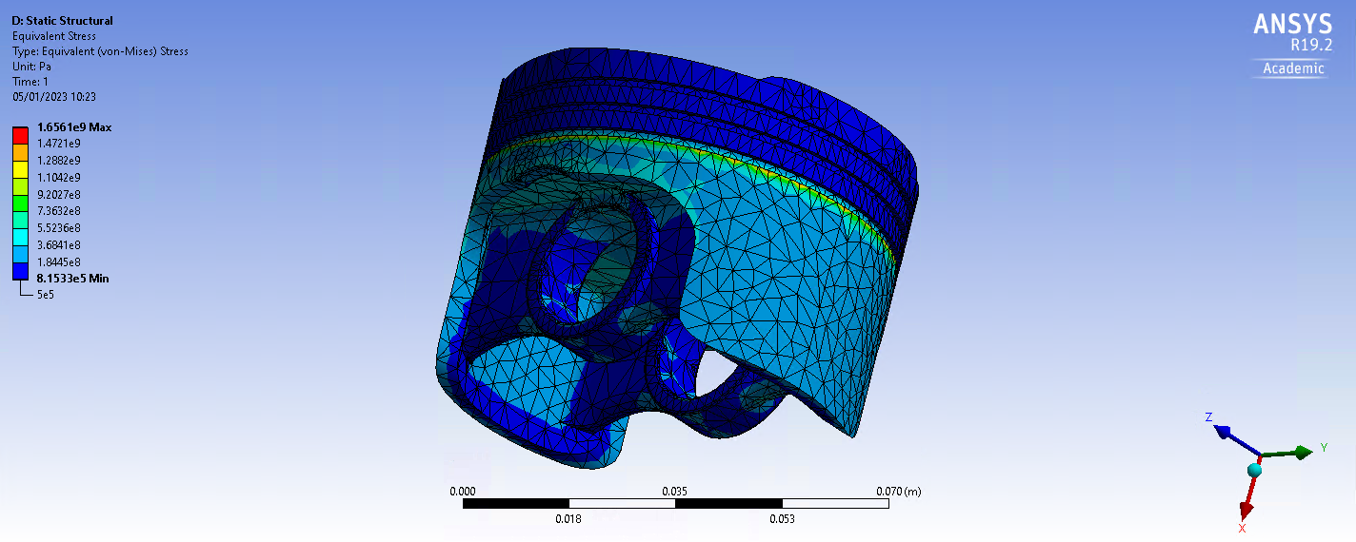
Figure 8 – A rendering of the complete static structural equivalent stress across the piston head using GRANTA titanium.
For the third simulation, GRANTA titanium (ANSYS, 2023) is used as the third material where can see the total deformation max is at 0.0001316 and the minimum 0.0000014983. Compared to the aluminium the total deformation max is at 0.000347 and the minimum is 0.0000040798 and compared to the cast steel the total deformation max is at 0.000347 and the minimum is 0.0000040798.
The maximum total deformation of titanium is lower than that of both aluminium and steel, with the titanium's maximum total deformation being 62.11% and 70.46% lower, respectively. The minimum total deformation of titanium is lower than that of both aluminium and steel, with the titanium's minimum total deformation being 96.42% and 97.70% lower, respectively.

5.4. Material Evaluation
Based on the information provided, it appears that titanium may be the most resistant to deformation among the three materials. In the simulation, the maximum and minimum total deformation of titanium were both lower than those of both aluminium and steel. The maximum total deformation of titanium was 62.11% and 70.46% lower than that of aluminium and steel, respectively, and the minimum total deformation of titanium was 96.42% and 97.70% lower than that of aluminium and steel, respectively. This suggests that titanium may be more resistant to deformation than both aluminium and steel under the conditions of the simulation.

6. References
Dlubal, 2022. Elastic Bending – Continuous Load. [Online]
Available at: https://www.dlubal.com/en/downloads-and-information/examples-and-tutorials/verification-examples/000016
[Accessed 19 12 2022].

