LEVEL/ LEfEL 5

Student Name: Emma Williams
Student P Number: 1904789
Module Title: Network Operating Systems and Services
Module Code: ACCA5023
Assignment Title: Manage and maintain network resources, and its services applying suitable policies and drafting security and redundancy practices.
Module Tutor: Dr. Nitheesh Murugan Kaliyamurthy
Word Count: 2500

Section | Contents
Task 1. | Managing and Maintaining Network Resources Using Network Policy and Security Practises
Task 2. | Routing and Packet Filtering within Core TCP/IP Services and Critical Failover/Redundancy Practices
Task 3. | Observations

Task 1: Managing and Maintaining Network Resources Using Network Policy and Security Practices

- Understanding NFTS and Share Permissions
1.1 NTFS
User logged on to WS1-NWT PC using administrator account and created new folder titled Share_File_NOSS in Local (C:) Drive.
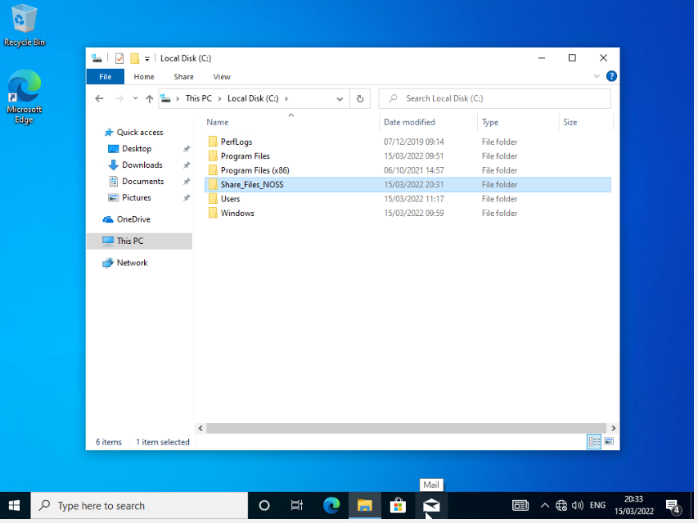
User created new text document within the Share_File_NOSS folder titled NOSS_Important File.
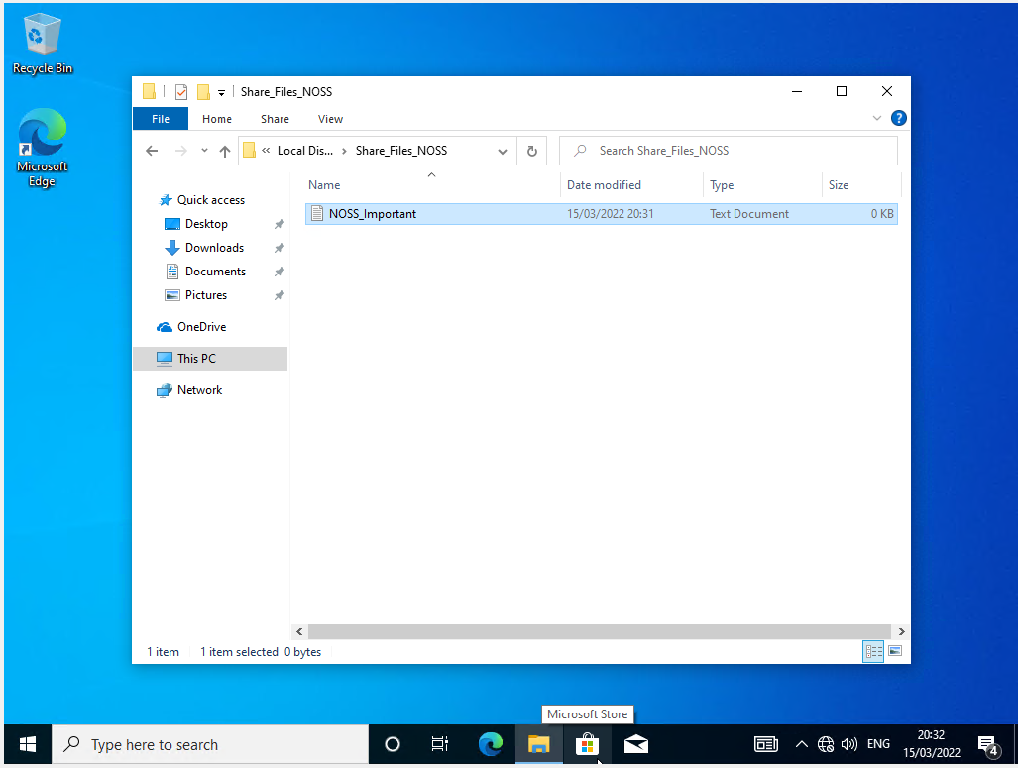

1.2 Share Permissions
There are 6 permission options available within NTFS – Full Control, Modify, Read & Execute, List Folder Contents, Read and Write.
X1 administrator user permitted ‘Full Control’.
x1 network user permitted ‘Read and Execute’ access.
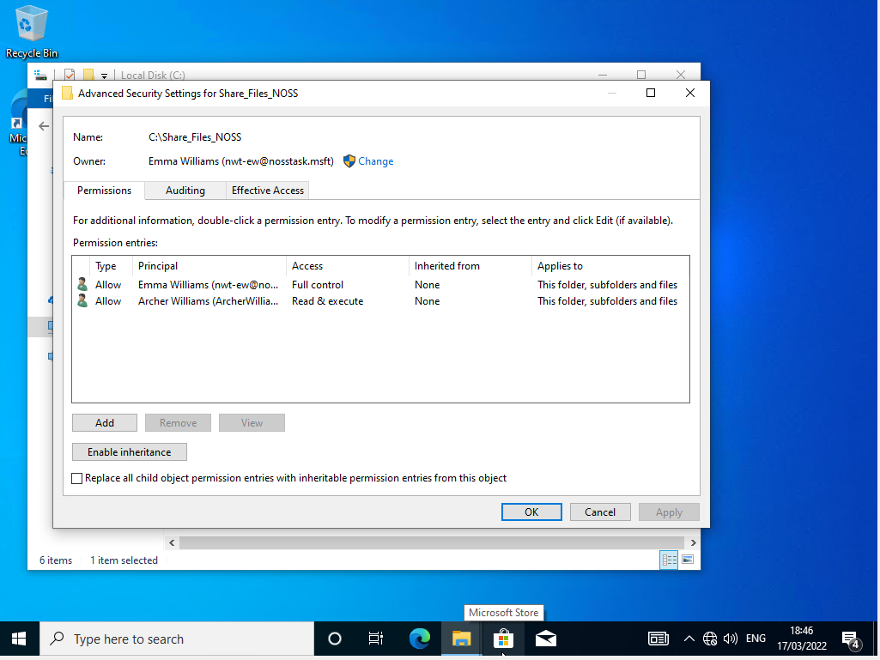
To test file permissions have applied correctly, non-admin user account logged on. User navigates to (C:) drive, opens Share_Files_NOSS folder, then NOSS_Important file. User unable to modify or save, permissions set do not allow modification.
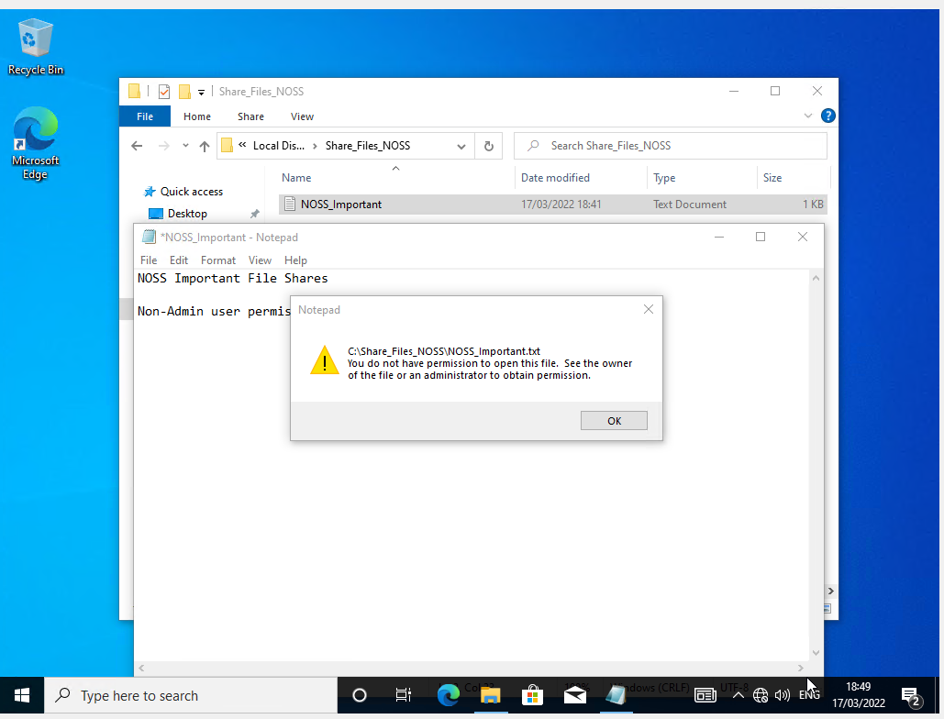

User creates Folder Share on Server Manager, with SMB Share-Quick profile option. Permissions implemented and managed here override local NTFS permissions.
- Share name, includes $ sign to ensure it is hidden from all attempts to view shares on the network:

Share_Files_NOSS$

- Local path to share:

C:\Share\Share_Files_NOSS$

- Remote path to Share:

\\DC1-NWT\Share_Files_NOSS$

Share settings configured to ‘allow caching of share’, enabling users to view offline and ‘access-based enumeration’. User access only available to files and folders permitted to view.
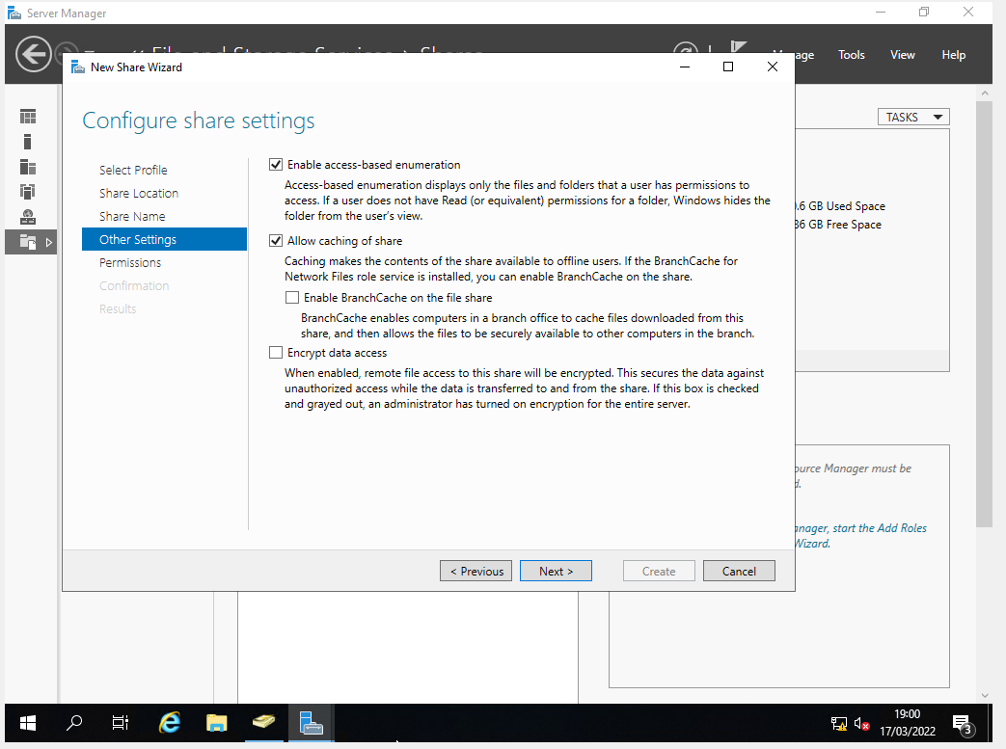
X3 user permissions granted:
X1 Admin user = Full Control Access
X2 Domain users = Read and Execute Access
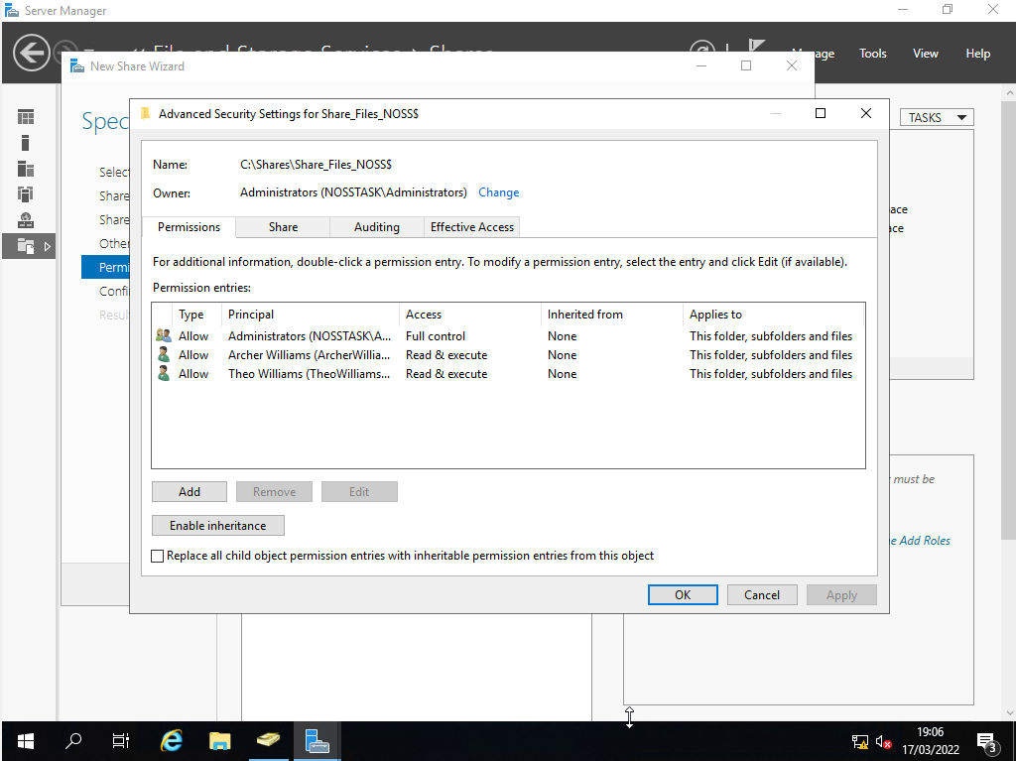
‘Confirm Selections Screen’ ensures ‘File Share’ has been configured correctly before creation.
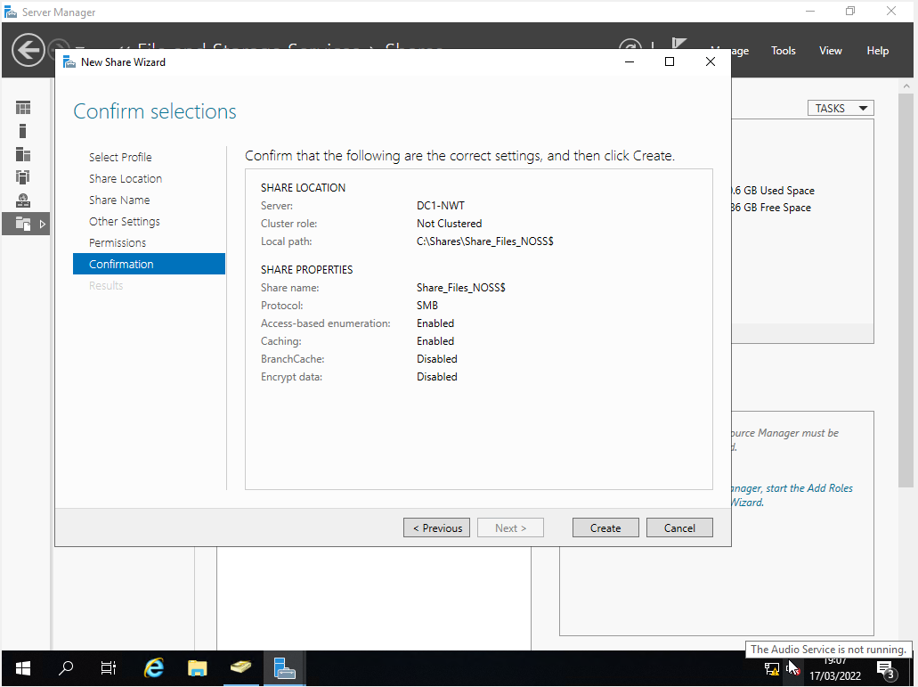
1.3 Accessing the File Share/Server Over the Network

Network Drive mapped on WS1-NWT PC, to Drive (Z:):
Remote Network Share Path as configured when creating File Share on Server:
\\DC1-NWT\Share_Files_NOSS$
Mapped drive verification:
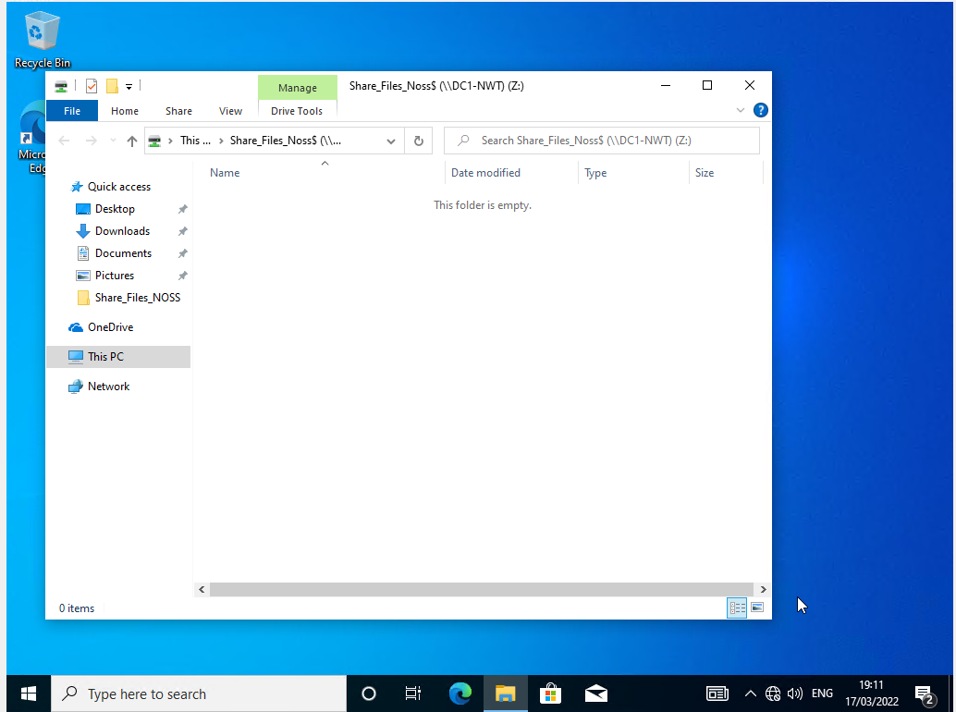
- Utilising Group Policy Management Console to better facilitate network object management.

2.1. Configuring User Environment and Computer Environment, ‘Network Group Policy Objects’
Group Policy Objects (GPO) are organisational or departmental settings and conditions centrally administered and applied to Active Directory (AD) objects user and computer accounts within the Group Policy Management Console (GPMC) hierarchical system.

GPO 1: Moderating Access to the Control Panel
‘Non-Admin Users’ OU created in Active Directory Users and Computers (ADUC), nosstask.msft domain. New user accounts created in ‘Non-Admin users’ OU.

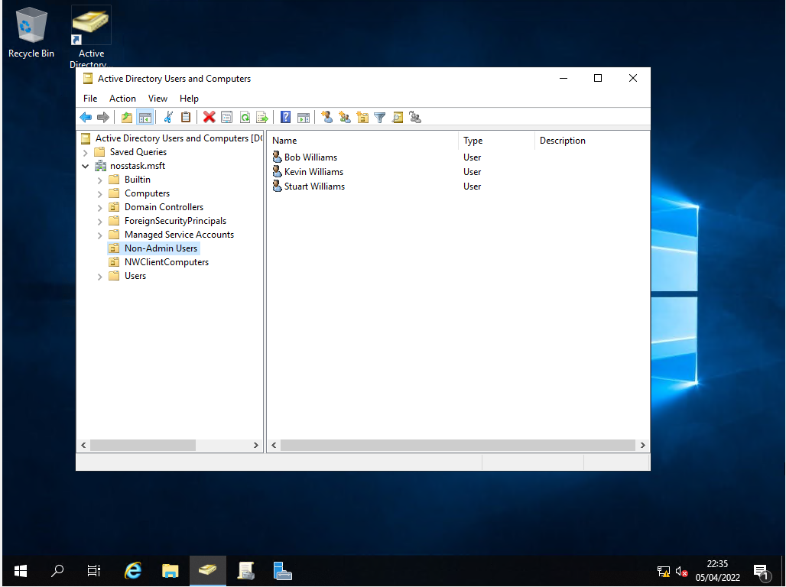
Group Policy Object (GPO) created and applied within GPMC, titled: ‘NoCtrlPanAccess’, prohibiting access to the control panel for all non-admin users.

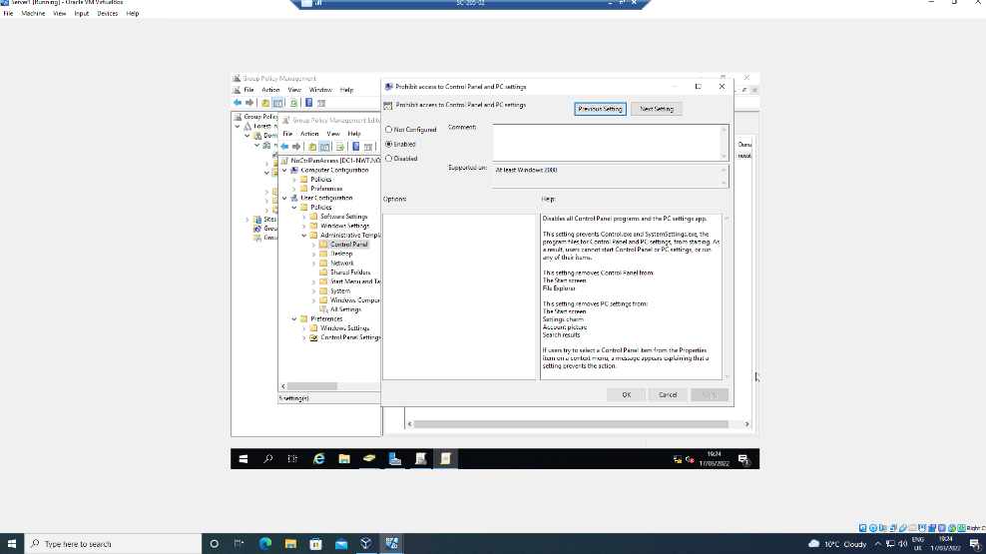
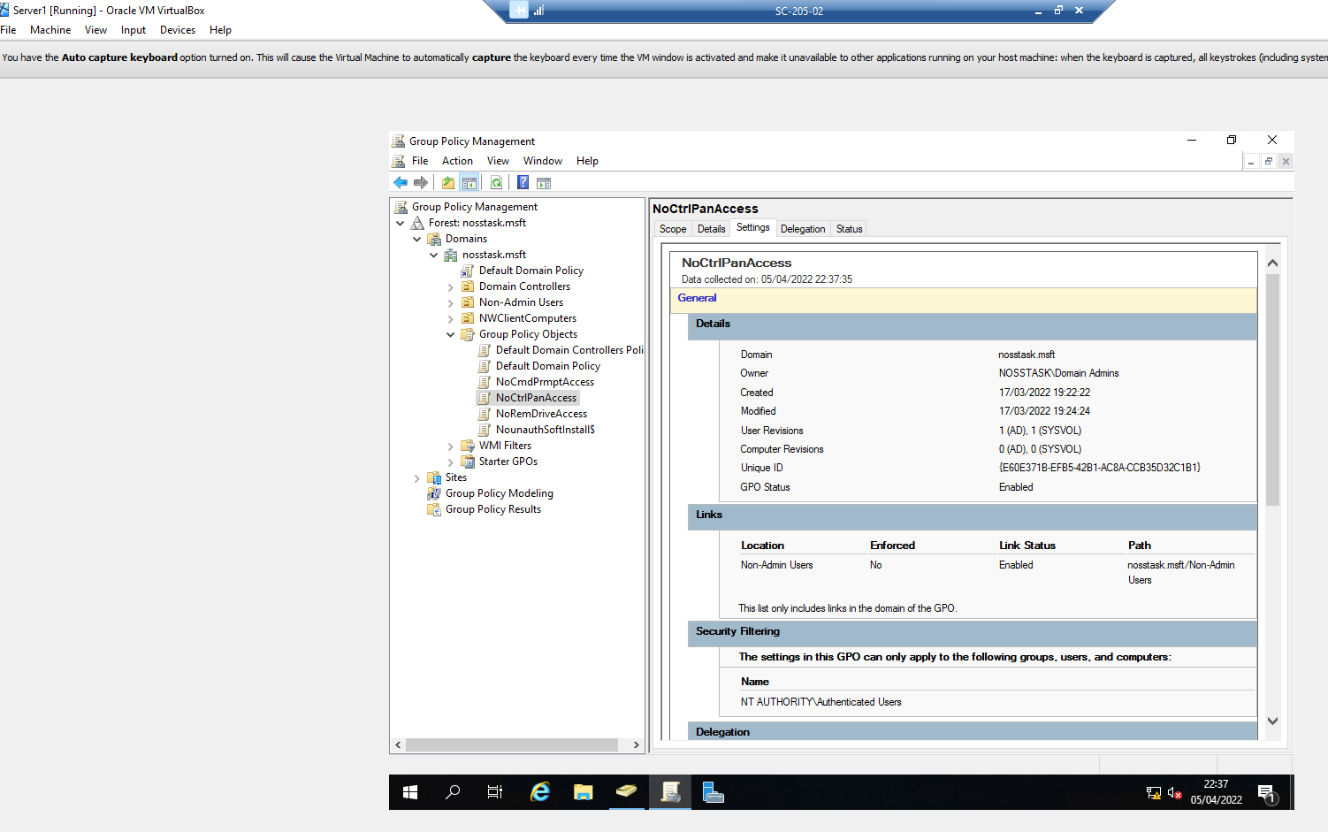
Command Prompt (CMD) run as ‘Administrator’ with ‘gpupdate /force’ command run, forcing administrator changes to settings and policies.

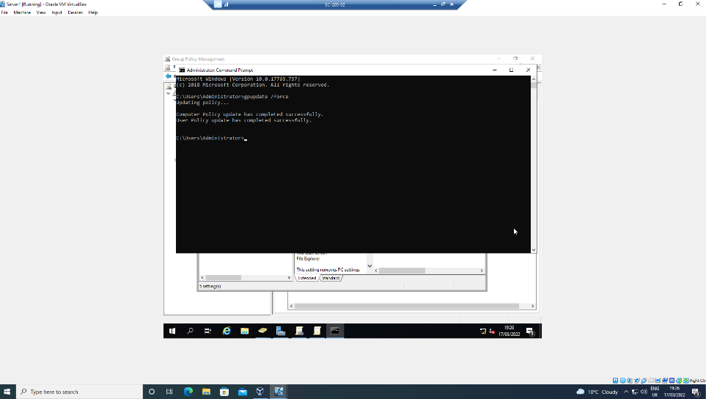

WS1-NWT PC logged on with non-admin user account, and tested access to control panel.
Access denied as per applied GPO 1.

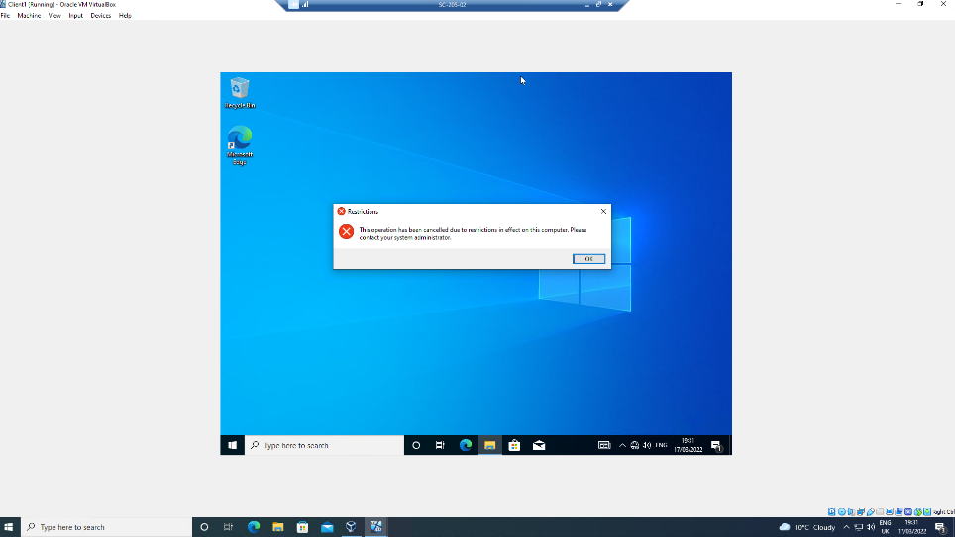

GPO 2: Removing Access to the Command Prompt
GPO created within GPMC: ‘NoCmdPrmptAccess’, prohibiting access to the command prompt (CMD).

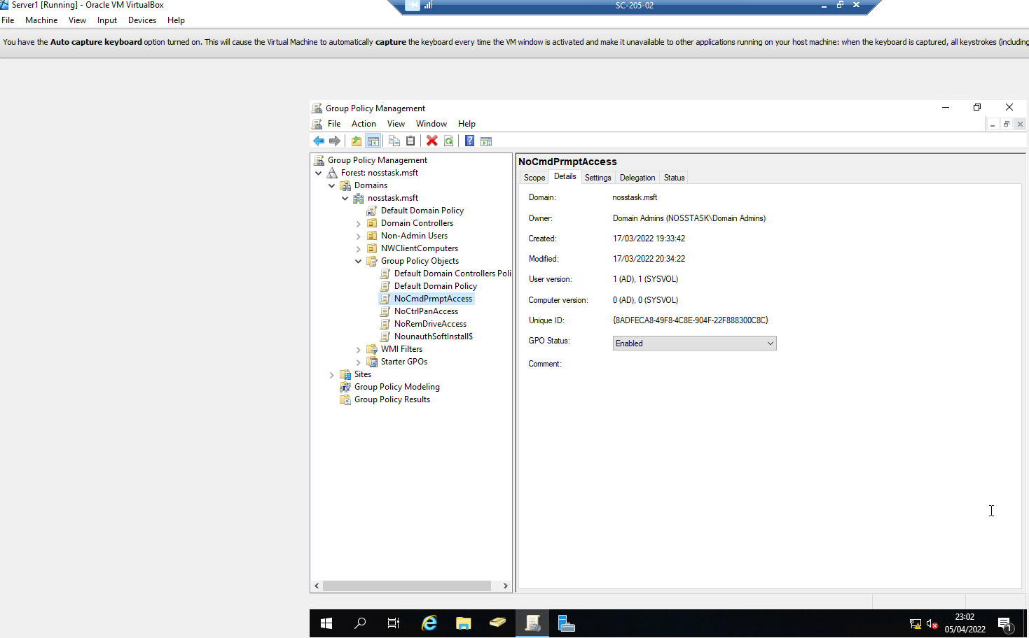

‘gpupdate /force’ command run in CMD.

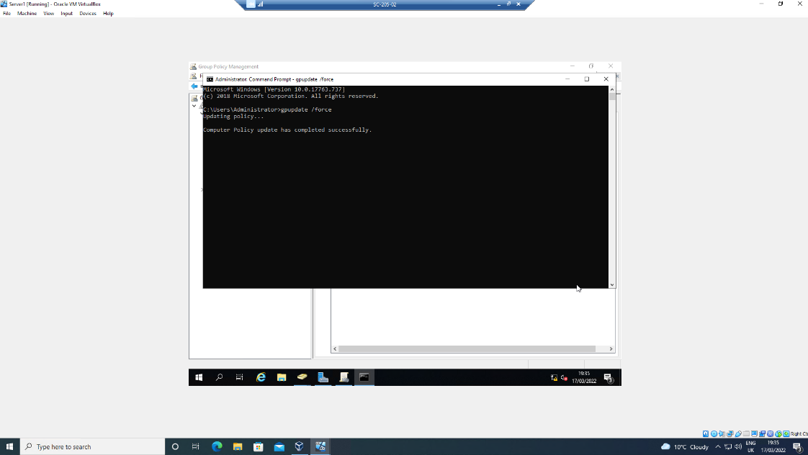

WS1-NWT PC user logon, access to command prompt tested and denied as per applied GPO 2.
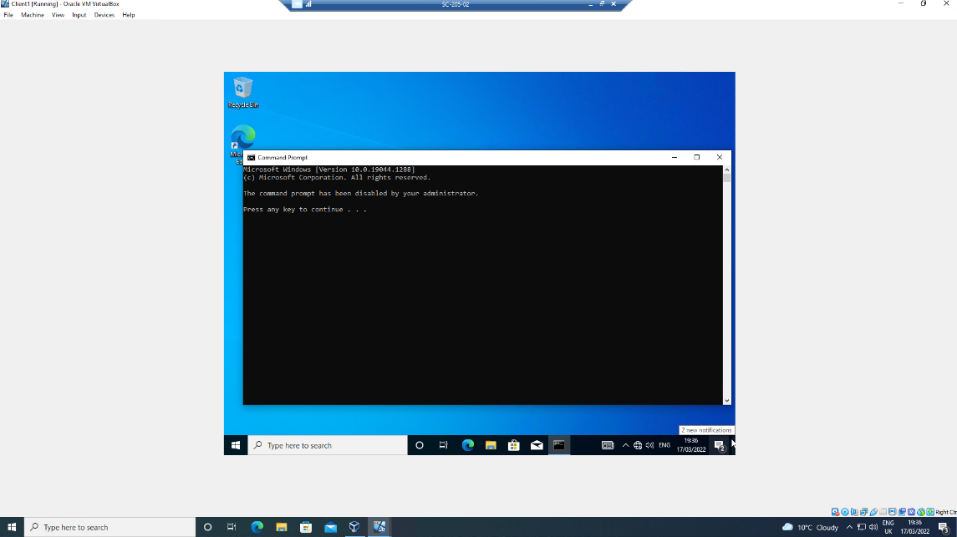

GPO 3: Restricting Access to Removable Media Drives
GPO created within GPMC: ‘NoCmdPrmptAccess’. Restricting access to ‘Removable Media Drives’. Due to potential introduction of viruses or removal/copying of confidential organisational data, breaching ‘General Data Protection Regulation’ (GDPR).

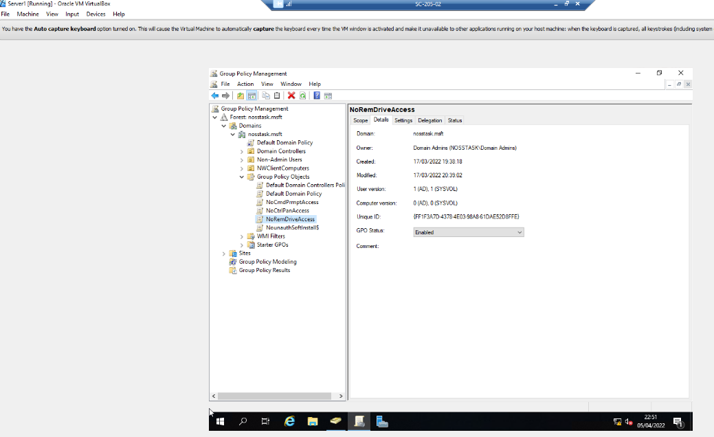
‘gpupdate /force’ command run in CMD.
WS1-NWT PC user logon, access to command prompt tested and denied as per applied GPO 3.

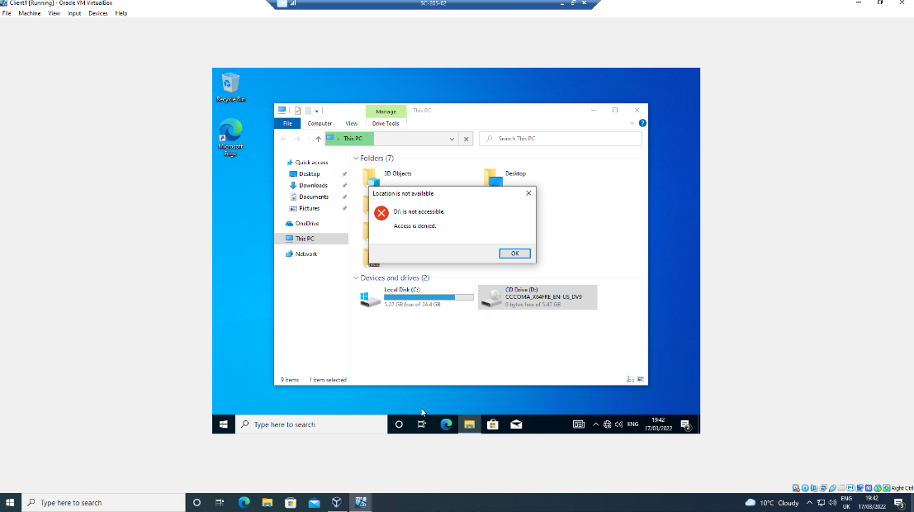

GPO 4: Restricting Software Installs
To restrict unauthorised software installations, GPO is applied within an ADUC ‘Computers’ container. Ensuring the software estate is controlled and monitored, guarantees only permitted, licenced and current software is accessed, as per business requirements and software usage policy.
Organisational unit (OU) created in ADUC: ‘NW Client Computers’ and WS1-NWT device located and moved to this OU.
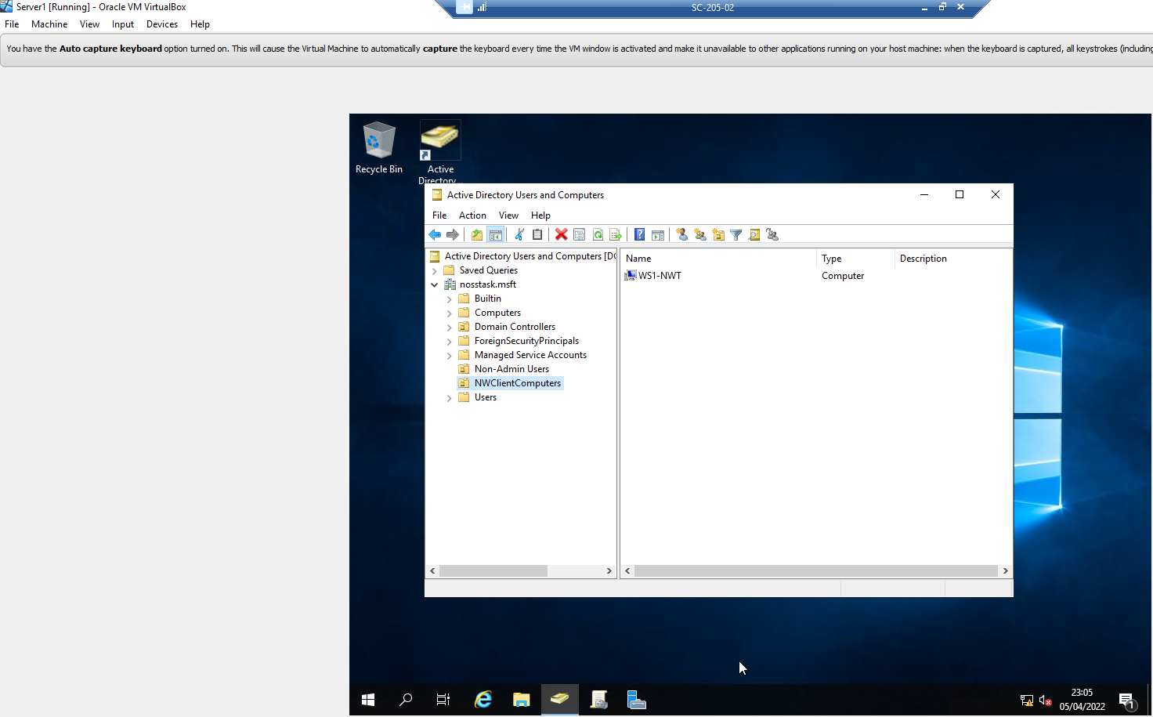
Within GPMC, GPO created within NWTClient Computers OU, and ‘Prohibit User Install’ policy enabled.
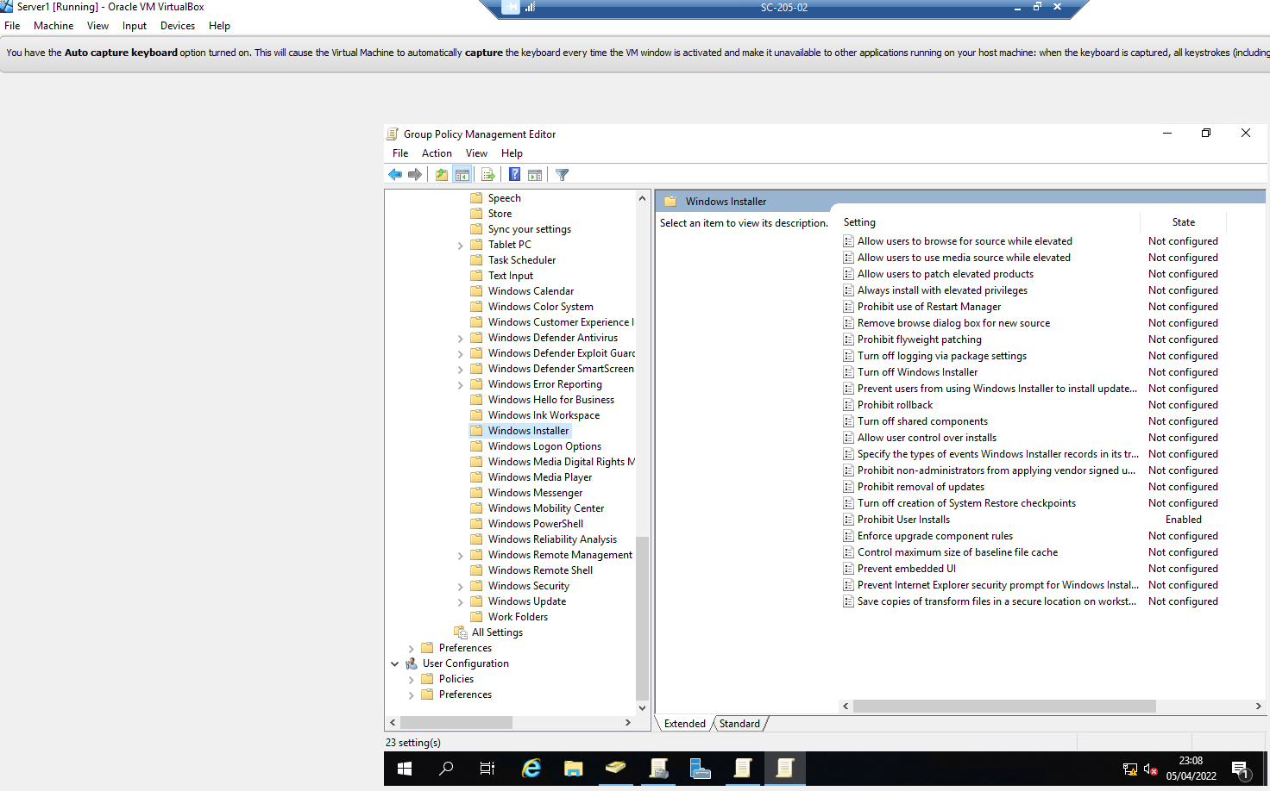
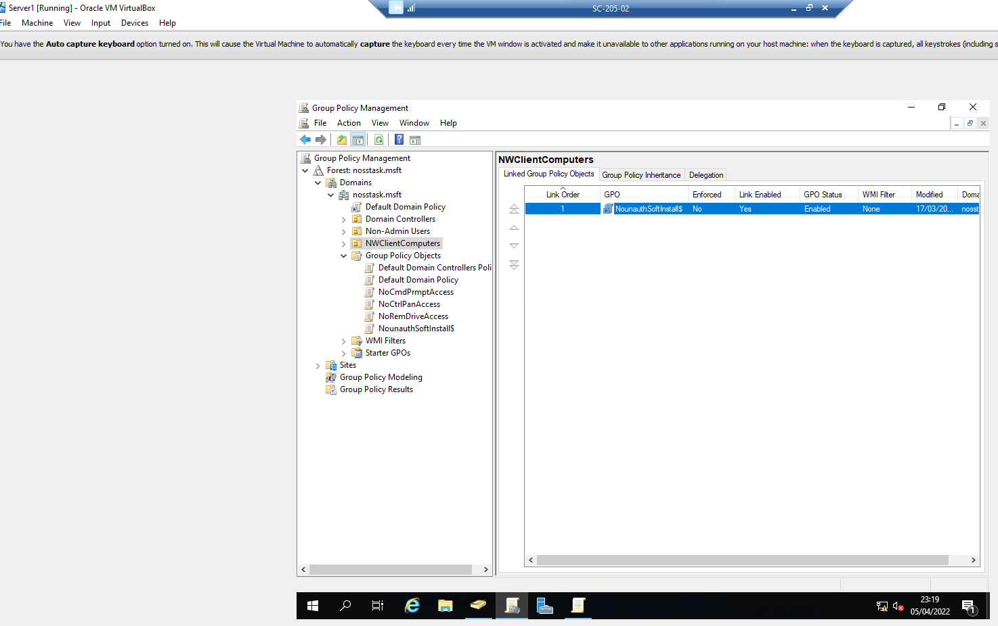

‘gpupdate /force’ command run in CMD.
Non-admin user logged onto WS1-NWT, navigates to Services, Windows Installer, properties, service status shows ‘Stopped’. User unable to attempt software install as device not connected to WAN.

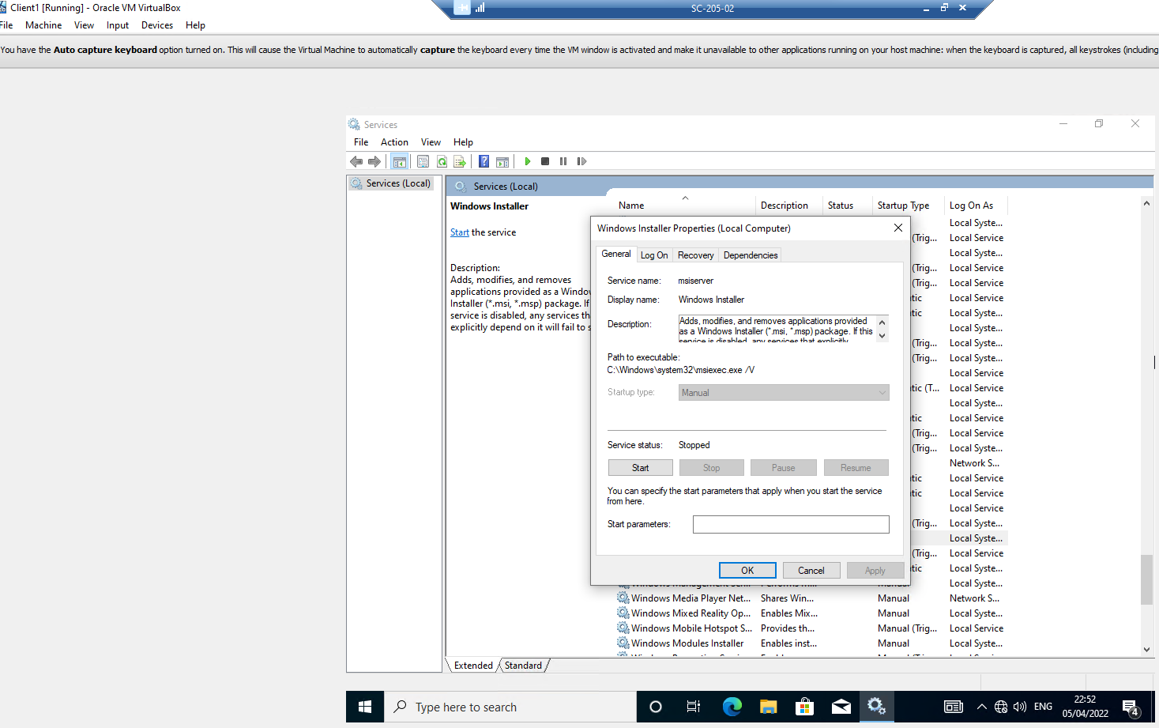

GPO 5: Enforcing Password Policy in the ‘nosstask.msft’ Domain
Password Policy settings configured in GPMC Default Domain Policy GPO. Values set to ensure complexity requirements are met to enable strong, secure passwords.
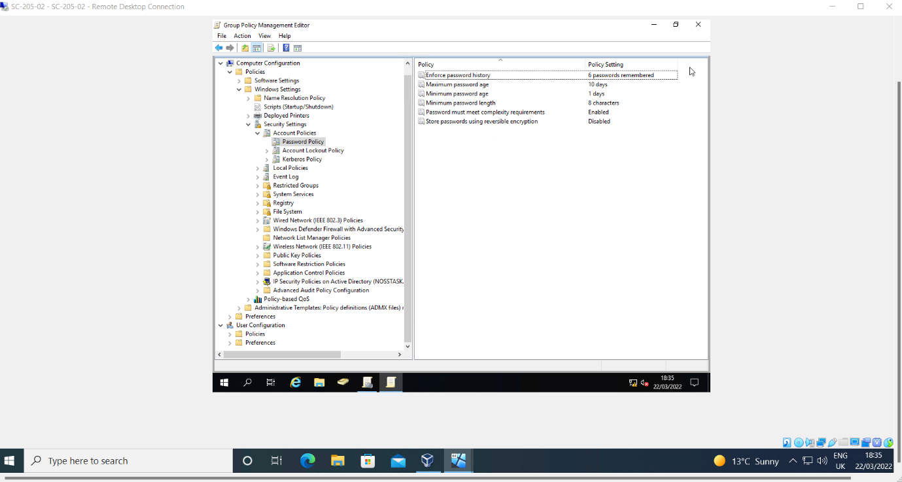
New user account created in ADUC, password set to Hello1. Unable to set password as does not meet complexity requirements of policy.
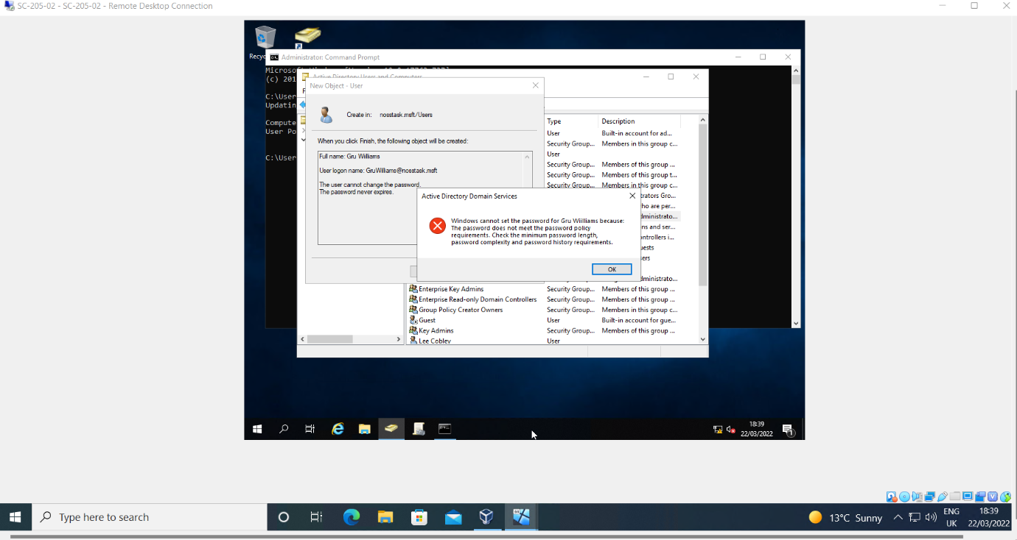
New password set to passphrase with 15 characters, symbol and number. Password accepted.

Task 2: Routing and Packet Filtering Within Core TCP/IP Services and Critical Failover/Redundancy Practices
- Utilising ARP and Routing Tables

Server1 CMD ‘arp -a’ command provides device NIC (interface), NIC MAC address and NIC internet address.
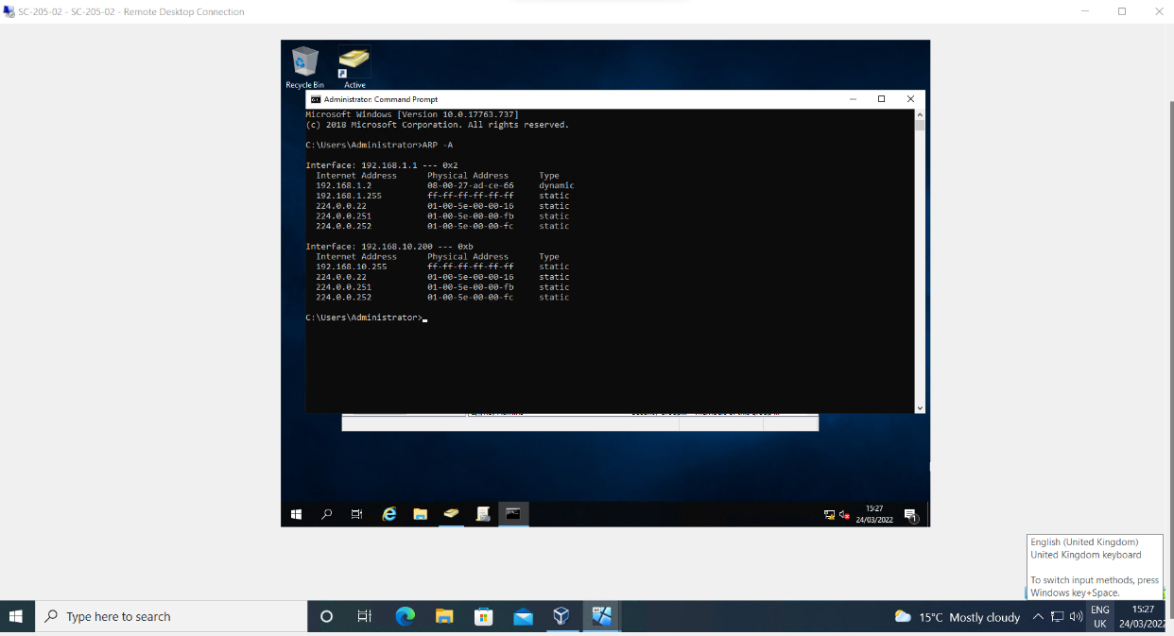
When connecting to other devices in the network, ARP table entries are updated accordingly.
Successful ‘Internet Control Message Protocol’ (ICMP) or ‘ping’ from Server1 to client 1 establishes devices are connected on the LAN.

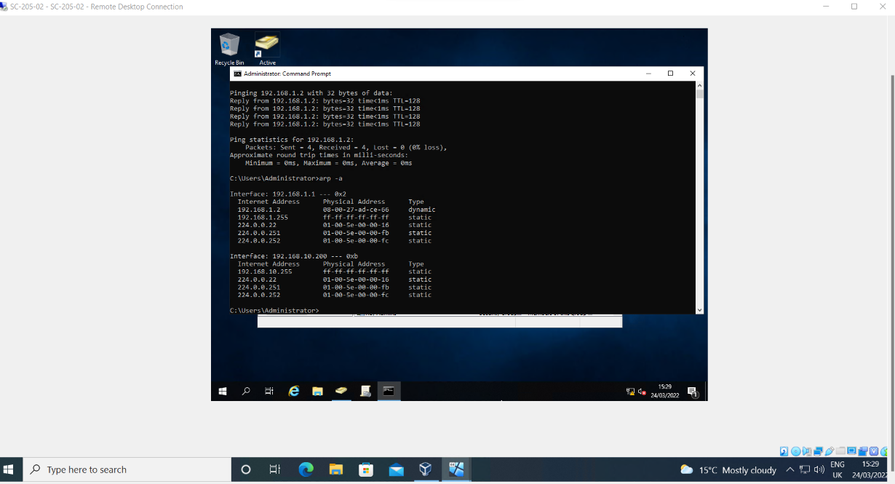

Server1 CMD ‘route print’ command – Routing table provides updated connected network information.
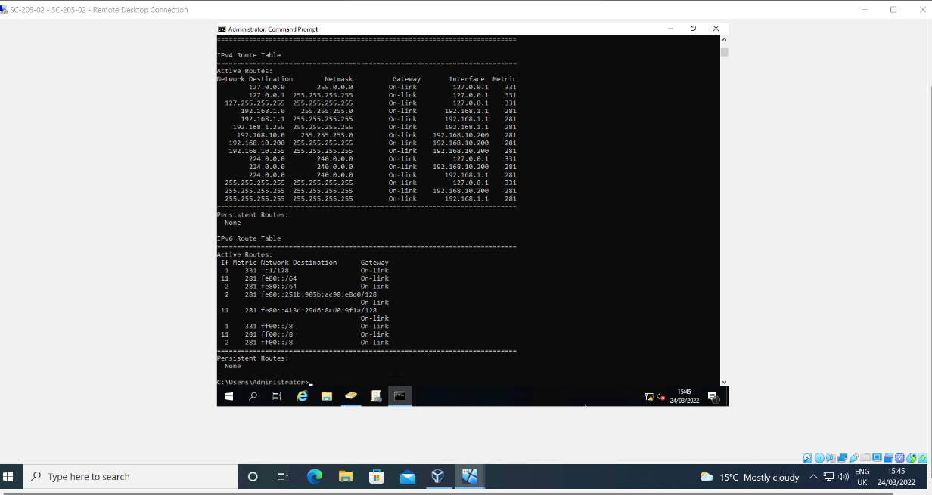

- Deploy Core Services (FTP Server)

FTP server role implemented on Server2
Role: Web Server Internet Information Services (IIS) role
Role Service: FTP Server
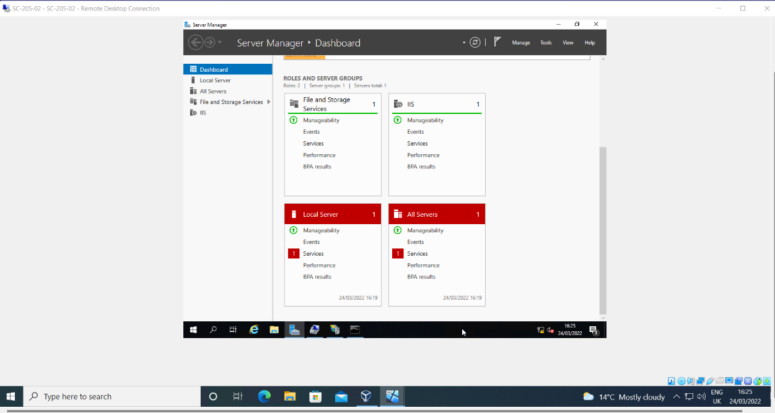
Local user account created for FTP access, in Server Manager, Local users and Groups.
User: ftpuser22
Password: P@ssw0rd
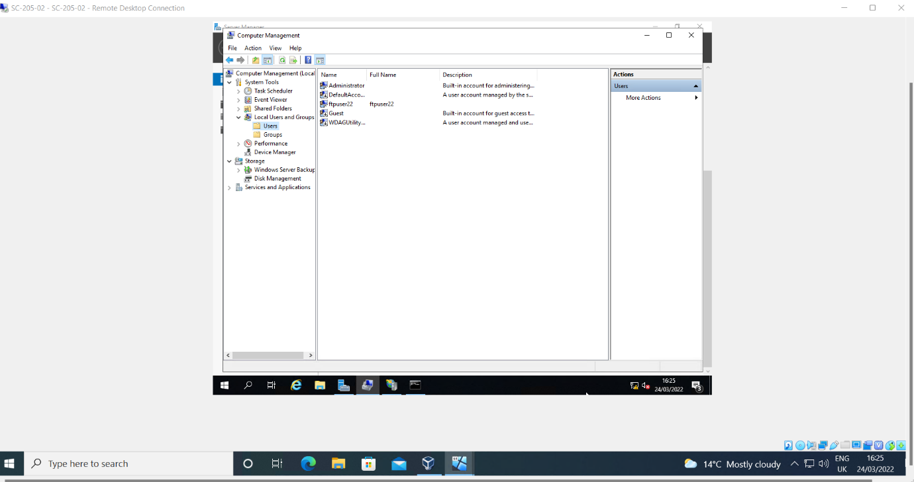
Within IIS manager, FTP site added:
Site Name: MYFTPSITE
Root Drive: C:\Inetpub\ftproot
No SSL
Port Number: 21
Basic Authentication: Specified Users – SRV2-NWT\ftpuser22

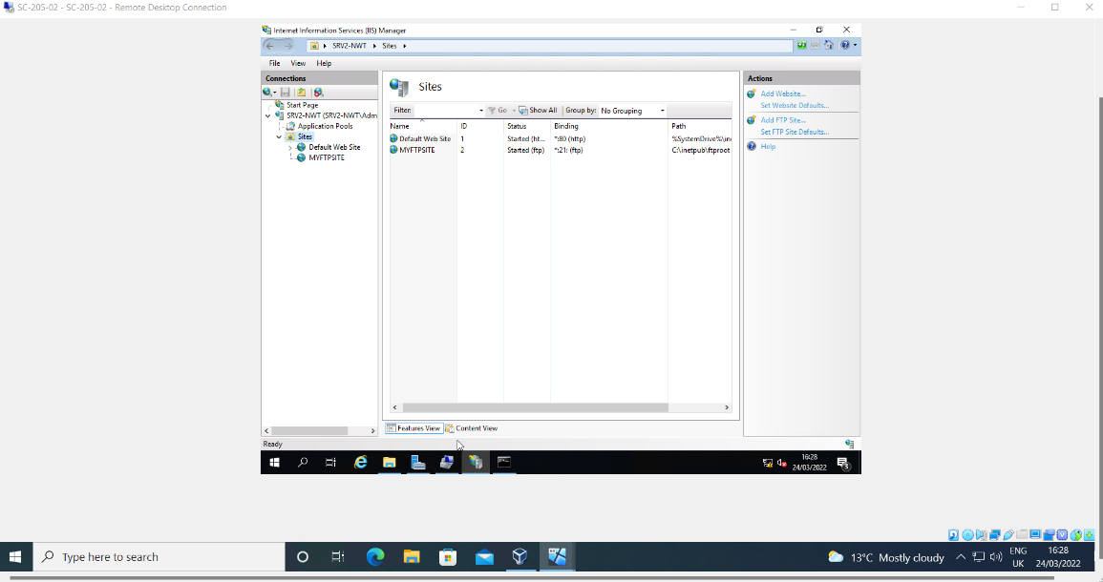

Welcome banner created.
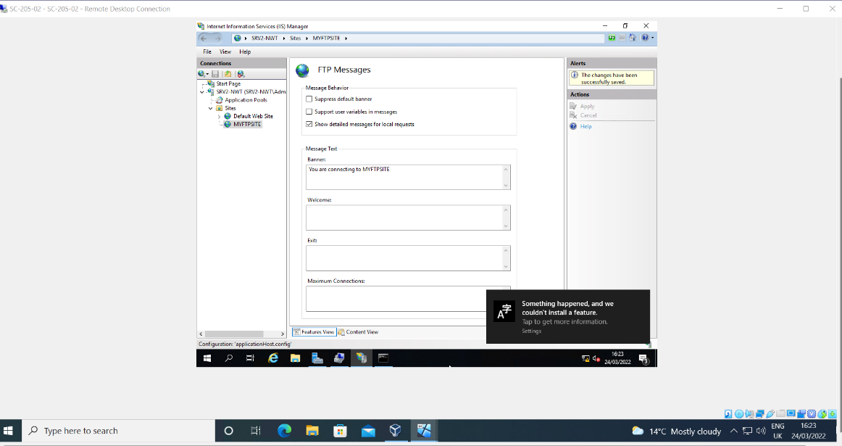b
Local user account added to ‘ftproot’ folder.
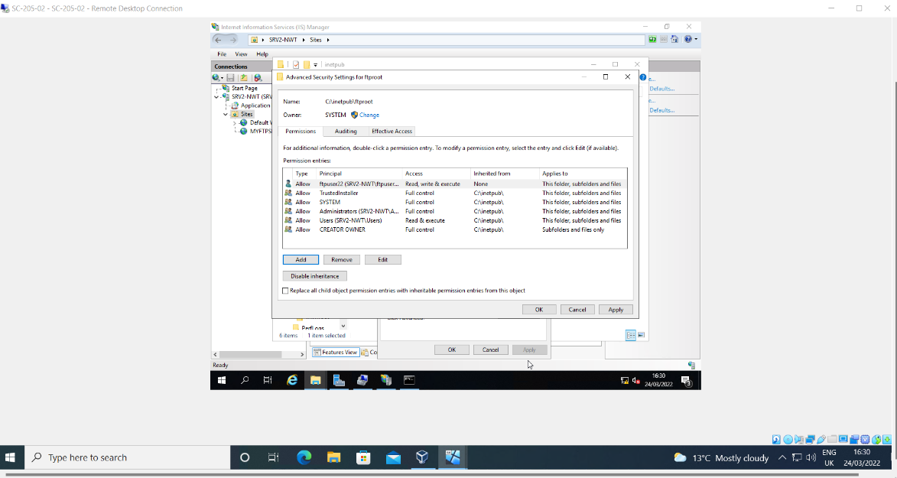
To test FTP service, new folder created within C:\Inetpub\ftproot titled ‘MyFtpuploads’.
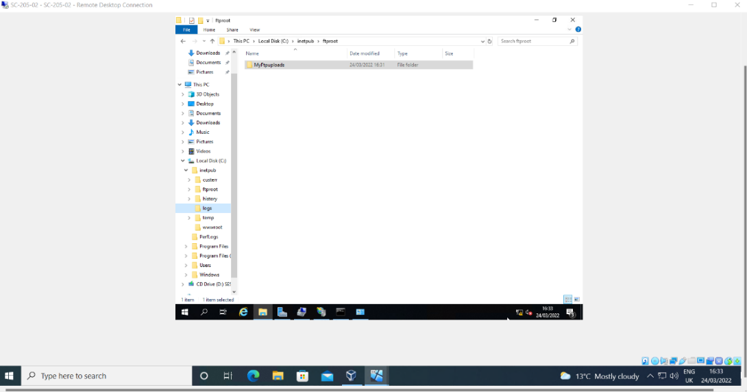
For FTP Service to work, Windows Firewalls disabled on Server2 and Client2 devices.
Server 1 – Firewall Disabled.
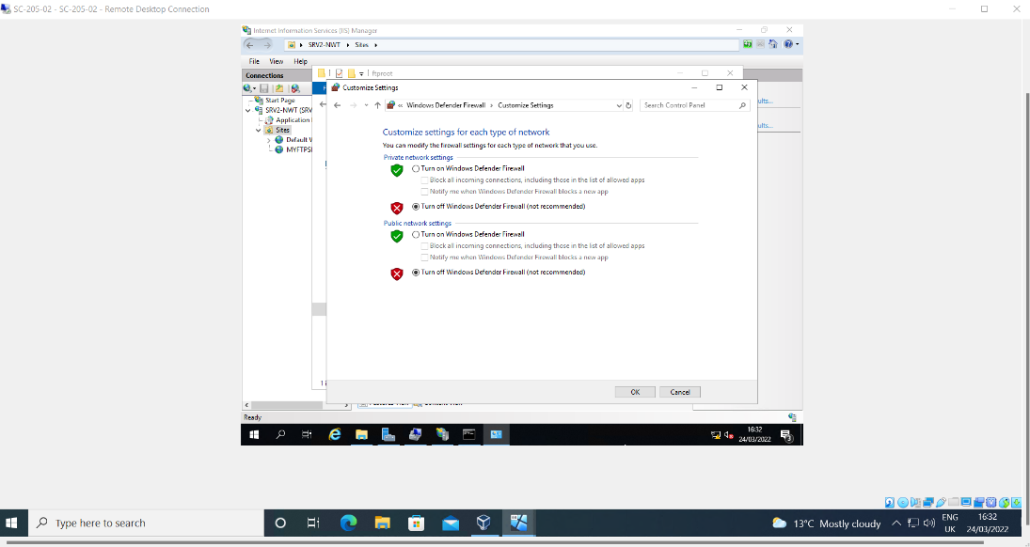
Client2 logged in as administrator account, firewall disabled.
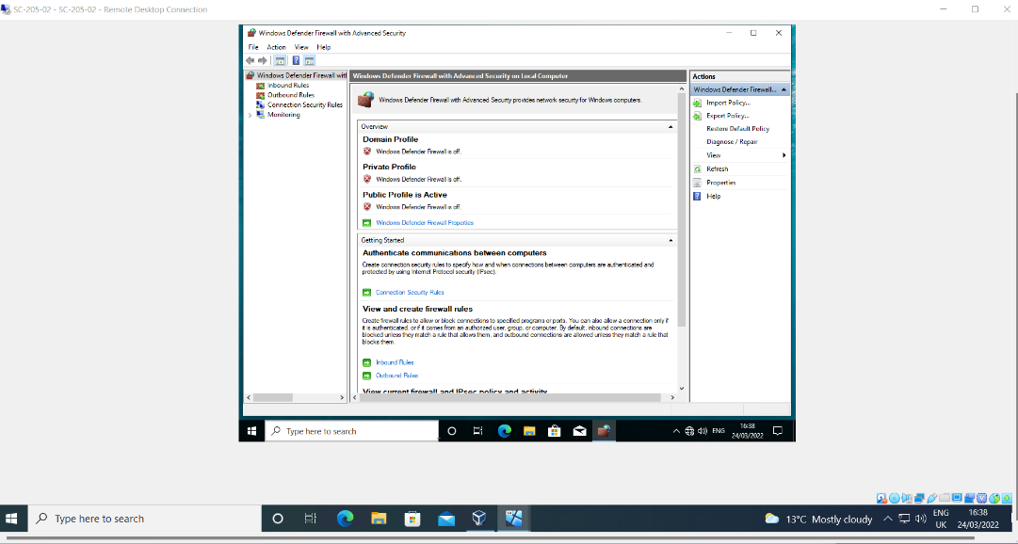
To test FTP service is configured correctly, new folder and file created within C:\ drive on client2 titled ‘MYFTPFILES’ and ‘myftpfileupload.txt’.
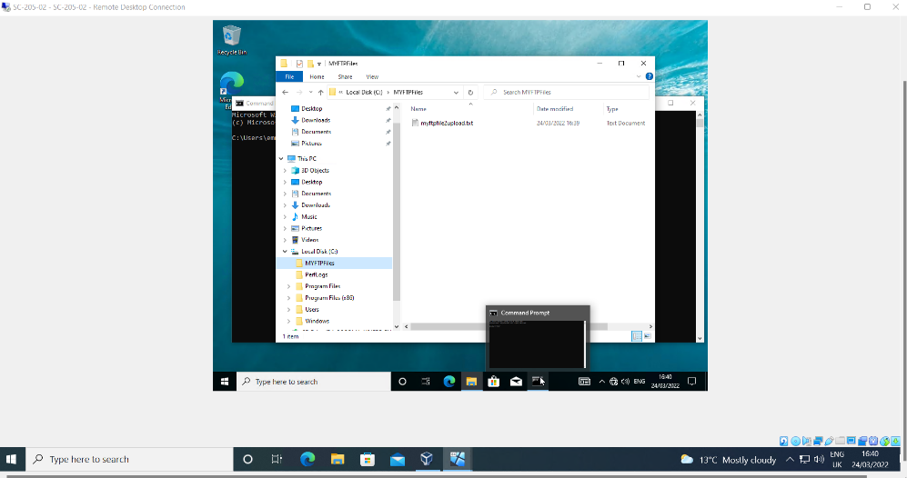
User connects to FTP Service via CMD using the ‘ftp’ command and IP address of FTP Server and local ftp user credentials.
Command: ftp 192.168.1.1
Username: srv2-nwt\ftpuser22
Password: P@ssw0rd
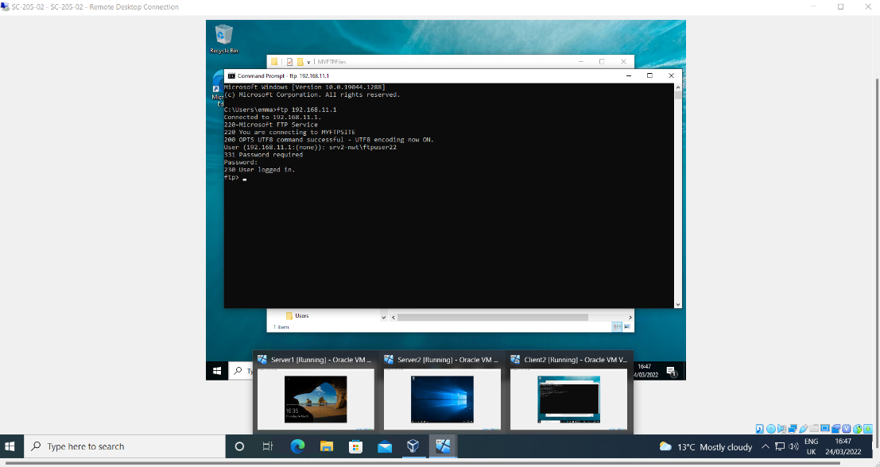
User connects to local directory to accesses file and folder created within the C:\ drive:
Command: lcd C:\MYFTPFILES
Using ‘put’ command uploads chosen file to FTP Service:
ftp> put myftpfileupload.txt
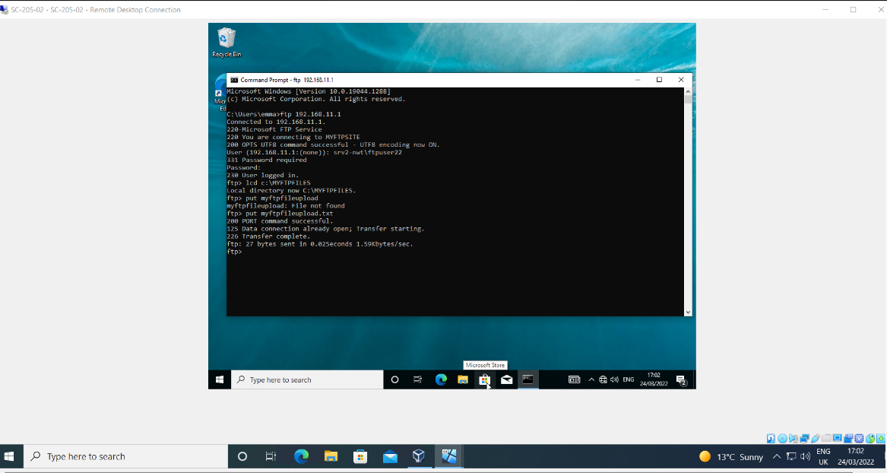
User reconnects to Server2, navigates to C:\Inetpub\ftproot folder and views successfully uploaded file, establishing FTP Service is working correctly.
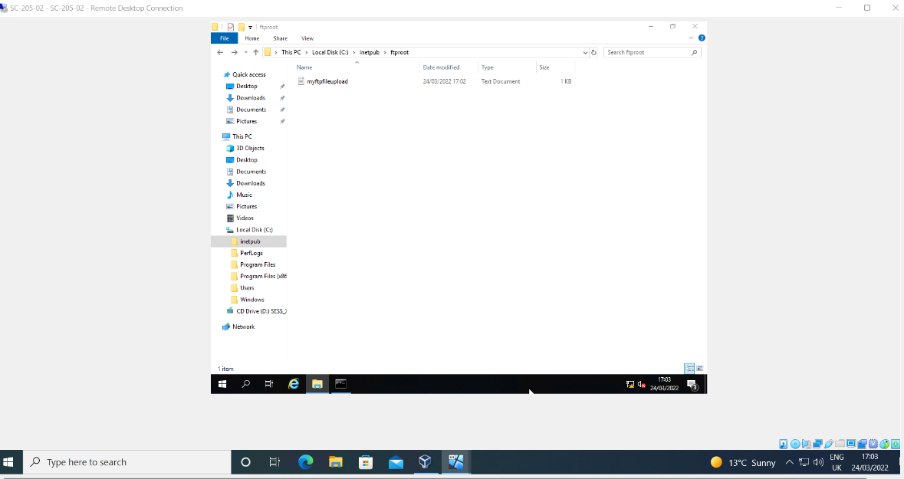

3. Installing and Configuring the Routing and Remote Access Service
Remote Access server role implemented on Server1.
Role: Remote Access
Role Service: DirectAccess, VPN, Routing Services
VPN Only Deployed
LAN Routing configured.
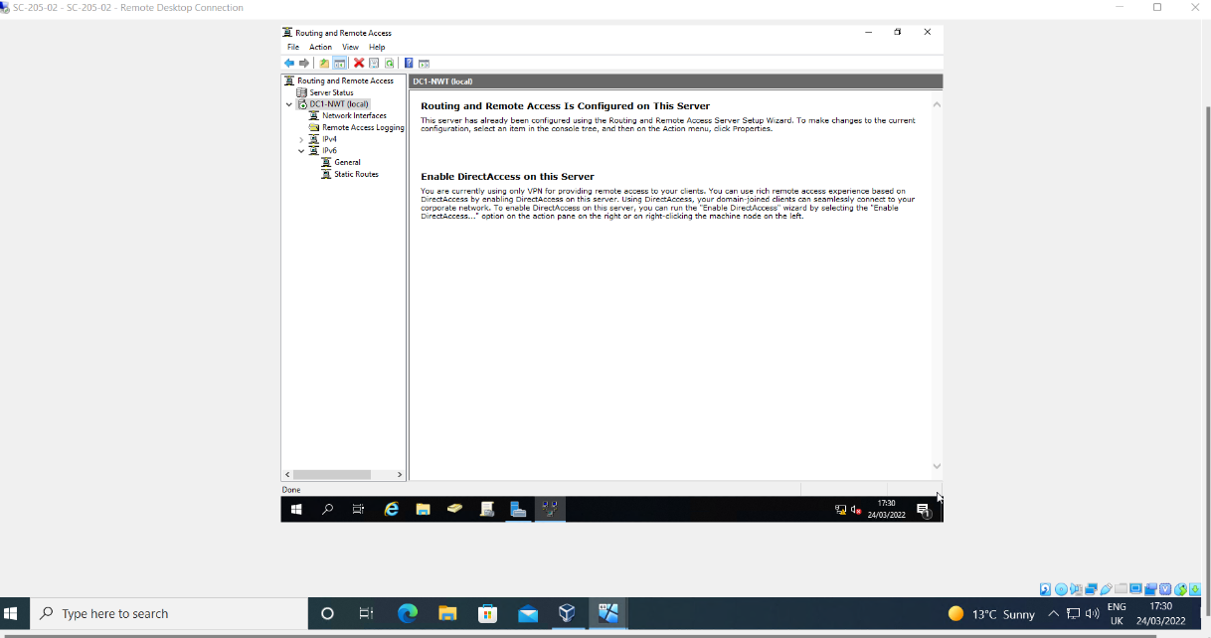

IPV4 new RIP V2 Routing Protocol configured.
2 interfaces added within RIP V2: PublicNet & PrivateNet1

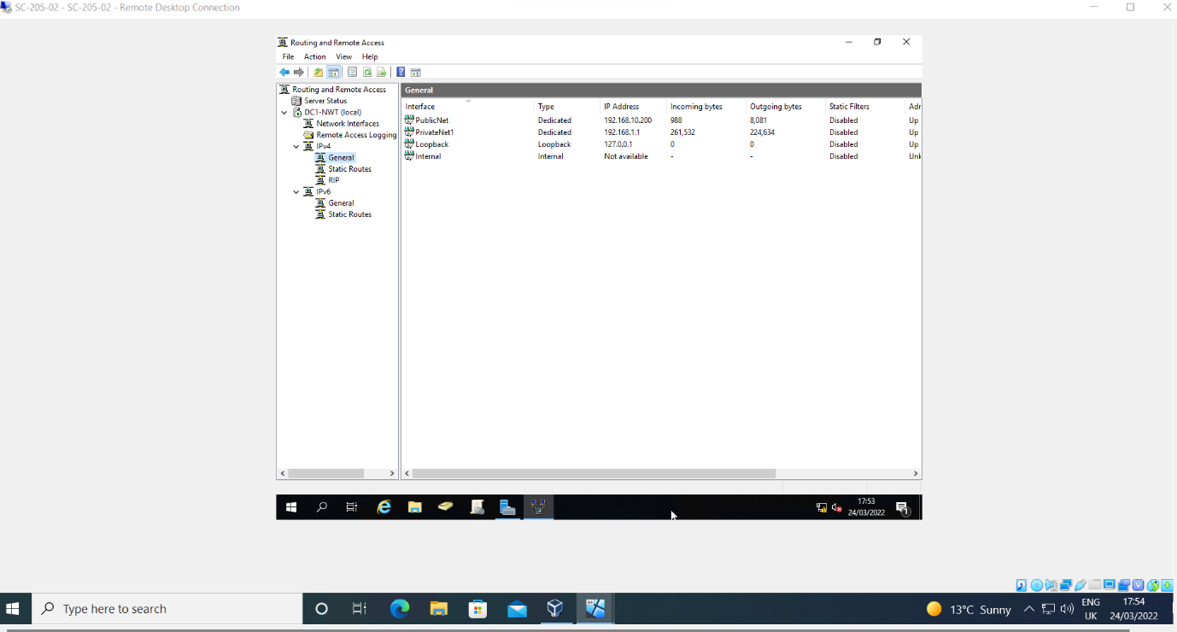

Remote Access server role implemented on Server2.
Role: Remote Access
Role Service: Routing and Remote Access
VPN Only Deployed
LAN Routing configured.
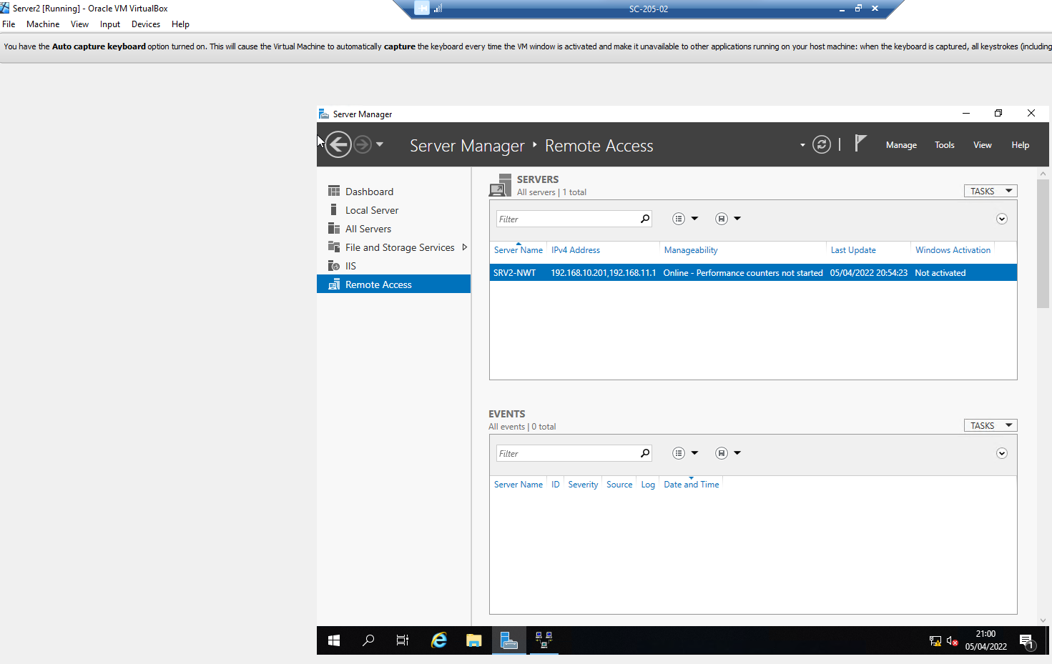

IPV4 new RIP V2 Routing Protocol configured.
2 interfaces added within RIP V2: PublicNet & PrivateNet2

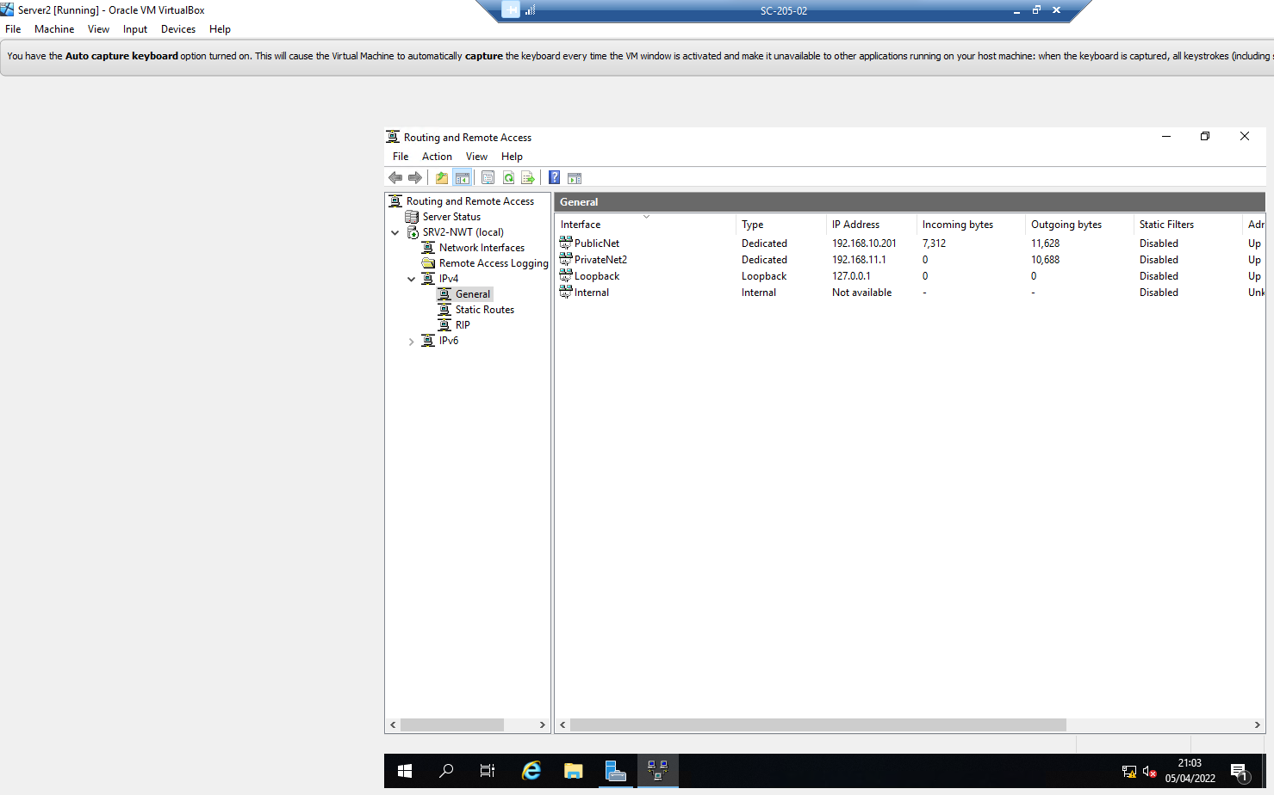

Default Gateway configured on Client1 and Client2:
Client1: 192.168.1.1
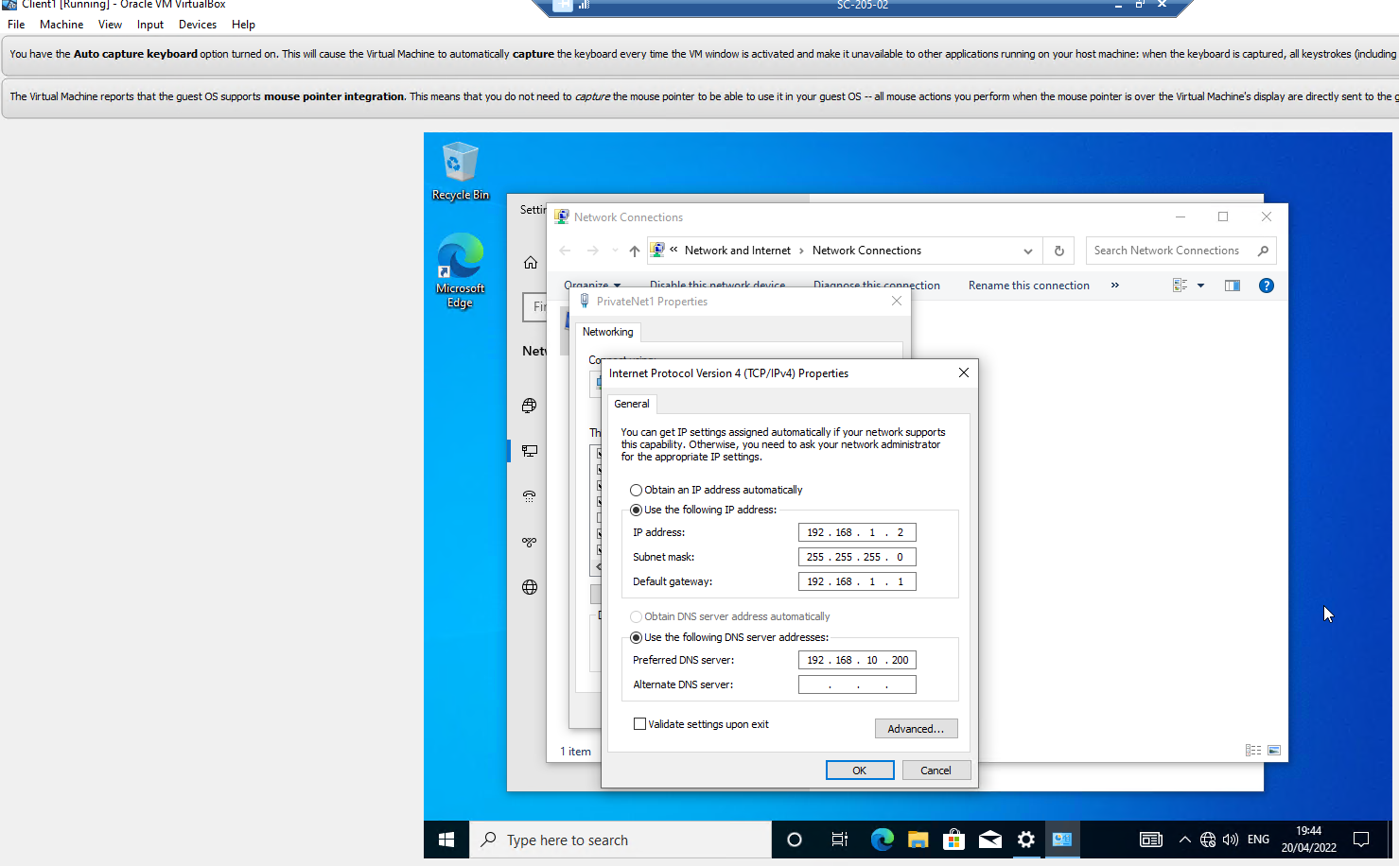

Client2: 192.168.11.1

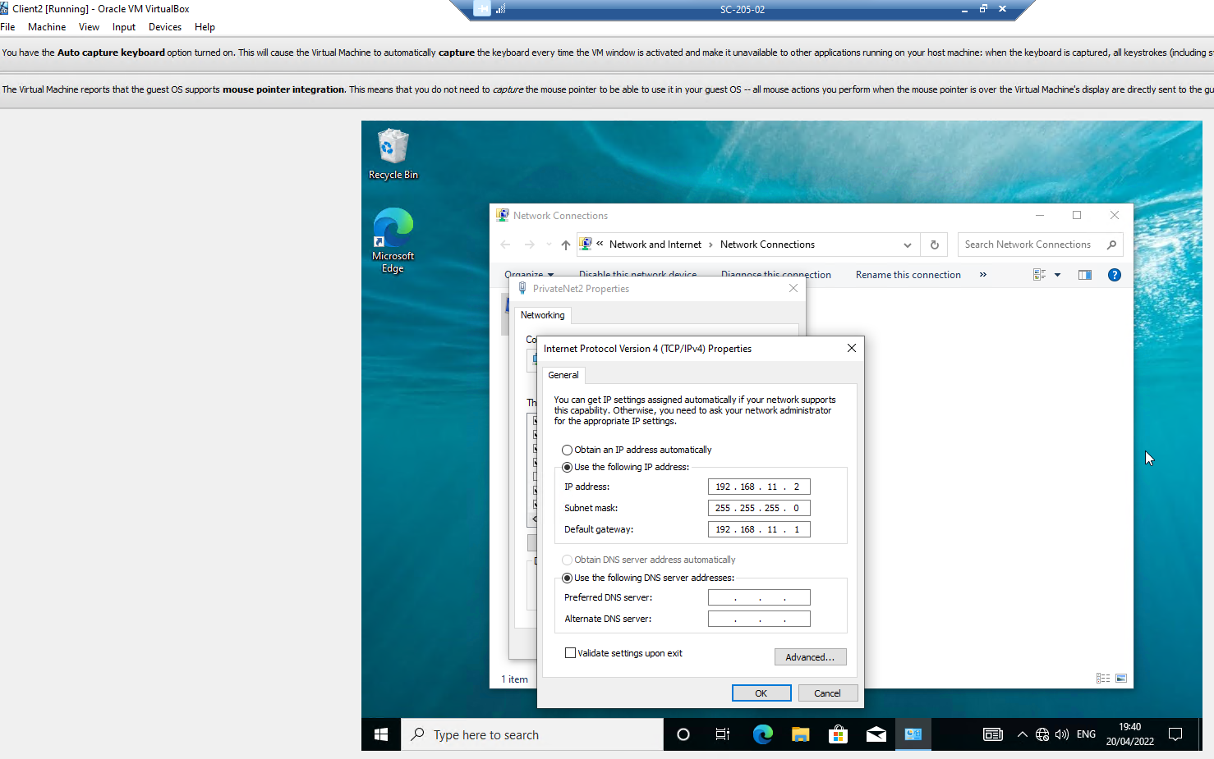
Successful ‘ping’ Server1 to Server2 192.168.10.201
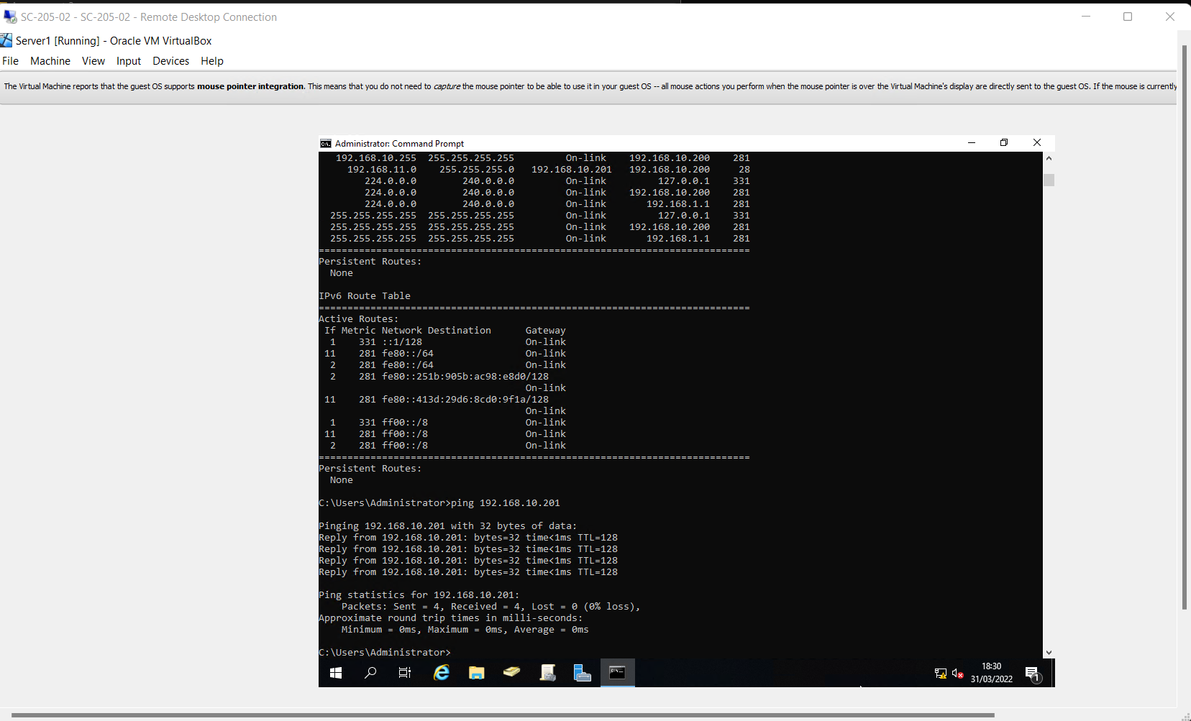
Successful ‘ping’ Client1 to Client2 192.168.11.2
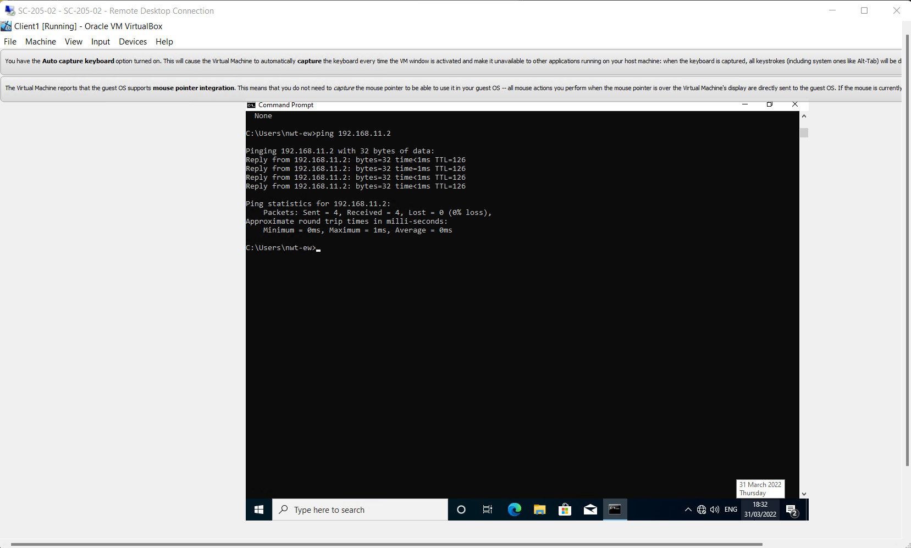

- IP Packet Filtering
Two filter options available on Routing and Remote Access service:
Inbound Filter – applies to traffic entering inbound to the router from the internal network - PrivateNet1 to Server1 & PrivateNet2 to Server2

Outbound Filter – applies to traffic sent outbound from the router to destinations in the PublicNet network.

Filter 1: Stopping ‘anyone’ in PrivateNet1 from Pinging the Router Firewall Service

Inbound filter configured on PrivateNet1 interface on Server1
Source Network: N/A – applies to all clients on PrivateNet1 LAN
Destination Network:
IP: 192.168.1.1 [Server1 Router/Default Gateway]
Subnet Mask: 255.255.255.255
Protocol: ICMP – to stop all ‘ping’ traffic

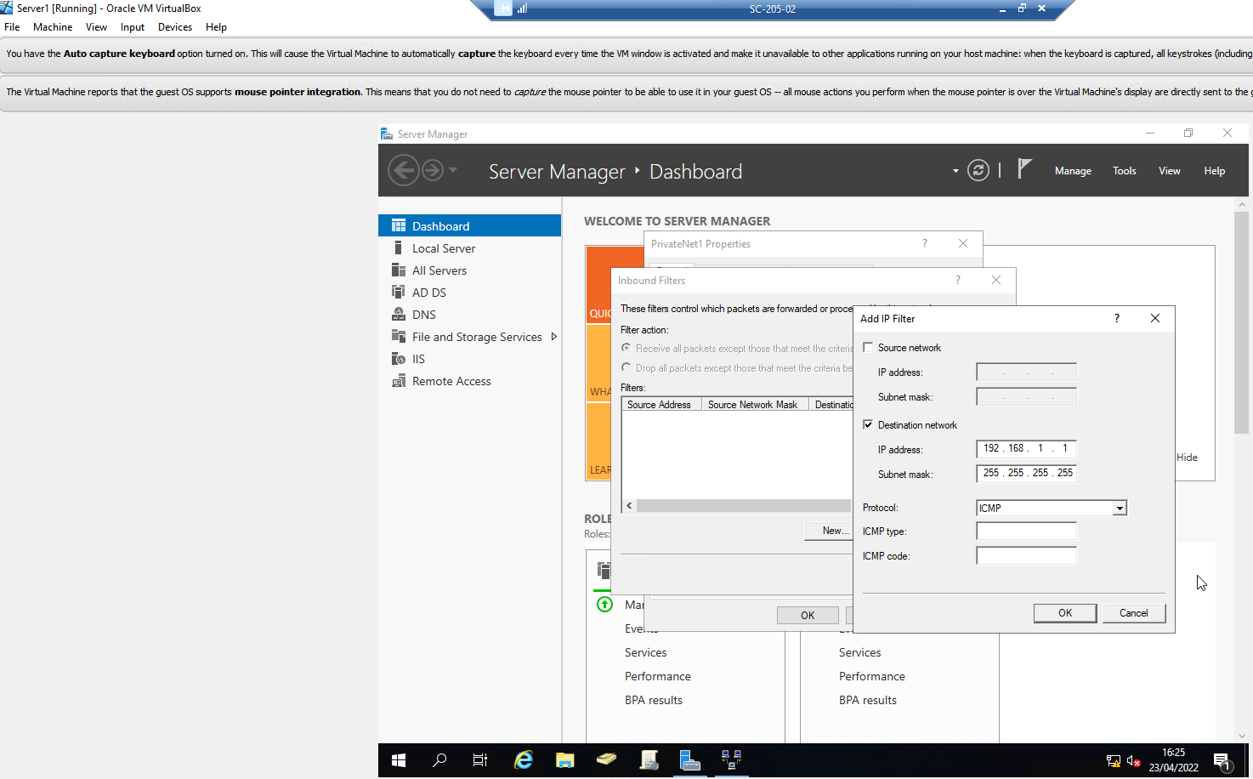

Filter action: ‘Receive all packets, except those that meet the criteria below’, as relating to traffic entering the router.
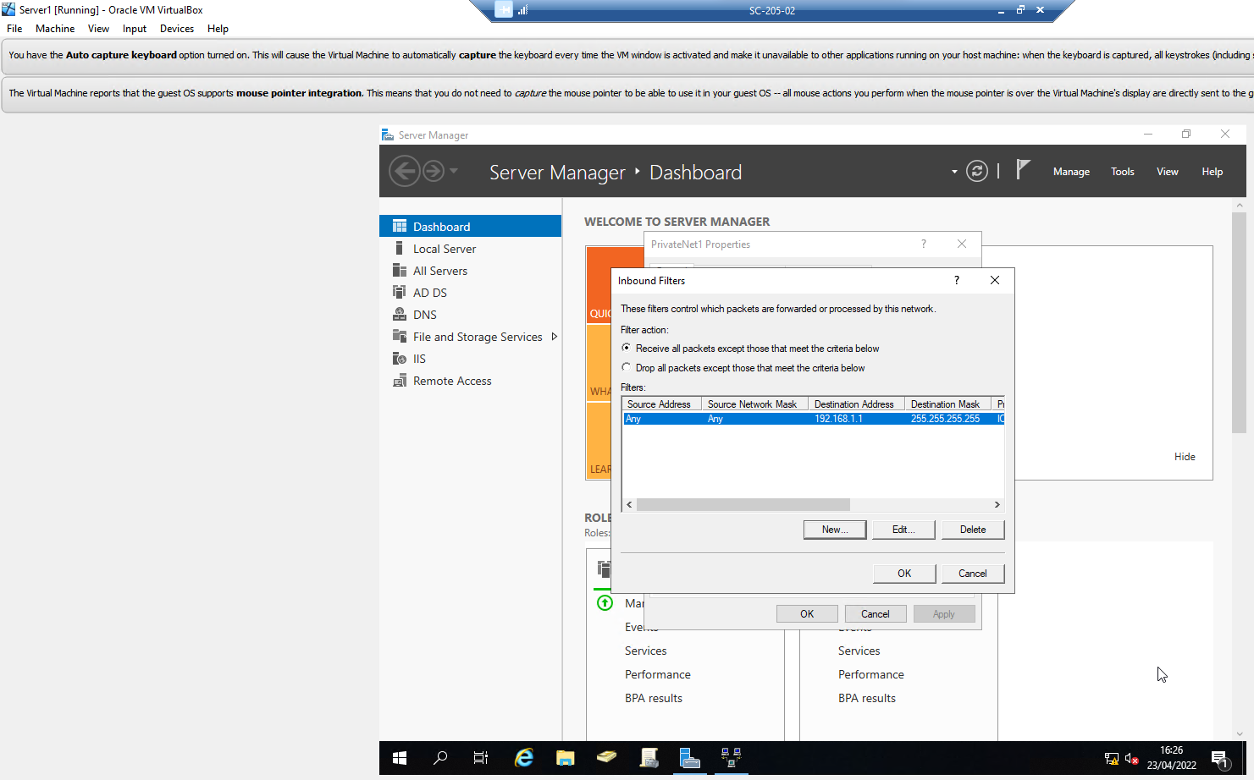
Failed ‘Ping’ test from Cient1 to Server1 IP: 192.168.1.1 - Filter1 has been successfully applied.

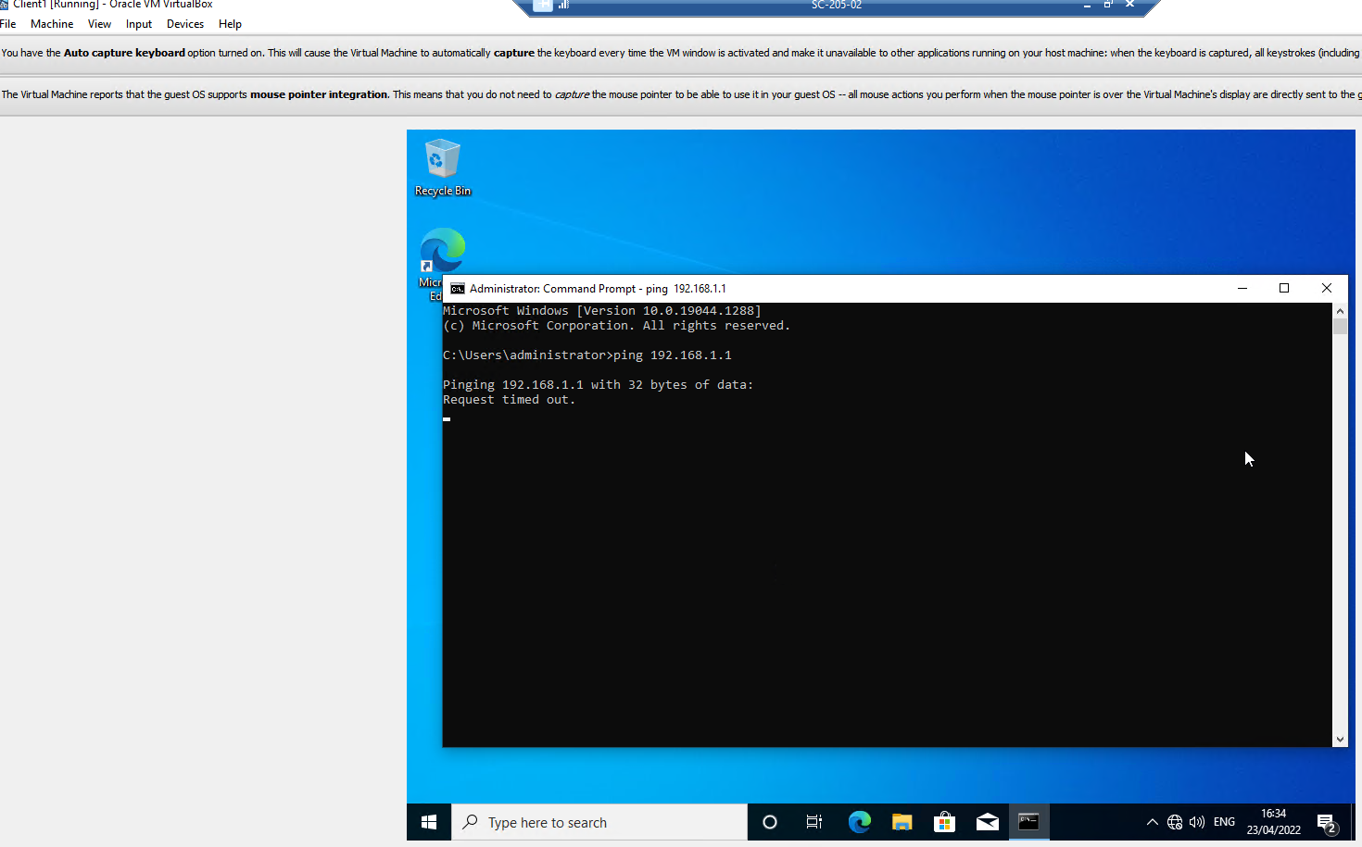

Successful ‘ping’ sent to Server1 IP: 192.168.10.200 PublicNet, filter1 only applies to Destination IP 192.168.1.1 on PrivateNet network card.

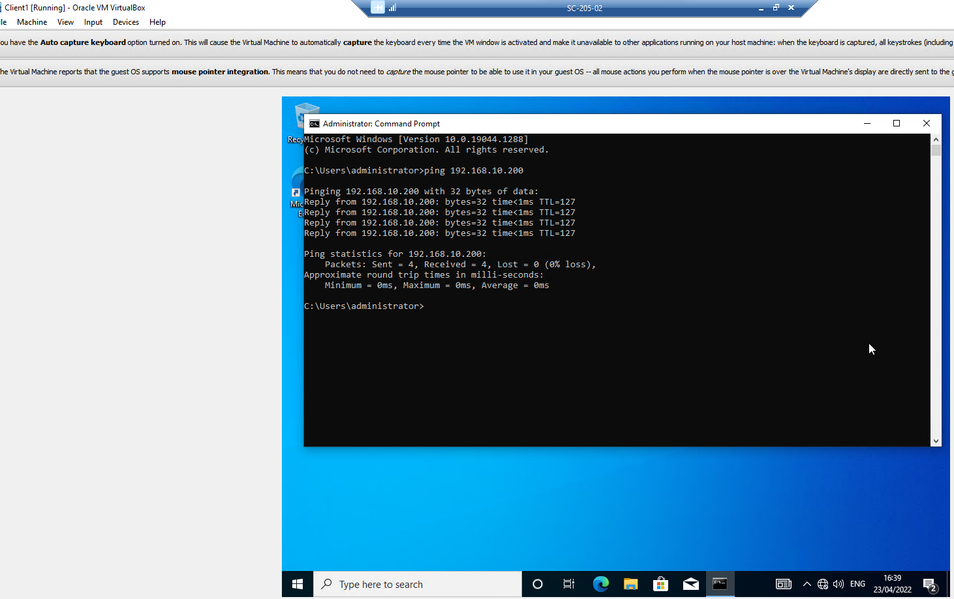

Filter 2: Restrict Access to FTP Service running on Server2 to only hosts in PrivateNet2

X2 Outbound filters configured on PublicNet interface on Server1 as there as 2 interfaces on Server2.
1st Filter
Source Network: N/A – applies to all clients on PrivateNet1 being restricted.
Destination Network:
IP: 192.168.10.201 [Server2 NIC 1]
Subnet Mask: 255.255.255.255
Protocol: TCP – FTP is a core service that runs on the TCP/IP Protocol
Port: 21 [FTP service runs on Port 21]

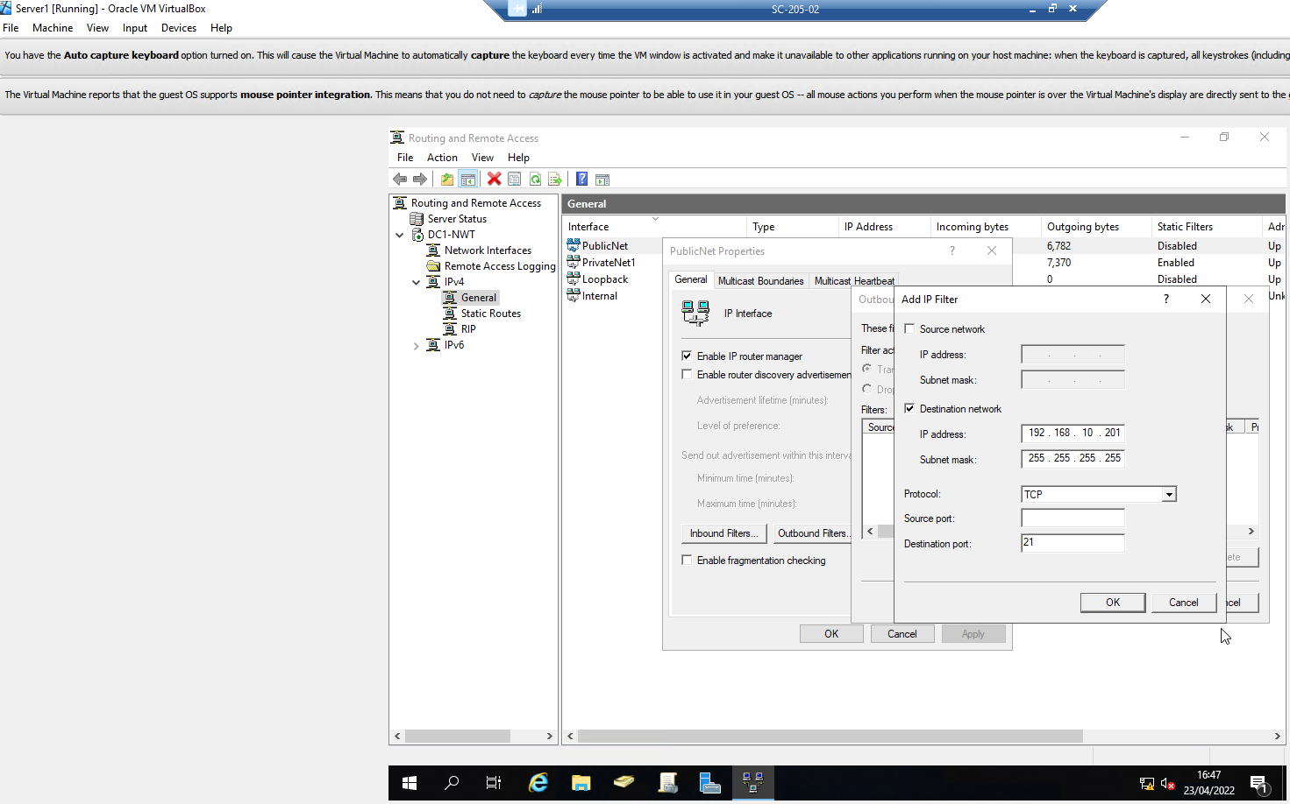
2nd Filter
Source Network: N/A – applies to all clients on PrivateNet1 being restricted.
Destination Network:
IP: 192.168.11.1 [Server2 NIC 2]
Subnet Mask: 255.255.255.255
Protocol: TCP
Port: 21
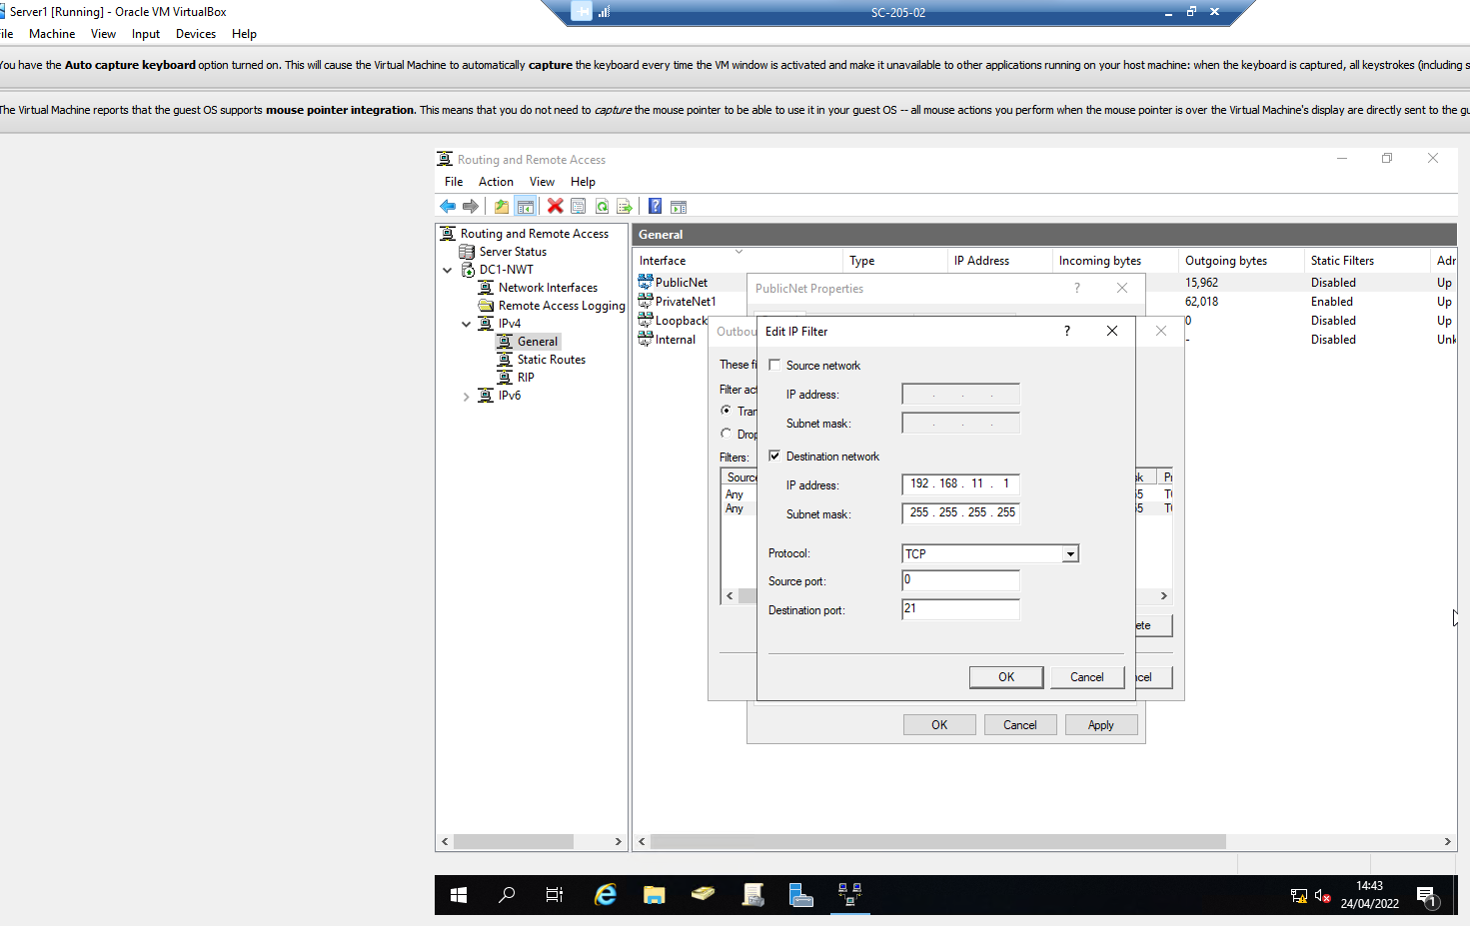

Filter action: ‘Transmit all packets except those that meet the criteria below’.
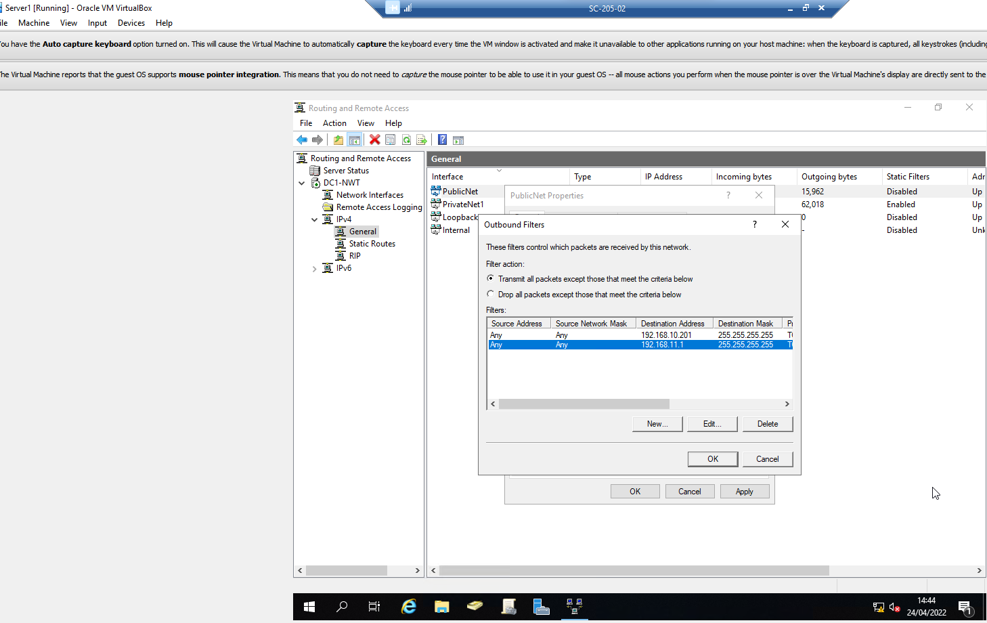f

Unsuccessful FTP connection request sent from Client1 to Server2 192.168.10.201 & 192.168.11.1
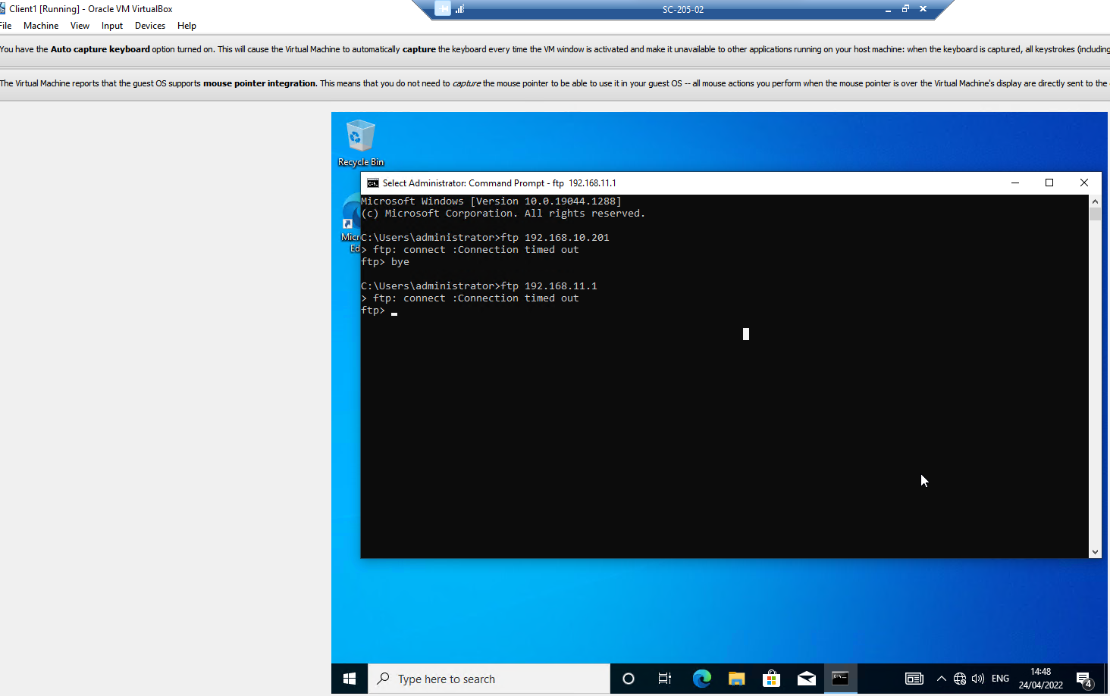
Successful FTP connection request sent from Client2 to Server2 192.168.10.201 & 192.168.11.1
Filters have been applied successfully.
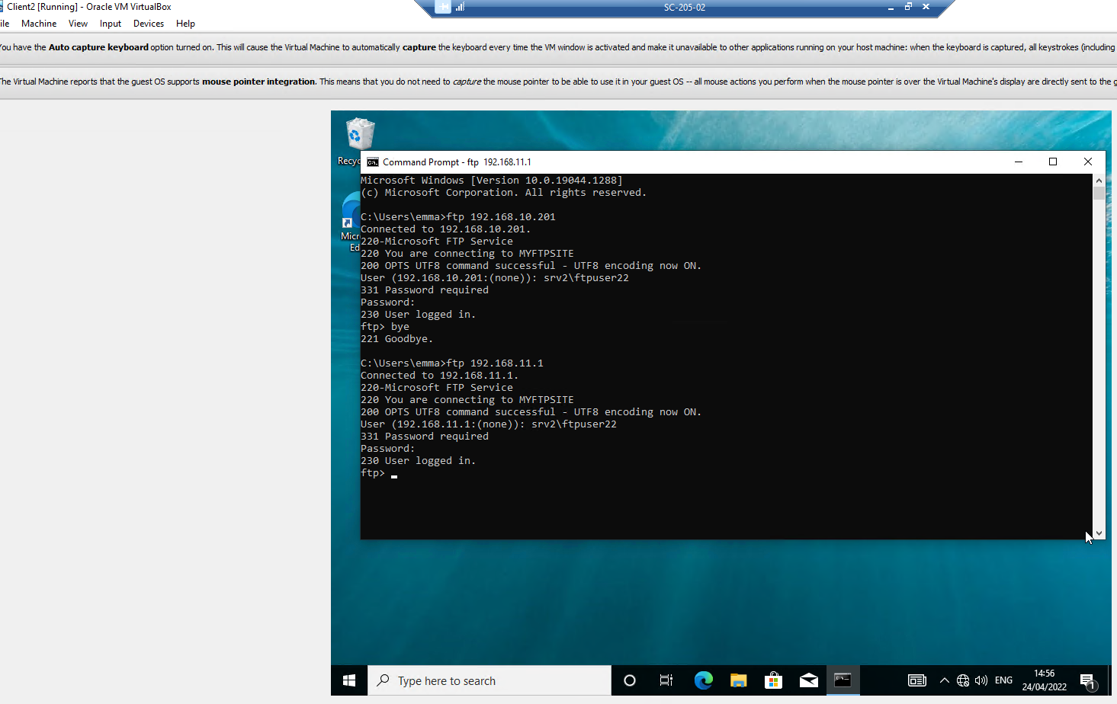

Filter 3: Only allow specific hosts in PrivateNet1 to access the FTP Service running on Server2
Access to FTP to allow only Client1 IP: 192.168.1.2 access to FTP on Server2.
Filter2 deleted due to opposing effect on this configuration. These filters are allowing FTP from Client1 and restricting remaining clients, not restricting entire PrivateNet1 LAN.
X2 Inbound filters configured on PrivateNet1 interface on Server1, to allow FTP connections and traffic from Client1 to the FTP Service on Server2 and drop all other FTP requests from all other clients on PrivateNet1 LAN.
1st Filter
Source Network:
IP: 192.168.1.2 [Client1]
Subnet Mask: 255.255.255.255
Destination Network:
IP: 192.168.10.201 [Server2 NIC 1]
Subnet Mask: 255.255.255.255
Protocol: TCP
Port: 21

2nd Filter
Source Network:
IP: 192.168.1.2 [Client1]
Subnet Mask: 255.255.255.255
Destination Network:
IP: 192.168.11.1 [Server2 NIC 2]
Subnet Mask: 255.255.255.255
Protocol: TCP
Port: 21
Filter action: ‘Drop all packets except those that meet the criteria below’, as FTP traffic is restricted from all other clients on PrivateNet1.
Successful FTP connection request sent from Client1 to Server2 192.168.10.201 & 192.168.11.1
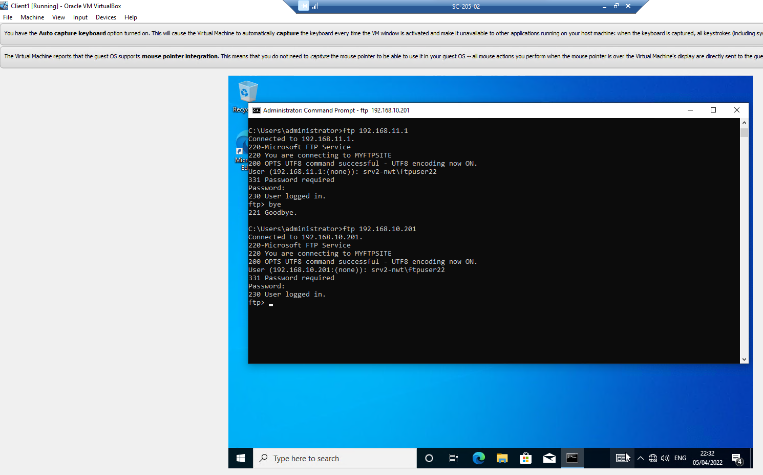

Task 3: Observations (1500 Words)

- Sound ‘password’ principles in modern network environments.
Password principals relate to conditions set via password security policies and enforced via Group Policy to ensure all passwords set within an enterprise network are robust and meet minimum requirements and criteria, making them more secure against phishing and social engineering attacks.
Users are known to set easy memorable passwords which are weak, predictable, and susceptible to brute-force or dictionary attacks. No system, service or organisation are immune to weak password exploitations. Weak passwords and attacks are not limited to standard users, SysAdmin and Admin accounts are also vulnerable to attack and must be mitigated with a ‘Break Glass’ account. SysAdmin and DomainAdmin accounts should also be limited and audited regularly.
- Weak password examples: Password, Spring, Christmas, 123456, Wales.
People on average have over 100 passwords to remember. The National Cyber Security Centre (NCSC) announced that ‘123456’ is used by 23.2 million, and ‘password’ by 3.6 million in the UK [1]. They have also published a list of the top 100,000 used passwords [2]
Azure Active Directory (ADD) also recognises the issue with weak passwords and has created a ‘global banned password list’ that is included and updated for all licenced Azure AD tenancies. Enterprises can create custom deny lists that include locally known entries such as Country and organisational terms [3]
To ensure strong secure passwords are used, the conditions must be set in accordance with the GPO.
Figure 1 - Example as created in task 1, Question 2, GPO5
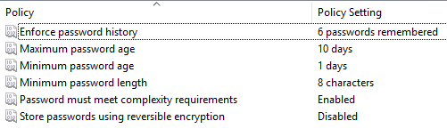:
- Complex passwords require: Minimum 8 characters, including a mix of upper- and lower-case letters & symbols:
E.G. Axm1nSt£r
- Passphrase – a password that consists of 3 random unrelated words that include the same criteria as above:
E.G. T0rchCurryBlu3*
- Cannot use the same password more than once.
- Passwords changed regularly can mitigate a compromised password. A highly debated process due to NCSC’s advice to stop expiring passwords. Regular changing of passwords increases the vulnerabilities of using the same passwords across many systems, writing them down, or just changing the digit or symbol [4].
Multi-Factor Authentication (MFA) - An additional security step to secure accounts, requires an added authentication method to prove you are who you say you are.
- Something you have – a phone call, text message, One-Time Passcode (OTP) or approval notification sent to an Authenticator app on your mobile or tablet device.
- Something you know – your password.
When a password is compromised, attackers would proceed further than entering a user’s stolen credentials, they would also need the user’s device.
MFA and complex passwords used together helps secure accounts and provide a further barrier to attacks.

- Failover Clustering for High Availability Systems/Services
‘High Availability’ (HA):
Enterprise network systems and services such as Active Directory Domain Services, Email, DHCP, DNS, File Servers, and critical business applications, expected to be available 99% of the time.
‘Continuous Availability’ (CA):
Systems and services available 100% of the time, such as Hospitals and Emergency Services, the loss of which could cause harm to life.
A failover cluster is critically important as it can deliver high availability. Within a failover cluster, systems, applications, and services are shared across a group of connected hardware or virtual servers, known as nodes. Together they provide services that are resilient, available 99% of the time, scalable, fault tolerant and eliminate single points of failure (SPOF)[5].
- Concepts that require consideration when implementing a Failover Cluster:

- Identify HA systems.
- Configure Windows Server Roles: Database Sever, File Server or Hyper-V Server
- Implement Redundant Storage alleviating a ‘Single Point of Failure’ (SPOF):
RAID (redundant array of independent disks) configured appropriately for HA systems such as RAID 1, or SAN (Storage area network).
- Continuous server health monitoring and communications:
Software or device to monitor node health, viability, routes, failures, errors in a cluster, communicated to each other via ‘Heartbeats’. Such as the ‘Network Fault Tolerant’ (NetFT) adaptor included with Windows virtual cluster.

- Windows Server OS role:

File Server Role: Clustered file shares perform as ‘active-passive’, all file shares are available on one cluster, which if fails, a passive cluster will assume the active role, ensuring availability [6].
Prerequisites required for each server node within the virtual cluster [7]:
- Windows Server Version: E.G., ‘Windows Server 2019 (64-bit)’.
- Server within same Active Directory Domain (ADD)
- Dedicated OU (Organisational unit)
- Failover Cluster Features installed on all server nodes and Failover Cluster Manager installed on one dedicated server.

- Implementation: [7]
Server Manager: Role or feature based installation
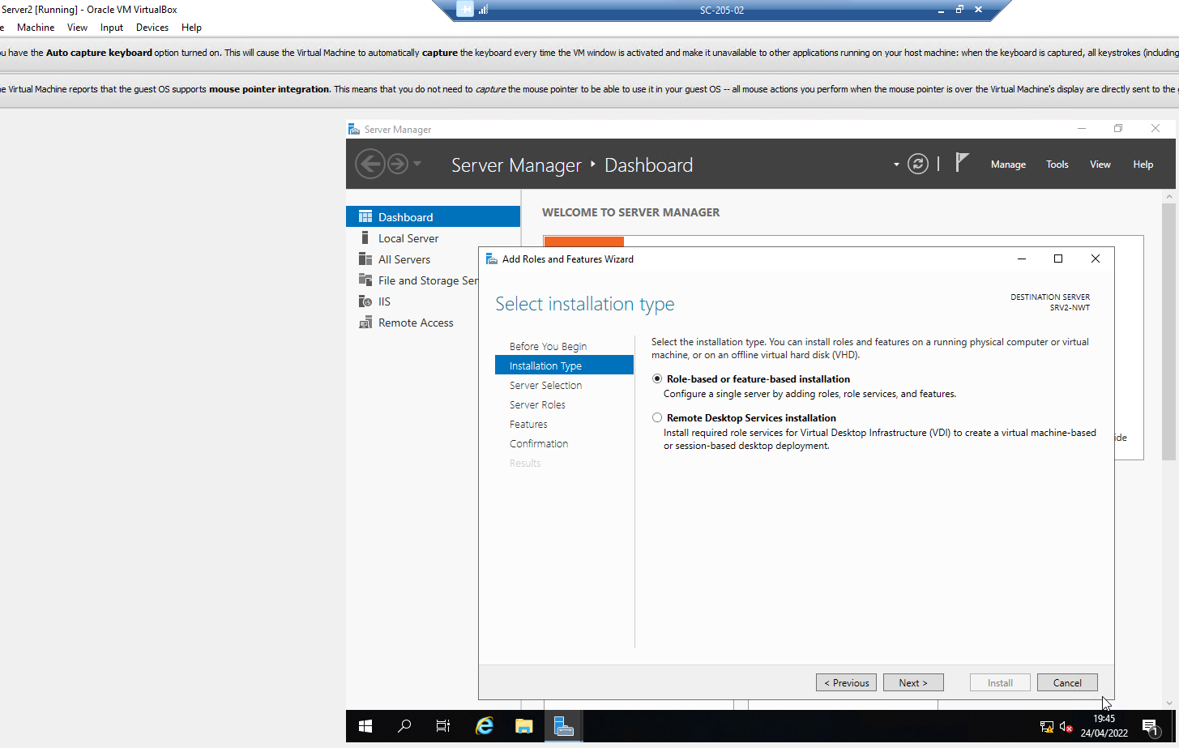
Server selected: SRV2-NWT
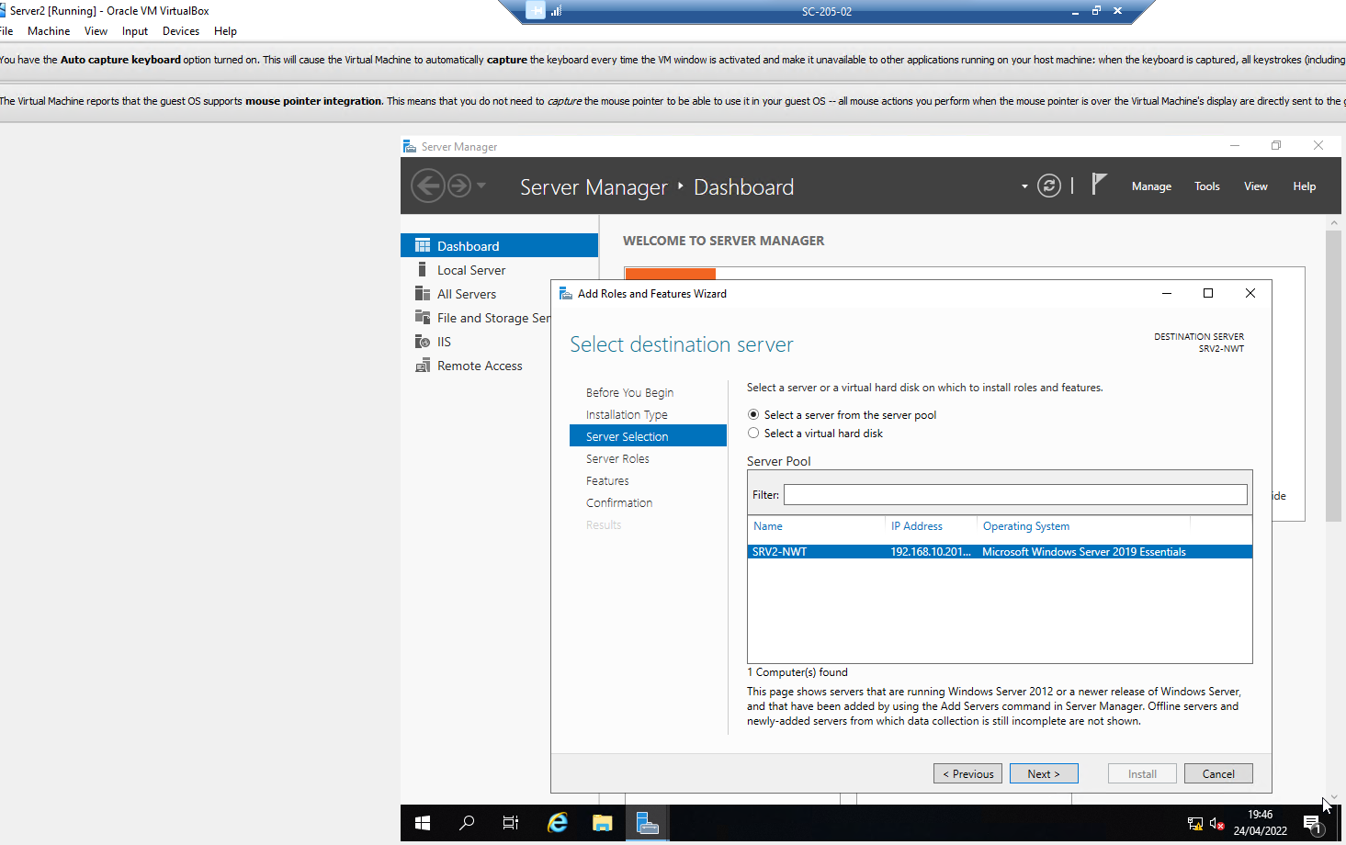
Add Features: Remote Server Administration Tools (RSAT)
Feature Administration Tools
Failover Clustering Tools: Failover Cluster Management Tools & Failover Cluster Module for Windows PowerShell
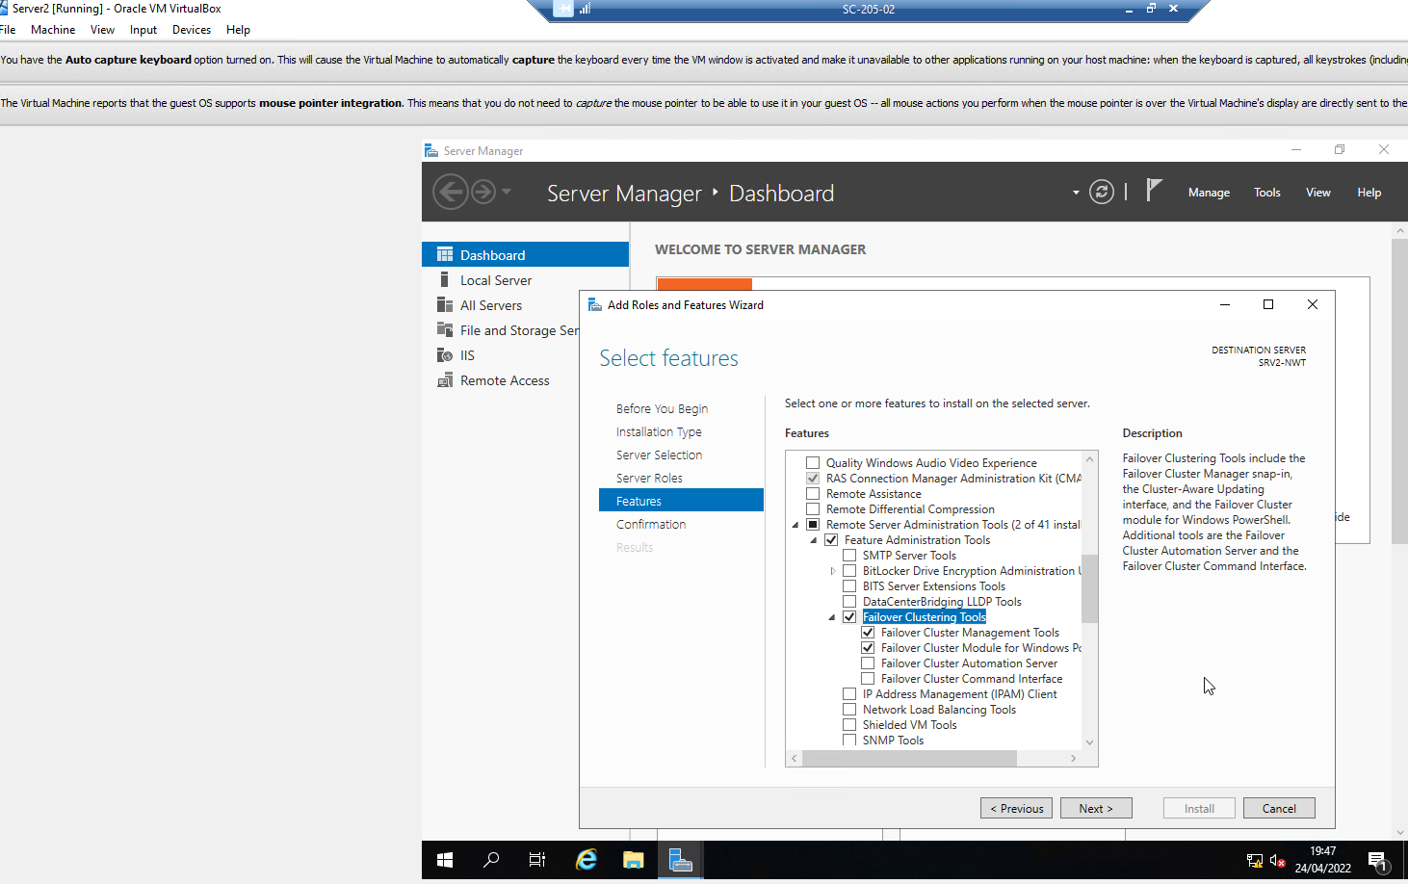

Successful installation of Failover Cluster Management Tools
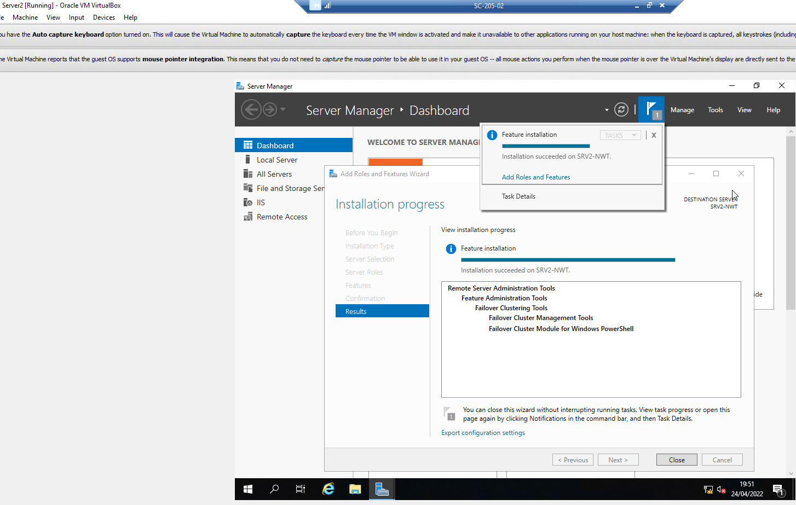
File Server Failover clusters can be managed via Windows Admin Centre allowing viewability of nodes, roles, networks, and shared disks [8]

- Network Security Policy – Draft
Our Organisation
- Introduction:
This network security policy defines the procedures, technical guidance, and responsibilities of ‘Our Organisation’, to provide and ensure a robust, safe and secure computer network.
- Scope:
This policy applies to the management and control of systems, the ‘Our Organisation’ network, data communications, end-user and network devices, all staff, end users, and external stakeholders.

- Topology:
This image describes the topology and design of the network:
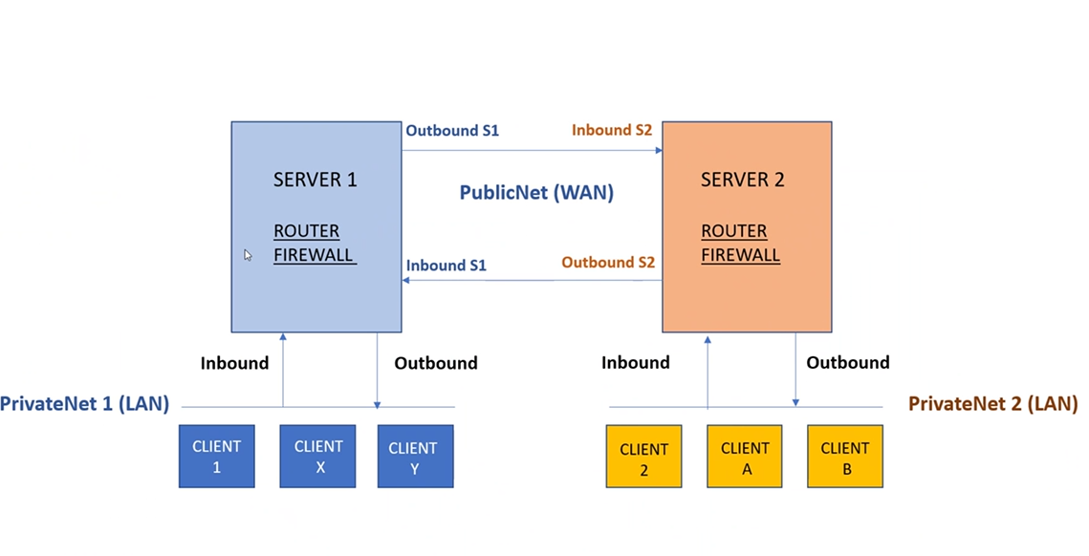
Figure 1 - Our Organisation Network Topology
- The network consists of internal and external networks, cloud managed systems and software, hardware and virtualised managed servers, internal and external firewalls, managed and encrypted end user devices, secure print services, and network file shares.

- Network Management & Responsibilities:

- The IT Network Manager and IT Network Administrator are responsible for the overall design, management, control, guidance, administration, monitoring, and maintenance of the network, supported by the IT Security Officer and IT Network Team.

- The IT Security Officer is responsible for the administration, management, enforcement, risk analysis, monitoring and securing of the network, network access, network communications, security policies and violation mitigations and responses, supported by the Cyber Security Incident Response Team (CSIRT), IT Security, IT Infrastructure and IT Communications Teams, which include and are not limited to the Administrator, Domain Administrator, and Systems Administrator.

- All key personnel, IT staff, users external agencies must work collaboratively to ensure network access, security practices and policies are implemented and adhered to.

- High Availability and Fault Tolerance Practices:

- Systems, Services & Critical Business Applications are managed and maintained with the implemented ‘Windows Failover Cluster’. Providing resiliency, scalability and fault tolerance to ensure ‘High Availability’ 99% of the time.
This includes the internal and external Firewalls, Active Directory Domain Services, Dynamic Host Configuration Protocol (DHCP), Domain Name System (DNS), Email, Internet, Secure Print and File Servers, and critical business applications.

- Network Access & Security Practices:

- Only organisational provided or approved laptop, mobile and printing devices are permitted access to the network.
- All devices are secured with encryption software and configured and managed using Endpoint Configuration Management software. Reported lost, stolen, missing devices, or devices that have not communicated with the management console, will be remotely locked and wiped.
- All devices have ‘Virtual Private Network’ (VPN) Management software installed.
- All devices are installed with Antivirus and Antimalware, which is regularly updated and monitored. Any updates or device scans not accepted, will be automatically removed from the network.
- All software applications are managed and installed by the IT Team. Any additional software requests or requirements must be accompanied by a business case and management authorisation. Software Centre provides a repository of approved software applications. Access to which is permitted based on business requirements and validated permissions.
- Software patching and updates are carried out using Endpoint Configuration Management.
- Access to the internal network is via encrypted VPN. Enabling agile and home working, while securing data and information being transmitted, stored and accessed.
- All systems and services not in use are disabled with immediate effect.
- Internet usage: All social media, inappropriate sites, file/cloud storage and 3rd party virtual meeting software are blocked by default. All usage is logged and monitored and reported upon to senior managers.
- All network traffic is filtered and logged through the firewall.
- All external emails are encrypted using Office 365 Message Encryption (OME)[9].
- Any breaches to the above will lead to disciplinary action.

- Enforcement of security policies:

- All users will be provided with an organisation approved and managed device and Office 365 user account, configured and managed via the IT Team using Azure Active Directory (ADD).
- All accounts are secured via a complex password or passphrase which must consist of a minimum 10 characters, to include a number and symbol. Passwords must not be shared, declared, or written down and can only be used once, as per the ‘Password Policy’.
- The ‘Password Policy’ is enforced via Group Policy which ensures passwords meet the complexity requirements, are not re-used, and meet the minimum length and age.
- Logon hours are restricted to between 8am and 8pm except for IT staff and are configured within Active Directory Users and Computers (ADUC). Any changes must be requested and approved by senior management.
- Multifactor Authentication is enforced on all user accounts, adding an additional security step to protect users accounts and the organisations data and network. All logins must be approved using a notification received via the Authenticator app installed on your mobile device, SMS or phone call.
- All user accounts of staff who leave the organisation will be disabled with immediate effect.
- Access to internal network File Shares is controlled via Packet Filtering, implemented within the internal firewall.
- Access to the control panel, command prompt, software installations and removable media (Hard Drives, USB Memory Drives, etc) is denied to all users outside of the IT Team and enforced via Group Policy Objects.

- Security Risk Analysis & Network Monitoring:

- The organisations ‘Vulnerability Management Program’ (VMP) – uses infrastructure and application vulnerability scanners to identify vulnerabilities via systems discovery and validation. Performing automated regular scans of virtual and physical assets such as laptops, printers, servers, routers, and web applications, to compare with the organisation’s asset management software [10].
- Using the internal and external firewall, the DHCP and DNS servers and network switches enables logging and monitoring of internal and external network communications, access and authentication attempts and configuration information and IT assets to ensure any breaches or attacks to systems and data are mitigated [11].
- 3rd party ‘Penetration Testing’ exercises are carried out annually.
- All patching of and security updates to; vulnerabilities, servers, systems, software applications and end user devices will be managed and carried out when required to ensure and protect against attacks.

- Violation Mitigations:

- The Incident Management and Response Plan is managed and updated by our CSIRT.
- Regular monitoring of incident reports from Government Organisations is carried out and weekly threat reports are received from the NCSC [12] .
- A robust DR Policy and plan is in place, with annual testing and cyber-attack exercises carried out, with the results collated and the DR Plan updated/amended accordingly to ensure it is effective and up to date.
- Staff Awareness – Staff must always be vigilant and carry out mandatory regular organisation led, cyber security awareness training.
- Staff must report all phishing emails, breaches and irregular activities or incidents.
- Phishing exercises will be carried out on a regular basis to ensure threat awareness, knowledge and understanding is updated and communicated.
- All incidents, threats or queries can also be reported to the ITSecurityIncidents@theorganisaion.com mailbox.

[1] “Most hacked passwords revealed as UK cyber survey exposes... - NCSC.GOV.UK.” https://www.ncsc.gov.uk/news/most-hacked-passwords-revealed-as-uk-cyber-survey-exposes-gaps-in-online-security (accessed Apr. 23, 2022).
[2] “Passwords, passwords everywhere - NCSC.GOV.UK.” https://www.ncsc.gov.uk/blog-post/passwords-passwords-everywhere (accessed Apr. 23, 2022).
[3] “Configure custom Azure Active Directory password protection lists | Microsoft Docs.” https://docs.microsoft.com/en-us/azure/active-directory/authentication/tutorial-configure-custom-password-protection#what-are-banned-password-lists (accessed Apr. 23, 2022).
[4] “The problems with forcing regular password expiry - NCSC.GOV.UK.” https://www.ncsc.gov.uk/blog-post/problems-forcing-regular-password-expiry (accessed Apr. 23, 2022).
[5] “Failover Clustering | Microsoft Docs.” https://docs.microsoft.com/en-us/windows-server/failover-clustering/failover-clustering-overview (accessed Apr. 24, 2022).
[6] “Implement Scale-Out File Server - Learn | Microsoft Docs.” https://docs.microsoft.com/en-us/learn/modules/implement-windows-server-file-server-high-availability/4-implement-scale-out-file-server (accessed Apr. 25, 2022).
[7] “Create a failover cluster | Microsoft Docs.” https://docs.microsoft.com/en-us/windows-server/failover-clustering/create-failover-cluster#verify-the-prerequisites (accessed Apr. 24, 2022).
[8] “Manage Failover Clusters with Windows Admin Center | Microsoft Docs.” https://docs.microsoft.com/en-us/windows-server/manage/windows-admin-center/use/manage-failover-clusters (accessed Apr. 25, 2022).
[9] “Manage Office 365 Message Encryption - Microsoft Purview | Microsoft Docs.” https://docs.microsoft.com/en-us/microsoft-365/compliance/manage-office-365-message-encryption?view=o365-worldwide (accessed Apr. 28, 2022).
[10] “Vulnerability Scanning Tools and Services - NCSC.GOV.UK.” https://www.ncsc.gov.uk/guidance/vulnerability-scanning-tools-and-services (accessed Apr. 28, 2022).
[11] “Introduction to logging for security purposes - NCSC.GOV.UK.” https://www.ncsc.gov.uk/guidance/introduction-logging-security-purposes (accessed Apr. 28, 2022).
[12] “Incident management - NCSC.GOV.UK.” https://www.ncsc.gov.uk/collection/incident-management (accessed Apr. 28, 2022).

