

Is there a correlation between Adverse Childhood Experiences and criminality?

Student: Kelly Lee
Student Number: 213448
Word Count: 8622

Degree: BSc (Hons) Professional Policing Practice
UWTSD 2025

Acknowledgements

I would like to express my deepest gratitude to my dissertation tutor, Samantha Mcalister Wilson, for her invaluable guidance, patience, and support throughout this research journey. Her insightful feedback and encouragement have been instrumental in shaping this dissertation.
I am also immensely grateful to my colleagues for their assistance, advice, and shared knowledge, which have enriched my understanding and approach to this study. A special thanks to my fellow probationary officers, whose camaraderie and shared experiences have made this process more manageable and rewarding.
I would like to express my appreciation to my husband, Jon, for his love, support, and patience, and for taking care of our three daughters, while I have been focused on my academic studies. You and the girls have been my motivation, and I hope all this hard work will ultimately pay off for us. I would also like to thank my parents who have offered me great support throughout and believed in me. Without their help, this dissertation would have been extremely difficult to complete.
Finally, I acknowledge all those who participated in or contributed to this research. Their time and insights have been invaluable in making this work possible.
Thank you all.

.

Declaration

This work has not been previously approved for any academic degree and is not being submitted for consideration for any other degree at the same time.
Signed: 213448. K. Lee Date: 04.04.25

STATEMENT 1
This dissertation is being submitted in partial fulfilment of the requirements for the degree of BA.
Signed: 213448. K. Lee Date: 04.04.25

STATEMENT 2
This dissertation is the result of my own independent work/investigation, except where otherwise stated.
Other sources are acknowledged by footnotes giving explicit references. A bibliography is appended.
Signed: 213448. K. Lee Date: 04.04.25

STATEMENT 3
I hereby give consent for my dissertation, if accepted, to be available for photocopying and for interlibrary loan, and for the title and summary to be made available to outside. organisations.
Signed: 213448. K. Lee Date:04.04.25

STATEMENT 4
I hereby give consent for my dissertation, if accepted, to be available on the university’s IT system to those who have consent to use the system.
Signed: 213448. K. Lee Date: 04.04.25

Abstract

This research aimed to investigate the relationship between individuals who have experienced Adverse Childhood Experiences (ACES) and its potential association with criminality.
The researcher conducted a comprehensive critical study of the current academic literature regarding ACES and its correlation with criminality. Subsequently, the researcher conducted primary research using questionnaires to collect quantitative data and then analysed it with secondary data to identify any emerging patterns.
It analyses the perspectives of police officers, police community support officers (PCSOs), and child sexual exploitation officers (CSEOs) while drawing analogies between contemporary research initiatives and past studies undertaken by theorists and researchers.
The findings from this study were then documented, and as a result, recommendations were made to improve ACES training for police officers, to have better collaboration between multi -agencies and to provide early intervention. It is hoped that these recommendations may help by reducing the likelihood of individuals being engaged in the criminal justice system. Consequently, this would alleviate the burden of policing and prison service.

Contents Table
Acknowledgments……………………………………………………………………………2
Declaration…………………………………………………………………...........................3
Abstract ……………………………………………………………………………………...4
Acronyms …………………………………………………………………………………………....8
Chapter 1: Introduction
1.1: Introduction …………………………………………………………………………….9
1.2: Background and Rationale ………………………………………………………….9-10
1.3. Aims and objectives ………………………………………………………………...10
1.3.1 Aim ………………………………………………………………………………….10
1.3.2 Objectives …………………………………………………………………………...10
Chapter 2: Literature Review
2.1: Background ……………………………………………………………………...…. 11
2.2: Aims of Research …………………………………………..........................................11
2.3: Theoretical Framework between ACES and Criminality …………………………….12
2.4: Mechanisms linking ACES to Criminality …………………………………………. .12
2.5: Gender differences ……………………………………………………………………13
2.6: The impact of ACES ………………………………….………………………………13
2.7: The impact of ACES in a specific Welsh context……………. ……………………...14
2.8: Intervention and prevention strategies ……………………………………………….15
2.9: Early intervention and prevention with partner agencies…………………………….16
2.10: Police training on ACES with Multi-Agency Partners………………………………17
2.11: The gaps in the research………………………………… ………………………17-18
2.12: Conclusion …………………………………………………………………………18
Chapter 3: Methodology
3.1: Introduction ……………………………………………………………………….......19
3.2: Research Strategy………………………………………………………………......19-20
3.3: Sample and Recruitment………………………………………………………………20
3.4: Methods/ Data Collection …………………………………………………………….20
3.5: Analysis ………………………………………………………………………………21
3.6: Ethical Considerations ……………………………………………………………… 21
3.7: Limitations…………………………………………………………………………….22
3.8: Conclusion………………………………………………………………………. …...22
Chapter 4: Results Chapter
4.1: Introduction ………………………………………………………………………….23
4.2: Data Analysis ……………………………………………………………………......23
4.3: Questionnaire Findings………………………………………………………………23
4.3.1: Evaluate the link between ACES and criminality through existing research……24-25
4.3.2: Is there enough awareness of police officers recognising the signs of ACES. Have they had adequate training to provide the early intervention……………………………25-29
4.3.3: To examine whether the police are working with the right multi- agencies………29-30
4.4: Conclusion ………………………………………………………………………….31
Chapter 5: Findings and Conclusion
5.1: Introduction……………………………………………………………………………32
5.2: The achievement of objectives ……………………………………………………32-33
5.3: Main findings……………………………………………………………………...33-34
5.4: Recommendations …………………………………………………………………….34
5.4.1 Recommendations one – Mandatory Trauma -Informed ACES Training for Police Officers……………………………………………………………………………………….34
5.4.2 Recommendation Two – Increased investment in early intervention programs…35
5.4.3 Recommendation Three- Strengthening Multi-Agency Partnerships ……………….35
5.4.4 Recommendation Four -Implementing Trauma- Responsive Policing Strategies 35-36
5.5: Further Research …………………………………………………………………… 36
5.6: Limitations ……………………………………………………………………………36
5.7: Self-Reflection ……………………………………………………………………….37
5.8: Conclusion ……………………………………………………………………...........37
Chapter 6: Bibliography ……………………………………………………………....38-44
Chapter 7: Appendices
7.1: Appendix One: Questionnaire ……………………………………………………45-57
7.2: Appendix Two: Questionnaire Results ……………………………………………58-69
7.3: Appendix Three: Dissertation Proposal … ……………………………………….70-75
7.4: Appendix Four: Ethics Form ……………………………………………………...76-91

Acronyms

ACES Adverse Childhood Experiences

PCSOS Police Community Support Officers

CSEOS Child Sexual Exploitation officers

NPCC National Police Chiefs Council

EAT Early Action Together

ACs ACE Coordinators

MAPS Multi -Agency Partners

PSE Personal and Social Education

Chapter 1: Introduction

1.1 Introduction
This dissertation will examine the correlation between Adverse Childhood Experiences (ACEs) and criminality, especially within the South Wales Police Force. It will discuss the potential correlations between these experiences and criminal behaviour and evaluate the extent of the influence of ACEs. It will examine the potential reasons why early intervention is so important to prevent criminality. It is hoped that by gaining a better understanding from response officers, police community support officers (PSCOs) and child sexual exploitation officers (CSEOs) who engage in this research, it will boost confidence, improve awareness on ACES and expand training. Comprehending the intricacies of this link can guide policy and practice with the aim of breaking the cycle of trauma and crime. It will next compare this with other associated aspects before concluding on the implications and proposing specific strategies for addressing this issue.

1.2 Background and Rationale
The researcher chose this subject due to their personal experience in the police force and their focus on recognising signs of ACES. It is a worthy topic and one in which they believe more awareness is needed in identifying and assisting individuals with ACES. It was of interest to the researcher as to why individuals with ACES become involved in crime and whether the South Wales Police Force should be doing more to investigate their backgrounds and provide early intervention to address these issues.

ACES are traumatic life events that occur in a child's life prior to the age of eighteen, which are beyond the child's control. ACES have been classified into ten distinct categories in recent studies: domestic violence, parental separation, having a parent with mental health disorders, experiencing abuse (physical, sexual, emotional), suffering from neglect, having a parent incarcerated, and being raised in a household with substance abuse issues (Journal of Public Health, 2020). Poor childhood experiences lead to poor mental health, self-image, and self-worth, resulting in health-harming behaviours and potential diseases like cancer, heart disease, and diabetes. These experiences can also affect school performance and crime involvement (Public Health Wales, 2020).

Furthermore, ACES have a significant impact on everyday policing. According to (Craig, J.M. and Piquero, A.R., 2018) individuals with higher ACE Scores are significantly more likely to be involved in criminal activities, leading to more frequent police contact. ACES frequently trigger a cycle of poor health and anti-social behaviour within families thereby perpetuating the cycle of adversity. To break this cycle of adversity, it would be extremely beneficial for police officers to possess the ability to identify indicators of ACES and direct individuals towards appropriate avenues of support by working with Multi- Agency Partners (MAPs). The purpose of this approach is to implement early intervention, ensuring timely and appropriate assistance and reducing the likelihood of individuals being engaged in the criminal justice system. Consequently, this would alleviate the burden on policing and prison services.

1.3. Aims and objectives
    - Aim
The aim of this dissertation is to investigate and critically evaluate if there was a correlation between ACES and criminality.
1.3.2 Objectives
Objective 1: Review the literature surrounding ACES.
Objective 2: To identify and evaluate secondary data of ACES.
Objective 3: To conduct primary surveys with response officers, PSCOS & CSEOS to determine their perspectives, concepts, and suggestions on areas where assistance and support can be improved.
Objective 4: Collate, analyse and display both primary and secondary data to establish trends and identify areas for improvement.

Chapter 2: Literature Review

2.1 Background
As outlined in the introduction chapter, ACEs are not a new phenomenon. The landmark ACES Study first identified ACES in the 1990s, establishing a clear link between childhood trauma and long-term health and social outcomes (Felitti et al., 1998). The study identified ten types of ACEs, including physical, emotional, and sexual abuse, as well as parental mental illness, substance abuse, and incarceration. These experiences collectively predict a range of adverse outcomes, including an increased likelihood of engaging in criminal behaviour (Public Health Wales, 2020). MacMillan et al. (2001) conducted longitudinal research, revealing that children who endured maltreatment were markedly more likely to exhibit delinquent behaviour throughout adolescence and criminal behaviour at maturity. This study emphasised that the nature of ACE—be it physical, emotional, or sexual abuse—can vary depending on the propensity for criminal behaviour.
2.2 Aim of Research
This literature aims to examine the various themes identified in previously published literature. It seeks to consolidate current research on the correlation between ACEs and criminal behaviour by emphasising the underlying processes, implications for intervention, and considerations for future research. This chapter is divided into 12 sections. Section 1 will provide the background of ACES; Section 2 will provide the aims of research. Section 3 will look at the theoretical framework, Section 4 will explore the mechanisms linking ACEs to criminality. Section 5 will examine gender differences, Section 6 examines the impact of ACEs, Section 7 explores the impact of ACES in a Welsh context, Section 8 will examine intervention and prevention strategies. Section 9 will examine early intervention with MAPs, section 10 will explore police training on ACES, section 11 will examine the gaps in the research, followed by a conclusion.

2.3 Theoretical Framework between ACES and Criminality
The life-course perspective suggests that early life experiences shape developmental pathways that lead to criminal behaviour, and several theoretical frameworks can explain the relationship between ACES and criminality. The life-course perspective asserts that early adverse experiences can disrupt normal developmental pathways, leading to abnormal behaviour in adulthood (Elder, 1994). The social learning hypothesis suggests that children exposed to violent or criminal conduct may emulate similar behaviours in their lives (Bandura, 1977). According to Agnew's (1992) general strain theory, traumatic experiences can induce psychological distress, perhaps prompting individuals to resort to criminal behaviour as a coping mechanism.
2.4 Mechanisms linking ACEs to Criminality
The research specifies several mechanisms connecting ACEs with criminal behaviour that are intricate and diverse. One key factor is the impact of ACEs on emotional regulation and decision-making. Rasche (2016) shows how significantly related trauma is to the development of maladaptive coping strategies, which can lead to impulsivity and aggressive behaviour. Additionally, ACEs can disrupt attachment processes, leading to difficulties forming healthy relationships and a greater propensity for antisocial behaviour (Felitti et al., 1998). According to Shore (2003), ACEs can disrupt attachment styles and interpersonal relationships. Children who experience trauma often struggle with trust and emotional regulation, which can impair their social functioning and increase their likelihood of engaging in antisocial behaviour. Furthermore, Teicher et al. (2003) have shown that the neurobiological impacts of ACEs, including alterations in stress response systems, increase impulsivity and aggression, further correlating with criminal behaviour. ACEs are linked to a higher risk of mental health disorders like depression, anxiety, and PTSD, which can lead to maladaptive coping mechanisms like substance abuse and criminal behaviour (Widom et al., 2007). Moreover, the social context in which a child grows up can exacerbate the effects of ACEs. Children from disadvantaged backgrounds, where exposure to crime and violence is common, are at an increased risk of both experiencing ACEs and engaging in criminal activities themselves (Shonkoff et al., 2012). It is vital that police officers can identify these signs and work with MAPs to provide early intervention at the earliest opportunity to prevent them from involved with the criminal justice system.
2.5 Gender Differences
Research indicates that the impact of ACEs on criminality may differ by gender. According to Zoccolillo (1993), boys exposed to ACEs may be more likely to exhibit externalising behaviours, such as aggression and delinquency, while girls may be more susceptible to internalising behaviours that lead to depression and relational aggression. Due to traumatic behaviours like prostitution and drug use, women with high ACE scores are more likely to commit non-violent crimes and enter the criminal justice system. In contrast, males are more likely to engage in more violent crimes due to differing trauma-related social and psychological responses (Levenson, 2016). This gendered response highlights the need for tailored interventions that consider these differences.
2.6 The impact of ACES
Research indicates a strong correlation between ACEs and criminality. Hughes et al. (2017) indicates that children frequently encounter an ACE due to neglect, sexual exploitation, and domestic abuse in their early years. Evidence indicates that children who endure unpleasant childhood experiences have negative impacts that can influence their health throughout their entire lives. Children with ACEs may develop behavioural patterns that result in them committing acts of violence. According to Bellis et al. (2014) findings, individuals with four or more ACEs are seven times more likely to engage in violent behaviour in adulthood and over eight times more likely to face imprisonment. ACEs are potentially stressful incidents occurring throughout childhood; 61% of adults had at least one ACE, while 16% encountered four or more types of ACEs (Centres for Disease Control and Prevention, 2024). Instances of these events include physical violence, sexual abuse, and emotional abuse. These factors can substantially affect children, resulting in academic challenges, behaviour problems, and potential involvement in criminal activities. According to Hughes et al. (2017), ACEs can lead to enduring psychological suffering and have lasting impacts on physical health, drug abuse, interpersonal aggression, and self-harm. The Welsh Adverse Childhood Experiences project found that 50% of the children in Wales suffered at least one ACE, and 13% suffered at least four. (Department of Health,2018). Research suggests that police should adopt a preventative policing style towards antisocial behaviour in children, raising awareness of ACEs, and reducing the likelihood of criminal behaviour. Such an approach could reduce future policing demands and prevent children from becoming involved in organised criminal activities. (College of Policing, n.d.).

2.7 The impact of ACEs in a specific Welsh context
An examination of the prevalence of negative childhood experiences among imprisoned individuals yields intriguing findings. In 2018, Bangor University and Public Health Wales conducted the first ACE prevalence study in a male prison setting in Wales (Ford et al., 2019). The Prisoner ACE Survey intended to assess the pervasiveness of ACEs among an offender populace and study any associations among ACEs and crime types. The survey also intended to examine the association between ACEs and offending. The survey analysed 11 categories of ACEs, including demographics, conviction frequency, incarceration incidence, and lifetime imprisonment duration (Ford et al., 2019). The percentage of prisoners with specific ACEs fluctuated from 11.5% for physical neglect to 57.8% for parental separation or divorce. 32.9% of prisoners reported having a family member receive a prison or youth offender institution (YOI) sentence during their upbringing. Compared to the 2017 Welsh ACE and Resilience Study, the Prisoner ACE Survey participants reported a significantly higher prevalence of ACEs than the general population. The Prisoner ACE Survey revealed that 45.9% of prisoners served a sentence in a YOI, with 91.2% having at least one ACE and 60.0% having four or more, and those with four or more ACEs spending more time in a Youth offending institute (YOI). The study revealed that theft was the most common crime, followed by drugs and violence with injury. On average, Ford et al. (2019) found convictions for four types of crimes. This illustrates the adverse impact on individuals who have had ACEs and their subsequent effects, emphasising distinct patterns in the research.

2.8 Intervention and Prevention Strategies
To address the intergenerational cycle of trauma and prevent future ACEs in children, understanding the correlation between ACEs and criminality has significant implications for intervention and prevention strategies. Early identification and intervention among children experiencing ACEs can mitigate long-term negative outcomes, including criminal behaviour. Programs that focus on improving family dynamics, providing trauma-informed care, and teaching coping skills can be effective in reducing the likelihood of future criminality (Masten et al., 2008). According to Kerig (2018), trauma-informed care, mental health treatments, and family support programs have reduced criminal behaviour. McCance-Katz (2018) emphasises trauma-informed care as a service paradigm that prioritises the emotional, psychological, and physical security for both professionals and individuals while also empowering them. Johnson SB (2013, p. 131) provided evidence for this. Experiences and interactions, in continuity with our genetic composition, shape our biology, which involves our brains. Adversity and trauma significantly impact health, leading to risky behaviours and diseases in adulthood, often occurring years after trauma. Furthermore, negative experiences may influence poor health outcomes independently of maladaptive coping behaviours (Dong et al., 2003). Research indicates a link between childhood trauma and adversity and a higher risk of early humanity (Rokach and Clayton, 2023). Traumatic experiences (ACEs) have severe health and social influences, such as diminished educational achievement, reduced graduation rates, increased teen pregnancy, and elevated imprisonment rates, complicate the understanding of the long-term ramifications of trauma. (Gordon, 2019).
Implementing trauma-informed care within educational and social services is essential. Recognising the impacts of ACEs on behaviour and decision-making, practitioners can create supportive environments that promote resilience and recovery (SAMHSA, 2014). Training for professionals working with children should emphasise the importance of understanding the background and experiences of at-risk children's early years to foster better support systems. Research finds that police forces are now becoming trauma- informed. The Chief Constable of South Wales Police and Welsh forces have recently committed to becoming trauma-informed organisations, with the aim of improving service, reducing trauma impact, and developing strategies to prevent re-traumatisation (College of Policing, 2018). Police officers need the knowledge and training in trauma-informed policing strategies to understand the impact of trauma on community needs, particularly for children with high ACEs. This increases empathy, enables appropriate responses, and connects children with necessary services. Addressing children's needs promotes community trust and reduces crime. There were big improvements in many areas of the Trauma aware Policing Attitudinal (Chopra et al., 2024) study that looked at Barnardo’s trauma -informed training for West Midlands Police officers from November 2022 to February 2023. This will be explored in my own research.

2.9 Early intervention and prevention with MAPs

Over the past decade, South Wales Police (SWP) has seen a 30% increase in public welfare and safety (HMICFRS, 2018). Police calls in the UK are shifting, focussing more on welfare, public safety, or vulnerability rather than crime. (Bellis et al., 2015; Boulton et al., 2017). Evidence suggests that some forces may not have the capacity to manage the significant demand for vulnerability that police face, which leads to operational police often lacking training on vulnerability response and frontline support, leading to a lack of understanding and appropriate referral to appropriate agencies.

The National Police Chiefs Council (NPCC) and the College of Policing identified the situation and put a plan in place to enhance their response for the need for early intervention and prevention (NPCC, 2016). The NPCC 2025 vision aimed to develop a workforce capable of operating autonomously and with accountability, enabling police officers to recognise vulnerable people at the promptest opening and decrease harm risk through early intervention. The Home Office funded the Early Action Together (EAT) program from 2018 to 2020, assisting four Welsh police forces in developing an all-Wales holistic approach to vulnerability. (Hardcastle, Bellis, and Hopkins, 2021). Frontline police and MAPs received training to enhance their comprehension and reaction to ACEs and trauma life course impacts. The program aimed to improve service vulnerability by transforming police and MAPs responses beyond statutory safeguarding. It focused on early intervention and preventative action, developing a comprehensive system response for support when vulnerability fell below statutory thresholds, and using community assets to create resources for local communities. (Rodriguez et al., n.d.). In my research, I will analyse whether this has been effective and whether a difference has occurred.

2.10 Police training on ACES with MAPs
Between October 2018 and March 2020 ACE Coordinators (ACs) from Barnardo's conducted a one-day mandatory training program at both police and external locations. Barnardo’s (ACs) were proficient in addressing vulnerability. Each force area had 2 to 3 ACs who conducted the instruction in pairs. After the training, ACs persisted in facilitating the shift to a trauma-informed workforce via a process of integration. The findings reflect on a previous evaluation of the ACE TIME training, which significantly enhanced police and MAPs knowledge and practice in understanding and working with vulnerability and ACEs, with 81% of participants reporting confidence in responding to vulnerability using an ACE-informed approach.48% of police reported putting the training's knowledge into practice. 33% of police identified ACEs and were more aware of their public impact post-training. 39.2% of police and MAPs reported high confidence in working with ACEs 9-15 months after training. The study found that MAPs had a higher confidence level than police, and 46.5% of them are highly confident in working with vulnerable individuals after training. The training package, which was completed by 80.7% of police and MAPs, enabled them to confidently respond to vulnerabilities using an ACE-informed approach nine to fifteen months later (Rodriguez et al., n.d.). This clearly shows that the ACE training; has improved the confidence of police officers when responding to vulnerabilities by using the ACE informed training, however, there has been a big intake of new officers since 2020, and there is no research out there stating that they have had training on ACES. I plan to explore this further in my own research.

2.11 The gaps in the research

Despite extensive study on poor childhood experiences, there are gaps in the literature about the efficacy of early intervention. Are the police and MAPS effectively detecting the evident connection between ACEs and crime, and are they sufficiently implementing early intervention measures? Are police officers getting regular training to recognise the signs of ACES? There has been a lack of research on this since 2020. Research priorities and the evidence base still exhibit deficiencies. This entail formulating and, more importantly, assessing solutions. They also encompass the ability to identify and assess risk in children who have had ACEs. Significant gaps encompass a deeper examination of specific developmental phases, the potential impact of teaching resilience in schools, and the presence of external difficulties beyond the family environment. These adverse effects may arise when children affected by ACEs lack appropriate early assistance, increasing the probability of a behavioural cycle that culminates in crime. Existing research emphasises physiological studies rather than interventions at the community level, where they are necessary. Lorenc et al. 2020, pp. 1-10, proved that while experimental and qualitative research suggests that individuals exposed to ACEs, particularly multiple ACEs, frequently exhibit complex requirements, the assessment literature provides little information on the optimal methods to meet these needs. I will try and bridge these gaps by doing my own research on these topics.

2.12 Conclusion
The literature has well established the correlation between ACEs and criminality, emphasising the need for comprehensive strategies that address the root causes of both childhood trauma and criminal behaviour by providing early intervention. Further research is needed to understand the prevalence of ACEs and their correlation with offending and intergenerational cycles in female offender populations in the UK. Future research ought to focus on longitudinal studies that monitor the effects of certain types of ACEs across time, along with intervention studies that evaluate the efficacy of trauma-informed care in mitigating criminal behaviour. The ramifications of this research unequivocally validate the established research question and elucidate the necessity for its investigation, as the dissertation will not only assess the correlation between ACEs and criminality within the South Wales Police Force but also determine the perspectives of the police and multi-agency stakeholders, thereby proposing various strategies to enhance this outlook for the specific force; consequently, offering a comprehensive rationale for the research. Comprehending the intricacies of this link can guide policy and practice aimed at breaking the cycle of trauma and crime

Chapter 3: Methodology
3.1 Introduction
The previous chapter of this dissertation looked at the existing literature surrounding the correlation between ACES and criminality. This chapter will evaluate and detail the methods used in this study to investigate the perceived relationship between ACES and criminality. This chapter will elucidate the rationale for selecting questionnaires as the optimal method for data collection and will address any ethical concerns that may have arisen. Methodology refers to the systematic approach employed for collecting and presenting research (Clough and Nutbrown, 2012). This chapter will delineate the methodological strategy for this study to further the research and enhance knowledge.

3.2 Research Strategy
Research is categorised into two types: primary and secondary. Primary research refers to data that the researcher has directly gathered from individuals, rather than utilising pre-existing data obtained from prior studies. This type of study is otherwise known as secondary research (Bryman, 2016). According to Ahmed, Pereira, and Jane (2024), questionnaires are classified as a mixed approach as they encompass both quantitative and qualitative data.
I have decided to generate a questionnaire using Microsoft Forms. Individuals will be supplied with questionnaires to complete. This facilitates the examination and collection of patterns and trends from the results.
This approach is the most direct and effective means of conducting a survey. This strategy is cost-effective, and because of the substantial amount of quantitative data needed, it is the most straightforward means to guarantee sufficient participant numbers. According to Garton et al. (1999), research can be time-intensive; consequently, 40 individuals will be provided with the questionnaire to provide sufficient quantitative data to ascertain the conclusion, hence enhancing the reliability and validity of this study to achieve the desired participant count. Questionnaires were deemed the least time-consuming method of data collection, which is why they were selected over interviews, as the professionals needed for participation may lack the time for an interview.
3.3 Sample and recruitment
Forms will be accessible online via hyperlinks and social media platforms. This method recognises the sensitivity of the topic, which may deter participation if addressed in person (Lelkes et al., 2011).
The questionnaire will target three key groups: police officers, PCSOs and CSEOs. The aim is to understand the perspectives of these groups on ACES and early intervention, training on ACES and agencies they work with, as these are the best groups which will enable the researcher to get the best results from the survey. The questionnaire will be distributed online using mixed questions. The survey will be developed with different variety of questions, to enable to get the best findings. Each question will be clear and direct to ensure reliable responses.
When evaluating the audience, it is likely that there will be divergent perspectives from police officers, PSCOs, and CSEOs. The various survey questionnaires comprise multiple-choice responses, open responses, and binary yes or no answers. This format facilitates the analysis of distinct patterns and trends, ensuring fairness and representativeness. Participants may be reluctant to engage in the research; but assurance of anonymity might motivate them to answer subjective questions more candidly

3.4 Methods / Data Collection
Questionnaires were determined to be the most suitable research approach for this instance, considering the target audience and information objective. The questionnaires are derived from the deficiencies identified in the current literature study about the relationship between ACES and criminality, as well as the agencies with whom the police collaborate with.
The results will undergo thematic analysis and be presented to illustrate the police's self-perception regarding their efforts to address ACES and what agencies they work with. This segment of the findings may be somewhat more qualitative, necessitating concise responses for those enquiries. The proposed analytical approach, together with subsequent analysis and conclusions, examined answers to identify correlations and contrasts, which would be shown via several graphs and table formats. Responses, when contrasted, should demonstrate the unequivocal perspective of the South Wales Police Force about the association between ACES and criminality. A plan will be proposed based on this analysis.

3.5 Analysis
The one anticipated drawback is that collecting and analysing the quantitative data from the questionnaire would require considerable time and effort. The questionnaires are designed to fill gaps in the recent literature review on early intervention with MAPs and police training on ACES, aiming to gather information from respondents through a series of questions (McLeod, 2018).

3.6 Ethical Considerations
The main ethical issues addressed were maintaining participant's anonymity and ensuring no questions disclosed the individual's identity. This research will comply with the guidance set by Bera (2018), which ensures that participants are treated fairly and sensitively. It is vital that all participants have voluntarily accepted to participate in the research and are informed that they may withdraw at any moment, resulting in the exclusion of their data. Implementing this approach aims to foster ultimate anonymity, therefore encouraging participation from persons who would otherwise be deterred Discussing ACES could be unsettling for participants if they have experienced or dealt with it in their professional practice. Considerations will be put into place, and participants will be signposted to support agencies if they feel they need support.

3.7 Limitations
Every study always encounters limits or potential issues outside the researcher's control. In the realm of research technique and data analysis, there exists no definitive "gold standard”. Many methodologies are not amenable to accurate replication and, thus, cannot be validated. A primary challenge in encouraging individuals to complete questionnaires is that participants may perceive them as lengthy, confusing, or ambiguous. As Beretta (2014) discovered, this perception can lead to incomplete responses; thus, the questions will be straightforward and concise, incorporating multiple-choice options and requiring brief answers from participants. The limitation of 8,000 words is expected to restrict the scope of this investigation. Time limitations and deadlines may also impact participation rates and research results. Furthermore, the study is constrained by time limitations resulting from shift patterns, given that it is an undergraduate dissertation conducted with a full-time position in the police force. To alleviate these limitations, I will devise a timetable to ensure I have enough time to complete the study around my shift patterns.

3.8 Conclusion
This chapter has outlined and clarified all parts of this study approach. The following chapter aims to assemble, examine, and present the findings from the data collection methods discussed in this chapter.

Chapter 4: Results Chapter

4.1 Introduction
The previous chapter defined the research's methods and methodology. This chapter aims to analyse the diverse factors contributing to the association between ACES and criminality. As a result, primary research has been undertaken, in the form of a survey, to address the research questions. The findings of this research will be presented in graphs and tables to demonstrate patterns and trends identified and to categorise themes by conducting this type of research, it will assist in filling the gap in the current literature and how well this issue is being addressed and prevented. The sections covered in this chapter are data analysis, questionnaire findings, followed by a conclusion.

4.2 Data Analysis
Data analysis is the systematic examination, organisation, and extraction of information from extensive datasets to elucidate patterns or themes, with consistent or analogous responses potentially signifying solutions to research questions (Bryman and Hardy, 2009). This chapter's data analysis will consistently aim to address the research question often referenced in the project. Nguyen et al., (2021) proposed the theory of jigsaw puzzle completion analysis. Consequently, it was determined that integrating various data sets and study findings yields a more comprehensive and detailed analysis. The data was collected and processed using the Microsoft Office Forms survey application. This way of gathering data was easily accessible for the participants and was not time- consuming. David (2024) determined that a consistent and precise methodology is essential for research reliability. The questionnaires were sent via email to 40 individuals; there were 32 respondents. All findings from the primary survey will be in the appendix.

4.3 Questionnaire Findings
The questionnaire aimed to compare views of response officers, CSEOs, and PCSOs. Results showed 66% were Response officers, 19% were PCSOs and 12% were CSEOs, and 3 % were sergeants. The table below demonstrates the findings:

Figure 1

4.3.1 Evaluate the link between ACES and criminality through existing research?

When analysing the data ,66% of the participants strongly agreed that ACES contributed to individuals engaging in criminal behaviour, while 34% agreed. No one disagreed. In addition, participants were also asked how often individuals involving in criminal behaviour displayed signs of having ACES; 56% said daily and 35% said weekly and 9% monthly. These echo (Ford et al., 2019. findings, as noted in the literature review. Having analysed the findings, there is a belief among officers that ACES are connected to criminality. The charts below demonstrate the findings:

Figure 2

Figure 3

4.3.2 Is there enough awareness of police officers recognising the signs of ACES? Have they had adequate training to provide the early intervention?

When analysing the 32 responses, in relation to receiving any formal training on ACES. 12% of the participants said that they had extensive training, 69% said that they had some training, while 13% said that they had not received any ACE- specific training, while 6% said No, but had received related training (e.g., trauma-informed care, vulnerability).

In addition, participants were asked if they had received training on ACEs; how effective was it in increasing their understanding of the potential link between ACEs and criminality? 56% of those surveyed said ‘somewhat effective’, while 13% of the participants said, ‘no training’, 6% said ‘somewhat ineffective’, and 3%, said ‘neither effective nor ineffective’, while 22% thought that it was ‘very effective’.

When analysing data further regarding sufficient training on how to address trauma- related needs of victims of crimes linked to ACES ,53% of participants thought that the training was inadequate, while 31% said somewhat adequate training, while only 6% said that they received adequate training and 9% were unsure.

It is evident that there are discrepancies within the literature review whereby (Rodriguez et al., n.d.) states that training completed by 80.7% of police and MAPs, enabled them to confidently respond to vulnerabilities using ACE-informed training. In the literature review, the Chief Constable of South Wales Police and Welsh forces pledged to become trauma-informed organisations to improve service delivery, mitigate trauma effects, and prevent re-traumatisation (College of Policing, 2018). This strategy will be expanded upon in the conclusion and further recommendations suggested. The charts below demonstrate the findings:
,
Figure 4

Figure 5

Figure 6

When analysing the data further, 91% participants said yes, saying they believe early intervention could prevent future criminal behaviour in individuals who have been exposed to ACES. Only 9% were unsure and no one said no. The chart below demonstrates the findings:

Figure 7

In addition, participants were asked if they believed there were adequate early intervention programmes available to address the needs of individuals affected by ACEs before they became involved in criminal behaviour. 78% said ‘no’,3% answered yes, and 19% said ‘maybe’. The chart below demonstrates the findings:

Figure 8

When the participants were asked if they feel there is enough focus and prevention (rather than reactive measures) when dealing with individuals affected by ACES in their roles, 75% of the participants answered ‘no’ and 12% of the participants answered ‘yes’, while 13% of the participants answered ‘maybe. The chart below demonstrates the findings:
Figure 9

These findings clearly show that the participants believe that there are not adequate early intervention programs available and that there is no focus on prevention. (Masten et al., 2008) notes in the literature review how early intervention can be effective in reducing the likelihood of future criminality. This is further supported by (Kerig, 2018). This strategy will be expanded upon in the conclusion and further recommendations suggested.

4.3.3 To examine whether the police are working with the right MAPS?

When analysing the 32 responses, 75% of the participants said no-not proactively enough when police work with MAPS. 13% said yes, but there were gaps in intervention, while 9% said yes proactively & effectively, only 3%were unsure. This differs to what (Rodriguez et al., n.d.) states in the literature review. This strategy will be expanded upon in the conclusion and further recommendations suggested. The chart below demonstrates the findings:

Figure 10

The participants were asked, “How do you think the criminal justice system can improve its approach to dealing with individuals affected by ACEs who become involved in criminal behaviour?” 35% of participants support the implementation of preventative and diversion programs, 33% suggest better collaboration with support agencies, and 32% suggest improved officer training. The chart below demonstrates the findings:

Figure 11

4.4 Conclusion
In conclusion, the study suggests closing the gap between ACEs and criminality by increasing officer training, improving communication and accountability across MAPs and ensuring a solid system of implementing early intervention. This approach reduces the likelihood of individuals engaging in the criminal justice system, alleviating the burden on policing and prison services. A correlation has been made between this research and literature review. The following chapter will examine the data in greater depth to discover distinct trends, allowing for recommendations to be made.

Chapter 5: Findings and Conclusion

5.1 Introduction
The preceding chapters of this dissertation have navigated the research project through the introduction, research, planning, and analysis phases, culminating in the most recent chapter, which examines the outcomes derived from the main data gathered via quantitative research. The quantitative data analysis revealed significant themes that align with similar findings documented in the literature review of this research. This chapter will explicitly outline these propensities and based on the findings, propose recommendations to interrupt the cycle of trauma and criminality. This chapter will conclude by elucidating the association between ACES and crime while also delineating the limitations of this study and potential for future academic research on the topic.

5.2 The achievement of objectives.
The primary aim of this research project was to look at whether there was a correlation between ACES and Criminality. This study has completed the set objectives.
- Review the literature surrounding ACES.

- To identify and evaluate secondary data of ACES
Objectives one and two was attained by completing a comprehensive literature review focusing on locating existing research and statistics addressing the link between ACES and criminality.

- To conduct primary surveys with response officers, PSCOS & CSEOS, to determine their perspectives, concepts, and suggestions on areas where assistance and support can be improved.

Objective three was accomplished. A questionnaire was developed and distributed to examine officers' perceptions.

- To collate, analyse and display both primary and secondary data to establish trends and identify areas for improvement.

The fourth objective was achieved by creating a survey using Microsoft Forms, enabling the collection of quantitative data for analysis, which was then compared to secondary research data to identify emerging trends and correlations.

5.3 Main Findings
The findings from the literature review showed that those experiencing four or more ACEs are almost seven times more likely to engage in violent behaviour in adulthood and eight times more likely to face imprisonment Moreover, the comprehensive examination of the literature, mostly based on the findings of Bellis et al. (2014), indicated that a considerable portion of the Welsh population experiences abuse, neglect, and other ACEs, including exposure to domestic violence, alcohol, and substance usage throughout their formative years (Hughes et al., 2017), showing this research on the South Wales Police Force was conducted in an environment where the prevalence of ACEs appears to exceed national norms. The investigation and data analysis conducted corroborated this entirely.
Overall, the qualitative theme analysis indicated that all participants agreed that ACEs, are associated with crime, underscoring the established cause-and-effect relationship demonstrated in this study, as noted by Ford et al. (2019).
Nevertheless, and again linked to the literature review, understanding the correlation between ACEs and criminality is crucial for effective intervention and prevention strategies to prevent future ACEs in children. Programs that focus on improving family dynamics, providing trauma-informed care, and teaching coping skills can be effective in reducing the likelihood of future criminality (Masten et al., 2008). In my findings, participants were asked if they feel there is enough focus on prevention (rather than reactive measures) when dealing with individual’s affected by ACES. 75 % of my participants said no, 2 % said yes and 13% said maybe. This clearly shows that there is insufficient early intervention programs and no focus on prevention. (Masten et al., 2008) notes in the literature review how early intervention can be effective in reducing the likelihood of future criminality. In my findings participants were asked if they believe that there are adequate early intervention programs, available to address the needs of individuals affected by ACES, before becoming involved in criminal behaviour. 78% of my participants said no, 3% answered no, and 19% said maybe. Early identification of trauma and connection to appropriate services can help law enforcement address root causes of criminal behaviour before they escalate, potentially reducing arrests, incarceration rates, and recidivism, often linked to ACES (Kerig, 2018).
Conversely, a gap existed in the literature review that this research addresses. Evidence regarding the rationale behind this link and the adequacy of risk assessment by police and multi-agencies was limited. The findings were inconclusive, revealing contradictions; however, the results, in conjunction with the research, indicated that further action could be taken by having better collaboration between MAPS. ACEs training emphasises the need for collaboration between law enforcement, mental health professionals, social workers, and community organisations to address trauma-related criminal behaviour. This approach allows police officers to work with specialists in mental health and trauma, resulting in more comprehensive responses and reduced strain on the criminal justice system.

5.4 Recommendations
The subsequent recommendations are derived from the insights obtained throughout the study effort. The predominant sentiment among participants in this survey was a lack of efficient training on ACES, to improve communication and accountability across MAPs and ensure a solid system of implementing early intervention. This study's increased exposure to issues can enhance engagement and problem recognition, thereby aiding future problem-solving efforts (Rice, 2019).

5.4.1 Recommendation One: Mandatory Trauma-informed ACES Training for Police Officers.
Police forces should implement yearly mandatory training on ACEs, trauma, and de-escalation techniques to improve interactions with vulnerable individuals. By recognising trauma-related behaviours, officers are more likely to connect individuals to support services rather than making arrests. This reduces unnecessary criminalisation, particularly for individuals experiencing mental health crises or trauma-related behavioural issues. It also helps reduce incarceration rates, which disproportionately affect marginalised communities.

5.4.2 Recommendation Two: Increased Investment in Early Intervention Programs.
Early intervention is key to break the cycle of trauma and criminality. Schools, youth services, and mental health providers should receive more funding to identify and support children exposed to ACEs, reducing their likelihood of engaging in criminal activity.

5.4.3 Recommendation Three: Strengthening MAPs.
To improve multi-agency working with the police, social services, health professionals, and education providers, by collaborating more effectively to share information and provide integrated support for at-risk individuals. For instance, through Personal and Social Education (PSE) classes. Police officers could concentrate on the origins of ACES (as elaborated in the dissertation) with the aim of enhancing openness about these matters at an early stage in schools before their experiences lead to deeper involvement with the criminal justice system. Effective inter-agency collaboration is based on mutual respect and shared goals. All parties should respond in a unified manner, ensuring that individuals are not bounced between agencies or left without support.

5.4.4 Recommendation Four: Implementing Trauma-Responsive Policing Strategies
Police forces should develop policies that prioritise rehabilitation over punishment for individuals affected by ACEs, such as diversion schemes and restorative justice programs. For example, when individuals are brought into custody, they are asked by the custody sergeant if they have an alcohol/drug problem or suffer from any mental health issues. Not all individuals understand what ACES are. Individuals could get screened for ACES, while getting booked into custody and explained what they are. The individuals can then be signposted to services and resources for additional support, which could then lead to a reduction in crime and improved overall community well-being.

Implementing these recommendations will enhance the criminal justice system's support for individuals affected by childhood trauma: the anticipation is it would lead to reductions in crime and enhance community safety. While these challenges cannot be addressed immediately, this dissertation proposes strategies to mitigate the issue.

5.5 Further Research
Further research could investigate gender differences disparities. Zoccolillo (1993) suggests that boys exposed to ACEs may display externalising behaviours like violence and criminality, whereas girls may exhibit internalising behaviours like depression and relational hostility. Women with high ACE scores are more likely to conduct non-violent crimes and enter the criminal justice system due to traumatic activities like prostitution and drug addiction. Due to trauma-related social and psychological reactions, men commit more violent crimes (Levenson, 2016). This might increase comprehension of the issue and reveal areas that require more attention and dedication.

5.6 Limitations
A responsibility in a research venture is to define the study's boundaries. The principal constraint of this study is in its methodology and context. The study focused on South Wales Police, particularly analysing the staff of the South Wales Police Force. Consequently, the research is restricted to South Wales, potentially hindering its application to affluent areas. However, when combined with a literature review, it can be easily applied nationally, as it explains the framework of ACEs and their association with crime. The collected quantitative data has been beneficial for numerical analysis; nevertheless, a deeper insight might be attained through interviews with participants utilising open-ended questions. This method would require further preparation and time investment for the project.

5.7 Self -Reflection
The researcher gained a comprehensive understanding of the link between ACES and criminality through a dissertation. They faced challenges in time management and self-study, but the independent learning process and engagement with a tutor proved invaluable. They used various new programs like Excel and Microsoft Forms to complete the questionnaire. The study aimed to identify the reasons behind ACES' link to criminality, and the researcher hopes to use this knowledge to propose recommendations to break the cycle of trauma and crime.

5.8 Conclusion.
In conclusion, a review of the academic literature and primary data clearly indicates that ACES do have a key impact on criminality. This confirms the accuracy of the study hypothesis. The dissertation has examined the correlation between ACES and criminal behaviour. The researcher has maintained an impartial position and emphasised the advantages of the current level of support. This study has identified and emphasised gaps in the existing literature. These gaps may be investigated further soon to expand officer training, implement early intervention and have a better collaboration between MAPS. ACEs training is a vital aspect of modern law enforcement, enhancing early intervention, fostering better collaboration between law enforcement and social services, and promoting positive outcomes for individuals and the criminal justice system. It shifts focus from punitive measures to trauma-informed approaches. The dissertation has identified prevailing obstacles, with the expectation that supplementary resources may be implemented to interrupt the cycle of trauma and criminality.

Chapter 6: Bibliography
Ahmed, A., Pereira, L. and Jane, K. (2024). Mixed Methods Research: Combining Both Qualitative and Quantitative Approaches. [online] ResearchGate. Available at: https://www.researchgate.net/publication/384402328_Mixed_Methods_Research_Combining_both_qualitative_and_quantitative_approaches.
(Accessed on 3rd Of April 2025)
Bandura, A. (1977). Social Learning Theory. Englewood Cliffs, NJ: Prentice-Hall

Bellis, M.A., Hughes, K., Leckenby, N., Perkins, C., and Lowey, H. (2014). National Household Survey of Adverse Childhood Experiences and Their Relationship with Resilience to Health-Hazarding Behaviours in England. BMC Medicine, [online] 12(1). doi: https://doi.org/10.1186/1741-7015-12-72
(Accessed on 20th of October 2024)

Bera. (2018) Ethical Guidelines for Educational Research, fourth edition. Available at: https://www.bera.ac.uk/publication/ethical-guidelines-for-educational-research-2018-online (Accessed on 6th December 2024).

Beretta, J. (2014). Top Ten Common Problems in Designing Effective Survey Questions - Satrix Solutions. [online] www.satrixsolutions.com. Available at: https://www.satrixsolutions.com/blog/top-ten-common-problems-designing-effective-survey-questions.
(Accessed on 22nd of January 2025)
Boulton, L., McManus, M., Metcalfe, L. & Brian, D. (2017). Calls for police service: Understanding the demand profile and the UK police response. The Police Journal: Theory, Practice, and Principles, 90(1), 70-85

Bryman, A and Hardy, M. (2009) Handbook of Data Analysis. London: Sage Publications

Bryman, A. (2016). Social Research Methods. 5th ed. Oxford: Oxford University Press.
Craig, J.M. and Piquero, A.R., (2018.) The effects of childhood adverse experiences on criminal offending: A meta-analysis. Journal of Criminal Justice, 57, pp.1-14
Centres for Disease Control and Prevention (2024). About Adverse Childhood Experiences. [online] U.S. Centres for Disease Control and Prevention. Available at: https://www.cdc.gov/aces/about/index.html.
(Accessed on 7th of October 2024)

Chopra, I., Wilkinson, D., Puttick, M.-R. and Badger, S. (2024). An evaluation of Barnardo’s trauma-informed policing training. Forensic Update, 1(146), pp.24–32. doi: https://doi.org/10.53841/bpsfu.2024.1.146.24.
(Accessed on 26th of March 2025)
College of Policing (2018). Responding to trauma in police A practical guide Better Professionals for Better Policing for Better PolicingTM. [online] Available at: https://assets.college.police.uk/s3fs-public/2021-02/responding-to-trauma-in-policing.pdf.
(Accessed on 13th of October 2024)

College of Policing. (n.d.). Research projects map. [online] Available at: https://www.college.police.uk/research/projects.
(Accessed on 20th of October)
‌Clough, P. and Nutbrown, C. (2012) A Student’s Guide to Methodology. Available at: https://books.google.co.uk/books?hl=en&lr=&id=jKUBy_v-KPsC&oi=fnd&pg=PP2&dq=a+students+guide+to+methodology&ots=fHEcsUhyf9&sig=WKQpvjCO1DuWcYjQvfpfHp0ShBE#v=onepage&q=a%20students%20guide%20to%20methodology&f=false
(Accessed on 7th December 2024).

David, E. (2024). 12 Advantages & Disadvantages of Questionnaires. [online] ProProfs Survey Blog. Available at: https://www.proprofssurvey.com/blog/advantages-disadvantages-of-questionnaires/.
(Accessed 29th of January 2025

Department of Health (2018). Misuse of drugs legislation | Department of Health. [online] Health. Available at: https://www.health-ni.gov.uk/articles/misuse-drugs-legislations.
(accessed on 20th of October 2024).

Dong, M., Dube, S.R., Felitti, V.J., Giles, W.H., and Anda, R.F. (2003). Adverse Childhood Experiences and Self-reported Liver Disease. Archives of Internal Medicine, 163(16), p. 1949
. doi: https://doi.org/10.1001/archinte.163.16.1949

Elder, G. H. (1994). Time, Human Development, and the Life Course. In J. T. Mortimer & M. J. Shanahan (Eds.), Handbook of the Life Course (pp. 239-264). New York: Springer.

Felitti, V. J., Anda, R. F., Nordenberg, D., Williamson, D. F., Spitz, A. M., Edwards, V.,... & Giles, W. H. (1998). Relationship of Childhood Abuse and Household Dysfunction to Many of the Leading Causes of Death in Adults. American Journal of Preventive Medicine, 14(4), 245-258.

Ford, K. (2017). Safelives blog: Living with domestic abuse as an Adverse Childhood Experience (ACE). [online] ResearchGate. Available: https://www.researchgate.net/publication/314100971_Safelives_blog_Living_with_domestic_abuse_as_an_Adverse_Childhood_Experience_ACE
(Accessed on 7th of October 2024)
Ford, K., Barton, E., Newbury, A., Hughes, K., Bezeczky, Z., Roderick, J., and Bellis, M. (2019). The Prisoner ACE Survey. [online] Available at: https://phw.nhs.wales/files/aces/The Prisoner's Ace Survey
(Accessed on 7th of October 2024)
‌
Ford, K., Newbury, A., Meredith, Z., Evans, J., and Roderick, J., 2019. An evaluation of the Adverse Childhood Experience (ACE) Informed Approach to Policing Vulnerability Training (AIAPVT) pilot. Public Health Wales

Garner, A.S., Forkey, H., and Szilagyi, M., 2015. Translating developmental science to address childhood adversity. Academic Paediatrics, 15(5), pp. 493-502.

Garton, L. et al. (1999) Doing Internet Research: Critical Issues and Methods for Examining the Net. Available at: https://books.google.co.uk/books?hl=en&lr=&id=tQhzAwAAQBAJ&oi=fnd&pg=PP1&ots=R45aZBiDUc&sig=33FStPCmKt-c7JgEqUka6c5qHLY&redir_esc=y#v=onepage&q&f=false
(Accessed on 22nd of January 2025)

Gordon (2019). Adverse childhood experiences: Using evidence to advance research, practice, policy, and prevention. S.L.: Elsevier Academic Press.

Hardcastle, K., Bellis, M., and Hopkins, J. (2021). The Early Action Together Programme: Outcomes, impacts, and lessons for future transformation. [online] Available at: https://www.rsph.org.uk/static/b294237d-63b0-4b65-81cf4441fc486d75/PHW-EAT -Summary-Report-
(Accessed on the 23rd of October 2024)

HMICFRS (2018). Policing and Mental health: Picking up the Pieces. [online] His Majesty’s Inspectorate of Constabulary and Fire & Rescue Services. Available at: https://hmicfrs.justiceinspectorates.gov.uk/publications/policing-and-mental-health-picking-up-the-pieces/.
(Accessed on the 28th of October 2024)
‌
Johnson SB, Riley AW, Granger DA, Riis J. The science of early life toxic stress for paediatric practice and advocacy. Paediatrics. 2013;131(2):319–27.

Kerig, P. K. (2018). Polyvictimization and girls’ involvement in the juvenile justice system: Investigating gender-differentiated patterns of risk, recidivism, and resilience. Journal of Interpersonal Violence, 33(5), 789-809.

Lee, H., Kim, Y., and Terry, J., 2020. Adverse childhood experiences (ACEs) on mental disorders in young adulthood: Latent classes and community violence exposure. Preventive medicine, 134, p. 106039

Lelkes, Y, et al. (2011)
Available at: http://pprg.stanford.edu/wp-content/uploads/Anonymity-JESP-FINAL-June-2012.pdf
(Accessed 22nd of January 2025).

‌Levenson, J. S. (2016). Adverse childhood experiences and subsequent substance abuse in a sample of sexual offenders: Implications for treatment and prevention. Victims & Offenders, 11(2), 199-224.

Lorenc, T., Lester, S., Sutcliffe, K., Stansfield, C., and Thomas, J., 2020. Interventions to support people exposed to adverse childhood experiences: systematic review of systematic reviews. BMC public health, 20, pp. 1-10.

MacMillan, H. L., Fleming, J. E., Streiner, D. L., & Boyle, M. H. (2001). Childhood abuse and lifetime victimisation in a community sample. Journal of the American Academy of Child & Adolescent Psychiatry, 40(2), 227-235.

Masten, A. S., Best, K. M., & Garmezy, N. (2008). Resilience and Development: Contributions from the Study of Children Who Overcome Adversity. Development and Psychopathology, 20(3), 921-946.

McCance-Katz, E.F. (2018). The Substance Abuse and Mental Health Services Administration (SAMHSA): New Directions. Psychiatric Services, 69(10), pp. 1046–1048. doi: https://doi.org/10.1176/appi.ps.201800281
(Accessed on 13th of October 2024)

McLeod, S. (2018) Questionnaire: Definition, Examples, Design and Types. Available at: https://www.simplypsychology.org/questionnaires.html
(Accessed on 7th December 2024).

Nguyen, T.N.M., Whitehead, L., Dermody, G. and Saunders, R. (2021). The use of theory in qualitative research: Challenges, development of a framework and exemplar. Journal of Advanced Nursing, 78(1). doi: https://doi.org/10.1111/jan.15053.
(Accessed on 29th of January 2025)
NPCC (2016). Police Chiefs and PCCs set out a vision for policing in 2025. [online] Police.uk. Available at: https://news.npcc.police.uk/releases/police-chiefs-and-pccs-set-out-a-vision-for-policing-in-2025.
(Accessed on 23rd of October 2024)

‌Public Health Wales (2020). Adverse Childhood Experiences—Public Health Wales. [online] Nhs.wales. Available at: https://phw.nhs.wales/topics/adverse-childhood-experiences/.
(Accessed on 7th of October 2024)

phw.nhs.wales. (n.d.). Early Action Together—Public Health Wales. [online] Available at: https://phw.nhs.wales/services-and-teams/early-action-together/.
(Accessed on 20th of October 2024)

‌Rasche, K., Dudeck, M., Otte, S., Klingner, S., Vasic, N., and Streb, J., 2016. Factors influencing the pathway from trauma to aggression: A current review of behavioural studies. Neurology, Psychiatry, and Brain Research, 22(2), pp. 75-80.

Rice, L. (2019) The Plastic Straw Movement: How Green Corporate Social Responsibility Impacts Specific Ohio Restaurants. London: Kent State University.

Rokach, A., and Clayton, S. (2023). Adverse Childhood Experiences and Their LifeLong Impact. Elsevier.

Rodriguez¹, G., Glendinning², F., Harker¹, S., and Hayley, D. (n.d.). Adverse Childhood Experience Trauma-Informed Multi-agency The Early Action Together (ACE TIME) training is a 15-month follow-up program for police and partners. Early Action Together: Police & Partners ACEs Programme Adverse Childhood Experience Trauma-Informed Multi-agency Early Action Together (ACE TIME) training is a 15-month follow-up program for police and partners. Authors. [online] Available at: https://www.rsph.org.uk/static/03bc2b85-4f12-45f4-96c6baa4e3eb8fa3/PHW-EAT-Time-Training-Follow-Up-report.pdf
(Accessed 23rd October of 2024)

‌Shore, R. (2003). The Heart of a Child: The Care of Children in Crisis. New York: Basic Books.

Teicher, M. H., Anderson, C. M., & Polcari, A. (2003). Developmental Neurobiology of Childhood Stress and Trauma. Psychiatric Clinics of North America, 26(3), 503-520.

‌Widom, C. S., Marmorstein, N., & White, H. R. (2007). Childhood victimization and drug use in adulthood: A prospective investigation. Journal of Studies on Alcohol and Drugs, 68(6), 817-825

World Health Organisation Collaborating Centre on Investment for Health and Well-Being. (n.d.). The study conducted an evaluation of the Adverse Childhood Experience Trauma Informed Multi-agency Early Action Together (ACE TIME) training, which was rolled out nationally to police and partners. [online] Available at: https://phwwhocc.co.uk/resources/an-evaluation-of-the-adverse-childhood-experience-trauma-informed-multi-agency-early-action-together-ace-time-training-national-roll-out-to-police-and-partners-2/.
(Accessed on 20th of October 2024)

Zoccolillo, M. (1993). Gender Differences in the Development of Conduct Disorder and Antisocial Personality Disorder. Psychological Bulletin, 113(2), 283-292.

Chapter 7: Appendices

  - Appendix one: Questionnaire
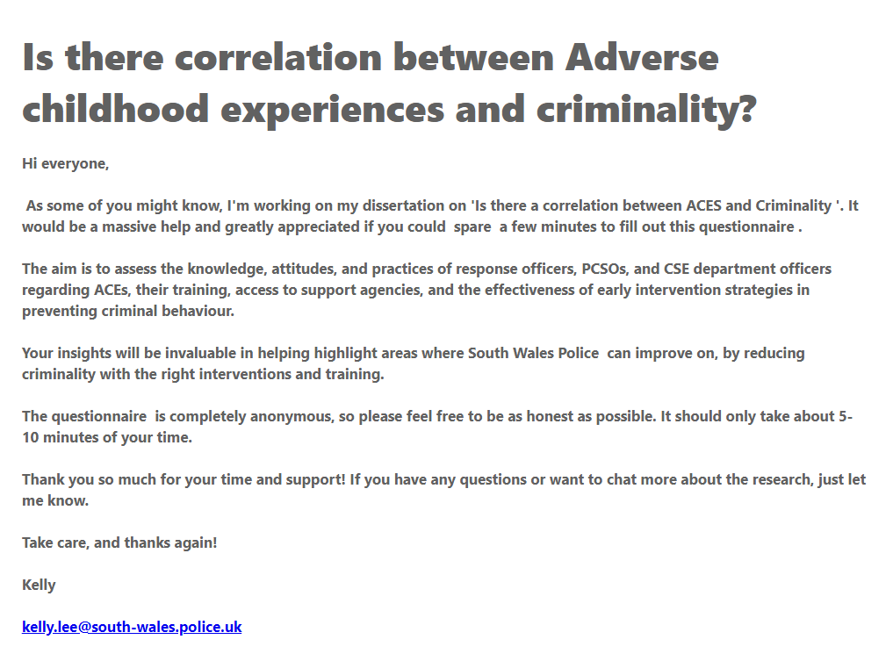
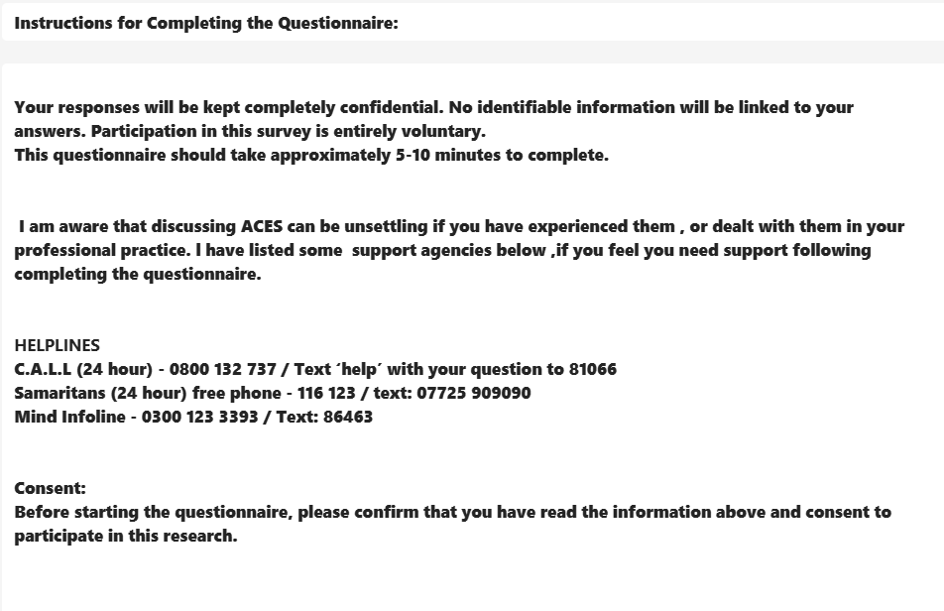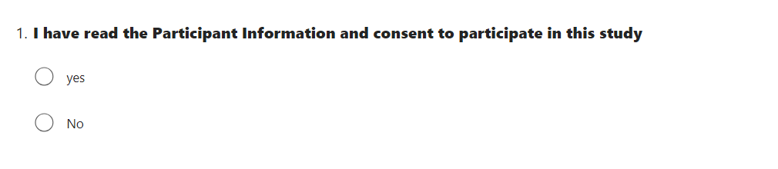

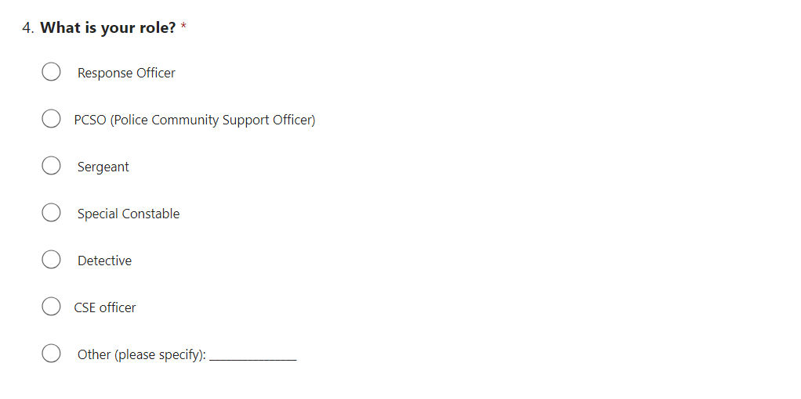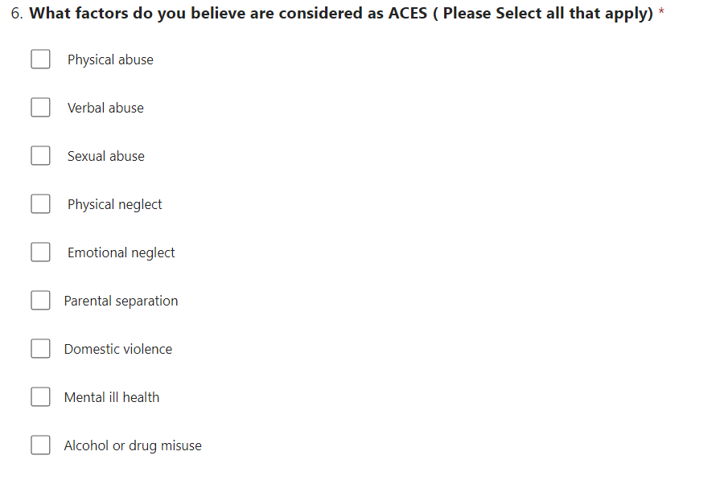
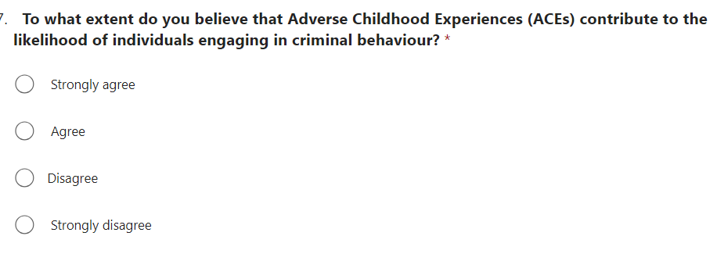
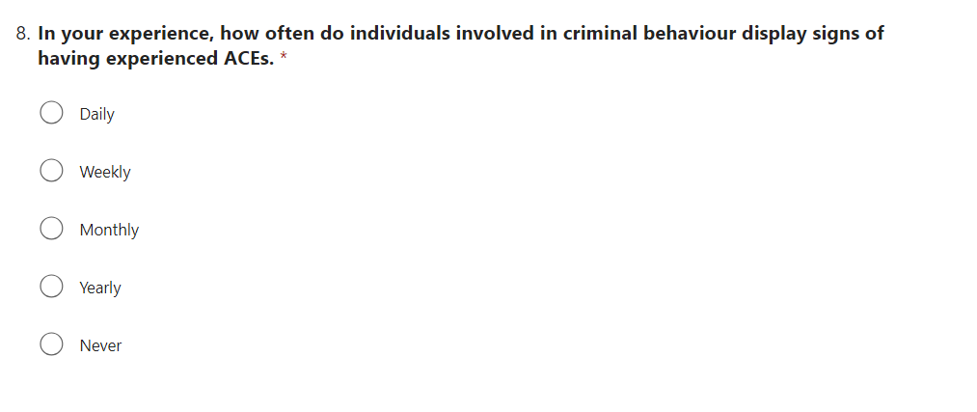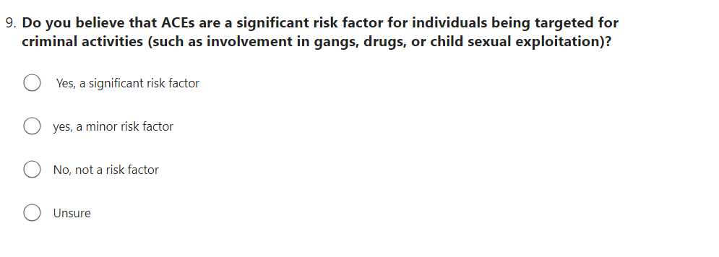

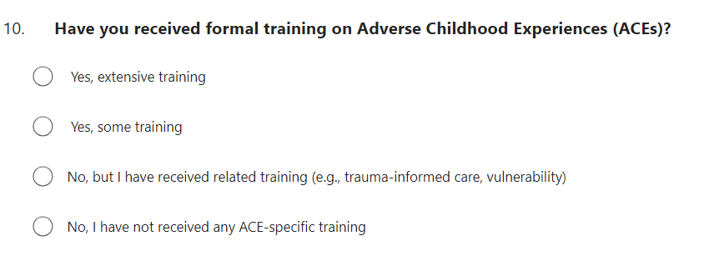
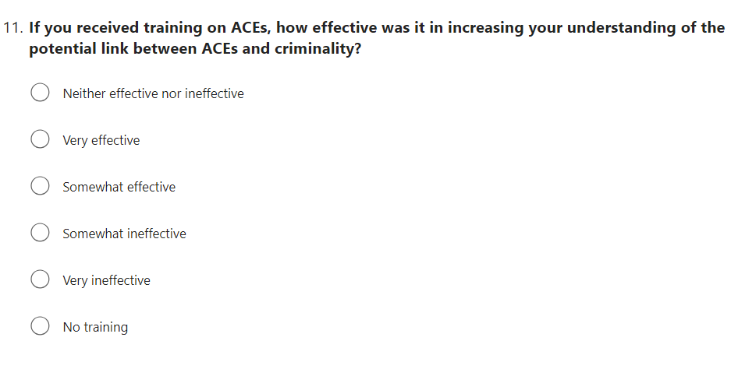

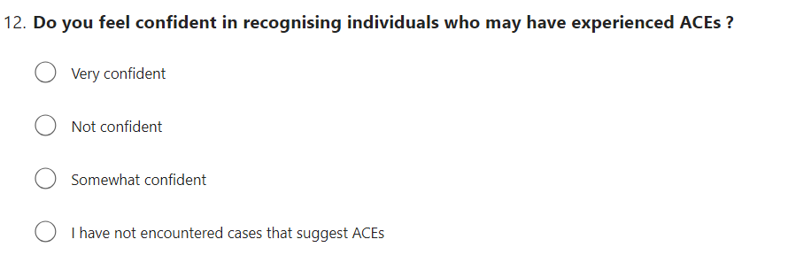

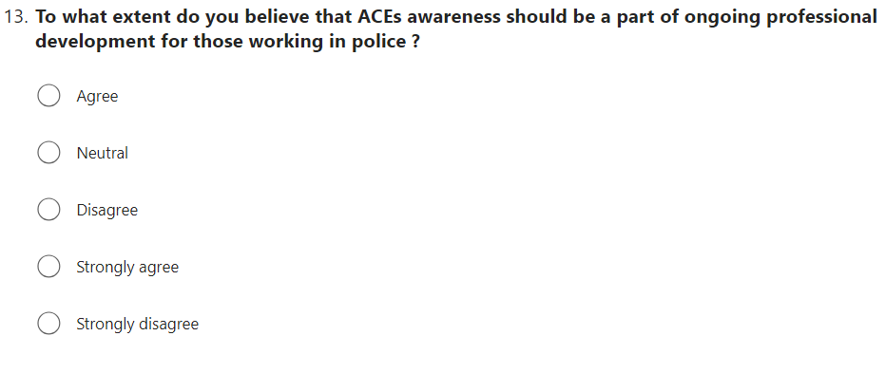

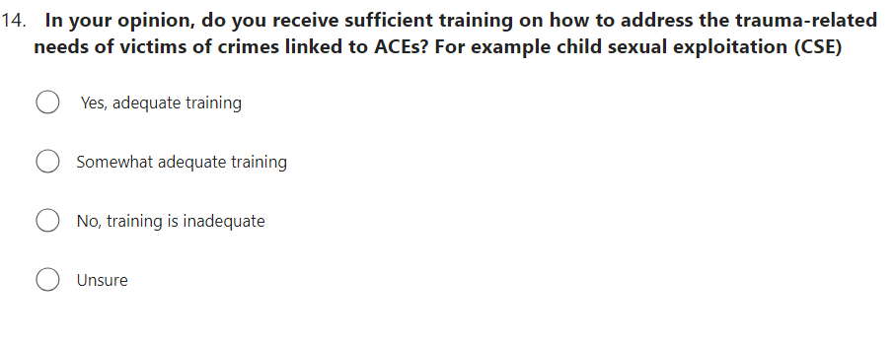

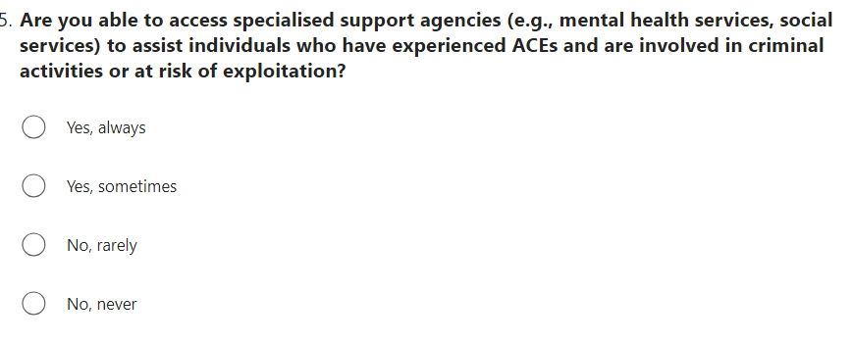

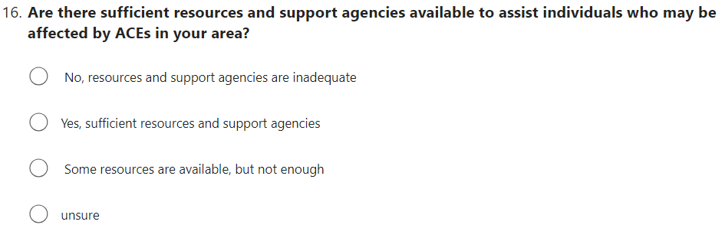

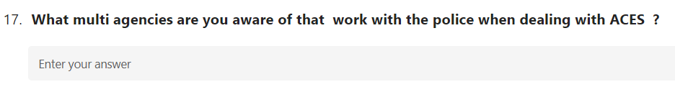

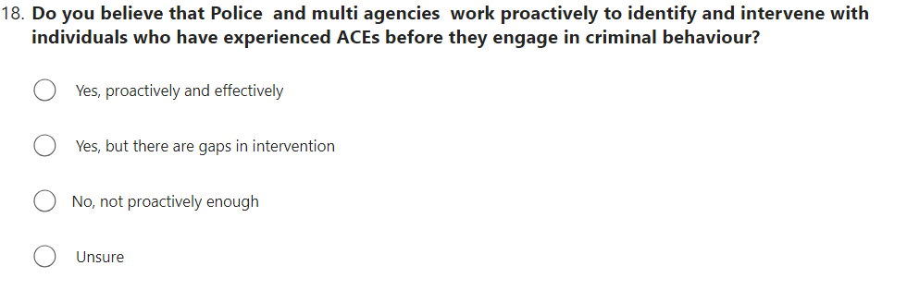

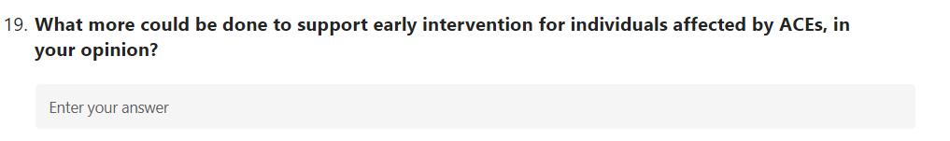

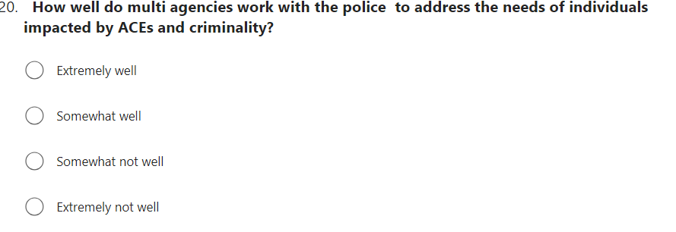

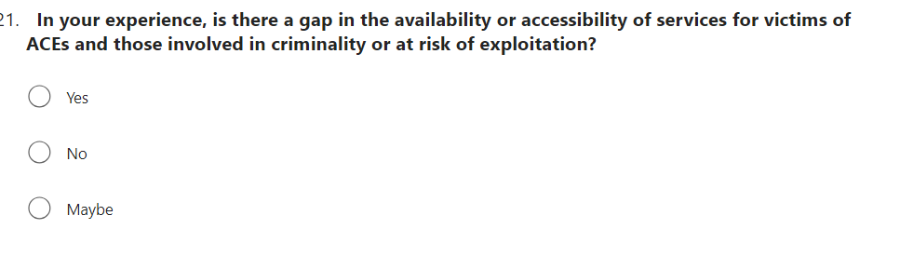

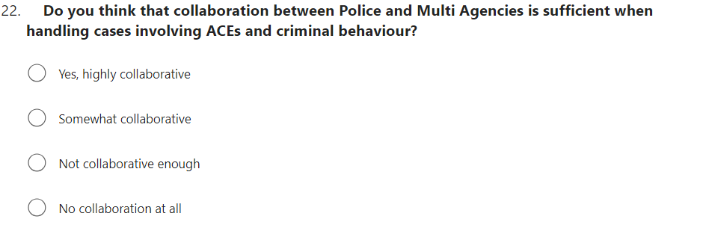

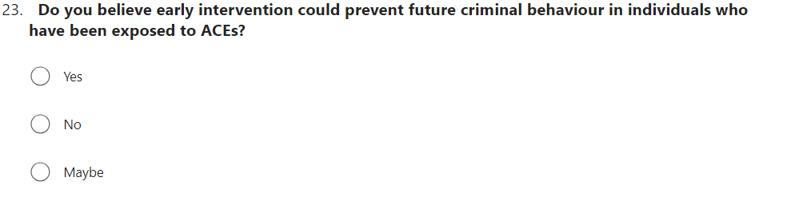

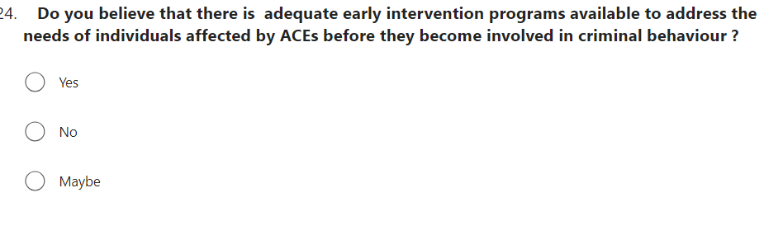

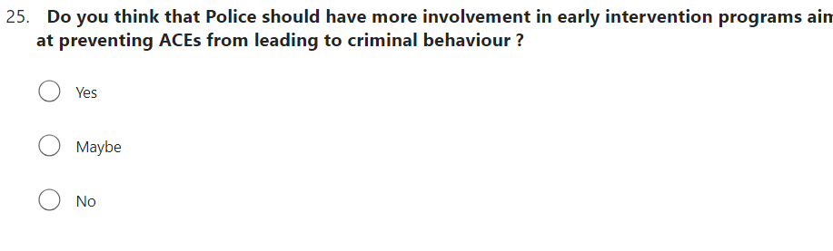

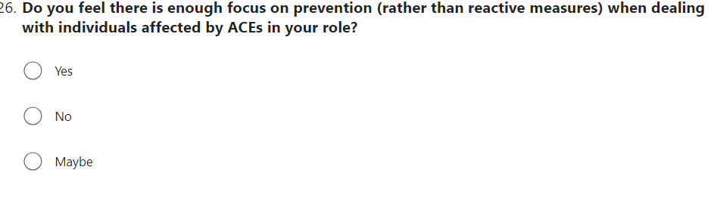

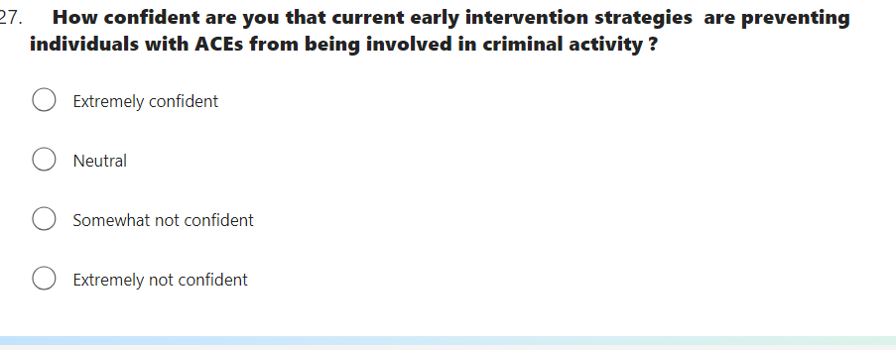

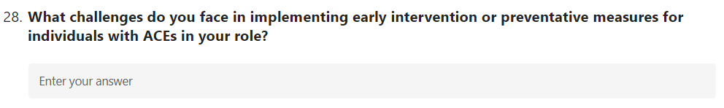

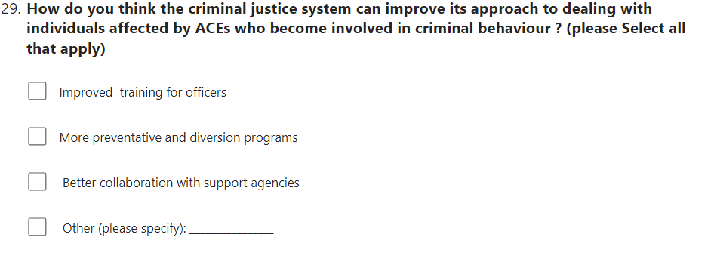

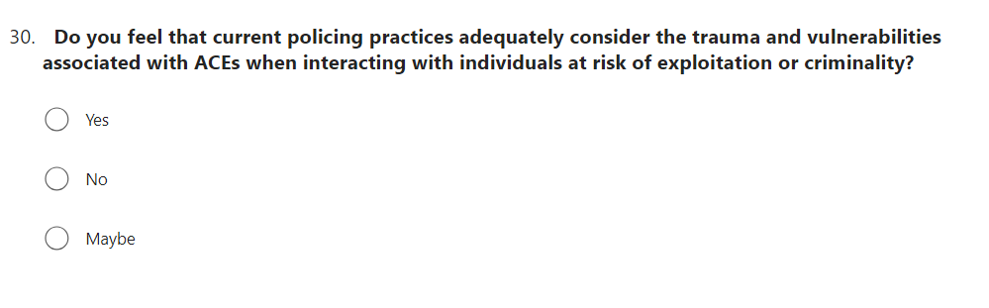

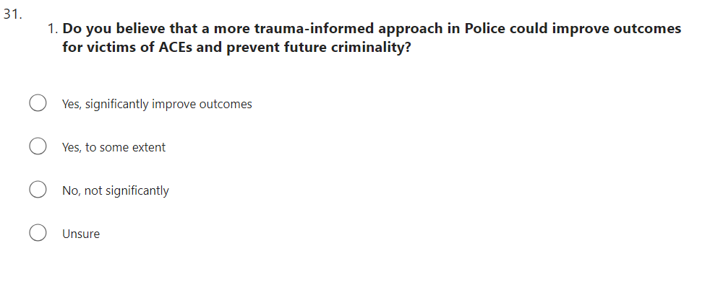

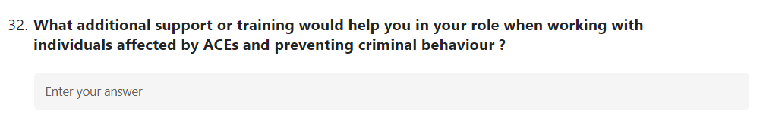

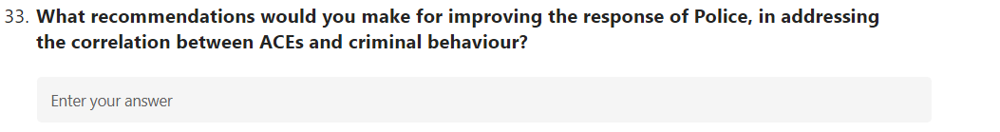

7.2Appendix two: Questionnaire results

Question 1

Question 2

Question 3

Question 4

Question 5

Question 6

Question 7

Question 8

Question 9

Question 10

Question 11

Question 12

Question 13

Question 14

Question 15

Question 16

Question17
What multi agencies are you aware of that work with the police when dealing with ACES ?
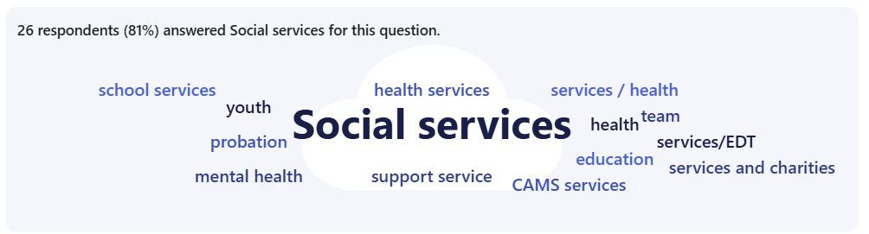

Question 18

Question 19
What more could be done to support early intervention for individuals affected by ACEs, in your opinion?
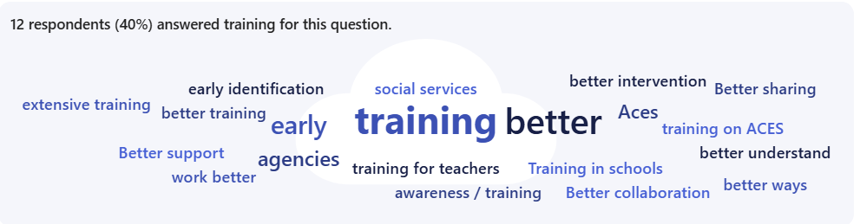

Question 20

Question 21

Question 22

Question 23

Question 24

Question 25

Question 26

Question 27

Question 28
What challenges do you face in implementing early intervention or preventative measures for individuals with ACEs in your role?
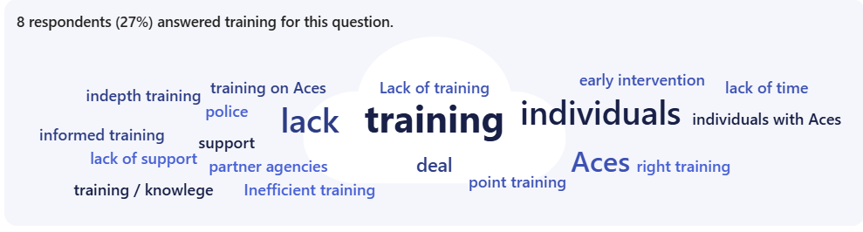

Question 29

Question 30

Question 31

Question 32
What additional support or training would help you in your role when working with individuals affected by ACEs and preventing criminal behaviour?
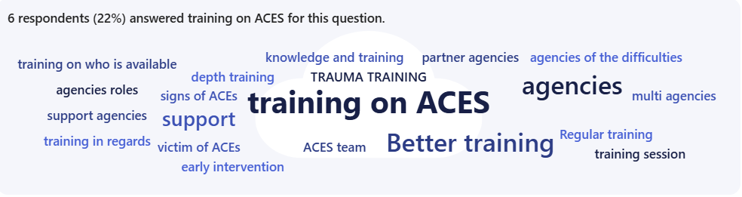
Question 33
What recommendations would you make for improving the response of Police, in addressing the correlation between ACEs and criminal behaviour?
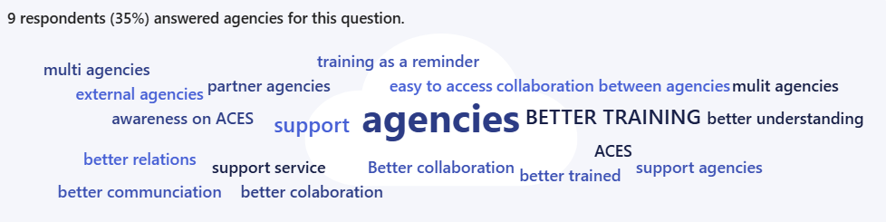

7.3 Appendix Three: Dissertation Proposal



UNDERGRADUATE DISSERTATION
RESEARCH PROPOSAL FORM

Please complete the following research proposal and submit it to Turnitin.

Which project option are you taking? Please tick:

8,000-word project:
OR
4,000-word project and presentation:

.
NAME: Kelly Lee | STUDENT ID No: 2134478
DRAFT RESEARCH TITLE QUESTION:

Is there a correlation between Adverse Childhood Experiences (ACES) and criminality?

INTRODUCTION:

This dissertation will look at if there is a correlation between Adverse Childhood Experiences (ACES) and criminality. It will discuss the potential reasons on why Early intervention so important to prevent criminality.

Adverse childhood experiences, including verbal, mental, sexual, and physical abuse, can significantly impact a person's health and well-being, often resulting from domestic violence, alcohol abuse, parental separation, or drug abuse. Poor childhood experiences lead to poor mental health, self-image, and self-worth, resulting in health-harming behaviours and potential diseases like cancer, heart disease, and diabetes. These experiences can also affect school performance and crime involvement (Public Health Wales, 2020).

The researcher selected the topic based on their own experience with it. The issue is significant, and they think that there is a need for more awareness in identifying and assisting victims of Adverse Childhood Experiences (ACES).

Furthermore, Adverse childhood experiences have a big impact of everyday policing. Often leading to a cycle of poor health and anti-social behaviour in families, perpetuating the cycle of adversity. To break this cycle of adversity it would be extremely beneficial for operational police officers to possess the ability to identify indicators of Adverse Childhood Experiences (ACES) and direct them towards appropriate avenues of support by working with multi agency partners. The purpose of this approach is to implement early intervention, ensuring timely and appropriate assistance, hence reducing the likelihood of individuals being engaged in the criminal justice system. Consequently, this would alleviate the burden on policing and prison services.

SUMMARY OF RESEARCH OBJECTIVES:

The aims of the study are.

- To identify if ACES lead to criminality.

- To examine if South Wales Police are working with the right support agencies

- To Explore if Police officers have adequate training on ACES

4 Is there enough awareness of Police officers recognising the signs of ACES and providing the right intervention.

The aims of the research will be met by the following objectives
5. Review the literature surrounding ACES
6. To identify and evaluate secondary data of ACES
7. To undertake primary surveys with, response officers CSE department team , to determine their perspectives, concepts, and suggestions on areas where assistance and support might be enhanced.
8.The objective is to collect, evaluate, and present both primary and secondary data to find patterns and highlight areas that need improvement.

LITERATURE REVIEW:

This literature review explores the link between Adverse Childhood Experiences (ACEs), including abuse, neglect, and household dysfunction, and criminal behaviour, focusing on how early trauma influences later involvement in crime.

The life-course perspective suggests that early life experiences shape developmental pathways leading to criminal behaviour. Social learning theory suggests children exposed to violence may internalize these behaviour’s as normative, increasing their likelihood. Attachment theory explains how disrupted attachment relationships in childhood can hinder healthy social bonds, protecting against criminal behaviour.

Research consistently shows a high prevalence of ACEs among criminal justice system individuals, with studies showing a significant correlation between childhood trauma and criminal behaviour, particularly violent crimes. Studies by Anda et al. (2006) and Wolff and Baglivio (2017) also found similar findings.

Different type ACEs, including child abuse, neglect, and household dysfunction, are linked to various forms of criminal behaviour. A study by Fox et al (2015) found that exposure to multiple ACEs increases the risk of criminal behaviour, with those experiencing four or more ACEs being particularly vulnerable to engaging in crime.

Multiple methods have been suggested to explain how ACEs cause crime. Chronic stress may create neurodevelopmental abnormalities that impair emotional regulation and increase impulsivity, increasing criminality (De Bellis & Zisk, 2014). ACEs may also cause socioeconomic deprivation and low educational performance, which increase criminal risk (Widom, 1989).

Multiple ACEs promote chronic offending, according to the cumulative risk model. Baglivio et al. (2014) observed that young people with high ACE scores were more likely to become chronic offenders, emphasising the significance for early intervention to prevent criminality.

ACEs and crime may vary by gender, according to research. Due to trauma-coping behaviours like prostitution and drug use, women with high ACE scores are more likely to commit non-violent crimes and enter the criminal justice system (Levenson, 2016). In contrast, males are more likely to engage in more violent crimes due to differing trauma-related social and psychological responses.

Early intervention and prevention are crucial since ACEs are strongly linked to crime. Trauma-informed care, mental health treatments, and family support programmes have reduced criminal behaviour (Kerig, 2018). It is key to address the intergenerational cycle of trauma and prevent future ACEs in youth. It’s vital that police officers have the knowledge and training on Trauma-informed policing strategies, to improve officers' understanding that trauma effects community needs, especially for victims with high levels of ACEs. This increases empathy, enables officers to respond appropriately, and connect victims with necessary services. Addressing victims' needs promotes community trust and reduces criminal behaviour.

SUMMARY OF RESEARCH –SURVEY METHOD:

The research methodology involves the creation of a questionnaire using Outlook Microsoft Forms, which will then be made accessible online via hyperlinks and social media platforms. This method recognises the sensitivity of the subject matter and admits that participants may be discouraged if the research was done in person. By adopting this approach, complete anonymity will ideally incentivise persons who may typically be deterred from participating.

SUMMARY OF SAMPLING FRAMEWORK:

To conduct primary surveys with Police officers, third party charities/organisations.

ETHICAL ISSUES:

There will be no substantial ethical limitations since the research will not include any victims. Participants will be asked for permission to use anonymised information. The questions will be ethical, and as mentioned before, all personal data will be eliminated to ensure that no persons or places can be recognised.

TIME SCALE:
.

The current timeframes are set out by the submission deadlines determined by the university. My objective is to finish all tasks well in advance of the due dates, giving me enough time to confer with my tutor and incorporate any suggested adjustments to my academic work as the project progresses. I strive to maintain regular connection with her to assure the timely progress of my project.

REFERENCE LIST:

Anda, R. F., Felitti, V. J., Bremner, J. D., Walker, J. D., Whitfield, C., Perry, B. D., ... & Giles, W. H. (2006). The enduring effects of abuse and related adverse experiences in childhood: A convergence of evidence from neurobiology and epidemiology. European Archives of Psychiatry and Clinical Neuroscience, 256(3), 174-186.

Baglivio, M. T., Epps, N., Swartz, K., Huq, M. S., Sheer, A., & Hardt, N. S. (2014). The prevalence of adverse childhood experiences (ACE) in the lives of juvenile offenders. Journal of Juvenile Justice, 3(2), 1-23.

De Bellis, M. D., & Zisk, A. (2014). The biological effects of childhood trauma. Child and Adolescent Psychiatric Clinics of North America, 23(2), 185-222.

Fox, B. H., Perez, N., Cass, E., Baglivio, M. T., & Epps, N. (2015). Trauma changes everything: Examining the relationship between adverse childhood experiences and serious, violent, and chronic juvenile offenders. Child Abuse & Neglect, 46, 163-173.

Kerig, P. K. (2018). Polyvictimization and girls’ involvement in the juvenile justice system: Investigating gender-differentiated patterns of risk, recidivism, and resilience. Journal of Interpersonal Violence, 33(5), 789-809.

Levenson, J. S. (2016). Adverse childhood experiences and subsequent substance abuse in a sample of sexual offenders: Implications for treatment and prevention. Victims & Offenders, 11(2), 199-224.

Public Health Wales (2020). Adverse Childhood Experiences - Public Health Wales. [online] Nhs.wales.
Available at: https://phw.nhs.wales/topics/adverse-childhood-experiences/.
‌Accessed 26/07/2024

Widom, C. S. (1989). The cycle of violence. Science, 244(4901), 160-166.

Wolff, K. T., & Baglivio, M. T. (2017). Adverse childhood experiences, negative emotionality, and pathways to juvenile recidivism. Crime & Delinquency, 63(12), 1495-1521

7.4 Appendix Four: Ethics Form

APPLICATION FOR ETHICAL APPROVAL

RESEARCH STUDENTS
This form is to be completed by the student within SIX months for full-time students and TWELVE months for part time students, after the commencement of the research degree or following progression to Part Two of your course.

Once complete, submit this form via the MyTSD Doctoral College Portal at (https://mytsd.uwtsd.ac.uk).

This document is also available in Welsh.

RESEARCH STAFF ONLY
All communications relating to this application during its processing must be in writing and emailed to pgresearch@uwtsd.ac.uk , with the title ‘Ethical Approval’ followed by your name.

STUDENTS ON UNDERGRADUATE OR TAUGHT MASTERS PROGRAMMES should submit this form (and receive the outcome) via systems explained to you by the supervisor/module leader.

In order for research to result in benefit and minimise risk of harm, it must be conducted ethically. A researcher may not be covered by the University’s insurance if ethical approval has not been obtained prior to commencement.

The University follows the OECD Frascati manual definition of research activity: “creative work undertaken on a systematic basis in order to increase the stock of knowledge, including knowledge of man, culture and society, and the use of this stock of knowledge to devise new applications”. As such this covers activities undertaken by members of staff, postgraduate research students, and both taught postgraduate and undergraduate students working on dissertations/projects.

The individual undertaking the research activity is known as the “principal researcher”.

Ethical approval is not required for routine audits, performance reviews, quality assurance studies, testing within normal educational requirements, and literary or artistic criticism.

Please read the notes for guidance before completing ALL sections of the form.

This form must be completed and approved prior to undertaking any research activity. Please see Checklist for details of process for different categories of application.

SECTION A: About You (Principal Researcher)
1 | Full Name: |  | Kelly Lee
2 | Tick all boxes that apply: |  | Member of staff: | ☐ | Honorary research fellow: | ☐
 | Undergraduate Student | ☒ | Taught Postgraduate Student | ☐ | Postgraduate Research Student | ☐

3 | Institute/Academic Discipline/Centre: | UWTSD
4 | Campus: | Swansea
5 | E-mail address: | 2134478@student
6 | Contact Telephone Number: | 07427699923
 | For students:
7 | Student Number: | 2134478
8 | Programme of Study: | Professional Policing Practice
9 | Director of Studies/Supervisor: | Jane Davies

SECTION B: Approval for Research Activity
1 | Has the research activity received approval in principle?  (please check the Guidance Notes as to the appropriate approval process for different levels of research by different categories of individual) |  | YES | ☒ | NO | ☐
 |  |  |  |  | Date
2 | If Yes, please indicate source of approval (and date where known): Approval in principle must be obtained from the relevant source prior to seeking ethical approval | Research Degrees Committee |  | ☒
2 |  | Institute Research Committee |  | ☐
2 |  | Other (write in) |  | ☐

SECTION C: Internal and External Ethical Guidance Materials
 | Please list the core ethical guidance documents that have been referred to during the completion of this form (including any discipline-specific codes of research ethics, location-specific codes of research ethics, and also any specific ethical guidance relating to the proposed methodology). Please tick to confirm that your research proposal adheres to these codes and guidelines. You may add rows to this table if needed.
1 | UWTSD Research Ethics & Integrity Code of Practice | ☒
2 | UWTSD Research Data Management Policy | ☒
3 | [List any other relevant documents here] | ☐

SECTION D: External Collaborative Research Activity
If there are external collaborators then you should gain consent from the contact persons to share their personal data with the university. If there are no external collaborators then leave this section blank and continue to section E.
1 | Institution
2 | Contact person name
3 | Contact person e-mail address
4 | Is your research externally funded? |  | YES | ☐ | NO |  | ☐
5 | Are you in receipt of a KESS scholarship? |  | YES | ☐ | NO |  | ☐
6 | Are you specifically employed to undertake this research in either a paid or voluntary capacity? | Voluntary | YES | ☐ | NO | ☐
7 |  | Employed | YES | ☐ | NO | ☐
8 | Is the research being undertaken within an existing UWTSD Athrofa Professional Learning Partnership (APLP)? | If YES then the permission question below does not need to be answered. | YES | ☐ | NO |  | ☐
9 | Has permission to undertake the research has been provided by the partner organisation? | (If YES attach copy)  If NO the application cannot continue | YES | ☐ | NO |  | ☐

Where research activity is carried out in collaboration with an external organisation
10 | Does this organisation have its own ethics approval system? | YES | ☐ | NO | ☐
 | If Yes, please attach a copy of any final approval (or interim approval) from the organisation (this may be a copy of an email if appropriate).

SECTION E: Details of Research Activity
1 | Indicative title: | Is there a correlation between Adverse Childhood Experiences (ACES) and criminality?
2 | Proposed start date: | 01/07/2024 | Proposed end date: | 07/04/2025 I will consider using a survey to ask individuals, police and any third party agencies a series of questions to enable me to gather data to analyses for potential tends or gaps compared to secondary data.
Introduction to the Research (maximum 300 words per section)0
Ensure that you write for a Non-Specialist Audience when outlining your response to the points below:
- Purpose of Research Activity
- Proposed Research Question
- Aims of Research Activity
- Objectives of Research Activity
Demonstrate, briefly, how Existing Research has informed the proposed activity and explain
- What the research activity will add to the body of knowledge
- How it addresses an area of importance.
3 | Purpose of Research Activity  The purpose of this study is to investigate the reasons why ACES are linked to criminality.  This study will look at the effects ACES have on victims and why early intervention is so important to prevent criminality,  Furthermore, it will look at if police officers have enough awareness of recognising the signs of ACES and are they aware of all the relevant support agencies.  (this boxffec should expand as you type)
A | Research Question  Is there a correlation between Adverse Childhood Experiences (ACES) and criminality?  (this box should expand as you type)
5 | Aims of Research Activity  - To identify if ACES lead to criminality.  - Why early intervention is so important.  - Are the police working with the right support agencies.  - What are Police Officers perceptions on ACES  - Is there enough awareness of Police officers recognising the signs of ACES and providing the right intervention.  (this box should expand as you type)
6 | Objectives of Research Activity  5. Review the literature surrounding ACES  6. To identify and evaluate secondary data of ACES.  7. To undertake primary surveys with friends, relatives, police officers, and other charity organisations to determine their perspectives, concepts, and suggestions on areas where assistance and support might be enhanced.  8.The objective is to collect, evaluate, and present both primary and secondary data to find patterns and highlight areas that need improvement.  (this box should expand as you type)
Proposed methods (maximum 600 words)
Provide a brief summary of all the methods that may be used in the research activity, making it clear what specific techniques may be used. If methods other than those listed in this section are deemed appropriate later, additional ethical approval for those methods will be needed. You do not need to justify the methods here, but should instead describe how you intend to collect the data necessary for you to complete your project.
7 | I will consider using a survey to ask individuals, police and any third-party agencies a series of questions to enable me to gather data to analyses for potential tends or gaps compared to secondary data.  (this box should expand as you type)
Location of research activity
Identify all locations where research activity will take place.
8 | Swansea  (this box should expand as you type)
Research activity outside of the UK
If research activity will take place overseas, you are responsible for ensuring that local ethical considerations are complied with and that the relevant permissions are sought. Specify any local guidelines (e.g. from local professional associations/learned societies/universities) that exist and whether these involve any ethical stipulations beyond those usual in the UK (provide details of any licenses or permissions required). Also specify whether there are any specific ethical issues raised by the local context in which the research activity is taking place, for example, particular cultural and/or legal sensitivities or vulnerabilities of participants. If you live in the country where you will do the research then please state this.
9 | N/A  (this box should expand as you type)

10 | Use of documentation not in the public domain: Are any documents NOT publicly available? | NO | ☒
10 |  | YES | ☐
11 | If Yes, please provide details here of how you will gain access to specific documentation that is not in the public domain and that this is in accordance with the current data protection law of the country in question and that of England and Wales.  (this box should expand as you type)

 | Does your research relate to one or more of the seven aims of the Well-being of Future Generations (Wales) Act 2015? | YES | NO
12 | A prosperous Wales | ☐ | ☒
13 | A resilient Wales | ☐ | ☒
14 | A healthier Wales | ☐ | ☒
15 | A more equal Wales | ☐ | ☒
16 | A Wales of cohesive communities | ☐ | ☒
17 | A Wales of vibrant culture and thriving Welsh language | ☐ | ☒
18 | A globally responsible Wales | ☐ | ☒
19 | If YES to any of the above, please give details:
 | (this box should expand as you type)

SECTION F: Scope of Research Activity
 | Will the research activity include: | YES | NO
1 | Use of a questionnaire or similar research instrument? | ☒ | ☐
2 | Use of interviews? | ☐ | ☒
3 | Use of focus groups? | ☐ | ☒
4 | Use of participant diaries? | ☐ | ☒
5 | Use of video or audio recording? | ☐ | ☒
6 | Use of computer-generated log files? | ☐ | ☒
7 | Participant observation with their knowledge? | ☐ | ☒
8 | Participant observation without their knowledge? | ☐ | ☒
9 | Access to personal or confidential information without the participants’ specific consent? | ☐ | ☒
10 | Administration of any questions, test stimuli, presentation that may be experienced as physically, mentally or emotionally harmful / offensive? | ☐ | ☒
11 | Performance of any acts which may cause embarrassment or affect self-esteem? | ☐ | ☒
12 | Investigation of participants involved in illegal activities? | ☐ | ☒
13 | Use of procedures that involve deception? | ☐ | ☒
14 | Administration of any substance, agent or placebo? | ☐ | ☒
15 | Working with live vertebrate animals? | ☐ | ☒
16 | Procedures that may have a negative impact on the environment? | ☐ | ☒
17 | Other primary data collection methods. Please indicate the type of data collection method(s) below. | ☐ | ☒
 | Details of any other primary data collection method:  (this box should expand as you type) | ☐ | ☒
If NO to every question, then the research activity is (ethically) low risk and may be exempt from some of the following sections (please refer to Guidance Notes).

If YES to any question, then no research activity should be undertaken until full ethical approval has been obtained.

SECTION G: Intended Participants
If there are no participants then do not complete this section, but go directly to section H.

 | Who are the intended participants: | YES | NO
1 | Students or staff at the University? | ☐ | ☒
2 | Adults (over the age of 18 and competent to give consent)? | ☒ | ☐
3 | Vulnerable adults? | ☐ | ☒
4 | Children and Young People under the age of 18? (Consent from Parent, Carer or Guardian will be required) | ☐ | ☒
5 | Prisoners? | ☐ | ☒
6 | Young offenders? | ☐ | ☒
7 | Those who could be considered to have a particularly dependent relationship with the investigator or a gatekeeper? | ☐ | ☒
8 | People engaged in illegal activities? | ☐ | ☒
9 | Others. Please indicate the participants below, and specifically any group who may be unable to give consent. | ☐ | ☒
 | Details of any other participant groups:  (this box should expand as you type) | ☐ | ☒

Participant numbers and source
Provide an estimate of the expected number of participants. How will you identify participants and how will they be recruited?
10 | How many participants are expected? | I anticipate that there will be approximately 15- 30participants  (this box should expand as you type)
11 | Who will the participants be? | Police officers, third party organisations, Adults ( persons over the age of 18)  (this box should expand as you type)
12 | How will you identify the participants? | I will allocate each person a number so that will be the method of identifying them. No names or addresses will be taken or disclosed .  (this box should expand as you type)

 | Information for participants: | YES | NO | N/A
13 | Will you describe the main research procedures to participants in advance, so that they are informed about what to expect? | ☒ | ☐ | ☐
14 | Will you tell participants that their participation is voluntary? | ☒ | ☐ | ☐
15 | Will you obtain written consent for participation? | ☒ | ☐ | ☐
16 | Will you explain to participants that refusal to participate in the research will not affect their treatment or education (if relevant)? | ☐ | ☐ | ☒
17 | If the research is observational, will you ask participants for their consent to being observed? | ☐ | ☐ | ☒
18 | Will you tell participants that they may withdraw from the research at any time and for any reason? | ☒ | ☐ | ☐
19 | With questionnaires, will you give participants the option of omitting questions they do not want to answer? | ☒ | ☐ | ☐
20 | Will you tell participants that their data will be treated with full confidentiality and that, if published, it will not be identifiable as theirs? | ☒ | ☐ | ☐
21 | Will you debrief participants at the end of their participation, in a way appropriate to the type of research undertaken? | ☒ | ☐ | ☐
22 | If NO to any of above questions, please give an explanation
 | (this box should expand as you type)

 | Information for participants: | YES | NO | N/A
24 | Will participants be paid? | ☐ | ☒ | ☐
25 | Is specialist electrical or other equipment to be used with participants? | ☐ | ☒ | ☐
26 | Are there any financial or other interests to the investigator or University arising from this study? | ☐ | ☒ | ☐
27 | Will the research activity involve deliberately misleading participants in any way, or the partial or full concealment of the specific study aims? | ☐ | ☒ | ☐
28 | If YES to any question, please provide full details
 | (this box should expand as you type)

SECTION H: Anticipated Risks

Outline any anticipated risks that may adversely affect any of the participants, the researchers and/or the University, and the steps that will be taken to address them.

If you have completed a full risk assessment (for example as required by a laboratory, or external research collaborator) you may append that to this form.
1 | Full risk assessment completed and appended? |  | Yes | ☐
1 |  |  | No | ☒
2 | Risks to participants  For example: sector-specific health & safety, emotional distress, financial disclosure, physical harm, transfer of personal data, sensitive organisational information
 | Risk to participants:  Possible emotional distress  (this box should expand as you type) | How you will mitigate the risk to participants:  I will explain clearly to all potential participants what my survey subject is before asking them to take part.  I do not want to cause any person and alarm or distress .  (this box should expand as you type)
3 | If research activity may include sensitive, embarrassing or upsetting topics (e.g. sexual activity, drug use) or issues likely to disclose information requiring further action (e.g. criminal activity), give details of the procedures to deal with these issues, including any support/advice (e.g. helpline numbers) to be offered to participants. Note that where applicable, consent procedures should make it clear that if something potentially or actually illegal is discovered in the course of a project, it may need to be disclosed to the proper authorities
N/A
(this box should expand as you type)
4 | Risks to the investigator  For example: personal health & safety, physical harm, emotional distress, risk of accusation of harm/impropriety, conflict of interest
 | Risk to the investigator:  N/A  (this box should expand as you type) | How you will mitigate the risk to the investigator:  N/A  (this box should expand as you type)
5 | University/institutional risks  For example: adverse publicity, financial loss, data protection
 | Risk to the University:  N/A  (this box should expand as you type) | How you will mitigate the risk to the University:  N/A  (this box should expand as you type)
6 | Environmental risks  For example: accidental spillage of pollutants, damage to local ecosystems
 | Risk to the environment:  N/A  (this box should expand as you type) | How you will mitigate the risk to environment:  N/A  (this box should expand as you type)

 | Disclosure and Barring Service
 | If the research activity involves children or vulnerable adults, a Disclosure and Barring Service (DBS) certificate must be obtained before any contact with such participants. | YES | NO | N/A
7 | Does your research require you to hold a current DBS Certificate? | ☐ | ☐ | ☒
8 | If YES, please give the certificate number. If the certificate number is not available please write “Pending”; in this case any ethical approval will be subject to providing the appropriate certificate number.

SECTION I: Feedback, Consent and Confidentiality

1 | Feedback  What de-briefing and feedback will be provided to participants, how will this be done and when?
Once the findings have been gathered and examined, I will retain the results for my own purpose. Participants will not get direct communication, but, if they choose to obtain the results, they may contact me using the provided contact number, and the results will be discussed.

(this box should expand as you type)
2 | Informed consent  Describe the arrangements to inform potential participants, before providing consent, of what is involved in participating. Describe the arrangements for participants to provide full consent before data collection begins. If gaining consent in this way is inappropriate, explain how consent will be obtained and recorded in accordance with prevailing data protection legislation.
Prior to participants engaging in any study survey, a comprehensive explanation of the terms and conditions for information collection and consent will be provided.
(this box should expand as you type)
3 | Confidentiality / Anonymity  Set out how anonymity of participants and confidentiality will be ensured in any outputs. If anonymity is not being offered, explain why this is the case.
Strict confidentiality and complete anonymity will be provided from the beginning. The surveys will not include any personal data, such as names or addresses. Participants will be assigned a number, which will serve as their unique identifier.

(this box should expand as you type)

SECTION J: Data Protection and Storage

 | Does the research activity involve personal data (as defined by the General Data Protection Regulation 2016 “GDPR” and the Data Protection Act 2018 “DPA”)? | YES | NO
1 | “Personal data” means any information relating to an identified or identifiable natural person (‘data subject’). An identifiable natural person is one who can be identified, directly or indirectly, in particular by reference to an identifier such as a name, an identification number, location data, an online identifier or to one or more factors specific to the physical, physiological, genetic, mental, economic, cultural or social identity of that natural person. Any video or audio recordings of participants is considered to be personal data. | ☐ | x
 | If YES, provide a description of the data and explain why this data needs to be collected:
2 | (this box should expand as you type)
 | Does it involve special category data (as defined by the GDPR)? | YES | NO
3 | “Special category data” means sensitive personal data consisting of information as to the data subjects’ –  (a) racial or ethnic origin,  (b) political opinions,  (c ) religious beliefs or other beliefs of a similar nature,  (d) membership of a trade union (within the meaning of the Trade Union and Labour Relations (Consolidation) Act 1992),  (e) physical or mental health or condition,  (f) sexual life,  (g) genetics,  (h) biometric data (as used for ID purposes), | ☐ | x
 | If YES, provide a description of the special category data and explain why this data needs to be collected:
4 | (this box should expand as you type)

 | Will data from the research activity (collected data, drafts of the thesis, or materials for publication) be stored in any of the following ways? | YES | NO
5 | Manual files (i.e. in paper form)? | ☐ | ☒
6 | University computers? | ☐ | ☒
7 | Private company computers? | ☐ | ☒
8 | Home or other personal computers? | ☐ | ☒
9 | Laptop computers/ CDs/ Portable disk-drives/ memory sticks? | ☒ | ☐
10 | “Cloud” storage or websites? | ☐ | ☒
11 | Other – specify: | ☐ | ☒
12 | For all stored data, explain the measures in place to ensure the security of the data collected, data confidentiality, including details of backup procedures, password protection, encryption, anonymisation and pseudonymisation:
Laptop is password protected and only I have access to it .
(this box should expand as you type)

 | Data Protection
 | Will the research activity involve any of the following activities: | YES | NO
13 | Electronic transfer of data in any form? | ☐ | ☒
14 | Sharing of data with others at the University outside of the immediate research team? | ☐ | ☒
15 | Sharing of data with other organisations? | ☐ | ☒
16 | Export of data outside the UK or importing of data from outside the UK? | ☐ | ☒
17 | Use of personal addresses, postcodes, faxes, emails or telephone numbers? | ☐ | ☒
18 | Publication of data that might allow identification of individuals? | ☐ | ☒
19 | Use of data management system? | ☐ | ☒
20 | Data archiving? | ☐ | ☒
21 | If YES to any question, please provide full details, explaining how this will be conducted in accordance with the GDPR and Data Protection Act (2018) (and any international equivalents, where appropriate):
N/A

(this box should expand as you type)
22 | List all who will have access to the data generated by the research activity:
The researcher (Me)

(this box should expand as you type)
23 | List who will have control of, and act as custodian(s) for, data generated by the research activity:
The researcher (Me)

(this box should expand as you type)
24 | Give details of data storage arrangements, including security measures in place to protect the data, where data will be stored, how long for, and in what form. Will data be archived – if so how and if not why not.
N/A

(this box should expand as you type)
25 | Please indicate if your data will be stored in the UWTSD Research Data Repository (see https://researchdata.uwtsd.ac.uk/ ). If so please explain. (Most relevant to academic staff)
N/A
(this box should expand as you type)
26 | Confirm that you have read the UWTSD guidance on data management (see https://www.uwtsd.ac.uk/library/research-data-management/) | YES | ☒
27 | Confirm that you are aware that you need to keep all data until after your research has completed or the end of your funding | YES | ☒

SECTION K: Declaration
The information which I have provided is correct and complete to the best of my knowledge. I have attempted to identify any risks and issues related to the research activity and acknowledge my obligations and the rights of the participants.

In submitting this application I hereby confirm that I undertake to ensure that the above named research activity will meet the University’s Research Ethics and Integrity Code of Practice which is published on the website: https://www.uwtsd.ac.uk/research/research-ethics/
1 | Signature of applicant: | Kelly Lee | Date:24/08/24

For STUDENT Submissions:
2 | Director of Studies/Supervisor: |  | Date:
3 | Signature: |  | Date:

For STAFF Submissions:
4 | Academic Director/ Assistant Dean: |  | Date:
5 | Signature: |  | Date:

Checklist: Please complete the checklist below to ensure that you have completed the form according to the guidelines and attached any required documentation:
☒ | I have read the guidance notes supplied before completing the form.
☒ | I have completed ALL RELEVANT sections of the form in full.
☒ | I confirm that the research activity has received approval in principle
☐ | I have attached a copy of final/interim approval from external organisation (where appropriate)
☐ | I have attached a full risk assessment (where appropriate) ONLY TICK IF YOU HAVE ATTACHED A FULL RISK ASSESSMENT
☒ | I understand that it is my responsibility to ensure that the above named research activity will meet the University’s Research Ethics and Integrity Code of Practice.
☒ | I understand that before commencing data collection all documents aimed at respondents (including information sheets, consent forms, questionnaires, interview schedules etc.) must be confirmed by the DoS/Supervisor, module tutor or Academic Director.

RESEARCH STUDENTS ONLY
Once complete, submit this form via the MyTSD Doctoral College Portal at (https://mytsd.uwtsd.ac.uk).

RESEARCH STAFF ONLY
All communications relating to this application during its processing must be in writing and emailed to pgresearch@uwtsd.ac.uk , with the title ‘Ethical Approval’ followed by your name.

STUDENTS ON UNDERGRADUATE OR TAUGHT MASTERS PROGRAMMES should submit this form (and receive the outcome) via systems explained to you by the supervisor/module leader.

