

Postgraduate/Distance Learning
Assignment coversheet & feedback form

THIS SHEET MUST BE THE FIRST PAGE OF THE ASSIGNMENT YOU ARE SUBMITTING (DO NOT SEND AS A SEPARATE FILE)

For completion by the student:
Student Name:Catherine Hornby

Student University Email: 27001103@student.uwtsd.ac.uk
Module code:HPCA7015  Module title:Foundations in Cultural Astronomy and Astrology | Student ID number:270011103 |  |  | Educational support needs:  Yes/
Assignment title:
Essay based on a Sky Journal

Assignment due date: 14/12/2023
This assignment is for the 1st 2nd X 3rd 4th 5th 6th module of the degree
I confirm that this is my original work and that I have adhered to the University policy on plagiarism.
Signed C. Hornby
Email submission:if you are submitting this form via email, please tick this box □X
(as a substitute for your signature) to confirm that you agree to the above declaration.
Assignment Mark
1st Marker’s Provisional mark
2nd Marker’s/Moderator’s provisional mark
External Examiner’s mark (if relevant)
Final Mark

NB. All marks are provisional until confirmed by the Final Examination Board.

For completion by Marker 1 :
Comments:

Markers signature: |  |  | Date:
For completion by Marker 2/Moderator:

Comments:

Markers Signature: |  | Date:
External Examiners comments (if relevant)

External Examiners Signature: |  | Date:

Essay based on a Sky Journal: a consideration of Vincent Van Gogh's quote: "Be clearly aware of the stars and infinity on high. Then life seems almost enchanted after all" and analysis of the Sky Journal and its significance in relation to the phases and appearances of the Moon, as seen from Lampeter in November 2023.

The aim of this essay was to observe the night sky, focusing on the moon, in terms of its phases and appearances. The observation period was one month, in November 2023. I live in Lampeter and viewed the moon from my back garden and from sundry locations about the town. This essay will begin with an exploration and contextualisation of Van Gogh’s quote. A justification for the use of the quote as a primary source will follow. The quote will then be connected to Van Gogh’s sky paintings, which, between them, include both the stars, which feature in the quote, and the moon, which is the heavenly body focused on in the Sky Journal. Material on Van Gogh will segue into analysis and reflections on the Sky Journal. Both the appearances of the moon during different phases and its apparent disappearances during periods of its invisibility will be considered. Visual evidence will include both pictures of the moon and representations of local art works.

The titular Vincent Van Gogh quotation is located in a letter written to his brother, Theo Van Gogh, a close and frequent correspondent. Their epistolary relationship is referred to in the book Vincent Van Gogh: Artists & Masterpieces, which states that:

“In 1869… [Vincent] began to write to his younger brother Theo, a correspondence which continued for the rest of Van Gogh’s life.”

Michael Woodford also comments on the fraternal correspondence, noting that:

“The frequent letters between them give us more insight into Vincent’s public and private life than is usual for artists of the time.”

Such endorsements from critics and biographies further justify the utilisation of the letters as a primary source. Furthermore, Donald W. Olson stresses the “important and fundamental… collected letters - the artist’s own words”, ranking them above secondary sources.

In the case of Van Gogh’s comments on the stars, his use of the terms ‘infinity’ and ‘enchanted’ could indicate that his experience of sky viewing was one of wonder. This is certainly relatable to my own experience, and Van Gogh’s subsequent sky paintings arguably support this reading. In a newspaper article from 2013, the TV presenter Dara O’ Briain reflects on the success of the programme Stargazing Live, having reached three million viewers, stating that:

“With astronomy it’s very easy to tap into a sense of wonder. It’s elemental, it’s one of the most fundamental things, it’s the wonder of gazing up and recognising where we are in the universe.”

This view of stargazing is fairly universal and timeless, rather than being tied to a specific era or locale. It is therefore entirely possible that it resembled Van Gogh’s own experience. A comparable quotation by Oscar Wilde, who was a contemporary of Van Gogh’s also comes to mind:

“We are all in the gutter, but some of us are looking at the stars.”

While this quotation is often read as a metaphorical expression of optimism, it can also be interpreted as referring to literal stargazing. Indeed, it may well have both meanings. As one of the most legendary depressives in history, Van Gogh is not generally strongly associated with optimism. He could hardly avoid such a reputation, due to his famous self-mutilation of cutting off his ear, prior to suicide, as well as alcohol issues and mental instability. But even he, on the topic of astronomy, can seem somewhat optimistic, although of course he has to qualify his “enchanted after all” with an “almost”, in deference to his depression, one might assume. Considering the star paintings that were likely inspired by his astronomy musings, in this case, his optimism (albeit qualified) was on point and completely justified.

The letter in question is dated 11th August 1888. Between 1888 and 1889, Van Gogh painted (among other works) three pictures featuring his distinctive starry sky. Chronologically, these were: the Café Terrace at Night (1888), the Starry Night Over the Rhone (1888) and perhaps his most famous work of all, completing the trilogy in 1889, the Starry Night. The timing of these paintings suggests a connection to the letter, indicating that his written musings on the stars may have influenced his work. The Café Terrace at Night, the first in the sequence, features a small patch of the night sky, in the top right hand corner of the painting. From this point, Van Gogh began to progress to painting full skyscapes. It is significant that the said Starry Night appears on the cover of the book Skyscapes. It was thus chosen as the ultimate skyscape to represent the book. A contributing factor to this choice may have been the picture's fame, as it may have been desirable for the cover image to be recognisable. Comparably, the aforementioned book, Vincent Van Gogh: Artists & Masterpieces, also features the Starry Night as its cover picture. This suggests that the painting can be used to surmise Van Gogh’s work as a whole.

Interestingly, although all three of the aforementioned paintings feature night time scenes, only one prominently features the moon. This is the Starry Night. The placement of the crescent moon in the top right hand corner mirrors the location of the night sky in the Café Terrace at Night. Thus, this painting could be viewed as a microcosm of the fuller Skyscapes. Olson’s description of the Starry Night painting is as follows:

“the painting created in mid-June 1889 and depicting a village, a cypress tree, the Moon, and stars surrounded by halos in a swirling sky”.

The halos and swirls referred to here could be considered blurry effects, which, in turn, can be traced to Van Gogh’s Impressionistic roots. He is sometimes classified as a Post-Impressionist artist. Blurry effects could also imply troubled eyesight or difficulty focusing. This brings me to the choices I made regarding my own Sky Journal.

The Sky Journal focuses on the moon, specifically its phases and appearances. Due to my own visual impairment and its symptoms, I was unable to view the day sky sufficiently or with comfortable focus. Furthermore, I cannot see the stars clearly enough to identify any constellations. The moon was essentially chosen by default, due to being the only feature of the sky that is both visible to me and comfortable to view. After all, the sun is not recommended viewing for anyone, let alone the visually impaired. The sun was therefore never a contender. Additionally, it occurred to me that the moon was the heavenly body most suited to the month-long investigation. This is because of the lunar cycle constituting a month. The moon is therefore the most visible evidence of the passing of time viewable in the night sky. It was aptly expressed by Shakespeare’s Juliet Capulet, when she referred to “the inconstant moon/ Nightly she changes in her circled orb.”

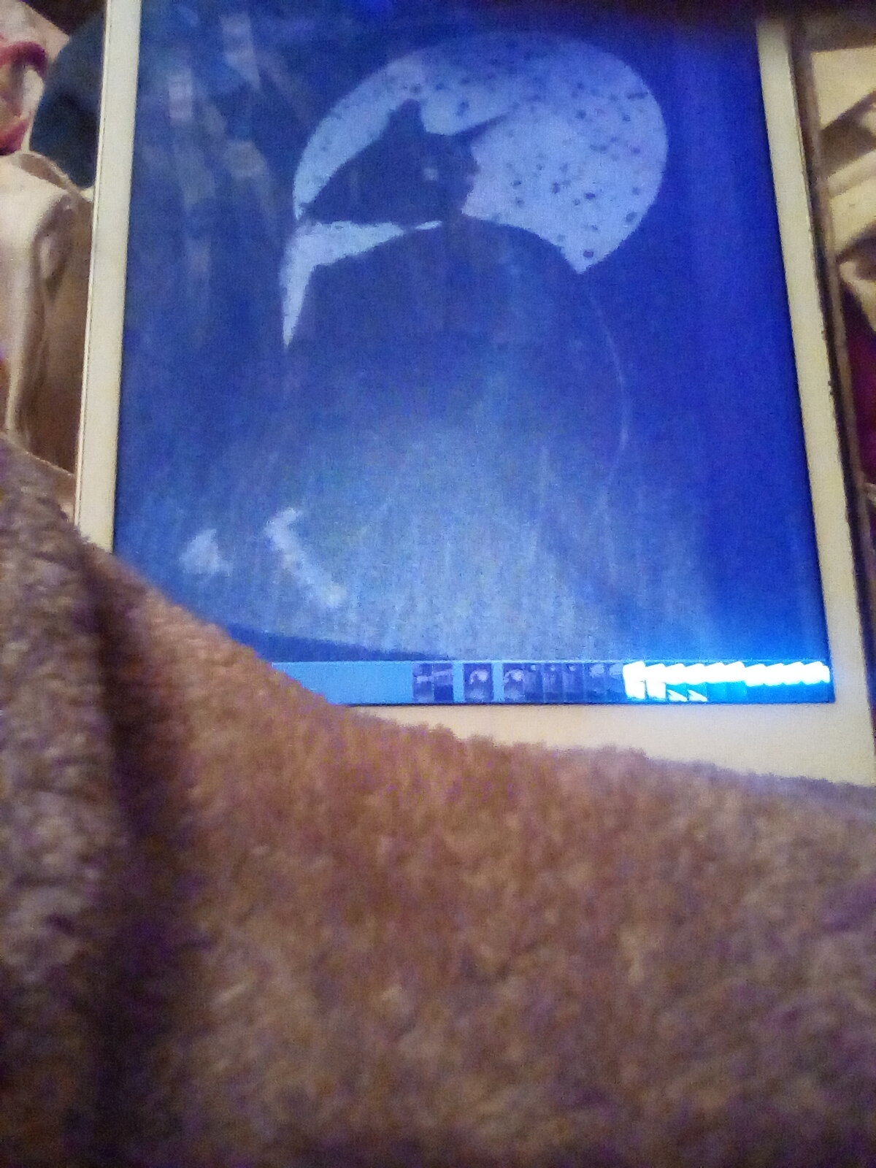
Such phases and changes were indeed observed during the month of November. Admittedly, the month began with disappointment due to having missed the unusual lunar eclipse activity at the end of October. However, a full calendar month seemed a fitting choice for this assignment. November’s full moon was observed from the back garden, but the excessive downpours connected to Storm Cieran prevented photographs from being taken. Nevertheless, I had corroborative company for this lunar viewing, as my two cats Tibby and Smiler observed the full moon with me. In lieu of documentary pictures of this event, I would instead like to include representations of these paintings by a local artist:

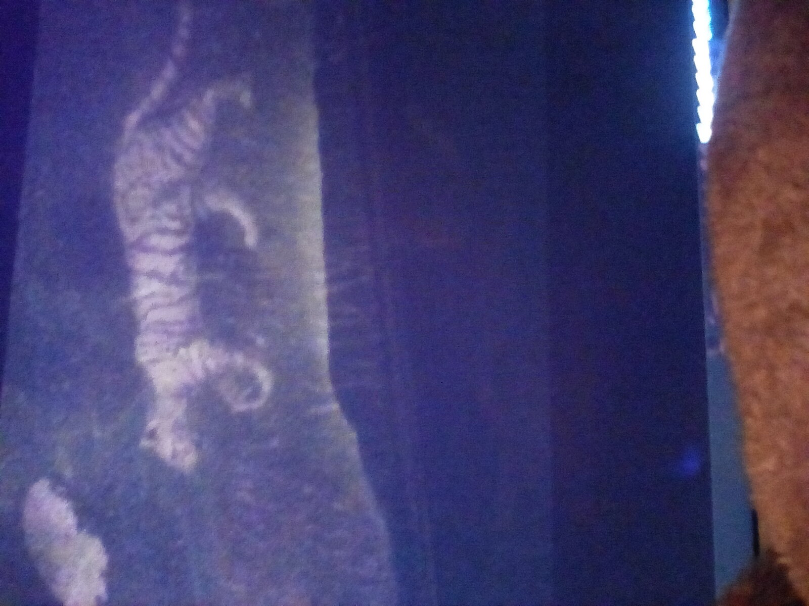

Upper (Figure 1, Home before Midnight, Anita Wood, photograph by Catherine Hornby, 14/12/2023)
Lower (Figure 2, Burning Bright, Anita Wood, photograph by Catherine Hornby, 14/12/2023)

The above pictures were taken from greetings cards bought at an art exhibition (Mulberry Bush cafe, Lampeter). It was the cheapest manner of obtaining a copy of the picture, which could subsequently be photographed. Furthermore, the idea of art at a cafe seemed reminiscent of Van Gogh, who painted the previously mentioned cafe scene. Additionally, in his book, Olson recommended the use of postcards in the study of art history. Greetings cards seem to be comparable with postcards. Judging by the titular reference to Blake's 'The Tiger' poem, the stripy feline is intended to represent a tiger. However, for my purposes, the pictures feature my cats, Tibby and Smiler, engaged in lunar observation.

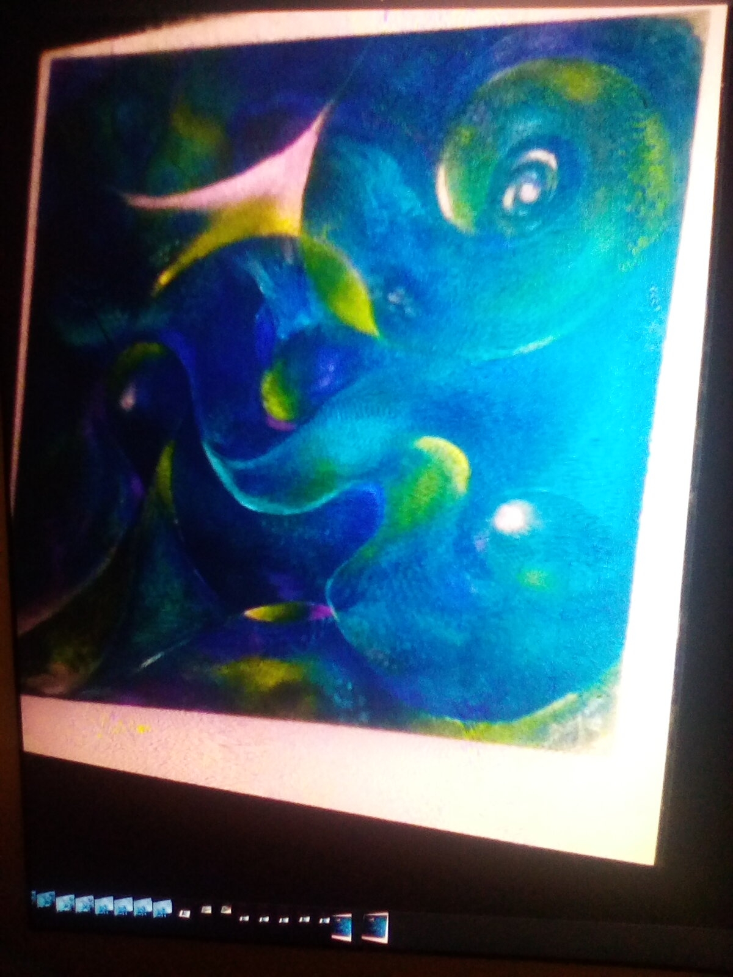
At the same exhibition as the above images were discovered, I also found a modern painting by a local artist that appeared to be influenced by Van Gogh’s Starry Night.

(Figure 3, photograph by Catherine Hornby, 14/12/2023)

The resemblance may be merely superficial. Nevertheless, the blue shades and the swirls seem reminiscent of the Starry Night. Admittedly, this may be more revealing of my own mind, than that of the artist, due to my current focus on the painting. This piece did not have reproductions available in greetings card form. I therefore had to settle for taking a picture with my oldest gadget. This might account for the blurriness of an already somewhat blurred picture. It also might explain the fact that I was unable to ascertain the author or the title, due to not seeing them. Admittedly, it is unclear whether or not the moon is represented. Nevertheless, the painting arguably shows the ongoing influence of Van Gogh's famous work.

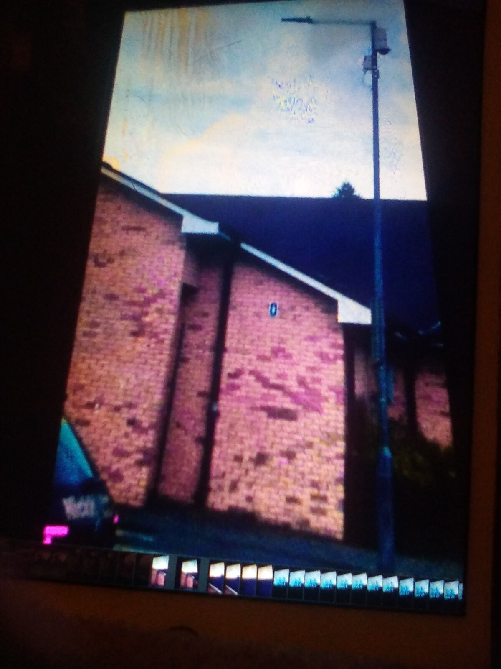
En route home from the art exhibition, I encountered and photographed the twilight moon. This is comparable with the day moon, when the moon is visible in the day sky in full daylight. The twilight moon appears at dusk, rising just as the sky begins to darken. It is thus a good moon to photograph, second only to the day moon, when the weather is dry.
Upper (Figure 4, view of the twilight moon above Lampeter, photograph by Catherine Hornby, 25/11/2023, 4.09pm)

Lower (Figure 5, zoomed in version of the same picture to improve the view of the moon.)

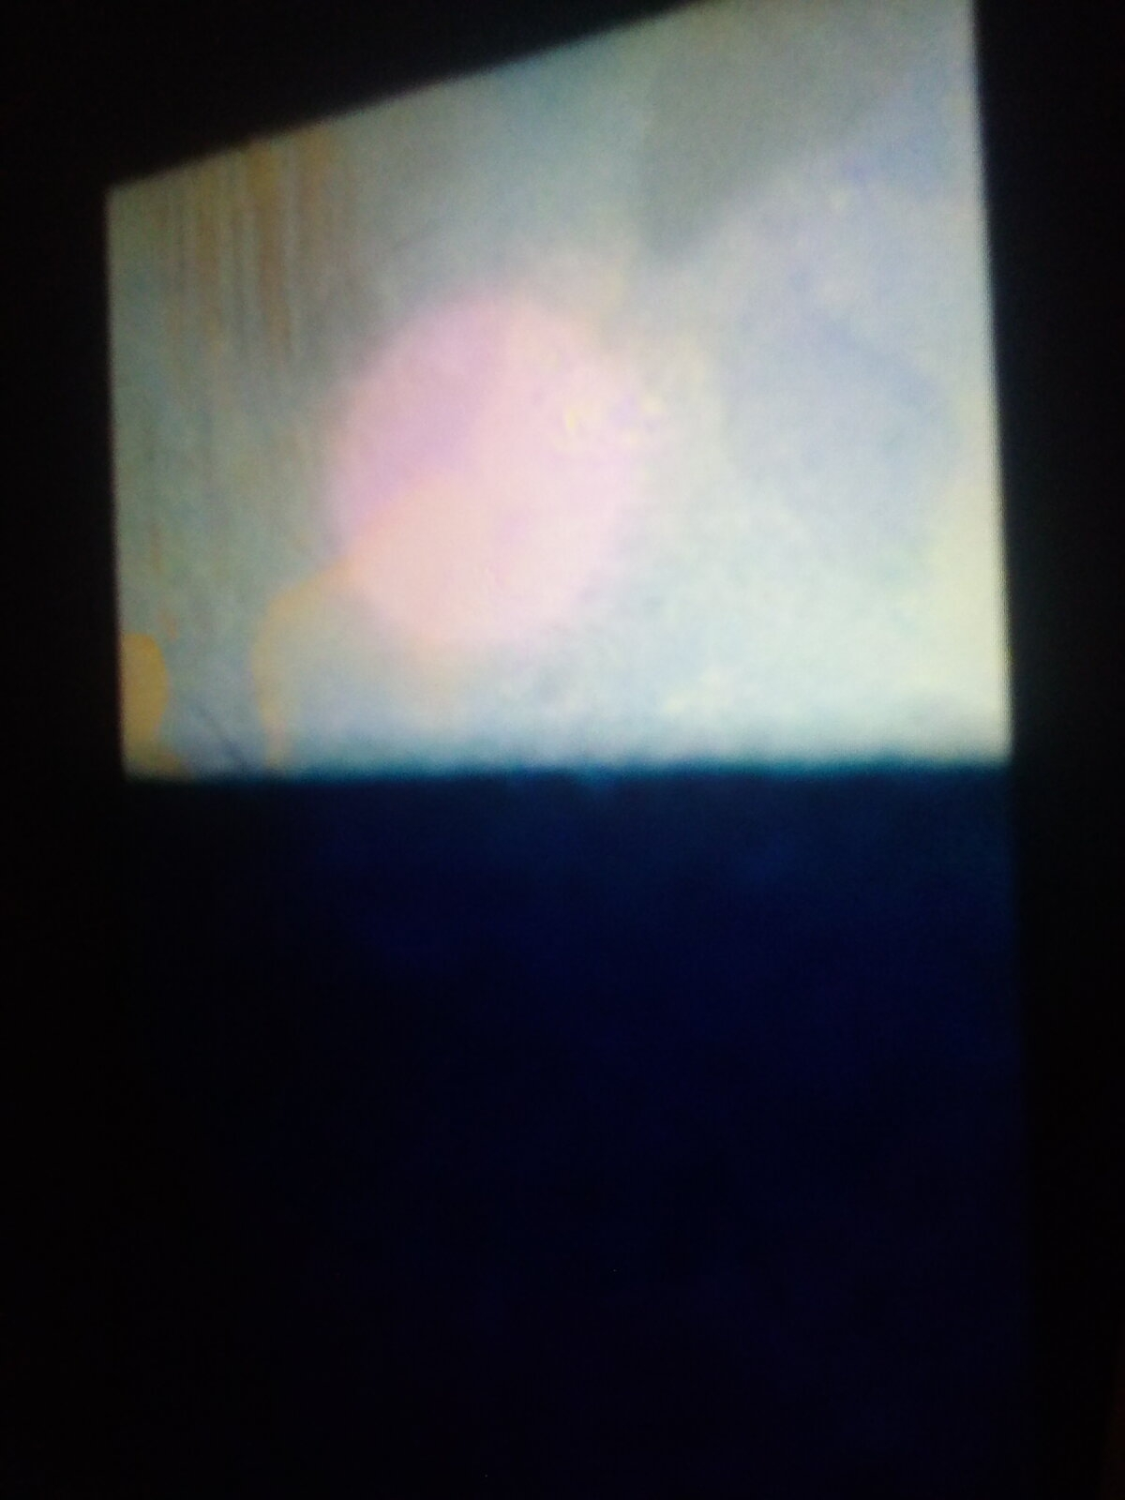

The date in question was therefore among the most successful of the project, as it included the discovery of significant local art, and culminated in the interesting experience of trailing the moon home. It eventually eluded me by disappearing behind the library. When I reached home, I found it again in the back garden and took another picture:

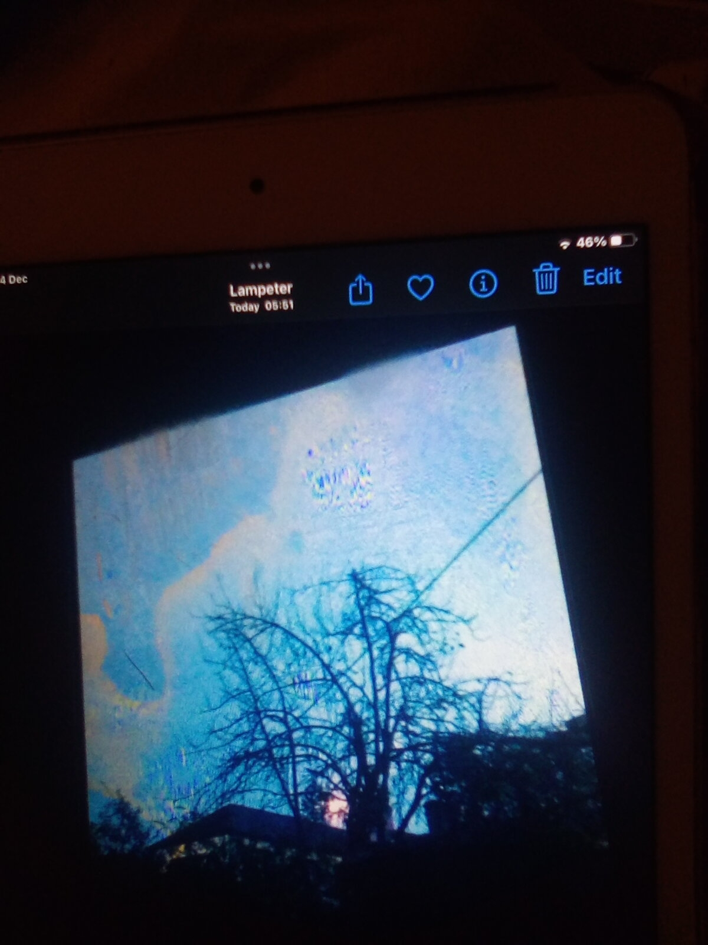
(Figure 6, the twilight moon in the back garden, 25/11/2023, 4.38pm, photograph by Catherine Hornby.)
The increased darkness and the moon appearing behind a tree altered its appearance.

As the photographs indicate, the twilight moon was almost full; specifically known as waxing full. It was a tremendous delight to see it, an experience of wonder in fact, as earlier in the month, the moon had remained invisible for multiple nights. The dark moon was too dark to see at all, and this effect was ongoing and further increased by the cloudy weather. This led to a frustrating and disappointing experience as the moon seemed to evade my sight. Nights of the dark moon may have more palatable to the ancient Greek experience. In their myth of Selene and Endymion, they had an explanation for moonless nights, in the form of the goddess Selene visiting Endymion in his cave. Perhaps it was easier to view it in such terms.

Nowadays, the experience of multiple gods is arguably replaced by that of multiple apps. In the sense of both gods and apps being (ideally) accessible and having multiple functions. The app of most significance to this assignment is the Stellarium app. However, it is of limited use, both to the visually impaired and to the study of the moon. As the app’s name suggests, its primary focus is the stars. One lunar related function it does have, is the ability to search for the moon. Having done this, the app can then specify whether or not the moon is visible from a given location. The answer to this was usually not, as I consulted the app during the dark of the moon. This brought the relief of enabling me to cease to take the moon’s non-appearance as a personal slight. I could not help initially feeling thus, as I was the one searching for the moon. Additional relief came from being able to conclude that the moon was invisible to everyone in my area, rather than my inability to see it being indicative of worsening eyesight. The anticipation of which is a constant source of anxiety.

Segueing on from the matter of forming conclusions, this essay has now reached its point to conclude. After all, like the month of lunar observations, it had to reach its natural end. Regrettably, Van Gogh’s life came to an unnatural end; being concluded by suicide in 1890. But prior to this, he had been inspired by the sky and experienced wonder in observing and recreating it. This is evidenced by both his quotation and his sky paintings. It seems arrogant to compare myself to him by claiming to have done the same. Nevertheless, it has been an interesting experience to faintly walk in his footsteps by observing the moon and attempting its representation. In my case, this was in the form of photographs that appeared blurrier than the view I saw. After all, I am no Van Gogh and no photographer. I was therefore glad of the opportunity to shore up my visual evidence with the local works of art that I found at the exhibition. They themselves provide evidence that the moon continues to create wonder and inspire the creation of art.

Bibliography

Books

Campion, N., Astrology and Cosmology in the World’s Religions, (New York University Press, 2012)

Hodge, S., Vincent Van Gogh, (The Great Artists, Kindle Edition)

Lovell, A. C. B., The Individual and the Universe, (Oxford University Press, 1958)

Olson, D. W., Investigating Art, History, and Literature with Astronomy (Chichester: Praxis Publishing, 2022, Kindle Edition)

Silva, F., and N. Campion eds., Skyscapes: The Role and Importance of the Sky in Archaeology (Oxbow Books, 2015)

Shakespeare, W., Romeo and Juliet

The Letters of Vincent Van Gogh (Penguin Books Ltd., 2003, ebook)

Vincent Van Gogh: A Life from Beginning to End, (Hourly History, 2018, Kindle Edition)

Vincent Van Gogh: Artists & Masterpieces (Enlight International Publishing, 2011, ebook)

Wilde, O., Lady Windermere’s Fan, (1892)

Woodford, M., Vincent Van Gogh, (Kindle Edition, 2017)

Apps

Moon

Stellarium

Vincent Van Gogh: Artists & Masterpieces (Enlight International Publishing, 2011, ebook)
M. Woodford, Vincent Van Gogh, (Kindle Edition, 2017)
D. W. Olson, Investigating Art, History, and Literature with Astronomy (Chichester: Springer Praxis Books, Kindle Edition, 2022)
Dara O’Briain cited in Anon, ‘Nerds don’t care that cool kids like them at last’, The Times, 10 June 2013, p.7, accessed online 13/12/2023
Oscar Wilde, Lady Windermere’s Fan, (1892)
The Letters of Vincent Van Gogh (Penguin Books Ltd., 2003, ebook)
F. Silva and N. Campion eds., Skyscapes: The Role and Importance of the Sky in Archaeology (Oxbow Books, 2015)
Vincent Van Gogh: Artists & Masterpieces (Enlight International Publishing, 2011, ebook)
Olson, 2022
Ibid
W. Shakespeare, Romeo and Juliet, 2.2

