
Skills for the Workplace
Module Assignment Submission
Student Name: | Leah Thomas
Student Number: | 2121772
Module No: | BMSK4005
Module Title: | Professional Career Development

Statement of Confirmation of Authenticity
By the act of making this submission, the student declares that this is the work of the student named above. The work has not, in whole or in part, been knowingly presented elsewhere for assessment, or where assessment has been built on a previous assessment, this has been identified. Where materials have been used from other sources it has been properly acknowledged. If this statement is untrue, the student acknowledges that an assessment offence has been committed.
Attention is drawn to the plagiarism and unfair practice policies of both the University and of ILM.

Table of Contents
Section 1: Know how to identify development needs 3
1.1 Identify learning styles for self and another 3
1.2 Use a simple technique for identifying development needs for self & another 4
1.3 Identify potential barriers to learning for self and another. 5
1.4 Explain how these barriers to learning can be overcome. 6
Section 2: Know how to develop self & others to achieve organisational objectives 6
2.1 Analyse learning/development options to meet needs of self & another. 6
2.2 Identify support mechanisms for the development of self & another 6
2.3 Prepare development plans for yourself and another person 7
2.4 Method used to monitor the development of self & another. 8
Section 3: Know how to prepare for the recruitment process 8
Reflection on the recruitment process 8
3.1 Description 8
3.2 Feelings 9
3.3 Evaluation 9
3.4 Analysis 9
3.5 Conclusion 9
3.6 Action Plan 9
References 10
Appendix A 10
Appendix B 10
Appendix C 10
Appendix D 10

Section 1: Know how to identify development needs

1.1 Identify learning styles for self and another

Here are 4 predominant learning styles: Visual, Auditory, Read/Write, and Kinesthetic.
I used the Vark questionare which was developed to determine what style of learning is best suited to me. The VARK model was designed by Neil Fleming in 1987. In this model, Fleming developed a way to help students learn more about their preferences. The main learning style that came up for me was Kinesthetic. I do agree with this result as my preferred method of learning is a more practical hands-on learning style.
Kinesthetic-Tactile Style
- Like to create things together with your hands.
- Remember best when you make things for your studies.
- Making something for a subject makes a difference to better understanding.
- Prefer making charts or blurbs for bunch ventures to gather the information.
- Remember spelling words superior in case you type them several times.
This was followed by the Read/write style
- prefer to learn by reading notes, textbooks
- making use of dictionaries and other reference materials
- benefit by rewriting and re-reading notes over and over.
The other two learning styles are Visual and Aural.
Visual learners learn by reading or seeing pictures while auditory learners prefer to hear what they are learning. These two learning styles did not come up very high for me.( see appendix)

Learning preferences of another;
I also used this Vark questionnaire to determine the learning style of another .. the results were quite different to mine. His results came back as multimodal, this learning style can channel different modes whether it be visual, aural, read/write or kinesthetic. This person has multiple learning styles and can adapt to all four. When asked if he agreed with this outcome he strongly agreed and confirmed that he preferred to use all styles when learning. ( see appendix A )

Honey and Mumford learning styles;

There is another internationally proven tool which was created by Peter Honey and Alan Mumford. I took this questionnaire along with another and the results came up as follows…

Total: 12 | Total: 13 | Total: 10 | Total: 10
Activist | Reflector | Theorist | Pragmatist

My results came up highest as being a reflector.
reflectors prefer to:
- stand back and observe
- Think before acting
- carefully consider and analyse
- reach a decision in their own time without pressure
I totally agree with this result. It describes me best.

My chosen others results came up as:

Total: 20 | Total: 10 | Total: 10 | Total: 5
Activist | Reflector | Theorist | Pragmatist

Their results came up as being mostly an activist
Activists prefer to:
- ‘have a go’ try without preparing
- Keen to take risks
- most keen
When asked if he agreed with the results again, he strongly agreed.
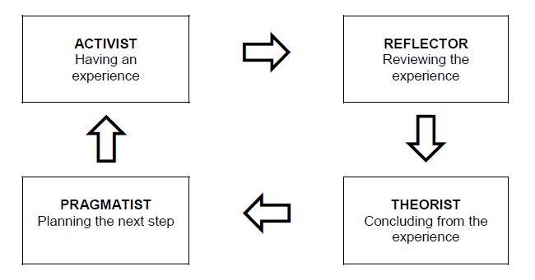

Every student can learn, just not on the same day, or the same way.”
George Evans

1.2 Use a simple technique for identifying development needs for self & another

SWOT Person 1

STRENGTHS  - quick learner  - reliable  - punctual  - loyal | WEAKNESSES  - Low confidence  - fearful  - public speaking issues  - anxiety
OPPORTUNITIES  - management  - higher pay  - meet new people  - grow in confidence | THREATS  - Covid redundancies  - lack of managerial skills  - qualifications  - geographical

SWOT Person 2

STRENGTHS  - good physical strength  - hand/eye coordination  - team player  - punctual | WEAKNESSES  - anxiety/depression  - hot/cold weather  - physically demanding  - low pay to start  - risks
OPPORTUNITIES  - pay rise  - increasing rates of house building  - higher skills  - knowledge in other trades | THREATS  - injuries/ accidents  - cost of materials  - competition  - self employed

1.3 Identify potential barriers to learning for self and another.

Learning obstructions can be caused by different components. A few are absolutely outside: tight plans, as well much work, need of accessible materials or advances, and so forward. Others are inside and start in people’s preexisting encounters, feelings, or mindsets. In some cases inner and outside variables connect powers.

Barriers may be internal: (dependency on others, work, private life)
Barriers may be external: (behavioural, psychological, levels of skill and knowledge.

looking at the barriers to learning that personally affect me;
- Motivational factors- this being a big one for me. suffering with mental health issues there are times where i can find it difficult to be motivated. My extreme lows can affect my learning performance.
- emotional factors- the fear of failure for me is a barrier, sometimes i lack confidence. This then can cause me to have feelings of anger as to why I'm feeling this way. This then has a knock on effect, it affects my critical thinking, problem solving and overall function. These are key roles in learning.
- personal factors- starting this first year of study was a big move for me as i hadn't been in any sort of education for many years. My knowledge on this subject was not the best so it's taken me a bit of time to get the hang of learning again. my personality can sometimes take over and my attention span isn't always on form. Procrastination is part of my personality that holds me back.

Barriers to learning for my chosen other:
- work-life balance- This person has recently left school and has become employed for the first time. This has taken a bit of time to adjust to as they are long working days, he can feel very tired and struggling to keep up a social life.

- motivational factors- Being a teenager this one finds it hard to even get up in the mornings, mental health isn't always great so can affect his way of learning.

1.4 Explain how these barriers to learning can be overcome.

overcoming learning barriers for myself:
- motivational factors- i will overcome these issues by firstly trying to get as much exercise as possible, sticking to a health and fitness routine can almost always have a positive effect on my mood, i'll keep on top of the therapy i receive and use meditation.

- emotional factors- i'll try not to be so hard on myself, i'll keep building my confidence by asking for feedback from family members and colleagues as well as asking for support if needed.

- personal factors- i will keep up to date with revision, keep reading and researching as much as possible. Write down key plans and priorities. I am hopeful to keep procrastination at a minimum and dedicate sufficient time to my studies.

overcoming learning barriers for chosen other:
- worklife-life balance - He will stick to a realistic bedtime routine that will prevent him from being too tired to maintain work life balance and a social life.

- motivational factors- as mentioned above a bedtime routine is key, this will lead to better sleep quality therfore lifting his mood and motivation.

Section 2: Know how to develop self & others to achieve organisational objectives

2.1 Analyse learning/development options to meet needs of self & another.

I analysed my learning/development skills by completing two different questionnaires which were, The Vark and the Honey and Mumford styles. I also looked back at the SWOT and realised that there are things I'm good at but also there are things I need to work on. I did agree with the results that came up , I think they are a good way to reflect on my overall learning skills. Going forward I'd like to attend more classes to help with my confidence issues. I also think this would be a good way to build on my social anxiety skills as this can be a real weakness for me. Taking on board all the results that came up I am looking forward to putting my ideas into practice in the future hoping to finish this course with the desired skills needed to progress further with my ideas and visions. Procrastination is a key part of my learning journey that I will need to work on and I will do this by prioritising my assignments when first handed to me.

Looking at my chosen other ways of learning I would say they also have room for improvement on turning weaknesses into strengths. self confidence being a big one, allowing himself to take on the support he needs whilst gaining some independence would really benefit him. Perhaps not allowing his fear to take over his emotions, doing this by getting enough rest and establishing a good sleep routine and accepting that there is help available. Deep down he has the minerals to start a great career.

2.2 Identify support mechanisms for the development of self & another

I have come to realise that there are a lot of support options available for me. Family and friends are always offering help. My children are a big support for me which gives me the drive I need to go forward successfully . I can communicate with other classmates and my Tutor to ask for advice. Always taking on board feedback from all mentioned which motivates my learning.

My chosen other has identified that he will need to attend regular courses and with the support of his family/friends and colleagues this will also help him with his motivation to reach his targets . Looking at the SWOT of my other person, there are many things that he is good at, but I think there are things that he can improve by turning his weaknesses into strengths. For example, confidence. If you struggle with public speaking, talking to others may help you gradually gain confidence in public speaking. Turning stubbornness into determination to succeed is a great place to start and a great way to combat anxiety.

2.3 Prepare development plans for yourself and another person

Part 1: Personal Analysis
See SWOT Analysis in 1.2

Part 2: Setting Goals

What do I want to learn? | What do I have to do? | What support and resources will I need? | How will I measure success? | Target Date for Review
i'd like to have more knowledge in Microsoft office packages | attend courses online or on site | i will need a laptop , access to Microsoft office packages | i'll give myself 6 months to learn the basics | April 2023
to successfully finish my course | attend classes regularly and keep up with research | laptop, access to library and access to uni staff members | ask for feedback | January 2023
i'd like to have my own business | continue gaining qualifications | support from family friends and colleagues , up to date technology | give myself a time frame | October 2023

What do I want to learn? | What do I have to do? | What support and resources will I need? | How will I measure success? | Target Date for Review
skills and additional trades | attend classes, work and regular research | tools, books access to online learning and practical learning | feedback from line manager | October 2023
to be more independent | make decisions alone and learn to give myself emotional support | get into community activities and have more interaction with others | feedback from family and colleagues | October 2023
stress management | make time to unwind and talk to others | family , friends and colleagues | to manage stress as better as soon as possible | January 2023

Part 3: Personal Objectives for myself

Short Term Goals (next 12 months)
to successfully finish my course in the next year , gaining qualifications

Medium Term Goals (2-3 years)
hold down a full time job to gain experience

Long Term Goals (3-5 years)
to own my own business and be successful

personal objectives for another

Short Term Goals (next 12 months)
manage stress and anxiety

Medium Term Goals (2-3 years)
to learn more trades and get higher qualifications

Long Term Goals (3-5 years)
look to own my own business or start building on a business

2.4 Method used to monitor the development of self & another.

pdp for myself
What happened?

What did I do?
Discovered learning styles, SWOT and working on threats and weaknesses

How do I think/feel about this?

bit more confident than before
How well or how badly did it go?
Learning how to determine my learning skill went well, I agreed with it and have researched different ways in which people learn.

My conclusions/reflections/lessons learned

What did I learn?
I learned that everyone learns in a different way and it's not one fits all.

What have I achieved?
The ability to ask questions and ask for help and guidance

How have I put any theory into practice?
By reflecting on things I have learned. I have done a lot of research and have looked at different ways of learning.

What have I learned about myself?
That with hard work I can achieve my goals. I can work on my confidence and be more positive about the future.

How does what I am doing lead me to becoming better at a skill?
By analysing situations and using my reflective skills to guide me to the right conclusion

How can I use this to plan for the future?
I will be able to use the skills I have learned already by reflecting on situations and always trying to find the ways of learning that work best for me.

How can I use this to plan new learning experiences?
Trying different learning styles, trying a range of different things to help me along the way.

My plan to do something better/different by using what I have learned

What will I do differently next time?
I will start the assignment earlier to take off the stress of leaving it late. I have carefully researched and used knowledge I have gained recently and I have found parts of the assignment easier to digest.

How will I do it differently next time?
Having easy access to all of my notes and research materials, taking breaks between parts, and not attempting to accomplish everything at once.

pdp for another

What happened?

What did I do?
Communicated with my chosen other , asked tutor for help and feedback, identified learning styles for both me and another.

How do I think/feel about this?
i think it's a good way to put into perspective that each individual have preferred ways pf learning.

How well or how badly did it go?
Good, happy with feedback, happy to communicate with others and ask for help when needed

My conclusions/reflections/lessons learned

What did I learn?
How to communicate efficiently, different learning skills for myself and others.

What have I achieved?
How to use a laptop a little more effectively, how to use various office products, and how to develop social skills

How have I put any theory into practice?
i wanted better understanding of learning skills and i feel as though I have done well so far in communicating with others and reaching out for help

What have I learned about myself?
I can face my fears head on and accomplish the things I never thought possible.

How does what I am doing lead me to becoming better at a skill?
showing me that I don't have to do everything on my own and how to accept help. It isn't as bad when I ask my peers for assistance when I'm stuck.

How can I use this to plan for the future?
By remembering the skills I have learned and putting them into practice

How can I use this to plan new learning experiences?
I used to take a back seat and let someone else use the computer, but as my IT abilities improve, I feel more comfortable utilising it if someone asks me to access anything.
My plan to do something better/different by using what I have learned

What will I do differently next time?
Not to be afraid of asking for help when needed.

How will I do it differently next time?
So that I know where to go first and last, identify the support islands. A good technique to determine what I am good at and what I need to focus on is to make a list of my strengths and shortcomings.

Section 3: Know how to prepare for the recruitment process

Reflection on the recruitment process
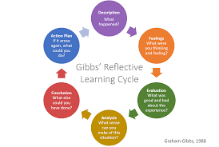
Gibbs, 1988

3.1 Description

This assignment's goal is to reflect on my learning needs and development for myself and another for this module. I was wary of undertaking this because I had never done it before. My intention was to develop a deeper understanding of how things can affect ways of learning and to show greater creativity than the other competition in the field. I knew it would be challenging as this is not something I have done before .

3.2 Feelings

This experience has taught me that sometimes I allow my negative emotions to take control, especially when it comes to anxiousness, which I did experience a bit during this assignment although I did find it enjoyable and has been my favourite assignment so far. The study was intriguing, but I must admit that it was harder than I had anticipated. Now that it's complete, though, I feel like I'm ready for the challenge of the upcoming project.
The completion of this module does make me feel a little relaxed, but I'm also looking forward to the upcoming modules and putting what I've learned to use. It's made me feel a variety of things, including tears of joy once completed.Its been a learning curve and I look forward to a positive and productive future.

3.3 Evaluation

I've learned from this experience that I can accomplish anything if I really set my mind to it, and I've also discovered that I occasionally perform better under pressure. For me, the entire experience was more pleasant than negative.
Having two kids made it significantly more challenging, but I managed to adjust well, and I think my kids actually gave me inspiration to get through it. I do believe that I could perform more effectively if I could manage my anxiousness a little better. Additionally, finding quality time to conduct research and acquire information was made easier by working a full-time job.

3.4 Analysis

I realised that during this module my main area of concern is my confidence and believing in myself that I am capable. I think it's very important to put your passion into what you want to do. Because if you don't love or believe in yourself , how can you convince others? This is something I will be taking on board for the future.

3.5 Conclusion

Even though I think I did okay considering that this was my first time doing an assignment like this there are still undoubtedly areas where I can improve. I do believe that I've given myself more time to complete my work rather than putting it off this time and I think it's paid off as I have not been as stressed, getting in more research and paying more attention to detail. I have really surprised myself. I am proud of being able to truly implement a strategy; to me, it is an accomplishment in and of itself.

3.6 Action Plan

It is crucial to pay attention to your critics, consider whether their criticisms are valid, and finally choose what is best for you. Once you've done that, accept accountability for your choices. People may occasionally disagree with your decisions. Even if other people don't, have faith in yourself.
A learner's mindset and a willingness to try new things will always be necessary traits for entrepreneurs. The correct network, confidence, and a goal-oriented approach, however, can greatly aid your firm in getting off the ground.

References

Neil Fleming. 2022
What Is A Kinesthetic Learner? 2022.
, Biography - VARK-08-19T05:18:55+00:00, 2014-last update. Available: https://vark-learn.com/introduction-to-vark/biography/ [Oct 26, 2022].
, Read/Write Strategies - VARK-07-30T04:44:40+00:00, 2014-last update. Available: https://vark-learn.com/strategies/readwrite-strategies/ [Oct 26, 2022].
, 4 Types of Learning Styles | The VARK Model | Sphero. Available: https://sphero.com/blogs/news/learning-styles-for-kids [Oct 26, 2022].
Gibbs' Reflective Cycle. Available: https://www.ed.ac.uk/reflection/reflectors-toolkit/reflecting-on-experience/gibbs-reflective-cycle [Oct 26, 2022].
Swain, W.by R. (no date) 7 good questions to ask at an interview, Prospects.ac.uk. Available at: https://www.prospects.ac.uk/careers-advice/interview-tips/7-good-questions-to-ask-at-an-interview (Accessed: October 27, 2022).

Common barriers to learning (no date) Unionlearn. Available at: https://www.unionlearn.org.uk/common-barriers-learning (Accessed: October 27, 2022).

Appendix A

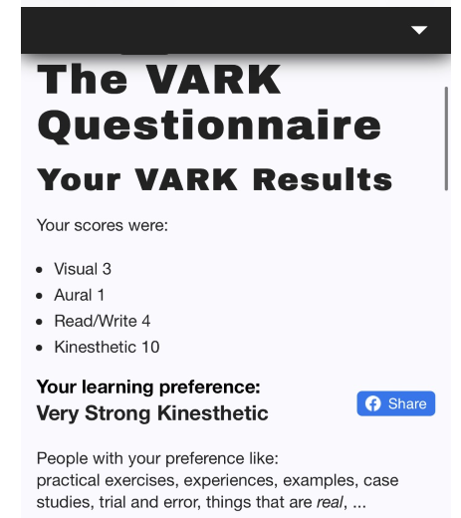

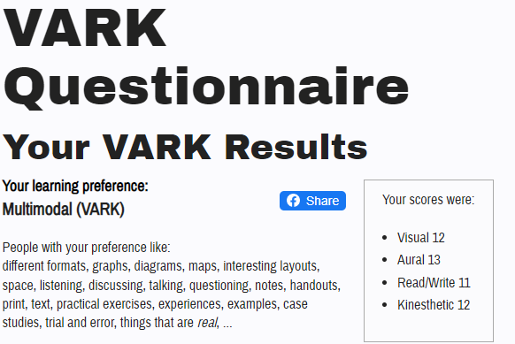

Appendix B

ADMINISTRATION ASSISTANT

Surname
THOMAS
Dr Mrs Mr Miss Ms
MISS
First names
LEAH
Address
3 Clos burlais
Cwmdu
swansea
Postcode sa5 8lh
Email:LEAH_THOMAS11@LIVE.CO.UK
Telephone
Home 01792 415369
Business 07464626941
If not British or EU, do you have authority to work in the UK?
 | Yes  x |  | No
What notice is required by your present employer?
N/A
Where did you see this post advertised?
GOOGLE WEBSITE

SECONDARY AND HIGHER EDUCATION in reverse chronological order please.
Dates
From  mth. yr | To  mth. yr | School, college or university | Examinations taken | Results obtained,  scholarships and other distinctions.  Please state the title of any thesis
09.02 | 07.07 | Daniel James Comprehensive school | MATHS GCSE  SCIENCE GCSE  ENGLISH GCSE | A  A  B
TECHNICAL PROFESSIONAL OR OCCUPATIONAL TRAINING
Dates
From  mth. yr | To  mth. yr | College, institute or employer | Type of training eg full time, part time, distance learning | Subjects studied | Qualifications gained
02.22 | 01.22 | University of Wales Trinity Saint David | Full Time | Leadership & Management | CertHE

EMPLOYMENT HISTORY in reverse chronological order, please
Dates
From  mth. yr | To  mth. yr | Name, address and description of employer | Position(s) held & brief details of duties | Final salary and reason for leaving
09.07  02.09  03.15 | 01.09  02.15  Present | Office Angels, Kingsway, Swansea.  Azets, Manor Road, Swansea  Hornbill Engineering, Neath | Administrative assistant - sorting mail outgoing and incoming, taking calls arranging meetings  Receptionist - Greeting visitors, arranging meetings,  Business administrator - assist with the marketing department and support business needs. | temporary  Redundancy  Location

Please explain how you believe that your current skills, experience and qualifications enable you to meet the essential requirements that we have set for this post.
I have over 10 years experience in administration and reception work. I have excellent communication skills and I can deal with people from all walks of life, I have the ability to work under pressure and complete tasks according to deadlines. I have knowledge of Microsoft packages and I am also willing to learn according to business needs
The Open University Students Association welcomes applications from disabled people and information about disability is only requested on the application form in order that appropriate arrangements for an interview can be made if necessary.
Do you consider yourself disabled? |  | Yes |  | No  X
Are you registered disabled? |  | Yes |  | No  X

Appendix C

Leah Thomas
3, Clos Burlais Cwmdu, Swansea sa5 8lh
07464626941
Leah_thomas11@live.co.uk

personal profile
I have excellent communication skills, the ability to run a switchboard efficiently, and a professional appearance. Having worked under pressure in a fast-paced environment, I am able to greet visitors with friendliness and assistance. able to work as an integral part of a team in administration, following directions and being open to learning.

Career progression
2020 until the present, University of Wales Trinity Saint David(Operations)
Administrator)
working in a reception setting and offering phone answering, administrative, and
In addition to organising the mail, greeting guests, and offering
courtesy shown to clients and guests.
Duties:
Returning all incoming calls and emails to the proper persons after answering them.
Greeting guests and students, making sure they are signed in, inducted.
Taking the post, opening it, and dispersing it.
General administrative tasks, such as filing and photocopying.
Attending any questions at the front desk. any issues should be reported to the
building supervisor.
Attending requests for parking spaces and catering needs.
Making sure the lobby is clutter- and mess-free.
Managing a switchboard and computer system.

2004–2011: Debt relief Management UK

Working over the phone, in writing, or by email to reach a debt settlement arrangement with consumers, creating spreadsheets in Excel, managing day-to-day office tasks, and setting up file and office organisation systems.

References

References are available on request

Appendix D

Dear sir or Madam,

As a highly experienced Administrator with 10 years experience, I would like to apply for the full time Administrative Assistant position you have advertised on Indeed.co.uk.

After working as an Administrator for over 10 years I have advanced experience in all Microsoft packages, and dealing with students and visitors on a daily basis my communication skills are excellent.

I am currently studying for a certificate of higher education in Leadership and Management at The University of Wales Trinity Saint David and after completion I hope to work for a company where I can grow my experience and knowledge. With the right opportunities I am confident I can achieve my goal.

Please see attached a copy of my CV for additional information of my skills and experience.

Thank you for taking the time to consider my application. I look forward to hearing from you shortly.

Yours Faithfully

Leah Thomas

