Critical Thinking
Student Name: Chelsie Gallagher
Student Number: 2213739
Programme of Study: Design Crafts
Module: Ways of Thinking (ADDA4022)

Semiotics

Semiotics is the study of signs and symbols. It explores how we interpret and understand them in our daily lives, like words, images, gestures and sounds. By examining how we interpret and assign significance semiotics helps us unravel the hidden layers in communication. Roland Barthes a philosopher and semiotician explored the ways in which signs and symbols shaped our understanding of culture, literature and society. Colette A Granger 2004 Silence in second language learning [page 108] mentioned a quote from Barthes that “Language is a skin. I rub my language against the other. It is as if I had words instead of fingers,” “My language trembles with desire.” This quote captures the idea of language as a medium in that we interact with. It highlights the power and emotion of language in the world of semiotics.

Advertisers will use signs and symbols to display hidden messages in their ads. By carefully choosing colours, images, words and placements to invoke specific emotions to the advert’s viewers. Therefore, by understanding semiotics advertisers can strategically design their ads to effectively communicate with their target audience and create an impact.

For example...

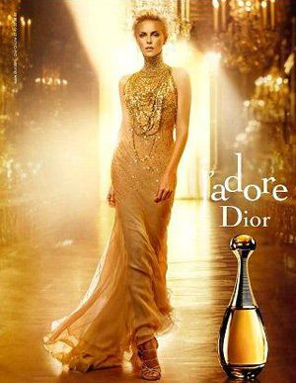
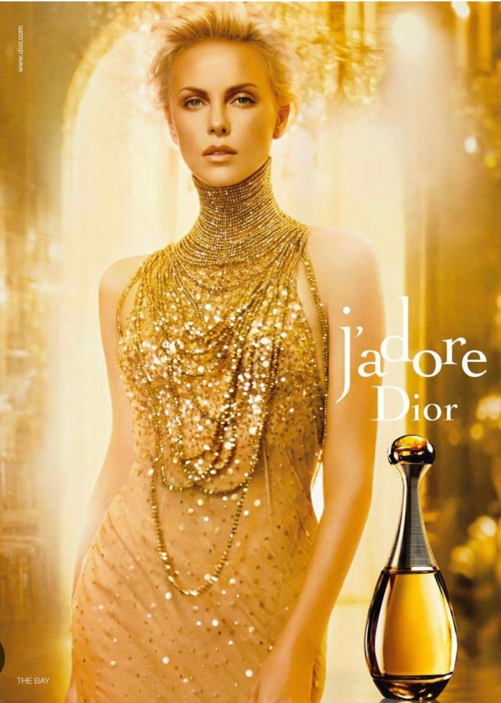
The women/ her clothing
Placements
The brand/ font
Main colours
Jewellery
Facial expression

Colour Theory.

In semiotics, colour theory can impact us in three different ways cultural, emotions and socio economical. Advertisers often use specific colour palettes show off different emotions or associations in their audience. Certain colours are commonly used to make a reaction. Blue is often used to convey calmness whilst green is commonly associated with nature.

In this J’adore advert its only filled with warm colours. Hints of oranges but mainly associating with gold. The warm colour in this advert gives off the impression of luxury and wealth. Gold is an obvious example that’s often seen as superior. HuddleCreative (2022) Your Non-Scientific Guide to Colour Semiotics [online] available at www.huddlecreative.com [22.11.23] mentions that “Orange is a attention attraction colour” and they also say “its associations tend to be feelings of adventure, confidence, creativity, enthusiasm and success.”

So, I believe that the J’adore advertisers created this advert for not only the symbolising the colour of the perfume itself but to give the viewer the impression that using this product will make you feel superior. That this perfume is a luxury item.

The Model

The main feature of the advert is not the perfume bottle but Charlize Theron an actress whose placed dead centre filling the whole main frame whilst the actual product is in the corner. Charlize Theron is a tall, attractive blonde hair woman stereotypically can represent this perfect woman. Advertisements will often use attractive people because they will grab attention of the viewers. Using celebrities is a marketing strategy, based on the idea that people are drawn to beauty and can be influenced by it. Kalturablog (2023) Celebrity Endorsement: How to Use a Celebrity for Your Campaigns and Events [online blog] available at www.corp.kaltura.com [22.11.23] says “celebrity endorsement helps increase sales in the short term and brand awareness in the long term”. Which is another reason on why companies use celebrities.

Theron is facing the camera straight on which can come across as powerful or intense and has her mouth slightly opened gives the impression of seduction. Her makeup is nude, and her hair is pinned back They are keeping her quite neutral like a natural whilst her outfit takes the full attention.
She is wearing a long nude floor length dress with golden sequin details that represents this repeating luxury theme. She is also wearing a golden choker styled necklace that completely covers the whole neck. The necklace mirrors the shape of the bottles neck.

The Brand/ Font

The brand Dior was created in France. Known for selling high quality products like fashion, accessories, fragrance and beauty supplies. J’adore translates to ‘I adore’ which symbolizes romance. The country has been associated with romance for centuries, partly because of its cities like Paris, which is known as the “City of Love”. Additionally, France has a long history of artistic expression, literature and film that often explores themes of love and passion. All these factors have contributed to the romantic image of France.

The font that J’adore Dior use is Serif. According to Grace Fussell (2023) The Psychology of Fonts (Fonts that Evoke Emotions) [online] available at www.elements.envato.com [22.11.23] “Serifs is trustworthy” she also says, “psychological associations of Serif fonts is stability, tradition, intellect and formality.” A good typography enhances readability, it is important for creating an impactful and engaging visual. Dior has created a timeless brand font for themselves that will forever look pleasing to the eye.

Information found from:

Thomas Albert Sebeok. (2001). Signs: An Introduction to Semiotics [22.11.23]

Collette A Granger (2004) Silence in Second Language (page 108) [22.11.23]

Huddle creative (2022) Your Non-Scientific Guiled to Colour Semiotics [online] www.huddlecreative.com [22.11.23]

Kalturablog (2023) Celebrity Endorsement: How to use a Celebrity for your Campaigns and Event [online] www.corp.kaltura.com [22.11.23]

Grace Fussell (2023) The Psychology of Fonts (Fonts that Evoke Emotions) [online] www.elements.envato.com [22.11.23]

Alex W. White (2015) Advertising Design and Typography [22.11.23]

