Name: Jennarong Trongklang

Student number: 1902236

Programme of Study: Outdoor Adventure Education

Module: Business Inquiry and Research

Tutor: Dr Roisin Mullins

Date: 07-05-2021, by 3pm

Research Proposal

Introduction

I have decided to name my research using this title “How has Covid-19 changed the way we practice outdoor adventure activities?”. I have chosen this title because it summarises the whole topic that I would be studying. For example I will be discussing the changes made to the way outdoor practitioners travel to their place to undertake their activities and whether they have to alter the way they do things due to safety aspects such as social distancing and personal hygiene. The aim of this study is to find out how outdoor practitioners have managed the challenges faced from the Covid-19 Pandemic. The Covid-19 pandemic has made it difficult for everyone to stick to their normal life routine and this partially affects almost most outdoor practitioners because of the lockdowns that have been in place and this has made it difficult for them to carry on with their practices. Mackenzie and Goodnow (2020) mention that “COVID-19 has forced many to embrace locavist approaches to adventure on the most micro level”. So I have decided to use this as a study topic to explore the implications as well as the solutions that people have come up with to solve this issue. Issues such as limiting travelling distances, limited contact with other people and use of public places. I will be collecting primary data using surveys meaning this is a quantitative method of research and it is positivist. This is where the researcher is normally seen as independent from those who are being researched (Saunders et al, 2016). The participants in this study will then be known as respondents. I will be using a survey that has been used in my previous studies on SurveyMonkey, however I would need to create my own survey; independent from SurveyMonkey if I wanted a bigger sample population. This is because SurveyMonkey only allows forty free participants until subscription fees have to be paid. Due to choosing to use a quantitive method, my survey will have to have questions that have been carefully thought out because they would need to be coded numerically in order for analysis later on.

Once the primary data has been collected from my surveys, I will be collecting secondary data from peer reviewd journals that are recent to ensure that the information is up to date and valid. I can then compare the primary data to the secondary to see if there are any relationships or similarities between the primary and secondary data. The comparison will then show me whether the realities of the theories from the secondary data connect with my data from my primary data collection.

Review of pertinent literature

In this section I will be reviewing the research and data collected to show that they are relevent to my chosen area of study. I will be using some examples of the research to demonstrate, in this proposal, how I will make this dissertation current and relevant. To begin with, I have chosen an article called “Adventure in the Age of COVID-19: Embracing Microadventures and Locavism in a Post-Pandemic World” written by Mackenzie and Goodnow (2020). This article speaks a lot about the challenges that outdoor practitioners faced when the Covid-19 pandemic struck. They also mention a lot about the solutions that have been created to work around these challenges. For example they talk a lot about a new concept of “micro-adventure” where people can still go out seeking adeventures but instead of travelling to another country to ski or climb a mountain, we can use the resouces that the local area provides and undertake our adventures locally. This will help the local community because the local shops and tourist attractions have not been busy due to travel restrictions, so if more people use them, then this would help keep their businesses running. Travelling shorter distances also means less strain on global warming and it would be cheaper than flying to another country. Pre-pandemic ideas of traditional adventuring involved extended travel to remote environments and communities (e.g., Rantala, Rokenes, & Valkonen, 2018) and I would like to explore the new concept of outdoor adventuring.

I believe this is a good article to use for my study because it is relevant; being focused on Covid-19 and how solutions have been made to help tackle the challenges faced. Furthermore, it was published in 2020 so the article is current, making it more reliable. From this article I can then use this research as a guide to help me create a survey for people to fill in. For example this article mentions the use of “micro-adventures” would allow us to go on adventures more frequently and “Experiencing adventure more often (e.g., weekly), rather than via an extended trip every 6–18 months” Mackenzie and Goodnow (2020). I can use this in my survey by asking a question such as “how often would you go out and go on adventures pre pandemic?” then ask them the same question but post-pandemic. I can then use their answers to compare against eachother and anaylyse the results. I would have

Littlewood (2020) explains that the “tourism-dependent economy has screeched to a halt in a matter of weeks and the industry has called for a “serious rethink” of tourism to benefit communities and environments, with an emphasis on domestic/regional travel”. This is also what is included in the article mentioned above and it shows that a lot of the information in the article is really relevant to my study. It also supports my idea of how people are creating and thinking of new ways to undertake outdoor adventure activities.

Dissertation Proposal 3 | P a g e

Research Strategy and Methodology

The methodology process is a crucial part of the dissertation because it explains the structure of the dissertation. I will be using both primary, which is quantive so I will collect research using a survey, and then secondary data from peer reviewed journals and articles. The survey will be designed with the questions carefully thought out so that the relationships with the variables can be used for analysis. I will make sure that my results are more reliable by getting a greater sample to rule out biased answers. I will then compare the primary data to the secondary data to see if theer are connections and links made. I believe that using a quantive approach to this study is best because it involves using facts and figures which is objective and not subjective which is what is involved when using a qualitative approach. I will then be using tools that will help me analyse this data, so for example graphs and charts made from the primary data collected. These can either be created using microsoft excel or SPSS. If I use SPSS then I can use its software capabilities to compare my primary data and change the independent variables to look for correlations. I could also use excel, but this has limits on what I can do with the data collected and I have less knowledge of how to properly use excel.

Dissertation Proposal 4 | P a g e

Logistical and ethical consideration

This proposal will include the logistics and ethical considerations. So I will take the time that it would take to complete this dissertation into account and any financial expenses such as possibly paying a subscription fee for SurveyMonkey. My subjects that will be completing my surveys will be kept anonymous so that their privacy is respected and I intend to create at least 60 surveys for people to fill out. In order to ensure I have a minimum amount of data collected, I will use the free amount of 40 surveys that SurveyMonkey offers along with a few more of my surveys that will be sent out using a different method. For example I can print them out and hand them to people to fill in. This way I will have a higher chance of having some primary data as insurance and then the extra surveys filled will help make the data even more reliable. It would be best to use social media instead of printing out surveys because it would save spending money on printing fees. I can post a template of the survey on a social media platform and the participants can then personally send me their completed surveys by private message. On the one hand this saves printing and money. However, on the other hand, participants would be exposing their social media accounts to me which I will explain that I will keep their information confidential and I would only use it for my University studies. The only thing that would concern me would be the time the participants complete the surveys by. I have also considered the ethical factors such as avoiding giving surveys to underage people or vulnerable categories. I will briefly explain on the questionnaire, why I have created the survey and that their identity and answers will be kept confidential. I will also give a brief explanation of who I am and what my study is about. The participants would also be allowed to decline and stop completing the survey if they feel the need to or do not want to proceed. As a sign of gratitude, I would add a note of thanks to all the questionnaires and then ask for a gitial signature confirming that they are happy for me to use their completed survey.

Dissertation Proposal 5 | P a g e

A planned timetable

This is an example of the timetable that I would be stitching to when completing this study. This table includes all of the aspects that have to be covered in the process of doing this study, so an example shown above is begging at a discussion about what topic to choose to research for the study, collecting primary data, collecting secondary data and then collating all the information above to form a report. Each of the tasks mentioned above will have “task deadlines'' to follow so that I can make sure I am keeping up with the workload otherwise I would end up with lots to compleet in a short space of time. There will also be an option to either write in a task completion percentage or fill in a coloured bar to represent the amount completed in that task. This type of chart is also known as a gantt chart. This gantt chart would help me keep to schedule so that things are completed on time and I can also keep track of what needs to be done. This gantt chart will be created in microsoft excel and will be kept open to allow me to revisit it to check my progress. The gantt chart below, was created as an example to show how I would complete a gantt chart and this was filled in as an example. The blue coloured boxes represent the weeks which need to be completed.
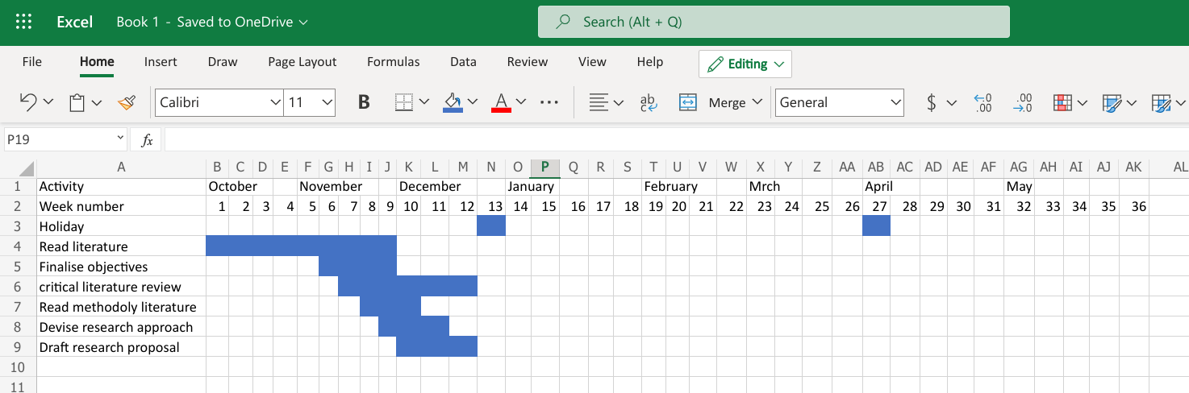

Words: 1826

References

Mullins, R. (2021) ‘Quantitive research’ [PowerPoint presentation]. Module code: Business inquiry and research BMSP5007. Available at: https://moodle.uwtsd.ac.uk/pluginfile.php/484073/mod_resource/content/1/Week%206%20Quantitative%20Foundations%206.0.pptx (accessed: 05/05/21).

Saunders, M., Lewis, P., Thornhill, A. & Bristow, A., (2016). Research Methods for Business. 7th ed. Harlow: Pearson.

Littlewood, M. (2020, April 19). Call for serious rethink of New Zealand’s approach to tourism. https://www.stuff.co.nz/timaru-herald/news/121112865/call-for-serious-rethink-of-new-zealands-approach-to-tourism

Mackenzie, S. and Goodnow, J., (2020). Adventure in the Age of COVID-19: Embracing Microadventures and Locavism in a Post-Pandemic World. Leisure Sciences, 43(1-2), pp.62-69.

Rantala, O., Rokenes, A., & Valkonen, J. (2018). Is adventure tourism a coherent concept? A review of research approaches on adventure tourism. Annals of Leisure Research, 21(5), 539–552. doi: 10.1080/11745398.2016.1250647

