

Student Name: RUPANSHI ARPANBHAI SETALVAD

Student ID: 2521736

Module Name: Human Capital Management

Module Code: LCMB7023

Lecturer’s Name: Gladius Kulothungan Eno Maycock

Term 1

Contents
Designing a Human Capital Architecture for Strategic Renewal at Helios Urban Mobility (HUM) 3
1.INTRODUCTION 3
TASK A: 3
1.SOCIALISATION, IDENTITY AND BUSINESS ACTIVISM 3
1.1.There are two types of onboarding: 3
1.2.There are two onboarding methods: 3
2. A STRUCTURED SOCIALISATION FRAMEWORK FOR HELIOS URBAN MOBILITY 4
2.1.Key interventions include: 4
2.2.Key components include: 5
2.3.Interventions include: 5
3. Cultivating Organisational Identification, Ethical Professionalism and Business Activism 5
3.1.ORGANISATIONAL IDENTIFICATION 5
3.2.ETHICAL PROFESSIONALISM 5
3.3.BUSINESS ACTIVIST MINDSET 6
TASK B: 7
1.Job Design for Motivation and Innovation 7
1.1.A STRATEGIC APPROACH TO JOB DESIGN THAT IS INNOVATIVE. 7
1.2.JOB CHARACTERISTICS MODEL 7
1.3.JOB CRAFTING 8
1.4.SBA and ITM (Internal Talent Marketplace) 8
2. PROVIDING ENCOURAGEMENT FOR INTRINSIC MOTIVATION AND INNOVATION 9
2.1.Innovation is supported via: 9
TASK C: REFLECTIVE REPORT 10
1.INTRODUCTION 10
2.STRATEGIC INFLUENCING SKILLS: 10
3.GLOBAL MOBILITY AWARENESS: 10
CONCLUSION 11
REFERENCES 12

Designing a Human Capital Architecture for Strategic Renewal at Helios Urban Mobility (HUM)

1.INTRODUCTION
Helios Urban Mobility (HUM) works in an exciting and knowledge-driven industry spanning the field of artificial intelligence, smart infrastructure and sustainable urban mobility. The organisation has grown at a rate that has seen it expand rapidly in London, Berlin and Singapore, but its human capital issues – low organisational socialisation, a drop in engagement and high turnover of high-potential graduates – indicate the need to bridge strategy and people systems. Here strategic renewal is less about ‘tweaking the HR system' and more about ‘deliberate re-design of the human capital system to create human capital commitment, capability and shared purpose'.
This paper tackles the Board's mandate by suggesting an integrated approach to the development of reflective capability, job design and organisational socialisation. Task A analyses the traditional onboarding process and strategic organisational socialisation, and proposes a framework for building organisational identification, ethical professionalism and a mindset of business activist within the organisation. Task B is an innovative approach to job design to boost intrinsic motivation and innovation. Task C includes a reflective report on the responsible use of AI in decision making and a personal capability development plan for future employability.

TASK A:

1.SOCIALISATION, IDENTITY AND BUSINESS ACTIVISM

1.1.There are two types of onboarding:
Traditional Onboarding and Strategic Organisational Socialisation.

1.2.There are two onboarding methods:
Traditional Onboarding and Strategic Organisational Socialisation.
Onboarding is usually limited to administrative paperwork, getting acquainted with the job, and immediate task effectiveness. Uncertainty reduction and task facilitation activities like induction sessions, IT access, policy briefings and basic training aims to shorten the time required to accomplish the task (Bauer & Erdogan, 2011). Such strategies can lead to higher early productivity, but are rarely focused on more complex social and psychological dynamics, which can lead to poor organisational attachment and long ramp-up times, as shown in HUM's eight-month average.
Strategic organisational socialisation, on the other hand, is a process of socialisation that takes place over a period of time, and helps newcomers to internalize the values, norms and purpose of the organization (Van Maanen & Schein, 1979). The six socialisation tactics proposed by Van Maanen and Schein are: collective vs individual, formal vs informal, sequential vs random, fixed vs variable, serial vs disjunctive and investiture vs divestiture. These dimensions are explicitly created in strategic socialisation systems to encourage certain actions and identities.
The difficulties currently faced by HUM seem to be that it has become too dependent on individualised and informal and flexible tactics, and newcomers are left to ‘sink or swim'. Studies indicate that these strategies lead to higher role ambiguity and turnover, especially among the graduates who are less likely to have professional schemas (Ashforth et al., 2007).
These results are also related to psychological contract theory. The psychological contract is the employee's idea of mutual commitments between the individual and the organisation (Rousseau, 1995). A lack of developmental support, a lack of ethical purpose and a lack of inclusion in the workplace during the first months of employment result in perceptions of contract breach and thus, disengagement and exit (Conway & Briner, 2009). HUM's engagement score has decreased (54%) showing a lack of this unwritten contract.
There's yet another layer, that of identity construction theory. Roles are learned, not the same as professional identities are created (Ibarra, 1999). In sectors where a mission is crucial, like sustainable mobility, it is detrimental to the meaning and commitment to embed a compelling organisational identity. Traditional onboarding uses the concept of identity as an add-on, strategic onboarding uses the concept of identity work as the main activity.
Hence, HUM needs to change from a transactional approach to onboarding to an identity approach to organisational socialisation, which explicitly connects its strategic purpose and stakeholder responsibility

2. A STRUCTURED SOCIALISATION FRAMEWORK FOR HELIOS URBAN MOBILITY
To tackle the challenges faced by HUM, a three-phase socialisation is suggested: pre-boarding, first 90 days and year one. This structure is based on empirical findings that the extent to which socialisation outcomes change is dependent on the early sensemaking process and is not finished until the first year (Bauer et al., 2007).
The first phase, pre-boarding, involves forming the psychological contract.The first phase – Pre-boarding – is the forming of the psychological contract.
Pre-boarding starts when the offer of admission is accepted and influences expectations prior to admission. Structured, collective and investiture oriented tactics should be used by HUM at this phase.

2.1.Key interventions include:
• Digital orientation platform of HUM's mission, ethical stakes on urban sustainability, stakeholder's impact.
Welcome messages from senior leaders to personalise roles and link to the positive outcomes in society.
• Limited to a trained “culture mentor” before the first day.
The practice indicates organizational support and purpose, which helps to enhance the psychological contract and minimize early uncertainty (Klein et al., 2015).
The first 90 days are crucial and known as Phase 2 (First 90 Days): Identity Anchoring and Capability Integration.
There is a critical period of the first 90 days when role clarity and anchoring of one's identity is paramount. It is during this time that the formal, collective and sequential socialisation tactics should be adopted by HUM.

2.2.Key components include:
A programme of induction to the organisation, based on a cohort, reinforced through shared story at sites (virtual and hybrid).
Structured learning pathways that combine technical skills and ethical decision-making in AI and in the public sector.
Socialisation as a process taking place through the experiences of “Helios citizens” who show the desired behaviours through mentoring.
The focus of performance during this stage should be on learning, working together and values alignment, not on producing results. This helps to minimize anxiety and psychological safety which is critical for innovation (Edmondson, 1999).
This phase focuses on Year One students and their commitment, voice and citizenship.
The period of Year 1 should focus on the transition from structured to empowered socialisation for the rest of Year 1.

2.3.Interventions include:
• Cross-functional project rotations with people seeing multiple points of view.
Collaboration with the city government in “urban impact labs” to co-create solutions.
Reflections on identity, ethics and purpose of professional practice in a formal setting.
This step helps integrate organisational values and foster organisational citizenship behaviours to mitigate HUM's retention issues with high-potential graduates.

3. Cultivating Organisational Identification, Ethical Professionalism and Business Activism

3.1.ORGANISATIONAL IDENTIFICATION
Organisational identification takes place when employees identify themselves as a member of an organisation (Ashforth & Mael, 1989). HUM can develop identification by establishing linkage to the concept of sustainable urban mobility of individual roles on a consistent basis. Use symbolical artefacts (common language, ritual), leadership narrative and recognition systems to strengthen a collective “Helios identity.”

3.2.ETHICAL PROFESSIONALISM
In the context of HUM's work with AI applied in public infrastructure, ethic and professionalism cannot be compromised. An ethical socialisation should consist of:
• Ethics-integrated training that is part of technical training.
Simulations of ethical situations involving data privacy, algorithmic bias and public accountability.
Establish lines of communication and psychological safe-harbor for ethical voice.
These practices transcend ethics to professional identity (Treviño et al., 2014).

3.3.BUSINESS ACTIVIST MINDSET
The HR business partner is a role that has been transformed by Ulrich and his team and is focused on the business activist—those who question the accepted beliefs, represent stakeholders and influence strategy (Ulrich et al., 2013). In stakeholder capitalism, HUM employees need to consider both commercial viability as well as societal impact.
To develop this attitude:
All staff need to be trained in stakeholder mapping and systems thinking.
Constructive dissent and challenge based on evidence should be legitimate in socialisation narratives.
Reward systems need to take into account long-term rather than short-term measures of stakeholder value creation.
In this way, HUM can create organisational citizens who have an attitude of commitment and courage.

TASK B:

1.Job Design for Motivation and Innovation

1.1.A STRATEGIC APPROACH TO JOB DESIGN THAT IS INNOVATIVE.
The roles at HUM seem to be role-oriented and remain unchanged, leading to low levels of engagement and employee turnover. A new approach should incorporate the Job Characteristics Model (JCM), job crafting theory and a skills-based talent architecture.
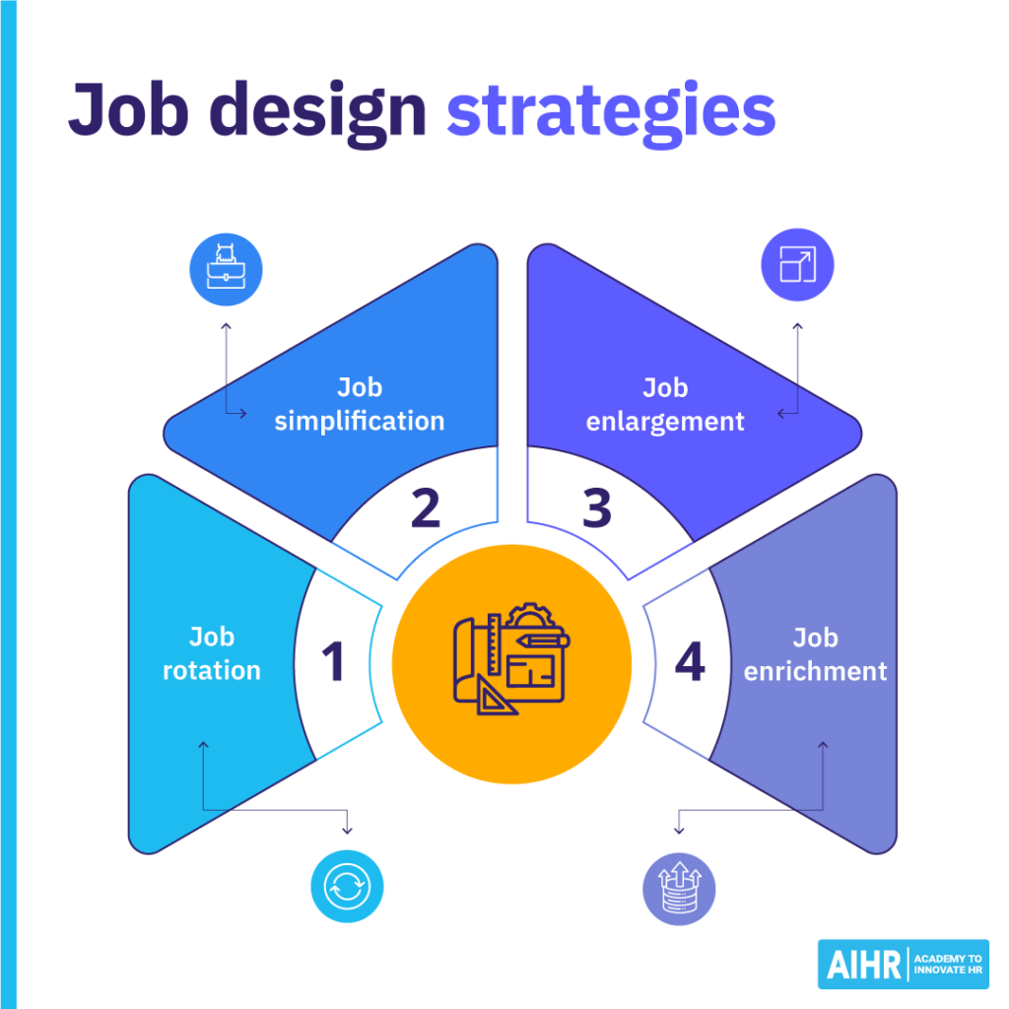
.

1.2.JOB CHARACTERISTICS MODEL
Hackman and Oldham (1976) suggest that there are five components of a job that give rise to intrinsic motivation – skill variety, task identity, task significance, autonomy and feedback. HUM needs to restructure jobs to expand:
• Variation of skills through cross sectional project activities.
Explain the importance/need of tasks explicitly with respect to urban sustainability outcomes.
• Autonomy through goal setting of results, not process.
Feedback by real-time project dashboards & involvement of stakeholders.
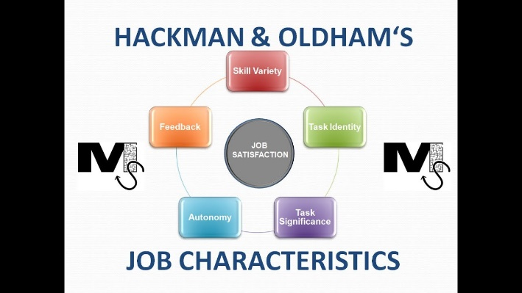
1.3.JOB CRAFTING
This theory of job crafting is based on the premise that individuals will proactively mold their jobs to make them more meaningful and fit to them (Wrzesniewski & Dutton, 2001). HUM needs to legitimate and support job crafting through:ss
Providing employees with a percentage of time to work on their own project ideas.
Educating training managers to become “crafting coaches” not task controllers.
Promoting relational crafting by involving stakeholders.
This helps to ensure that ownership and engagement are raised, especially with the higher caliber graduates who are looking for growth opportunities.

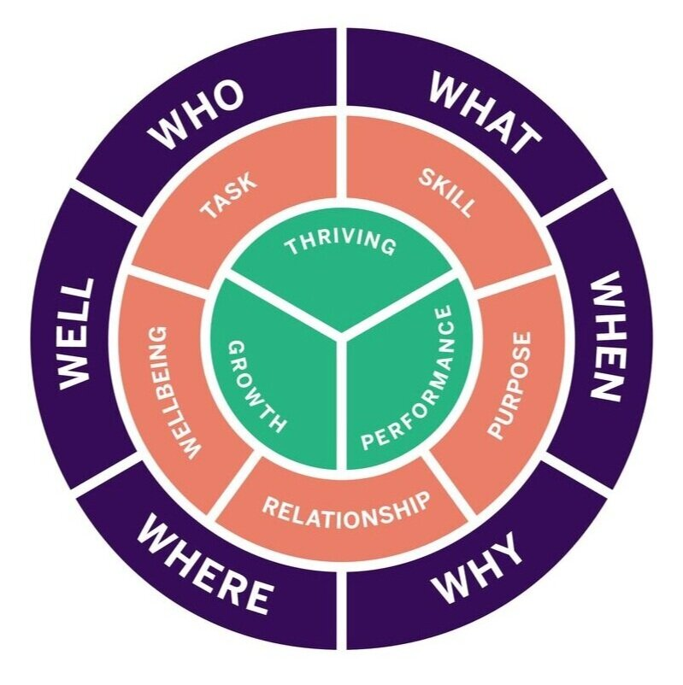

1.4.SBA and ITM (Internal Talent Marketplace)
A skills-based architecture replaces the traditional job-based with the more flexible concept of dynamic capabilities (Boudreau et al., 2015). HUM needs to have an internal Talent marketplace that matches the skills with the project, not the job. This enables:
Quick transfer of skills to innovation projects.
Ongoing skill enhancement and transparence of career opportunities.
Provided internal mobility options to minimise attrition.

2. PROVIDING ENCOURAGEMENT FOR INTRINSIC MOTIVATION AND INNOVATION
Based on self-determination theory (Deci & Ryan, 2000), the proposed job design helps to meet autonomy, competence and relatedness needs, thus boosting intrinsic motivation. Staff members have purposeful work, growth and contribute to society, which are all drivers of engagement.

2.1.Innovation is supported via:
Autonomy and ethical voice that foster psychological safety.
Knowledge recombination through cross functional mobility.
• The ability to learn new skills and adapt to new situations.
These mechanisms combine to make HUM an adaptive organization that can generate innovation.

TASK C: REFLECTIVE REPORT

1.INTRODUCTION
In this section, we discuss the use of AI as Decision-Support in order to avoid replacing Humans. first use of AI is as Decision-Support without replacing humans.
I believe that as an HR professional, my role is not to make a decision, but to be a decision support machine and that is what AI can do. AI can improve pattern recognition analysis in engagement data, attrition risk and skills forecasting, but it doesn't have any context, ethics, or moral responsibility.
In order not to become too reliant, I would:
Take AI answers with a grain of salt, and use them as hypotheses, not as conclusions.
Use triangulation of AI, qualitative and management judgement.
Be aware of algorithms and question and dispute unfair results.
This is in line with the Augmented Intelligence principle that relies upon the human judgment as the central principle in this approach (Davenport & Kirby, 2016).
A Personal Capability Development Plan (PCDP).
I will be seeking development in 4 areas to further improve my employability in the future:
Data Literacy:
I will become proficient in HR Analytics and will be able to critically analyse dashboards and have a questioning mindset towards data.
Utilizing AI to enhance human resources. Enhancing HR with AI.
While learning about ethical governance of AI in HR, I am looking to gain hands-on experience in using AI-powered HR tools.

2.STRATEGIC INFLUENCING SKILLS:
I will develop and improve my stakeholder management and persuasive communication skills to be able to work as a BUSINESS ACTIVIST and not a technical specialist.

3.GLOBAL MOBILITY AWARENESS:
I'm looking forward to increasing my knowledge of cross-cultural management and international labour markets and mobility policies, as HUM has an international presence.
By creating this integrated development plan, I am now in the role of an HR professional who will be able to reflect and is prepared for the future.

CONCLUSION
Helios Urban Mobility has problems because of the socialisation and job design systems, but not because of the lack of talent. HUM can achieve sustainable strategic renewal through a strategic human capital architecture based on identity-based socialisation, motivational job design and ethical business activism. The suggested framework emphasizes commitment, innovation and the value to stakeholders; ensuring that human capital is an asset that provides a competition advantage for the long term.

REFERENCES

- Ashforth, B.E. & Mael, F. (1989) ‘Social identity theory and the organization’, Academy of Management Review, 14(1), pp. 20–39.
Available at: https://doi.org/10.5465/amr.1989.4278999 (Accessed: 25 June 2026).
- Ashforth, B.E., Sluss, D.M. & Harrison, S.H. (2007) ‘Socialization in organizational contexts’, International Review of Industrial and Organizational Psychology, 22, pp. 1–70.
Available at: https://doi.org/10.1002/9780470753378.ch1 (Accessed: 25 June 2026).
- Bauer, T.N. & Erdogan, B. (2011) ‘Organizational socialization’, in Zedeck, S. (ed.) APA Handbook of Industrial and Organizational Psychology. Washington, DC: APA, pp. 51–64.
Available at: https://www.apa.org/pubs/books/4316015 (Accessed: 25 June 2026).
- Bauer, T.N. et al. (2007) ‘Newcomer adjustment during organizational socialization’, Journal of Applied Psychology, 92(3), pp. 707–721.
Available at: https://doi.org/10.1037/0021-9010.92.3.707 (Accessed: 25 June 2026).
- Boudreau, J.W., Jesuthasan, R. & Creelman, D. (2015) Lead the Work: Navigating a World Beyond Employment. Hoboken: Wiley.
Available at: https://www.wiley.com/en-gb/Lead+the+Work-p-9781119046538 (Accessed: 25 June 2026).
- Conway, N. & Briner, R.B. (2009) ‘Fifty years of psychological contract research’, International Review of Industrial and Organizational Psychology, 24, pp. 71–130.
Available at: https://doi.org/10.1002/9780470745267.ch3 (Accessed: 25 June 2026).
- Deci, E.L. & Ryan, R.M. (2000) ‘The “what” and “why” of goal pursuits’, Psychological Inquiry, 11(4), pp. 227–268.
Available at: https://doi.org/10.1207/S15327965PLI1104_01 (Accessed: 25 June 2026).
- Edmondson, A. (1999) ‘Psychological safety and learning behavior in work teams’, Administrative Science Quarterly, 44(2), pp. 350–383.
Available at: https://doi.org/10.2307/2666999 (Accessed: 25 June 2026).
- Hackman, J.R. & Oldham, G.R. (1976) ‘Motivation through the design of work’, Organizational Behaviour and Human Performance, 16(2), pp. 250–279.
Available at: https://doi.org/10.1016/0030-5073(76)90016-7 (Accessed: 25 June 2026).
- Ibarra, H. (1999) ‘Provisional selves’, Administrative Science Quarterly, 44(4), pp. 764–791.
Available at: https://doi.org/10.2307/2667055 (Accessed: 25 June 2026).
- Rousseau, D.M. (1995) Psychological Contracts in Organizations. Thousand Oaks: Sage.
Available at: https://uk.sagepub.com/en-gb/eur/psychological-contracts-in-organizations/book5384 (Accessed: 25 June 2026).
- Treviño, L.K., den Nieuwenboer, N.A. & Kish-Gephart, J.J. (2014) ‘Unethical behaviour in organizations’, Annual Review of Psychology, 65, pp. 635–660.
Available at: https://doi.org/10.1146/annurev-psych-113011-143745 (Accessed: 25 June 2026).
- Ulrich, D., Younger, J., Brockbank, W. & Ulrich, M. (2013) HR from the Outside In. New York: McGraw-Hill.
Available at: https://www.mheducation.com/highered/product/hr-outside-ulrich/M9780071802662.html (Accessed: 25 June 2026).
- Van Maanen, J. & Schein, E.H. (1979) ‘Toward a theory of organizational socialization’, Research in Organizational Behavior, 1, pp. 209–264.
Available at: https://dspace.mit.edu/handle/1721.1/1934 (Accessed: 25 June 2026).
- Wrzesniewski, A. & Dutton, J.E. (2001) ‘Crafting a job’, Academy of Management Review, 26(2), pp. 179–201.
Available at: https://doi.org/10.5465/amr.2001.4378011 (Accessed: 25 June 2026).

