A comparison of the marketing methods of two multinational hotel brands

Mihai Daniel Mihalcea
2244870
Marketing Essentials
BMIH4005
Dale Clarke
1448

Marketing Method Comparison: Holiday Inn vs Six Senses
The marketing mix includes product items, price mechanisms, placement opportunities, and promotional activities the business entities perform for marketing their operational products and services. From the product item side of the marketing mix tool, Six Senses strongly emphasises providing different types of wellness offerings and luxury experiences. The major product or service provided by the company is the resource which is being designed to create a tranquility sense. Also, it additionally offers different types of eco-adventures, spa treatments, and yoga retreats (Bojanic, 2022). Furthermore, this brand strongly emphasises sustainable practices using locally sourced raw materials and organic promotional environment conservation. The company also exhibits its commitment to society by participating in collaborative, fair trade practices. Therefore, customers can expect an eco-friendly luxury vacation experience at this hotel.
On the other hand, Holiday Inn Express offers very comfortable accommodations and a diverse range of amenities suitable for leisure and business travellers. In this case, the Holiday Inn Express company mainly features oil-equipped guest rooms for meeting different facilities, including swimming pools, fitness centres, and dining options. That is why the product of this company has become so accessible and consumer convenient for a wide range of travellers (Bojanic, 2022). Six Senses usually provides value exclusivity and some unique and premium exceptional services from that price mechanism. The company follows a premium pricing strategy, which is justified because they offer more personalised services, luxurious amenities, and sustainability initiatives. On the other hand, Holiday Inn Express provides an affordable or budgeted pricing mechanism. For this reason, the company offers different competitive rates for attracting budget-conscious travellers. Moreover, they provide a consistent level of service quality across their properties. Six Senses strategically selects breathtaking locations worldwide for their resort services. Some locations mainly feature different types of pristine natural environments, and some remote islands, mountainous regions, or lush jungles. However, Holiday Inn Express mainly focuses on easily accessible and convenient locations for budget-oriented customers (George, 2021). That is why they provide their services in major business cities and other popular tourist destinations so that convenient and comfortable service will be provided for their clients. From that promotional perspective of the market mix, it can be stated that Six Senses mainly promotes its operational brand by target marketing efforts, focusing mainly on luxury and sustainability. That's why they have different types of digital platforms along with partnerships with other travel agencies to reach their target customer audience. In contrast, the Holiday Inn Express mainly engages in promotional activities like implementing an effective search engine optimisation tool and other online travel agencies (George, 2021). In addition, they also provide different types of loyalty programs to encourage travellers.
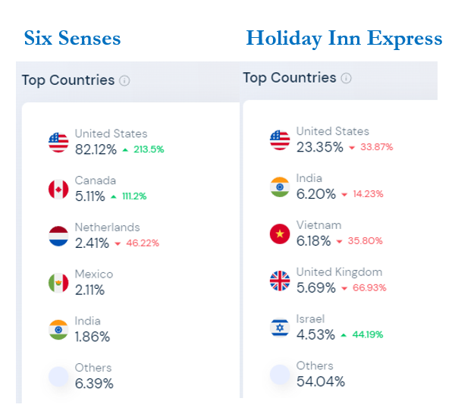
Figure 1: Country Segmentation (Source- (Similarweb, 2023)
Another important strategic marketing analysis aspect is segmentation, targeting and positioning or STP analysis. From a segmentation perspective, Six Senses mainly targets high-end luxury travellers seeking very immersive and exclusive experiences. That is why their target market mainly consists of affluent individuals persons. For this reason, the company mainly segments their markets based on different psychographic factors, focusing on environmental sustainability and customised services (Setini & Caisar Darma, 2020). On the other hand, Holiday Inn Express mainly adopts a broader perspective on market segmentation strategy. That is why they cater not only to business travellers but also to leisure travellers. Also, they can target diverse customer segments based on their demographics, like budget-conscious corporate travellers or family members. That is why the company has successfully provided comfortable accommodation and some other affordable, very appealing hotel amenities. From the above graphical representation of countrywide segmentation, it can be stated that Six Senses are mainly focused on the US and European region (Similarweb, 2023). On the other hand, Holiday Inn Express is focusing additionally on Asian countries as well. For instance, Six Senses has around 82% market share across the entire US market and also from that market Holiday Inn Express has around 23% market share (Similarweb, 2023). In addition, from the Asian market analysis, Holiday Inn Express has around 6% market share in India and Vietnam (Similarweb, 2023). From a targeting perspective, Six Senses mainly targets a very much niche market which consists of very high net-worth individuals who are mainly luxury travellers. This is why the company focuses on attracting guests, paying a very premium price for sustainable environmental practices and exceptional personalised guest experiences. The company's target customers are mainly interested in different types of eco-friendly resorts that will provide personalised service and immersive activities that mainly promote clients' well-being. On the other hand, Holiday Inn Express mainly focuses on a massive market targeting strategy, so they aim to capture many market shares by focusing on a broader customer base catering mechanism. As a result, they have targeted customers, mainly family members or business travellers and other tourists seeking very convenient and affordable accommodation alternatives. That is why that company provides each customer a comfortable and consistent guest experience across their properties, focusing on accessibility, reliability, and value for their expense. Six Senses has been positioned mainly by offering exclusive resorts in different types of breathtaking locations and focusing on their commitment to different types of environmentally sustainable conservations (Setini & Caisar Darma, 2020). That means the company positions or exhibits itself as an eco-conscious operational brand by promoting a holistic approach to the well-being of the people. On the other hand, Holiday Inn Express is an affordable and reliable hotel brand suitable for both leisure and business travellers. That is why they're mainly positioned as their travellers' trusted partner or brand by seeking hassle-free accommodation.
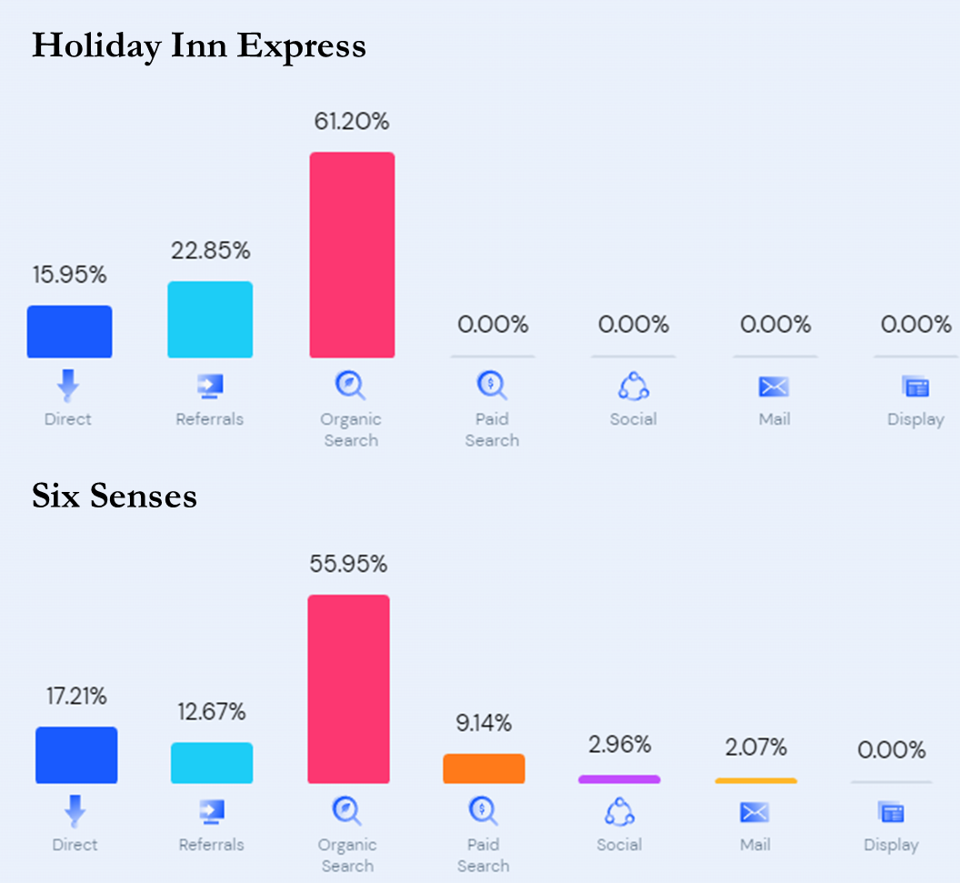
Figure 2: Marketing Channel Distribution (Source- (Similarweb, 2023)
The above graphical representation reflects different marketing strategies two operational hotel chains took. For both companies, the major portions of their marketing tactics are being developed by organic search, representing more than 55% for both companies (Similarweb, 2023). There are also direct marketing tactics used by both companies, which reflect more than 15% (Similarweb, 2023). Furthermore, another similar marketing tactic is also used for both companies: the referral program. And that is why there are similarities between those two companies regarding organic search, direct marketing and referral marketing programs (Similarweb, 2023). However, the major differential point among those companies' marketing strategies is adopting social media integration or digital marketing approaches. From the above graphical representation, it can be seen clearly that Holiday Inn Express has 0% marketing involvement in digital marketing platforms or social media platforms (Similarweb, 2023). However, on the other hand, around 3% of market promotion in social media platforms has been conducted by Six Senses (Similarweb, 2023). From this viewpoint, it can be easily understood that Six Senses Company is focusing on transitioning from traditional marketing tactics to digital marketing platforms like social media marketing adoption.
There are different types of contemporary issues like the COVID-19 situation, Russia Ukraine war, and other geopolitical issues. That is why there is a requirement for enhancing the marketing activities for better promotion from the companies in the hospitality market in the recent contemporary business world. First of all, companies need to focus on eco-friendly and sustainable practices. Six Senses have already emphasised this focus, which is why Holiday Inn Express needs to focus on environmentally friendly servicing to attract a new customer base. Another way to enhance their marketing activities is by showing support and empathy for the COVID-19 and Russia-Ukraine war-affected people. In this case, they can take different initiatives like partnerships with charitable institutions, fundraising campaigns, or contributions to different relief efforts to help the companies build a positive brand image and show their social commitment to the customers. In this way, the companies can enhance their marketing and promotional activities to be sustainable in the hospitality market, focusing on contemporary issues.
Six Senses and Holiday Inn Express have expressed their unique approaches to target and serve their desired customer base effectively. Six Senses accentuates its brand image with a luxurious yet sustainable business model. Holiday Inn contrasts the former by focusing its efforts towards serving a wider range of customers seeking affordable vacation destinations. The unique marketing strategy of Six Senses integrates both digital marketing and social media integration. Holiday Inn can follow the example of Six Senses and focus on eco-friendly messaging in its marketing campaigns to improve its brand image globally. This strategy can help the company attract a new niche of eco-conscious customers willing to pay a premium price for the products. The company can also partner with local businesses to share its drive for sustainability. This will both increase customer satisfaction and have a positive impact on local communities.

References
Bojanic, D. (2022) 'Hospitality marketing mix and service marketing principles', Handbook of Hospitality Marketing Management, pp. 59–84. doi:10.1016/b978-0-08-045080-3.50006-8.
George, R. (2021) 'Designing the tourism and hospitality promotions mix', Marketing Tourism and Hospitality, pp. 343–368. doi:10.1007/978-3-030-64111-5_11.
Setini, M. and Caisar Darma, D. (2020) 'Towards market share: Segmentation, Target and market position', International Business Management, 13(9), pp. 405–414. doi:10.36478/ibm.2019.405.414.
Similarweb, S. (2023a) Sixsenses.com Traffic Analytics & Market Share | similarweb. Available at: https://www.similarweb.com/website/sixsenses.com/ (Accessed: 16 May 2023).
Similarweb, S. (2023b) Similarweb.com market share, revenue and Traffic Analytics | Similarweb. Available at: https://www.similarweb.com/website/holidayinnexpress.com/#technologies (Accessed: 16 May 2023).

