
Component 1 – profesinal career development
BMSW4005

Andrei Selaru
2112461
November 19, 2021
University of Wales Trinity Saint David
WORDS: 2100

Contents
0
Introduction 2
Findings 3
Conclusion (average of 10% of word count) 9
References 9
Appendices 11

Introduction

The purpose of this reflection report is to demonstrate my skills and knowledge that make me capable of working effectively, my ability to succeed in the workplace, and my understanding of my strengths and potential for improvement. By understanding my improvement potential, it will also improve my self-awareness, and this will help me to make right decisions and boost my self-confidence. Stephen Covey (1989, cited in Simon & Schuster, 2020, p113) described self-awareness as a powerful must have tool to explore your deepest values and progress towards a limitless future. Continuous progression and self-improvement are on high importance in every individual life as through self-improvement you can identify and enhance your strength, from careers to personal relationships making the most of your strengths of vital importance. By identifying what you desire, you are more likely to excel.
By setting goals, you can achieve them. If you don't know what you want, you can't achieve it (Belin, 2021). In the report below I will be using notorious models and theories to define a personal development plan and set a career goal. This report will include a SMART goals analysis using S. Covey habits to help me define my goals and this will be related to Albert Humphrey SWOT model where I will include conversions strategies. I will also undertake and attach a VARK and Honey & Munford learning style questionnaire to discover and understand my learning style.

Findings

- SMART goals
Having goals provides purpose, motivation, a clear focus, and a sense of importance to your business or life. By setting goals, you provide yourself with a target to aim for. As an acronym, SMART stands for Specific, Measurable, Achievable, Realistic, and Timely. To achieve a SMART goal, each of these criteria must be considered, which enables you to narrow your focus and increase your chances of success. The reason I wish to change my status is the lack of personal progressions as well as professional, along with the need of accomplishment and financial safety feeling. A. Maslow (1954) identifies these needs and mentioned that in terms of evolutionary development, a higher need exists and defines us as species. Maslow proposed that motivation is the result of a person's attempt at fulfilling five basic needs: physiological, safety, social, esteem and self-actualization. According to Maslow, these needs can create internal pressures that can influence a person's behaviour. Below is my SMART goal.
Specific - I would like to secure a leadership position within my current workplace since I have worked for Amazon in the same role for 5 years. I will strive to obtain a higher position because I need to get out of my comfort zone in order to develop professionally and personally. Apart from the compulsory diploma that is required to apply for the job, I need to develop my employability skills such as writing a CV, communication, or academic writing. I would like to apply locally for the fulfilment centre located in the Jersey Marina area, but I will consider any opportunities on the 20 miles radius as there is more smaller locations belonging to the company.
Measurable – achievement of a level 6 certificate in Leadership and Management as well as obtaining the required skills. I will complete all three years of the course that I am currently enrolled on.
Achievable – To accomplish my goal, I will complete all assignments and get the passing grades to qualify for the certificate. I believe that my goal is realistic in light of the fact that I have close working experience with managers and other leaders in the warehouse.
Relevant – My goal is worthwhile for myself and my career, I find this being the right time as I’m 27 years old and, in my work experience I been acting the role of a bridge between manager and associates as I’ve been doing jobs that are in close contact with the management team, with many occasions where I been asked to perform some of their duties. As a short conclusion, I have had an inside look of what a manager job is, and I think I’m fit for this position.
Time bound – I will try to achieve my goal over 3 years with the deadline being 2024. Meanwhile I will learn all I need for it by attending all courses and passing all modules grades.

- SWOT analysis –
Albert S. Humphrey developed the SWOT Analysis in the 1960s. SWOT analysis is a simple model to assess what a business can and cannot do, along with its potential opportunities and threats. An organization uses a SWOT analysis to identify its internal and external issues (strengths, weaknesses, opportunities, and threats) based on its environmental analysis. My SWOT analysis is as fallows:

Strengths  • Hard working  • Leadership skills  • Good communication skills  • Fast learner | Weakness  • Time management  • Non-native English speaker  • Confidence issues  • Public speaking
Opportunities  • Current workplace  • Advancing technology  • Growing local economy  • Workforce demands | Threats  • Colleagues  • Unfair competition  • Changing economy  • Pandemic

  - Conversion Strategies
Public speaking - weakness to Opportunities
Use workplace opportunity to conduct team briefs in front of large group of people in order to overcome the fear and develop oratory skills. Also present myself in interviews.
Current workplace – opportunities to strengths
Take advantage of the vast resources and progression opportunities present in Amazon do educate myself into being more productive and efficient. I will ‘’sharpen the saw’’ by attending mock interviews for different positions, volunteer for learning activities and apply for apprenticeships related to my goals.
Confidence issues – weakness to strength
I will use workplace and this course to learn and expand new skills, I will overcome the insecure feeling by asking questions towards competent people every time I feel confused. I will also try to focus on my goals to eliminate negative distractions.

- Skills Audit
Employability skills are defined as those skills, understandings, and personal attributes that make graduates more likely to succeed in their chosen professions, benefiting their careers, the community, and the economy (Yorke, 2006 cited in Frances, 2017,).
A manager position in a big company as Amazon requires some sharp skills and I think the most skills that I’m lacking are the following: academic writing, time management, self-awareness. In this section I will present my plan to develop these skills.
Academic writing
- attend this course and read academic books and journals
- use the resources and tutorials given by the university
- improve vocabulary by looking to use uncommon synonyms and expressions related to the course
- request feedback from tutors and ways to improve writing
Time management
- plan ahead
- prioritize tasks
- try to finish my task before deadline
- limit things that I can say yes to do
- take advantage of technology to organise commitments by creating a shopping list like planner
- procrastinate on low impact tasks
Self-awareness
- clearly define my goals and plans
- take definitory tests such as personality and learning style tests
- develop productive habits
- objectively look on myself
- critically reflect on the day that just passed

3.1. Johari self-awareness window
Johari window techniques help people gain a deeper understanding of their relationship with themselves and others. Created in 1955 by psychologists Joseph Luft and Harrington Ingham, it is used primarily for experiential exercises in self-help groups and corporate backgrounds. Johari window is seen as an evaluation system for social interactions, as well as self-disclosure (Koca & Erigüç, 2020). The model is called Johari due to the combination of their first names Joseph and Ingham). Feedback is interpreted in this model as a way of conveying and accepting it. The Johari is defined as a four-paned common window this panel represents two aspects of self, while the other two represent parts of self-unknown to others. Through socializing and getting feedback from others in the group, information is transferred from one part to another as a result of mutual trust. Below I will apply Johari model on myself, and I will try to convert my resourceful attribute from not known to myself or others onto known to myself and others by:
- requesting to be assigned into unfamiliar task at work
- engage in small team projects
- educate myself into always searching for improvement

Powerful
Complex
Resourceful
Calm
Logical
Realistic
Intelligent
Trustworthy
Organised
Coherent
Overthinker
Nervous
Shy
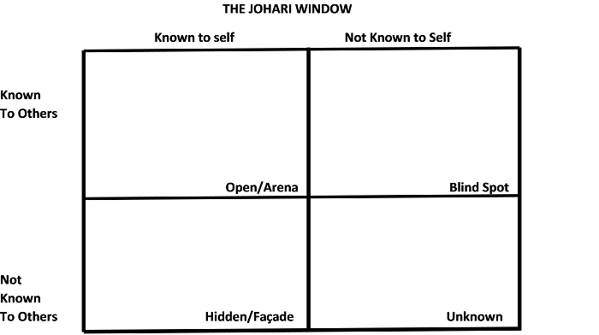
https://study.com/cimages/multimages/16/johari_window.png

3.2. The four stages of competence
Noel Burch developed this concept further in the 1970s, calling it "the four phases of learning new skills" after Martin M. Broadwell created the theory in 1969. Individuals who go from incompetence to competence for a certain skill may go through the progression of the four stages of competence. In an article in ‘’The gospel guardian’’ Broadwell (1969) writes about teaching, as a specific example of skill that a very few of individuals have without any effort to be made into developing that skill.
Academic writing is a skill that for me situates into conscious incompetence and I will try to move it towards conscious competence by taking following actions:
- produce academic work
- write my assignments
- write as I speak
- keep practicing writing outside modules assignments
- read academic work to improve vocabulary
- structure my work ahead
- write on point of subject to meet reader expectation
- get feedback before submitting final work

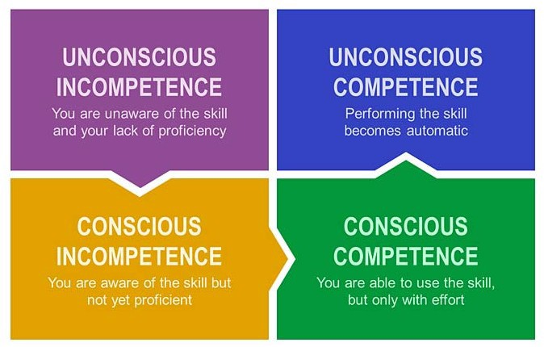
https://www.lanredahunsi.com/wp-content/uploads/2020/05/the-four-stages-of-competence.jpeg

- Learning Styles
4.1. VARK
In 1987, Neil Fleming, from Christchurch, New Zealand, developed a series of questions with help sheets which could be used individuals to strengthen their skills.
Despite its shortness and simplicity, it has been well received because its dimensions are intuitively understood, and it has practical applications that assist people in understanding each other (vark-learn, online).
According to VARK questionnaire, my learning style is Kinaesthetic. To help myself learning more efficient I can read lectures that has real life examples, pay more attention to exhibits, samples and photographs but I can also take field trips and field tours. It is recommended to focus on short concrete examples and information as those are the easier to recall for me.

4.2. Honey and Mumford
A refined version of Honey and Mumford's Learning Style Questionnaire was developed in 1985 in place of Kolb's Learning Style Inventory. Similar as VARK, the questionnaire has been designed to find and explore your learning style. In describing how an individual interacts with and responds to a learning environment, learning style is determined by a combination of cognitive, emotional, and psychological factors (Duff & Duffy, 1995).
After undertaking the Honey and Mumford questionnaire, it revealed that my learning style (close tie with reflector) is theorist. The theorist observations are adapted and incorporated into complex, logically sound theories. For them, problems are solved logically in a vertical manner. Various facts are integrated into a coherent theory. Theorists are perfectionists, they require tidying up and fitting everything into rational schemes before they can rest easy. They learn best from activities where they are intellectually stretched into situations with a clear purpose, and they are offered interesting concepts and ideas even they are not relevant immediately.

4.3. Personal Development Plan
PDP It is designed to achieve academic, career, or personal goals by developing detailed action plans to help achieve improvement. I find myself in the position to ask why I really came to university. I must realize that the motivations of people differ, along with the combination of the most important factors (Dawson, 2015).
Development Objectives | Specific Action | Barriers and how to overcome them | Support required | How will I know I have achieved the objective
Team working | Take part of group projects by performing the problem solve role and use my theorist skills to provide logical, straight-forward conclusions. | Lack of projects availability. I will request my supervisors to delegate me into small projects on behalf of company good. | Supervisors, colleagues. | Get feedback and measure results.
Leadership skills | Request more responsibility tasks and take ownership. | Bad feedback. I will reflective analyse what went good and wrong and come up with an improvement plan. | Supervisors. | Use my kinaesthetic learning style to focus on results and not get lost in detail.

Conclusion
Setting a professional goal is equally important as setting a personal goal. Every individual has a goal more or less defined with a clear or not plan to achieve it (Mann & Weston, 1993).
My goal is to progress in my career and now I have a well-defined plan along with various strategies to achieve it. Has been a learn full journey into discovering myself and set a plan to reach my goals. I discovered a lot of resources to help me develop my skills such as Covey 7 habits or/and Maslow pyramid. I will put this resource into good use and do my best to get my goal.

References
Abraham H. Maslow 1954, Motivation and personality, London: Harper & Row Publishers, [1954].
Angus Duff & Tim Duffy (2002) ‘Psychometric properties of Honey & Mumford's Learning Styles Questionnaire (LSQ)’, 33(1), pp 147-163.
Belin A, 2021, The importance of self-improvement no matter how old you are, Available at: https://www.lifehack.org/819195/importance-of-self-improvement, Accessed on 15/11/2021.
Dowson, P. (2015). Personal & professional development for business students.
Koca, & Erigüç, G. (2020). The effects of communication skills levels of health professionals on the dimensions of the Johari Window model. International Journal of Healthcare Management, 13(S1), pp 434–446. https://doi.org/10.1080/20479700.2019.1596393.
Mann, & Weston, P. (1993). Setting & Achieving Your Goals. Channel 1 Creative Media. Available at: https://video-alexanderstreet-com.ezproxy.uwtsd.ac.uk/watch/setting-achieving-your-goals?utm_campaign=Video&utm_medium=MARC&utm_source=aspresolver
Martin M. Broadwell (1969), The Gospel Guardian, Teaching for Learning, 20, pp 1-3. Available at: http://www.wordsfitlyspoken.org/gospel_guardian/v20/v20n41p1-3a.html accessed on 15/11/21
Stephen R. Covey, 1989, The 7 habits of highly effective people: powerful lessons in personal change, New York: Simon & Schuster, 2020, p113.
Trought, Frances. Brilliant Employability Skills PDF eBook: Brilliant Employability Skills 2e, Pearson Education, Limited, 2017. ProQuest eBook Central, Available at: http://ebookcentral.proquest.com/lib/trinity/detail.action?docID=5186341.
Vark-learn, Introduction to VARK, do you know how you learn? Available at: https://vark-learn.com/introduction-to-vark/ accessed on 18-11-2021

Appendices


