Innovation, Creativity and Value Creation in Health and Social Care
Student Name: Anita Johnsn
Student ID Number:2422551
Module Title: Changemakers: Creativity and Value Creation.
Lecturer's Name: Laila Surani
Module Code: BMHP501
Date of Submission:

Table of contents
Contents
INTRODUCTION 3
TASK 1: DEFINING KEY CONCEPTS IN PRACTICE 3
Innovation 3
Creativity 4
Value Creation 4
Change 4
TASK 2: MIND MAP – DIGITAL EXCLUSION IN HEALTH AND SOCIAL CARE 5
TASK 3: SELF-REFLECTION ON THE CONVERGENT AND DIVERGENT THINKING ACTIVITY 6
TASK 4: DIGITAL THERAPY TOOLS 7
TASK 5: STAFF BURNOUT IN HEALTH AND SOCIAL CARE 8
TASK 6: EXPLORING DIGITAL INNOVATION IN HEALTH AND SOCIAL CARE 9
Wearable Health Technologies and Chronic Condition Management 9
Electronic Health Records and Provider Communication 9
Digital Technology for Preventive Care and Health Promotion 9
TASK 7: UNDERSTANDING THE NHS LEADERSHIP FRAMEWORK 10
TASK 8: SELF-REFLECTION JOURNAL ENTRY 11
Reference List. 11

INTRODUCTION

This portfolio offers evidence of my engagement with the module content on innovation, creativity, leadership, and value creation within health and social care. Additionally, I relate theoretical models to real practice examples, critically reflect on my own learning, and evaluate a UK innovation and a current workforce issue using peer-reviewed evidence across eight tasks. This is because the demand for health and social care services is rising, the workforce is in short supply, and resources are limited, making the ability to develop innovative, value-adding, and sustainable solutions more crucial than ever (Porter, 2010). Therefore, the portfolio moves from identifying key concepts to analysing their application in practice and reflecting on how this learning will influence my future professional approach.

TASK 1: DEFINING KEY CONCEPTS IN PRACTICE

Innovation

Innovation is defined as the successful implementation of a new or significantly improved idea, product, service or process that creates value (Rogers, 2003). Rogers’ Diffusion of Innovation Theory describes how new ideas and technologies are disseminated within organisations and are slowly accepted by employees (Rogers, 2003). Innovation is important in health and social care because of the ageing population, staff shortages, and the increasing costs of care, which mean that current methods of working are not always sustainable and that new approaches are needed to ensure the quality of care (Porter, 2010). For example, remote monitoring technology in community nursing enables vital signs to be monitored at home rather than through repeated home visits, freeing up staff time for patients with more complex needs.

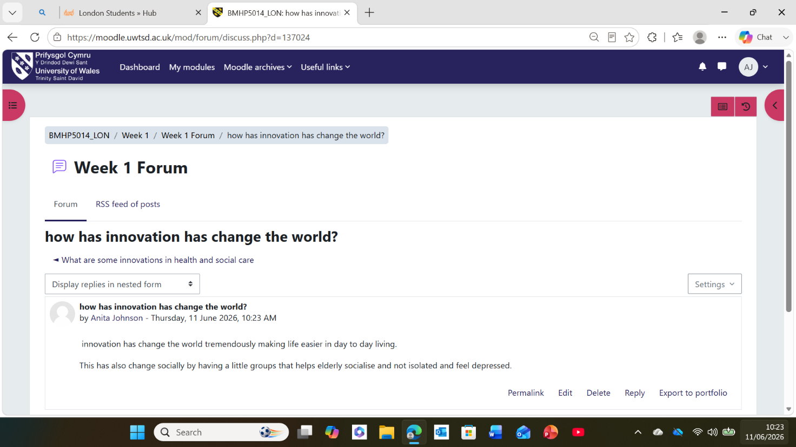

Creativity

Creativity is the production of new and useful ideas, and in a care context, this is the ability to think in new ways to address ongoing issues (Amabile, 1996). According to Amabile's Componential Theory of Creativity, creativity results from the combination of individuals' knowledge, skills, and motivation to generate useful new ideas (Amabile, 1996). Creativity is important in health and social care because rigid, procedure-driven environments can otherwise limit staff's ability to respond flexibly to individual service-user needs. For instance, a care home staff team rearranges mealtimes to allow people with dementia to eat together, select their own food and have a more relaxed atmosphere. As a result, this simple change helps improve their well-being and quality of life.

Value Creation

Value creation means providing better care and achieving good results while making good use of available resources. According to Porter, value in healthcare is defined as "the improvement of patient outcomes at a lower cost of delivering the care" (Porter, 2010). In health and social care, this idea is significant because budgets are limited and more people require care. As a result, organisations must demonstrate that the money they spend leads to better care and better outcomes, rather than simply providing more services. For instance, a hospital discharge team can help prevent unnecessary hospital readmissions by ensuring patients receive appropriate follow-up care after discharge. Consequently, this is not only good for patients

Change
In an organisational context, change is the transition from a current state of working to a new, improved state. According to Lewin's Change Management Model, change occurs through unfreezing current practice, implementing new behaviours, and stabilising the improvement (Burnes, 2017). In health and social care, it is important to understand change because it is constantly occurring, with new policies, technologies, and models of care being introduced. If change is poorly managed, it can lead to staff resistance and disruption to patient care.

TASK 2: MIND MAP – DIGITAL EXCLUSION IN HEALTH AND SOCIAL CARE
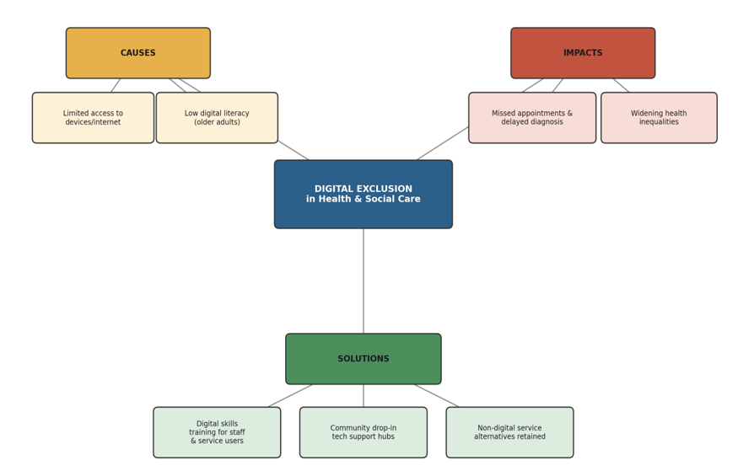

Digital exclusion, defined as the inability of service users to access or fully trust digital health services, is important because, as more services become digital, it could exacerbate health inequalities. According to a systems-thinking approach, health and social care issues are caused by a combination of factors within the broader care system rather than a single cause (Meadows, 2008), and so the mind map does not view digital exclusion as a single problem. Firstly, the causes include limited access to devices or the internet, as well as low digital literacy, especially among older adults. Consequently, the impacts branch illustrates how these causes result in missed appointments, delayed diagnosis and increasing inequality. If unaddressed, the people already most disadvantaged, such as older or low-income service users, would be further excluded from care. Therefore, the solutions branch recommends digital skills training, community support hubs, and the retention of non-digital alternatives.

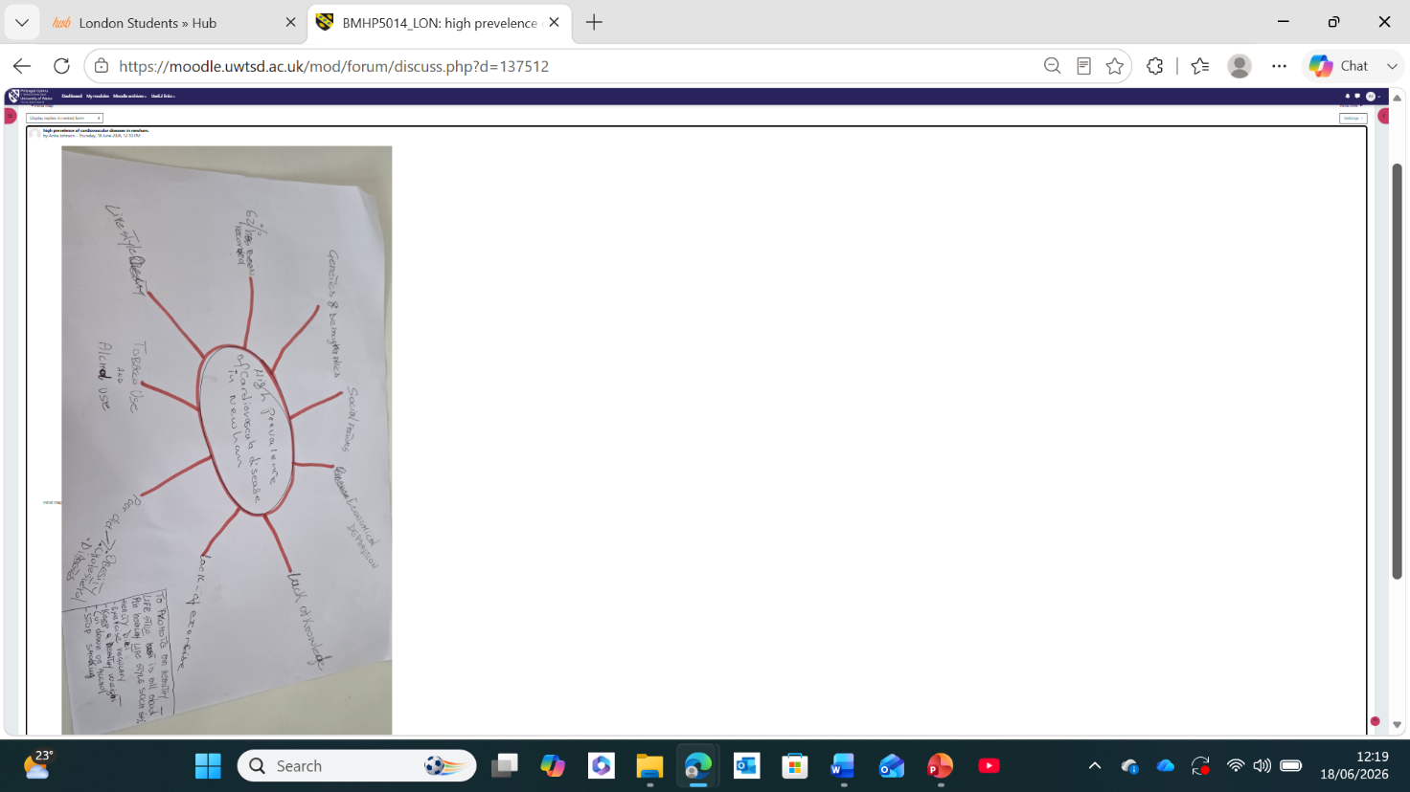

TASK 3: SELF-REFLECTION ON THE CONVERGENT AND DIVERGENT THINKING ACTIVITY

Using Gibbs' (1988) Reflective Cycle, I reflect on the Convergent and Divergent Thinking group activity. Divergent thinking is the generation of many ideas or solutions, whereas convergent thinking is the process of narrowing down the ideas to the most viable solution (Gibbs, 1988). Our group was asked to generate solutions to reduce missed outpatient appointments and then select one to present. Feelings: I initially found the open, divergent brainstorming stage uncomfortable, because I prefer structure. Evaluation: divergent thinking generated a variety of ideas, such as reminder text messages and transport support; however, the group did not seem to be able to shift to convergent thinking without conflict. Analysis: When we didn't agree, I proposed a list of pros and cons against the agreed criteria, which brought the group to a decision efficiently. Conclusion: I discovered that I am more of a convergent thinker and that tools can help balance a divergent-thinking team. Therefore, next time, I would use a decision-making tool earlier in the process, before there is any disagreement, to keep the group moving productively.



TASK 4: DIGITAL THERAPY TOOLS

SilverCloud, an online cognitive behavioural therapy (CBT) programme delivered through NHS Talking Therapies, was selected as the digital therapy innovation for this case study. The need arose from long waiting lists for face-to-face psychological therapy and limited workforce capacity to meet rising demand for treatment of mild-to-moderate anxiety and depression (NHS England, 2024). In response, creativity was applied by reimagining CBT delivery as a self-guided, interactive online programme that patients can complete independently or with therapist support, rather than relying solely on fixed weekly appointments (NHS England, 2024). According to Rogers' Diffusion of Innovation Theory, new healthcare ideas are adopted over time when they are seen as useful, easy to use and beneficial to staff and patients (Rogers, 2003), which reflects SilverCloud's growing adoption across NHS Talking Therapies services nationally. However, the results are not always the same. While NHS-funded services report high patient satisfaction and good improvement for many adults, a 2025 study of the SilverCloud programme in a Child and Adolescent Mental Service found no major improvement in symptoms. This shows that the programme may work well for some groups but not for others (Bell, 2025).

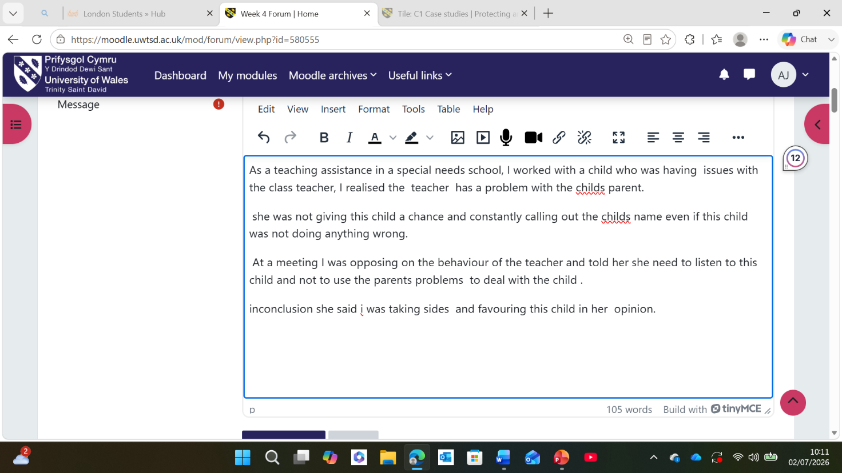

TASK 5: STAFF BURNOUT IN HEALTH AND SOCIAL CARE

Staff burnout is a current issue that has been identified as a persistent problem in the health and social care workforce. For example, around 1,900 healthcare staff were surveyed by Telzak et al. (2022), and they found that a lack of organisational capacity to meet patients' wider social needs was strongly associated with burnout, indicating that burnout is not just about workload, but about a lack of ability to meet the wider social needs of patients. This is why staff in roles with high emotional demands, such as community and social care, might be particularly vulnerable. Similarly, Hansel, Saltzman and Melton (2024). studied healthcare workers in medically underserved, disaster-prone communities and found high rates of depression, anxiety and burnout, connected to individual stressors, agency-level factors such as scheduling and workload, and wider systemic pressures. Overall, both articles concur that burnout is a complex phenomenon, not a result of a single cause, and that organisational and systemic factors are important contributors rather than individual resilience. However, they vary in emphasis: Telzak et al. (2022) emphasise the emotional toll of unmet social needs, whereas Hansel, Saltzman, and Melton (2024) emphasise structural and environmental stressors. In practice, burnout manifests as staff shortages, sickness absence, and reduced quality of care in real care settings.

TASK 6: EXPLORING DIGITAL INNOVATION IN HEALTH AND SOCIAL CARE

Wearable Health Technologies and Chronic Condition Management

Smartwatches and other wearable devices enable ongoing monitoring of vital signs, activity levels and symptoms, providing patients and clinicians with real-time information about a chronic condition, not just at periodic check-ups. According to Adepoju (2025), wearable technology can help detect deterioration earlier and enable more personalised treatment adjustments for diseases such as diabetes and cardiovascular disease, thereby giving patients greater control over their health. In addition, the Technology Acceptance Model suggests that if digital healthcare tools are useful and easy to use, patients are more likely to use them, which is relevant, as wearables with simple interfaces tend to have higher patient engagement. For instance, a person with type 2 diabetes who wears a continuous glucose monitor can make immediate changes to their diet and activity, thereby avoiding emergency hospital admission.

Electronic Health Records and Provider Communication

Electronic Health Records (EHRs) enable patient data to be accessed instantly by teams and settings, rather than relying on paper notes or delayed handoffs. For example, Vos et al. (2020) found that EHRs can facilitate collaboration by providing shared overviews, messaging, and awareness across various medical specialities; however, this is contingent on the consistency of staff use of the system. Similarly, Amano et al. (2023) found that EHRs can be used to communicate efficiently and effectively among care teams, though they can hinder more social and richer communication when used excessively. In practice, a community nurse and hospital consultant can access the same current medication record for the same patient, which helps to minimise the risk of prescribing errors at discharge and thus enhances continuity of care

Digital Technology for Preventive Care and Health Promotion

Digital technology is increasingly used to deliver preventive care, moving away from reactive treatment toward proactive health promotion by identifying risk before the condition becomes serious. For example, a wearable device that tracks glucose levels or blood pressure can warn the user of early signs of cardiovascular risk, thereby enabling lifestyle changes or clinical assessment before a costly hospital admission becomes necessary (Adepoju, 2025). In addition, a hypothetical example is a local authority public health team implementing an app-based step-count challenge linked to wearable data to promote physical activity in a community with high levels of obesity-related illness, thereby engaging the population at large and individuals through technology.

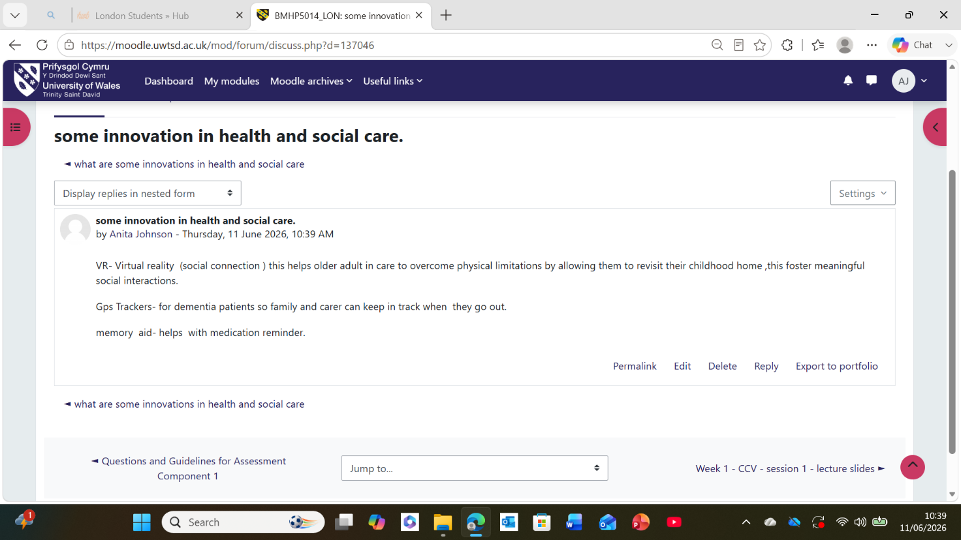

TASK 7: UNDERSTANDING THE NHS LEADERSHIP FRAMEWORK

The NHS Healthcare Leadership Model sets out nine dimensions of leadership behaviour: inspiring shared purpose, leading with care, evaluating information, connecting our service, sharing the vision, engaging the team, holding to account, developing capability, and influencing for results (NHS Leadership Academy, 2013). However, the model does not define leadership as a specific role or position, but rather as a series of observable behaviours that can be exhibited by any member of staff, regardless of their position. This is important in health and social care because effective, distributed leadership at every level, from ward staff to executives, has been shown to influence the quality, safety and consistency of patient care. In addition, the model provides a shared language for teams to review their leadership development and identify areas for growth.
One of the leadership behaviours is inspiring shared purpose, which is about establishing a shared sense of direction that links individual staff actions to patient outcomes (NHS Leadership Academy, 2013). Similarly, transformational leadership entails motivating employees by setting a vision, encouraging and supporting them, and facilitating the development of new ideas and practices (Bass and Avolio, 1994). For example, a ward manager who uses this behaviour may regularly communicate that a new documentation process is directly related to safer patient care, thereby ensuring staff feel motivated to embrace change rather than fear it and foster a more creative and improvement-oriented team culture.

TASK 8: SELF-REFLECTION JOURNAL ENTRY

This module has changed how I understand creativity, moving me away from viewing it as an innate talent and towards Amabile's (1996) view that creativity can be deliberately developed by combining knowledge, skill and motivation. In particular, the Case Study task on SilverCloud, an online cognitive behavioural therapy (CBT) programme, helped me to understand that innovation in health and social care is not necessarily about creating something new, but rather about using existing technology and resources in new and creative ways to address a pressing problem. Similarly, the Convergent and Divergent Thinking activity helped me realise that I am more of a convergent thinker, and that by being aware of this, I can create space for more divergent and exploratory thinking in group discussions. Going forward, I will continue to apply the idea of value creation to my practice by constantly asking myself whether a new idea is creative or adds value to the service user relative to the resources it consumes (Porter, 2010).

Reference List.
Adepoju, V.A., Jamil, S., Biswas, M.S. and Chowdhury, A.A. (2025) 'Wearable technology in the management of chronic diseases: A growing concern', Chronic Diseases and Translational Medicine, 11(2), pp. 117–121. Available at: https://mednexus.org/doi/pdf/10.1002/cdt3.156 (Accessed: 9 July 2026).
Amabile, T.M. (1996). Creativity in Context. Boulder, CO: Westview Press.
Amano, A., Brown-Johnson, C.G., Winget, M., Sinha, A., Shah, S., Sinsky, C.A., Sharp, C., Shanafelt, T. and Skeff, K. (2023) 'Perspectives on the intersection of electronic health records and health care team communication, function, and well-being', JAMA Network Open, 6(5), p. e2313178.
Bass, B.M. and Avolio, B.J. (eds.) (1994) Improving Organisational Effectiveness through Transformational Leadership. Thousand Oaks, CA: Sage.
Bell, D. (2025) 'Evaluation of a trial of computerised cognitive behavioural therapy programme within local child and adolescent mental health services', Journal of Evaluation in Clinical Practice, 31(1), p. e70022. Available at: https://onlinelibrary.wiley.com/doi/pdf/10.1111/jep.70022 (Accessed: 8 July 2026).
Burnes, B. (2017). Managing Change. 7th edn. Harlow: Pearson Education.
Davis, F.D. (1989) 'Perceived usefulness, perceived ease of use, and user acceptance of information technology', MIS Quarterly, 13(3), pp. 319–340.
Gibbs, G. (1988) Learning by Doing: A Guide to Teaching and Learning Methods. Oxford: Further Education Unit, Oxford Polytechnic.
Hansel, T.C., Saltzman, L.Y. and Melton, P.A. (2024) 'Work environment and health care workforce well-being: Mental health and burnout in medically underserved communities prone to disaster', American Journal of Public Health, 114(S2), pp. S156–S161. Available at: https://ajph.aphapublications.org/doi/pdf/10.2105/AJPH.2023.307478 (Accessed: 9 July 2026).
Meadows, D.H. (2008). Thinking in Systems: A Primer. White River Junction, VT: Chelsea Green Publishing.
NHS England (2024) Digitally Enabled Therapies: Assessment Criteria. Available at: https://www.england.nhs.uk/mental-health/adults/nhs-talking-therapies/digital/assessment-criteria/ (Accessed: 8 July 2026).
NHS Leadership Academy (2013) The Healthcare Leadership Model: The Nine Dimensions of Leadership Behaviour. Leeds: NHS Leadership Academy.
Porter, M.E. (2010) 'What is the value in health care?', New England Journal of Medicine, 363(26), pp. 2477–2481.
Rogers, E.M. (2003). Diffusion of Innovations. 5th edn. New York: Free Press.
Telzak, A., Chambers, E.C., Gutnick, D., Flattau, A., Chaya, J., McAuliff, K. and Rapkin, B. (2022) 'Health care worker burnout and perceived capacity to address social needs', Population Health Management, 25(3), pp. 352–361. Available at: https://pmc.ncbi.nlm.nih.gov/articles/PMC9232233/pdf/pop.2021.0175.pdf (Accessed: 7 July 2026).
Vos, J.F., Boonstra, A., Kooistra, A., Seelen, M. and Van Offenbeek, M. (2020) 'The influence of electronic health record use on collaboration among medical specialties', BMC Health Services Research, 20(1), p. 676. Available at: https://link.springer.com/content/pdf/10.1186/s12913-020-05542-6.pdf (Accessed: 9 July 2026).

