Engine control systems
Electronic ignition and fuel injection systems

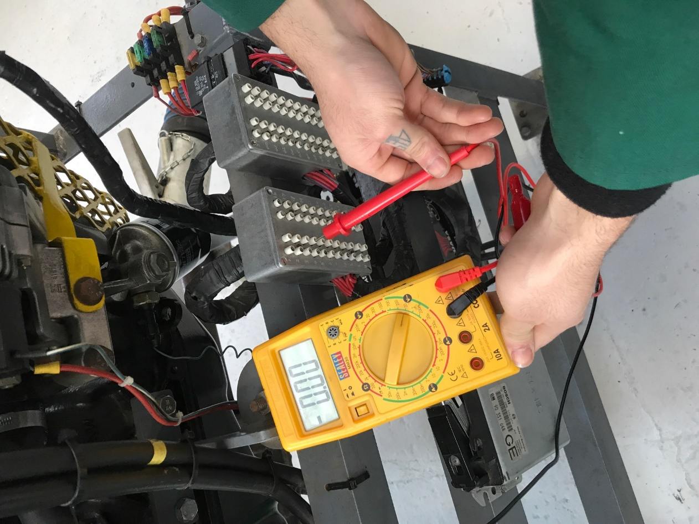

By
Deion Atkinson

Contents
Introduction 3
Research and Literature review 4
Methodology 6
Analysis of Results 9
Motronic System – Static Test 9
Jetronic LE3 – Static Test 10
Motronic System - Live test 11
Jetronic LE3 – Live Test 13
NTC2 Graph – Comparison 14
Motronic Waveforms Analysis 15
Jetronic Waveform Analysis 17
References 18
Appendicies 19

Introduction

In the automotive industry many advancements have been made over the years to improve engine control systems, the variation of advancements can be seen when comparing vehicles makes and models, but the popular and most looked at advancement to this day is using fully electrical vehicles instead of the fuel combustion engine. Looking at two different engine control systems, the Motronic and Le3, a full systems operation test will be carried out by a working group comparing the two systems. Examination will be to explain how injection on time is addressed to meet the different operating conditions that would frequently occur on an engine, inputting all compulsory safety measures required by law in the workshop.
The different operating conditions that will be tested in the workshop are:
- Ignition on, engine not running
- Cranking from cold
- Warm up procedure
- Acceleration
- Deceleration
- Idle speed at operating temperature

The test equipment used to carry out the engine testing is included with a brief explanation of why they are used and what they are used for within the automotive engineering industry. Before the live testing commenced, test readings are compared to manufacturer’s specifications on the engines, using the ECU pins and different sensors and actuators on the engines. The data collected from the live test results will be analysed and compared between the two systems by using data tables and graphs. Plotting these graphs will give an understanding of the differences between the two systems and how they adapt differently to engine temperatures, which are explained and discussed. Differences in the main system operations of the engines are compared, therefore a discussion will take place with the intention of improving one of the engines by modifying and changing latter technology with newer ones that would be of benefit for the engine, not taking into consideration how they would be fitted and what would need to be modified to achieve the change in component.

Research and Literature review

The Bosch Motronic 4.1 management system was introduced on a 2 litre Vauxhall engine in 1987, despite changes made to the chassis in 1989 the management system was still the same. In the early 1990’s, Bosch changed the system to the Motronic 1.5 which was slightly different to the 4.1, the reason being that the 1.5 system had a throttle position sensor instead of a throttle position switch, giving the ability to test all throttle positions and movement. Also introduced in the 1980’s was the Jetronic LE3 management system, this one being slightly older than the Motronic system and having less modern technology.

In the late 1980’s the emission regulations changed due to government proposals, this led to an agreement for manufacturers to produce new engines with cleaner emissions. This agreement is what changed fuel-delivery designs from carburettors to electronically controlled management systems, some companies modified the current carburettors to be fitted with an electronically controlled system, but the increasing demand for better fuel economy and lower emissions caused the carburettor system for a more suitable design. Improvements were made and electronic petrol injection was introduces, this provided manufacturers with better engine performance and fuel economy along with a better way of monitoring and altering the ignition and fuel injection process (Hillier, 2014). From this change in regulation, developments in engine control systems have advanced and keep on doing so.

Engine management, generally used to describe an electronically controlled engine system, its complexity varies throughout a variety of makes and models of vehicles. Several sensors provide computer inputs and there are several actuators that respond to computer outputs, for the system to operate efficiently all of these sensors and actuators need to respond in a fully working order, causing no faults in the system. Despite the system being in fully working order, some faults may be caused by non-electronic parts such as a faulty spark plug or a dirty air filter, justifying the reason of analysing the engine before any electronic diagnosis is attempted (Bonnick, 1998).

The purpose of the engine control system is to accurately control the air and fuel mixture ratio via a fuel injection system, to provide precise ignition timing for all operating conditions such as cold cranking and warm up phase, and to monitor numerous additional parameters such as exhaust-gas recirculation and idle speed throughout the operating conditions (Chowanietz, 1995). This is all done through the ECU, engine control unit, the ECU is a microprocessor-based control unit that processes signals by taking the inputs from the sensors and deciding what actions the actuators should take. Identifying faults in a system is much easier when the ECU is found, this is done by identifying its inputs and outputs. Types of sensors that input into the ECU are knock sensors and temperature sensors, by inputting this information into the ECU it can then control the ignition and fuel much better and make the engine more economical and efficient (Robinson, 1994).

Methodology

To be able to get the most accurate results on the engines the equipment needs to be of a high standard and used in the right manner. Dedicated testing equipment was used to carry out the testing, after ensuring that the equipment is in fully working order and checked regularly. Multimeters were used to carry out the static tests and for the live testing, a Bosch dual scope was used. A dual scope is a dedicated piece of testing equipment which is very popular in the automotive industry, this type of testing equipment is a digital oscilloscope that you can control and change readings with different voltage and time intervals. The software is easy to use and very efficient, making it one of the most popularly used control systems tester in the industry, providing the same end result as an analogue oscilloscope but giving the ability to freeze and save the plotted information, unlike the analogue version (Denton, 1995). Once the dipstick of the dual-scope is inserted into the engine instead of the original dipstick, the computer will show what the temperature of the engine is, making it easier to test in intervals without having to check the temperature too often. Testing the engines in the workshop meant that the data wasn’t going to be as accurate as it would in a test cell because of the front door being opened before-hand in case one of the exhaust vents started to leak. This meant that the environment the engine was tested in had changed which will have an impact on some of the results. Both engines are tested in 10 degrees of oil temperature increments but couldn’t be tested at 0 degrees because the room temperature was 15 or above. This didn’t have an impact on the initial live testing but prevented the engines from being tested from 0 degrees.

While using the workshop to test the engines, health and safety procedures had to be adhered to by every individual in the working facility. Working in the motor industry can be very dangerous, workshops with heavy machinery, compressed gas and many other different dangers surround a motor vehicle workshop. When testing the engines in the workshop personal protective equipment had to be worn, steel toe cap boots and dust coats are mandatory. Also making sure that all jewellery is removed along with clothing that could be caught in machinery such as scarfs.

Before the testing commenced, one of the most important thing to be done is cover the exhaust with the vent pipe to ensure there are no fumes leaking into the building, after doing this a check must be done to ensure there is nothing loose and that everything is ready to start, for example, check if the belt guards are all tight and all the safety equipment is ready such as the fire extinguishers. While the engines are being tested everyone must stand back and make sure that nothing can be trapped in the drive belt of the engine. Oil and water leaks are to be checked for throughout the testing period and if any leaks occur they need to be cleaned with absorbing pads to prevent anyone from slipping.

The first part of testing was a static test on both systems, this was done by checking all of the ECU pins for voltage to make sure everything was connected and that the battery voltage was present, these checks were done along with resistance checks within the sensors that were fitted onto the engine. This type of test was done to ensure that there weren’t any defects before starting the live testing, the resistances were checked on the sensors and then compared with values in the book provided in the workshop ensuring confidence that all sensors were in fully working order. An example of sensor testing is the throttle switch, this is when the throttle switch indicates the ECU where the throttle is, for example if the throttle was at idle position then the ECU processes the information and alters the air/fuel ratio to suit the engine speed, making the engine run smoothly. At total opposite, which would be throttle fully open, the ECU will receive a signal from the throttle switch and enrich the air/fuel mixture, these changes are all down to the throttle switch (Bonnick, 1998). The ECU pins were checked for voltage values to ensure the battery wasn’t too weak, this was done by checking the pins and ensuring that the battery supply pin had around 12 volts of supply, meaning that the battery was in fully working order.

Live testing was then performed on the engines, giving a clear understanding that the Motronic system is a little further advanced due to there being more ECU pins and sensors to test. Dynamically testing the engines with a dual scope gives much more conclusive information giving a better understanding of how the engine management system works. The dynamic test of both systems was performed in 10 degree increments of the oil temperature, doing this provided information on the range of operating conditions, from cold to operating temperature.

While the engines were being live tested, once up to the right temperature, the resistance and voltage value of the NTC2 was recorded, this was done to see the differences between the readings as the engine warmed up because the relationship between the two will determine a fault in the system if the values don’t gradually increase or decrease. This is because of Ohms law, where the relationship between the current in a conductor and the voltage across it are linearly proportional. Meaning that for a given constant resistance, if one electrical quantity is increased or decreased by a certain percentage, the other quantity will increase or decrease by the same percentage. Given this description, the resistance of a conductor is the ratio between V/I, where V is the potential difference across the conductor and I is the current in it (Chowanietz, 1995).

Analysis of Results

Motronic System – Static Test

 | Test Results | Book Tolerances
Potentiometer | Throttle closed – 2000 Ohms  Throttle open – 1040 Ohms | 1900 – 2000 Ohms  1000 – 2000 Ohms
Air flow sensor | Pin 4 and 1 – No catalytic converter  Pin 4 and 2 – 30 Ohms  Pin 4 and 3 – 560 Ohms | 8 – 2500 Ohms  300 – 550 Ohms
Idle control valve | 7.9 Ohms | 8 Ohms
Injector resistance | All four – 15.7 Ohms | All four to be 15 – 17 Ohms
Ignition coil | Primary – 9 Ohms  Secondary – 7060 Ohms
HT Leads | 1 - 18040 Ohms  2 - 17700 Ohms  3 - 15000 Ohms  4 – 20030 Ohms
Table 1- Motronic Static Test Results
From the table above, the data gathered from the static test on the Motronic system shows that everything was in tolerance with the tolerances given by the Vauxhall handbook. This gives the confidence to pursue onto live testing knowing that every component tested gives the right resistance reading. Looking at the resistances in the HT leads it shows that the value decreases as the leads get shorter, this is because the longer the wire the lower the current. As said in Hillier sixth edition, the resistance in a wire is the opposite of the current, therefore the longer the wire the larger the resistance (Hillier, 2014). But looking at lead number 4, the resistance dramatically increases back up to 20030 Ohms, meaning that there must be a fault in the lead or that the multimeter wasn’t accurately read. While doing the static tests the ignition was on but the engine wasn’t running, meaning the injection on time was completely off.

Jetronic LE3 – Static Test

 | Test readings | Book readings
Throttle switch | 0  O.L | 0  O.L
Aux air valve | 46.7 Ohms | 40 Ohms
Injector | All injectors read 16.1 Ohms | All injectors to read 15-17 Ohms
HT Leads | 1 – 8590 Ohms  2 – 8580 Ohms  3 – 7443 Ohms  4 – 5400 Ohms  King lead – 5570 Ohms
Ignition coil | Primary – 0.8 Ohms  Secondary – 7560 Ohms
Table 2 - Jetronic LE3 Static Test Results

Above are the static test results for the Jetronic system, comparing the test results to the book results it shows that all readings were in tolerance giving the impression that all of the tested equipment on the engine was in working order and that the live testing can commence. Unlike the Motronic system test results, the HT leads were tested and the value of the resistance recorder is seen gradually decreasing meaning that there are no obvious faults within the leads, the king lead reading shows that it is slightly shorter than lead number 4 because of the slightly higher resistance reading. Unlike the Motronic system, the LE3 system uses a throttle switch instead of a throttle potentiometer, this means that the throttle position can only be tested at closed or open.

Motronic System - Live test

Oil Temperature | NTC2 - Ohms | NTC2 - Volts | Injection m/s | Keying ratio  % | Charcoal solenoid | Lambda sensor
20 | 1750 | 3.3 | 3.2 | 47 | OFF | OFF
30 | 1050 | 2.6 | 3.7 | 45 | OFF | OFF
40 | 680 | 2.1 | 3.0 | 49 | OFF | ON
50 | 472 | 1.7 | 3.0 | 41 | OFF | ON
60 | 311 | 1.2 | 2.9 | 45 | ON | ON
70 | 271 | 1.1 | 3.0 | 47 | ON | ON
80 | 243 | 1.1 | 3.4 | 46 | ON | ON
Table 3 - Motronic Live Test Results

Similar to the Jetronic system results below, the table above shows that the NTC2 values decrease as the temperature rises, and so does the injection. But the injection results show that at 80 degrees the injection increases by 0.4 milliseconds, this could be because the engine wasn’t quite at perfect idle when the recording was taken on the computer. Unlike the Jetronic system, the injection time is smaller at 20 degrees by 1.4 milliseconds meaning that the engine is using less fuel and is running more efficiently at 20 degrees. Cold cranking for the Motronic system was at 16.5 degrees celsius and injection on time was 27.9 milliseconds, this means that the injection was majorly enriched because of the engine being cold.

The charcoal solenoid is a switch that it turned on by the ECU to let fuel vapour out of the charcoal canister, the canister contains carbon granules that absorb the fuel vapour until it is sucked into the inlet manifold by the vacuum of the engine, preventing the fuel vapour leaking into the atmosphere (Devlin, 2014). As table 3 indicates, the solenoid was activated at 60 degrees of oil temperature, this is because the charcoal canister is full and needs to be emptied. If the solenoid doesn’t operate properly it will display a check engine light on the dashboard of the vehicle.

The lambda sensor showed a signal at 40 degrees onwards, the sensor is designed to indicate the effectiveness of the combustion process by measuring the oxygen content in the exhaust, by giving this measurement the ECU will process that the air/fuel mixture is chemically correct or adapt to an incorrect mixture. The reason of it being off at 20 and 30 degrees is due to the system being open-loop and that the fuelling is enriched due to it being in the warm up phase. Otherwise, the lambda sensor will be a closed loop and maintained throughout all throttle conditions except for snap acceleration (Gibson, 2014).

Jetronic LE3 – Live Test

Oil temperature | NTC2 - Ohms | NTC2 - Volts | Injection - Milliseconds
20 | 2523 | 1.9 | 4.6
30 | 1067 | 1.1 | 3.1
40 | 753 | 0.8 | 3.0
50 | 533 | 0.6 | 2.8
60 | 399 | 0.5 | 2.6
70 | 303 | 0.4 | 2.7
Table 4 - Jetronic LE3 Live Resuls
Throughout the whole process of the engine warm up, the values of resistance, voltage and injection decrease. Being a thermistor sensor, it is now the most popularly used temperature sensor on a vehicle because of it being so cheap and durable. The NTC2 is a negative temperate coefficient, meaning that with rising temperatures a decrease in resistance is happening (as seen in table 3), this resistance values is then sensed by the ECU and interpreted as a temperature for further processing or display (Chowanietz, 1995). This is because it is made of a semiconductor material, for example silicone, unlike PTC which increases in resistance with rising temperature, the reason being that it has a sensing capsule. The NTC is very useful and effective if used to measure under 200 degrees, anything above that temperature a thermocouple sensor is used, this type of sensor uses a galvanometer to register EMF and can detect temperatures up to 1100 degrees (Gibson, 2014). As the table shows, the voltage also drops with the rise in temperature along with the resistance, there is minimal voltage readings when the engine is cold therefore after warming up it is under half a volt.
As explained about the NTC, this is what inputs the resistance into the ECU so it can process and give outputs to control the air/fuel mixture. This is what causes the injection to decrease in time as the engine warms up. At cold cranking, the injection on time was 41.3 m/s at 19.6 degrees, compared to the Motronic system this is clearly much higher making the Motronic system much more economical when cold cranking. The table shows that from 40 degrees of oil temperature to 70 the time intervals don’t change much indicating that the engine is warm enough to operate with the same amount of fuel. This test was done on idle speed therefore the throttle switch was fully closed, meaning that the ECU was sending outputs of enrichment until the engine was at operating temperature (Mellard, 1987).

NTC2 Graph – Comparison

Figure 1 - NTC2 Graph Comparison

As explained for table 4, the NTC resistance value will decrease as the temperature rises, which is true for both engine systems. But as it can be seen in figure 1, the NTC value for the Motronic system is lower than the Jetronic and has a more evenly spread decrease whereas the Jetronic system values majorly decrease between 20 degrees and 30 degrees, but then gradually decreases the same as the Motronic. The difference in resistance between the two systems could be due to the length of the wires that feed into the ECU, this is because the longer the lead the lower the resistance value, therefore the Motronic NTC2 feed could be shorter than the Jetronic.

Waveform Analysis
When live testing took place different aspects were tested and printed as waveforms, these waveforms are explained and compared between the two systems through technical analysis.

Motronic Waveforms Analysis

Appendix A – Secondary wave form is shown in this appendix and when looking at the left side of the graph, the damp oscillations of a spark is shown and then the dwell time, after dwell on the right hand side of the graph the coil saturation period is happening.

Appendix B - Referring to appendix B, the spark plug grounds at around 7.8 m/s for around 6.5 m/s and then produces a back EMF of 129.2 volts. The back EMF is the force that causes the current, which is supplied by the battery. The spark duration is when the energy from the coil is dissipated in the arc between the plug electrodes, after this stage the spark ceases, where the lines are oscillating, this is because most of the energy from the coil has been exhausted and there is not enough current available to maintain ionization. When the spark ceases it is also known as a damp oscillation, the dwell time then occurs which indicates that the coil’s primary circuit is closed, this is usually about 60% of the complete spark cycle (Chowanietz, 1995).

Appendix C - This represents the rotary idle valve, the top line represents the valve closed and the bottom line represents the valve to be open. This is where the keying ratio is discovered by working out the percentage of how much the valve is open. The rotary idle valve is also to compensate for electrical loads, such as lights and radio, that bring the engine rpm down therefore it keeps the engine at a steady idle.

Appendix D – The top reading of the graph represents the supply from the ignition, whereas the bottom reading shows the earth return. These two readings change with each other, so when the supply is grounded the earth discovers a change in voltage.

Appendix E – Shown here is the multipoint simultaneous injection, this is when all four injectors fire at the same time, which is why both graphs are the same. It shows the injector firing for 3 m/s simultaneously, meaning that all four cylinders receive the same amount of fuel giving better efficiency than the single point injection (Devlin, 2014).

Appendix F – This time only one injector cycle is shown on the graph, it indicates the injector is grounded by the ECU at 10.5 m/s and is then open for 3 m/s giving the impression that, referring to table three, it is idling at 40 degrees of oil temperature. This is when the control module has completed the injector circuit and has provided a ground path for current flow, this is done through a driver transistor. When the injector stops firing back EMF is induced into the injector winding because the injector circuit is switched off, the control module will then switch off the driver transistor to open the ground circuit. When the voltage is on the way back down to open circuit voltage a slight deflection is visible, this indicates that the injector valve is fully closed (Snap-on, 2010)

Appendix G – Similar to the above but when the engine is under acceleration, it indicates that the injector is open for 8 m/s seconds. The back EMF is still the same as when the injector is open for only 3 m/s because it is created when the injector is switched off, meaning there is no relationship with the time the injector is open for. When the engine accelerates, the ECU is dependent on the throttle position, this will inform the ECU with how much enrichment is needed and then the ECU will provide momentary additional enrichment to prevent any ‘flat spots’ to occur (Chowanietz, 1995).

Appendix H – Opposite to appendix G, this is when the engine decelerates. Indicated in the graph, the injector is only open for about 1.5 m/s meaning that there is hardly any fuel being injected into the cylinders. At deceleration, the ECU will detect that the throttle is closed but the engine speed is higher than idle, it will then cut off the fuel injection process completely until the idle speed is recovered (Chowanietz, 1995). This is done to reduce fuel consumption and emissions, as can be seen in the graph after the second injector pulse where only the battery voltage is shown.

Appendix I – This is the lambda oxygen sensor, the oscillations in the graph show the variation in voltage when the sensor detects oxygen on both sides of the platinum measuring element. When the oscillations drop down to a minor voltage it means that the air/fuel mixture is lean and when the oscillations rise up, where as in the graph they climb up to around 0.7 volts, it means that the mixture is rich (Bonnick, 1998).

Appendix J – The crankshaft sensor oscillations are dictated by the speed of the crankshaft, where appendix J graph is concerned, the oscillations are all the same meaning that the engine is at idle speed. However, in the middle there is a slightly larger gap giving the impression that the sensor detected a missing tooth usually meaning that, in the graph, cylinder one is top dead centre is at 29 m/s.

Jetronic Waveform Analysis

Appendix A – This is the acceleration mode, where similar to the Motronic, the injectors fire quicker and deliver more fuel into the cylinder. In this acceleration example the injectors fire in a quicker manner than the Motronic but the injection on time can’t be addressed because the time scale of measurement might not be the same on both of the system graphs and the acceleration is not determined to be the same.

Appendix B – In this example, the engine is in deceleration therefore the injection on time is much shorter than the acceleration. Similar to the Motronic system the cut off for the fuel is engaged and the battery voltage is settled after the last injection is addressed.

Appendix D – Working in the same way as the motronic, the primary circuit on the Jetronic gets grounded and creates back EMF when the coil circuit is switched off. After this the spark voltage is displayed and the spark duration can also be calculated.

Appendix E – The speed reference here is a hall effect sensor, when the rotating vane is in the air gap between the magnet and the hall integrated circuit, the magnetic field is diverted away from the semiconductor which turns the primary ignition circuit on (Gibson, 2014). The graph shows that the sensor is grounded for a much shorter period than it is off, this indication is given to the ECU by the frequency of the change in the on/off period.

Appendix F – Secondary voltage indicated that coil saturation has taken place and after this the firing line occurs when the points open instantly which represents the rise of the secondary voltage from zero to the value required to break down the gap between the plug electrodes, this will then cause ionization of the air/fuel mixture (Chowanietz, 1995). Damp oscillations are then experienced which leads on to dwell time before the next coil saturation happens.

Jetronic System Upgrades
Upgrading the Jetronic system with more advanced systems will be of benefit to the engine by increasing fuel economy and engine performance, doing this will also improve the ability to read the system data after testing which will give a better understanding of what is happening.

Injection Sytem
The first improvement to the Jetronic system will be changing the injection system from the simultaneous to the sequential injection. Doing this would benefit because the sequential injection system delivers much better fuel efficiency because of the improvement in mixture homogeneity, it will deliver a full charge of fuel at the end of the exhaust stroke prior to the induction stroke of the next cycle (Chowanietz, 1995). By changing from simultaneous injection the engine will perform much better and experience better fuel economy because of the full amount of fuel being burned in one stroke (360 degrees) instead of two (720 degrees).

Wide Band Lambda Sensor and Knock Sensor
Fitting a wide band sensor to the Jetronic system would be of benefit by increasing fuel economy, similar to the injectors but in a different manor. This type of sensor is known as a modern version of the lambda and is used to meet the high demands of fuel economy and lower emissions (Gibson, 2014). The wide band sensor will achieve precise fueling mixture and will also keep a close control of the fuel delivery and also ignition timing. This type of sensor is chosen because of its ability to eliminate the lean/rich cycling of the narrow band sensors.

As well as fitting the lambda sensor, an accelerometer knock sensor will also be added to the system. This will detect the vibrations from detonation within the cylinder block by detecting an oscillatory motion, the sound waves vary the compression of the crystal causing a small EMF. This is then transmitted to the ECU and after filtering the removal of the unwanted waves, the signal is converted into a digital form and if detonation is detected the ignition timing will be retarded to prevent excessive damage (Gibson, 2014).

The knock sensor will also detect any abnormal fuel burning characteristics through vibrations, the sensor will send a signal to the ECU which will react by decreasing the ignition timing until the vibrations have gone (DIY, 2017). This indicates that both of these sensors will work together to increase fuel efficiency along with prevention of excess damage if detonation is detected.

Coil on plug
Upgrading the ignition system on the Jetronic to a coil on plug system will achieve many benefits, one of them being the amount of room gained by getting rid of things such as the HT leads. Even though it’s still a wasted spark system because of the coils spark in pairs, the coil on plug system will provide improvements in the spark generation which works with higher combustion pressures and weaker air/fuel ratio, this making the engine more economical with less emissions (Hillier, 2014).

Evaluation

When testing the engines, as a group, discussion and communication is key to a successful test, this was achieved by giving each group member a role and ensuring that the role was understood. To ensure the test is as accurate as possible, repeating the test procedure twice or three times is possibly the best way to achieve the best results, this could be the difference between a healthy and un-healthy engine. Another difference that would make the testing more accurate would be the location, the testing equipment was appropriate and in fully working order but to ensure the best possible results would be to complete the test within a test cell, this would ensure the accuracy of temperature which would impact on the results given in the tables.

By looking at the test results it clearly shows that the Motronic system is more economical and efficient throughout the warm up phase and cold cranking, this is the reason why upgrading the Jetronic system is better. Upgrading the Jetronic system will benefit a lot by giving the engine the ability to perform at its best and also make it much more efficient and reliable.

References

Bonnick, A., 1998. Vehicle Electronic Systems and Fault Diagnosis. London: Arnold, Hodder Headline Group.

Chowanietz, E., 1995. Automobile Electronics. Oxford: Butterworth-Heinemann Ltd.

Denton, T., 1995. Automobile Electrical and Electronic Systems. 2 ed. London: Arnold, Hodder Headline Group.

Devlin, B., 2014. Fundamentals of Automotive Electronics. 6 ed. Oxford: Oxford University Press.

Gibson, A., 2014. Fundamentals of Automotive Electronics. 6 ed. Oxford: Oxford University Press .

Hillier, 2014. Fundamentals of Motor Vehicle Technology. 6 ed. Oxford: Oxford University Press.

Mellard, T., 1987. Automotive Electronic Systems. Oxford: Heinemann Proffesional Publishing Ltd.

Robinson, S., 1994. Automotive Electrical Maintenance. London: Arnold, Hodder Headline Group.

Appendices

Motronic

Appendix A

Appendix B

Appendix C

Appendix D

Appendix E

Appendix F

Appendix G

Appendix H

Appendix I
Appendix J

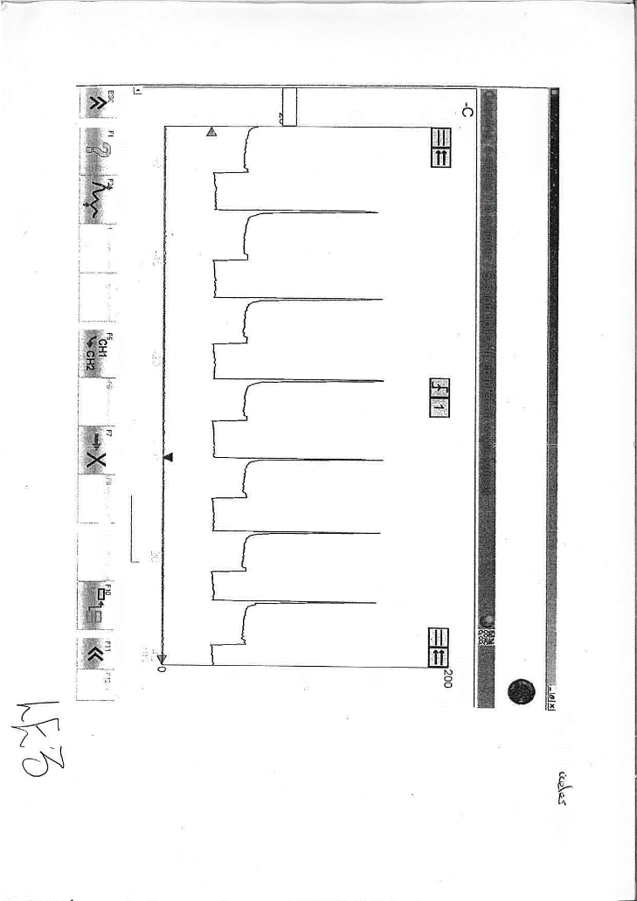
Jetronic

Appendix A

Appendix B

Appendix C

Appendix D

Appendix E

