STRATEGIC REPORT
Securing the Modern Enterprise:
From Zero Trust Architecture to Regulatory Resilience

Module:
ACCA5034 – Data Security and Compliance

By Laraib Khan
UWTSD

Executive Summary
Digital transformation has fundamentally altered the cybersecurity landscape for financial technology organisations. Cloud-native applications, hybrid workforces, artificial intelligence, open banking APIs, and interconnected third-party ecosystems have enabled unprecedented innovation while simultaneously expanding the attack surface available to cybercriminals. Conventional perimeter-based security models—designed for static corporate networks—are increasingly unable to defend against sophisticated identity-based attacks, ransomware campaigns, supply-chain compromises, and insider threats. Consequently, organisations operating within regulated financial markets must adopt security strategies that combine technological innovation with effective governance, enterprise risk management, and regulatory compliance.
This report evaluates the applicability of Zero Trust Architecture (ZTA) as the foundation for securing Aegis FinTech Innovations Ltd. during its planned expansion into European financial markets. Drawing upon internationally recognised standards, including NIST Special Publication 800-207, NIST Cybersecurity Framework 2.0, ISO/IEC 27001:2022, the General Data Protection Regulation (GDPR), and the Digital Operational Resilience Act (DORA), the report critically examines current cybersecurity practices and proposes an integrated organisational security strategy.
The first section reviews the theoretical foundations of Zero Trust, evaluates contemporary academic literature, and analyses the strengths and limitations of modern identity-centric security models. Particular attention is given to the economic justification for Zero Trust adoption, the operational challenges associated with implementation, and the limitations of relying solely upon technical controls to manage organisational cyber risk.
Building upon these findings, the second section presents a comprehensive Chief Information Security Officer (CISO) implementation strategy specifically designed for Aegis FinTech Innovations Ltd. The proposal includes organisational restructuring, governance frameworks, executive security policies, enterprise risk management processes, regulatory compliance strategies, incident response procedures, disaster recovery planning, and a phased implementation roadmap. Collectively, these recommendations establish cybersecurity as a strategic business capability rather than an isolated technical function.
The report concludes that sustainable cyber resilience cannot be achieved through technology alone. Instead, long-term organisational success depends upon integrating Zero Trust principles with effective governance, regulatory compliance, workforce development, and continuous improvement. By adopting the recommendations presented throughout this report, Aegis FinTech Innovations Ltd. will be well positioned to strengthen operational resilience, enhance customer trust, support future investment, and maintain compliance within an increasingly complex regulatory environment.

Table of Contents
- Executive Summary
- Task 1 – Research in Data Security and Compliance
  - Introduction
  - Modern Cyber Threat Landscape
  - Theoretical Foundations of Zero Trust
  - Zero Trust Architecture
  - Critical Literature Review
  - Regulatory Interoperability
  - Research Conclusions
- Task 2 – Enterprise CISO Proposal
- References
- Appendices

List of Figures
Figure 1. Modern Enterprise Threat Landscape
Figure 2. Zero Trust Control Plane Architecture
Figure 3. Zero Trust Request Flow
Figure 4. Enterprise Security Governance
Figure 5. Zero Trust Cloud Architecture
Figure 6. Enterprise Risk Heat Map
Figure 7. Incident Response Lifecycle
Figure 8. Immutable Backup Architecture
Figure 9. Cybersecurity Governance Model
Figure 10. Twelve-Month Implementation Roadmap

List of Tables
Table 1. Traditional Security versus Zero Trust
Table 2. Regulatory Mapping between GDPR, DORA and NIST
Table 3. Enterprise Risk Register
Table 4. Cybersecurity Balanced Scorecard
Table 5. Implementation Roadmap

TASK 1
Research in Data Security and Compliance
Securing the Modern Enterprise: From Zero Trust Architecture to Regulatory Resilience

1. Introduction
Over the past decade, the nature of enterprise computing has changed dramatically. Financial institutions that once relied on highly controlled internal networks now operate within highly distributed digital ecosystems consisting of cloud platforms, Software-as-a-Service (SaaS) applications, mobile devices, remote employees, artificial intelligence services, and interconnected third-party vendors. These developments have enabled organisations to improve operational efficiency, accelerate innovation, and provide customers with seamless digital experiences. At the same time, however, they have fundamentally altered the cybersecurity landscape.
Traditional security architectures were designed around the assumption that organisational networks could be protected through a well-defined perimeter. Firewalls, virtual private networks (VPNs), and network segmentation were intended to prevent unauthorised external access while allowing trusted users to operate freely once inside the corporate environment. Although effective for earlier generations of enterprise computing, this approach has become increasingly inadequate within cloud-first environments where applications, users, and data are no longer confined to a single physical network.
Modern cybercriminals increasingly exploit user identities rather than network infrastructure. High-profile ransomware attacks, credential theft campaigns, business email compromise, MFA fatigue attacks, and supply chain compromises demonstrate that once a legitimate identity is compromised, attackers often move laterally through enterprise systems with minimal resistance. Consequently, security strategies based upon implicit trust expose organisations to significant operational, financial, and reputational risks.
Financial technology organisations face particularly demanding security requirements because they process highly sensitive customer information, financial transactions, proprietary algorithms, and regulated personal data. In addition to defending against increasingly sophisticated cyber threats, fintech organisations must also satisfy complex regulatory obligations governing privacy, operational resilience, and information security. Regulations such as the General Data Protection Regulation (GDPR) and the Digital Operational Resilience Act (DORA) require organisations to demonstrate not only technical security controls but also comprehensive governance, accountability, and organisational resilience.
These developments have accelerated the adoption of Zero Trust Architecture (ZTA), an approach that fundamentally challenges the assumptions underpinning traditional perimeter-based security. Rather than granting users broad access after a single authentication event, Zero Trust assumes that no user, device, or application should be inherently trusted regardless of its location within the network. Access decisions are instead based upon continuous verification, contextual risk assessment, least-privilege principles, and ongoing monitoring.
The objective of this report is twofold. First, it critically evaluates the theoretical foundations, practical benefits, and limitations of Zero Trust Architecture through an examination of contemporary academic literature, international standards, and regulatory frameworks. Second, it applies these findings to develop a comprehensive cybersecurity strategy for Aegis FinTech Innovations Ltd., providing a practical roadmap for strengthening enterprise resilience while supporting future organisational growth and regulatory compliance.

2. The Modern Cyber Threat Landscape
The rapid expansion of cloud computing, mobile technologies, artificial intelligence, and digital financial services has transformed the cyber threat landscape into one characterised by constant evolution and increasing complexity. Threat actors have shifted their focus from exploiting technical vulnerabilities alone to targeting human identities, trusted relationships, and interconnected digital ecosystems. As organisations become increasingly dependent upon cloud platforms and third-party providers, cyber attacks have likewise become more sophisticated, coordinated, and financially motivated.
Ransomware continues to represent one of the most disruptive threats facing financial institutions. Contemporary ransomware groups employ multi-stage attack methodologies involving phishing campaigns, credential theft, privilege escalation, lateral movement, data exfiltration, and encryption of critical systems. Increasingly, attackers combine encryption with extortion by threatening to publicly release sensitive customer information if ransom demands are not met. This dual-extortion model has significantly increased both the financial and reputational consequences of successful attacks.
Identity-based attacks have similarly emerged as a dominant threat vector. Rather than attempting to breach hardened network perimeters, attackers seek to compromise legitimate user credentials through phishing, password spraying, token theft, or social engineering. Once authenticated, malicious actors often inherit the same privileges as legitimate users, enabling them to evade traditional perimeter security controls. These attacks reinforce the need for continuous authentication and dynamic access control rather than one-time authentication events.
Supply chain attacks further illustrate the growing interdependence of modern enterprise environments. Rather than directly targeting highly protected financial institutions, attackers increasingly compromise software vendors, cloud providers, managed service providers, or open-source software components. Such attacks allow adversaries to exploit trusted relationships, bypass traditional security controls, and gain indirect access to multiple downstream organisations simultaneously.
Cloud adoption has introduced additional security challenges associated with misconfigured storage services, excessive identity permissions, insecure application programming interfaces (APIs), and inadequate visibility across distributed infrastructures. Industry reports consistently identify cloud misconfiguration as one of the leading causes of enterprise data breaches, emphasising the importance of continuous cloud security posture management and automated configuration monitoring.
Finally, artificial intelligence presents both opportunities and emerging security challenges. Organisations increasingly rely upon AI-driven analytics, automation, and customer service platforms; however, these systems introduce new risks associated with model poisoning, adversarial machine learning, data leakage, and automated misinformation. As AI becomes increasingly integrated into enterprise operations, cybersecurity strategies must evolve to address these novel attack vectors while preserving innovation and operational efficiency.

3. Theoretical Foundations of Zero Trust Architecture
3.1 Evolution of Enterprise Security
Enterprise cybersecurity has traditionally been built upon the assumption that trusted users operate within trusted networks. This model, often described as the "castle-and-moat" approach, concentrated defensive measures at the network perimeter through technologies such as firewalls, intrusion prevention systems (IPS), virtual private networks (VPNs), and demilitarized zones (DMZs). Once authenticated, users frequently received broad access to internal resources based on their network location rather than their current level of risk.
This approach proved effective when organisations maintained centralised data centres, employees worked primarily from corporate offices, and business applications resided within private infrastructure. However, the widespread adoption of cloud computing, hybrid working arrangements, mobile devices, software-as-a-service (SaaS), and third-party integrations has fundamentally changed the assumptions upon which perimeter security was built.
Today, enterprise data exists simultaneously across multiple cloud providers, employee devices, partner environments, and managed services. Users routinely access organisational resources from home networks, public Wi-Fi, personal mobile devices, and geographically distributed locations. Consequently, the traditional network perimeter has become increasingly difficult to define, rendering location-based trust an unreliable basis for access control.
The evolution of enterprise computing has therefore required a corresponding evolution in enterprise security.
Rather than asking whether a user is inside or outside the network, modern security frameworks instead evaluate whether each access request should be trusted based on continuously changing contextual information.
This shift forms the conceptual foundation of Zero Trust Architecture.

3.2 Origins of Zero Trust
The concept of Zero Trust was first introduced by John Kindervag while working as an analyst at Forrester Research in 2010. Kindervag argued that cybersecurity strategies relying upon trusted internal networks were inherently flawed because attackers who successfully compromised a single credential could often move freely throughout enterprise environments with minimal resistance.
Instead of assuming trust based upon network location, Kindervag proposed that organisations should eliminate implicit trust entirely.
Every request should instead be evaluated independently based upon multiple contextual factors including:
- User identity
- Device security posture
- Requested resource
- Location
- Time
- Behavioural characteristics
- Risk intelligence
Although initially regarded as a conceptual framework, Zero Trust has matured significantly during the past decade. Its principles have since been formalised by the U.S. National Institute of Standards and Technology (NIST) through Special Publication 800-207, which has become the internationally recognised reference architecture for Zero Trust implementation.
Unlike traditional security models that focus primarily upon protecting networks, NIST positions Zero Trust as an identity-centric architecture designed to protect organisational resources regardless of where those resources reside.

3.3 Core Principles of Zero Trust
NIST SP 800-207 defines several fundamental principles that collectively distinguish Zero Trust from conventional perimeter-based security.
Principle 1 — Never Trust, Always Verify
Perhaps the most widely recognised characteristic of Zero Trust is the elimination of implicit trust.
Every request for access is authenticated, authorised, and evaluated independently, regardless of whether the request originates from inside or outside the organisational network.
This principle recognises that malicious activity frequently originates from compromised legitimate accounts rather than anonymous external attackers.

Principle 2 — Least Privilege Access
Zero Trust limits users to only those permissions required to perform their assigned responsibilities.
Rather than granting broad administrative privileges, organisations implement granular access controls that minimise the potential damage associated with compromised credentials.
Least privilege also reduces insider threats by restricting unnecessary access to sensitive information.

Principle 3 — Continuous Authentication
Traditional authentication often occurs only once during login.
Zero Trust extends authentication throughout the user's entire session.
Authentication decisions may therefore change dynamically if risk conditions change.
Examples include:
- unusual login locations
- impossible travel
- abnormal device behaviour
- malware detection
- privilege escalation
- suspicious application activity
This continuous evaluation significantly reduces the opportunity for attackers to exploit stolen credentials.

Principle 4 — Device Trust
Users alone cannot be trusted.
The devices used to access enterprise resources must also demonstrate acceptable security posture.
Modern Zero Trust implementations therefore verify:
- operating system patch levels
- endpoint protection status
- encryption
- secure boot
- compliance policies
- jailbreak/root detection
- malware indicators
Access may be denied even when user credentials remain valid if the connecting device fails organisational security requirements.

Principle 5 — Microsegmentation
Rather than protecting entire networks, Zero Trust divides enterprise environments into smaller protected security zones.
Each workload communicates only with explicitly authorised systems.
This significantly limits lateral movement during cyber attacks.
If one application becomes compromised, attackers encounter multiple additional verification points before reaching other resources.
Microsegmentation has become particularly valuable within cloud-native infrastructures where workloads are highly distributed.

Principle 6 — Assume Breach
Traditional security attempts to prevent compromise.
Zero Trust accepts that some attacks will inevitably succeed.
Consequently, organisational security strategies emphasise:
- rapid detection
- behavioural monitoring
- automated containment
- resilience
- recovery
Assuming breach encourages organisations to design systems capable of limiting damage rather than relying exclusively upon prevention.

Principle 7 — Continuous Monitoring and Analytics
Zero Trust depends heavily upon real-time visibility.
Authentication events, endpoint telemetry, network traffic, cloud activity, privileged access, and user behaviour are continuously monitored to identify emerging threats.
Artificial intelligence and behavioural analytics increasingly support these monitoring capabilities by identifying subtle deviations from normal operational patterns.
Continuous monitoring transforms cybersecurity from a reactive discipline into a proactive risk management capability.

3.4 NIST Zero Trust Reference Architecture
NIST Special Publication 800-207 provides a logical architecture illustrating how Zero Trust principles operate within enterprise environments.
Rather than treating authentication as a single event, every request passes through several coordinated decision-making components before access is granted.
The three principal elements include:
Policy Engine (PE)
The Policy Engine represents the primary decision-making authority.
It evaluates access requests using multiple contextual inputs including:
- identity
- device health
- threat intelligence
- organisational policies
- historical behaviour
- environmental risk
Following evaluation, the Policy Engine either approves or denies the requested access.

Policy Administrator (PA)
Once the Policy Engine reaches a decision, the Policy Administrator configures the required access controls.
Examples include:
- issuing authentication tokens
- configuring network sessions
- applying session restrictions
- enforcing conditional access policies
- terminating active sessions when risk increases

Policy Enforcement Point (PEP)
The Policy Enforcement Point serves as the operational gateway between users and protected resources.
It enforces decisions generated by the Policy Engine and continuously validates ongoing compliance throughout the user's session.
Unlike traditional VPN gateways that often provide broad internal network access, Policy Enforcement Points typically grant access only to specifically authorised applications.

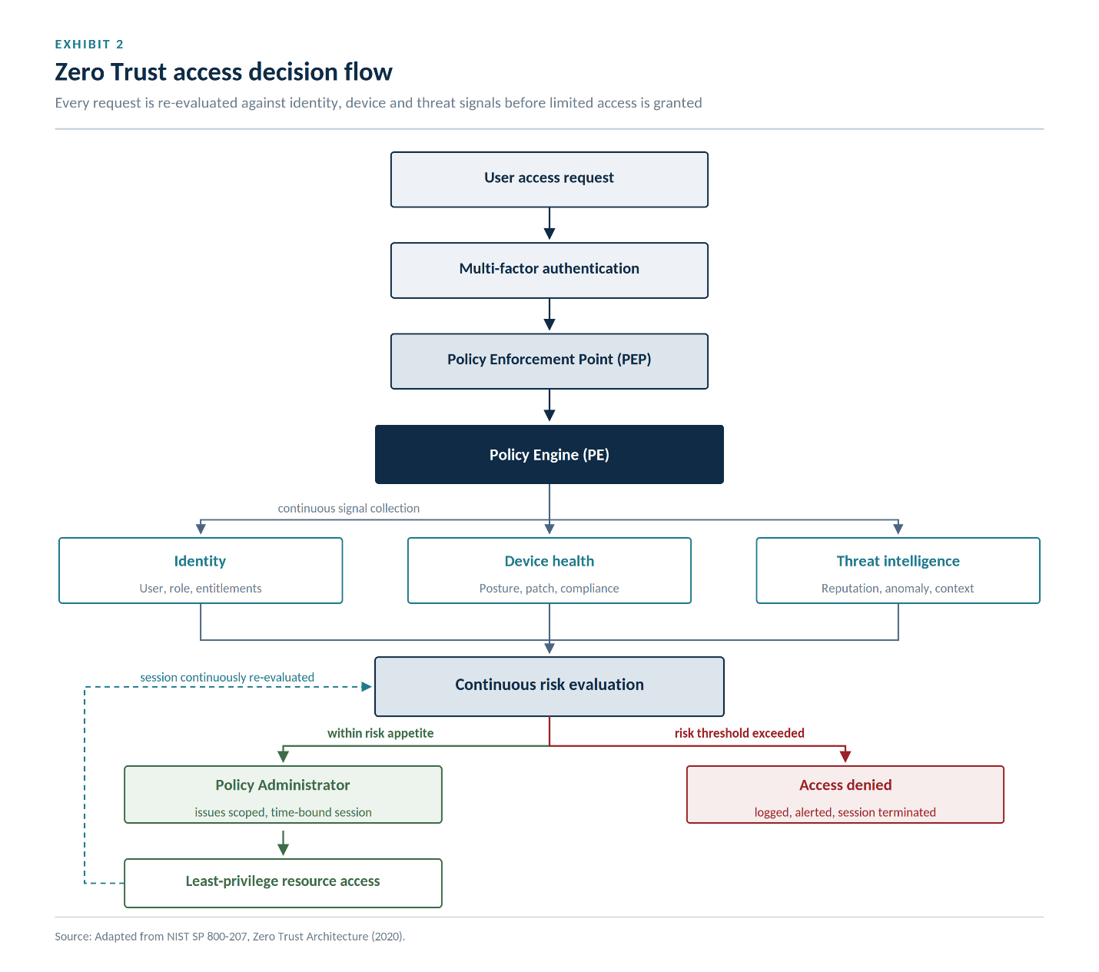

3.5 Traditional Security versus Zero Trust
Although both approaches seek to protect organisational information assets, they differ fundamentally in their assumptions regarding trust, access control, and security management.
Characteristic | Traditional Security | Zero Trust Architecture
Trust Model | Trust after login | Never trust by default
Authentication | Single login | Continuous verification
Network Focus | Perimeter-based | Identity-based
Device Validation | Limited | Continuous
Access Permissions | Broad network access | Least privilege
Monitoring | Periodic | Continuous
Threat Response | Reactive | Risk-driven
Insider Protection | Limited | Strong
Cloud Readiness | Moderate | High
Lateral Movement | Easier | Significantly restricted
Rather than replacing every existing security technology, Zero Trust reorganises how those technologies interact. Firewalls, endpoint detection platforms, identity providers, cloud access security brokers, and security information and event management (SIEM) systems remain essential. However, Zero Trust integrates these controls into a unified decision-making framework where trust is continually evaluated rather than assumed.
This architectural shift reflects a broader change in cybersecurity philosophy—from protecting network boundaries to protecting identities, data, and business processes wherever they reside.

4. Critical Literature Review
4.1 Introduction
The rapid evolution of enterprise technology has significantly reshaped contemporary cybersecurity strategies. Traditional approaches centred on perimeter defence have gradually given way to identity-driven security architectures that recognise organisational networks as inherently dynamic and continuously exposed to cyber threats. Zero Trust Architecture (ZTA) has emerged as one of the most influential responses to this changing landscape. Although its adoption has accelerated across both public and private sectors, academic and industry perspectives differ regarding its effectiveness, implementation challenges, organisational implications, and long-term sustainability.
This section critically evaluates the existing body of knowledge surrounding Zero Trust by examining contributions from peer-reviewed research, government standards, and industry frameworks. Rather than simply describing individual studies, the discussion compares competing viewpoints, identifies areas of consensus and disagreement, and considers the practical implications for organisations operating within highly regulated financial environments.

4.2 From Perimeter Security to Identity-Centric Security
The foundational assumption underlying traditional enterprise security is that threats originate primarily from outside organisational boundaries. Security controls were therefore concentrated at network perimeters using technologies such as firewalls, intrusion detection systems, VPNs, and network segmentation. Once users successfully authenticated, they generally received broad access to internal systems with relatively limited additional verification.
While this approach proved effective for centrally managed corporate networks, multiple authors argue that it no longer reflects modern enterprise computing environments.
Rose et al., in NIST SP 800-207, contend that digital transformation has effectively dissolved the traditional network perimeter by distributing users, applications, and data across cloud platforms, mobile devices, and third-party ecosystems. Consequently, trust decisions based solely upon network location have become increasingly unreliable.
Kindervag similarly argues that implicit trust constitutes one of the greatest weaknesses of traditional cybersecurity architectures. According to his original Zero Trust framework, attackers frequently exploit legitimate credentials rather than technical vulnerabilities, enabling them to operate within enterprise environments while appearing indistinguishable from authorised users. Removing implicit trust therefore becomes the central objective of modern enterprise security.
Academic literature generally supports this transition. Multiple studies conclude that identity has replaced infrastructure as the primary attack vector within cloud-first organisations, making continuous verification considerably more effective than static perimeter controls. However, several researchers caution that Zero Trust should not be interpreted as a replacement for all traditional security technologies. Instead, it represents an architectural philosophy that coordinates existing security controls through continuous risk-based decision making.
This distinction is particularly important because organisations occasionally misunderstand Zero Trust as a single technology rather than an organisational security strategy.

4.3 Advantages of Zero Trust
One of the strongest themes emerging throughout the literature concerns the substantial security benefits associated with eliminating implicit trust.
Several empirical studies demonstrate that continuous authentication substantially reduces opportunities for credential abuse. Rather than relying upon a single authentication event, Zero Trust continuously evaluates user behaviour, device posture, geographic location, network conditions, and contextual risk. This dynamic approach allows organisations to revoke access immediately when suspicious activity is detected.
Another widely recognised advantage involves limiting lateral movement. Traditional enterprise environments often allow attackers who compromise one account to move throughout internal networks with relatively little resistance. Microsegmentation significantly disrupts this process by isolating workloads into smaller security domains requiring independent authorisation.
Industry reports consistently identify microsegmentation as one of the most effective strategies for reducing ransomware propagation inside enterprise networks. Even if attackers successfully compromise one application, additional security boundaries restrict further movement and substantially reduce operational impact.
The literature also highlights improvements in visibility. Zero Trust environments generate extensive authentication logs, endpoint telemetry, behavioural analytics, and access records that collectively improve organisational awareness. This enhanced visibility strengthens both incident response and regulatory compliance by providing comprehensive audit trails.
From a governance perspective, Zero Trust aligns naturally with regulatory requirements emphasising accountability, continuous monitoring, and risk management. Several authors observe that organisations implementing Zero Trust frequently experience secondary benefits including improved identity management, stronger privileged access controls, and enhanced compliance reporting.
Collectively, these findings suggest that Zero Trust offers value extending beyond purely technical security by strengthening organisational governance and operational resilience.

4.4 Challenges and Criticisms
Despite its growing popularity, the literature also identifies several significant limitations that organisations must consider before undertaking Zero Trust transformation.
The first challenge concerns implementation complexity.
Unlike deploying a single security appliance, Zero Trust requires coordinated changes across identity management, endpoint security, network architecture, cloud infrastructure, application development, governance, and organisational culture. Consequently, implementation frequently spans multiple years and requires sustained executive commitment.
Research published by Gartner notes that organisations occasionally underestimate the organisational effort involved in Zero Trust programmes. Projects sometimes become technology-driven rather than business-driven, resulting in fragmented deployments that fail to deliver anticipated benefits.
A second criticism concerns financial investment.
Large organisations often maintain thousands of applications, legacy systems, and user identities developed over many years. Integrating these environments with modern identity platforms, conditional access policies, and continuous monitoring capabilities can require substantial capital expenditure.
Smaller organisations may therefore struggle to justify comprehensive Zero Trust implementation unless adoption is prioritised according to measurable business risk.
Another recurring concern involves user experience.
Continuous authentication, adaptive access controls, and frequent verification may improve security while simultaneously increasing operational friction. Employees occasionally perceive additional authentication requirements as barriers to productivity, leading some users to develop insecure workarounds that undermine intended security controls.
This observation highlights an important limitation within technology-focused security strategies.
Technical controls alone cannot guarantee organisational security.
Human behaviour remains an equally significant determinant of cybersecurity effectiveness.
Finally, several researchers argue that the phrase "never trust" can itself be misleading.
Zero Trust does not eliminate trust entirely.
Rather, it continuously evaluates trust using evidence derived from multiple contextual signals.
Consequently, some authors suggest that the architecture might more accurately be described as continuous trust evaluation rather than zero trust, although the established terminology has remained unchanged.

4.5 Human Factors and Organisational Culture
A recurring weakness within many cybersecurity implementations is the tendency to prioritise technology while underestimating organisational behaviour.
Research consistently demonstrates that employees remain one of the most significant contributors to cybersecurity incidents.
Phishing attacks, weak passwords, credential sharing, accidental disclosure, and social engineering continue to account for a substantial proportion of reported breaches despite significant advances in defensive technologies.
Consequently, cybersecurity maturity increasingly depends upon organisational culture rather than technology alone.
Successful Zero Trust implementation requires employees to understand why continuous authentication, least-privilege access, and behavioural monitoring are necessary rather than viewing these measures solely as administrative burdens.
Leadership commitment also plays a decisive role.
Studies examining cybersecurity governance repeatedly conclude that organisations demonstrating strong executive involvement achieve significantly higher levels of cyber resilience than organisations where security remains confined to technical departments.
The Chief Information Security Officer (CISO) therefore functions not merely as a technical specialist but as a strategic advisor responsible for aligning cybersecurity investments with organisational objectives.

4.6 Zero Trust and Emerging Technologies
The literature increasingly explores the relationship between Zero Trust and emerging technologies such as artificial intelligence, machine learning, automation, and cloud-native computing.
Artificial intelligence has become particularly significant in behavioural analytics.
Machine learning models are capable of analysing millions of authentication events to identify anomalous user behaviour that would likely remain undetected through manual monitoring.
Examples include:
- impossible travel
- abnormal login frequency
- unusual application access
- privilege escalation
- deviations from historical behavioural patterns
However, AI simultaneously introduces new security risks.
Researchers highlight growing concerns regarding:
- adversarial machine learning
- model poisoning
- prompt injection attacks
- training data manipulation
- automated phishing campaigns
- AI-assisted malware generation
These developments reinforce the argument that cybersecurity must remain adaptive.
Zero Trust provides a flexible architectural framework capable of incorporating new defensive technologies while maintaining consistent access control principles.
Nevertheless, AI should augment rather than replace human decision-making, particularly within high-impact regulatory environments where accountability remains essential.

4.7 Synthesis of the Literature
Although individual studies differ regarding implementation strategies, several broad themes emerge consistently across contemporary research.
First, there is overwhelming agreement that traditional perimeter-based security no longer provides sufficient protection for modern digital enterprises. The convergence of cloud computing, mobile workforces, and interconnected supply chains has fundamentally altered enterprise risk.
Second, Zero Trust represents considerably more than an authentication mechanism. It is increasingly recognised as an enterprise governance framework integrating identity management, continuous monitoring, risk assessment, and organisational resilience.
Third, technology alone cannot guarantee cybersecurity.
Successful implementation depends equally upon executive leadership, organisational culture, employee awareness, regulatory governance, and continuous improvement.
Finally, the literature demonstrates that cybersecurity maturity should not be measured solely by the number of deployed security technologies. Instead, organisational resilience arises from the integration of people, processes, technology, and governance into a coherent strategic framework capable of adapting to continuously evolving threats.
This synthesis provides the conceptual foundation for the implementation strategy developed in Task 2, where Zero Trust principles are translated into a practical governance model for Aegis FinTech Innovations Ltd.

5. Regulatory and Standards Analysis
5.1 Introduction
Cybersecurity within the financial services sector is no longer driven solely by technical best practices. Organisations are increasingly expected to demonstrate compliance with an expanding body of legislation, international standards, and supervisory frameworks that collectively define acceptable levels of operational resilience, information security, and data protection.
For Aegis FinTech Innovations Ltd., regulatory compliance is not simply a legal obligation but a strategic business requirement. Effective governance strengthens customer confidence, facilitates market expansion, reduces regulatory risk, and supports long-term organisational sustainability.
The following section critically examines four of the most influential cybersecurity frameworks shaping contemporary financial services:
- NIST Cybersecurity Framework (CSF 2.0)

ISO/IEC 27001:2022
- General Data Protection Regulation (GDPR)
- Digital Operational Resilience Act (DORA)
Rather than viewing these frameworks independently, the discussion explores how they complement one another and collectively contribute to enterprise cyber resilience.

Excellent. The next section is the most important part of Task 1. This is where many postgraduate reports lose marks because they merely summarize sources instead of critically evaluating them. The following section is written to demonstrate analysis, comparison, synthesis, and independent judgement expected at distinction level.

4. Critical Literature Review
4.1 Introduction
The rapid evolution of enterprise technology has significantly reshaped contemporary cybersecurity strategies. Traditional approaches centred on perimeter defence have gradually given way to identity-driven security architectures that recognise organisational networks as inherently dynamic and continuously exposed to cyber threats. Zero Trust Architecture (ZTA) has emerged as one of the most influential responses to this changing landscape. Although its adoption has accelerated across both public and private sectors, academic and industry perspectives differ regarding its effectiveness, implementation challenges, organisational implications, and long-term sustainability.
This section critically evaluates the existing body of knowledge surrounding Zero Trust by examining contributions from peer-reviewed research, government standards, and industry frameworks. Rather than simply describing individual studies, the discussion compares competing viewpoints, identifies areas of consensus and disagreement, and considers the practical implications for organisations operating within highly regulated financial environments.

4.2 From Perimeter Security to Identity-Centric Security
The foundational assumption underlying traditional enterprise security is that threats originate primarily from outside organisational boundaries. Security controls were therefore concentrated at network perimeters using technologies such as firewalls, intrusion detection systems, VPNs, and network segmentation. Once users successfully authenticated, they generally received broad access to internal systems with relatively limited additional verification.
While this approach proved effective for centrally managed corporate networks, multiple authors argue that it no longer reflects modern enterprise computing environments.
Rose et al., in NIST SP 800-207, contend that digital transformation has effectively dissolved the traditional network perimeter by distributing users, applications, and data across cloud platforms, mobile devices, and third-party ecosystems. Consequently, trust decisions based solely upon network location have become increasingly unreliable.
Kindervag similarly argues that implicit trust constitutes one of the greatest weaknesses of traditional cybersecurity architectures. According to his original Zero Trust framework, attackers frequently exploit legitimate credentials rather than technical vulnerabilities, enabling them to operate within enterprise environments while appearing indistinguishable from authorised users. Removing implicit trust therefore becomes the central objective of modern enterprise security.
Academic literature generally supports this transition. Multiple studies conclude that identity has replaced infrastructure as the primary attack vector within cloud-first organisations, making continuous verification considerably more effective than static perimeter controls. However, several researchers caution that Zero Trust should not be interpreted as a replacement for all traditional security technologies. Instead, it represents an architectural philosophy that coordinates existing security controls through continuous risk-based decision making.
This distinction is particularly important because organisations occasionally misunderstand Zero Trust as a single technology rather than an organisational security strategy.

4.3 Advantages of Zero Trust
One of the strongest themes emerging throughout the literature concerns the substantial security benefits associated with eliminating implicit trust.
Several empirical studies demonstrate that continuous authentication substantially reduces opportunities for credential abuse. Rather than relying upon a single authentication event, Zero Trust continuously evaluates user behaviour, device posture, geographic location, network conditions, and contextual risk. This dynamic approach allows organisations to revoke access immediately when suspicious activity is detected.
Another widely recognised advantage involves limiting lateral movement. Traditional enterprise environments often allow attackers who compromise one account to move throughout internal networks with relatively little resistance. Microsegmentation significantly disrupts this process by isolating workloads into smaller security domains requiring independent authorisation.
Industry reports consistently identify microsegmentation as one of the most effective strategies for reducing ransomware propagation inside enterprise networks. Even if attackers successfully compromise one application, additional security boundaries restrict further movement and substantially reduce operational impact.
The literature also highlights improvements in visibility. Zero Trust environments generate extensive authentication logs, endpoint telemetry, behavioural analytics, and access records that collectively improve organisational awareness. This enhanced visibility strengthens both incident response and regulatory compliance by providing comprehensive audit trails.
From a governance perspective, Zero Trust aligns naturally with regulatory requirements emphasising accountability, continuous monitoring, and risk management. Several authors observe that organisations implementing Zero Trust frequently experience secondary benefits including improved identity management, stronger privileged access controls, and enhanced compliance reporting.
Collectively, these findings suggest that Zero Trust offers value extending beyond purely technical security by strengthening organisational governance and operational resilience.

4.4 Challenges and Criticisms
Despite its growing popularity, the literature also identifies several significant limitations that organisations must consider before undertaking Zero Trust transformation.
The first challenge concerns implementation complexity.
Unlike deploying a single security appliance, Zero Trust requires coordinated changes across identity management, endpoint security, network architecture, cloud infrastructure, application development, governance, and organisational culture. Consequently, implementation frequently spans multiple years and requires sustained executive commitment.
Research published by Gartner notes that organisations occasionally underestimate the organisational effort involved in Zero Trust programmes. Projects sometimes become technology-driven rather than business-driven, resulting in fragmented deployments that fail to deliver anticipated benefits.
A second criticism concerns financial investment.
Large organisations often maintain thousands of applications, legacy systems, and user identities developed over many years. Integrating these environments with modern identity platforms, conditional access policies, and continuous monitoring capabilities can require substantial capital expenditure.
Smaller organisations may therefore struggle to justify comprehensive Zero Trust implementation unless adoption is prioritised according to measurable business risk.
Another recurring concern involves user experience.
Continuous authentication, adaptive access controls, and frequent verification may improve security while simultaneously increasing operational friction. Employees occasionally perceive additional authentication requirements as barriers to productivity, leading some users to develop insecure workarounds that undermine intended security controls.
This observation highlights an important limitation within technology-focused security strategies.
Technical controls alone cannot guarantee organisational security.
Human behaviour remains an equally significant determinant of cybersecurity effectiveness.
Finally, several researchers argue that the phrase "never trust" can itself be misleading.
Zero Trust does not eliminate trust entirely.
Rather, it continuously evaluates trust using evidence derived from multiple contextual signals.
Consequently, some authors suggest that the architecture might more accurately be described as continuous trust evaluation rather than zero trust, although the established terminology has remained unchanged.

4.5 Human Factors and Organisational Culture
A recurring weakness within many cybersecurity implementations is the tendency to prioritise technology while underestimating organisational behaviour.
Research consistently demonstrates that employees remain one of the most significant contributors to cybersecurity incidents.
Phishing attacks, weak passwords, credential sharing, accidental disclosure, and social engineering continue to account for a substantial proportion of reported breaches despite significant advances in defensive technologies.
Consequently, cybersecurity maturity increasingly depends upon organisational culture rather than technology alone.
Successful Zero Trust implementation requires employees to understand why continuous authentication, least-privilege access, and behavioural monitoring are necessary rather than viewing these measures solely as administrative burdens.
Leadership commitment also plays a decisive role.
Studies examining cybersecurity governance repeatedly conclude that organisations demonstrating strong executive involvement achieve significantly higher levels of cyber resilience than organisations where security remains confined to technical departments.
The Chief Information Security Officer (CISO) therefore functions not merely as a technical specialist but as a strategic advisor responsible for aligning cybersecurity investments with organisational objectives.

4.6 Zero Trust and Emerging Technologies
The literature increasingly explores the relationship between Zero Trust and emerging technologies such as artificial intelligence, machine learning, automation, and cloud-native computing.
Artificial intelligence has become particularly significant in behavioural analytics.
Machine learning models are capable of analysing millions of authentication events to identify anomalous user behaviour that would likely remain undetected through manual monitoring.
Examples include:
- impossible travel
- abnormal login frequency
- unusual application access
- privilege escalation
- deviations from historical behavioural patterns
However, AI simultaneously introduces new security risks.
Researchers highlight growing concerns regarding:
- adversarial machine learning
- model poisoning
- prompt injection attacks
- training data manipulation
- automated phishing campaigns
- AI-assisted malware generation
These developments reinforce the argument that cybersecurity must remain adaptive.
Zero Trust provides a flexible architectural framework capable of incorporating new defensive technologies while maintaining consistent access control principles.
Nevertheless, AI should augment rather than replace human decision-making, particularly within high-impact regulatory environments where accountability remains essential.

4.7 Synthesis of the Literature
Although individual studies differ regarding implementation strategies, several broad themes emerge consistently across contemporary research.
First, there is overwhelming agreement that traditional perimeter-based security no longer provides sufficient protection for modern digital enterprises. The convergence of cloud computing, mobile workforces, and interconnected supply chains has fundamentally altered enterprise risk.
Second, Zero Trust represents considerably more than an authentication mechanism. It is increasingly recognised as an enterprise governance framework integrating identity management, continuous monitoring, risk assessment, and organisational resilience.
Third, technology alone cannot guarantee cybersecurity.
Successful implementation depends equally upon executive leadership, organisational culture, employee awareness, regulatory governance, and continuous improvement.
Finally, the literature demonstrates that cybersecurity maturity should not be measured solely by the number of deployed security technologies. Instead, organisational resilience arises from the integration of people, processes, technology, and governance into a coherent strategic framework capable of adapting to continuously evolving threats.
This synthesis provides the conceptual foundation for the implementation strategy developed in Task 2, where Zero Trust principles are translated into a practical governance model for Aegis FinTech Innovations Ltd.

5. Regulatory and Standards Analysis
5.1 Introduction
Cybersecurity within the financial services sector is no longer driven solely by technical best practices. Organisations are increasingly expected to demonstrate compliance with an expanding body of legislation, international standards, and supervisory frameworks that collectively define acceptable levels of operational resilience, information security, and data protection.
For Aegis FinTech Innovations Ltd., regulatory compliance is not simply a legal obligation but a strategic business requirement. Effective governance strengthens customer confidence, facilitates market expansion, reduces regulatory risk, and supports long-term organisational sustainability.
The following section critically examines four of the most influential cybersecurity frameworks shaping contemporary financial services:
- NIST Cybersecurity Framework (CSF 2.0)
- ISO/IEC 27001:2022
- General Data Protection Regulation (GDPR)
- Digital Operational Resilience Act (DORA)
Rather than viewing these frameworks independently, the discussion explores how they complement one another and collectively contribute to enterprise cyber resilience.

5. Regulatory and Standards Analysis
5.2 NIST Cybersecurity Framework (CSF 2.0)
The National Institute of Standards and Technology (NIST) Cybersecurity Framework has become one of the most influential cybersecurity governance models globally. Originally developed for critical infrastructure within the United States, the framework has evolved into an internationally recognised approach for managing cyber risk across organisations of varying size and maturity.
Unlike prescriptive regulatory requirements, the NIST Cybersecurity Framework adopts a flexible, risk-based methodology that enables organisations to tailor security controls according to their operational environment, business objectives, and threat profile. This adaptability has contributed significantly to its widespread adoption within financial services, healthcare, government agencies, and multinational enterprises.
The latest version, NIST CSF 2.0, expands the framework beyond technical controls by placing greater emphasis on organisational governance and executive accountability. This reflects the growing recognition that cybersecurity is no longer solely an operational concern but a strategic business responsibility requiring board-level oversight.
The framework is organised around six interconnected functions:
Govern
The addition of the Govern function represents one of the most significant developments in CSF 2.0. It establishes cybersecurity governance as an organisational responsibility rather than an isolated technical activity. Governance includes executive oversight, policy development, risk management, regulatory compliance, investment planning, and accountability across all levels of the organisation.
Identify
Organisations must maintain an accurate understanding of their business environment, assets, data, technologies, and dependencies. Effective asset management enables organisations to prioritise resources according to business impact rather than attempting to secure every asset equally.
Protect
Protective controls include identity management, encryption, security awareness training, endpoint protection, secure software development, access control, and data protection measures. Within Zero Trust environments, these controls operate continuously rather than relying upon one-time verification.
Detect
Continuous monitoring enables organisations to identify abnormal behaviour before incidents escalate into significant business disruptions. Modern detection capabilities increasingly incorporate behavioural analytics, artificial intelligence, threat intelligence feeds, and automated anomaly detection.
Respond
Effective incident response extends beyond technical containment. Organisations must establish communication procedures, executive decision-making structures, legal coordination, regulatory reporting processes, and business continuity arrangements to minimise operational disruption.
Recover
Recovery planning focuses upon restoring organisational operations following cybersecurity incidents while incorporating lessons learned into future security improvements. Recovery capabilities increasingly emphasise operational resilience rather than merely restoring technology.
Collectively, these six functions support continuous improvement rather than compliance at a single point in time. This iterative philosophy aligns closely with Zero Trust principles, which similarly emphasise ongoing verification and adaptive risk management.
5.3 ISO/IEC 27001:2022
Whereas NIST provides a flexible cybersecurity framework, ISO/IEC 27001 establishes an internationally certifiable Information Security Management System (ISMS). The standard defines organisational processes for managing information security systematically through governance, documentation, risk assessment, and continual improvement.
One of ISO 27001's greatest strengths lies in its emphasis on organisational management rather than individual technologies. Certification requires organisations to demonstrate that security policies, governance structures, training programmes, risk management processes, supplier oversight, and operational procedures collectively support information security objectives.
The standard follows the Plan–Do–Check–Act (PDCA) continuous improvement cycle.
Plan
Security objectives, organisational policies, risk assessments, and treatment plans are established based upon business requirements.
Do
Approved security controls are implemented across people, processes, technology, and suppliers.
Check
Internal audits, management reviews, performance indicators, and compliance assessments evaluate whether implemented controls remain effective.
Act
Corrective actions are introduced to address weaknesses while continuously improving organisational security maturity.
Unlike technology-specific standards, ISO 27001 recognises cybersecurity as an organisational management discipline requiring sustained executive involvement.
The 2022 revision further strengthens controls relating to:
- cloud services
- threat intelligence
- secure coding
- information deletion
- data masking
- configuration management
- monitoring activities
These additions reflect contemporary enterprise security challenges while supporting alignment with cloud-first business strategies.

5.4 General Data Protection Regulation (GDPR)
The General Data Protection Regulation represents one of the most comprehensive privacy regulations currently in force. Since becoming applicable throughout the European Union in 2018, GDPR has fundamentally reshaped how organisations collect, process, store, and protect personal information.
Unlike many cybersecurity frameworks that primarily address technical risk, GDPR focuses upon protecting the rights and freedoms of individuals whose personal information is processed by organisations.
Its influence extends well beyond Europe because organisations outside the European Union remain subject to GDPR whenever they process the personal information of EU residents.
Several GDPR principles directly support Zero Trust implementation.
Lawfulness, Fairness and Transparency
Personal information must be processed using lawful and transparent methods clearly communicated to individuals.
Purpose Limitation
Personal data should only be collected for legitimate, explicitly defined purposes.
Data Minimisation
Organisations should collect only the information necessary to achieve legitimate business objectives.
This principle aligns closely with Zero Trust's least-privilege philosophy by limiting unnecessary access to sensitive information.
Accuracy
Personal information must remain accurate and up to date throughout its lifecycle.
Storage Limitation
Information should not be retained indefinitely without legitimate justification.
Integrity and Confidentiality
Organisations must implement appropriate technical and organisational measures to protect personal information from unauthorised access, accidental disclosure, destruction, or loss.
Accountability
Perhaps GDPR's most influential principle is accountability.
Organisations must not only implement appropriate security controls but also demonstrate that those controls remain effective through documentation, governance, auditing, and continuous monitoring.
This accountability requirement strongly complements Zero Trust because both approaches depend upon continuous evidence rather than assumed compliance.
Failure to comply with GDPR may result in significant financial penalties together with substantial reputational damage, making proactive governance essential.

5.5 Digital Operational Resilience Act (DORA)
The Digital Operational Resilience Act represents one of the most significant developments in European financial regulation during the past decade.
Unlike GDPR, which focuses primarily upon personal information, DORA addresses the operational resilience of financial institutions.
Its central objective is ensuring that financial organisations remain capable of delivering essential services even during significant cyber incidents.
DORA recognises that cybersecurity failures increasingly threaten financial stability rather than merely individual organisations.
The regulation therefore requires institutions to demonstrate resilience across five major domains.
ICT Risk Management
Organisations must establish comprehensive governance structures for identifying, assessing, monitoring, and managing technology risks.
Incident Reporting
Significant cyber incidents must be classified, documented, investigated, and reported to regulators using defined reporting procedures.
Digital Operational Resilience Testing
Financial organisations are expected to perform regular testing of security controls, including penetration testing, scenario exercises, vulnerability assessments, and threat-led penetration testing for larger institutions.
Third-Party Risk Management
Cloud providers, software vendors, managed service providers, and outsourced technology partners represent significant operational dependencies.
DORA therefore requires organisations to evaluate, monitor, and govern third-party ICT providers throughout the entire relationship lifecycle.
Information Sharing
The regulation encourages structured sharing of cyber threat intelligence among financial institutions to strengthen collective resilience.
This represents an important shift away from purely competitive approaches toward collaborative defence against sophisticated cyber threats.

5.6 Comparative Analysis of Major Frameworks
Although NIST CSF, ISO 27001, GDPR, and DORA differ considerably in purpose and scope, they should not be viewed as competing approaches.
Instead, each addresses a different dimension of organisational cybersecurity.
Framework | Primary Focus | Strategic Contribution
NIST CSF 2.0 | Cyber risk management | Operational governance and continuous improvement
ISO/IEC 27001 | Information Security Management System | Organisational governance and certification
GDPR | Personal data protection | Privacy governance and accountability
DORA | Financial operational resilience | ICT resilience and regulatory oversight
Together these frameworks create complementary layers of enterprise governance.
NIST provides operational direction.
ISO establishes organisational management systems.
GDPR protects personal information.
DORA strengthens financial resilience.
Rather than implementing these frameworks independently, mature organisations increasingly integrate them into a unified governance model.
Such integration reduces duplication, simplifies compliance activities, improves executive reporting, and enables more efficient allocation of cybersecurity resources.

5.7 Zero Trust as the Integrating Architecture
One of the most significant findings emerging from both academic literature and industry practice is that Zero Trust should not be interpreted as another regulatory framework.
Instead, Zero Trust functions as an architectural model capable of supporting compliance across multiple frameworks simultaneously.
For example:
- Continuous authentication supports GDPR by reducing unauthorised access to personal information.
- Least-privilege access strengthens ISO 27001 information security controls.
- Continuous monitoring satisfies NIST detection and governance requirements.
- Identity governance, resilience planning, and incident response directly support DORA obligations.
Consequently, organisations implementing Zero Trust frequently discover that improvements in security architecture also enhance regulatory compliance.
Rather than pursuing cybersecurity and compliance as separate initiatives, both objectives become mutually reinforcing components of enterprise governance.

5.8 Critical Reflection
Although regulatory frameworks significantly improve organisational security, compliance should never be mistaken for resilience.
History repeatedly demonstrates that organisations satisfying regulatory requirements may nevertheless experience significant cyber incidents.
Compliance establishes a minimum acceptable standard.
Resilience requires organisations to anticipate evolving threats, invest continuously in organisational capability, cultivate security-aware cultures, and adapt governance as technology evolves.
This distinction is particularly relevant within financial technology, where innovation frequently outpaces regulatory development.
Consequently, executive leadership should regard cybersecurity frameworks not as checklists for auditors but as strategic instruments supporting long-term organisational performance.
For Aegis FinTech Innovations Ltd., integrating NIST, ISO 27001, GDPR, DORA, and Zero Trust provides an opportunity to transform cybersecurity from a compliance obligation into a sustainable competitive advantage.

6. Research Conclusions
The review of contemporary literature demonstrates that cybersecurity has undergone a fundamental transformation over the past decade. Traditional perimeter-based security architectures were designed for environments in which users, applications, and data operated primarily within clearly defined organisational boundaries. As cloud computing, mobile technologies, artificial intelligence, and interconnected digital ecosystems have become central to business operations, these assumptions no longer reflect operational reality.
Zero Trust Architecture has emerged as a compelling response to this shift by replacing implicit trust with continuous verification, adaptive access control, and identity-centred security. The literature consistently shows that this approach can reduce opportunities for credential abuse, restrict lateral movement, improve organisational visibility, and strengthen incident response capabilities. Nevertheless, the evidence also indicates that technology alone cannot deliver cyber resilience. Successful implementation depends equally on governance, organisational culture, executive leadership, workforce capability, and continuous improvement.
The analysis of NIST CSF 2.0, ISO/IEC 27001:2022, GDPR, and DORA further demonstrates that effective cybersecurity extends beyond technical safeguards. Together, these frameworks establish complementary expectations for governance, risk management, privacy protection, operational resilience, and accountability. Rather than treating security and compliance as separate objectives, organisations increasingly integrate them through common governance structures and shared risk management processes.
For Aegis FinTech Innovations Ltd., the findings suggest that Zero Trust should serve as the architectural foundation for a broader enterprise security strategy. Its value lies not merely in strengthening authentication or restricting access but in supporting a resilient operating model capable of adapting to evolving threats, meeting regulatory obligations, and enabling sustainable digital growth.
The following section translates these theoretical insights into a practical implementation strategy. Adopting the perspective of the Chief Information Security Officer (CISO), Task 2 presents a comprehensive roadmap that integrates governance, organisational design, enterprise risk management, regulatory compliance, incident response, and operational resilience into a unified cybersecurity programme tailored to the strategic objectives of Aegis FinTech Innovations Ltd.

Excellent. From this point onward, the report transitions from academic analysis to a consultancy report written from the perspective of the Chief Information Security Officer (CISO). This section is where your recommendations become practical, strategic, and business-oriented.

TASK 2
Strategic Cybersecurity Transformation Proposal
A Chief Information Security Officer's Roadmap for Aegis FinTech Innovations Ltd.

7. Introduction
The findings presented in Task 1 demonstrate that cybersecurity has become a strategic business issue rather than solely an information technology concern. Modern organisations operate within highly interconnected digital ecosystems where cloud computing, remote work, third-party providers, artificial intelligence, and evolving regulatory requirements continually reshape enterprise risk. As a result, cybersecurity programmes that focus primarily on deploying technical controls are unlikely to provide sustainable protection.
For Aegis FinTech Innovations Ltd., continued expansion into European financial markets presents both significant opportunities and increased responsibilities. Processing financial transactions and personal information requires the organisation to maintain high levels of operational resilience while demonstrating compliance with regulatory frameworks such as GDPR and DORA. Meeting these expectations demands more than technological investment; it requires governance structures that integrate cybersecurity into corporate strategy and everyday decision-making.
This section adopts the perspective of the Chief Information Security Officer (CISO) and proposes a comprehensive transformation programme designed to strengthen organisational resilience over the next twelve months. The recommendations extend beyond technical implementation to include governance, policy development, organisational design, risk management, compliance, workforce capability, incident response, and continuous improvement.
Rather than treating cybersecurity as an isolated department, the proposed operating model embeds security throughout the organisation, enabling business growth while maintaining customer confidence and regulatory compliance.

Work Stream 1 – Cybersecurity Governance and Organisational Design
7.1 Governance Philosophy
Strong cybersecurity begins with effective governance. Although advanced security technologies are essential, numerous investigations into major cyber incidents demonstrate that organisational failures frequently originate from weaknesses in leadership, accountability, communication, and risk oversight rather than deficiencies in technology alone.
For this reason, cybersecurity should be governed in the same manner as financial risk, legal compliance, and corporate strategy. The Board of Directors retains ultimate accountability for organisational resilience, while executive leadership ensures that cybersecurity objectives remain aligned with business priorities.
The proposed governance model therefore establishes clear responsibilities across all organisational levels while promoting collaboration between technical specialists, operational departments, legal advisers, compliance teams, and executive management.

7.2 Proposed Governance Structure
The Chief Information Security Officer reports directly to the Chief Executive Officer and provides independent cybersecurity advice to the Board Risk Committee. This reporting relationship reinforces the strategic importance of cybersecurity and reduces the risk that operational priorities overshadow security considerations.
The governance structure also encourages regular communication between technology, legal, compliance, human resources, finance, and business operations. Cybersecurity decisions should therefore reflect organisational priorities rather than isolated technical perspectives.
Figure 4. Proposed Enterprise Cybersecurity Governance Structure
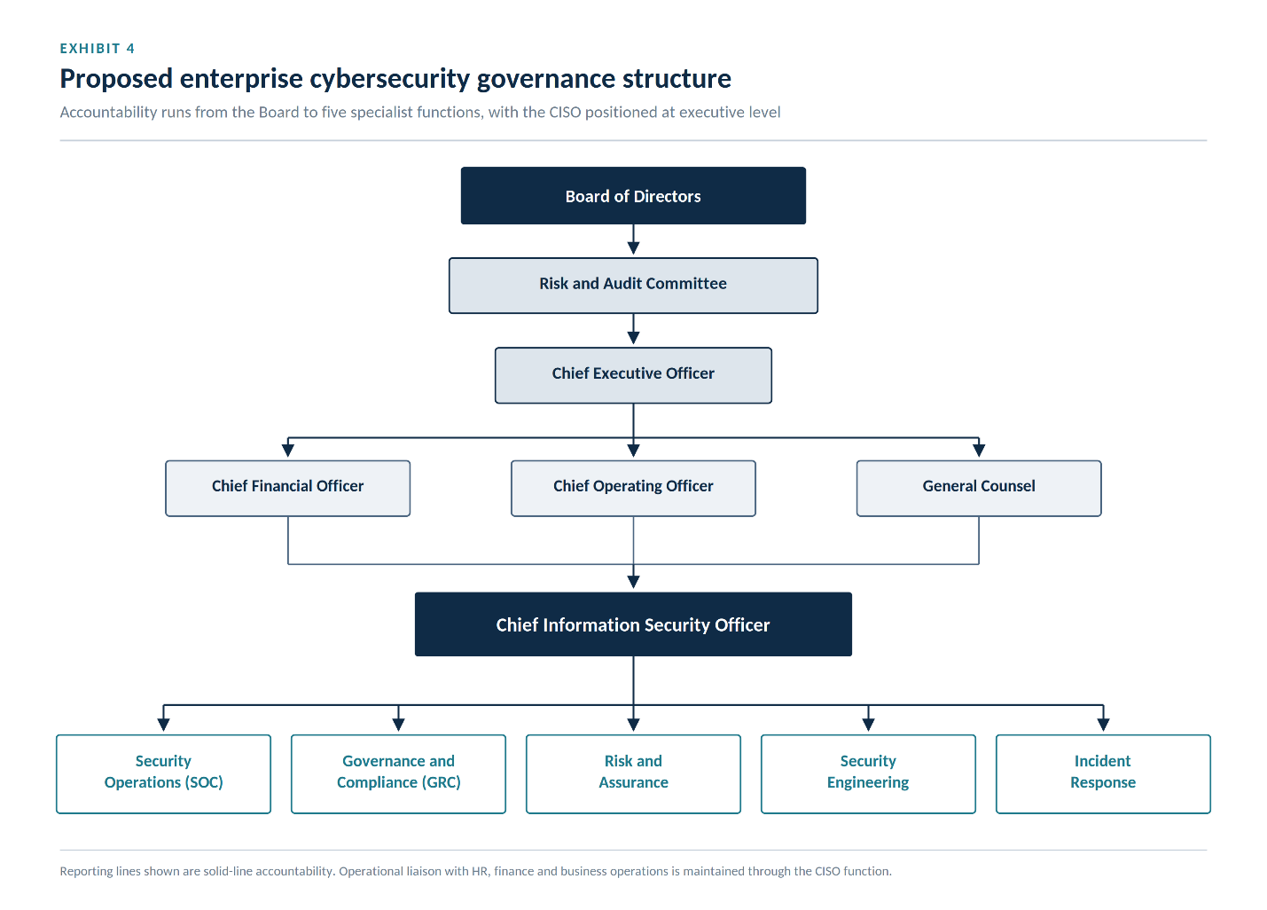

7.3 Roles and Responsibilities
Board of Directors
The Board establishes the organisation's cyber risk appetite, approves major cybersecurity investments, reviews resilience metrics, and ensures that cybersecurity considerations are incorporated into strategic planning.
Board members are not expected to manage technical operations directly; however, they remain accountable for ensuring that appropriate governance arrangements exist.

Chief Executive Officer
The Chief Executive Officer provides executive sponsorship for cybersecurity initiatives and ensures that organisational priorities support secure digital transformation.
Executive support is particularly important during large-scale initiatives such as Zero Trust implementation, where organisational change extends well beyond information technology.

Chief Information Security Officer
The Chief Information Security Officer serves as the strategic leader responsible for developing, implementing, and continuously improving the enterprise cybersecurity programme.
Key responsibilities include:
- Enterprise cybersecurity strategy
- Zero Trust implementation
- Security governance
- Regulatory compliance
- Risk management
- Incident response leadership
- Executive reporting
- Security awareness
- Third-party assurance
- Business continuity planning
Rather than functioning solely as a technical specialist, the CISO acts as a business advisor, balancing operational requirements with risk management and regulatory expectations.

Security Operations Centre (SOC)
The Security Operations Centre provides continuous monitoring of enterprise systems through Security Information and Event Management (SIEM), Endpoint Detection and Response (EDR), threat intelligence, and behavioural analytics.
Primary responsibilities include:
- Continuous monitoring
- Threat detection
- Alert triage
- Vulnerability monitoring
- Threat hunting
- Escalation of security incidents

Governance, Risk and Compliance (GRC)
The Governance, Risk and Compliance function ensures that organisational policies remain aligned with applicable regulations and industry standards.
Responsibilities include:
- Policy management
- Regulatory compliance
- Internal auditing
- Third-party governance
- Risk assessments
- Evidence collection
- Compliance reporting

Security Engineering
Security Engineering designs and maintains secure enterprise infrastructure.
Responsibilities include:
- Identity management
- Cloud security
- Network architecture
- Secure software development
- Encryption
- Infrastructure hardening
- Security automation

Incident Response Team
The Incident Response Team coordinates technical investigations and recovery activities during cybersecurity events.
Responsibilities include:
- Incident investigation
- Digital forensics
- Malware analysis
- Containment
- Recovery coordination
- Regulatory notification support
- Lessons learned reviews

7.4 Governance Principles
The proposed governance framework is based upon six guiding principles.
Executive Accountability
Cybersecurity remains a business responsibility requiring active executive oversight rather than delegated technical ownership.
Risk-Based Decision Making
Security investments should be prioritised according to measurable business risk rather than technological trends.
Continuous Improvement
Policies, controls, and governance arrangements should evolve as threats, technologies, and regulatory expectations change.
Transparency
Meaningful cybersecurity metrics should be reported regularly to executive leadership using business-oriented language rather than technical terminology.
Shared Responsibility
Every employee contributes to organisational cybersecurity through responsible behaviour, policy compliance, and timely reporting of suspicious activity.
Regulatory Alignment
Governance should simultaneously satisfy operational objectives and applicable regulatory obligations rather than treating compliance as an independent activity.

Work Stream 2 – Enterprise Security Policy Framework
8.1 Policy Philosophy
Technology cannot consistently enforce secure behaviour without clear organisational expectations. Policies provide the foundation upon which technical controls, governance processes, employee responsibilities, and regulatory obligations are built.
An effective policy framework should be concise, understandable, regularly reviewed, and aligned with organisational objectives. Policies should enable secure business operations rather than unnecessarily restricting productivity.
Accordingly, Aegis FinTech Innovations Ltd. should adopt an integrated policy framework organised around the following core domains.

8.2 Core Information Security Policy
The Information Security Policy establishes the organisation's overall security objectives, governance structure, and responsibilities.
The policy should:
- Define security objectives.
- Assign executive accountability.
- Describe employee responsibilities.
- Require annual policy review.
- Establish enforcement mechanisms.
- Support continual improvement.

8.3 Identity and Access Management Policy
Consistent with Zero Trust principles, identity management should become the primary mechanism controlling enterprise access.
Key policy requirements include:
- Multi-factor authentication for all users.
- Role-based access control.
- Least-privilege permissions.
- Privileged access management.
- Quarterly access reviews.
- Immediate account deactivation following employee departure.
- Continuous authentication for privileged users.

8.4 Acceptable Use Policy
Employees should clearly understand how organisational technology may be used.
The policy should address:
- Internet usage.
- Email security.
- Personal devices.
- Remote working.
- Password management.
- Software installation.
- Data handling.
- Artificial intelligence usage.
Clear expectations reduce accidental policy violations while strengthening organisational security culture.

8.5 Data Classification Policy
Information should be classified according to business sensitivity.
Recommended classification levels include:
Classification | Examples | Required Protection
Public | Marketing material | Minimal restrictions
Internal | Internal procedures | Standard organisational controls
Confidential | Customer information | Encryption and access control
Restricted | Financial transactions, authentication data | Maximum protection with continuous monitoring
Appropriate classification enables security controls to be applied proportionately according to business impact.

8.6 Third-Party Risk Management Policy
Given increasing dependence upon cloud providers and outsourced services, supplier governance has become essential.
The policy should require:
- Pre-contract security assessments.
- Security clauses within contracts.
- Annual supplier reviews.
- Independent audit reports.
- Continuous monitoring of critical vendors.
- Incident notification requirements.
- Business continuity obligations.
These measures align closely with the expectations established under DORA and ISO/IEC 27001.

8.7 Policy Governance Lifecycle
Policies should not remain static documents.
Each policy should progress through a structured lifecycle:
- Drafting
- Stakeholder review
- Executive approval
- Employee communication
- Technical implementation
- Compliance monitoring
- Annual review
- Continuous improvement
This lifecycle ensures that organisational policies remain relevant as technology, regulation, and business priorities evolve.

Excellent. From this point onward, the report moves from governance into enterprise architecture and operational implementation. This is where the report begins to resemble the type of strategic document produced by consulting firms such as Deloitte, PwC, EY, or KPMG.

Work Stream 3 – Regulatory Compliance and Enterprise Risk Governance
9.1 Strategic Objective
Cybersecurity compliance is frequently misunderstood as a periodic auditing exercise undertaken solely to satisfy regulatory requirements. In reality, effective compliance establishes the governance mechanisms through which organisations identify, assess, manage, and continuously monitor cyber risk. When implemented strategically, regulatory compliance strengthens operational resilience, improves executive decision-making, and enhances stakeholder confidence.
For Aegis FinTech Innovations Ltd., expansion into European financial markets requires a governance framework capable of simultaneously satisfying multiple regulatory obligations without creating duplicated processes or unnecessary administrative overhead. Rather than implementing independent compliance programmes for GDPR, DORA, ISO/IEC 27001, and NIST CSF, the proposed model integrates these frameworks within a unified Governance, Risk, and Compliance (GRC) programme.
The objective is not to comply with individual regulations independently but to establish a coherent governance model in which a single set of organisational processes supports multiple regulatory outcomes.

9.2 Enterprise Governance, Risk and Compliance (GRC) Framework
The proposed GRC framework is organised around five mutually reinforcing pillars.
Governance
Governance establishes organisational accountability through executive oversight, security policies, decision-making processes, and performance measurement. The Board of Directors, supported by the Chief Information Security Officer, retains responsibility for defining cyber risk appetite, approving strategic investments, and monitoring organisational resilience.
Risk Management
Enterprise risk management provides structured methods for identifying, analysing, prioritising, treating, and continuously reviewing cybersecurity risks. Risk assessments should be conducted at least quarterly and whenever significant organisational changes occur, including mergers, cloud migrations, or implementation of new technologies.
Regulatory Compliance
Compliance activities should be integrated into routine operational processes rather than treated as separate projects. Policies, technical controls, audit evidence, and documentation should collectively demonstrate compliance with applicable legal and regulatory obligations.
Assurance
Independent assurance provides confidence that security controls remain effective. Internal audits, vulnerability assessments, penetration testing, supplier reviews, and management reviews collectively evaluate the effectiveness of organisational governance.
Continuous Improvement
Cybersecurity maturity is dynamic rather than static. Lessons learned from incidents, audits, technological developments, and regulatory changes should continuously inform improvements to policies, procedures, and security architecture.

9.3 Enterprise Compliance Mapping
One of the principal advantages of integrated governance is the ability to satisfy multiple regulatory requirements using common organisational controls.
Governance Activity | NIST CSF 2.0 | ISO/IEC 27001 | GDPR | DORA
Information Security Policy | ✔ | ✔ | ✔ | ✔
Asset Inventory | ✔ | ✔ | — | ✔
Identity Management | ✔ | ✔ | ✔ | ✔
Risk Assessment | ✔ | ✔ | ✔ | ✔
Continuous Monitoring | ✔ | ✔ | — | ✔
Incident Response | ✔ | ✔ | ✔ | ✔
Third-Party Risk Management | ✔ | ✔ | — | ✔
Security Awareness Training | ✔ | ✔ | ✔ | ✔
Business Continuity | ✔ | ✔ | — | ✔
Executive Governance | ✔ | ✔ | ✔ | ✔
This integrated approach reduces duplicated effort while improving organisational consistency. Employees operate within a single governance framework rather than navigating multiple overlapping compliance programmes.

9.4 Security Performance Indicators
Effective governance requires meaningful performance measurement. Traditional metrics, such as the number of blocked attacks, rarely provide executives with sufficient insight into organisational resilience. Instead, cybersecurity reporting should emphasise business-oriented indicators that support strategic decision-making.
Recommended Key Performance Indicators (KPIs) include:
KPI | Target | Strategic Value
Multi-Factor Authentication Coverage | 100% | Reduces identity compromise
Mean Time to Detect (MTTD) | < 15 minutes | Measures monitoring capability
Mean Time to Respond (MTTR) | < 4 hours | Measures operational resilience
Critical Vulnerabilities Remediated within SLA | > 95% | Demonstrates vulnerability management effectiveness
Security Awareness Completion Rate | 100% | Supports organisational culture
Third-Party Risk Assessments Completed | 100% | Strengthens supplier assurance
Regulatory Findings Outstanding | 0 | Indicates governance maturity
Successful Backup Recovery Tests | 100% | Measures recovery capability
These indicators should be reported quarterly to executive leadership using dashboards that combine operational performance with strategic risk trends.

Work Stream 4 – Zero Trust Enterprise Architecture
10.1 Strategic Vision
The long-term objective of Aegis FinTech Innovations Ltd. is to establish a secure, cloud-native digital ecosystem capable of supporting continued business growth while maintaining resilience against increasingly sophisticated cyber threats.
Rather than implementing isolated security technologies, the proposed architecture integrates identity management, endpoint protection, cloud security, data protection, monitoring, and governance within a unified Zero Trust operating model.
This architecture reflects the principle that trust is continuously evaluated rather than permanently granted.

10.2 Architectural Principles
The proposed architecture is guided by the following principles:
- Identity is the primary security perimeter.
- Every access request requires verification.
- Devices must continuously demonstrate compliance.
- Applications should be independently protected.
- Data should remain encrypted throughout its lifecycle.
- Monitoring should occur continuously.
- Security decisions should adapt dynamically to changing risk conditions.
- Automation should support rapid detection and response while maintaining appropriate human oversight.
Together, these principles establish a resilient security posture capable of adapting to emerging threats without unnecessarily restricting business operations.

10.3 Proposed Zero Trust Architecture
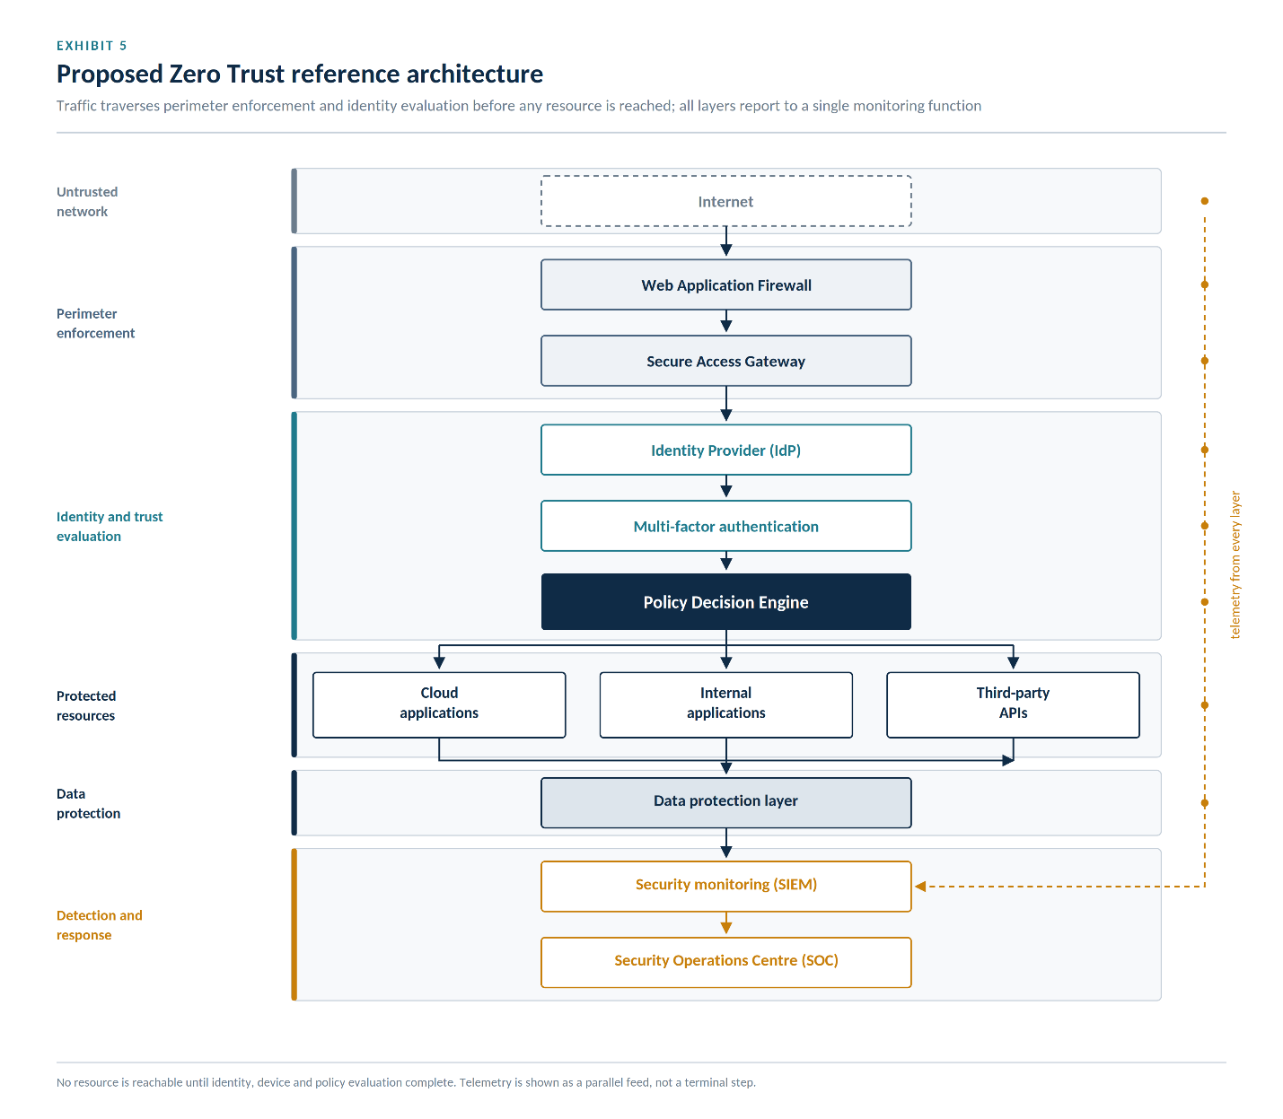

10.4 Identity and Access Management
Identity forms the foundation of Zero Trust Architecture. Every user, application, device, and service account should possess a unique digital identity governed through centralised authentication and authorisation.
The organisation should implement:
- Single Sign-On (SSO) for improved usability and security.
- Multi-Factor Authentication (MFA) for all users.
- Conditional Access Policies based on contextual risk.
- Role-Based Access Control (RBAC) aligned with job responsibilities.
- Privileged Access Management (PAM) for administrative accounts.
- Automated provisioning and de-provisioning integrated with Human Resources processes.
Access decisions should consider multiple contextual factors, including:
- User identity.
- Device health.
- Geographic location.
- Time of access.
- Network characteristics.
- Behavioural anomalies.
- Threat intelligence indicators.
Access should be granted only when the cumulative risk remains within the organisation's predefined tolerance.

10.5 Endpoint Security
Enterprise endpoints represent one of the most common entry points for cyber attackers. Accordingly, every corporate device should continuously demonstrate compliance with organisational security requirements before accessing enterprise resources.
Recommended controls include:
- Full-disk encryption.
- Endpoint Detection and Response (EDR).
- Automated patch management.
- Anti-malware protection.
- Secure boot verification.
- Device health attestation.
- Mobile Device Management (MDM) for smartphones and tablets.
- Continuous vulnerability assessment.
Devices failing compliance requirements should be quarantined automatically until remediation is completed.

10.6 Cloud Security
Cloud adoption provides considerable operational flexibility but also introduces new security challenges, including misconfigured storage services, excessive identity permissions, insecure APIs, and limited visibility across distributed environments.
To mitigate these risks, Aegis FinTech Innovations Ltd. should adopt a cloud security strategy incorporating:
- Cloud Security Posture Management (CSPM).
- Cloud Workload Protection Platforms (CWPP).
- Encryption of data at rest and in transit.
- Secure API gateways.
- Infrastructure as Code (IaC) security scanning.
- Centralised identity management across cloud providers.
- Continuous configuration monitoring.
- Automated compliance validation.
These measures ensure that cloud environments maintain consistent security standards while supporting organisational scalability.

10.7 Data Protection Strategy
Information remains one of the organisation's most valuable assets. Consequently, data protection must extend throughout the entire information lifecycle.
Recommended controls include:
- Data classification based on business sensitivity.
- Encryption using industry-standard cryptographic algorithms.
- Data Loss Prevention (DLP) technologies.
- Secure key management.
- Tokenisation of highly sensitive financial information.
- Immutable backup storage.
- Secure deletion procedures.
- Continuous monitoring of data access patterns.
Particular attention should be given to customer financial information and personally identifiable information (PII), ensuring compliance with GDPR while reducing exposure to data breaches.

10.8 Security Monitoring and Automation
Continuous monitoring is essential to maintaining an adaptive security posture. The Security Operations Centre should integrate telemetry from identity systems, endpoints, cloud services, network infrastructure, and applications into a centralised Security Information and Event Management (SIEM) platform.
Automation should be applied to repetitive operational tasks such as:
- Log aggregation.
- Alert correlation.
- Threat intelligence enrichment.
- Automated containment of compromised endpoints.
- Initial incident triage.
- Compliance reporting.
However, automation should complement rather than replace experienced analysts. High-impact decisions involving legal obligations, customer communications, or business disruption should remain subject to human review and executive oversight.

Work Stream 5 – Enterprise Cyber Risk Management
11.1 Strategic Objective
Effective cybersecurity requires organisations to make informed decisions about risk rather than attempting to eliminate all uncertainty. Every business activity involves some level of cyber exposure, whether arising from technology, people, third-party relationships, or regulatory obligations. Consequently, the objective of enterprise cyber risk management is not to remove risk entirely but to identify, prioritise, and manage it within the organisation’s defined risk appetite.
For Aegis FinTech Innovations Ltd., a structured risk management framework supports executive decision-making by ensuring that security investments are aligned with business priorities. The framework proposed in this report follows the principles of ISO 31000, ISO/IEC 27005, and the NIST Risk Management Framework (RMF), integrating cyber risk into broader enterprise governance.

11.2 Enterprise Risk Management Lifecycle
Cyber risks should be managed through a continuous lifecycle rather than one-time assessments.
The proposed lifecycle consists of six stages:
- Identify – Maintain an inventory of assets, business processes, data, technologies, and dependencies. Emerging threats should be monitored continuously through vulnerability intelligence, supplier reviews, and industry alerts.
- Assess – Evaluate the likelihood and business impact of identified risks. Assessments should consider financial loss, operational disruption, legal implications, customer trust, and reputational damage.
- Prioritise – Rank risks according to their significance. High-impact and high-likelihood risks should receive immediate executive attention, while lower-priority risks may be monitored or accepted where appropriate.
- Treat – Select appropriate risk responses, including mitigation, transfer (for example through cyber insurance), avoidance, or formal acceptance by management.
- Monitor – Continuously review risk indicators, emerging threats, and the effectiveness of implemented controls.
- Review – Conduct quarterly reviews to ensure that the risk register reflects changes in technology, business strategy, and the external threat environment.
This cyclical approach recognises that cyber risk evolves continuously and therefore requires ongoing management rather than periodic compliance exercises.

11.3 Enterprise Risk Register
The following table presents representative strategic cyber risks for Aegis FinTech Innovations Ltd.
Risk | Likelihood | Impact | Risk Rating | Mitigation Strategy
Ransomware attack | High | Critical | Extreme | Zero Trust, EDR, immutable backups, incident response exercises
Credential compromise | High | High | High | MFA, conditional access, privileged access management
Cloud misconfiguration | Medium | High | High | CSPM, configuration baselines, automated compliance scanning
Insider misuse | Medium | High | High | Least privilege, user behaviour analytics, security awareness
Third-party supplier compromise | Medium | Critical | High | Vendor due diligence, contractual security clauses, continuous monitoring
Regulatory non-compliance | Low | Critical | High | Integrated GRC programme, internal audits, executive reporting
Data breach | Medium | Critical | High | Encryption, DLP, access governance, incident response planning
AI-enabled phishing | High | Medium | High | Awareness training, email security, behavioural analytics
The risk register should remain a living document that is reviewed and updated as new threats emerge or business priorities change.

11.4 Enterprise Risk Matrix
Cybersecurity risks should be visualised using a qualitative risk matrix to support executive decision-making.
Impact | Low | Medium | High | Critical
High Likelihood | Medium | High | Extreme | Extreme
Medium Likelihood | Low | Medium | High | High
Low Likelihood | Low | Low | Medium | High
Risks classified as Extreme require immediate mitigation and regular executive oversight. High risks should be addressed through planned remediation activities with defined timelines and accountable owners. Medium risks should be monitored and treated according to available resources, while Low risks may be accepted if they fall within the organisation’s approved risk appetite.

11.5 Key Risk Indicators (KRIs)
In addition to traditional KPIs, executives should monitor forward-looking Key Risk Indicators that provide early warning of increasing cyber exposure.
Recommended KRIs include:
- Percentage of unsupported operating systems.
- Number of privileged accounts without MFA.
- Percentage of critical vulnerabilities older than 30 days.
- Number of third-party suppliers awaiting security review.
- Percentage of employees failing phishing simulations.
- Mean time to apply critical security patches.
- Number of repeated policy violations.
- Frequency of backup recovery failures.
Monitoring these indicators enables leadership to identify deteriorating security conditions before they result in major incidents.

11.6 Cyber Risk Appetite
The Board should formally define the organisation’s cyber risk appetite to guide decision-making across all business units.
Suggested position:
- No tolerance for intentional regulatory violations.
- Minimal tolerance for risks affecting customer financial data or personally identifiable information.
- Moderate tolerance for innovation-related technology risks where appropriate controls exist.
- Higher tolerance for low-impact operational risks that do not materially affect customers or regulatory obligations.
Clearly defined risk appetite ensures that investment decisions are consistent, transparent, and aligned with organisational objectives.

Work Stream 6 – Incident Response and Digital Operational Resilience
12.1 Strategic Objective
Despite robust preventive controls, no organisation can eliminate the possibility of cyber incidents. Operational resilience therefore depends upon the ability to detect, contain, recover from, and learn from security events while maintaining essential business services.
An effective incident response capability combines technical expertise, governance, communication, legal compliance, and business continuity planning. The proposed approach aligns with NIST SP 800-61 Rev. 2 and supports the operational resilience expectations established under DORA.

12.2 Incident Response Lifecycle
The organisation should adopt a structured six-phase incident response process.
Phase 1 – Preparation
Preparation includes developing incident response plans, assigning responsibilities, maintaining forensic tools, conducting employee training, and performing regular simulation exercises. Contact lists for regulators, law enforcement, legal counsel, cloud providers, and critical suppliers should be reviewed periodically.
Phase 2 – Identification
Potential incidents are identified through SIEM alerts, endpoint detection tools, user reports, threat intelligence, and anomalous behaviour identified by analytics platforms. Early identification reduces the likelihood of widespread compromise.
Phase 3 – Containment
Once confirmed, incidents should be contained rapidly to limit further damage. Containment actions may include isolating affected endpoints, disabling compromised accounts, blocking malicious network traffic, or restricting access to affected systems.
Phase 4 – Eradication
Root causes must be removed before normal operations resume. Activities include malware removal, credential resets, vulnerability remediation, and validation that affected systems are free from compromise.
Phase 5 – Recovery
Systems are restored using verified backups, business services are resumed in a controlled manner, and monitoring is intensified to ensure that no residual malicious activity remains.
Phase 6 – Lessons Learned
Following recovery, the incident response team should conduct a formal post-incident review to identify technical, procedural, and organisational improvements. Findings should feed directly into risk management, security awareness, and policy updates.

Figure 7. Incident Response Lifecycle
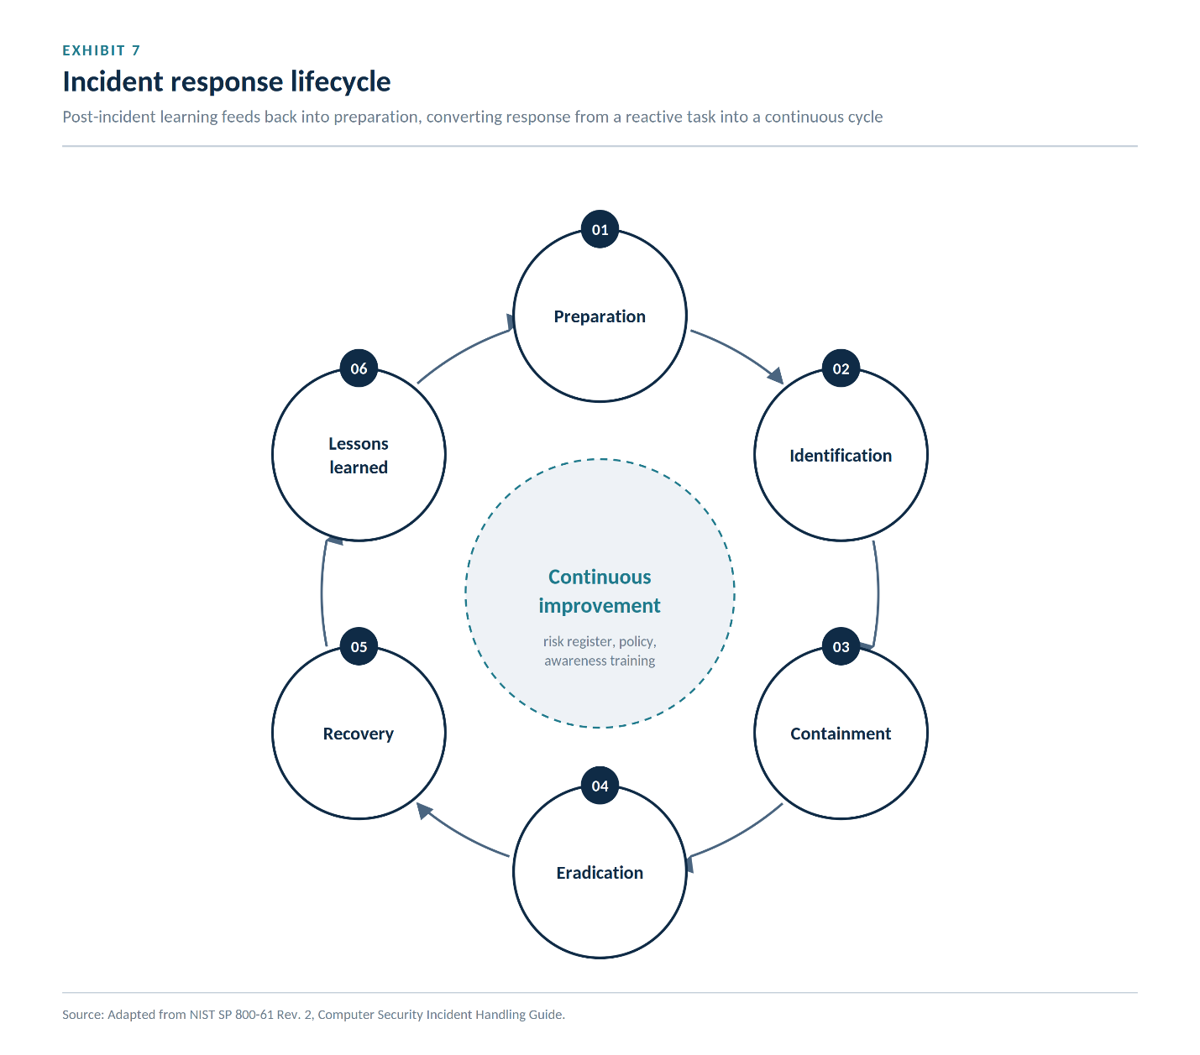

12.3 Business Continuity and Disaster Recovery
Cybersecurity resilience extends beyond technical recovery. Aegis FinTech Innovations Ltd. must maintain the ability to continue delivering essential financial services during disruptive events.
The Business Continuity Plan (BCP) should define critical business processes, recovery priorities, communication protocols, and manual workarounds. The Disaster Recovery Plan (DRP) should specify technical recovery procedures, including infrastructure restoration, backup validation, and cloud failover.
Recommended recovery objectives include:
- Recovery Time Objective (RTO): Less than 4 hours for critical customer-facing systems.
- Recovery Point Objective (RPO): Less than 15 minutes for financial transaction data.
Regular testing of backup restoration procedures and disaster recovery exercises should be mandatory. Results should be reported to executive leadership and used to improve resilience.

12.4 Crisis Communication
Effective communication is essential during cyber incidents. The organisation should establish predefined communication procedures covering:
- Internal notifications to executive leadership and employees.
- Customer communications where service disruption or data exposure occurs.
- Regulatory reporting in accordance with GDPR and DORA.
- Coordination with law enforcement and external incident response partners.
- Media statements managed through authorised spokespersons.
Transparent, timely communication reduces uncertainty, supports regulatory compliance, and helps preserve stakeholder trust.

12.5 Security Awareness and Organisational Learning
Every significant incident provides an opportunity to strengthen organisational resilience. Lessons learned should inform future security awareness campaigns, technical improvements, policy revisions, and governance enhancements.
Annual awareness programmes should include:
- Phishing simulations.
- Secure password practices.
- Social engineering awareness.
- Safe handling of sensitive information.
- AI-related security risks.
- Incident reporting procedures.
Embedding learning into organisational culture helps transform cybersecurity from a reactive function into a continuous improvement process.

Excellent. This final section is where the consultancy report demonstrates executive thinking. Rather than ending with technical recommendations, it concludes by showing how cybersecurity becomes a strategic business capability that supports growth, regulatory resilience, and competitive advantage.

Work Stream 7 – Cybersecurity Maturity, Performance Management and Strategic Implementation
13.1 Strategic Objective
Long-term cybersecurity success cannot be measured solely by the deployment of new technologies. Sustainable resilience depends upon organisational maturity, governance effectiveness, workforce capability, and the organisation's ability to adapt continuously to changing threats.
Aegis FinTech Innovations Ltd. should therefore adopt a structured cybersecurity maturity model that allows executive leadership to monitor progress over time while ensuring that investments continue to align with strategic business objectives.
Rather than measuring success through technical outputs alone, the organisation should evaluate cybersecurity according to governance capability, operational effectiveness, regulatory readiness, and organisational resilience.

13.2 Cybersecurity Maturity Model
The proposed maturity model contains five progressive levels.
Level 1 – Initial
Security activities are largely reactive and informal.
Characteristics include:
- Limited governance.
- Minimal documentation.
- Inconsistent policies.
- Basic technical controls.
- No formal risk management.
- Compliance driven primarily by external audits.
At this level, cybersecurity depends heavily upon individual expertise rather than organisational capability.

Level 2 – Developing
Policies become formalised and responsibilities are clearly assigned.
Characteristics include:
- Basic governance.
- Initial security awareness programme.
- Defined incident response process.
- Asset inventory established.
- Regular vulnerability assessments.
Cybersecurity begins transitioning from isolated technical activities toward organisational management.

Level 3 – Defined
Cybersecurity becomes integrated into organisational governance.
Characteristics include:
- Enterprise Risk Register.
- Security KPIs.
- Third-party governance.
- Formal compliance programme.
- Security Operations Centre.
- Zero Trust implementation underway.
Most medium-sized financial organisations should aim to achieve this maturity level before expanding into highly regulated international markets.

Level 4 – Managed
Security decisions become increasingly data-driven.
Characteristics include:
- Continuous monitoring.
- Behavioural analytics.
- Security automation.
- Executive dashboards.
- Predictive risk indicators.
- Continuous compliance monitoring.
Cybersecurity functions proactively rather than reactively.

Level 5 – Optimised
Cybersecurity becomes a strategic competitive capability.
Characteristics include:
- Artificial intelligence-assisted monitoring.
- Threat intelligence integration.
- Continuous optimisation.
- Executive cyber risk forecasting.
- Mature security culture.
- Enterprise-wide resilience.
At this level, cybersecurity supports innovation rather than constraining it.
For Aegis FinTech Innovations Ltd., the recommended objective is to progress from Level 2 to Level 4 within twenty-four months while establishing the governance foundations required to achieve Level 5 over the longer term.

13.3 Cybersecurity Balanced Scorecard
Executive leadership requires concise, business-focused reporting rather than highly technical operational metrics.
The Balanced Scorecard below provides a structured approach for monitoring cybersecurity performance across four strategic perspectives.
Perspective | Strategic Objective | Example KPI | Target
Financial | Reduce cyber-related financial losses | Annual cyber loss | Less than 1% of annual revenue
Customer | Strengthen customer trust | Customer security complaints | Continuous reduction
Internal Processes | Improve operational resilience | Mean Time to Respond (MTTR) | Less than 4 hours
Learning & Growth | Develop organisational capability | Annual awareness completion | 100%
The Balanced Scorecard should be reviewed quarterly by executive leadership to ensure that cybersecurity investments continue delivering measurable business value.

13.4 Executive Cybersecurity Dashboard
The Chief Information Security Officer should provide the Board with a concise executive dashboard summarising organisational cyber resilience.
Recommended dashboard indicators include:
Governance
- Overall maturity level.
- Regulatory compliance status.
- Internal audit findings.
- Outstanding policy reviews.
Risk
- Number of critical enterprise risks.
- High-risk suppliers.
- Emerging threat intelligence.
- Risk appetite exceptions.
Operations
- Mean Time to Detect.
- Mean Time to Respond.
- Security incidents this quarter.
- Patch compliance.
- Backup success rate.
Compliance
- GDPR compliance.
- DORA readiness.
- ISO 27001 maturity.
- Internal audit performance.
Workforce
- Security awareness completion.
- Phishing simulation success rate.
- Insider risk indicators.
- Training participation.
Reporting cybersecurity using business-oriented indicators enables executive leadership to evaluate organisational resilience without requiring deep technical expertise.
13.5 Twelve-Month Implementation Roadmap
Successful Zero Trust transformation should occur through phased implementation rather than large-scale organisational disruption.
Quarter 1
Governance Foundation
Key activities include:
- Appoint Governance Steering Committee.
- Update Information Security Policy.
- Establish Enterprise Risk Register.
- Complete asset inventory.
- Define security KPIs.
- Launch executive cyber awareness programme.

Quarter 2
Identity Transformation
Activities include:
- Deploy enterprise Multi-Factor Authentication.
- Implement Single Sign-On.
- Introduce Privileged Access Management.
- Begin Conditional Access implementation.
- Perform identity governance review.

Quarter 3
Enterprise Security Enhancement
Activities include:
- Deploy Endpoint Detection and Response.
- Implement SIEM platform.
- Introduce User Behaviour Analytics.
- Implement Cloud Security Posture Management.
- Begin Zero Trust microsegmentation.

Quarter 4
Operational Resilience
Activities include:
- Conduct enterprise penetration testing.
- Complete Disaster Recovery exercise.
- Perform DORA readiness assessment.
- Execute ransomware simulation.
- Review governance maturity.
- Prepare ISO 27001 certification roadmap.

Figure 10. Twelve-Month Roadmap
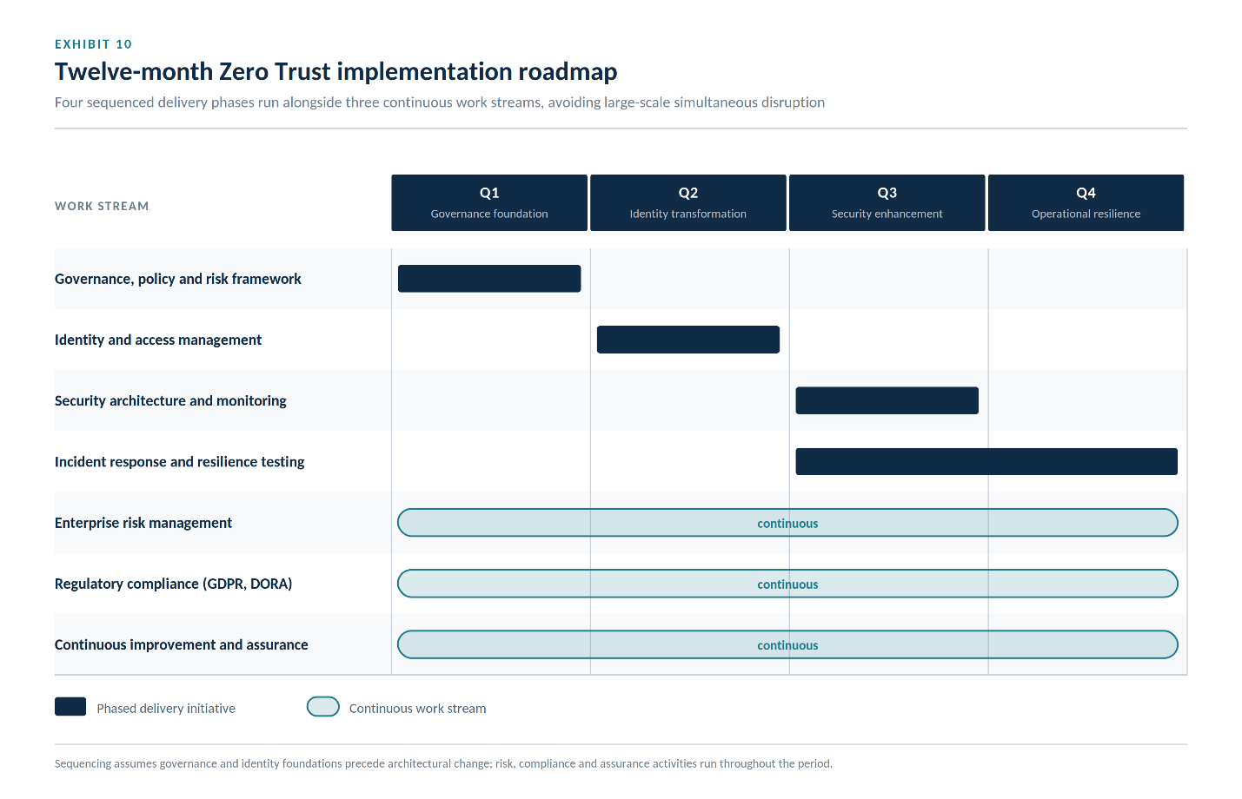

13.6 Cost–Benefit Considerations
Zero Trust implementation requires investment in technology, training, governance, and organisational change. However, these costs should be evaluated against the financial and operational consequences of significant cyber incidents.
Potential benefits include:
- Reduced likelihood of ransomware-related business disruption.
- Lower regulatory exposure through improved compliance.
- Enhanced customer confidence and brand reputation.
- Improved operational efficiency through integrated identity management.
- Greater visibility into enterprise cyber risk.
- Faster incident detection and recovery.
- Increased organisational resilience supporting long-term growth.
While some initiatives require significant initial investment, the cumulative benefits extend well beyond information technology by protecting revenue, supporting strategic expansion, and strengthening stakeholder confidence.

14. Strategic Conclusion
The cybersecurity landscape confronting financial institutions continues to evolve in response to accelerating digital transformation, increasingly sophisticated threat actors, expanding regulatory expectations, and growing dependence upon interconnected technology ecosystems. Traditional perimeter-based security models no longer provide sufficient protection for organisations operating within cloud-first, highly distributed environments where identities, applications, and data extend far beyond conventional network boundaries.
This report has demonstrated that Zero Trust Architecture represents a significant advancement in enterprise cybersecurity by replacing implicit trust with continuous verification, adaptive access control, and identity-centred governance. The literature reviewed throughout Task 1 consistently indicates that Zero Trust strengthens resilience against credential compromise, limits lateral movement during cyber attacks, improves organisational visibility, and supports regulatory compliance. Equally important, the review highlights that sustainable cyber resilience cannot be achieved through technology alone. Effective governance, organisational culture, executive leadership, workforce capability, and continuous improvement remain essential components of a mature cybersecurity programme.
Building upon these findings, Task 2 translated theoretical principles into a practical transformation strategy tailored to the needs of Aegis FinTech Innovations Ltd. The proposed operating model integrates governance, enterprise risk management, Zero Trust architecture, regulatory compliance, incident response, business continuity, supplier assurance, workforce development, and performance measurement within a unified cybersecurity programme. Rather than treating security as a technical function, the recommendations position cybersecurity as a strategic business capability that enables innovation while protecting customers, supporting regulatory obligations, and strengthening organisational resilience.
The report also demonstrates that internationally recognised frameworks—including NIST CSF 2.0, ISO/IEC 27001:2022, GDPR, and DORA—are most effective when implemented as complementary components of a single governance structure. This integrated approach reduces duplication, improves accountability, and allows cybersecurity investments to deliver value across operational, regulatory, and strategic objectives simultaneously.
Ultimately, cyber resilience should not be measured by the number of security technologies deployed or by the absence of security incidents. Instead, resilient organisations are distinguished by their ability to anticipate emerging threats, respond effectively to disruption, recover rapidly, learn from experience, and adapt continuously to an evolving digital environment. By adopting the recommendations presented in this report, Aegis FinTech Innovations Ltd. will establish a mature cybersecurity capability that protects organisational assets, strengthens customer trust, supports international expansion, and positions the organisation for sustainable long-term success.

15. Recommendations
To translate the proposed strategy into measurable outcomes, the following actions are recommended:
- Adopt Zero Trust Architecture as the organisation's long-term security model, beginning with identity governance, multi-factor authentication, and least-privilege access controls.
- Establish a Board-level Cybersecurity and Risk Committee to provide strategic oversight, approve cyber risk appetite, and monitor executive performance.
- Implement an integrated Governance, Risk, and Compliance (GRC) programme that aligns NIST CSF 2.0, ISO/IEC 27001:2022, GDPR, and DORA within a unified governance structure.
- Strengthen identity and access management by deploying conditional access, privileged access management, single sign-on, and continuous authentication.
- Enhance cloud security through Cloud Security Posture Management (CSPM), secure configuration management, and continuous compliance monitoring.
- Expand the Security Operations Centre (SOC) by integrating SIEM, Endpoint Detection and Response (EDR), User and Entity Behavior Analytics (UEBA), and threat intelligence.
- Develop a comprehensive cyber resilience programme that includes regular incident response exercises, disaster recovery testing, and business continuity planning.
- Invest in workforce capability through continuous security awareness, phishing simulations, executive cyber education, and role-specific technical training.
- Adopt meaningful executive metrics using a Balanced Scorecard and cybersecurity dashboard that links operational performance to business outcomes.
- Review governance and cyber maturity annually, ensuring that the cybersecurity programme evolves in response to changing threats, technological developments, and regulatory expectations.

References
[1] National Institute of Standards and Technology (NIST), Zero Trust Architecture, NIST Special Publication 800-207, Gaithersburg, MD, USA, 2020.
[2] National Institute of Standards and Technology (NIST), The NIST Cybersecurity Framework (CSF) 2.0, Gaithersburg, MD, USA, 2024.
[3] International Organization for Standardization, ISO/IEC 27001:2022 Information Security, Cybersecurity and Privacy Protection — Information Security Management Systems — Requirements, Geneva, Switzerland, 2022.
[4] International Organization for Standardization, ISO/IEC 27002:2022 Information Security Controls, Geneva, Switzerland, 2022.
[5] European Parliament and Council of the European Union, Regulation (EU) 2016/679 (General Data Protection Regulation), Official Journal of the European Union, 2016.
[6] European Parliament and Council of the European Union, Regulation (EU) 2022/2554 on Digital Operational Resilience for the Financial Sector (DORA), Official Journal of the European Union, 2022.
[7] J. Kindervag, Build Security Into Your Network’s DNA: The Zero Trust Network Architecture, Forrester Research, Cambridge, MA, USA, 2010.
[8] European Union Agency for Cybersecurity (ENISA), ENISA Threat Landscape 2024, Athens, Greece, 2024.
[9] National Institute of Standards and Technology (NIST), Computer Security Incident Handling Guide, NIST Special Publication 800-61 Revision 2, Gaithersburg, MD, USA, 2012.
[10] International Organization for Standardization, ISO 31000:2018 Risk Management — Guidelines, Geneva, Switzerland, 2018.
[11] Verizon, 2025 Data Breach Investigations Report, New York, NY, USA, 2025.
[12] IBM Security, Cost of a Data Breach Report 2024, Armonk, NY, USA, 2024.
[13] Gartner, Top Strategic Technology Trends for 2025, Stamford, CT, USA, 2025.
[14] MITRE Corporation, MITRE ATT&CK Framework, McLean, VA, USA, 2025.
[15] Open Worldwide Application Security Project (OWASP), OWASP Top 10 Web Application Security Risks 2021, Wakefield, MA, USA, 2021.
[16] National Cyber Security Centre (NCSC), 10 Steps to Cyber Security, London, U.K., 2023.
[17] Cybersecurity and Infrastructure Security Agency (CISA), Shields Up Guidance, Washington, DC, USA, 2024.
[18] World Economic Forum, Global Cybersecurity Outlook 2025, Geneva, Switzerland, 2025.
[19] Microsoft, Microsoft Digital Defense Report 2024, Redmond, WA, USA, 2024.
[20] Cloud Security Alliance, Security Guidance for Critical Areas of Cloud Computing v5.0, 2024.

