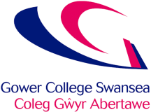
Academic & Employability Skills (ACCA4016)
Applied Computing, HND
Lecturer: Paul John
Reflection upon the application of the academic and professional skills learned.

Table of Contents
1. Introduction 2
2. Application of Fundamental Learning Techniques 3
2.1. Academic progression and reflection 3
2.2. Vak Test 3
3. Organisation of Resources and Self-Management 5
3.1. File Management 5
3.2. Environment Conductive to Learning 6
3.3. Assignment/Exam Time Management 8
4. Demonstration of Academic Skills 10
4.1. Report Structure 10
4.2 Presentation Techniques 11
5. Application of Research Methods 13
5.1 Referencing Log 13
5.2 Notetaking 14
6. Professional Skills for Future Work 15
6.1. Soft skills 15
6.2. Employability Skills 15
6.2.1. CV version 1 & 2 17
6.3. Team-Working 20
6.4. Acknowledge, legal, ethical and sustainability issues 20
7. Appendix 20

Introduction

I have been asked to reflect and document my academic progress through this course I have applied myself to. On this report I am documenting the improvements of my attitude towards studying, professional skills, self-management, research methods, transferable skills, and appropriate study area, based on my previous studies.
I will be providing several screenshots to reflect on the professional skills learned. This will consist of proper use of referencing, report writing, presentation techniques, effective planning and prepayment of assignments/exams.

Application of Fundamental Learning Techniques

2.1. Academic progression and reflection

This academic year has made me recognise the importance of applying appropriate and diligent learning techniques throughout my journey in Higher Education. The standards and expectations of HE has enhanced the way I approach academic work, as in my previous studies it was divergent. In HE it emphasises independent learning, critical thinking, and self-management, overall, these points demonstrate a deeper understanding and attitude towards my various subjects.

2.2. Vak Test

Throughout this year its expected to apply appropriate styles, formats, and techniques to understanding task criteria. To better improve academic performance, I have conducted a vak learning test to decide if I am either a visual, auditory, or kinaesthetic learner.

10/10/23

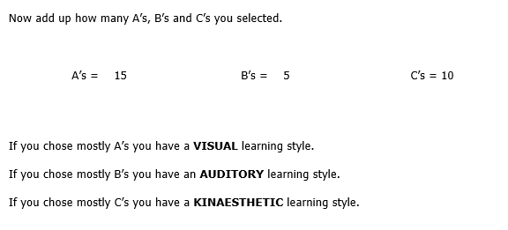
Figure 1 – This is the first Vak test I conducted on the 10th of October.

In October I conducted a Vak test to evaluate what type of learning style I have. When I completed the test, the results showed that I take a visual approach to learning. Personally, I believe this is true as I find that visual explanations are easier to breakdown and understand, rather than a listening to it or approach it hands-on.
To show improvement I have taken another test in December to distinguish any changes that could have taken place.

12/12/23
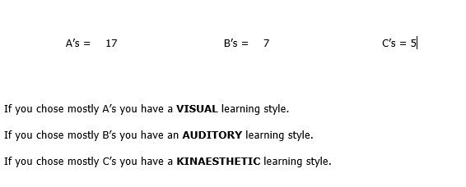
Figure 2 – Second Vak test I conducted on the 12th of December.

We can see that there is a slight difference in the way I perceive each learning style. As previously I am still more of a visual type of learner as I didn’t really expect it to change much. However, I have changed in the way I perceive an auditory learning style. I believe the reason is because of my perception of understanding was very little when I had taken the first test. However, with a mixture of visual and auditory can greatly boost my level of understanding, rather than being oblivious and experimenting myself. This indicates that I am more attuned to listening rather than taking it hands-on.
For my final evaluation I conducted one last Vak test in February to see if anything ad changed over the festive holiday.

14/03/24
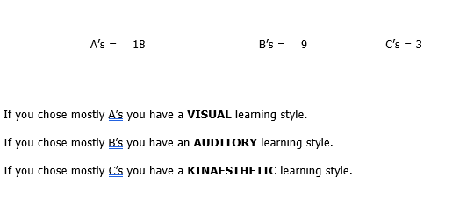
Figure 3 – This is the final Vak test I conducted on the 14th of March.

Once again, I am more of a visual type of learner, and I don’t think much has changed over the holidays. I believe the marks I had does reflect on the type of learning style that benefits me the most.

Organisation of Resources and Self-Management

3.1. File Management

When utilising files for a company it is important to consider the structure and allocation of resources, and naming conventions. Appropriate file management will ensure that any user that request access can easily and efficiently navigate through the folders and subfolders. At the start of my academic career, In Figure 4, I was inconsiderate of proper naming conventions which look’s messy and unprofessional. This a strong indication that I do not manage my files and folders accordingly, which will not be tolerated in a working environment.
Here is a screenshot of my folders and subfolders to demonstrate my organisational skills:

18/09/23
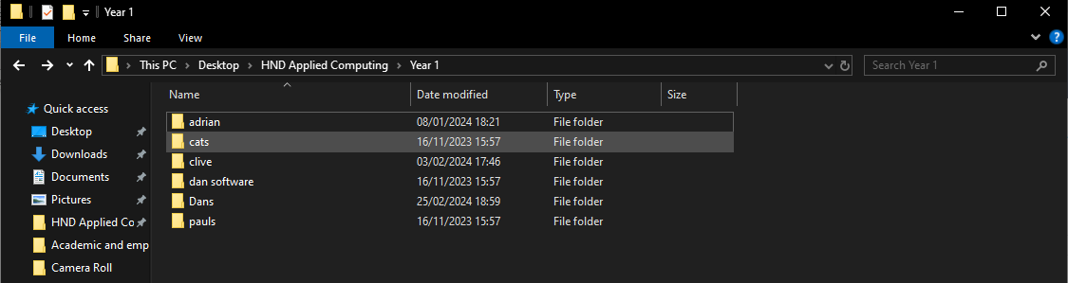
Figure 4 – Inappropriate file management that isn’t professional.

05/12/23
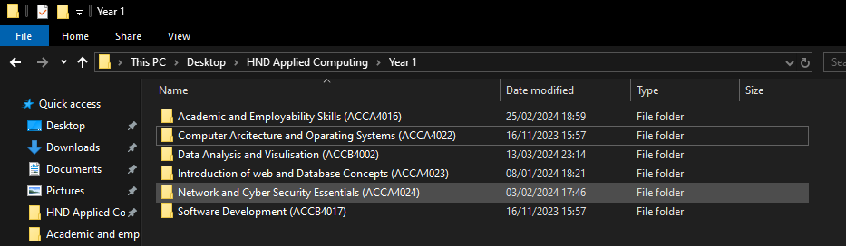
Figure 5 – Appropriate file management with corrected course titles and module numbers.

You can see in Figure 5, that I adjusted the allocation and names accordingly. So that professional users can quickly and efferently navigate through, with respected module codes. In a working environment this will be accepted, as it displays clearly what each folder and subfolder consist of.

3.2. Environment Conductive to Learning

To ensure that studying isn’t interrupted or distracted, it useful to have your environment appropriate for learning. Eliminating all distractions will greatly impact your effectiveness to study and to ensure that you can achieve maximum potential. I’ve dedicated efforts to making my study area organised and distract-free. I find that my bedroom is the best place to study, as I won’t be interrupted by other siblings, or family members.

29/12/23

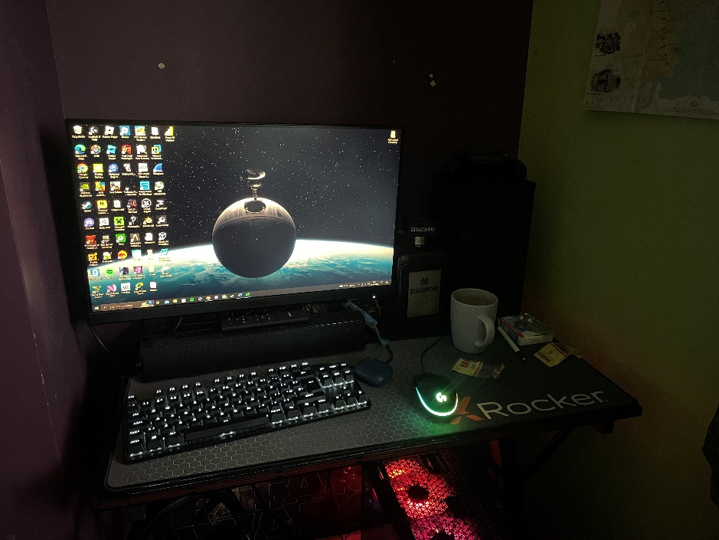.
Figure 6 – This is a picture I took of my study environment in December.
This is the photo I took in November. You can see that it is not tidy or distract-free. On my desk I have a games console which isn’t useful when studying as if I get bored, I will start playing my games, which isn’t conductive to learning.

05/01/24
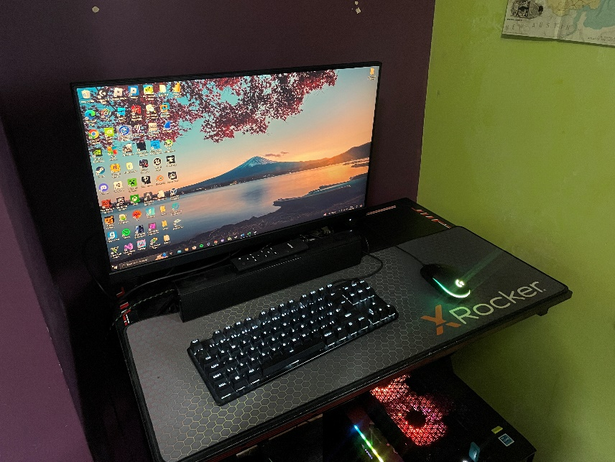

Figure 7 – This is a picture of my improved environment which is conversive to learning.

In the second picture you can see that all distractions have been eliminated, and accessories have been properly organised. Having a clean desk will also ensure that hygiene and space to move is constant.

3.3. Assignment/Exam Time Management

To prepare for all upcoming assignments and exams I have created a time and date list to help me organise and manage my time studying and working. To plan effective management, I have used OneNote on windows to help me plan my studies effectively. OneNote is a useful tool when documenting assignment and exam due dates, I feel it really helps me plan and remind me on what coursework is due.

16/11/23
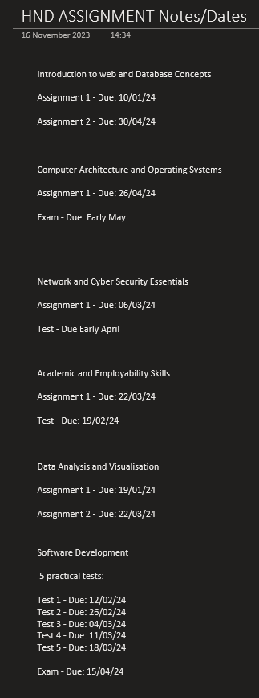
Figure 8 – Use of OneNote to plan and organise assignments, and exam due dates.

Here in Figure 8, you will see that I have effectively planed my assignments and exam dates, so that when I come back too review, I can see how long I have left to finish or prepare for them. Setting out assignments and exams into written dates can help me academically stay organised, whilst being focused on my studies. I believe that OneNote has greatly helped me stay on top of my studies by its useability and reliance.

Link to OneNote:
https://gowercollegeswanseaacuk-my.sharepoint.com/:o:/g/personal/joh20857875_stu_gcs_ac_uk/ElABDeL_zX5PsL6FUusWMEQBKaD07wR0xb-oFdxtJDObJw

Demonstration of Academic Skills

4.1. Report Structure

Creating professionally laid out, and structured reports is crucial in enchanting efficiency and clarity within a working environment. keeping your reports clean and structured will ensure that presentability and self-management is applied, so that in a working environment, colleague’s, managers, and clients, can understand and navigate without confronting problems. I have applied this to my studies as I want to make sure that my presentability skills are transferable in a working environment. I have taken into consideration to create an assignment template that I have used across various subjects. Creating a template is beneficial, as you won’t need to waste time creating a new report each time an assignment is released. It can also guarantee that different fonts, sizes and headings won’t be different, as its good to keep consistency through my studies.
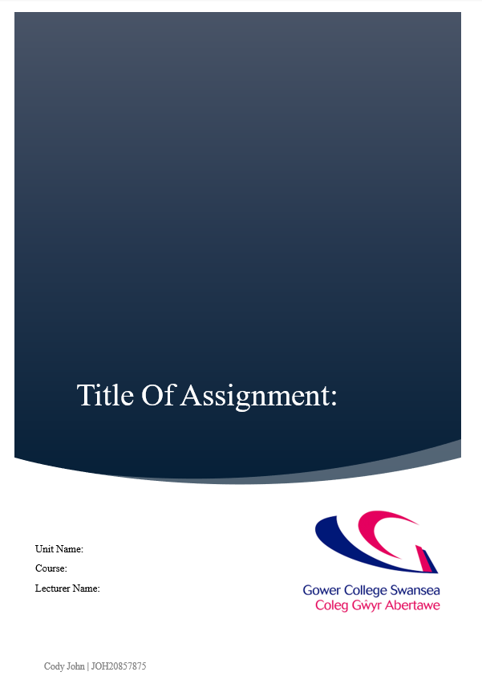
Figure 9 – Cover page with appropriate detailing’s.

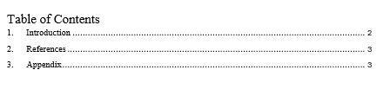
Figure 10 – Table of Contents with relevant headings.

To apply professionalism, I have created a cover page with relevant details as seen in Figure 9. I have used a simple yet stylish type of cover page that offers related information about the subject. Such as applying unit name, student name, course, and lecturer. Additionally, I have included the logo of my education board, as I believe it leaves a professional touch to the report, enhancing its visual appeal and credibility. What also enhances the reliability and navigation, is a well implemented Table of Contents. Including a table of contents will make finding important headings in a document easier, with the help of page numbers too. Including an introduction to your report gives the viewer a short explanation of the context and what’s contained. This advances the viewers understanding whilst also looking professional. Use of references will also give credibility to a sourced desiccation where all references are documented for the viewer to investigate. Additionally, including a possible appendix provides supplemental information that contextualises the main content discussed. I have included this is some of my studies, depending on the relevance.

4.2 Presentation Techniques

To showcase my academic and employability skills, I conducted a short presentation that reflects on the performance of my presentability skills. To guarantee improvement I performed two versions of this presentation. The presentation was based around a popular video game called Red Dead Redemption II. The Presentation lasted about six minutes with 4 minutes of presenting and further two minutes asking questions to the audience. As seen in Figure 11, it was obvious that I didn’t rehearse my presentation and that there where numerous spelling and grammatical errors. In a working environment, this would showcase a lack of proof reading and preparedness, whilst also indicating a lack of commitment. However, I spoke with enthusiasm pointing out that I was passionate about the topic. I also faced my audience, and with eye contact, proving that I was engaged with the audience.
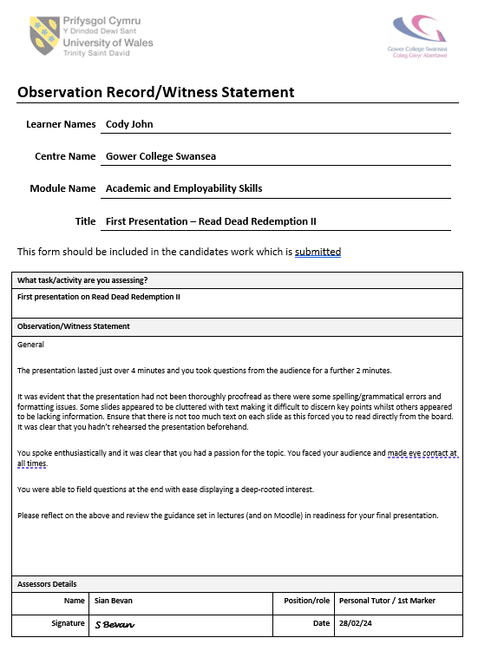
Figure 11 – Witness testimony for my first presentation.

For my second presentation I had reflected on the feedback that was given, and improved the structure and contents so that readability was consistent. To create a more structured and professional presentation, I chopped down big chunks of paragraphs so that each slide wasn’t cluttered with text. I also made sure that images were clear and sources accordingly with credit due. My second testimony was much better than my first, as I had improved on the errors made, and applied all corrections. In Figure 12, you can see that I delivered a very good presentation with an open body language. I had improved on the layout of my slides as it states that I included a variety of images which were appealing and engaging. What also improved is my ability to speak to the audience without reading off the board, which shows that I have rehearsed and proofread my slides. Overall, I displayed a huge passion for the topic and had great enthusiasm on my ability to speak too the audience.

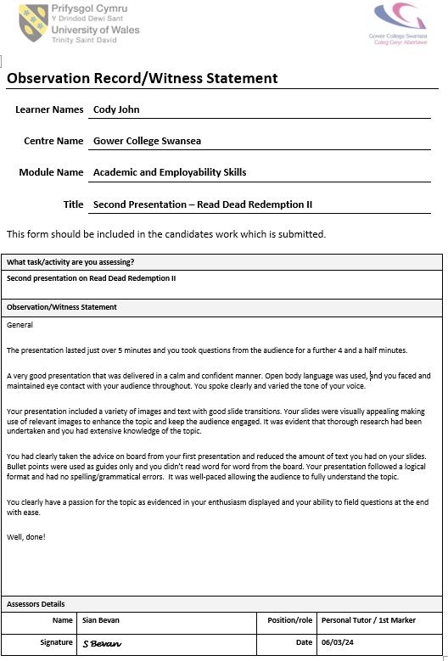
Figure 12 – Second testimony of my final presentation.

Application of Research Methods

5.1 Referencing Log

In this report I have been asked to document my application of research methods that have been applied to my studies. With each assignment there is a level of independent research that is expected to apply. The use of finding relevant, and functional references can further enhance the context of the scenario. I have applied these techniques to my studies. To keep track of my use of references I have created a reference log that documents all citations that I have used throughout my various units.
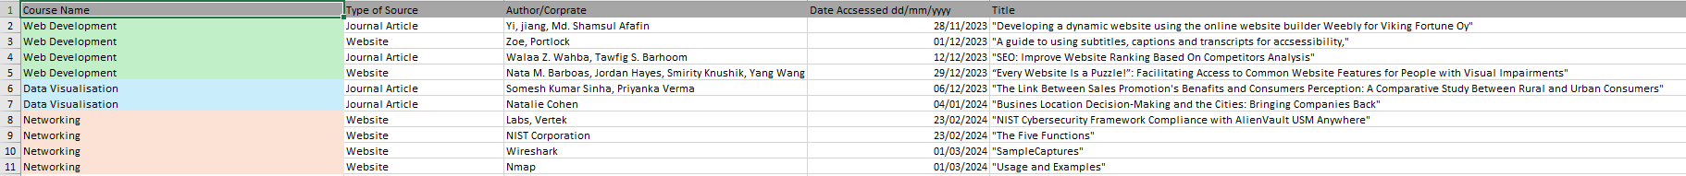
Figure 13 – A reference log of all citations used.

As shown in Figure 13, I have created a reference log that stores all citations used in my academic coursework. It serves as a record of all used sources, ensuring proper crediting of authors, titles, day accessed, and links to websites. In professional practice, referencing remains crucial in Higer Education and professional work. By accurately referencing, it demonstrates accountability and respect for a person’s intellectual property. To make sure that sources are properly researched I have used the IEEE referencing library. An example of me using the source is in my web development assignment, as I had to gather a peer-reviewed research study that reflects on the accessibility, useability and search engine optimisation of websites for each of those points. Personally, I did not use the library as I already found a study from different reliable sources.

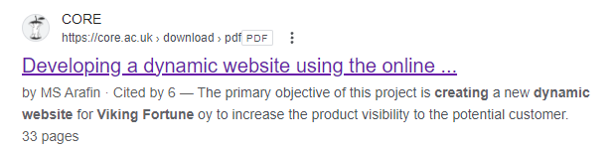
Figure 14 – This is a research study that I used for the importance of useability and utility for websites.

5.2 Notetaking

To ensure that all points given in a lecture are noted and acknowledge, I have consulted to note taking on my cellular device, as I am able to make my notes with me anywhere. Note-taking serves as a valuable study aid, providing me with personalised resources for revision and proof-reading. Keeping it organised will ensure that I can easily locate and revisit important information when preparing for assignments and exams.

Professional Skills for Future Work

6.1. Soft skills

When applying for work or presenting higher education skills, its important to display an abundance of soft skills that can be both utilised in my studies, and treasurable skills for employers. Because of this I have created a personal skills audit to demonstrate my dedication and needs for the right job. In higher education this is also required, as keeping a recurring record of your personal skills and attributes can ensure personal development is at the expectations of Higher Education and the workplace.

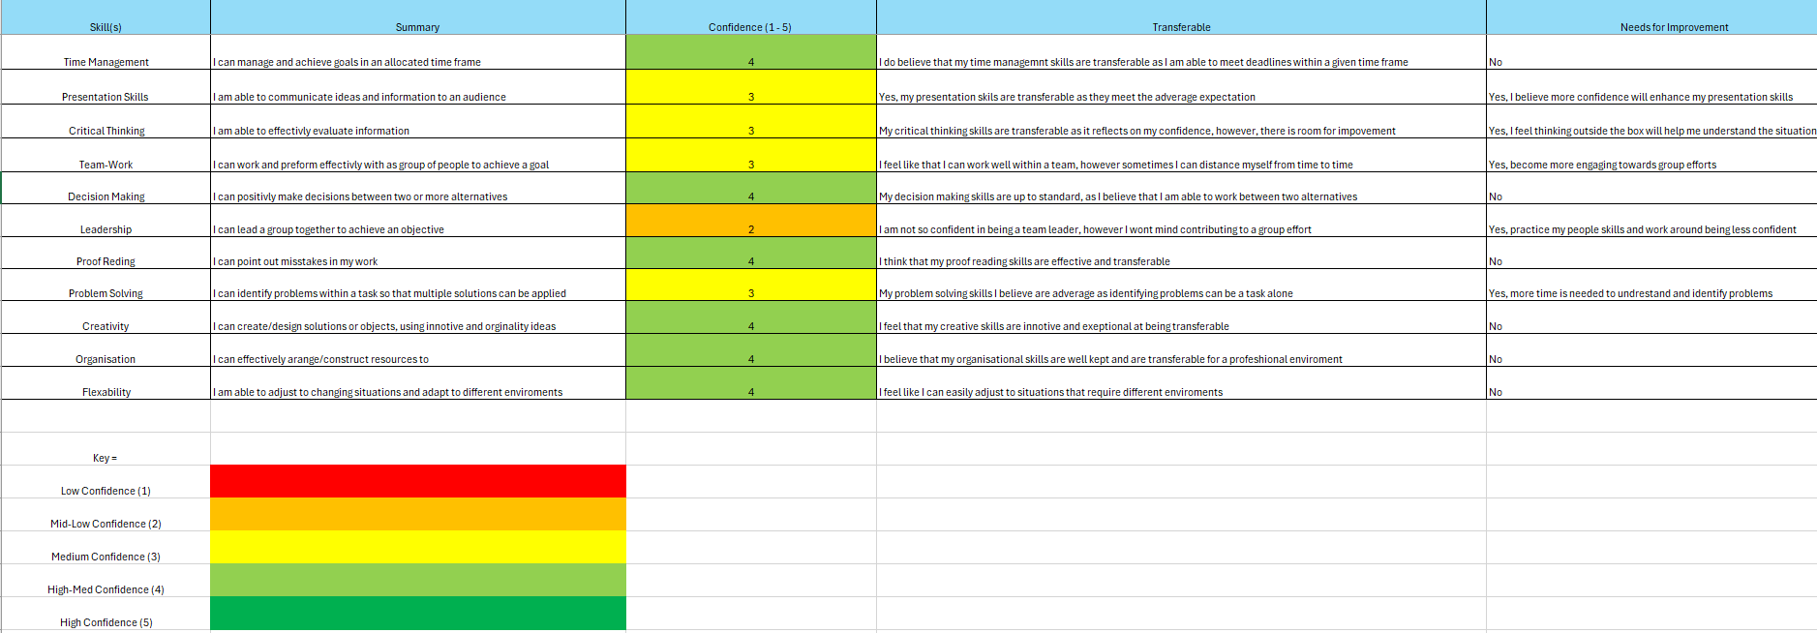
Figure 15 – I have created a Skills Audit to demonstrate my confidence levels and commitment.

As seen above in Figure 15, I have created a skills audit that demonstrates my confidence in various skills. I have given my level of confidence and how transferable the skills are to both Higher Education and a working environment. Overall, the figure shows that my skills are adaptable to certain key skills, with some in need of improvement. However, the majority are acceptable. Employers are able to use a skills audit to gain insights into their workforce. It identifies key skills and weaknesses that can be used for identifying people who fit specific job requirements or descriptions.

6.2. Employability Skills

When considering employment, it is important to establish a self-created e-portfolio that demonstrates all skills learned and accomplished to an employer. Proper use of this can prove to employers that you are able to perform the right job for the right skills. To find out what type of skills are needed, I have researched some jobs that require sets of skills that apply to my studies. I have had a look on Indeed.com and have compared some of their job requirements.
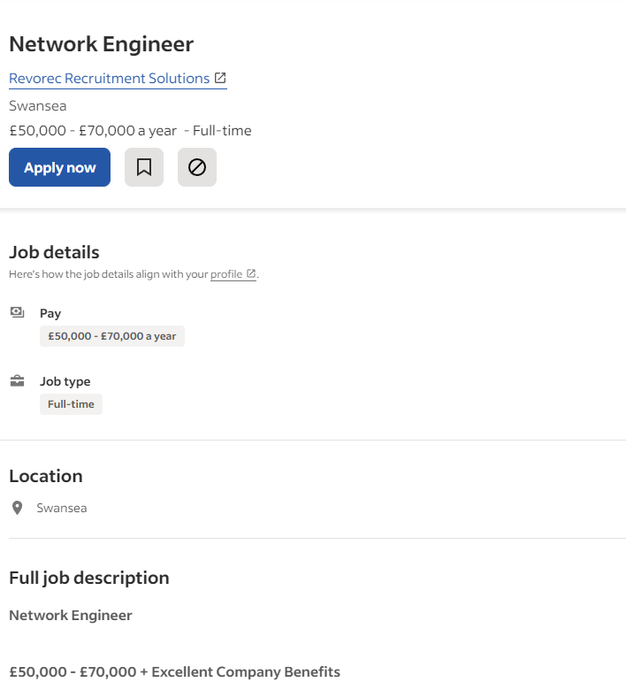
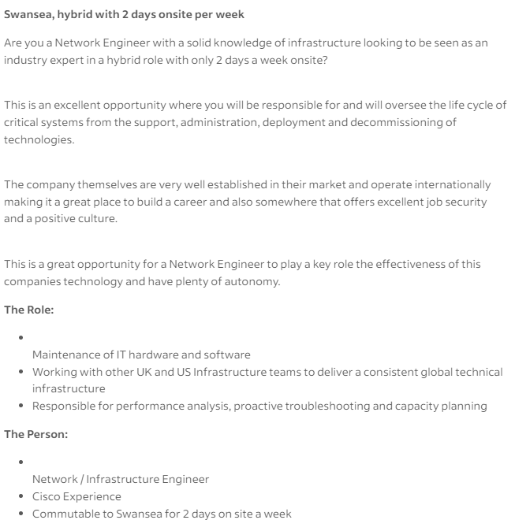
Figure 16 – A Network engineer job application I found on Inded.com.

In Figure 16, I found a network engineer position that states what they pay, the type of job, the location, the type of role you will undertake, and your responsibility’s. It also states that you must have some previous experience with some tools and systems. You must also need to be flexible with your time, as you will need to be commutable for wo days on site. This can affect your flexibility skills, as exposure to diverse work environments can enhance your adaptability and overall professional experience. Prioritising job descriptions that fit your key and professional skills will guarantee a long successful career.

6.2.1. CV version 1 & 2

Forming a CV is essential to stand out from the crowd and to prove to employers that your skills and self are fit enough for the job requirements. Because of this I have created two CV’s that will demonstrate my personal attributes, and key skills that are sought after, and match towards a job description.
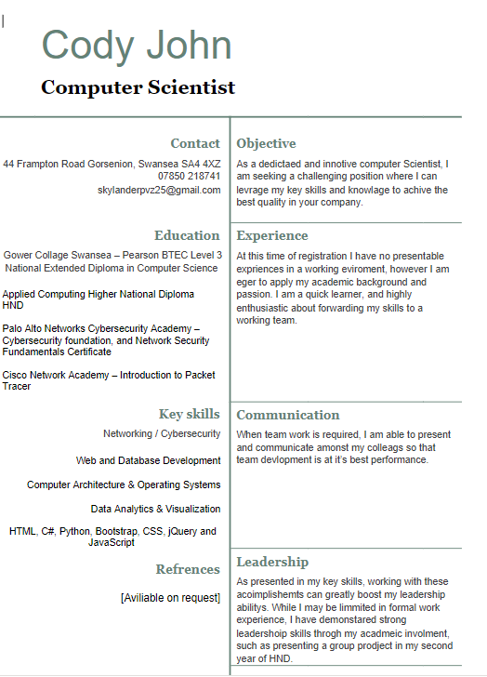
Figure 17 – My first attempt at writing a CV.

As seen in Figure 17, I have created my first draft of my CV, which clarifies my personal details, current carer objective, my working skills and key skills. What is most important in a CV is including your education and qualifications, which gives an employer a basis to work around your skill boundary.
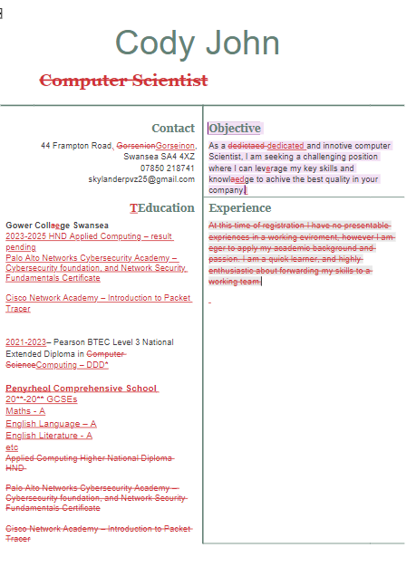
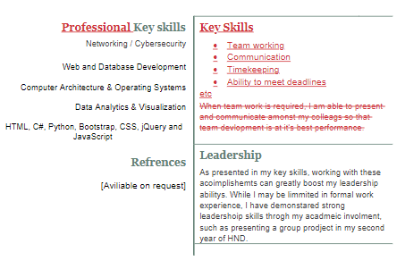
Figure 18 – First draft sent to my lecturer to critique and change.

In Figure 18, we can see the changes that are needed to be done, as what I originally put down may not have been up to standard or acceptable. To make sure that employers are betting the best information about me I need to create a second CV that is corrected.
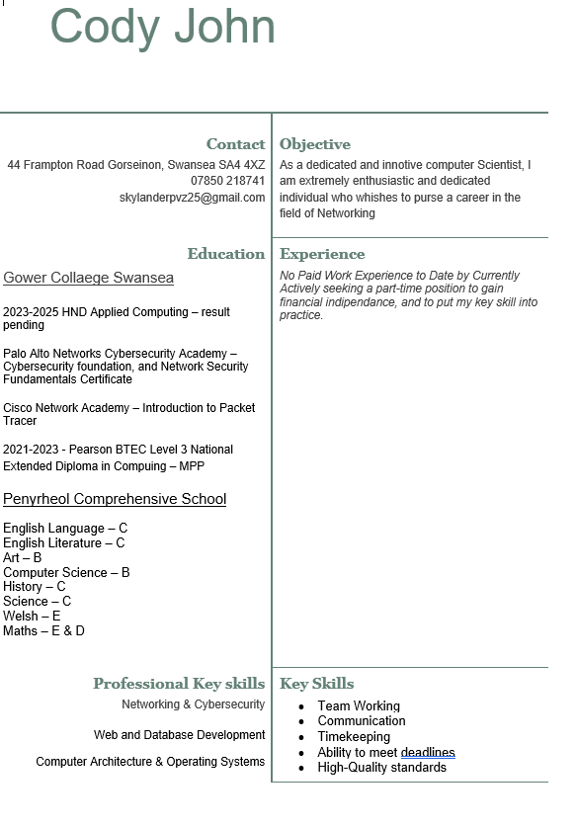
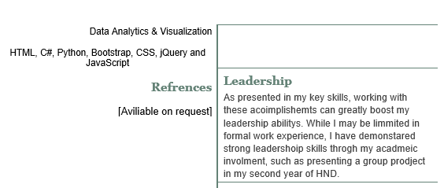
Figure 19 – My corrected and final version of my CV

To comply with the lectures needs for improvement, I have altered the descriptions so that important information, and qualifications are displayed for an employer to read. I have also corrected some of my wording as my original may not have been relevant or correct. However, I believe this final version accurately displays my leading and professional skills that are backed by my education and overall objective.

6.3. Team-Working

Acknowledging the importance of teamwork will eventually benefit not only the person, but the individuals involved as well. Collaborating as a team will ensure the best possible outcome of a group project or objective. Applying a wide range of skills, such as, people skills, being a team leader, and evaluating different intelligence types. I have used teamwork as a basis for building trust and a point of assistance to my classmates. If I wasn’t sure on something with the coursework, and I needed further assistance, I can happily turn to my classmates, as I can discuss with them that I didn’t get so that the next time I get it right. I would also do the same for them, as this would benefit everyone.
28/11/23
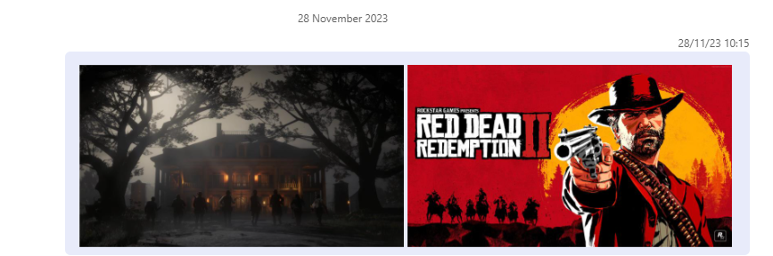
Figure 20 – I asked my classmate if he can alter the images I gave him for my web development assignment.

6.4. Acknowledge, legal, ethical and sustainability issues

When utilising inline resources and work it’s important to acknowledge the legal and professional practices involved. This include ensuring compliance with copyright laws, proper use of sources, and adherence to ethical guidelines. Failure to do so will result in legal consequences as employers and student in Higher Education will have to comply with these jurisdictions. The best solution is to approach the use of resources with consideration, and integrity. Respecting intellectual property rights and requesting the use of the property will ensure that ethical and professional standards are applied in both employment and Higher Education.

Appendix

Figure 1 – This is the first Vak test I conducted on the 26th of September.

Figure 2 – Second Vak test I conducted on the 12th of December.

Figure 3 – This is the final Vak test I conducted on the 20th of February.

Figure 4 – Inappropriate file management that isn’t professional.

Figure 5 – Appropriate file management with corrected course titles and module numbers.

.
Figure 6 – This is a picture I took of my study environment in December.

Figure 7 – This is a picture of my improved environment which is conversive to learning.

Figure 8 – Use of OneNote to plan and organise assignments, and exam due dates.

Figure 9 – Cover page with appropriate detailing’s.

Figure 10 – Table of Contents with relevant headings.

Figure 11 – Witness testimony for my first presentation.

Figure 12 – Second testimony of my final presentation.

Figure 13 – A reference log of all citations used.

Figure 14 – This is a research study that I used for the importance of useability and utility for websites.

Figure 15 – I have created a Skills Audit to demonstrate my confidence levels and commitment.

Figure 16 – A Network engineer job application I found on Inded.com.

Figure 17 – My first attempt at writing a CV.

Figure 18 – First draft sent to my lecturer to critique and change.

Figure 19 – My corrected and final version of my CV

