Qualification: CIPD Diploma in Applied Human Resources

Module Name: Developing Professional Practice in Human Resources (Activity 2).

Word count: 1000

Student Name: Ruth Taylor
Student Number: 1906248
CIPD Membership Number: 55478664

By signing below, I confirm that the work/evidence presented is my own, unaided work. I understand the regulations pertaining to candidate malpractice and the action that may be taken as a result.

Signed: Ruth Taylor
Date: 7 January 2020

What it means to be a HR professional and how the CIPD 2013 map defines the profession.

Executive Summary
This report sets out to explain what it means to be a HR professional and provide an overview of the CIPD 2013 map. It explains the different elements to the map and how they interlink together to provide effective people management skills to support an organisation. This reports also highlights the eight key behaviours that underpin the 10 professional areas of the map and how they can be used to aid an organisation to achieve its objectives.

__________________________________________________________________________________

Introduction
A professional is someone who holds specialist knowledge and skills in a particular field. They work to a core set of principles that are underpinned by specific expertise and knowledge (Lester, 2010). This definition does not require an individual to be a member of a governing body. However, there are differences of opinion to this. Johns & Perkins (2016), say that there are definitions which state this is an essential criteria. The CIPD is the only governing body overseeing the field of HR and, whilst it is not essential to be a member to work in this arena, it is looked on favourably during recruitment. I believe that regardless of being a member of a governing body or not, this should not have an impact on they way a professional carries out their role. Being a professional is about high standards and behaving in an ethical and moral way (Johns & Perkins 2016). The CIPD have developed a profession map, which supports HR professionals in their own development, which in turn supports the success of the business.

A key skill required of all professionals is self management. It is important that HR professionals ensure their knowledge and skills are up to date and they are aware of the ever-changing landscape of HR. To support this, the CIPD have developed a profession map (Appendix 1). The map shows the connection between 10 professional areas, eight essential behaviours and four bands of competence, skills and knowledge and how they interlink to provide effective people management for an organisation throughout a HR professional’s career. The map is flexible in that it allows the individual to focus on the necessary skills and knowledge required depending on their role in an organisation and their level of responsibility as well as highlighting the key skills and behaviours required to develop and progress throughout their career. (CIPD, 2013). It allows an individual to identify areas of development to ensure they have the skills, competency and knowledge required in the HR field in the foreseeable future. (Woodhams, C. Perkins, G. and Wilkinson, K. 2016).

At the centre of the map are two core areas. These are central as they are the most important skills required of all HR professionals, regardless of whether they are just setting out in their HR career or have been a professional for some time. (CIPD, 2013). Insights, strategy and solutions relate to requiring a full understanding of the business and its aims and objectives. This understanding will help to identify solutions to problems that fit with the business. (CIPD 2013). Leading in HR relates to being a role model, which is one of the nine essential behaviours, and highlights the need to lead by example with integrity, impartiality and independence. The use of an individual’s skills and knowledge to support, develop and measure others across the organisation are key components of this core area. (Woodhams, C. Perkins, G. and Wilkinson, K. 2016).

The remaining eight professional areas are more specific and functional, e.g. resource and talent planning, organisation design and employee engagement. The relevance of these professional areas depends very much on the role the individual has in an organisation (Woodhams, C. Perkins, G. and Wilkinson, K. 2016).

There are four bands within the 2013 HR profession map, numbered 1 – 4, and outline the roles, responsibilities and required competence of a professional at each point in their career. Band 1 relates to someone just beginning their HR career and increases through the bandings as roles require more autonomy and responsibility for decision making. Band 2 professionals will have a sound knowledge of the business and are able to provide advice, guidance and solutions to HR issues relating to an individual or team. Band 3 involves focus on a key area of HR whereby more in depth knowledge and skills are required allowing the opportunity to provide solutions to key organisational difficulties both in the long and short term. Band 4 relates to professionals at the top of their career who are responsible for the development and implementation of HR strategies across their professional area or whole organisation. (CIPD, 2013).

Underpinning each professional area of competence and banding are eight behaviours that are seen as essential to be an effective HR professional and support the success of an organisation (Appendix 2). A HR professional requires an increasing level of skill and knowledge to support these behaviours as roles and responsibilities become more substantial and the individual progresses through their career.

One of the eight behaviours is curiosity. The requires the individual to be future focussed and open minded (CIPD 2013). Health Education and Improvement Wales (HEIW) is a new organisation brought together by the amalgamation of three legacy organisations. As a new level 1/2 practitioner in this new organisation, my own curiosity was an essential behaviour I needed to display. It was imperative that I was curious as to why the organisations had joined together and I understood the individual role each legacy organisation played in the new structure. This gave me an overall understanding of the business and its objectives. I noticed that colleagues who had TUPE’d from the legacy organisations were finding it hard to demonstrate this behaviour. They tended to be more focussed on the past and present rather than seeing the future benefits that the amalgamation would bring. This is a contraindication to demonstrating curious behaviour (CIPD 2013).

Being curious at the outset increased my drive to deliver. It gave me a clear focus as to why I was completing my tasks and the part they played in helping the organisation deliver its objectives. This in turn helped me identify my role in achieving objectives and the need for getting things done. CIPD (2013) highlights enthusiasm and commitment as key skills that support a drive to deliver. I believe this skills links in well with a third behaviour, being a good role model, as the nature of an individual can have a significant impact on others (Johns & Perkins 2016).

Conclusion
To be a professional in the field of HR, you do not need to be member of the CIPD. The key to being a professional is a strong work ethic and the ability to work to high standards. The CIPD 2013 profession map is an excellent tool that should be used by all HR professionals at all levels of their career to identify progression needs and opportunities for continued professional development. The eight behaviours demonstrated help to underpin the core business areas and show how these behaviours develop as individuals progress through their career.

Recommendations
It is recommended that all HR professionals use the CIPD profession map and familiarise themselves with the various elements within it. This can then be utilised to aid direction of travel when looking to progress in a career. However, the CIPD have recently launched a New Profession Map (CIPD 2018). This focuses on impact rather than activity, remaining future-fit and encompassing the many new HR specialisms that have been developed. For a HR professional to recognise and achieve their full potential, it is recommended that the 2018 map is also utilised.

References:

CIPD (2013) The 2013 Profession Map (online) available at: https://www.cipd.co.uk/learn/profession-map/2013-profession-map. (Accessed 31 December 2019).

CIPD (2015) The CIPD Profession Map. Our Professional Standards. London: CIPD.

CIPD (2018) Explore the new Profession Map (online) available at: https://peopleprofession.cipd.org/profession-map (Accessed 31 December 2019).

Johns, T. and Perkins, G. (2016) Developing Professional Practice in Taylor, S. and Woodhams, C. Studying Human Resource Management (2nd edn). London: CIPD
Lester, S. (2010) On professionals and being professional (online). Stan Lester developments. Available at: devmts.org.uk/profnal.pdf (Accessed: 31 December 2019).

Woodhams, C. Perkins, G. Wilkinson, K. (2016) Developing the Knowledge and Skill of the HR Professional in Taylor, S. and Woodhams, C. Studying Human Resource Management (2nd edn). London: CIPD

Appendix 1

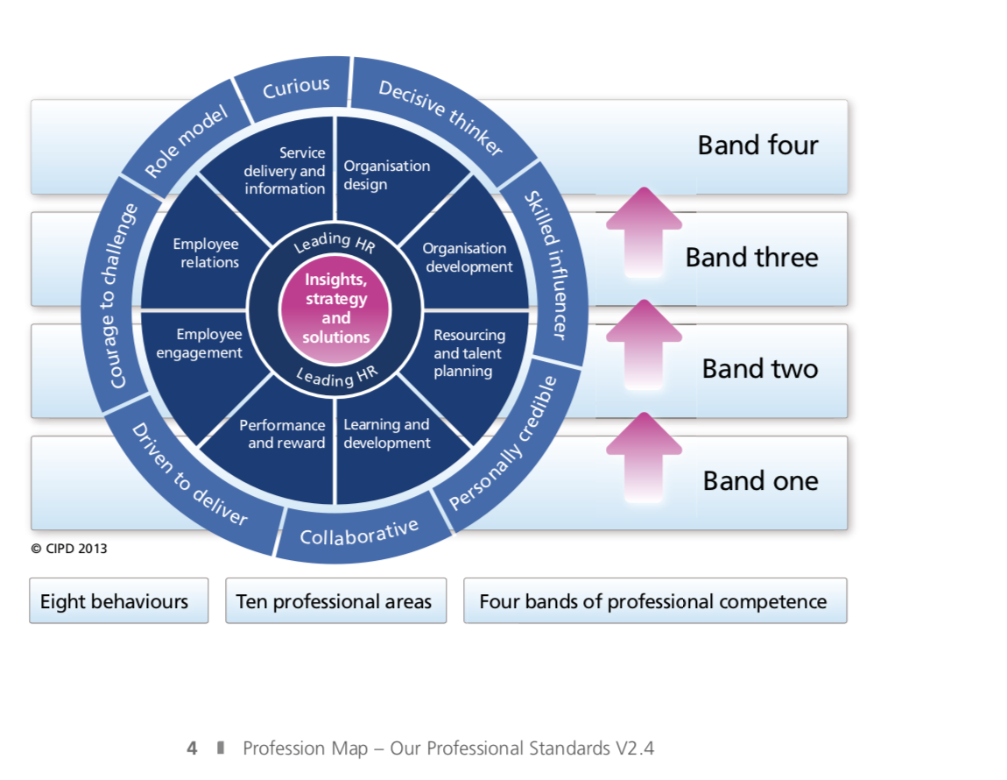
Image taken from CIPD (2015) The CIPD Profession Map. Our Professional Standards. London: CIPD.

Appendix 2

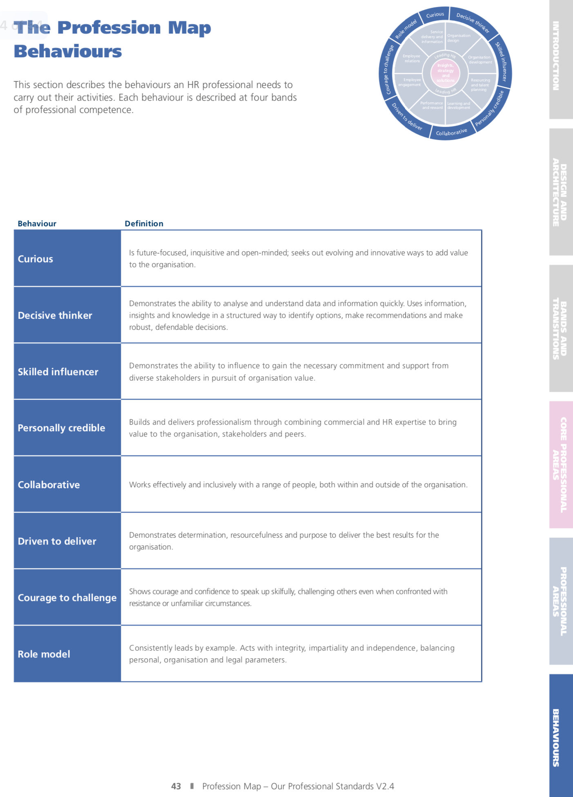
Image taken from CIPD (2015) The CIPD Profession Map. Our Professional Standards. London: CIPD.

Qualification: CIPD Diploma in Applied Human Resources

Module Name: Developing Professional Practice in Human Resources (Activity 4).

Word count: 1000

Student Name: Ruth Taylor
Student Number: 1906248
CIPD Membership Number: 55478664

By signing below, I confirm that the work/evidence presented is my own, unaided work. I understand the regulations pertaining to candidate malpractice and the action that may be taken as a result.

Signed: Ruth Taylor
Date: 7 January 2020

Team Dynamics and Political Behaviour - how they contribute to organisation success.

Executive Summary

This report sets out to explain the concept of team dynamics and the influence they have on the success and productivity of a team. It also highlights the affect political behaviour can have on an organisation and its success at achieving its objectives.

Introduction

Johns and Perkins (2016) state that a key dynamic of organisational life is that professionals must be able to work together, HR professionals included. They must be able to work with colleagues within their function and also other stakeholders. Poor teamwork causes substantial reduction to organisational productivity and can demotivate individuals. Therefore, understanding different dynamics is crucial when developing a team. Watson, (2014) highlights that teams are a regular occurrence in organisational structures, the purpose of them being to work towards a common goal. They are diverse and comprise different genders, ages and culture backgrounds, with each member bringing their own knowledge, skills and ideas.

Aranda et al (1998) identifies a number of team types. Management teams, task teams, work teams and parallel teams. They all have advantages and disadvantages. Team discussions and idea sharing can provide a broader range of solutions, however bringing a number of individuals together, away from their day to day activities, is a hidden cost that can affect organisational productivity. Being a member of a team and having a sense of belonging is known to increase effort. However, cohesive working to the extreme can lead to “group think”, a term penned by Janis, 1997, which describes an interference with collective decision making, leading to poor decisions and actions.

There are a number of factors that can influence how a team functions, including personalities, leadership style, team structure, power and status and processing and reporting mechanisms. To operate successfully as a team, each member needs to recognise how different people’s agendas and drivers will influence the team (Johns & Perkins, 2016). Leadership style can also have a significant impact on group dynamics and Professor Michael West has presented interesting research on the role of compassionate leadership in the NHS and “how it results in a working environment that encourages people to find new and improved ways of working” (Kings Fund, 2017).

Good communication is also an important factor which contributes to the effectiveness of an organisation (Mintzberg 1989). Pentland (2012) identifies “successful communication patterns”, which contribute to team success, including team members listening and speaking in equal measure, ensuring energic conversations and exploration of ideas outside of the team.

Allcorn, (1985) has identified three team roles, the first being group task roles which involve facilitating, identifying problems and initiating problem solving. The second role, group maintenance roles, focus on positive relationships and encouragement and the resolution of conflict and standard setting. Finally, self-orientated roles relate to individual needs and agendas. These have a positive impact on group dynamics, but can encourage negative behaviours such as resistance and dominance.

Watson, (2014) states that teams need to include a combination of interpersonal, technical and problem solving skills to be successful and show the ability to change to meet business need.

Tuckman’s (1965) model of the formation of a team (Appendix 1) has five stages:

- Forming
- Storming
- Norming
- Performing
- Adjourning

This highlights that the journey to a well-formed, productive team is not smooth. It should be recognised that difficulties and conflict form part of a team’s journey and leaders should have the skills to encourage effective team working to achieve a common goal. They also need to allow team members to take responsibility and lead as individuals (Quinn et al 2003), as micromanaging can have a negative impact on team dynamics.

Belbin (1981 & 2007) produced a team role test that gauges dominance, intelligence, intro/extroversion and anxiety and determination behaviours. An individual’s role or place in a team can be identified by measuring the combinations of these behaviours and attributes. However, this assessment tool only identifies behaviours rather than personalities (Watson, 2014). Stephens, (2010) notes that it is important that the right combination is identified to ensure work related elements are achieved and there is a harmonious social environment in which to function.

Political behaviour can be defined as a process of social influence, which is used strategically to enhance short or long term personal interest (Dubrin 2009). An example of this behaviour is an individual taking action to pursue their own personal goal, with little or no consideration for the impact it may have on others or the organisation. Holbeche (2003) reports that the Roffey Park 2003 Management Agenda Survey suggested that office politics can have a negative impact on organisational performance, with reduced trust being a factor in an individual’s performance. However, 60% of respondents believed that workplace political behaviour was required to meet to organisations objectives.

Holbeche (2003) recommends that a HR professional has excellent influencing skills (good political skills) in order to achieve organisational goals and objectives. They should be able to action a range of small political tactics if they wish to influence people. However, it is important that these tactics remain within their own morality and be organisationally ethical. A HR professional with a selection of positive political and influencing skills should be able to challenge obstruction to change successfully.

Conclusion
From the above, it is clear that both team dynamics and political behaviour have both negative and positive effects on organisational success. Being able to bring together the right mix of people with the required skills and knowledge and a willingness to learn are key ingredients to a successful team. Political behaviour used as an influencer can help an organisation achieve its objectives. However, the use of political behaviour as a means to satisfy an individual’s own needs to the detriment of others, will have a negative impact on an organisation, with decreased trust levels, leading to reduced productivity.

Recommendations
It is recommended that leaders take time to think about the makeup of their teams and how the different skills and behaviours are used to ensure the right team dynamic. Getting these factors right will improve the productivity of the team and also the quality of the results.

Organisations should be aware of political behaviour and how it can have an impact on an organisation’s objectives. Influencing used as a positive political behaviour can bring about good results and aid an organisation to successfully meet its goals.

References

Allcorn, S. (1985) What makes group tick. Personnel. September. pp52-8.

Aranda, E.K., Aranda, L and Conlon, K (1998) Teams: structure, processes, culture and politics. New York: Prentice Hall.

Belbin, R. (1981) Management Teams: why they succeed or fail. London: Heinemann.

Belbin, R. (2007) Management Teams: why they succeed or fail. London: Elsevier Butterworth Heinemann.

Dubrin, A. (2009) Political behaviour in Organisations. United States of America: SAGE publications Ltd.

Holbeche, L. (2003) ‘The politics of work’ People Management. Available at: https://www.peoplemanagement.co.uk/long-reads/articles/politics-work (Accessed 30 December 2019).

Appendix 1



