An investigation into the impact of mass media campaigns on changing health related behaviours: A focus group approach

Abstract

The literature surrounding the impact of mass media campaigns on preventing and reducing alcohol consumption and smoking highlights their successful elements and effectiveness, such as Stoptober meeting and exceeding the majority of its targets (Public Health England, 2019). However, other research has demonstrated several unsuccessful components of campaigns, such as the use of forceful language, messages that are easy to ignore, and behaviour-triggering content (Stanojlovic et al., 2019; Cataldo et al., 2015). Thus, the aim of this qualitative research was to investigate the impact of mass media campaigns on changing health related behaviours, specifically reducing smoking and harmful drinking, using a focus group-based approach. The non-experimental investigation was conducted by two Level 5 Applied Psychology students, for a thematic analysis of the transcript of the focus group discussion. The thematic analysis revealed various key themes, such as ‘Failure’, ‘Effective factors’, and ‘Overpowering influences’. In conclusion, the findings predominantly highlight the low impact that mass media campaigns have on changing smoking and alcohol behaviours among the participants, though showcase some effective elements of the campaigns, such as their memorability and ability to raise awareness.

Introduction

Health related behaviours refers to behaviours that either positively or negatively impact an individual’s health status (Carmody, 2014). This includes behaviours such as eating, exercise, alcohol consumption or substance use (Carmody, 2014). For several decades, mass media campaigns have been created and used in an attempt to encourage or prevent various health related behaviours in mass populations. For example, campaigns have primarily been aimed at drug use, alcohol use, heart-disease prevention, cancer screening, and tobacco use (Wakefield et al., 2010). However, according to the literature, anti-smoking and alcohol prevention campaigns, such as Stoptober and Dry January have reported high levels of effectiveness. For example, Stoptober met or exceeded the majority of its targets (Public Health England, 2019), while participants of Dry January had reduced their levels of harmful drinking 6 months after the event (Ballard, 2015). Therefore, for the purpose of this investigation, anti-smoking and alcohol prevention campaigns will be the primary focus.

Experimental research has showcased some of the effective elements of mass media health campaigns. For example, a study by Durkin et al. (2009) explored the effects of different types of antismoking adverts on reducing disparities in smoking cessation among 1491 adults smokers. The researchers followed the participants over 2 years and during follow-up, related their quitting status to antismoking advert exposure within the 2 years prior to the assessment (Durkin et al., 2009). The researchers explained that they found emotionally evocative adverts and averts involving personal stories regarding the effects of smoking to largely increase the likelihood of quitting smoking. These results were consistent with previous laboratory-based studies highlighting that highly emotional adverts are more likely to be discussed and perceived as more effective, and are more memorable (Durkin et al., 2009).

Furthermore, a systematic review conducted by Young et al. (2018) investigated the effectiveness of mass media campaigns in reducing alcohol consumption. Eight databases were searched and a total of 24 studies published in English were included in the review (Young et al., 2018). The researchers stated that anti-alcohol campaigns were often recalled by individuals and were associated with increases in knowledge about alcohol consumption, and changes in attitudes and beliefs about it (Young et al., 2018). Notably, some successful components of mass media campaigns include their memorability and ability to effectively raise awareness. Nevertheless, it should be mentioned that the quality of the studies included in the review was, overall, weak with most utilising self-report methods, thus limiting the reliability of their findings (Young et al., 2018). Consequently, the validity of the findings produced by Young et al. (2018) is questionable.

On the other hand, the body of evidence exploring the effectiveness of mass media campaigns could be deemed contradictory, since other research has suggested campaigns to be ineffective, and even counterproductive (Stanojlovic et al., 2019). For example, certain studies have suggested that alcohol prevention campaigns using intense or forceful language can result in state reactance, thus leads to increased intentions to drink (Dillard & Shen, 2005, as cited in Stanojlovic et al., 2019). This was also found with anti-smoking campaigns in a study by Cataldo et al. (2015) exploring the effectiveness of anti-tobacco messages and warnings among 51 current and former smokers aged 45 to 68. The findings revealed that participants perceived warning labels and anti-smoking messages as ineffective for motivating smoking cessation, especially since text-only warnings desensitise the effects of repeated smoking. Participants added that negative messages can be easily ignored, though often trigger intentions to smoke, thus highlighting how campaigns are often counterproductive (Cataldo et al., 2015). On the other hand, since the study was limited to older smokers, the results are not representative of younger adults, thus generalisations to a younger population cannot be made.

Investigating the impact of mass media campaigns on changing health related behaviour is important since it will determine the quality of such interventions. For example, the study will produce evidence regarding the efficacy of certain campaigns and their content and identify areas and elements that could be improved, removed, or continued to be implemented (O’Connor-Fleming et al., 2006). For instance, previous campaigns that have used an individual with lived experience to discuss a sensitive health message have been deemed effective among heavy alcohol users (Stanojlovic et al., 2019), thus the method is continually used. However, such evidence will also encourage the variation of strategies of designing mass media health campaigns, based on purpose and target audience (Stanojlovic et al., 2019). Consequently, this could increase the success rates of future campaigns, leading to a healthier society and easing the strain on healthcare systems.

In conclusion, the aim of the current study is to investigate the impact of mass media campaigns on changing health related behaviours, using a focus group approach and conducting a thematic analysis on the discussion. It is expected that the investigation will demonstrate the positive impact that mass media health campaigns can have on negative health related behaviours, such as smoking and alcohol consumption, though highlight some unsuccessful elements of the campaigns. Thus, the findings will demonstrate the quality of mass media campaigns.

Methodology

Design
A non-experimental qualitative investigation was conducted to explore the impact of mass media campaigns on changing health related behaviour. Specifically, the focus was on anti-smoking and anti-alcohol campaigns. A focus group-based approach was taken, and the discussion was audio recorded and later transcribed for a thematic analysis.

Participants
A convenience sample of 4 participants were involved in the focus group. 3 were female and 1 was male. Ages ranged from 32 to 42 (M = 36.75, SD = 3.70). Participants were all Applied Psychology undergraduate students and were aware of the purpose of the investigation.

Materials
- A laptop to transcribe the audio recording of the focus group discussion and to conduct the thematic analysis
- A Dictaphone to record the discussion
- A hardcopy of the researchers’ questions
- 4 consent forms
- 4 debrief forms
- 4 study information sheets
- Pens for participants to sign the consent forms
- Hardcopies of various campaign examples
- Microsoft Word to transcribe the audio recording of the discussion and to conduct the thematic analysis (Refer to Appendix 4 for the transcript and Appendix 5 and 6 for the thematic analysis)

Procedure
(Refer to Appendix 1)

Ethical Considerations
In line with the BPS ethical guidelines, participants were provided with written information outlining the nature of the study. They were informed of their opportunity to refrain from participation, as well as their right to withdraw from the study at any point, and their right to withdraw their data following the study, without penalty. The information provided also documented key ethical considerations, including information on how the data would be collected and stored and how it would remain anonymous. For example, participants were informed that they would each be assigned a code, thus remain anonymous within the data, and that the data would be stored securely by the researchers, in accordance with the Data Protection Act. Afterwards, the participants were required to provide written consent. Following the completion of the focus group discussion, participants were fully debriefed by the researchers. They were each administered a debrief from, which provided further information about the study, including information regarding the aims and research question, as well as the research supervisor’s and researchers’ contact details, in case of any questions or concerns.

Results and Discussion

Initial encounter with the text
The transcript of the focus group discussion showcases the opinions of four undergraduate Applied Psychology students, regarding the impact of mass media campaigns on changing health related behaviour, i.e., anti-smoking and anti-alcohol campaigns. This includes views that anti-smoking and anti-alcohol campaigns are overall, unsuccessful, with their content often being deemed as ineffective. However, at times, the discussion demonstrates some successful elements of said campaigns, through the participants’ sensitivity to certain content, as well as their recognition that the campaigns effectively showcase the risks involved with the behaviours, thus raise awareness. Having said that, throughout the discussion the participants showcase the robust impact of alternative factors on changing behaviour, such as knowledge, age, parenthood, and personal choices, which seem to go beyond the impact of campaigns.

Table 1
Summary table of the thematic analysis of the focus group discussion, demonstrating themes, codes, and supportive evidence.

Theme | Code | Quote | Page & Line Number
Theme 1: Failure | Code 1: Powerless content | “I don’t even know what the image is if I’m buying the pack of the cigarettes”  “They don’t affect me at all”  “I don’t even think it’s that disgusting to look at, because it’s not real”  “I wouldn’t give a second glance to that” | Page 1; Lines 24 -25  Page 4; Line 96  Page 4; Lines 99 - 100  Page 6; Lines 178 - 179
 | Code 2: Unsuccessful in changing behaviour | “You can cover them, or you can just avoid looking at them”  “It’s not going to stop me”  “It wouldn’t change my behaviour” | Page 1; Line 21  Page 1; Line 26  Page 4; Line 99
 | Code 3: Rebelling against campaigns | “When Stoptober came around and I was smoking, I would probably smoke a lot more”  “It was an affront to us, just to be presented with quitting” | Page 2; Line 49  Page 2; Line 51
Theme 2: Effective Factors | Code 4: Memorable campaigns | “There’s that one with the little girl, and she starts off by the tree”  “I can remember them hitting the windscreen and stuff”  “When you go to the pharmacy and they’ve got those jars, I think with the tobacco” | Page 3; Line 76  Page 3; Lines 82 - 83  Page 4; Line 101
 | Code 5: Raising awareness | “There is more knowledge now”  “It makes me feel as if I’ve got a reason not to drink”  “They are raising awareness with people of the illnesses”  “It is giving me more awareness about the harmful side” | Page 1; Line 18  Page 2; Lines 38 – 39  Page 7; Line 195  Page 7; Line 197
 | Code 6: Emotionally evocative | “That is quite a horrible one”  “That absolutely turns my stomach”  “This photo is the only one that would really touch me”  “It taps into something more personal” | Page 3; Lines 77 – 78  Page 4; Line 104  Page 5; Lines 137 - 138  Page 6; Line 167
Theme 3: Overpowering Influences | Code 7: Responsibility for others | “I don’t want to be responsible for hurting somebody else”  “It’s affecting somebody else then, isn’t it?”  “I’m a mother, that’s why this is very sensitive for me”  “The baby one is more effective” | Page 3; Lines 73 - 74  Page 5; Lines 146 - 147  Page 5; Line 148  Page 6; Line 164
 | Code 8: Personal experiences | “I don’t know whether that’s because of the campaign, or because of how I was raised”  “I don’t like what it does to me, especially the next day”  “I will agree, yeah, past experience, knowledge”  “More responsible and sensible as you get older” | Page 3; Lines 74 – 75  Page 4; Line 92  Page 4; Line 119  Page 5; Line 123
 | Code 9: Addiction | “They still do it if they’re addicted to it”  “If you’re reliant on alcohol this isn’t going to stop you drinking” | Page 1; Line 11  Page 5; Line 129
 | Code 10: Personal preference and enjoyment | “I like a bottle of wine, and it’s not going to stop me”  “If I want a glass of wine, I’ll have a glass of wine”  “I think if I enjoyed drinking a lot, I don’t think it would have changed me” | Page 1; Line 26  Page 2; Line 27  Page 2; Lines 39 - 40

Diagrammatical representation of the results

Figure 1 (Theme 1 - ‘Failure’): Figure 2 (Theme 2 – ‘Effective Factors’):

Figure 4 (Theme 3 – ‘Overpowering influences’):

Discussion of the results

Theme 1 – Failure
The theme ‘Failure’ involves four codes that are regularly demonstrated throughout the transcript, namely ‘Powerless content’ (Code 1), ‘Unsuccessful in changing behaviour’ (Code 2), and ‘Rebelling against campaigns’ (Code 3). Code 1 is represented by all participants through lines such as “this doesn’t do anything to me” (Participant 1, p.4; lines 103-104) and “I don’t even know what the image is if I’m buying the pack of the cigarettes” (Participant 3, p.1; lines 24-25). Such quotes would imply that the participants do not believe that certain campaign methods, such as the use of disturbing images on cigarette packaging, are successful in preventing the behaviour. This finding was supported by Code 2, in quotes such as “I don’t think they really work” (Participant 4, p.1; line 9) and “you can cover them, or you can just avoid looking at them” (Participant 3, p.1; line 21). Additionally, when directly asked “has a mass media smoking or alcohol prevention campaign ever prevented you from engaging in behaviours such as smoking or drinking”, three participants responded “no” (p.3; lines 70-72). These findings support previous research by Cataldo et al. (2015) that found participants to believe that warning labels and anti-smoking messages can be easily ignored, and that overall, they are ineffective methods for motivating smoking cessation.

Moreover, Code 3 is clearly demonstrated in quotes such as “when Stoptober came around and I was smoking, I would probably smoke a lot more” (Participant, p.2; line 49) and “it was like an affront to us, just to be presented with quitting” (Participant 2, p.2; line 51). Evidently, campaigns have the ability of increasing the intentions of engaging in behaviours, such as smoking, thus can be counterproductive. This idea was explained by Rains and Turner (2007, as cited in Stanojlovic et al., 2019), who stated that campaigns that request a drinking ban, such as Stoptober are occasionally less successful than campaigns encouraging responsible behaviour since the latter is less of an imposition for individuals. This finding supports statements by Dillard and Shen (2005, as cited in Stanojlovic et al., 2019), that research has showcased that alcohol prevention campaigns using intense or forceful language can lead to increased intentions to drink.

Theme 2 – Effective Factors
Contrastingly, the theme ‘Effective factors’ includes three codes, namely ‘Memorable campaigns’ (Code 4), ‘Raising awareness’ (Code 5), and ‘Emotionally evocative’ (Code 6). Code 4 is demonstrated through quotes such as “there’s that one with the little girl” (Participant 1, p.3; line 76) and “there’s like one when they’re all in the car” (Participant 2, p.3; line 82). Participants were able to easily recall past campaigns, thus their memorability could be deemed an effective element, especially since this was also found in previous research by Young et al. (2018). Furthermore, quotes such as “it is giving me more awareness about the harmful side” (Participant 3, p.7; line 197) and “it makes me feel as if I’ve got a reason not to drink” (Participant 4, p.2; lines 38-39) highlight the participants’ awareness that mass media campaigns are useful for enhancing knowledge regarding the negative effects of smoking and alcohol consumption, thus Code 5 was formed, showcasing another successful component of campaigns. This further supports the Young et al. (2018) finding that mass-media alcohol campaigns are associated with increased knowledge regarding alcohol consumption.

Lastly, Code 6 is represented by quotes such as “it taps into something more personal” (Participant 1, p.6; line 167) and “this is very sensitive for me” (Participant 3, p.5; line 148). It would appear that the participants were emotionally evoked by particular campaign content, such as distressing images as seen in ‘Smoking Campaign 2’ and ‘Alcohol Campaign 2’ (refer to appendix 2). Consequently, such content can influence positive behavioural changes in individuals, and this was implied in the quote “that type of campaign would definitely make me think twice about drinking” (Participant 4, p.4; lines 110-111). This finding supports the study by Durkin et al. (2009) that found emotionally evocative adverts to increase the likelihood of smoking cessation, as well as other past studies showcasing highly emotional adverts to be perceived as more effective (Durkin et al., 2009). Overall, theme 2 provides evidence of the successful elements of campaigns, which could be used to explain the high levels of campaign effectiveness showcased within evaluations such as the 2018 Public Health England evaluation of Stoptober, and the 2014 evaluation of Dry January by the University of Sussex.

Theme 3 – Overpowering influences
The final theme, ‘Overpowering influences’ is made up of four codes – ‘Responsibility for others’ (Code 7), ‘Personal experiences’ (Code 8), ‘Addiction’ (Code 9), and Personal preference and enjoyment’ (Code 10). Quotes such as “I don’t want to be responsible for hurting somebody else” (Participant , p.3; lines 73-74) and “I don’t like what it does to me” (Participant 4, p.4; line 92) make up Codes 7 and 8, while quotes such as “they still do it if they’re addicted to it” (Participant, p.1; line 12) and “I like a bottle of wine and it’s not going to stop me” (Participant 1; p.1; line 26) form Codes 9 and 10. Each of these codes and their supporting quotes suggest that there are a variety of factors that can highly influence health related behaviour, for example age, health, knowledge and past experience, as well as addiction. Thus, such influences go beyond the impact of campaigns. Consequently, the cause and effect of behaviour change cannot always be determined.

Limitations and future research suggestions
Moreover, it is important to discuss one of the main limitations of this study, concerning the small, homogeneous sample involved. 4 participants were included in the focus group, 3 were female, and all were undergraduate students between the ages of 32 and 42. Consequently, the generalisability and universality of these findings is extremely limited. In order to make generalisations about a wider population, future research is encouraged to further investigate this matter with a range of focus groups varying in age and gender. Furthermore, due to the nature of this study, other implications involve demand characteristics, where participants answer with what they believe to be required, and – since the researchers were present – the focus group may have been subject to interviewer effect, meaning participants answer based on how they perceive the researchers. Thus, it should be considered that these matters could have impacted the results, though the extent is unknown. Having said that, it can be difficult to prevent these issues from occurring, though to minimise the likelihood, future research is encouraged to ensure that all questions are well-written and clearly verbalised so that they are easily understood by the participants, leaving little room for interpretation or bias (Lavrakas, 2008).

Implications
Despite the limitations, the findings of the current study have important implications. For example, the identification of areas and elements of anti-smoking and alcohol prevention campaigns that are successful, or could be enhanced or altered, informs the future design of mass media health campaigns. Consequently, it would be expected that such campaigns would obtain higher success rates, thus lead to a healthier society. Of course, this would have beneficial implications for healthcare systems, since behaviours such as smoking, and alcohol consumption cause a significant strain on the NHS. For instance, during 2017-2018, smoking-related ill health led to 489,000 hospital admissions in England (NHS Digital, 2019), while alcohol-related issues cost the NHS approximately £3.5 billion each year (NHS, 2019). Evidently, such implications showcase the importance of investigating the impact of mass media campaigns on changing health related behaviour, therefore the matter should be further explored in the future, both quantitatively and qualitatively.

Conclusion

In conclusion, this qualitative study aimed to investigate the impact of mass media campaigns on changing health related behaviours, specifically smoking and alcohol consumption. A focus group approach was taken, and a thematic analysis was conducted on the transcript of the discussion. The analysis produced a variety of codes, which were clustered by similarity to form three themes, namely ‘Failure’, ‘Effective factors’, and ‘Overpowering influences’. The findings predominantly showcased the low impact that mass media campaigns have on changing health related behaviours such as smoking and alcohol consumption, which contradicted certain evidence, such as the Stoptober and Dry January success rates, though supported other research highlighting that campaigns are often ineffective for cessation, easily ignorable, and counterproductive. Furthermore, the findings importantly demonstrated that factors such as age, health, past experience, addiction and knowledge can each influence health related behaviour, beyond campaigns. Nevertheless, the study’s findings clearly demonstrated a variety of effective campaign elements, such as emotionally evocative content, the ability to raise awareness, and memorability. Consequently, previous research was supported (e.g., Durkin et al., 2009; Young et al., 2018).

References

Ballard, J. (2015). What is Dry January? British Journal of General Practice, 66(642), 32–32. https://doi.org/10.3399/bjgp16x683173
Carmody, T. (2007). Health-related behaviours: Common factors. In S. Ayers, A. Baum, C. McManus, S. Newman, K. Wallston, J. Weinman, & West, R. (Eds.), Cambridge Handbook of Psychology, Health and Medicine (pp. 102-109). Cambridge University Press. https://doi.org/10.1017/CBO9780511543579.023
Cataldo, J. K., Hunter, M., Petersen, A., & Sheon, N. (2015). Positive and instructive anti-smoking messages speak to older smokers: a focus group study. Tobacco Induced Diseases, 13(1), 2. https://doi.org/10.1186/s12971-015-0027-x
Clarke, V., Braun, V., & Hayfield, N. (2015). Thematic analysis. In J. Smith (Ed.), Qualitative psychology: A practical guide to research methods (pp. 222-248). Sage.
Durkin, S. J., Biener, L., & Wakefield, M. A. (2009). Effects of different types of antismoking ads on reducing disparities in smoking cessation among socioeconomic subgroups. American Journal of Public Health, 99(12), 2217–2223. https://doi.org/10.2105/ajph.2009.161638
Lavrakas, P. J. (2008). Encyclopedia of survey research methods. Sage. https://dx.doi.org/10.4135/9781412963947.n242
NHS. (2019). NHS Long term plan will help problem drinkers and smokers. https://www.england.nhs.uk/2019/01/nhs-long-term-plan-will-help-problem-drinkers-and-smokers/
NHS Digital (2019). Statistics on smoking – England, 2019. https://digital.nhs.uk/data-and-information/publications/statistical/statistics-on-smoking/statistics-on-smoking-england-2019
O’Connor-Fleming, L. M., Parker, E., Higgins, H., & Gould, T. (2006). A framework for evaluating health promotion programs. Health Promotion Journal of Australia, 17(1), 61–66. https://doi.org/10.1071/he06061
Public Health England. (2019). Stoptober campaign evaluation. https://www.gov.uk/government/publications/stoptober-campaign-evaluation
Rains, S. A., & Turner, M. M. (2007). Psychological reactance and persuasive health communication: A test and extension of the intertwined model. Human Communication Research, 33, 241-269. https://doi.org/10.1111/j.1468-2958.2007.00298.x
Stanojlovic, M., Cancela, A., Cárdaba, M. A. M., & Cuesta, U. (2020). Anti-alcohol campaigns effects depending on target drinking levels and source perception. Health and Addictions/Salud Y Drogas, 20(1), 43–51. https://doi.org/10.21134/haaj.v20i1.464
Wakefield, M. A., Loken, B., & Hornik, R. C. (2010). Use of mass media campaigns to change health behaviour. The Lancet, 376(9748), 1261–1271. https://doi.org/10.1016/s0140-6736(10)60809-4
Young, B., Lewis, S., Katikireddi, S. V., Bauld, L., Stead, M., Angus, K., Campbell, M., Hilton, S., Thomas, J., Hinds, K., Ashie, A., & Langley, T. (2018). Effectiveness of mass media campaigns to reduce alcohol consumption and harm: A systematic review. Alcohol and Alcoholism, 53(3), 302–316. https://doi.org/10.1093/alcalc/agx094
‌

Appendices

Appendix 1: Procedure

In preparation for the study, a convenience sample of participants were gathered and were informed of the date, time and room location of the study. An ethics form and study schedule were completed and approved by the research supervisor. Following approval, a consent form, debrief form and study information sheet were written and copies were printed for each of the participants. Additionally, a copy of the focus group questions, and the campaign examples were printed. At the time of the study, participants were each administered a study information sheet, outlining the details of the study, followed by a consent form. Once consent had been provided by each of the participants, the study began, along with the audio recording. Researcher 1 lead the focus group by asking a set of questions and administering campaign examples, while researcher 2 took notes. Once the final question had been answered, the focus group ended, and the audio recording was stopped. Participants were each administered study debrief sheets, which were verbally narrated by the researchers.

Following the study, the audio recording of the focus group discussion was transcribed using Microsoft Word. The Clarke et al. (2015) process was followed to conduct a thematic analysis on the transcript. In order to familiarise with the transcript content, the text was read several times, and an overview paragraph was produced, i.e., ‘initial encounter with the text’. Afterwards, the transcript was coded using a colour coding method, and once completed, the lines in which the codes appeared was stated. The analysis continued with the use of further colour coding to cluster similar codes together to create themes. Three themes were formed. Lastly, an APA formatted table was created to showcase the themes, codes and supporting evidence (quotes, page and line numbers).

Appendix 2: Focus Group Questions

Questions

Question 1 – What comes to mind when you think about mass media health campaigns?

Question 2: What are your views on Mass Media Campaigns that intend to reduce or prevent behaviours, such as quitting or reducing smoking or alcohol consumption?

Question 3 “The more alcohol people drink, the greater their risk of developing a number of serious, potentially life limiting health conditions, such as high blood pressure and heart disease, as well as seven types of cancer” (Drinkaware, 2021). Do you think reading something like this would encourage you to think about reducing alcohol consumption or behaviours such as smoking?

Question 4 If yes, why? If no, what are your reasons for this?

Question 5 Have you ever taken part in a mass media health campaign to reduce or quit a behaviour? Such as Stoptober or Dry January?

Question 6 (If yes) Why did you take part? And how did you find the experience – positive or negative? (If no, why not?)

Question 7: Has a mass media smoking or alcohol prevention campaign ever prevented you from engaging in behaviours such as smoking or drinking?

Question 8: Do you think campaigns such as these could ever prevent you in the future from engaging in these behaviours, and why? (Drinking campaign 2 and smoking campaign 1)

Question 9: Do you think personal experiences are more likely to encourage you to reduce smoking or alcohol behaviours, in comparison to a Mass Media Health Campaign?

Question 10: Which of these two campaigns do you think is more effective, and why? (Smoking campaign 1 or 2)

Question 11: Which of these two campaigns do you think is more effective, and why? [Alcohol campaign 1 or 2)

Question 12: Do you think campaigns that use disturbing images are more effective than campaigns that don’t? (Show smoking campaign 3 and alcohol campaign 3)

Question 13: Standardised cigarette packaging was introduced in the UK in 2016, do you think this would encourage you and others to reduce smoking or prevent you from smoking, and why? (Show Image 4)

Appendix 3: Focus group campaign handouts

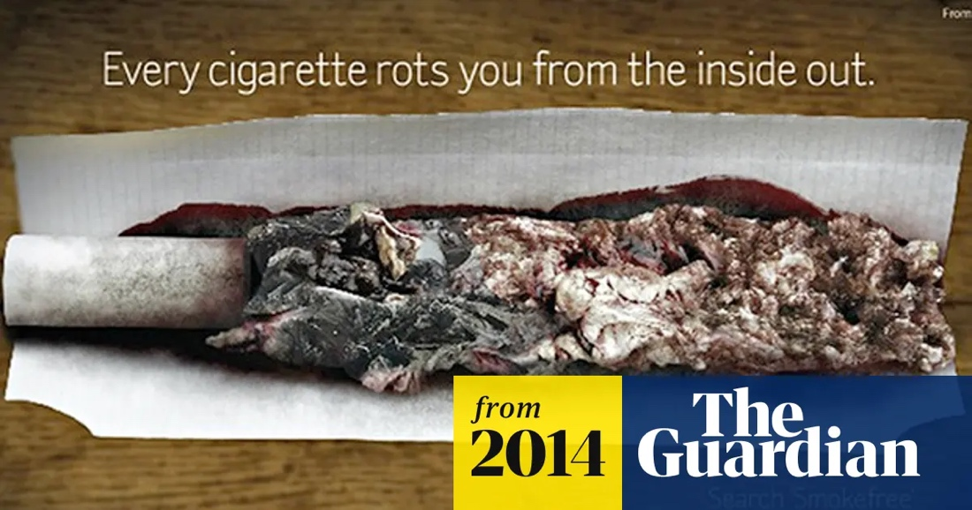
Smoking campaign 1

Smoking campaign 2
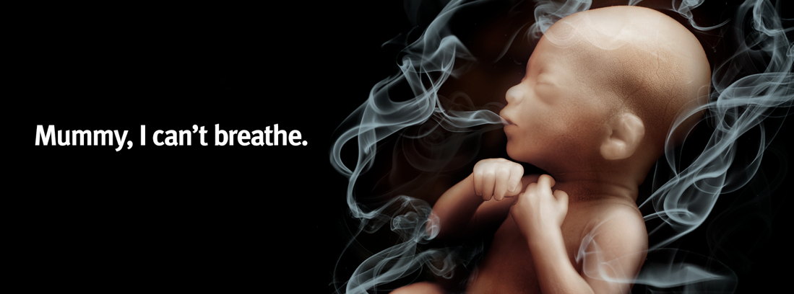

Smoking campaign 3
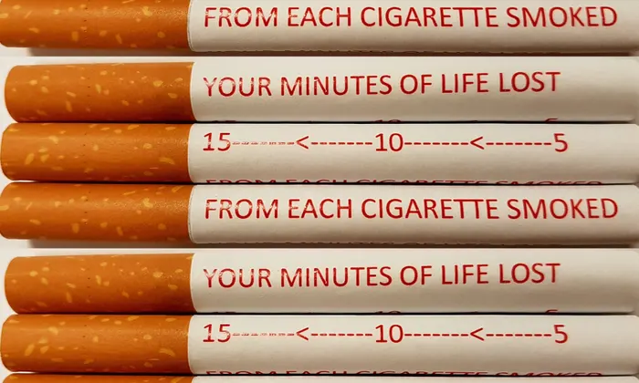

Alcohol campaign 1
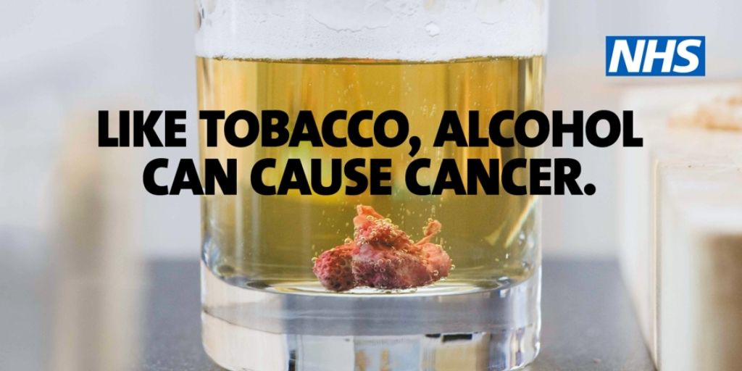

Alcohol campaign 2
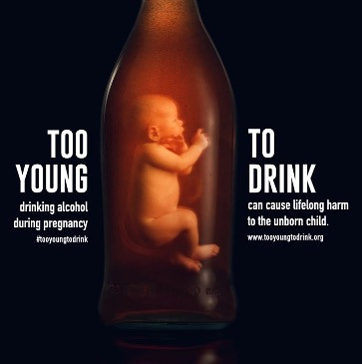

Alcohol campaign 3

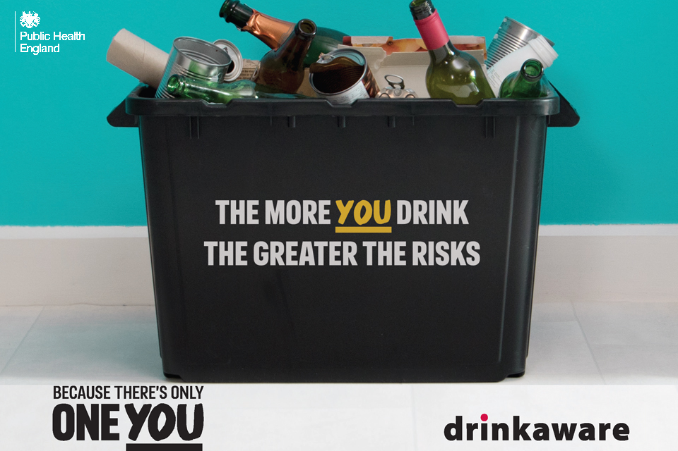

Cigarette Packaging – Image 4
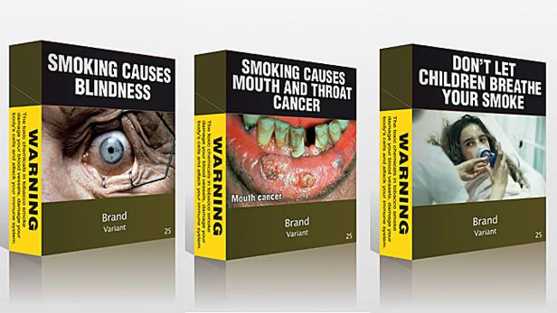

Appendix 4: Transcript of the focus group discussion (Clean copy)

Researcher 1: 2004323
Researcher 2: 2003591

- Researcher 1: Q1 – “What comes to mind when you think about
- mass media health campaigns?”
- P1: “Anti-smoking campaigns”
- P3: “Yeah, and smoking I would say as well”
- P2: “Yeah, don’t drink and drive”
- Researcher 1: Q2 – “What are your views on Mass Media Campaigns that intend to reduce
- or prevent behaviours, such as quitting or reducing smoking or alcohol consumption?”
- P4: “I don’t think they really work, for some people anyway, maybe they do for some, but…”
- P1: “I don’t think they do either”
- P4: “I think a lot of people that smoke, you know, no matter what pictures are on the boxes,
- they still do it if they’re addicted to it”
- P1: “Yeah, I would agree with that. If you’re going to do it, you’re going to do it, regardless
- of the picture”
- P4: “P2, you look like you want to say something”
- P2: “Just that the amount of people that do smoke has decreased, since like the 50’s, when
- research into it started”
- P3: “Don’t you think it’s because of the campaigns?”
- P1: “But there is more knowledge now than there would have been then”
- P3: “If we talk about the pictures on the packaging, I will say they don’t work”
- P2: “I used to cut back though”
- P3: “They’re disgusting but you can cover them, or you can just avoid looking at them”
- P1: “Aren’t they all completely plain now though? Or have they got those images on them?”
- P4: “They have got the images I think”
- P3” Yeah, they have, they have got the images, but I don’t even know what the image is if
- I’m buying the pack of the cigarettes
- P1: “But I like a bottle of wine, and it’s not going to stop me because I know it might pick on
- my liver. If I want a glass of wine, I’ll have a glass of wine. I know it can damage it…”
- P3: “Yeah, that’s true”
- Researcher 1: Q3 “The more alcohol people drink, the greater their risk of developing a
- number of serious, potentially life limiting health conditions, such as high blood pressure
- and heart disease, as well as seven types of cancer” (Drinkaware, 2021). Do you think
- reading something like this would encourage you to think about reducing alcohol
- consumption or behaviours such as smoking?”
- Researcher 1: Q4 – “If yes, why? If no, what are your reasons for this?”
- P1: “No, because some people die of those things, regardless”
- P3: “And then you think, if you’re drinking a bottle of wine per week that should be okay, so
- how much really is the risk level?”
- P4: For me though, I don’t really drink that much, and when I read things like that, it makes
- me feel better, it makes me feel as if I’ve got a reason not to drink. But I think if I enjoyed
- drinking a lot, I don’t think it would have changed me, I don’t think it would have put me off
- drinking, if you know what I mean? If that makes sense.”
- Researcher 1: Q5 – “Have you ever taken part in a mass media health campaign to reduce
- or quit a behaviour? Such as Stoptober or dry January?”
- P1: “I do dry January every year”
- P2: “No”
- P3: “No, I don’t”
- P1: “I’ve done it every year, probably the past 5 years I’ve done dry January. I don’t drink
- loads anyway but”
- P2: “When Stoptober came around and I was smoking, I would probably smoke a lot more,
- just to be a rebel. It like encouraged me to go out more, and I think a lot of people that I
- was smoking with also felt that it was like an affront to us, just to be presented with quitting,
- especially because it’s like a forced event every year. We’ve never partaken in Dry
- January, but then I don’t drink anymore either, so”
- P1: “I don’t drink that much”
- P3: “Nor me”
- P1: “But I like the idea of doing Dry January”
- P4: “I suppose I have done it, without intentionally doing it, because I haven’t drunk since
- boxing day”
- P1: “Well, I drunk on New Year’s Eve, and the first time I drunk then was last weekend, or
- the weekend before, so, I could’ve gone on but…”
- Researcher 1: Q6 – “Why did you take part? And how did you find the experience –
- positive or negative?”
- P1: “I don’t know, just to prove to myself that I could, I think. Because drinking isn’t a
- problem for me, I don’t drink that much. So, it’s just…I can stop whenever I wanted to”
- Researcher 1: “And how did you find the experience? Positive or negative?”
- P1: “Yeah it was fine. I didn’t feel any better or worse for it, because like I said I don’t really
- drink that much. They reckon you lose loads of weight…not a pound!”
- Researcher 1: Q7 – “Has a mass media smoking or alcohol prevention campaign ever
- prevented you from engaging in behaviours such as smoking or drinking?”
- P1: “No”
- P4: “No”
- P3: “No”
- P4 2: “I think the drink and drive ones do. I’ve never drunk and driven because I don’t want
- to be responsible for hurting somebody else, but I don’t know whether that’s because of the
- campaign, or because of how I was raised”
- P1: “There’s that one with the little girl, and she starts off by the tree, isn’t it? And doesn’t it
- go backwards in time? And then she comes up and then she…Yeah that is quite a horrible
- one”
- P3: “Yeah”
- P4: “Yeah that’s the speed one, isn’t it?”
- P1: “I think so, yeah”
- P2: “There’s like one when they’re all in the car with a pizza, and I can remember them
- hitting the windscreen and stuff, but I’ve never…So, that one was effective, but I don’t know
- if it was just that, or whether it was lots of other factors as well.
- Researcher 1: Q8 – “Do you think campaigns such as these could ever prevent you in the
- future from engaging in these behaviours, and why?” *Hands out drinking campaign 2 and
- smoking campaign 1*
- P3: “Disgusting”
- P4: “I suppose these do. I don’t drink very much…I suppose I do in the summer when the
- suns out!”
- P1: “Ice cold cider”
- P4: “But I’m quite sensible because I don’t like what it does to me, especially the next day,
- so, I try to be responsible, and I try to drink water before I go to bed and things, but yeah, I
- suppose these…seeing that, that’s pretty disgusting”
- P3: “It is disgusting! I’m just avoiding to even look at these”
- P1: “They don’t affect me at all”
- P3: “They don’t affect me in the way that they would change my behaviour
- P4: “No”
- P1: “No, it wouldn’t change my behaviour, I don’t even think it’s that disgusting to look at,
- because it’s not real, if that makes sense? If I was seeing it in front of me. Do you know
- when you go to the pharmacy and they’ve got those jars, I think with the tobacco…”
- P3: “Oh, this is disgusting!”
- P1: “…Now that makes me feel sick. That actually makes me feel sick. This doesn’t do
- anything to me, oh that absolutely turns my stomach, but this does nothing”
- P3: “The same with me, I’m a smoker, but that affects my perception of smoking”
- P4: “What’s that one? Drinking when pregnant is it?”
- P1 & P3: “Yeah”
- P2: “Oh, that’s a baby inside a bottle”
- P4: “That definitely would, if I ever thought of drinking when I was pregnant – I wouldn’t,
- but if I saw that and... that type of campaign would definitely make me think twice about
- drinking”
- Researcher 1: Q9 – “Do you think personal experiences are more likely to encourage
- you to reduce smoking or alcohol behaviours, in comparison to a Mass Media Health
- Campaign?”
- P1: “In my case, yeah”
- P3: “Definitely”
- P4: “Yeah that is definitely a reason why I don’t”
- P1: “I think so”
- P3: “I will agree, yeah, past experience, knowledge…”
- P1 & P4: “Yeah:
- P1: “Age”
- P3: “Yeah age”
- P1: “More responsible and sensible as you get older. I’m more sensible now than I was
- when I was 18”
- P3: “And problems with health”
- P2: “You wouldn’t have drunk whilst pregnant at 18 either”
- P1: “No, no, but generally. Well, I’d like to think I wouldn’t”
- P2: “Hopefully, you haven’t had a traumatic childhood, but that would have led you to
- relying on alcohol. So, if you’re reliant on alcohol, this isn’t going to stop you drinking
- whether you’re pregnant or not, because you rely on the alcohol, so…”
- P3: “the photo of this baby here, he seems comfortable there” *Laughing*
- P1: *Laughing*
- P2: “He’s ordering another one!”
- P1: “He’s drinking wine, of course he is comfortable!”
*Researcher 1 hands out smoking campaigns 1 and 2*
- P3: “Oh yeah, this one I don’t like, mummy I can’t breathe”
- P1: “No that’s not very nice is it”
- P3: “It is horrible. I think this photo is the only one that would really touch me on the
- packaging”
- P1: “Which one now?”
- P3: “With the baby”
- Researcher 1: Q10 - “Which of these two campaigns do you think is more effective, and
- why?” *Hands out smoking campaigns 1 and 2*
- P1: “The baby”
- P3: “The baby with the smoke”
- P1: “Yeah, the smoking one just looks like ash to be honest; it doesn’t look like…”
- P4: “I suppose it’s really these ones, we said it’s the babies, because its more…its
- affecting somebody else then, isn’t it? Whereas it’s just yourself that you’re affecting”
- P3: “Because, maybe, I’m a mother that’s why this is very sensitive for me”
- P4” Yeah”
- P1: “It’s quite disturbing to see smoke coming from a baby’s mouth”
- P3: “Because the other picture doesn’t touch me”
- P4: “No”
- P1: “It doesn’t do anything”
- Researcher 2: “P2 do you have anything to add?”
- P2: “Not in this particular case”
- Researcher 2: “Okay”
- P2: “I don’t think that I am overly affected by either image”
- P1: “It wouldn’t stop me if I was a smoker, but of all the ones to affect me, it would be
- that one”
- P3: “Yeah”
- P2: “Luckily during our pregnancy, I was able to carry on smoking anyway”
- Researcher 1: Q11 – “Which of these two campaigns do you think is more effective, and
- why?” *Hands out alcohol campaigns 1 and 2*
- P2: “the baby one is more effective”
- P1: “Yeah, I would say the baby one”
- P3: “yeah”
- P1: “It taps into something more personal, whereas that one, well that could be anything
- in there, but everyone knows what a baby looks like, if that makes sense?”
- Researcher 1: Q12 - Do you think campaigns that use disturbing images are more
- effective than campaigns that don’t? *Hands out smoking campaign 3 and alcohol
- campaign 3*.
- P3: “Definitely”
- Researcher 1: “So would that make any difference to you?”
- P3: “Of Course it would”
- P1: “it reminds me of going to the bottle bin yesterday”
- P2: “I though you didn’t drink a lot!”
- P1: *Inaudible* “…drinks more than I do; I don’t drink beer”
- P1: “Yeah, that wouldn’t. I would just, well I wouldn’t even look at that probably. I
- wouldn’t give a second glance to that”
- P3: “They’re catching attention more than those ones”
- Researcher 1: Q13 – “Standardised cigarette packaging was introduced in the UK in
- 2016, do you think this would encourage you and others to reduce smoking or prevent
- you from smoking, and why? *Hands out image of cigarette packaging*
- P2: “It was a pain because you couldn’t find the cigarettes that you wanted”
- P3: “That’s true! I said can you open the cabinet? He opened it, and they all look the
- same!”
- P2: “Yeah, so when you asked for a certain brand, they didn’t know where they were,
- and it took like, years for them to find it. And then the packing, so you used to have
- green and yellow Golden Virginia, but if you asked for the green pack, it’s obviously
- different to the yellow pack, but they didn’t know which one it was because they were all
- brown, and it was a pain. Absolute pain to try and buy the brand that you want, and the
- reason is because you’ve trained yourself to like that brand so any other brand tastes
- horrible, even though they all taste horrible, so yeah. Standardised packaging probably
- ruined smoking for me”.
- P3: “But I think that they are raising awareness with people of the illnesses they can
- have from smoking, because let’s say I didn’t know that they can affect vision, let’s say,
- and from this packing, it is giving me more awareness about the harmful side of the
- cigarettes”.
- P4: “I find it hard to answer the question really because I’ve never smoked, and you
- know these weren’t on packaging, I don’t think, years ago when people started smoking,
- and I didn’t smoke then, so I don’t know, it doesn’t really… I don’t want to smoke so, it
- doesn’t mean anything to me if you know what I mean?
- Researcher 1: Okay, that is the end of the study.

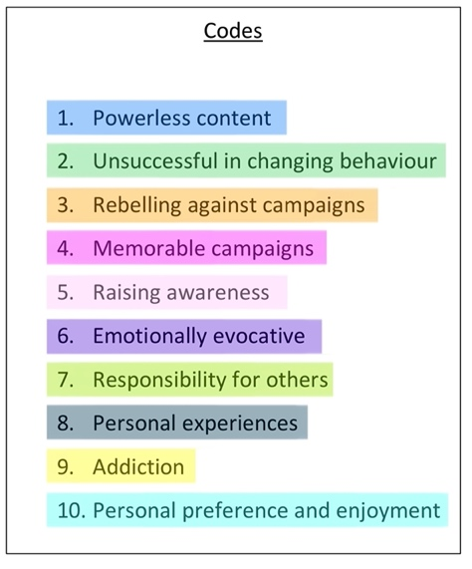
Appendix 5: Transcript of the focus group discussion (Analysed copy)

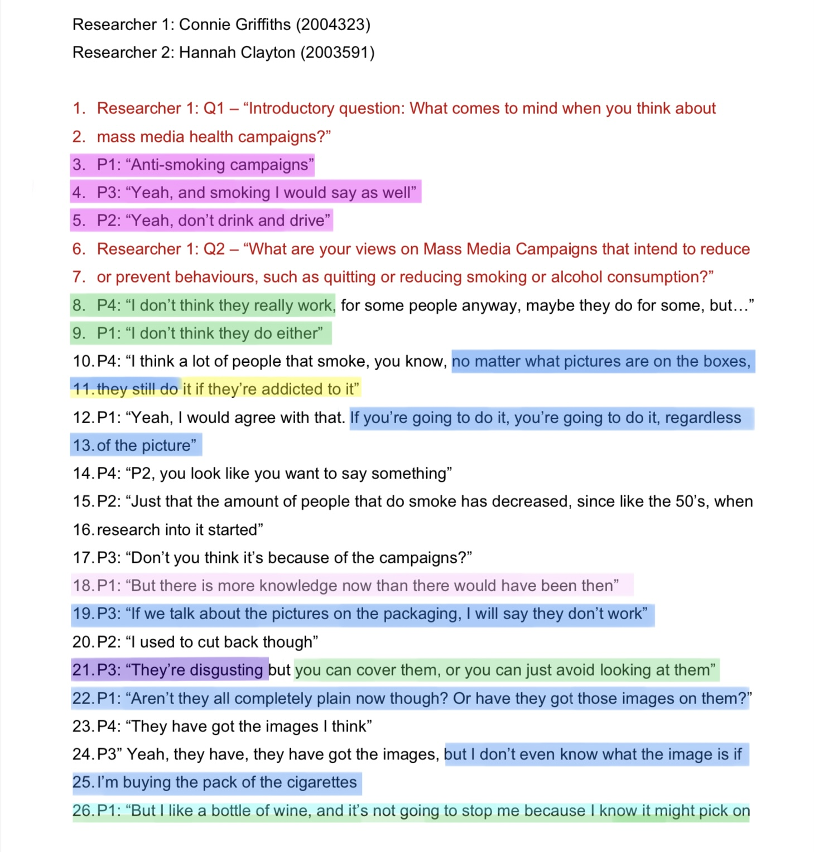

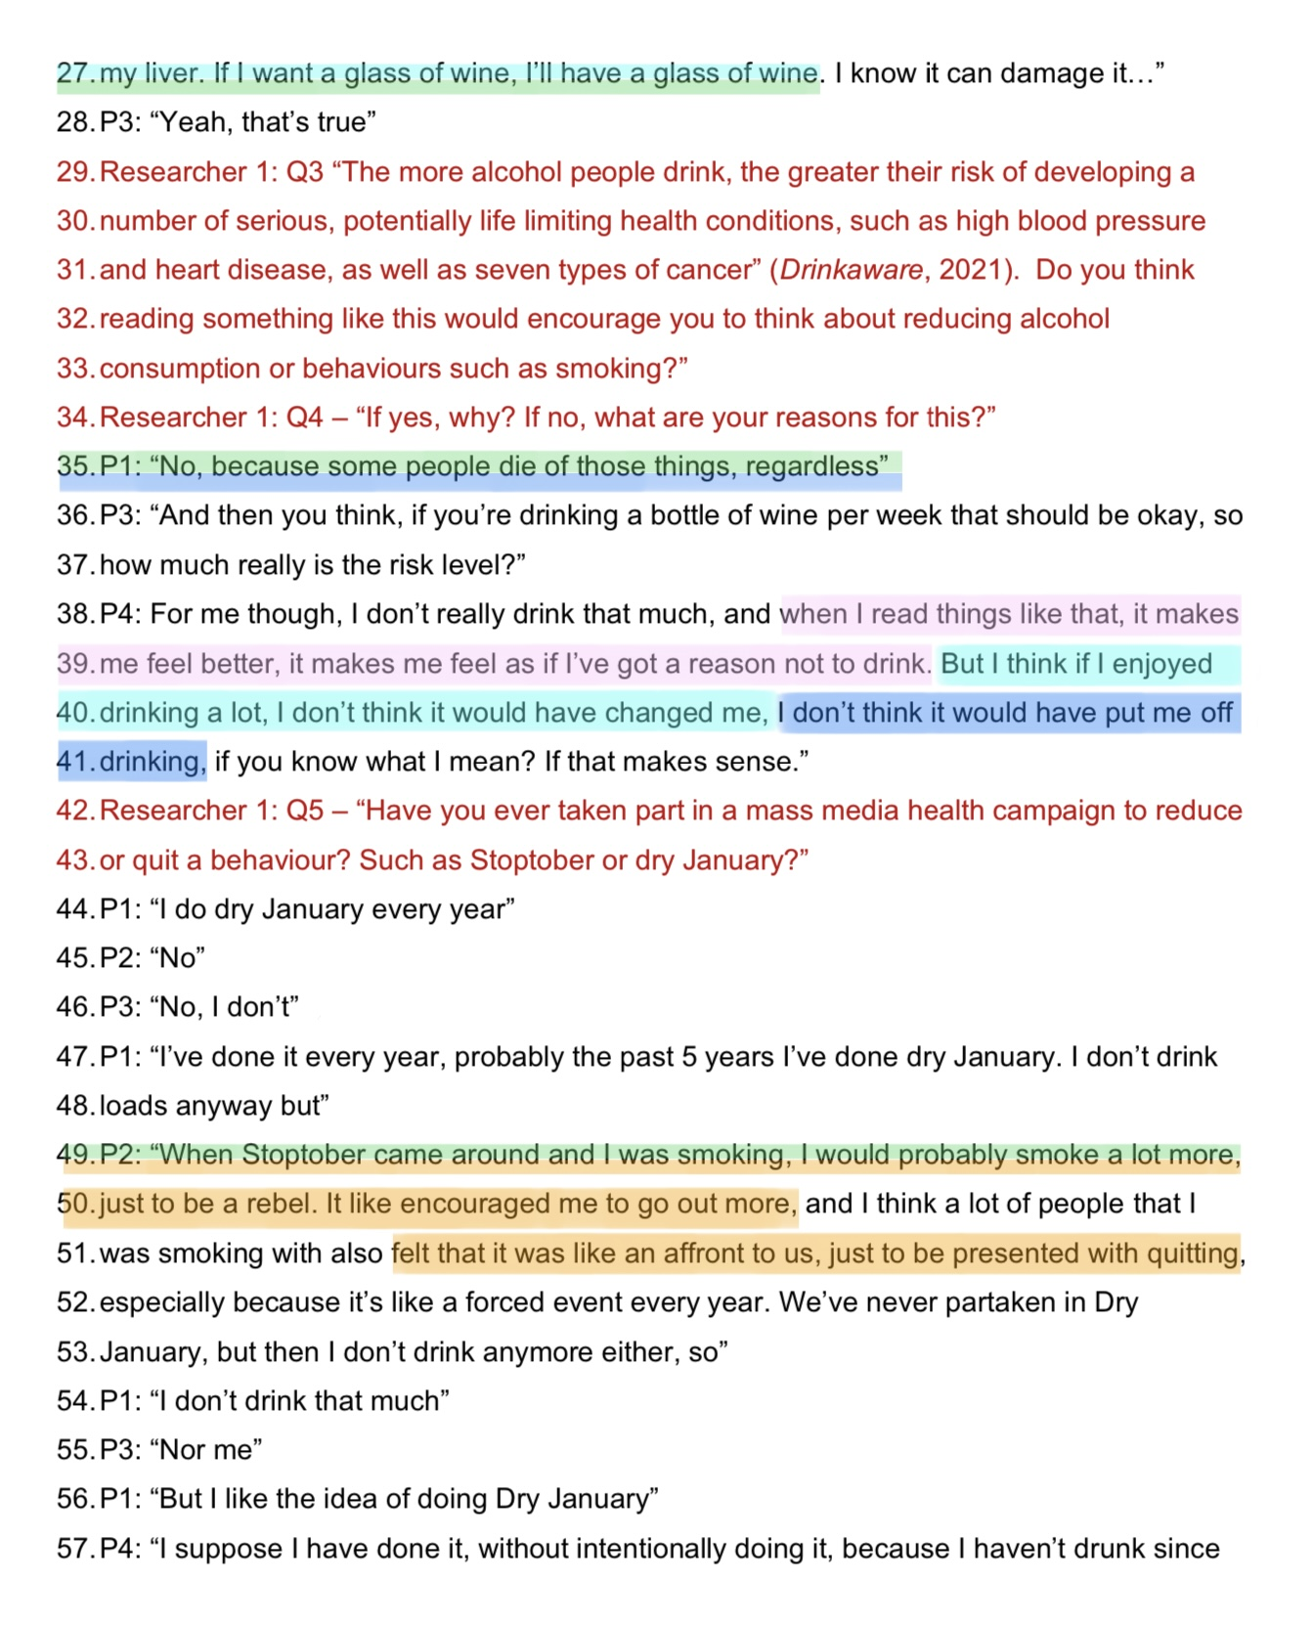

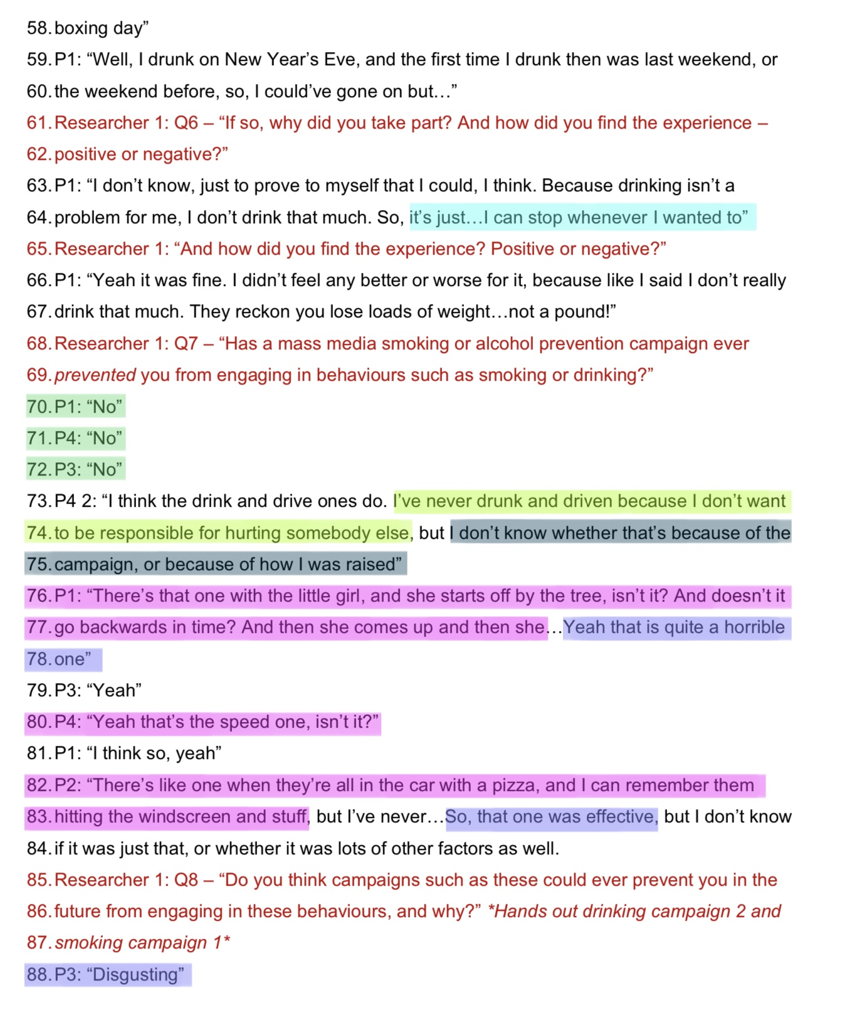

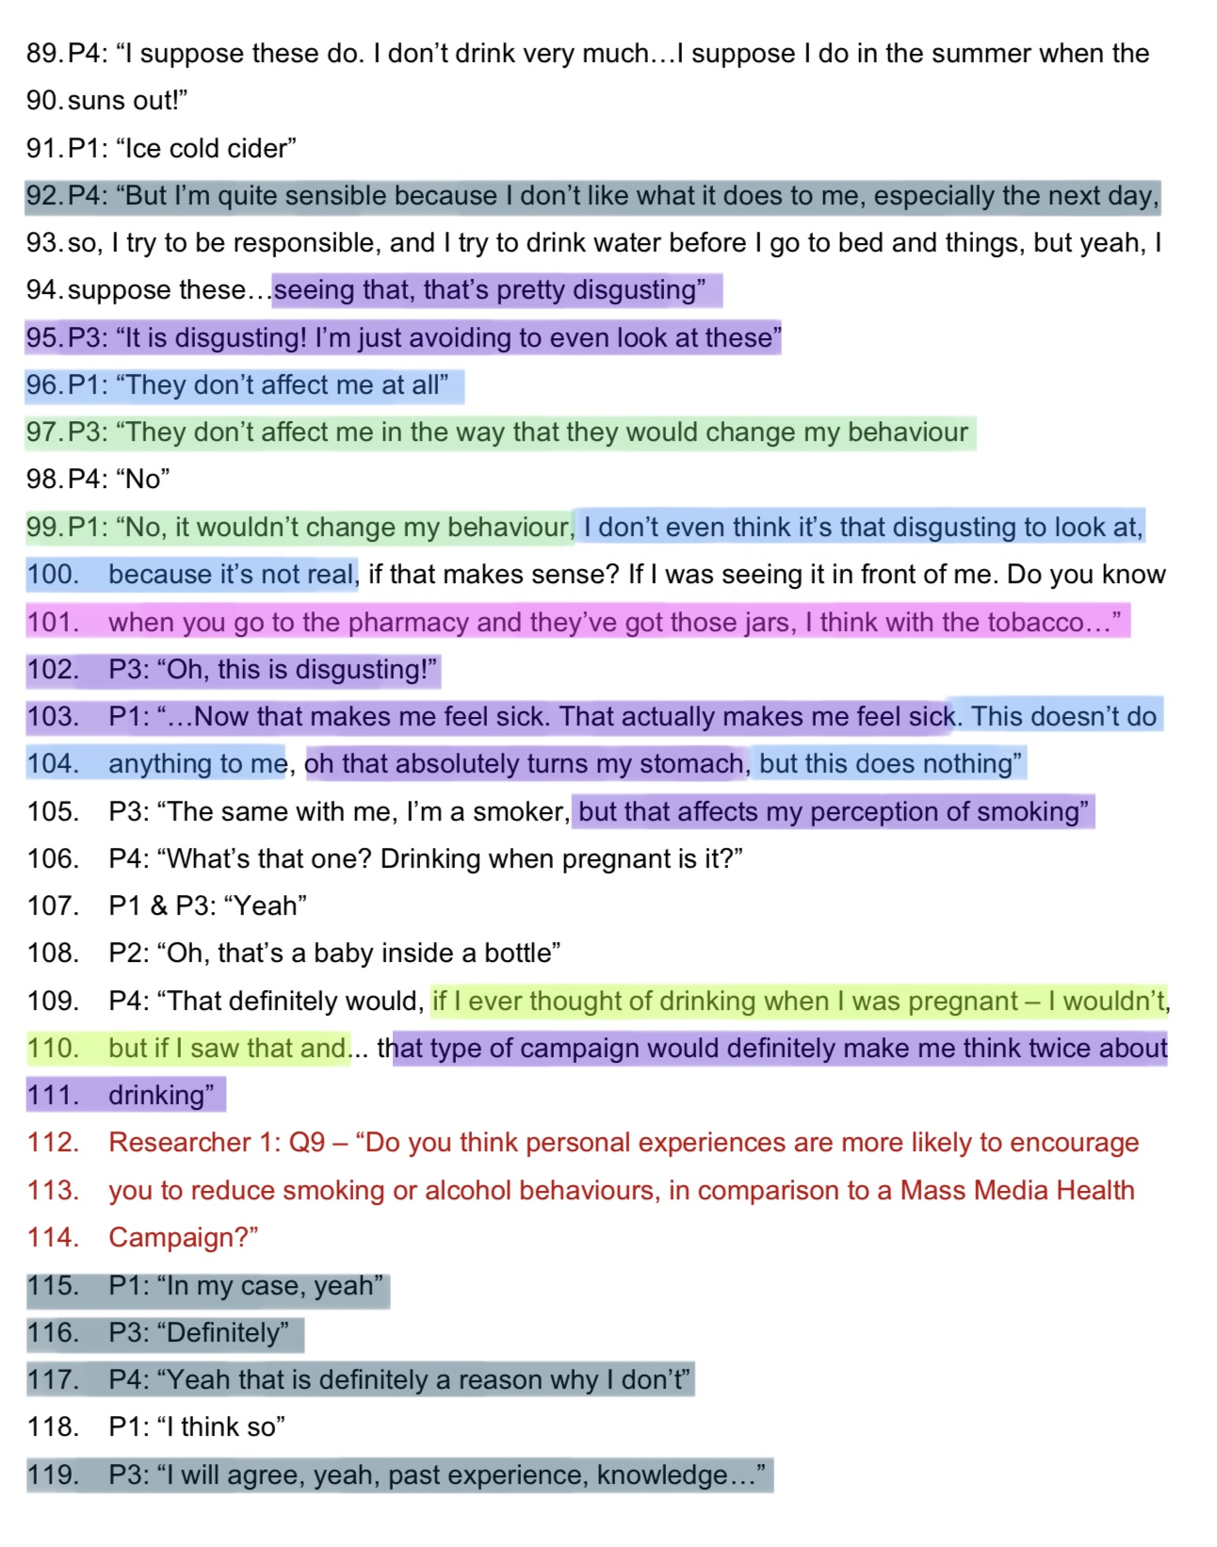

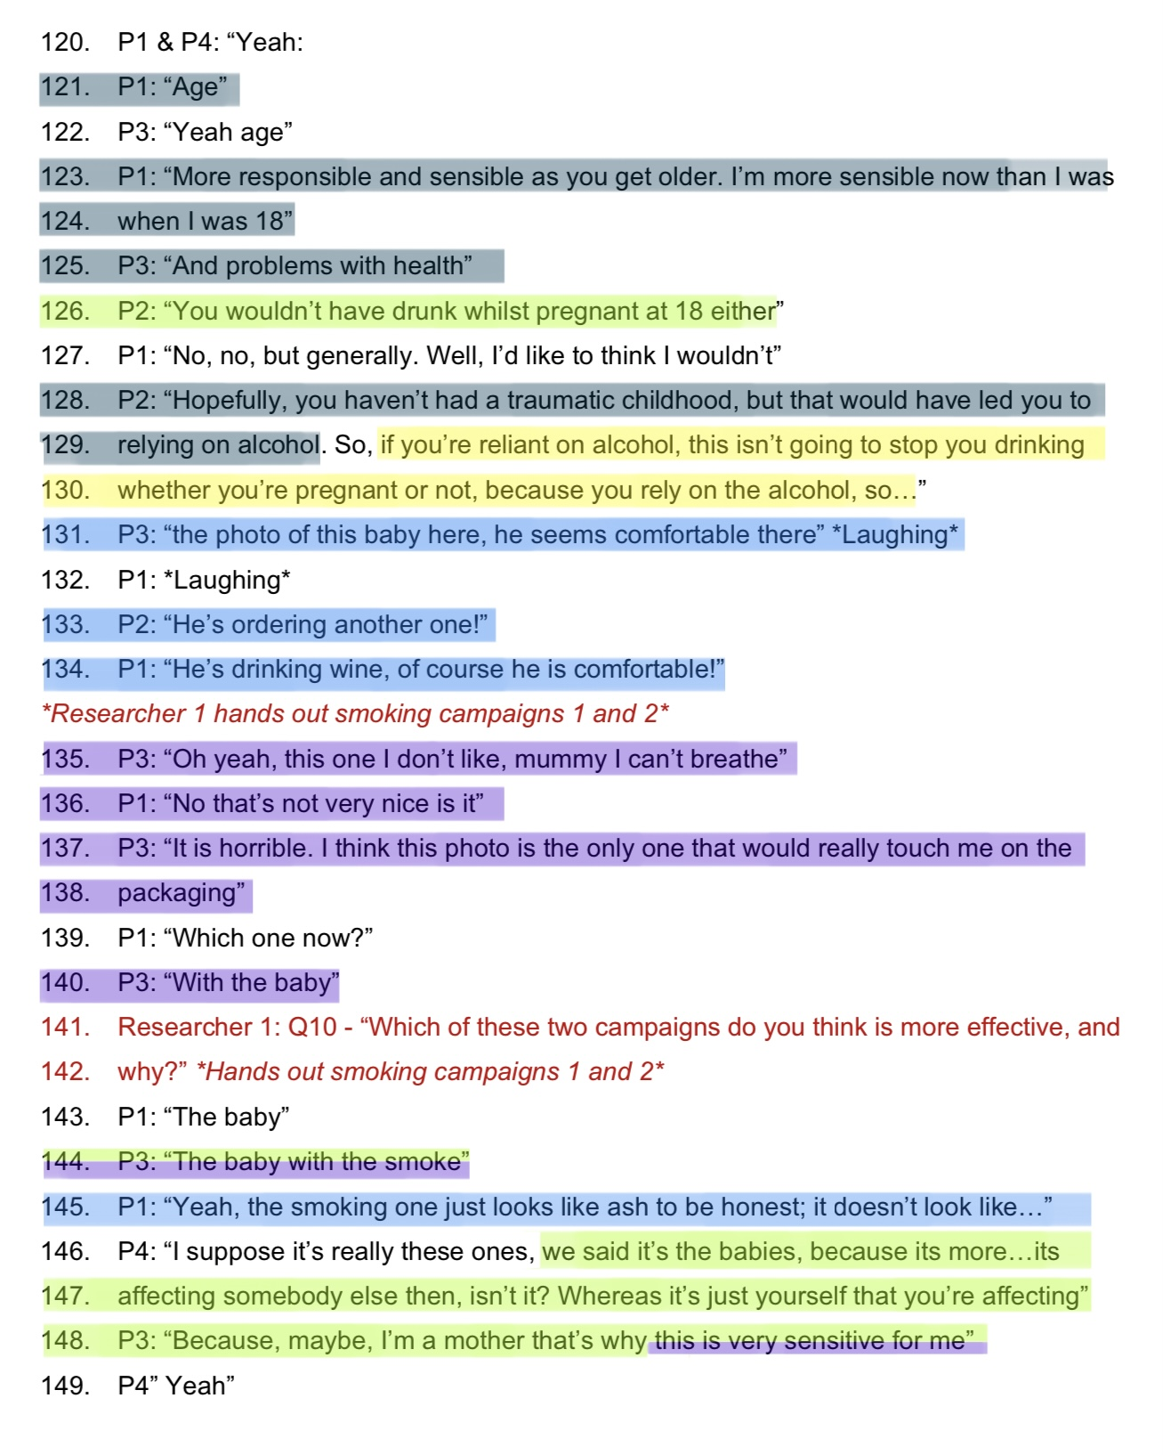

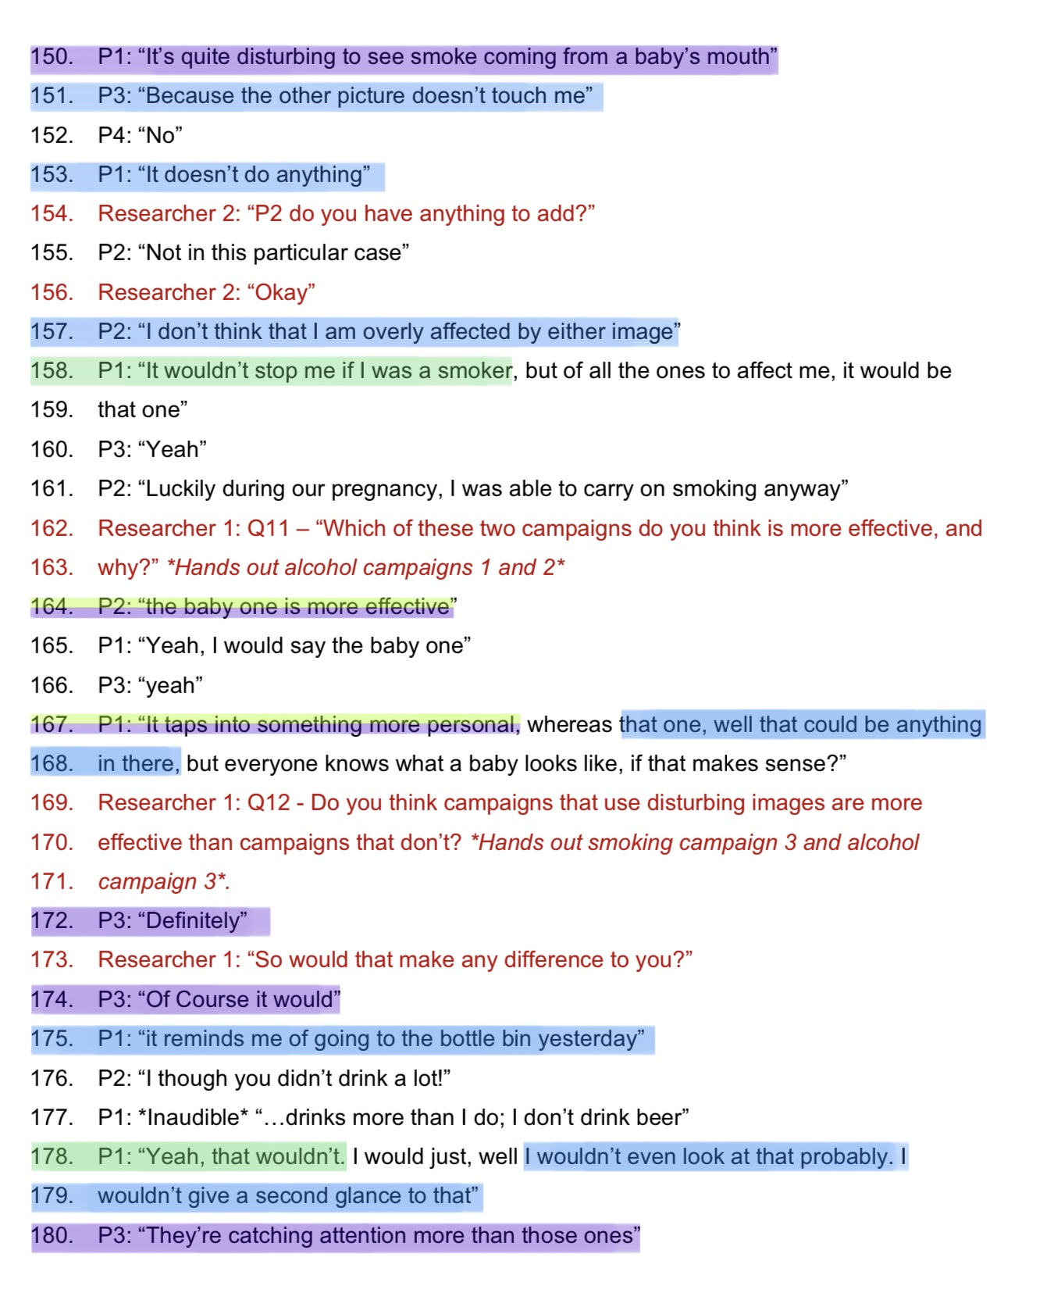

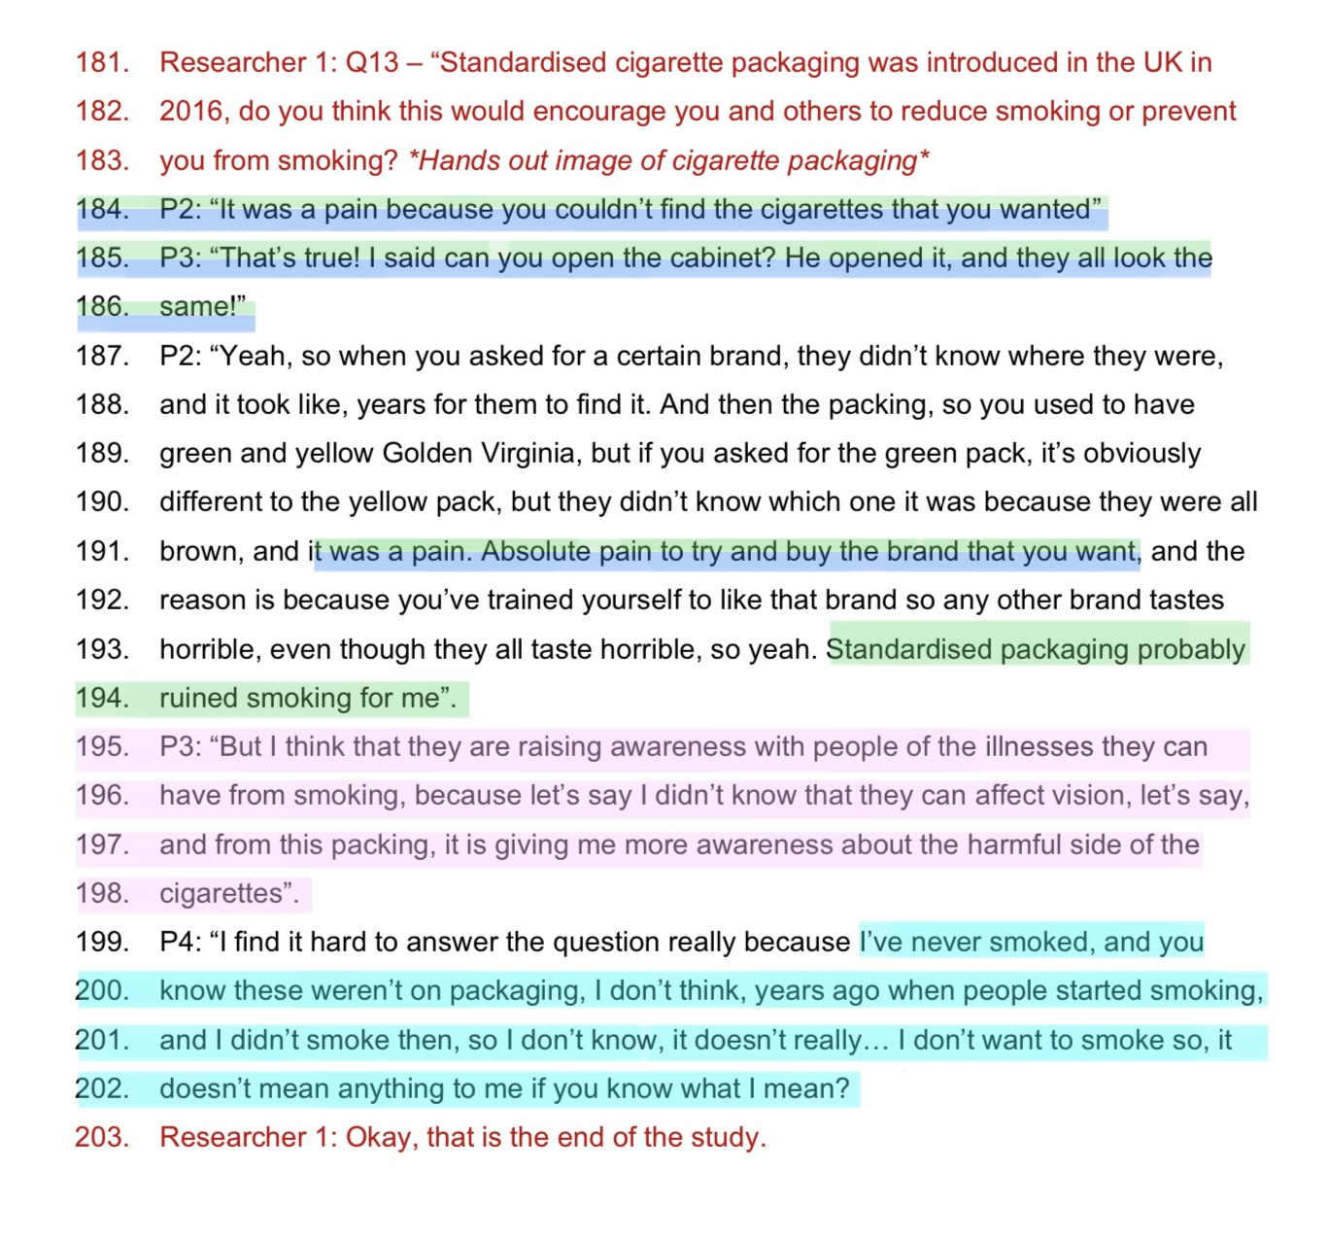

Appendix 6: Thematic Analysis

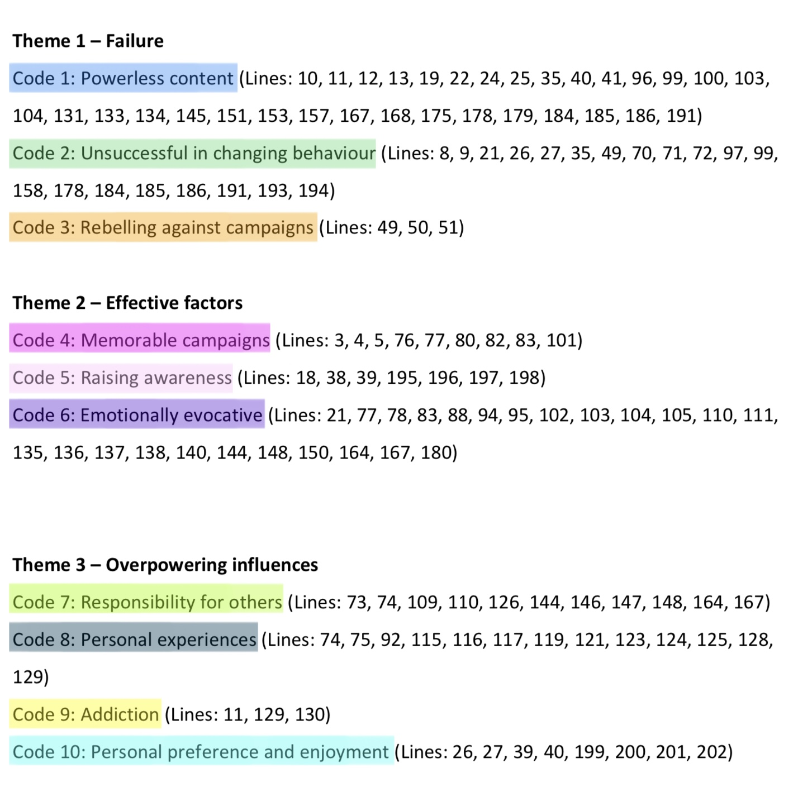

Appendix 7: Information sheet


Centre for Psychology and Counselling
BSc Applied Psychology
BSc Psychology
BSc Psychology and Counselling

Study Information Sheet

This document provides key information regarding the study and provides details about what will be expected of you as a participant. Therefore, please read this information carefully before providing consent to take part.

During this study you will be required to do the following:
- Take part in a focus group to discuss mass media health campaigns
- This will consist of four other participants
- Answer 14 questions regarding mass media health campaigns. The questions will be based on health campaigns that target smoking and alcohol drinking. Images from previous health campaigns will also be presented, with questions to follow.
  - Once a question has been asked, you will be encouraged to openly discuss the question as a group
  - The focus group discussion will be audio recorded by the researchers
- Once the discussion of the final question has ended, that will be the end of the study

At the end of the study, you will be debriefed by the researchers, and will be provided with a study debrief sheet containing further information about the study and contact details of the researcher.

If you feel you would feel uncomfortable answering questions about mass media health campaigns, namely alcohol or smoking prevention campaigns, or uncomfortable viewing potentially distressing campaign images; you are advised not to take part in this study.

If you have any questions, please ask the researcher now.

If you are happy to take part in this study, please read and sign the consent form.

Appendix 8: Consent form

Centre for Psychology and Counselling

Study Consent Form

I understand that this research study is being carried out by a 2nd year Applied Psychology Student for their Sport and Health Psychology assessment, and that taking part in this study will involve discussing the researcher’s questions about mass media smoking and alcohol prevention campaigns within a focus group, as well as viewing potentially distressing health campaigns. I understand that the focus group will be observed by the researchers, and audio recorded for transcription.

This study will take approximately 60 minutes to complete.

I understand that participation in this study is voluntary, and I am free to withdraw participation during or at the end of the study without giving a reason. I am aware that if I have concerns about the study, I can discuss these concerns with the researchers at any time during or after the study. I understand that I will be provided with the contact details of the researchers and research supervisor at the end of the study, should I have any concerns.

I understand that the information provided by me will be held confidentially, and a code will be assigned in place of my name. I understand that following the transcription of the audio recording, the recording will be destroyed. The remaining data will be stored indefinitely in accordance with the Data Protection Act.

I also understand that at the end of the study I will be provided with a debrief form and the opportunity to discuss any issues with the researcher.

I, ___________________________________(NAME) am over the age of 18 and consent to participate in the study conducted by 2003591 and 2004323, Centre for Psychology and Counselling, University of Wales Trinity Saint David, under the supervision of Dr. Stuart Jones
Participant Signature: ________________________________________________
Date: ___________________
Name and signature of researcher taking consent
___________________________________________________________________

Appendix 9: Debrief Sheet

Centre for Psychology and Counselling

Study Debrief Sheet

The impact of mass media campaigns on changing health related behaviours

Thank you for taking part in the study.

The aim of this study was to explore the impact of mass media campaigns on changing health related behaviours. We specifically wanted to find out whether mass media campaigns are effective in preventing or reducing negative health related behaviours, such as smoking and drinking.

We wanted to conduct this study since mass media health campaigns, such as Stoptober, have reported high levels of effectiveness. For example, the Stoptober 2018 campaign evaluation reported that the campaign met almost all targets set out by the government (Public Health England, 2019). For instance, the campaign recognition target was 60%, and 58% was achieved, the reported quit attempts target was 16%, while 19% was achieved, and the reported sustained quit attempts target was 8%, and 8% was achieved (Public Health England, 2019). Furthermore, a 2014 evaluation of the Dry January campaign by the University of Sussex revealed that 72% of participants had reduced their levels of harmful drinking 6 months after completing a month of no alcohol during the January (Ballard, 2015). Therefore, it is expected that this study will, overall, demonstrate the positive impact that mass media health campaigns can have on changing health related behaviours, such as smoking and harmful drinking.

If you wish to withdraw your data from the study, you must tell the researcher now.

If you do not wish to withdraw your data from the study, your data will be stored confidentially on password protected computers, only accessible by the researchers and module lead. The audio data will be transcribed using unique ID codes in place of names. The audio recording will be destroyed after transcription. The remaining data will be stored indefinitely in accordance with the Data Protection Act.

If taking part in this study has raised any questions or concerns, please speak to the researchers on 2003591@student.uwtsd.ac.uk or 2004323@student.uwtsd.ac.uk, or contact the academic supervisor, Stuart Jones, on s.a.jones@uwtsd.ac.uk

Thank you once again for taking time to participate in this study.
2003591 & 2004323
BSc Honours Applied Psychology
University of Wales Trinity Saint David, Carmarthen

Appendix 10: Ethics Form

APPLICATION FOR ETHICAL APPROVAL

In order for research to result in benefit and minimise risk of harm, it must be conducted ethically. A researcher may not be covered by the University’s insurance if ethical approval has not been obtained prior to commencement.

The University follows the OECD Frascati manual definition of research activity: “creative work undertaken on a systematic basis in order to increase the stock of knowledge, including knowledge of man, culture and society, and the use of this stock of knowledge to devise new applications”. As such this covers activities undertaken by members of staff, postgraduate research students, and both taught postgraduate and undergraduate students working on dissertations/projects.

The individual undertaking the research activity is known as the “principal researcher”.

Ethical approval is not required for routine audits, performance reviews, quality assurance studies, testing within normal educational requirements, and literary or artistic criticism.

Please read the notes for guidance before completing ALL sections of the form.

This form must be completed and approved prior to undertaking any research activity. Please see Checklist for details of process for different categories of application.

SECTION A: About You (Principal Researcher)
1 | Full Name: |  | Hannah Clayton & Connie Griffiths
2 | Tick all boxes that apply: |  | Member of staff: | ☐ | Honorary research fellow: | ☐
 | Undergraduate Student | ☒ | Taught Postgraduate Student | ☐ | Postgraduate Research Student | ☐

3 | Institute/Academic Discipline/Centre: | Psychology and Counselling
4 | Campus: | Carmarthen
5 | E-mail address: | Hannah Clayton: 2003591@student.uwtsd.ac.uk  Connie Griffiths: 2004323@student.uwtsd.ac.uk
6 | Contact Telephone Number: | 07723001903
 | For students:
7 | Student Number: | Hannah Clayton: 2003591  Connie Griffiths: 2004323
8 | Programme of Study: | BSc Applied Psychology
9 | Director of Studies/Supervisor: | Dr Stuart Jones

SECTION B: Approval for Research Activity

1 | Has the research activity received approval in principle?  (Please check the Guidance Notes as to the appropriate approval process for different levels of research by different categories of individual) |  | YES | ☒ | NO | ☐
 |  |  |  |  | Date
2 | If yes, please indicate source of approval (and date where known): Approval in principle must be obtained from the relevant source prior to seeking ethical approval | Research Degrees Committee |  | ☐
2 |  | Institute Research Committee |  | ☐
2 |  | Other (write in) |  | ☒ | September 2021

SECTION C: Internal and External Ethical Guidance Materials
 | Please list the core ethical guidance documents that have been referred to during the completion of this form (including any discipline-specific codes of research ethics, location-specific codes of research ethics, and also any specific ethical guidance relating to the proposed methodology). Please tick to confirm that your research proposal adheres to these codes and guidelines. You may add rows to this table if needed.
1 | UWTSD Research Ethics & Integrity Code of Practice | ☒
2 | UWTSD Research Data Management Policy | ☒
3 | BPS Code of Human Research Ethics (2014) | ☒
4 | BPS Code of Ethics and Conduct (2018) | ☒
5 | BPS Ethics for Internet-Mediated Research (2017) | ☒
6 | UWTSD Student Code of Conduct 2020-2021 | ☒

SECTION D: External Collaborative Research Activity
If there are external collaborators, then you should gain consent from the contact persons to share their personal data with the university. If there are no external collaborators, then leave this section blank and continue to section E.
1 | Institution
2 | Contact person name
3 | Contact person e-mail address
4 | Is your research externally funded? |  | YES | ☐ | NO |  | ☐
5 | Are you in receipt of a KESS scholarship? |  | YES | ☐ | NO |  | ☐
6 | Are you specifically employed to undertake this research in either a paid or voluntary capacity? | Voluntary | YES | ☐ | NO | ☐
7 |  | Employed | YES | ☐ | NO | ☐
8 | Is the research being undertaken within an existing UWTSD Athrofa Professional Learning Partnership (APLP)? | If YES, then the permission question below does not need to be answered. | YES | ☐ | NO |  | ☐
9 | Has permission to undertake the research has been provided by the partner organisation? | (If YES attach copy)  If NO the application cannot continue | YES | ☐ | NO |  | ☐

Where research activity is carried out in collaboration with an external organisation
10 | Does this organisation have its own ethics approval system? | YES | ☐ | NO | ☐
 | If yes, please attach a copy of any final approval (or interim approval) from the organisation (this may be a copy of an email if appropriate).

SECTION E: Details of Research Activity
1 | Indicative title: | An investigation, for the purposes of a qualitative thematic analysis, into the impact of mass media campaigns on changing health related behaviours.
2 | Proposed start date: | February 2022 | Proposed end date: | March 2022
 | - An investigation for the purposes of a qualitative thematic analysis, into the impact of mass media campaigns on changing health related behaviours
3 | Purpose of Research Activity  To engage with and complete a Level Five qualitative small-scale report. This will be a focus group task where other students of the Level 5 Applied Psychology cohort will be the participants. Following participation, we, as the researchers, will analyse and write up the results following the APA report writing format.
4 | Research Question  The impact of mass media campaigns on changing health related behaviours.
5 | Aims of Research Activity  To complete a group assessment task, with the aim of investigating the impact of mass media campaigns on changing health related behaviours. Specifically, whether mass media campaigns can prevent or reduce negative health related behaviours, such as smoking and harmful drinking.
6 | Objectives of Research Activity  As part of Assessment 1 for ECAP5006, we are required to complete a 2,500-word small scale qualitative report on the impact of mass media campaigns on changing health related behaviours.  We will independently analyse raw data gathered during the focus group.
Proposed methods (maximum 600 words)
Provide a brief summary of all the methods that may be used in the research activity, making it clear what specific techniques may be used. If methods other than those listed in this section are deemed appropriate later, additional ethical approval for those methods will be needed. You do not need to justify the methods here but should instead describe how you intend to collect the data necessary for you to complete your project.

7 | We will gather participants from the Level 5 Applied Psychology cohort, to form a focus group involving 5 participants. We will supervise the focus group and gather a raw data set as a pair, though we will analyse the data independently, as part of a qualitative thematic analysis that is individually assessed. The materials needed to participate in this study are a laptop, audio recorder (iPhone), one copy of the focus group questionnaire, and handouts of past mass media campaigns. We will explain the nature of the research and explain participant rights to each member of the focus group. We will then provide each participant with a copy of the consent form where they will have the opportunity to agree to, or refrain from participating in the study. Participants will also have the right to withdraw at any time, and any data will be excluded.  The participants will be fully debriefed at the end of the study by the debrief form, re-iterating the aims of the study, their rights as participants, and what happens to the data to ensure confidentiality and anonymity.  Raw data will be transcribed by the lead researchers
Location of research activity
Identify all locations where research activity will take place.
8 | Data collection will take place in a classroom environment, in a socially distanced manner. 5 students who have agreed to participate in the study will meet in the RH001 lecture room on the University of Wales Trinity St. David Carmarthen campus.
Research activity outside of the UK
If research activity will take place overseas, you are responsible for ensuring that local ethical considerations are complied with and that the relevant permissions are sought. Specify any local guidelines (e.g., from local professional associations/learned societies/universities) that exist and whether these involve any ethical stipulations beyond those usual in the UK (provide details of any licenses or permissions required). Also specify whether there are any specific ethical issues raised by the local context in which the research activity is taking place, for example, particular cultural and/or legal sensitivities or vulnerabilities of participants. If you live in the country where you will do the research, then please state this.
9 | N/A

10 | Use of documentation not in the public domain: Are any documents NOT publicly available? | NO | ☒
10 |  | YES | ☐
11 | If yes, please provide details here of how you will gain access to specific documentation that is not in the public domain and that this is in accordance with the current data protection law of the country in question and that of England and Wales.

 | Does your research relate to one or more of the seven aims of the Well-being of Future Generations (Wales) Act 2015? | YES | NO
12 | A prosperous Wales | ☒ | ☐
13 | A resilient Wales | ☒ | ☐
14 | A healthier Wales | ☒ | ☐
15 | A more equal Wales | ☐ | ☒
16 | A Wales of cohesive communities | ☐ | ☒
17 | A Wales of vibrant culture and thriving Welsh language | ☐ | ☒
19 | If YES to any of the above, please give details:
 | Due to the nature of the study, the potential impact on finding out the effectiveness of Mass Media Campaigns on reducing and preventing negative health related behaviour could have links to a healthier Wales, a resilient Wales, and a prosperous Wales.

SECTION F: Scope of Research Activity
 | Will the research activity include? | YES | NO
1 | Use of a questionnaire or similar research instrument? | ☐ | ☒
2 | Use of interviews? | ☐ | ☒
3 | Use of focus groups? | ☒ | ☐
4 | Use of participant diaries? | ☐ | ☒
5 | Use of video or audio recording? | ☒ | ☐
6 | Use of computer-generated log files? | ☐ | ☒
7 | Participant observation with their knowledge? | ☐ | ☒
8 | Participant observation without their knowledge? | ☐ | ☒
9 | Access to personal or confidential information without the participants’ specific consent? | ☐ | ☒
10 | Administration of any questions, test stimuli, presentation that may be experienced as physically, mentally or emotionally harmful / offensive? | ☐ | ☒
11 | Performance of any acts which may cause embarrassment or affect self-esteem? | ☐ | ☒
12 | Investigation of participants involved in illegal activities? | ☐ | ☒
13 | Use of procedures that involve deception? | ☐ | ☒
14 | Administration of any substance, agent or placebo? | ☐ | ☒
15 | Working with live vertebrate animals? | ☐ | ☒
16 | Procedures that may have a negative impact on the environment? | ☐ | ☒
17 | Other primary data collection methods. Please indicate the type of data collection method(s) below. | ☐ | ☒
 | Details of any other primary data collection method:
If NO to every question, then the research activity is (ethically) low risk and may be exempt from some of the following sections (please refer to Guidance Notes).

If YES to any question, then no research activity should be undertaken until full ethical approval has been obtained.

SECTION G: Intended Participants
If there are no participants then do not complete this section, but go directly to section H.

 | Who are the intended participants? | YES | NO
1 | Students or staff at the University? | ☒ | ☐
2 | Adults (over the age of 18 and competent to give consent)? | ☒ | ☐
3 | Vulnerable adults? | ☐ | ☒
4 | Children and Young People under the age of 18? (Consent from Parent, Carer or Guardian will be required) | ☐ | ☒
5 | Prisoners? | ☐ | ☒
6 | Young offenders? | ☐ | ☒
7 | Those who could be considered to have a particularly dependent relationship with the investigator or a gatekeeper? | ☐ | ☒
8 | People engaged in illegal activities? | ☐ | ☒
9 | Others. Please indicate the participants below, and specifically any group who may be unable to give consent. | ☐ | ☒
 | Details of any other participant groups: N/A | ☐ | ☒

Participant numbers and source
Provide an estimate of the expected number of participants. How will you identify participants and how will they be recruited?
10 | How many participants are expected? | We expect 5 participants to take part in a focus group.
11 | Who will the participants be? | The participants will be Level 5 BSc Applied Psychology students.
12 | How will you identify the participants? | Participants will be sourced in class and will be identified by a unique ID code assigned in place of their name.

 | Information for participants: | YES | NO | N/A
13 | Will you describe the main research procedures to participants in advance, so that they are informed about what to expect? | ☒ | ☐ | ☐
14 | Will you tell participants that their participation is voluntary? | ☒ | ☐ | ☐
15 | Will you obtain written consent for participation? | ☒ | ☐ | ☐
16 | Will you explain to participants that refusal to participate in the research will not affect their treatment or education (if relevant)? | ☒ | ☐ | ☐
17 | If the research is observational, will you ask participants for their consent to being observed? | ☐ | ☐ | ☒
18 | Will you tell participants that they may withdraw from the research at any time and for any reason? | ☒ | ☐ | ☐
19 | With questionnaires, will you give participants the option of omitting questions they do not want to answer? | ☒ | ☐ | ☐
20 | Will you tell participants that their data will be treated with full confidentiality and that, if published, it will not be identifiable as theirs? | ☒ | ☐ | ☐
21 | Will you debrief participants at the end of their participation, in a way appropriate to the type of research undertaken? | ☒ | ☐ | ☐
22 | If NO to any of above questions, please give an explanation

 | Information for participants: | YES | NO | N/A
23 | Will participants be paid? | ☐ | ☒ | ☐
24 | Is specialist electrical or other equipment to be used with participants? | ☐ | ☒ | ☐
25 | Are there any financial or other interests to the investigator or University arising from this study? | ☐ | ☒ | ☐
26 | Will the research activity involve deliberately misleading participants in any way, or the partial or full concealment of the specific study aims? | ☐ | ☒ | ☐
27 | If YES to any question, please provide full details

SECTION H: Anticipated Risks

Outline any anticipated risks that may adversely affect any of the participants, the researchers and/or the University, and the steps that will be taken to address them.

If you have completed a full risk assessment (for example as required by a laboratory, or external research collaborator) you may append that to this form.
1 | Full risk assessment completed and appended? |  | Yes | ☐
 |  |  | No | ☒
2 | Risks to participants  For example: sector-specific health & safety, emotional distress, financial disclosure, physical harm, transfer of personal data, sensitive organisational information
 | Risk to participants:  - Participants may be concerned with having to speak about their own experiences with negative health related behaviours.  - Due to the nature of the task, participants may feel coerced into participating in the study by peers, or by us as both the researchers and fellow students.  - At times, participants may feel emotionally distressed by the content of the campaigns we wish to demonstrate. | How you will mitigate the risk to participants:  - In line with BPS ethical guidelines (2018), participants will be made aware of the nature of the study and that it involves a discussion of mass media campaigns and negative health related behaviours, prior to consenting to participate in the study. We will disclose that if participants do not feel comfortable discussing such information, then they are advised not to take part in the study. They will also be informed of their right to withdraw at any point before or during the study without penalty, if they feel they would prefer not to continue. They will also be provided with our contact details should they wish to ask any questions or raise any concerns. Participants will also be informed that codes will be assigned in place of their names, and once a transcription of the audio recording has been completed, the recording will be destroyed, and the remaining data will be anonymous and stored confidentially.  - We will clearly verbalise information prior to the collection of the data to reassure that no coercion is involved. Each student will be informed of their rights as participants and the verbalised information will highlight that participation in the study will have no impact on their academic progress. They will also be informed that there is no right or wrong answer when discussing the questions. Participants will be fully debriefed following the focus group which will highlight the aim of the study, their rights as participants, including the right to withdraw their data.  - In line with the BPS Ethical Guidelines (2018), participants will be made aware of the nature of the study and that it will involve the viewing of mass media health campaigns with potentially distressing content, prior to participating in the study. We will disclose that if participants be do not feel comfortable viewing this type of content, then they are advised not to take part in the study. They will also be informed of their right to withdraw at any point before or during the study without penalty, if they feel, they would prefer not to continue. They will also be provided with our contact details should they wish to ask any questions or raise any concerns.
3 | If research activity may include sensitive, embarrassing or upsetting topics (e.g., sexual activity, drug use) or issues likely to disclose information requiring further action (e.g., criminal activity), give details of the procedures to deal with these issues, including any support/advice (e.g., helpline numbers) to be offered to participants. Note that where applicable, consent procedures should make it clear that if something potentially or actually illegal is discovered in the course of a project, it may need to be disclosed to the proper authorities
 | Due to the nature of the study (inclusion of sensitive topics and potentially distressing content), the researchers will provide the participants with their contact details, and the contact details of their research supervisor, in the case of any queries, worries or complaints. To deal with any issues raised, the researchers intend to provide participants with links to advice and support websites, as well as helpline numbers.
4 | Risks to the investigator  For example: personal health & safety, physical harm, emotional distress, risk of accusation of harm/impropriety, conflict of interest
 | Risk to the investigator:  - The risks to the investigators are minimal as this is a focus group experiment with students that the researchers already know. A potential risk to the researchers is unwelcomed/unkind communications from participants.  - Researcher bias or risk of accusation of harm/impropriety  . | How you will mitigate the risk to the investigator:  - To minimise this risk, all communications must go through the university e-mail provided, and students will be reminded that they should follow the UWTSD Student Code of Conduct throughout their participation.  - As student researchers, we will be compassionate, respectful and value the dignity and worth of each participant to discourage accusation of harm/impropriety. We will follow all ethical procedures as set out by the UWTSD and BPS ethics guidelines. In addition, we will clearly verbalise information prior to the collection of the data to reassure participants that no coercion is involved. Each participant will be informed of their rights as participants and will also be informed that there is no right or wrong answer in discussion of the focus group. Participants will be fully debriefed following the focus group discussion, which will highlight the aim of the study, their rights as the participant, including the right to withdraw their data.
5 | University/institutional risks  For example: adverse publicity, financial loss, data protection
 | Risk to the University:  - The reputation and integrity of UWTSD and the discipline of Psychology and Counselling could be endangered if researchers (this includes the Module lead and the students researchers) do not adhere to codes of ethics and research protocols.  - Data could be exposed, leaked, or used for other purposes | How you will mitigate the risk to the University:  - The University Ethics and Integrity Code of Practice and the BPS Code of Ethics and Conduct and the Code of Human Research Ethics will be followed by all involved in the module at every stage of the proposed study by both the module lead and the student researchers who conduct the study and then use the collected data for analysis purposes in order to write-up their report for a module assessment. These ethical guidelines will be followed to minimise any potential risks to the Institution from arising. Professionalism must always be exhibited by the module lead and student participants.  - The collected data will be stored in an anonymised format in accordance with UWTSD Research Data Management (RDM) rules and only used for the intended purpose, in compliance with ethical guidelines set out by UWTSD Research Ethics and Integrity Code of Practice policy and the British Psychological Society’s (BPS) Code of Human Research Ethics. To minimise any risk to UWTSD and the psychology department, all collected data will be stored securely by us as researchers. Paper copies of the raw data will be stored securely and held in line with UWTSD and GDPR policy.
6 | Environmental risks  For example: accidental spillage of pollutants, damage to local ecosystems
 | N/A | How you will mitigate the risk to environment:  N/A

 | Disclosure and Barring Service
 | If the research activity involves children or vulnerable adults, a Disclosure and Barring Service (DBS) certificate must be obtained before any contact with such participants. | YES | NO | N/A
7 | Does your research require you to hold a current DBS Certificate? | ☐ | ☐ | ☒
8 | If YES, please give the certificate number. If the certificate number is not available, please write “Pending”; in this case any ethical approval will be subject to providing the appropriate certificate number.

SECTION I: Feedback, Consent and Confidentiality

1 | Feedback  What de-briefing and feedback will be provided to participants, how will this be done and when?
In line with BPS ethical guidelines, participants will be debriefed at the end of the study.
The debriefing will provide participants with further information about the study, including information on the aims and research question. The module lead and researcher’s contact details will be provided should any participants wish to contact with any questions or concerns after they have completed the study.

2 | Informed consent  Describe the arrangements to inform potential participants, before providing consent, of what is involved in participating. Describe the arrangements for participants to provide full consent before data collection begins. If gaining consent in this way is inappropriate, explain how consent will be obtained and recorded in accordance with prevailing data protection legislation.
 | Participants will be provided with written information regarding the nature of the study. They will be informed of their opportunity to refrain from participation, as well as their right to withdraw from the study at any point, and their right to withdraw their data following the study (without penalty). The information provided will also document key ethical considerations, including information on how the data will be collected and stored and how it will remain anonymous. Due to the nature of the study and the time constraints, participants will be informed that they have 24 hours to contact the researchers requesting for their information to be withdrawn after completing the study.
3 | Confidentiality / Anonymity  Set out how anonymity of participants and confidentiality will be ensured in any outputs. If anonymity is not being offered, explain why this is the case.
 | Written consent will be required; therefore, participants will be required to provide their name. However, the participants will then each be assigned a code, thus they will remain anonymous within the data. No data will be linked to a particular individual. The collected data will be kept confidential and stored securely by us as the researchers, thus only we will have access to the data and the paper copies of the consent forms. Electronic transfer of the raw data will be imputed on password protected computers belonging to us, for the purpose of analysis, though will later be destroyed.

SECTION J: Data Protection and Storage

 | Does the research activity involve personal data (as defined by the General Data Protection Regulation 2016 “GDPR” and the Data Protection Act 2018 “DPA”)? | YES | NO
1 | “Personal data” means any information relating to an identified or identifiable natural person (‘data subject’). An identifiable natural person is one who can be identified, directly or indirectly, in particular by reference to an identifier such as a name, an identification number, location data, an online identifier or to one or more factors specific to the physical, physiological, genetic, mental, economic, cultural or social identity of that natural person. Any video or audio recordings of participants is considered to be personal data. | ü | ☐
 | If YES, provide a description of the data and explain why this data needs to be collected:
2 | Data on participant names will be collected, as this forms a standard reporting measure in  psychology reports within the participant subsection of the method. According to the UWTSD  Research Data Management Policy, this constitutes personal data. However, these data will not be attached to any identifying data about the participant.
 | Does it involve special category data (as defined by the GDPR)? | YES | NO
3 | “Special category data” means sensitive personal data consisting of information as to the data subjects’ –  (a) racial or ethnic origin,  (b) political opinions,  (c ) religious beliefs or other beliefs of a similar nature,  (d) membership of a trade union (within the meaning of the Trade Union and Labour Relations (Consolidation) Act 1992),  (e) physical or mental health or condition,  (f) sexual life,  (g) genetics,  (h) biometric data (as used for ID purposes), | ☐ | ü
 | If YES, provide a description of the special category data and explain why this data needs to be collected:
4

 | Will data from the research activity (collected data, drafts of the thesis, or materials for publication) be stored in any of the following ways? |  | YES | NO
5 | Manual files (i.e. in paper form)? | ☒ | ☐
6 | University computers? | ☒ | ☐
7 | Private company computers? | ☐ | ☒
8 | Home or other personal computers? | ☒ | ☐
9 | Laptop computers/ CDs/ Portable disk-drives/ memory sticks? | ☒ | ☒
10 | “Cloud” storage or websites? | ☒ | ☒
11 | Other – specify: | ☐ | ☒
12 | For all stored data, explain the measures in place to ensure the security of the data collected, data confidentiality, including details of backup procedures, password protection, encryption, anonymisation and pseudonymisation:
Raw data will be collected using an audio recording device and transcribed. Names collected will be assigned a unique number in place of their names, which may be used on the transcription; therefore, participant data will be anonymous. This will prevent personal information from being traced back to participants after the study has been completed.

Collected data will be kept confidential and will be stored securely by us researchers under lock and key in which only we will have access to. Paper Raw Data will be stored securely in line with UWTSD policy and GDPR. Following the end of year examination boards, raw data from the participants will be destroyed.

 | Data Protection
 | Will the research activity involve any of the following activities? | YES | NO
13 | Electronic transfer of data in any form? | ☒ | ☐
14 | Sharing of data with others at the University outside of the immediate research team? | ☒ | ☐
15 | Sharing of data with other organisations? | ☐ | ☒
16 | Export of data outside the UK or importing of data from outside the UK? | ☐ | ☒
17 | Use of personal addresses, postcodes, faxes, emails or telephone numbers? | ☐ | ☒
18 | Publication of data that might allow identification of individuals? | ☐ | ☒
19 | Use of data management system? | ☐ | ☒
20 | Data archiving? | ☐ | ☒
21 | If YES to any question, please provide full details, explaining how this will be conducted in accordance with the GDPR and Data Protection Act (2018) (and any international equivalents, where appropriate):
 | In accordance with the GDPR, transfer of audio from a mobile device to a personal computer will be carried out. This data will be transcribed in a MS Word document, using participant’s anonymous ID numbers. It will be ensured that the audio will be stored on a password protected computer or laptop. Once the module assessment has been reviewed by the end of year examination board, all electronic data will be destroyed.
22 | List all who will have access to the data generated by the research activity:
 | The student researchers (Hannah Clayton & Connie Griffiths) and the module lead (Stuart Jones).
23 | List who will have control of, and act as custodian(s) for, data generated by the research activity:
 | The student researchers (Hannah Clayton & Connie Griffiths)
24 | Give details of data storage arrangements, including security measures in place to protect the data, where data will be stored, how long for, and in what form. Will data be archived – if so, how and if not, why not?
 | Data will be stored securely under lock and key which only we, as the researchers, and the module lead will have access to. Data transferred from the mobile device to electronic format (MS word) will take place on a password protected personal computer that only we can use. As this is a module research study that is not expected to produce publishable standard data, it does not require archiving for public use. Nor does it require to be maintained for a period required for data in the public domain, Therefore, after review of the research reports produced, the appropriate examination board the data will be destroyed (in all but in exceptional circumstances this will then mean within ten months of data collection).
25 | Please indicate if your data will be stored in the UWTSD Research Data Repository (see https://researchdata.uwtsd.ac.uk/ ). If so, please explain. (Most relevant to academic staff)
26 | Confirm that you have read the UWTSD guidance on data management (see https://www.uwtsd.ac.uk/library/research-data-management/) | YES | ☒
27 | Confirm that you are aware that you need to keep all data until after your research has completed or the end of your funding | YES | ☒

SECTION K: Declaration
The information which I have provided is correct and complete to the best of my knowledge. I have attempted to identify any risks and issues related to the research activity and acknowledge my obligations and the rights of the participants.

In submitting this application, I hereby confirm that I undertake to ensure that the above named research activity will meet the University’s Research Ethics and Integrity Code of Practice which is published on the website: https://www.uwtsd.ac.uk/research/research-ethics/
1 | Signature of applicant: | H. Clayton  C. Griffiths | Date: 16/02/2022

For STUDENT Submissions:
2 | Director of Studies/Supervisor: |  | Date:
3 | Signature: |  | Date:

For STAFF Submissions:
4 | Academic Director/ Assistant Dean: |  | Date:
5 | Signature: |  | Date:

Checklist: Please complete the checklist below to ensure that you have completed the form according to the guidelines and attached any required documentation:
☒ | I have read the guidance notes supplied before completing the form.
☒ | I have completed ALL RELEVANT sections of the form in full.
☒ | I confirm that the research activity has received approval in principle
☐ | I have attached a copy of final/interim approval from external organisation (where appropriate)
☐ | I have attached a full risk assessment (where appropriate) ONLY TICK IF YOU HAVE ATTACHED A FULL RISK ASSESSMENT
☒ | I understand that it is my responsibility to ensure that the above-named research activity will meet the University’s Research Ethics and Integrity Code of Practice.
☒ | I understand that before commencing data collection all documents aimed at respondents (including information sheets, consent forms, questionnaires, interview schedules etc.) must be confirmed by the DoS/Supervisor, module tutor or Academic Director.

RESEARCH STUDENTS AND STAFF ONLY
All communications relating to this application during its processing must be in writing and emailed to pgresearch@uwtsd.ac.uk , with the title ‘Ethical Approval’ followed by your name.
You will be informed of the outcome of your claim by email; therefore, it is important that you check your University and personal email accounts regularly.
STUDENTS ON UNDERGRADUATE OR TAUGHT MASTERS PROGRAMMES should submit this form (and receive the outcome) via systems explained to you by the supervisor/module leader.

This form is available electronically from the Academic Office web pages: https://www.uwtsd.ac.uk/academic-office/appendices-and-forms/

