BMSW5104: Managing Projects in the Workplace
Submitted by - Vasile Daniel Baiculescu
Student ID: 2015926
Module Code: BMSW5104
Teacher Name: Sujeewa Herath

Table of Contents
Introduction 4
Project description 4
Scope of the project 5
Stakeholder analysis 6
Interest vs influence gird 8
Stakeholder engagement 8
Kickoff meetings 9
Emails 9
QUAD Chart 10
Work Breakdown Structure (WBS) 10
Resources 11
Gantt chart 13
Risk Assessment 15
Risk identification 15
Risk analysis 16
Risk evaluation 16
Risk planning 17
References 18

Introduction
When people think about advertising and promoting Pharmaceutical goods, one of the first things that come to their minds is that it may be difficult to do so in the Pharmaceutical industry (Hhm Global, 2022). This is especially true in the case of medication marketing. Companies need to be an expert in the sector in order to successfully sell their products and services and attract clients. Establishing a positive reputation in the consumer market for one's goods requires a significant investment of both money and effort. To successfully sell a Pharmaceutical product or promote a medication product, one must stay current on the latest occurrences in the Pharmaceutical industry on a daily basis. It is becoming more challenging to plan and implement a successful launch strategy as the influence of payers continues to expand and new medicines are aimed at patient groups that are smaller and have more complicated demands (Wikihow, 2022). A concerted attempt to introduce a novel approach to the consumer market is known as a product launch
Launching a product requires the participation of several teams, such as the sales team, the team responsible for providing customer support, product teams, product marketing, event management, and event managers. Even if the research behind the treatment is cutting edge and fascinating, there is still a chance that it may fail miserably when it is introduced to the Pharmaceutical market. Because it will play such an important role in getting medicine to market, the commercialization plan deserves a significant amount of attention and priority from the company and marketer. The above discussion shows that the product launch can be critical for Pharmaceutical companies. This report will discuss the launch of new multivitamins by the Pharmaceutical Company in detail.

Project description
The Pharmaceutical Company wanted to launch their new product which is multivitamins. This product will be for people who are malnutrition. This new supplement contains A, B, C, D, E, K, B12 and B-complex vitamins. According to Bruso (2022), deficiencies related to micronutrient often go along with protein energy malnutrition. World Health Organization (WHO) suggested that people having malnutrition should take a supplement of multivitamins as a course of the treatment. In order to prevent such deficiencies, the new multivitamin will assist people to overcome this.
The new multivitamins are supplements which will be taken on regular basis to add more vitamins in diet. Individuals who have chronic health condition, healthier, are expecting, nursing and trying to lose their weight can use multivitamins (Connectusfund, 2017). The new multivitamin will give a slew of essential minerals and range of vitamins, it can assist people to prevent vitamins deficiencies. Individuals who are suffering from the deficiency of iron, often focus on making sure that they are having enough iron intake in their regular diet. Adding the new multivitamins will assist them to level up their iron quickly. This new product will assist the brain and body by giving higher concentration and energy boost capabilities. It will have vitamin B which is mainly responsible for boosting energy.

Scope of the project
This product will be launch on full scale which means the entire United Kingdom will know about the new multivitamins. Full scale launching has high potential to get successful (280Group, 2022). The primary target customers of the new multivitamins will be the older adults and the population who are suffering from the malnutrition. The launch of new supplement will start from distributing and drafting marketing and sales collateral. Sales team will be trained on the new product launch as well as customer support department. Technical documentation will be completed before the launch of multivitamins. Moreover, the marketers will review and develop the preferences, behavior and journey of targeted audience towards the multivitamins. The process of launch will be monitored throughout the course of launch. Targeted audience behavior will be tracked and feedback from early consumers will be gathered.
Before the launch, the website will be made which will have an in detail description of the product, its advantages, contradiction, route and its launch date. In this course, traffic on website will be monitored through insights tool. Ads will be employed in order to redirect the consumers on website. Website will also have graphical representation and video of the manufacturing of multivitamins. Moreover, influential and famous physicians and nutrition review will be uploaded on the site regarding the new launch. Seeing the positive reviews and recommendation straight from the well-known healthcare providers will certainly gain the attention of consumers.

Stakeholder analysis
This section will analysis and discuss the stakeholders, who will be incorporated with the new launch. A stakeholder analysis is the technique of project management utilized to recognize the stakeholders of the project, the hurdles they concerned about and how they will be effected by the project. Conducting this analysis will highlight the major entities, project will communicate with about the scope and progress of the scope, the Topics Company and management need to keep them updated and informed as the project progresses.
The stakeholder analysis will be conducted at the start of the product launch in order to get better insight and understand the desires and need of every stakeholder and their main requirements. A stakeholder can be any group and person over which the project will be impacted, involving current and future investors, team members, advisors, investors and sponsors (Hoory & Bottorff, 2021). The analysis will be done in order to outline the main stakeholder and their requirements at the beginning of the launch. It will assist to have manifest insights and understanding of every stakeholder and what will they anticipate. Following are the stakeholder for the new launch of multivitamins:
- Government authorities
- Regulatory institutions

- Corporate executives
- Consumers
- Healthcare providers
- Malnourished patients
- Medicines and Healthcare Products Regulatory Agency (MHRA)
- Suppliers
- Distributors

Interest vs influence gird
Interest verses influence gird of stakeholders is created by evaluating the influence and interest of every stakeholder in this project. Interest axes depicting possible concerns of stakeholders and influence axes depicting their capacity to resist change and suggestions (Think Insights, 2022).
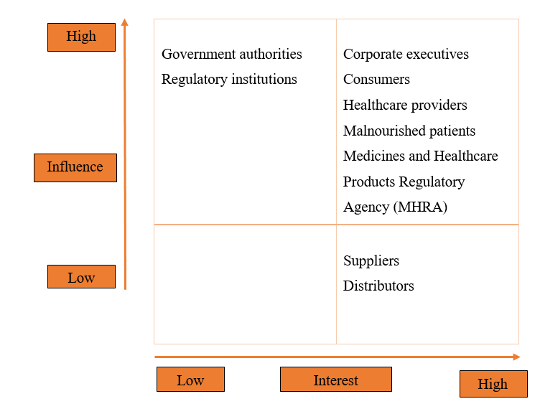

Stakeholder engagement
This section will outline the engagement plan with stakeholder throughout the launch of new multivitamins. Plan for stakeholder engagement is the way to include stakeholder in the decision making process. It will include everyone who will be affected by the launch and it will be a great way to uncover possible risks and build trust (Stobierski, 2020). Below plan for the stakeholder engagement will highlight the approaches and methodology for how team will communicate and interact with stakeholders.

Kickoff meetings
A kickoff meeting sets the roles, purpose, scope and goals of project. It will include every stakeholders in the meeting and it is considered as a great opportunity to set anticipations (Fellow, 2022). The kickoff meeting will be first meeting among marketer teams, executives, suppliers and other stakeholders. It will be hosted immediately after the scope of project sat. It will inform every stakeholder about the main deliverables, timelines and other important dates to assist bring all the stakeholders on one page. It will be one to one meeting will the groups of stakeholder like suppliers, physicians and executives. There will be main three meetings with suppliers, physicians and executives.
Meetings with them will have different and specific purposes. Meeting with suppliers will have the agenda to tackle the complications and risks associated with supply chain. It will address the factors of environmental changes, trade disputes, economic pressures and all other factors which can possibly delay the supply chain and consequently, the production process. Meeting with executives will have an agenda to secure the project budget, project progress and onboard resources. These meetings will be conducted on weekly basis.

Emails
Sending emails is one of the crucial tools for the engagement of stakeholder, however, at times getting stakeholders to respond and read to emails can be tough (Darzin, 2018). In order to keep stakeholders involved, periodic emails will be sent to them with updates on the status of project. The main purpose will be, ask queries and opinions from stakeholders.

QUAD Chart
Title : The launch of new product which is multivitamins
Purpose  - To launch the product successfully.  - To increase the sales of the company.  - To benefit malnutrition older adults. | Consumers  - Government authorities  - Regulatory institutions  - Corporate executives  - Consumers  - Healthcare providers  - Malnourished patients  - MHRA  - Suppliers  - Distributors
Desired end result  - Conducted the successful launch of new multivitamins.  - Placed the multivitamins on the top priority list of consumer who are at risk of malnutrition. | Measures of success  - Increased sales of multivitamins  - Older adults desired for new multivitamins for their cognition issues.  - Physician prescribe new multivitamins for patient.

Work Breakdown Structure (WBS)
WBS is the deliverable based deconstruction, hierarchical and visual of a project (Project Manager, 2022). It is a useful representation for project executives because it enables them to break the scope of project and think about all the possible major tasks needed to finish the projects. Breaking down the project centered on the deliverables assist executives and management with task management. Through the WBS, it will become easy to recognize resources needed to achieve the deliverable.
WBS of the launch of new multivitamins will be divided into four major task such as planning, market research, target audience and marketing strategy. These will be major tasks and further divided into subtasks such as scope identification and finalization, stakeholder identification, competitor and existing products analysis in terms of prize and presence, target audience segmentation, approaches to reach the audience like websites, ads social media, awareness events in organization and educational institute. Below is the graphical representation of the WBS for multivitamin launch.
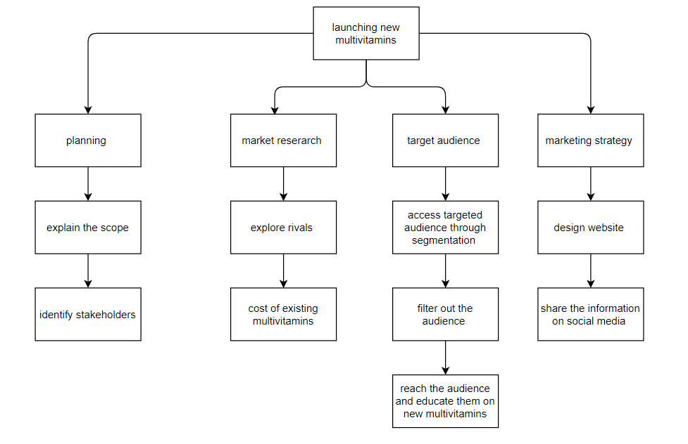

Resources
Resources are the type of supply which can be drawn on by an organization and person in order to execute and function projects and plans (Business Standard, 2022). It can be in the form of management, money, staff, expertise, material, energy, time and so many other resources. In this product launch, checklist will be maintained which will help to think through every steps, resource and processes. Following are the resources of this new launch;
- Time
- Money
- Executives
- Website for multivitamin
- Marketing planners
- Software and insights tool
- Distribution networks
- Employees
- Medical professionals
- Participants for trial phase
- Marketers
- perceived cost which is £ 822

Gantt chart
A Gantt chart, is mainly utilized in project management. It is considered one of the useful and popular ways of demonstrating events, activities and tasks beside time (Gantt, 2022). Below is the Gantt chart of the new launch of multivitamins. Activities and sub activities are listed on the left side of chart. Every activities and sub activities are denoted by bar. The length and position of the bar shows the start date, end date and duration of activities and sub activities.
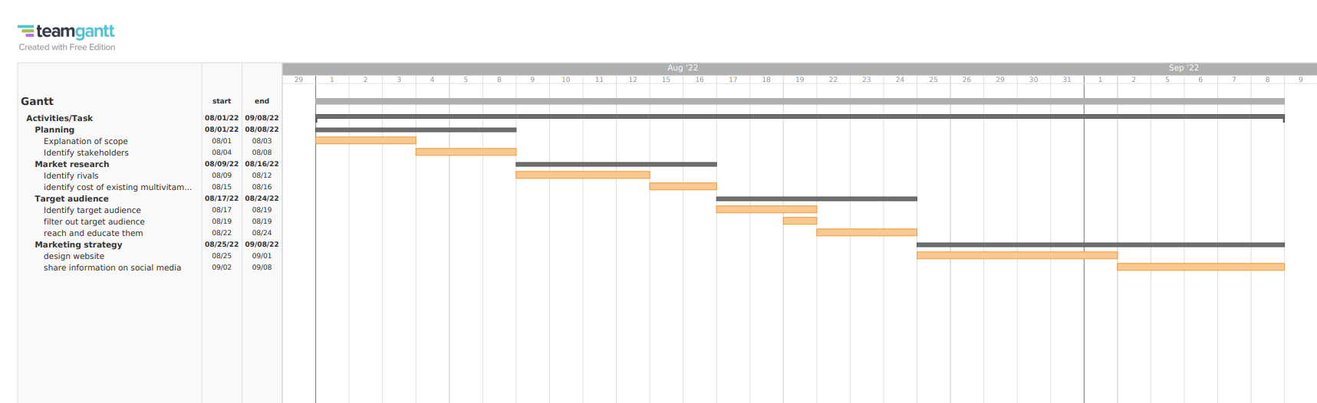

Risk Assessment

Risk identification
Risk identification refers to the process of list possible risks and their features (Bryce, et al., 2022). Pharmaceutical Company intending to launch new multivitamins can face so many risks in future. Economic fluctuation, competitors and customers can trouble the marketing plan. The only key is to evaluate the risk as best the company can and shape the strategies to tackle the issues most probably to confront new launch. The significant aspect of the risk for new multivitamins grounded on the marketing plan. If the strategy of Pharmaceutical Company is to sell a multivitamins for twice in the cost of existing and substitute multivitamins, then the probability of failure is high. The competitors will sell the product in low price and can drive down the profit and sales. Moreover. The strategy to sell the product at a low price can be a risk factor too for Pharmaceutical Company. The new multivitamins has so many competitors in market. The availability and quality of raw material can be considered as a risk factor in the launch of new medication. Another significant risk associated with the launch of product can be the uncertain disruption in the supply chain which can delay the production process and so the launch of the product. Besides this, supply chain is becoming very costly. These expenses come from many factors and also due to the insufficient accountability and visibility for lowering down the cost can result in increasing operational costs. It can make project run out of budget and make delay. Supply chain disruption include rising cost of fuel and increased cost from manufacturers and suppliers (Blume Global, 2022).
In addition to the identification of risks, following are the other risk factor:
- Political attitudes
- Approval timings
- Pricing
- Levels of need
- Affordability
- Unexpected adverse effect
- Differences between real-life new multivitamin usage and clinical-trial evidence
- Complication in the supply chain of the Pharmaceutical industry

Risk analysis
Risk | Importance  Impact | Likelihood  Probability
Political attitudes | H | L
Approval timings | L | L
Pricing | H | H
levels of need | H | L
Affordability | H | L
Unexpected adverse effect | H | L
Differences between real-life new multivitamin usage and clinical-trial evidence | H | H
Complication in the supply chain of the Pharmaceutical industry | H | H

Risk evaluation
Risk mitigation for the new launching multivitamins largely rely on planning which should be strategically comprehensive and financial workable. Overly optimistic budget calculation can result cost overrun. Uncertain changes can affect the project adversely (Kiss Flow, 2022). To mitigate the budget related risks, the company should research the market carefully and do not finalized the budget till the schedule and plan of product are done. In order to protect itself from the disruption of supply chain, pharmaceutical company should use domestic supply chain.
By purchasing their supplies from a variety of different suppliers, businesses may mitigate the risks associated with single sources as well as other supply-chain issues. Pharmaceutical company may choose to produce an input domestically again, nearshore the supply, or even offshore to new areas in order to improve their level of input security (Foster, et al., 2022). In order to foresee their vulnerabilities and unexpected adverse effects, assess the possible impact, and find ways to limit its impacts, businesses often employ simulation and scenario planning models.
To mitigate the risk of differences between real-life new multivitamin usage and clinical-trial evidence, Active surveillance plans can be made, which can include signal detection and signal confirmation. The process of recognizing a potential relationship between an outcome event and a potential causal agent is referred to as signal detection. The term "signal confirmation" refers to the examination or gathering of replicative instances that provides evidence that the report is accurate (Wright, et al., 2008). Individuals or organizations that are not likely to ignore or incorrectly disclose a relationship are included in the definition of independent (third) parties. Active surveillance plans are systems that are meant to detect cases. These plans often take the shape of specialist clinics or centers that deal with the targeted adverse events, big computerized datasets, and claims data from closed populations, or other sources.

Risk planning
As mentioned above plan, strategies, approaches and weekly meetings with stakeholder can save the product launch from every possible risk raised due to the uncertainty in the market. Controlling through the different stages should be done and checklist should be prepared. The checklist will ensure the progress is done according to the project. Besides weekly meeting, fluctuation in the national and international market should be noted carefully and step should be taken consequently.

References
280Group, 2022. What is a product launch plan?. [Online]
Available at: https://280group.com/what-is-product-management/documents-templates/product-launch-plan/
[Accessed 19 July 2022].
Blume Global, 2022. What are the main supply chain challenges?. [Online]
Available at: https://www.blumeglobal.com/learning/supply-chain-challenges/
[Accessed 19 July 2020].
Bruso, J., 2022. Can multi-vitamins prevent malnourishment?. [Online]
Available at: https://healthyeating.sfgate.com/can-multivitamins-prevent-malnourishment-11613.html
[Accessed 19 July 2022].
Bryce, S. et al., 2022. Risk identification: Definition, purpose & examples. [Online]
Available at: https://study.com/academy/lesson/risk-identification-definition-purpose-examples.html
[Accessed 19 July 2022].
Business Standard, 2022. What is resource. [Online]
Available at: https://www.business-standard.com/about/what-is-resource
[Accessed 19 July 2022].
Connectusfund, 2017. 7 Advantages and Disadvantages of Multivitamins. [Online]
Available at: https://connectusfund.org/7-advantages-and-disadvantages-of-multivitamins
[Accessed 19 July 2022].
Darzin, 2018. How to write engaging emails. [Online]
Available at: https://www.darzin.com/blog/write-engaging-emails/
[Accessed 19 July 2022].
Fellow, 2022. How to prepare and conduct a great stakeholder meeting. [Online]
Available at: https://fellow.app/blog/meetings/how-to-prepare-and-conduct-a-great-stakeholder-meeting/
[Accessed 19 July 2022].
Ford, J., Fezza, T. & Elsner, N., 2020. Key factors to improve drug launches. [Online]
Available at: https://www2.deloitte.com/us/en/insights/industry/life-sciences/successful-drug-launch-strategy.html
[Accessed 19 July 2022].
Foster, T., Patel, P. & Skiba, K., 2022. Four ways pharma companies can make their supply chains more resilient. [Online]
Available at: https://www.mckinsey.com/industries/life-sciences/our-insights/four-ways-pharma-companies-can-make-their-supply-chains-more-resilient
[Accessed 20 July 2022].
Gantt, 2022. What is a gantt chart?. [Online]
Available at: https://www.gantt.com/
[Accessed 19 July 2022].
Hhm Global, 2022. What is the process of launching a new drug?. [Online]
Available at: https://www.hhmglobal.com/knowledge-bank/news/what-is-the-process-of-launching-a-new-drug
[Accessed 19 July 2022].
Hoory, L. & Bottorff, C., 2021. What is a stakeholder analysis? everything you need to know. [Online]
Available at: https://www.forbes.com/advisor/business/what-is-stakeholder-analysis/
[Accessed 19 July 2022].
Kiss Flow, 2022. 5 major project management risks and how to mitigate them. [Online]
Available at: https://kissflow.com/project/project-risk-management/#:~:text=To%20mitigate%20against%20budget-related%20risks%2C%20do%20your%20research,until%20your%20project%20plan%20and%20schedule%20are%20complete.
[Accessed 19 July 2022].
Project Manager, 2022. Work breakdown structure (WBS). [Online]
Available at: https://www.projectmanager.com/guides/work-breakdown-structure
[Accessed 19 July 2022].
Stobierski, T., 2020. How to create a stakeholder engagement plan. [Online]
Available at: https://www.northeastern.edu/graduate/blog/stakeholder-engagement-plan/
[Accessed 19 July 2022].
Think Insights, 2022. Stakeholder analysis – interest – influence matrix. [Online]
Available at: https://thinkinsights.net/strategy/stakeholder-analysis/#:~:text=Stakeholder%20Interest-Influence%20Grid%20This%20is%20a%20useful%20map,indicates%20their%20ability%20resist%20your%20recommendation%20or%20change.
[Accessed 19 July 2022].
Wikihow, 2022. How to launch a pharmaceutical product. [Online]
Available at: https://www.wikihow.com/Launch-a-Pharmaceutical-Product
[Accessed 19 July 2022].
Wright, C., Schnoll, S. & Bernstein, D. .., 2008. Risk evaluation and mitigation strategies for drugs with abuse liability: Public interest, special interest, conflicts of interest, and the industry perspective. Annals of the New York Academy of Sciences, 1141(1), pp. 284-303..

