

STUDENT NAME: Rotimi Ogbe
STUDENT NUMBER: 2313492
PROGRAMME: BA Leadership and Management Skills for the Workplace
MODULE TITLE: Independent Project
MODULE CODE: LCLM6005
ASSIGNMENT: Research Process Reflection (Reflective Essay)
LECTURER: Dian Mayasari

INTRODUCTION
Reflective writing involves analysing experiences, thoughts and learning to make judgements about what you are good at, where you need to improve and how you can improve in the future.
REFLECTION ON MY RESEARCH (GIBBS' REFLECTIVE CYCLE)
Description:
Researching my topic “Identifying the Effective Strategies in Addressing the Impact of Cyber-Attack on Employee Performance: Based on Reports from the Automobile Industry in the UK” allowed me to develop my academic knowledge and research skills. Gibbs’ Reflective Cycle (1988) advocates dividing reflection into six pieces for better analysis: description, feelings, evaluation, analysis, conclusion, and action plan.
Feelings:
I chose to do a Systematic Literature Review (SLR) that analysed publications based on the impact on productivity, communication, and resilience of employees working in the automobile industry in the UK. Methods included using systematic searches from the UWTSD Library and Google Scholar, critically evaluating peer-reviewed journals, books, and official reports to establish theories and find evidence to answer the research questions (Snyder, 2019).
Evaluation:
At first, I did not feel confident researching due to the topic of cybersecurity being multi-disciplinary, covering areas of IT, leadership, organisational behaviour, and HR, managing employees and non-IT-related problems. However, as I became accustomed to searching, critically evaluating, and synthesising the evidence, I gained confidence throughout the literature review (Okoli, 2015).
Analysis:
In evaluating my research, I believe that choosing to do an SLR was a strength of my research. Systematic literature reviews give clear methodologies for searching and identifying evidence. I was able to compare different points of view and find recurring themes and gaps in the literature. For example, most literature covers technical recovery and not topics such as employee well-being and leadership after cyber-attacks. I feel Cyber resilience needs both technical and people-focused recovery efforts (Whitman and Mattord, 2022).
Conclusion:
By critically analysing my experience, I feel my weakness was not enough study concentrated on employees’ performance in the automobile industry in the UK. Literature concentrates on cyber-attack effects on financial services or healthcare organisations, which makes it difficult to generalise some articles on Manufacturing. I have learned it is essential to critique whether literature is useful, not the amount of literature (Radanliev et al., 2020).
Action plan:
Overall, I feel I have developed my ability to conduct independent research at a university level, critically analyse academic literature, and apply theory to organisational problems. I feel my academic writing skills, UWTSD Harvard referencing, and ability to synthesise cross-disciplinary evidence into cohesive arguments have improved (Neville, 2022).
CONCLUSION
In conclusion, I hope to develop my methodological knowledge by applying SLRs with primary research in the future. Conducting interviews and questionnaires to collect primary data from employees and managers in the automobile industry in the UK will be beneficial. I hope to discover how leadership, communication, and organisational culture can affect employee performance during cyber recovery. Researching my essay has allowed me to gain confidence in my ability to complete independent research in the future.
Figure 1: Research Reflection using Gibbs’ Reflective Cycle.
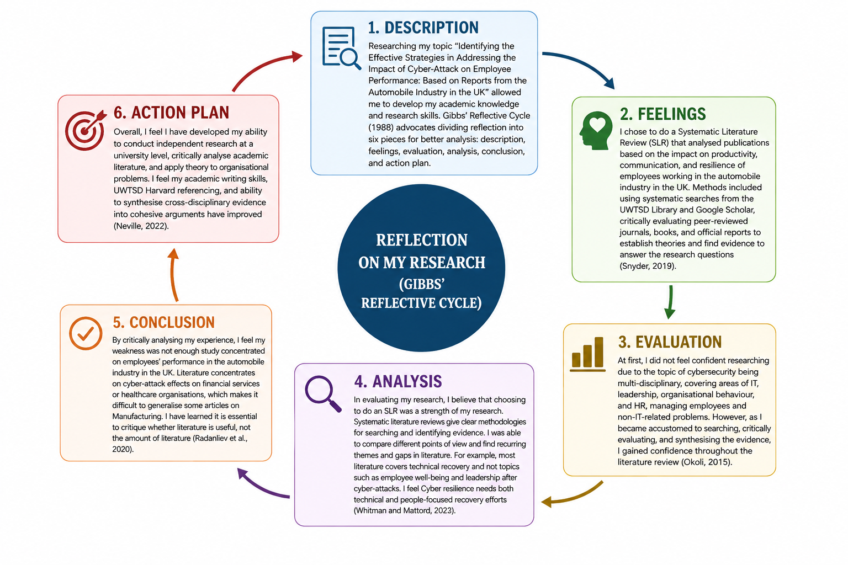
REFERENCES
Gibbs, G. (1988) Learning by Doing: A Guide to Teaching and Learning Methods. Oxford: Oxford Polytechnic.
Neville, C. (2022) The Complete Guide to Referencing and Avoiding Plagiarism. 5th edn. Maidenhead: Open University Press.
Okoli, C. (2015) ‘A guide to conducting a standalone systematic literature review’, Communications of the Association for Information Systems, 37(1), pp. 879–910.
Radanliev, P., De Roure, D., Cannady, S. and Montalvo, R.M. (2020) ‘Cyber risk at the edge: Current and future trends in cyber risk analytics’, Future Internet, 12(10), pp. 1–18.
Snyder, H. (2019) ‘Literature review as a research methodology: An overview and guidelines’, Journal of Business Research, 104, pp. 333–339.
Whitman, M.E. and Mattord, H.J. (2022) Principles of Information Security. 7th edn. Boston, MA: Cengage Learning.

