Gabriel Lacatusu Id number:2322893
Rexton Nting
Harnessing Social and Digital Media for Costumer Growth

Introduction
Social media platforms have completely changed how businesses interact with their audience in the digital age. Through the utilization of social media platforms such as Facebook, Twitter, and Instagram, businesses may successfully expand their customer base beyond conventional bounds. With the help of these technologies, you may interact with a wide range of people, build brand awareness, and encourage worldwide customer interaction.
The aim of this report is to explain how social medica can be used to promote businesses and reach a wider customer base.

How can social media help small businesses?
Digital media supports local small businesses' marketing efforts, both online and in physical places. With the help of digital media and marketing strategies, smaller companies may truly maintain a high ranking.
Who is to say whether the sophisticated website with thought-provoking images and engaging text is the result of a multimillion-dollar corporation or a three-person operation?
It may be two blocks or two thousand miles away from you. As a small business owner, you might not want it, yet digital media marketing opens up a global client base for you to grab.
Engagement is the key to using social media effectively, as we have discussed. The proprietor of a small business now has an advantage over the larger competitors. A firm cannot succeed if it does not actively interact with its customers.
The use of digital media platforms to promote a brand helps receive feedback from customers. And, when managed correctly using preset digital metrics, using digital media to promote your business can be an effective and cost-efficient form of online advertising. 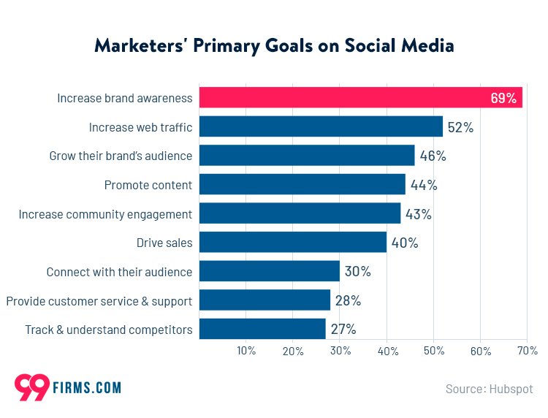
A business’s social media says a lot about the company. Not only does it provide visualization of the products or services being sold, but it also shows the inner workings and people of a company. The colors and pictures used also create a theme that makes the brand more recognizable, leading to a more memorable campaign.
Digital marketing for business
Because more consumers turn to technology for their shopping needs, as a business, you need to use digital marketing to reach those customers. In order to thrive, businesses must have a digital presence, whether that be on a website, using social media platforms, SEO, or, ideally, a combination of these.
Using digital marketing, you can reach a larger audience in a way that is both measurable and cost-effective. Analytics-driven digital media provides the opportunity to reach more consumers for less money than traditional marketing methods while getting to know your customer base, thus increasing brand loyalty.
Most businesses that effectively use digital marketing and digital marketing services increase sales and revenue, which is ultimately what business is all about. Isn’t it?
With digital media, you can hone your marketing and target your best consumer. By employing cookies and online tracking tools, we can help you better understand what your customer wants and get them to begin positively engaging with your brand. To put it simply, digital media will boost your current marketing campaign.
Cost Effective Marketing
Cost-effective marketing isn't just about spending less; it's about spending smarter. By leveraging the power of digital platforms, focusing on long-term strategies like content marketing and SEO, and getting creative with your tactics, businesses can achieve substantial growth without a substantial budget.
Benefits of cost-effective marketing
• increases Business Sustainability.
• Increases Profit Margin.
• Reduces Competition.
Building a Community
Community building is a vital strategy for businesses and content creators looking to expand their audience and drive growth. By fostering authentic relationships with community members, businesses can build engagement, loyalty, and a sense of belonging among their customers.
The power of a community in business
Community engagement allows businesses to connect with their customers on a deeper level. Customers are more likely to support and remain loyal to businesses that share their values and actively contribute to the betterment of the community.

Targeted Advertising
Targeted advertising can play an important role in building brand awareness and shaping the perception of a business in the minds of consumers. Targeted ads help create positive associations, reinforce brand values, and differentiate businesses from their competitors.
Here are some benefits of Targeted Advertising:
- Deliver a higher level of personalization.
- Establish brand awareness and increase brand perception.
- Streamline marketing efforts and keep resources focused on growth.
- Increase brand marketing ROI on marketing spend.
Influencer Partnership
Overall, improved credibility and trust are important benefits of influencer partnerships that can help to strengthen your brand's reputation, build trust among potential customers, and position your brand as a reputable and authoritative source in your industry.
How does it work?
The brand reviews and approves it and then the influencer posts the content on their platforms. Once the collaboration is done, the influencer gets paid according to the agreed terms. Sometimes, the influencer might agree to work with the brand for a certain amount of time rather than a one-off project.

Advantages of using social media
- Build brand awareness.
- Grow your audience.
- Create a solid brand image.
- Create efficient marketing campaigns.
- Market to the right people at the right time.
- Promote key products and services.
- Harness the power of online ads.
- Experiment with your content.
disadvantages of social and digital media for small business
- Times consuming.
- Negative feedback.
- Misinformation
- Competition.
- Qualified staff needed
- Privacy concerns

Conclusion
In conclusion social media is a very good way to promote and Increase brand recognition by building a strong social media presence through frequent posting and interaction. Furthermore, social media platforms may be an effective tool to improve customer service and increasing customer loyalty when used to communicate with customers and gather feedback.

Social media has provided a platform where businesses of any size can network and communicate with customers on a more personal level. Instead of simply trying to sell their products or services, the company can create relationships and get customers more accustomed to the brand.
Reference:
2024 Hiscox Ldt.
https://www.hiscox.co.uk/business-blog/benefits-of-social-media-for-business
Digital Logic 2024
https://www.digitallogic.co/blog/what-is-digital-media/
2012-2024 Bright Age
https://brightage.com/2022/01/18/social-media-affecting-business-communication/

