

CROSS-CULTURAL MARKETING STRATEGY FOR INTERNATIONAL MARKET ENTRY: A STUDY OF THE UK RETAIL MARKET

Student Name: Prit Jenishbhai Jariwala
Student ID: 2503896
Supervisor name: Dr. Ghulam Mujtaba
Head professor: Hoang Nguyen
Course name: Mba – international business
Course title – dissertation
Research title: cross cultural strategy for international market entry: a study of Uk retail market
Word Count: 14747
Date of submission: 25/09/2026

Declaration

Master’s Degrees by Examination and Dissertation
Declaration Form.
I, Prit Jariwala, declare that this dissertation has been composed by myself, that the work contained herein is entirely my own except where explicitly stated otherwise in the text, and that this work has not been submitted for any other degree or qualification, in whole or in part, except as specified.
Signature: Jariwala Prit Jenishbhai
Date:
24/09/2026

AI Use Acknowledgement
I confirm that no generative artificial intelligence (AI) tools were used to generate, write, analyse, or substantially modify the content of this dissertation. The research, analysis, interpretation, and writing presented in this dissertation were completed independently by the researcher using the sources cited in the reference list.

Acknowledgements
I would also like to mention that my dissertation supervisor has been of great help to me, with all the guidance, constructive feedbacks and academic support that was given to me during this research. I also owe my academic staff of the university the credit of shaping my knowledge and research skills in the programme. I would like to thank my family members and friends who remained supportive, patient and tolerant as I achieved this dissertation. Their assistance was a source of encouragement at tough moments in the research process. Lastly, I would like to recognise all those who helped either directly or indirectly with the successful achievement of this dissertation and my academic career.
Abstract
The dissertation evaluates the effects of cross-cultural marketing strategies on the effective introduction of foreign retailers into the UK market, which is increasingly discussed in the context of the post-Brexit retail. The researchers target five global retailers IKEA (Sweden), Aldi and Lidl (Germany), Uniqlo (Japan) and Costco (United States) based on their cultural, sectoral, and strategic variability in the UK market. With an interpretivist philosophy and inductive research design, the study is based on a qualitative, exploratory design in which both secondary data through peer-reviewed journals, industry reports, corporate publications, and institutional sources published between 2020 and 2026 are used. Thematic analysis Braun and Clarke six-step framework was used to analyse data. The theoretical concepts are Hofstede Cultural Dimensions Theory, and the Uppsala Internationalisation Model.
The results demonstrate that the influences of culture (especially individualism), ethical consumption, and ethnocentrism post-Brexit are dynamic forecasts of consumer behaviour among the UK consumers, not moderators. Strategies of hybrid glocalisation processes always succeed over pure standardisation strategies or total adaptation strategies whereas brand culture mediates a consumer acceptance and national culture. Cross-cultural challenges are seen as an ongoing and a cyclic process as opposed to a single-time goal. The four hypotheses are all accepted subject to some contextual adjustments. The research adds to theory extending both frameworks to the modern situation in the UK and also providing practical advice of international retailers such as cultural authenticity, gradual market entry, data-driven personalisation and culturally sensitive segmentation. Future research limitations and directions are noted.

Table of Contents
Declaration 2
AI Use Acknowledgement 3
Acknowledgements 4
Chapter 1: Introduction 10
1.1 Background and Context of the Study 10
1.2 Problem Statement 11
1.3 Scope of the Study 11
1.4 Research Aim 12
1.5 Research Objectives 12
1.6 Research Questions 12
1.7 Significance of the Study 13
1.8 Theoretical Framework 13
1.9 Structure of the Dissertation 15
Chapter 2: Literature Review 16
2.1 Cultural Factors in Consumer Behaviour 16
2.2 Consumer Purchasing Behaviour 17
2.3 Cross-Cultural Marketing Strategies (Standardisation vs Adaptation) 19
2.4 Market Entry Success 21
2.5 Theoretical Frameworks 24
2.5.1 Hofstede's Cultural Dimensions Theory 24
2.5.2 Uppsala Internationalisation Model 26
2.6 Conceptual Framework 27
2.7 Research Gap 27
2.8 Summary 28
Chapter 3: Research Methodology 30
3.1 Introduction 30
3.2 Research Philosophy 31
3.3 Research Approach 31
3.4 Research Design 31
3.5 Rationale for Secondary Qualitative Method 32
3.6 Data Sources 32
3.7 Case Study Selection 33
3.8 Data Collection Techniques 33
3.9 Analytical Approach (Thematic Analysis) 33
3.10 Ethical Considerations 34
3.11 Research Limitations 34
3.12 Summary 34
Chapter 4: Findings and Discussion 36
4.1 Introduction 36
4.2 Key Findings 37
4.2.1 Theme Generation and Understanding 37
4.2.2 Cultural Factors Influencing Consumer Behaviour in the UK Retail Market 38
4.2.3 Cross-Cultural Marketing Strategies Adopted by International Retailers Entering the UK 40
4.2.4 Effectiveness of Standardised versus Adapted Marketing Strategies in the UK Retail Sector 41
4.2.5 Challenges Faced by International Retailers Implementing Cross-Cultural Marketing Strategies 42
4.2.6 Recommendations for Effective Cross-Cultural Marketing Practices for UK Market Entry 43
4.3 Data Analysis 44
4.3.1 Cultural Factors Influencing Consumer Behaviour in the UK Retail Market: Discussion of Hypothesis 1 44
4.3.2 Cross-Cultural Marketing Strategies Adopted by International Retailers Entering the UK: Discussion of Hypothesis 2 46
4.3.3 Effectiveness of Standardised versus Adapted Marketing Strategies in the UK Retail Sector: Discussion of Hypothesis 3 48
4.3.4 Challenges Faced by International Retailers Implementing Cross-Cultural Marketing Strategies: Discussion of Hypothesis 4 50
4.3.5 Integration of Theoretical Frameworks and Summary of Hypothesis Testing 52
4.4 Summary 53
Chapter 5: Conclusion 55
5.1 Introduction 55
5.2 Revisiting the Research Aim and Questions 55
5.3 Summary of Key Findings 56
5.4 Addressing the Research Questions and Hypotheses 57
5.5 Addressing the Research Gap 57
5.6 Contributions to Theory and Practice 58
5.7 Limitations of the Study 58
5.8 Recommendations 59
5.9 Closing Reflection 59
Reference List 61

Table of Figures
Figure 1: Retail Sales in UK 7
Figure 2: Hofstede Insights in the UK 11
Figure 3: Hofstede's Cultural Dimensions Theory 21
Figure 4: Uppsala Internationalisation Model 23
Figure 5: Conceptual Framework 24
Figure 6: Research Onion 27
Figure 7: Factors influencing consumer behavior 35
Figure 8: Cross Cultural Brand Adaptation 37
Figure 9: Challenges in International Marketing 39

Chapter 1: Introduction

1.1 Background and Context of the Study
UK retail is one of the most evolving and competitive parts of the global economy. In 2024-25 retail sales in the UK reached a value of £517 billion, reflecting a very wide range of retail products and a large proportion of internet users that continue to influence their buying habits both online and in-store (Coface, 2025). The large market size and the cultural diversity of the British people have led to the United Kingdom becoming an interesting and lucrative place for overseas retailers to market their products beyond the domestic market. IKEA, Aldi, Lidl, Uniqlo, and Costco are a few international firms with a significant presence in the UK, all coping with the complexities of a market with cultural needs alongside high levels of operational efficiency (Everill, 2025).
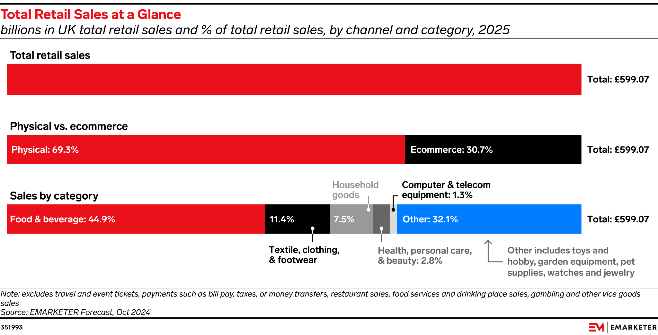

Figure 1: Retail Sales in UK
(Source: Perkins, 2025)
But the UK retail scene has experienced a backlash in recent years. With Brexit having taken place, new rules and regulations, changed trade relations and a new consumer mindset have come to an end. At the same time, British shoppers are more conscious about sustainability, fair sourcing practices, digital ease-of-use, and indeed personalised shopping experiences(Retail Economics, 2026). Such changing tastes make it almost impossible for any international store to simply rely on its international brand value, and have to become involved in the cultural distinctions that can drive the choice and actions of consumers in Britain. The context of globalisation, cultural diversity and the complexity of the market makes the UK retail industry a fascinating area to explore in the light of cross-cultural marketing strategies in influencing the success or failure of international market entry (Ng et al., 2025).

1.2 Problem Statement
Although increasing amounts of foreign direct investment (FDI) are being injected into the UK retail industry, a surprising number of overseas companies are finding it difficult to agree with British consumers about their marketing strategies. Some retailers have prospered because they have been able to tweak their approach to suit local ideals while others have not found success because of culturally resonant messaging, product mis-selection or defence of a script of globalisation. This is made more difficult by the post-Brexit regulatory landscape, which has added to the national barriers to market access and has increased consumers' sensitivity to national identity and sovereignty (Hasan et al., 2024). Although there has been much written on International Marketing and Market Entry in literature there is a significant lack of more up to date research that critically investigates which type of cross-cultural marketing strategy is successful in the contemporary UK retail environment. This is especially relevant as the cultural, economic and political context in the UK has changed considerably since 2020, in turn making many of the findings from that period less relevant to current times. Therefore, there is a growing need to examine this topic—how cross-cultural marketing strategy and market entry success are related in the current retail market in Britain.

1.3 Scope of the Study
This study concentrates on the UK retail market and deals with selected international retailers that are active in the UK. The research uses secondary qualitative data that were published from 2025 to 2026, explores the nature of cross-cultural marketing and its impact on consumer behaviour and entry into the market. The retailers chosen for analysis are from different cultural backgrounds, each is a different type of retailer, and comes with a background of differing strategies for entering the UK market and working in its culture. The findings are supposed to help international retailers decide to move towards the UK retail market and are recommended to guide them in deciding what to do in the future.The findings are supposed to provide guidance for future international retailers wishing to be in the UK retail space (Fu, 2024). The focus of the study does not include primary data collection (survey) or interviews and retailers outside the United Kingdom are not covered.

1.4 Research Aim
The aim of the research is to examine how cross-cultural marketing strategies influence the successful entry of international retailers into the UK market.

1.5 Research Objectives
- To identify the cultural factors that influence consumer behaviour in the UK retail market.
- To examine the cross-cultural marketing strategies adopted by international retailers entering the UK.
- To evaluate the effectiveness of standardized and adapted marketing strategies in the UK retail sector.
- To identify the challenges faced by international retailers in implementing cross-cultural marketing strategies.
- To recommend effective cross-cultural marketing practices for successful market entry into the UK retail market.

1.6 Research Questions
- What cultural factors influence consumer purchasing behaviour in the UK retail market?
- Which cross-cultural marketing strategies are commonly used by international retailers entering the UK?
- How effective are standardized versus adapted marketing strategies in the UK retail market?
- What challenges do international retailers face when implementing cross-cultural marketing strategies?
- What recommendations can improve international market entry success in the UK retail sector?

1.7 Significance of the Study
This research is of academic and practical importance. Academically, it adds to the current body of work on cross-cultural marketing as it is a contemporary analysis in the context of the post-Brexit UK retail context, which is an under-researched topic in the area of international business scholarship. The study connects the theory of marketing with real-life situations of international companies running their business in the UK market through case studies of international retailers in the UK (Xu, 2025). The study is also an extension of the applicability of existing theories, like Hofstede's Cultural Dimensions and Uppsala Internationalisation Model, in a contemporary retail environment, which makes a contribution to the theoretical discourse on cultural adaptation and market entry.
In practical terms, the results of the study will help international retail managers, marketing strategists and business consultants plan or implement a UK market entry. The study offers practical learnings on the most effective cross-cultural methods, cultural sensitivities that must be taken into account, and the challenge retailers must face in harmonising global branding with a local responsive approach (Mmadubuko et al., 2025). For the policy makers and trade bodies, the research emphasizes the cultural and strategic aspects affecting foreign retailers' performance and this could be used as inputs for the design of trade facilitation and retail development policies. In conclusion, this research is a strategic tool for firms aiming at successfully crossing the cultural challenges of the UK retail sector (Ramazanov et al., 2021).

1.8 Theoretical Framework
The theoretical bases of this research will be based on two previously existing frameworks, which will combine into a broader perspective for understanding cross-cultural marketing and international market entry. There are two theories that will be introduced to provide the context for discussing the dimensions of national culture; the first is Hofstede's Cultural Dimensions Theory which presents six dimensions: power distance, individualism/collectivism, masculinity/femininity, uncertainty avoidance, long-term orientation, and indulgence (Sağlam and Abdullahi, 2021).
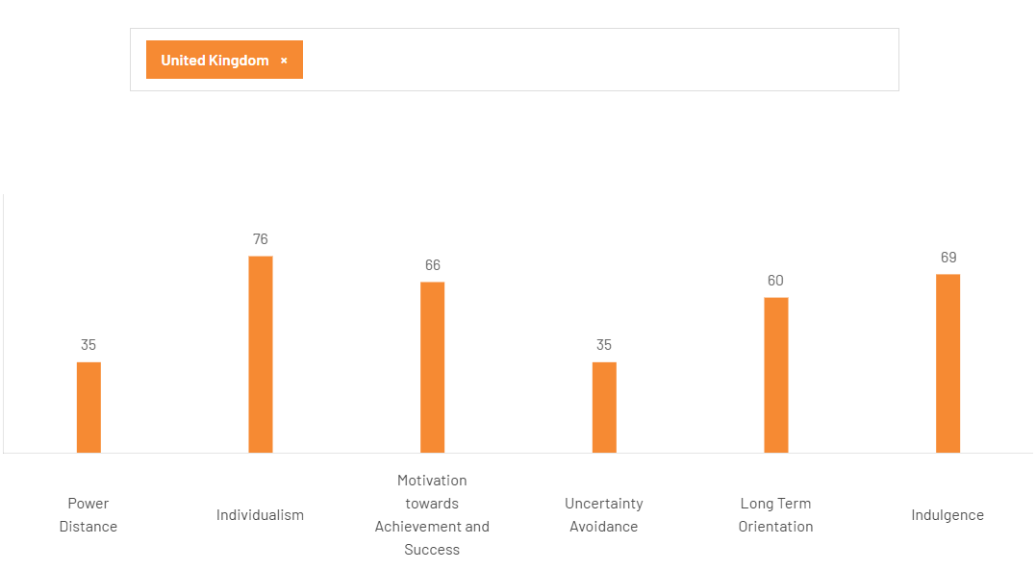

Figure 2: Hofstede Insights in the UK
(Source: The Culture Factor, 2025)
The United Kingdom ranks significantly high in terms of individualism (76), masculinity (66) and indulgence (68), consistently highlighting that the United Kingdom is an individualistic and achievement oriented country with a high preference for gratification (The Culture Factor 2025). These cultural characteristics have a definite effect on the way in which foreign retailers should position their brands, craft their communication messages and adjust their product line to fit British shoppers. While the model has been criticized for its assumption on the homogeneous nature of the cultures within the country (Ocak, 2025), it is still a widely used model that helps to understand general leaning characteristics towards consumer behavior.
The second theoretical approach follows the Uppsala Internationalisation Model where firms internationalise gradually by making contact with markets they are culturally close to and then gradually expanding into further markets as they gain market knowledge and market experience (Schweizer and Vahlne, 2021). The emphasis is not only on experiential learning for reducing uncertainty but also for informational input to strategic decisions around the commitments needed in respect of resources commitment. In terms of the UK retail market, the Uppsala Model accounts for the tendency of many international retailers to test overseas markets, for instance through online sales or limited stores before making a significant development decision for their incoming retail expansion (Brouthers et al., 2022). The two frameworks offer a cultural and strategic viewpoint on analyzing the approach of international entrepreneurs to the UK market and how their marketing strategies react in response to cultural learning and feedback from the market.

1.9 Structure of the Dissertation
This dissertation is organised into six chapters. The background, problem statement, research aim, objectives, research questions and the theoretical framework as guide of the study introduced by the present chapter. The review of the literature is provided in Chapter Two, which offers a critical perspective on the literature related to cross-cultural marketing and culture as a determinant of consumer behaviour, on the international entry strategies, and on the theoretical models relevant to this research. The research methodology is explained in chapter three, which presents the interpretationist approach and methodology of conducting the qualitative research focusing especially on the secondary research source, selection of cases and thematic analysis technique used for the present study. Chapter Four establishes data analysis and discusses the findings that came by using the second data sources systematically and shows the findings from the research questions. The results of the study are given in detail in chapter five which is thereafter explained according to the theoretical frameworks and existing literature and the research gap identified. Finally, Chapter Six summarizes the major findings, provides the contributions to theory and practice, notes limitations with the dissertation, and proposes avenues for further research and management practices.

Chapter 2: Literature Review

2.1 Cultural Factors in Consumer Behaviour
Cultural factors are the values, beliefs, norms, customs and traditions shared by people in a particular society which influence their decision making and behaviour. From the consumer behaviour point of view, cultural factors refer to language, religion, social status, ethnic group, life orientation to lifestyle, and generational factors which give shape to consumer perception towards product, consumer's evaluation of a brand, and consumer's purchase decisions (Brosekhan, Velayutham and Phil, 2024).
In their quantitative study of 584 online shoppers, Peña-García et al (2020) examines how culture affects online consumers' purchase intent and behavior comparing Colombia and Spain. Based on structural equation modelling and multi group analysis, the authors show that self-efficacy in online shops is an universal predictor of ecommerce-adoption across cultures but that national culture and underlying factors moderate several relationships in the proposed model. This study is also significant because it shows large differences between the emerging economies and the developed economies, but the focus on the context of the Latin European market does not necessarily mean that it can be directly transferred to the UK retail market.
However, Rehman and colleagues (2024) analyzed the role of cultural practices in consumers' purchasing behavior of fashion clothing during the COVID-19 Pandemic in Pakistan based on the Black-Box Model and methodology was surveyed with 600 respondents who were studied with PLS-SEM. Results showed a positive and significant correlation between cultural practices, Sales promotional activities, and buying behaviour, and uncovered ‘Ethnocentrism and xenocentrism were important factors in cultural influence. Internet decision-making mechanisms have not been enough explored in the context of culture; and while Peña-García et al. (2020) call attention to the moderating effect that culture has on decision-making, Rehman et al. (2024) take the discussion forward by showing that culture is not only a moderator but also a strong predictor of consumption, especially in times of environmental disruptions.
With a focus on modern-day consumption for sustainability, Kien et al. (2026) discussed the influences of socioeconomic and behavioural factors on secondhand fashion consumption among young people in Hanoi and combined the TPB with perceived economic value, environmental concern and shopping experience. The results of this study suggested that contrary to the prior studies, perceived risk did not contribute to the sustainable purchase intention and the best possible results were obtained for subjective norms and perceived economic benefit, which were analysed through PLS-SEM. In contrast to the more traditional notions of consumer motivations espoused by Peña-García et al. (2020) and Rehman et al. (2024), Kien et al. (2026) include a socio-environmental component which is relevant to the cultural values of younger generations.
Hypothesis 1: Cultural factors have a significant influence on consumer purchasing behaviour in the UK retail market.
The three empirical studies reviewed under consumer behaviour S have given Hypothesis 1. Operating between Colombian and Spanish online shoppers, Peña-Garcia et al. (2020) made it clear that culture modulates the pathways of purchase intention, suggesting culture acts on behaviour, but it does not lie next to it. Rehman et al. (2024) went even further by taking cultural practices, ethnocentrism and xenocentrism not as predisposing factors, but as the direct predictors of fashion purchasing in Pakistan. This was followed by a study by Kien et al. (2026) with findings that subjective norms and perceived economic gain were the dominant decisions among young second hand shoppers in Hanoi which was conditional upon cultural values and connected with generational consumption behaviors. Collectively read, and with the definitional backdrop presented by Brosekhan, Velayutham and Phil (2024), these data support the need to directly test how culture plays out in the British retail buying process.

2.2 Consumer Purchasing Behaviour
Consumer purchasing behaviour is the set of cognitive, emotional and behavioural reactions that people undergo while going through the process of locating, analysing and buying products and services to meet their needs and desires. It includes what decisions consumers make before, during and after buying – need recognition, information search, evaluation of alternatives, purchase decision, and post-purchase evaluation (Li and Deng, 2026).
Wang (2024) examined cross-cultural markets in consumer purchasing behaviour using a cross-cultural case about the purchase of intelligent board writing software, pointing out that the cultures of the markets have differences in market demand and consumption behaviour, therefore, cross-cultural strategies for the market must be designed. The study highlighted three key levers to play a role in driving consumer responses: language localisation, cultural adaptation and differentiated positioning of brands. The paper is strategic in nature, but lacks rigor in the analysis and theory presented—the claims are more conceptual than empirical, even though it should be empirically tested.
Unlike Yang et al. (2026), however, the investigation of the effect of cultural distance on purchase intention in cross-border live-streaming commerce relied on a rigorous, empirical model. After conducting structural equation modelling and multiple regression analyses, the authors tested their hypotheses and showed that cultural distance has a mediating effect on purchase intention by cultural novelty, and cultural identity positively moderates these relations. While Wang (2024) considers the process of adaptation to be the key to cross-culturalism marketing, Yang et al. (2026) redefine the behavior by convincing the readers that culture difference can be a source of consumer attraction instead of resistance, as long as novelty is the one that is within the cultural identity of the consumer. The key in this distinction, however, is the concept that it may not always be better to be exotic than to be different, as one strategy that can improve consumer interaction is a well-tuned display of ‘cultural difference'.
Based on this comparative perspective, Wang et al. (2026) performed a cross-cultural study of Chinese (n = 396) and American (n = 408) consumers, using multi-group confirmatory factor analysis and structural equation modelling procedures. The results of the study revealed that while hedonic value was positively related to impulse buying in both markets, utilitarian value was negatively related to impulse buying in the United States market but not in the Chinese market. The relationship between the atmospheric cues to hedonic values was reinforced by collectivist cultural orientations in China, and long-term orientation in the U.S. The results partly support Yang et al. (2026), who established that cultural orientation affects consumer responses, but do not support Wang (2024) by indicating that both the structural aspect of the buying process and the emotional route are consistent across cultures despite the cultural values influencing both the process and emotions.
Judged as a whole these three studies provide an important conflict in the literature. Wang (2024) believes it is best to adhere to comprehensive adaptation principles, Yang et al. (2026) point out that there is a strategic potential of cultural novelty, and Wang et al. (2026) illustrate culturally universal and culturally-conditioned purchasing mechanisms. If this is the case, as is the case for international retailers entering into the UK, consumer purchasing behaviour is not a consequence of cultural influence but rather an active site of negotiation between the "global" brand identity and the "local" cultural expectations which determine whether or not cross-cultural marketing strategies will be accepted or rejected by British consumers.
Hypothesis 2: Consumer purchasing behaviour significantly influences the acceptance of cross-cultural marketing strategies by international retailers in the UK.
Hypothesis 2 is a byproduct of the conflict between the three studies that fall under consumer purchasing behaviour topic. According to Wang (2024), using a cross-cultural case example of writing software based on the intelligent board as the cross-cultural, the localisation of language and cultural adjustment and positioning differing determined the response of the consumer, although these assertions remained hypothetical. The opposite intuition was empirically tested by Yang et al. (2026) who found a positive effect of cultural distance on purchase intention mediated by cultural novelty when cultural identity mediates the relationship between cultural difference and cultural identity; therefore, difference enhances purchase intention. Wang et al. (2026) made comparisons between 396 Chinese and 408 American consumers and discovered that hedonic value was the force behind impulse buying in the two markets and utilitarian value was nevertheless heterogenous across markets. These conflicting outcomes make cross-cultural strategies be approved or disapproved by consumer behaviour since liability and Deng (2026) define purchasing as a phased process.

2.3 Cross-Cultural Marketing Strategies (Standardisation vs Adaptation)
Cross cultural marketing strategies are the ones by which businesses call out, plan and enforce their value propositions to the various cultural markets. In general, these strategies lie on a spectrum from standardisation, meaning that the standard marketing mix is used in all markets in order to have scale and consistency, to adaptation, meaning that the marketing mix is adjusted in order to fit consumer habits, values and customs in the different cultures (Sahem, 2023). More and more, companies use hybrid approaches or 'glocalisation' in complex markets like the United Kingdom, where cultural diversity is not lost for the strong brand name awareness of the companies.
Kanumuri (2025) employed a mixed methods research design, which involved case studies of global companies, entrepreneurs survey analysis targeting consumers, and expert interviews, to research the importance of cross-cultural marketing in a successful brand in multiple consumer markets. The study identified that cultural sensitivity, localized content and co-creation with local influencers are major factors that reinforce a positive perception of the brand and localization lead to a sense of trust. sites under conflicting issues found that translation mistakes and cultural misinterpretation are always an issue. The study is of good utility but the key success factor appears to be the nature of adaptation as opposed to the operational efficiencies that standards could provide for cost-sensitive retailers like the discount stores Aldi and Lidl.
While Bhavini et al. (2025) followed the traditional concept of cross-cultural marketing, focusing on language/content translation, Masirci Scantara and Ferretti (2018) have approached the subject in a wider conceptual framework that also covers product adaptation, message adaptation, and branding adaptation, based on local values and customs. Discussing examples, the authors highlighted (as key to success in the international markets) cultural sensitivity, a well-informed local market research, and strategic flexibility. Bhavini et al. (2025) echo Kanumuri's (2025) call and appeal for adaptation, but the study is not as empirical, insofar as it provides principles of how to adapt rather than tested causal relationships. This restricts its explanatory capability, but enhances its value in a managerial decision making framework in situations of risk and uncertainty in the culture.
Sun (2024) presented a theoretical approach by examining cultural adaptability from the perspective of cultural dimensions and its impact on consumer behavior. The research reinforced the thesis that market segmentation, product and brand localisation and cultural-congruent communication campaigns are keys on the way to market penetration in globalised environments. Whereas, Kanumuri (2025) and Bhavini et al. (2025) are emphasising on tactical and strategic aspects respectively which directly relates to the theoretical constructs of adaptation, Sun (2024) has cubed with more rigorous academic discussion on why adaptation works when it works based on theoretical constructs such as Hofstede's dimensions etc.
Thus, an important moderated comparison of the three studies reveals that there was a shared understanding that adapting in general is more successful than standardisation, and especially better in culturally distant markets. All three are silent on the pitfalls that could occur when adaptation makes operations more complex and/or impacts on brand consistency; which can be especially relevant in the UK retail sector where the consumers expect authenticity and affordability.
Hypothesis 3: The adoption of cross-cultural marketing strategies (particularly adaptation) has a significant influence on the market entry success of international retailers in the UK.
Hypothesis 3 is based on the three studies examined on cross-cultural marketing strategies all of which culminate at adaptation. Combining case studies of international brands, surveys with consumers, and interviews with experts, Kanumuri (2025) found that the following factors promoted brand trust: cultural sensitivity, localised content, and co-creation with local influencers, and translation errors, in turn, undermined it uniformly. Bhavini et al. (2025) shifted that prism away and with language, to product, message and branding adaptation based on local values, presented managerial propositions, not tested causal relations. Sun (2024) provided the theoretical rationale, as to why they do work at all and why segmentation, localisation and culturally congruent campaigns are effective at particular cultural dimensions. The common finding in all three in terms of the standardisation-adaptation continuum as proposed by Sahem (2023) along with their silence on the issue of operational complexities, confirms testing adaptation as an important determinant of market success through market entry.

2.4 Market Entry Success
Market entry success (MES) is defined as the ability of a firm to reach its strategic, operational and financial goals on entering into the new international market. These include measurable results like a corporation reaching market share goals, revenue growth, customer acquisition, brand acceptance, and long-term profitability, but can also refer to intangible results like brand legitimacy, cultural resonance, and stakeholder trust (Butkouskaya, Llonch-Andreu and Alarcón-del-Amo, 2024). Within the context of cross-cultural marketing, success or failure in entering the market depends heavily on the firm's capacity to adjust its marketing strategy to the cultural, political and competitive conditions of the host market.
The association of macro-cultural orientations and preferences in access and lateral exchange markets were investigated in study by Peasley and Berndt (2025) utilizing structural equation modeling from a survey of 2,428 respondents from six culturally diverse countries. They found that markets that score high on indulgence, individualism, and low on uncertainty avoidance value different vertical exchanges, whereas an individual with a high degree of uncertainty avoidance, and with a high level of restraint and collectivism values the access exchange approach more. The study's novel contribution lies in its ability to show that of hosts fit of the type of offering placed in the host market, culture may serve as a fundamental condition of market entry success; however, with a focus on the sharing economy, the conclusions of the study do not have an immediate impact on traditional retail contexts.
In contrast, Martin et al. (2021) explored the ability of 140 Australian SMEs to perform internationally from a different but complementary perspective, namely the impact of prior knowledge of foreign market entry. Based on a knowledge-based view and a network approach, the authors concluded that foreign market entry knowledge boosts international performance via the mediators of international market selection and network capability. In contrast to Peasley and Berndt (2025), who stress the role of cultural fit in the success of entry, Martín et al. (2021) argue that organisational learning and network embeddedness, in addition to cultural fit, are also important mechanisms for entry success. This indicates that cultural fit is not enough for market entry success; there is also a need to convert the lessons learned to host market strategy and capitalize on the relationships established in the market.
By studying cross-cultural and cognitive difference as a driver of the organizational learning of Chinese emerging market companies that engage in cross-border technology acquisition actions (CATA), more specifically M&A, Chen et al. (2022) further expanded this discussion. By using PLS-SEM, the study has demonstrated that both cultural and cognitive differences are having significant impact on technical capability and learning performance and how they can interact to influence learning outcomes in cross-border M&A. This is a paradoxical finding that is receiving only partial attention in both the works investigated by the authors of this article: on the one hand cultural distance can hinder the absorptive capacity, on the other hand, it can facilitate the absorptive capacity of the firm depending on its strategic intent.
Based on a parallel criticism of the empirical studies, a parallel contrast between them leads us to a classification of three streams to market entry success: cultural fit (Peasley and Berndt, 2025), knowledge accumulation (Martín et al., 2021), and cognitive-cultural learning ( Chen et al., 2022). No single approach really offers value when viewed separately, but none of them put all these elements together in a holistic structure that is usable in retail internationalisation in advanced Western markets like the UK.
Hypothesis 4: Market entry success is significantly determined by the ability of international retailers to overcome cross-cultural challenges in the UK retail market.
Hypothesis 4 is a logical extension of the three market entry studies, which isolate different mechanisms. Surveying 2,428 subjects in six countries, Peasley and Berndt (2025) employed the structural equation modelling method and associated preferences of access and lateral exchange market with indulgence, individualism and uncertainty avoidance on a pre-condition of entry namely cultural fit. In a 140-SME Australian study, Martin et al. (2021) determined that knowledge of foreign market entry increased international performance based on market selection and network capability, creating a focus on organisational learning. Chen et al. (2022) investigated Chinese cross-border acquisitions of technology and demonstrated the existence of cultural/cognitive distance that curtails and facilitates absorptive capacity based on strategic intent. With the definition of entry success provided by Butkouskaya, Llonch-Andreu and Alarcón-del-Amo, (2024), none of them combines these three strands, thus, passing cross-cultural barriers becomes the determinant that can be tested in this case.

2.5 Theoretical Frameworks

2.5.1 Hofstede's Cultural Dimensions Theory
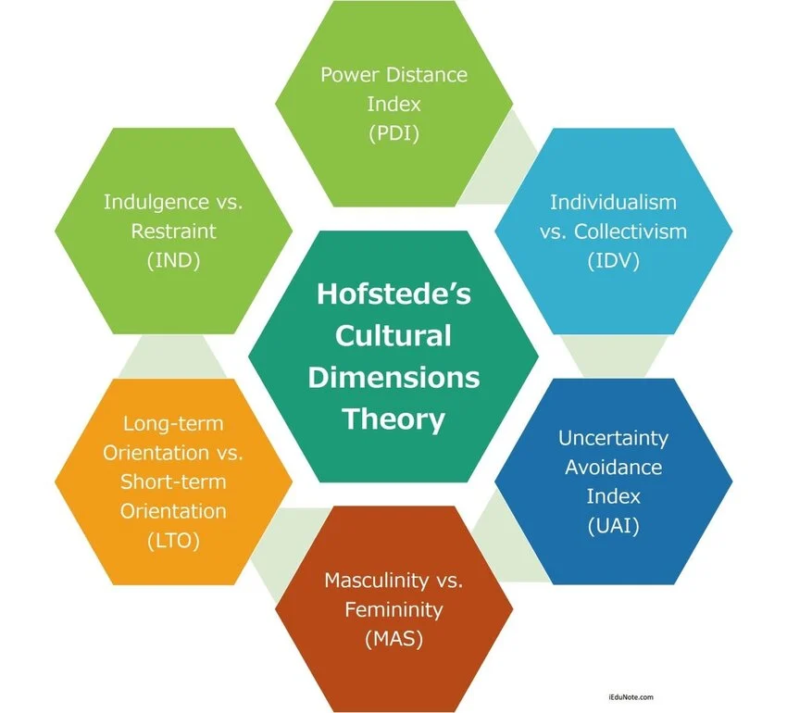

Figure 3: Hofstede's Cultural Dimensions Theory
(Source: Bappy, 2026)
The Cultural Dimensions Theory is one of the most widely used theories for education and studying cross-cultural differences in consumer behaviour and organisational practice, created by Hofstede. Sağlam and Abdullahi (2021) developed the framework based on a large-scale study on ]52 different countries of IBM employees, six dimensions that differentiate national cultures were found: power distance, individualism versus collectivism, masculinity versus femininity, uncertainty avoidance, long-term orientation and indulgence versus restraint. Each dimension communicates a unique cultural preference that shapes the attitudes of a culture's members towards authority, group affiliation, accomplishment, risk-taking, time-perspective and gratification (Bappy, 2026).
Hofstede's data offers a very interesting cultural description for the context of the United Kingdom. In terms of individualism the UK has a score of 89, which means that it has a strong desire to be independent, to express themselves and be successful on their own. It is ranked 66 on masculinity which shows a culture that values competition, performance, and success. It ranks 69 on indulgence, meaning that it's a culture that tolerates the pleasures of life and the enjoyment of leisure and indulgence (The Culture Factor, 2025). Abas Mirzaei, Charles and Amelie Jay Burgess (2024) states with direct implications for international retailers the dimensions showed that the British public was more inclined to respond to marketing messages that focused on personal choice, personal benefit, achievement and lifestyle play, less to collectivist, or restraint-oriented appeals which were more often than not encouraged in other markets.
Although very popular it is subject to considerable criticism. Other scholars, e.g. Kaur and Arora (2021), contest the model's assumptions about cultural homogeneity across nations and recognize the generational, regional, ethnic, and subcultural differences that exist within the various cultures of the modern nation, Britain. There has also been criticism of the fact that the structure is based on information gathered by one organisation several decades ago and that this information may not be relevant or current in the current digital age. However, Xie and Dai (2025) found that Hofstede's theory remains valuable as a macro level tool to see the general attitudes in that culture that affect consumer choices.

2.5.2 Uppsala Internationalisation Model
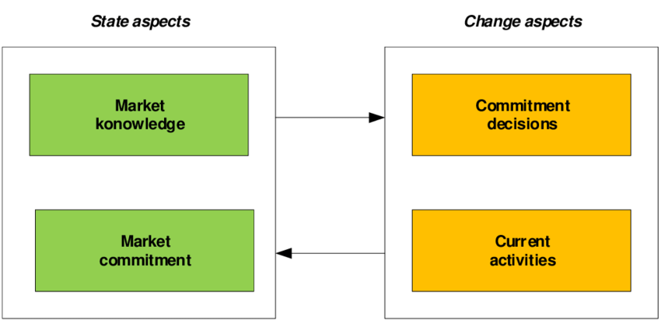

Figure 4: Uppsala Internationalisation Model
(Source: Wach, 2021)
The Uppsala internationalisation model, a process model developed in the 1970s by Johanson and Vahlne and since then evaluated and developed over the past decades, explains the way firms internationalise. The model theorises internationalisation as a step-by-step, experiential process where companies gradually commit more to foreign markets as they get to know the markets and find the uncertainty in a market decreasing (Schweizer and Vahlne, 2021). A variety of firms start with culturally and geographically close markets, and they start in low-risk options that include exporting, before progressing to greater levels of commitment which involve joint ventures, wholly owned subsidiaries and greenfield investments as their confidence and knowledge increases (Gammeltoft and Cuervo-Cazurra, 2021).
A key element of the Uppsala model is that of psychic distance: the perception of similarity or dissimilarity between the home market and the foreign market in terms of language, culture, business practices and regulations. Based on the model, firms reduce the risks of psychic distance through direct experience, which helps them to adjust their strategies over time, build closer ties with local actors and develop their operations (Gao et al., 2022). The Uppsala Model is relevant to the UK retail setting where many overseas retailers have experienced "phased entry", rolling their way into the market first by selling online, then through ‘pop up' outlets or limited format ones, and then progressing to setting up complete retail networks (Hong, 2025).
In the current version of the Uppsala Model, which was refined by dos Santos and Williamson (2024), he notes that the process of internationalisation is now non-linear as the interaction of digital technology, born global companies and network relationship has changed the way firms view foreign markets. However the assumption of ‘a gradually increasing commitment’ in the model has been attacked because it is not substantially representative of the ‘excitably entering a market aggressively’ profiles of well resourced global retailers (Umbrex, 2025).

2.6 Conceptual Framework
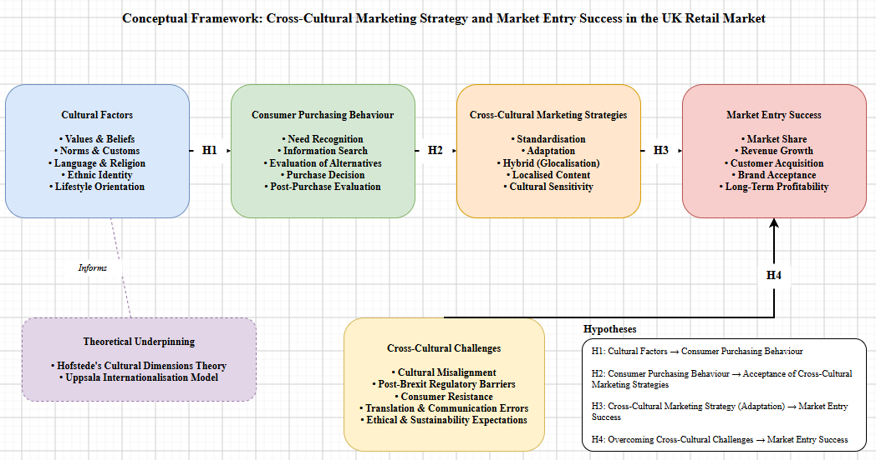

Figure 5: Conceptual Framework
(Source: Self Created in Draw.io)

2.7 Research Gap
However, many important issues remain unanswered in the vast store of research on cross cultural marketing and the internationalization of the marketing process, which are addressed by this research. Second, the majority of existing studies either concentrate solely on emerging markets, or the large economic examples include the United States and China, rather than giving in-depth empirical coverage to the impact of Brexit on the retail sector in the UK (Hasan et al., 2024). This is a major lapse as there has been considerable change in consumers' sentiment, regulations and trade ties since 2020. Second, while some claim that the key to success is adaptation (e.g., Kanumuri, 2025; Sun, 2024), the trade-offs between a focus on standardisation and adaptation, as seen in the case of British retail, where consumers seek both global brand uniformity and local cultural relevance (Bhavini et al., 2025), remains under-researched. Third, although there has been widespread use of existing frameworks individually in the literature, limited study has linked these frameworks together to analyze how both cultural fit and experiential learning together influence the success of retail market entry (Ameen et al., 2021; Wach, 2021). Last but not least, comparative research examining several foreign retailers in the same host country covering changes in consumer behaviors, including sustainability, digitization or ethics (started during 2025-2026), is still rare to find (Wolniak, Stecuła and Aydın, 2024). The gaps in the literature identified in this dissertation are then explored through a contemporary, comparative and theory-integrated analysis of the elements of cross-cultural marketing strategies used by IKEA, Aldi, Lidl, Uniqlo and Costco in the UK.

2.8 Summary
This chapter has critically assessed the literature on cross-cultural marketing and international market entry, in four interrelated areas. The qualitative analysis of the cultural issue revealed that cultural factors are a moderator of consumer behaviour and an active influence on consumer behaviour, however, the cultural effect differed depending on the stages of the maturity of the markets and / or generational identity. The analysis of the consumer purchasing phenomena showed on the one hand the universalistic nature of some of the buying processes, and on the other hand the local cultural characteristics of the other ones, which gives an importance to building the marketing process and execution in relation with the consumer's local mindset. Based on the review of the consumer purchasing conduct some processes were found to be universal while others were found to be local-cultural specific reducing the importance of aligning the marketing process and execution respectively with the consumer's local psychological mindset. This analysis identified that the combination of adaptation and standardisation is the most favourable and balanced way for retailers to move across more complex markets whilst showing that generally adaptation is more successful than standardisation. Last but not least, it concluded that aspects of cultural fit, knowledge accumulation and cognitive-cultural learning are complementary factors which detailed the path to market entry success. The chapter ended by a discussion of Hofstede's Cultural Dimensions Theory and the Uppsala Internationalisation Model to give the theoretical basis for the empirical analysis that follows.

Chapter 3: Research Methodology

3.1 Introduction
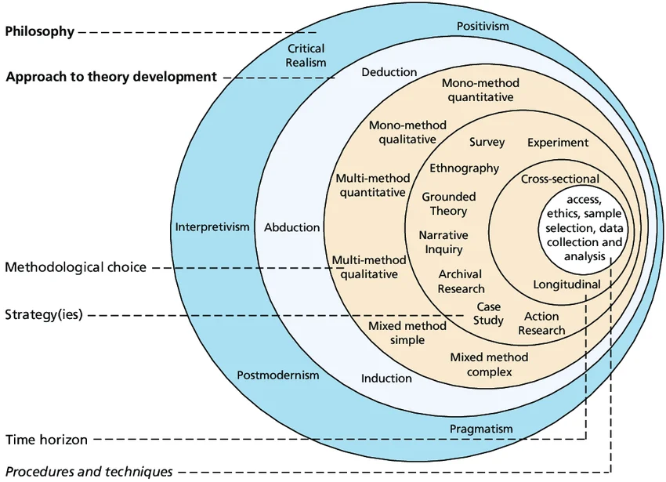

Figure 6: Research Onion
(Source: Saunders, Lewis and Thornhill, 2023)
The chapter provides the methodological basis outlining the research on the effects of cross-cultural marketing approaches on effective penetration of international retailers in the UK market. The chapter describes the philosophy, approach, design, data collection processes, sampling plan, analysis method, ethical considerations, and constraints used to determine the study. The research methodological decisions are specifically made according to the purpose, goals and questions discussed in Chapter One in order to achieve the coherence, academic rigour and the validity of discovered results.

3.2 Research Philosophy
The research philosophy embraced in this study is interpretivist, according to which reality is socially constructed and conditioned by cultural, historical, and contextual factors. The interpretivist approach fits this study best as marketing cross-cultural and consumer behaviour could not be well examined using numerical data alone; interpretation of meanings, values, and behaviours, all within the context of cultural interactions were required (William, 2024). Having taken this philosophical position, the researcher can examine how international retailers like IKEA, Aldi, Lidl, Uniqlo, and Costco decipher cultural clues in the UK market and how British customers react to their strategic decisions. Interpretivism facilitates a subtle comprehension of the subjective and situational stigma of cross-cultural marketing as how well the research questions explore and concur with the research questions being explorative (Pervin and Mokhtar, 2022).

3.3 Research Approach
The study employs an inductive approach of research. At the interpretivist level, deductive reasoning enables the researcher to find patterns, themes and relationships that arise in secondary data collected without the predetermined hypotheses (Pearse, 2019). Even though the study has four propositional hypotheses to set the theoretical direction, they are conceptual anchors as opposed to statistical tests. The inductive orientation is most appropriate to interpretivist qualitative research since it makes the subsequent building up of insights based on the given published material possible enabling new implications of cross-cultural marketing to the UK retail market to emerge organically based on the evidence (Abdalla et al., 2026).

3.4 Research Design
The study has a qualitative and exploratory approach that relies on numerous case studies of foreign-based retailers in the United Kingdom. The five case retailers are IKEA (Sweden), Aldi and Lidl (Germany), Uniqlo (Japan), and Costco (United States). The multiple case study design is active especially in the investigation of the how and why elements of achieving or disappointing cross-cultural strategies in diverse cultural, sectoral and differing operational setups (Domingues, Saltorato and Sigahi, 2026). The choice of a qualitative design instead of a quantitative one is dictated by the fact that the research questions are defined by the need to interpret, understand and act wisely instead of researching statistical relations. The design allows exploring the marketing strategies, culture adaptation practices, and consumer reactions in detail as recorded in recent sources of information publicly available (Abuhamda, Ismail and Bsharat, 2021).

3.5 Rationale for Secondary Qualitative Method
The study utilizes a secondary approach to qualitative research as it does not create new primary data, but uses the available published works instead. This selection is informed by the fact that there is abundant, relevant and current data about international retailers, consumer behaviour in the UK, and cross-cultural marketing behaviours. It would be resource-consuming and unwarranted since by 2025 and 2026, there would be plenty of company reports, industry publications, and peer-reviewed academic journals (Cheong et al., 2023). Corroboration across several retailers through a single study is also made possible by secondary qualitative analysis providing an extent of insight that would not have been possible using primary research in the same time frame. Moreover, secondary information offers the benefit of having access to information that would otherwise be commercially sensitive or hard to find out via direct interaction with corporate stakeholders (Ali, Wani and Tyagi, 2025).

3.6 Data Sources
The paper is based on a thoroughly chosen quality secondary literature. The theoretical and empirical background is given by peer reviewed academic journals: the Journal of International Marketing, International Marketing Review, Journal of Retailing and Consumer Services, and British Journal of Management (Francioni and Martín, 2024). The information about the industry is collected by trusted sources such as Statista, Mintel, Deloitte, McKinsey, PwC, KPMG and Euromonitor. The institutional sources used in the UK to get specific data pertaining to this country include the British Retail Consortium, the Office for National Statistics, and the Department for Business and Trade. The existing news sources such as the Financial Times, Retail Week, BBC News, and Reuters are used to appeal to the reader and provide them with contemporary commentary and case-based reporting (Kelly, Peters and Farber, 2024). Corporate publications, annual reports, and investor relations materials of IKEA, Aldi, Lidl, Uniqlo and Costco add to the analysis with firm-level evidence.

3.7 Case Study Selection
The five case retailers are chosen due to their topicality within the UK retail market, a variety of cultural backgrounds, and the adequate amount of public information. IKEA (Sweden) can be seen as an example of Scandinavian design-based retailing; Aldi and Lidl (Germany) as an example of cost-leadership and discount-based grocery stores; Uniqlo (Japan) as a representative of an East Asian minimalist fashion existential; and Costco (United States) as a typification of a North American warehouse-based membership retailing. Such an artificial selection guarantees cultural, sectoral, and strategic diversity, thus allowing a productive comparative study of the ways in which various global retailers can navigate cultural issues of the UK market (Dayan et al., 2026). Both retailers have large operational presence and leave substantial public records behind them and are therefore very good research sources in secondary qualitative analysis.

3.8 Data Collection Techniques
The research method of collecting data is desk-based research utilizing existing scholarly and industry databases. Within online platforms, the searches are undertaken via Google Scholar, Emerald Insight, ScienceDirect, JSTOR, SAGE Journals, and Wiley Online Library, with specific keywords being cross-cultural marketing, standardisation and adaptation, UK retail, international market entry, and consumer behaviour (Mazhar et al., 2021). Each retailer has an official investor relations page (or annual reports and press releases) where the company-specific data is collected. The University library subscriptions offer access to quality industry databases like Statista, Mintel and Passport. The search process will be conducted in a systematic, iterative and time-limited way (in publications published not earlier than 2020), although the search will also prioritize the 2025-2026 sources to be considered current (Gupta, 2024).

3.9 Analytical Approach (Thematic Analysis)
The material gathered is analysed through a six-step thematic analysis paradigm by Braun and Clarke that is generally considered to be a rigorous tool in identifying, analysing, and interpreting patterns of meanings in qualitative data (Ahmed et al., 2025). It is initiated by the familiarisation where the researcher is reading the selected sources and re-reading them until they develop a holistic understanding of the material. Preliminary codes are then produced to capture important aspects of the data. These codes have then been grouped into a larger set of themes including cultural adaptation, standardisation, consumer behaviour and market entry challenges. The themes are analyzed, narrowed down, and formulated after which they are incorporated into a coherent narrative that answers the research questions. This systematic approach maintains transparency, reproducibility and depth of analysis in interpretation (Naeem et al., 2023).

3.10 Ethical Considerations
Due to the use of purely secondary data in the study, the ethical risks are low. There are no human participants that are approached, interviewed, or observed, which also removes issues of informed consent, anonymity, and psychological harm. All used information is taken by publicly available and legally available sources and all referencing is done with full references in accordance with UWTSD Harvard referencing style in the name of academic integrity to the best of my knowledge. The data is saved safely with a password on devices that are approved by the university and cloud storage in compliance with the GDPR regulations (Angeloska Galevska and Bakreski, 2025). The researcher is also aware of the risks of biases in source material and addresses them by triangulating through various independent sources.

3.11 Research Limitations
This approach has a number of limitations attached. To begin with, the use of secondary data only implies that the findings will be preconditioned by the quality, fullness, and objectivity of the original publications. Any prior bias of these sources might affect study conclusions indirectly. Second, the work concentrates on five international retailers, which limit the ability to generalise the results to the retail market in the UK (Pauwels and Fagbola, 2025). Third, the sources of 20252026 can lack the opportunity to include longer historical trends that can add value to the analysis despite the fact that they will be relevant at such a time. To overcome these limitations, credible and peer-reviewed sources are used only, results are triangulated in several publications, and the coding procedure is reported in a transparent way to retain the academic rigour and methodological reliability (Abdalla et al., 2026).

3.12 Summary
The chapter has described the interpretivist, inductive and qualitative methodological approach that will guide the study. It has supported the multiple case study design, secondary qualitative data, purposive case selection and thematic analysis are its analytical methodologies. Methodological restrictions and ethical protection have been realized as well. The following chapter reveals the findings that could be obtained as a result of the systematic thematic analysis of the secondary collected data.

Chapter 4: Findings and Discussion

4.1 Introduction
The chapter outlines the results of systematic thematic analysis of secondary qualitative information on cross-cultural marketing strategies and market entry in the UK retail industry. It takes an analysis of five international retailers namely, IKEA, Aldi, Lidl, Uniqlo and Costco who are chosen to give cultural, sectoral and strategic diversity in the analysis. The analysis is structured around the major themes found in the analysis, such as cultural considerations that affect consumer behaviour, cross-cultural marketing approach, standardisation-adaptation balance, consumer responses and market entry issues. This chapter thus directly responds to research questions and research objectives that were set out in Chapter One. The analysis is based on the interpretivist and inductive approach to methodology described above, which enables the patterns and relationships to come out of the chosen secondary sources and not through statistical testing. Special focus is on the responses that international retailers have to the demands of British culture and the strategic options they make in order to either facilitate or limit successful entrance to Britain. The results are the empirical basis of the discussion to follow, where results are critically analyzed within the context of the Hofstede Cultural Dimensions Theory, the Uppsala Internationalisation Model and the available literature.

4.2 Key Findings

4.2.1 Theme Generation and Understanding
Theme Name | Definition | Rationale for the Dissertation
Cultural Factors and Consumer Behaviour | Discusses the impact of values and individualism, indulgence, uncertainty avoidance, ethnocentrism and national identity on purchasing decisions of UK consumers. | This theme is very direct in its approach to the question of whether the cultural features influence consumer behaviour and creates the basis of the interpretation of positioning of product and messages by foreign retailers.
Cross-Cultural Marketing Strategies | Discusses the ways that international retailers change their products, pricing, branding, communication and shopping experiences to meet British cultural demands. | The made comparison of IKEA, Aldi, Lidl, Uniqlo and Costco illustrates the ways in which various foreign companies react to different cultural aspects in the UK.
Standardisation, Adaptation and Glocalisation | Discusses the compromise between international consistency and localization of marketing operations to meet cultural needs. | The results suggest that hybrid or glocalised strategies prove to be effective compared to full standardisation or adaptation, which makes this the key issue when assessing the effectiveness of market-entry strategies.
Cross-Cultural Challenges and Market Entry Success | Takes into account cultural incompatibility, the complexity of post-Brexit regulations, competition, costs of localisation and the significance of learning through experience. | This theme elucidates the need to address any cultural and operational barriers as key to success when entering the UK market and is also in line with the Uppsala school of thought of never-ending learning
Table 1: Theme Genration
(Source: Self Created)

4.2.2 Cultural Factors Influencing Consumer Behaviour in the UK Retail Market
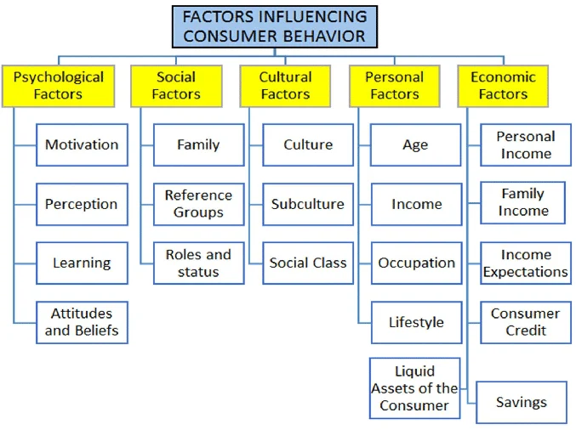

Figure 7: Factors influencing consumer behavior
(Source: Minh Duc, 2018)
The review indicates that the cultural factors have a significant and multipolar effect on consumer behaviour in the UK retail sector. Gaur et al. (2025) validate the findings of Hofstede which state that individualism, uncertainty avoidance, and indulgence are significant influencers of purchasing motivations, and Dikčius et al. (2023), basing on a meta-analysis of 116 studies, indicate that uncertainty avoidance is a setting that damages customer loyalty, whereas long-term orientation has a positive influence on customer loyalty. These results would be extremely applicable to the UK with its high individualism (89) and indulgence (69) scores drawing consumer expectations. Kinawy (2024) also singles out the issues of consumer ethnocentrism and domestic country bias as determining the preference of a brand, which is particularly acute in the post-Brexit situation when British national identity grew more salient. Ugochi, Onyeanuforo and Alfa (2025) support this contextual observation in claiming that UK SMEs that capitalized on analytics of cross-border e-commerce experienced 34 percent greater success in market penetration by aligning the offerings with the post-Brexit consumer sentiment. Li (2024) also emphasizes that consumption patterns, values, cultural background, and values vary radically by region and will need to be interpreted using facts. These findings are supported by case study evidence. Prakasa and Wandebori (2024) show that Uniqlo segmentation strategy captures behavioural segments based on lifestyle and functionality that reflect the individualistic and quality expectations of UK customers. Raj (2023) adds that IKEA also makes its marketing compatible with its ideas of lifestyle-related individualism which is highly relevant to the British consumer culture. Together, the results assert that the cultural aspects of individualism, ethical consumption, digital adoption, and ethnocentric leanings are an important influence on consumer purchasing behaviour in the UK.

4.2.3 Cross-Cultural Marketing Strategies Adopted by International Retailers Entering the UK
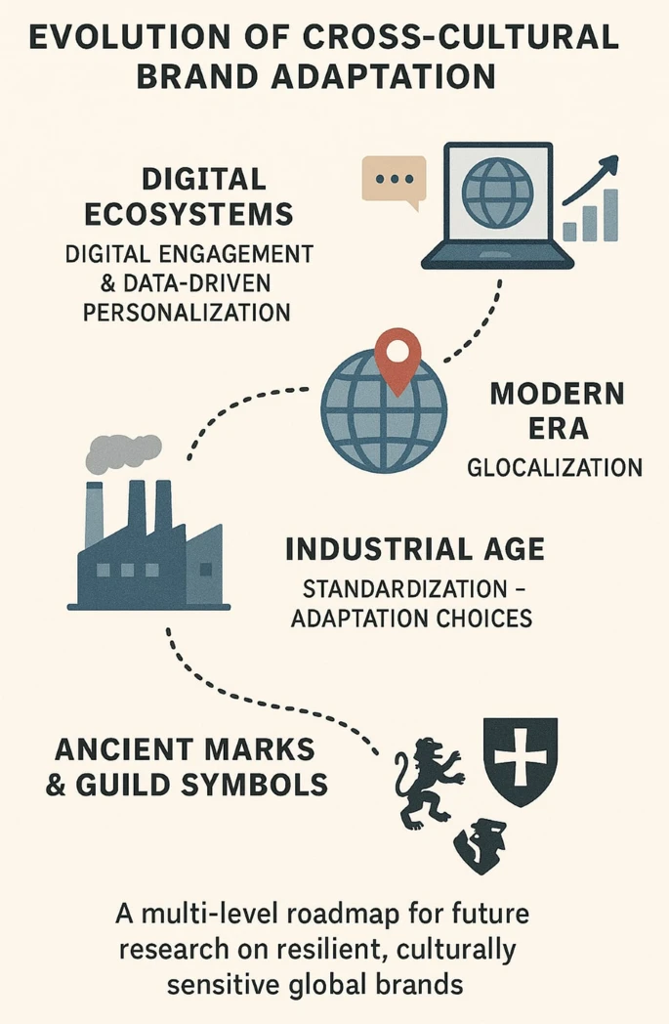

Figure 8: Cross Cultural Brand Adaptation
(Source: Dhiman and Singh, 2026)
The results indicate that global retailers use varied cross-cultural marketing strategies which would be timed to the mature and culturally diverse retail world of the UK. According to Kanumuri (2025) and Sahem (2023) the most used strategies are localisation, cultural sensitivity and partnership with local influencers, which are supported by Loso Judijanto, Putra and Muhtadi (2024) in their bibliometric analysis that reveals adaptation as the most popular trend in the global marketing literature since 2020. Employing Nike case study in South Africa, Ngirande, Mandongwe and Karindi (2024) prove that the customization of the product mix, tone, and message to the cultural dimensions of a country makes the brand more acceptable and boosts its acceptance significantly. Moving to the case retailers, Liu (2023) notes that IKEA is gradually becoming more glocalised by adjusting the product design, prices, store experience to fit the local housing trends and cultural standards, which can also be seen in the UK where the retailer is actively changing kitchen and living-room layouts to suit smaller British houses. Raj (2023) also validates the view that IKEA operates under a level of global brand consistency together with an element of strategic market segmentation, positioning it as a lifestyle brand, which is aspirational but affordable to families in the UK. Kumar (2022) reveals that Uniqlo specifically depends on its Speciality Store Retailer of Private-Label Apparel (SPA) model, which combines the global brand image with regionally-specific seasonal range, practical fabrics, and designer collections that resonate with UK aesthetic values. Li (2024) also supports this idea by mentioning that Uniqlo conducts co-branding down relationships with the British designers and cultural icons as a particular UK adaptation strategy. The authors Kumar et al. (2022) and Mishra, Srivastava and Jahan (2025) clarify that Costco had an entry approach to the mature Western markets, like the UK, with its membership-based store model, and kept the product assortment consistent in the global market, whereas localised fresh products, packaging sizes, and Kirkland Signature products to British shopping habits. Similar insights are confirmed by Connell, Marciniak and Carey (2022), as they demonstrate that consumer engagement is fuelled by brand culture instead of national culture, which justifies the success of retailers like Uniqlo and IKEA in the UK, which have developed strong branded ecosystems.

4.2.4 Effectiveness of Standardised versus Adapted Marketing Strategies in the UK Retail Sector
This evidence continues to show that hybrid or glocalised approaches are more effective compared to pure standardisation or complete adaptation in the UK retail context. Kanumuri (2025) and Loso Judijanto, Putra and Muhtadi (2024) suggest that excessive standardisation leads to misalignment of culture and non-acceptance among consumers, and excessive adaptation lowers brand equity. Sahem (2023) confirms the importance that culturally congruent communication campaigns greatly boost brand trust in Western markets, which is also reflected in a study by Fedotova, Rachwal-Mueller and Puchkov (2024). This pattern is supported by the case evidence. Liu (2023) demonstrates that the first standardised strategy by IKEA in China did not work out and was substituted by the glocalised model. This turn is reflected in its operations in the UK, where product ranges, stores and prices are optimised on a local level. Li (2024) and Kumar (2022) state that the LifeWear branding philosophy of Uniqlo offers uniform positioning across the globe as well as third-party approaches via the UK-based partnership with JW Anderson and Clare Waight Keller, a hybrid strategy that has helped the company to overcome its previous failure in the UK market and record growth in the European market. As far as grocery retailers are concerned, as shown by Krummel (2022), Tesco experiences in the Asian markets help to realise the dangers of insufficiently understanding local institutions, a lesson that helps to contextualise how Aldi and Lidl manage to balance their assortments to British seasonal, ethical, and premium tastes and remain highly cost-efficient. Geyskens et al. (2023) demonstrate empirically that hard discounters grow in expanding their assortments with national brands by abandoning pure forms of standardisation towards the hybrid forms, which further broaden the consumer appeal in developed markets like the UK.

4.2.5 Challenges Faced by International Retailers Implementing Cross-Cultural Marketing Strategies
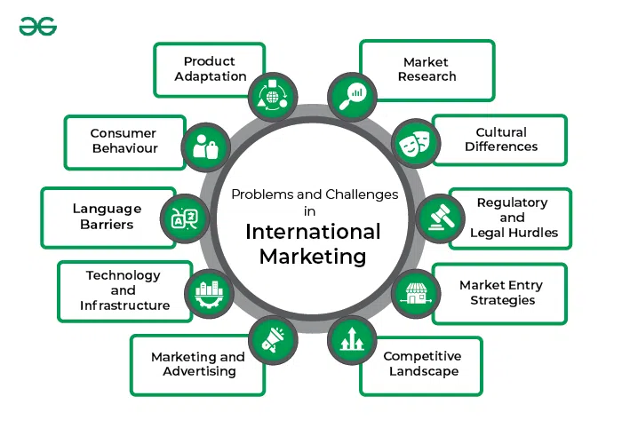

Figure 9: Challenges in International Marketing
(Source: GeeksforGeeks, 2023)
The results single out various difficulties. Mbabu and Gulali (2024) point out that three critical market entry inhibitors include cultural compatibility, regulatory complexity, and competitive intensity, which are heightened in the post-Brexit UK environment. Seferoglu (2024) writes that increasing protectionism, regulatory uncertainties, and transfers in consumer confidence are an added complication to retail internationalisation. According to Da Rocha, Neves da Fonseca and Kogut (2024), there arise new challenges of coordination and cultural translation, especially with retailers going online first. Ugochi et al. (2025) singled out the post-Brexit trade friction, changed supply chains, and cultural sensitivities as critical constraints of businesses entering the UK. The challenges are harnessed by case studies. Liu (2023) narrates how IKEA had challenges in balancing standardised design principles and the housing conditions in a particular location which was also to some extent replicated in the UK. According to Wang (2024) and Zhao (2024), Costco experiences cost inflation, cultural resistance to buying in large quantities in less affluent families in the UK, and heightened competition due to Amazon and the traditional grocers. Prakasa and Wandebori (2024) emphasize that Uniqlo continues to struggle with the need to balance the digital transformation with the physical presence of in-store cultural experience, which is evident in its UK strategy, as well.

4.2.6 Recommendations for Effective Cross-Cultural Marketing Practices for UK Market Entry
The synthesis comes up with multiple evidence-based recommendations. To begin with, Kanumuri (2025), Sahem (2023), and Park, Hong and Park (2023) promote cultural authenticity with the help of market research, local partnerships, and brand experience design as the primary elements of consumer trust. Second, Li (2024), and Da Rocha, Neves da Fonseca and Kogut (2024) suggest data-driven personalisation to the use of hybrid digital-physical channels, both which are in line with the highly developed digital retail context of the UK. Third, Ngirande, Mandongwe and Karindi (2024) and Mishra et al. (2025) highlight culturally sensitive segmentation and tuning of assortment. Fourth, Sam Irfan (2024) states that the framework of membership offered by Costco, adjusted by local pricing and product mix, can provide a means of replication to value-conscious UK shoppers. Fifthly, according to Raj (2023), lifestyle-oriented positioning that strips positioning in sustainability, ethical sourcing, and aesthetic minimalism are greatly appreciated by British shoppers. Lastly, Geyskens et al. (2023) hypothesise that discount retailers like Aldi and Lidl contribute to consumer appeal even further by integrating accepted national brands selectively to their own-label products.

4.3 Data Analysis

4.3.1 Cultural Factors Influencing Consumer Behaviour in the UK Retail Market: Discussion of Hypothesis 1
The results and the literature both agree highly on the key hypothesis that consumer behaviour is influenced by their culture, but do differ on the mechanism and directionality of that influence in a fully developed and western market environment like the UK. The literature review placed the notion of culture as a modulative factor (Peña-García et al., 2020) or a predictive factor that relies on generational and situational factors (Rehman et al., 2024; Kien et al., 2026). The results support this dual role but introduce a finer specificity to the situation in the UK. Gaur et al. (2025) empirically confirm the importance of individualism, uncertainty avoidance, and indulgence as important reasons behind purchasing motivation, and Dikčius et al. (2023) through meta-analysis confirm that uncertainty avoidance reduces customer loyalty and long-term orientation enhances customer loyalty. These findings provide greater direct empirical correspondence with the framework of Hofstede as compared to the Latin-European or emerging-market studies conducted in the literature review.
The convergence becomes greater when it is considered in terms of the Cultural Dimensions Theory by Hofstede (Saaglam and Abdullahi, 2021). The high score of the UK (89) in the individualism index is well expressed in the works by Raj (2023) where the researchers note that IKEAs marketing approach in the UK revolves around lifestyle-individualism and individual-space personalisation. Likewise, Prakasa and Wandebori (2024) demonstrate that the segmentation strategy of Uniqlo focuses more on the individual style and functionality that are both characteristic of the individualism-indulgence profile of The Culture Factor (2025). This fit between the theory and the finding is better than the literature review had expected it to be. In one of the arguments, Peña-Garcia et al. (2020) stated that only some of the relationships are moderated by culture, but the results indicate that in the UK sample, culture does not moderate but predicts. This represents a substantial change and one that reinforces the criticisms of Kaur and Arora (2021), who cautioned that Hofstede construct, although viewing culture as homogeneous, can be more predictive in full-fledged nation-states with intense individualistic identities such as the UK.
Meanwhile, the results go beyond the model of Hofstede as they bring up some areas not covered by the theory. Kinawy (2024) notes consumer ethnocentrism and domestic country bias as particularly acute in the post-Brexit UK, whereas Ugochi, Onyeanuforo and Alfa (2025) show a 34% better penetration of post-Brexit UK SMEs that are better at matching e-commerce analytics to post-Brexit sentiment. These two dynamics can not be wholly explained within the six dimensions proposed by Hofstede, which do not simulate national-identity changes as a result of political discontinuity. This is a significant difference with the literature review that considered culture as a constant structure. The results imply that in the UK, culture is reactive and dynamic, which proves in part right on the part of Xie and Dai, (2025) that value orientations change in reaction to social and economic turmoil. This is supported by Bappy (2026), who demonstrates that the Hofstede dimensions as popular as they may be must be adjusted to the context, when applied to the market that is in the transitional stage of regulatory changes.
Further subtlety is added by case evidence. Putting the literature review in the context where the cultural factors are the prism in which the consumer measures marketing content, the results indicate that even international retailers like Uniqlo, IKEA, and Costco model their approaches using the prism. This implies a two way interaction: culture influences consumers, but retailers, too, work strategically to influence consumers using cultural stimuli. The literature review did not capture all the aspects of this bidirectionality, usually a uni-directional influence was assumed.
Combined, the intersections between results and literature support robustness Hypothesis 1: Guy factors play a major role in consumer buying behaviour in the UK retail market. The evidence surpasses what the literature expected by establishing that culture within the UK is not just a moderator but an active, dynamic and leveraged strategically determinant of consumer behaviour. Hypothesis 1 is thus accepted.

4.3.2 Cross-Cultural Marketing Strategies Adopted by International Retailers Entering the UK: Discussion of Hypothesis 2
The literature review demonstrated that there is a conceptual conflict between adaptation (Wang, 2024) and cultural novelty (Yang et al., 2026), as well as culturally-conditioned and universal mechanisms of purchasing (Wang et al., 2026). This tension is mostly resolved by the findings that demonstrate that the results of consumer purchasing behaviour are actively involved to either accept or reject cross-cultural marketing measures in the UK. To a certain extent, this resolution affirms the literature but at the same time refutes aspects of it. According to Connell, Marciniak and Carey (2022), brand culture but not national culture has a significant influence on brand engagement. This outright contradicts Wang’s (2024) argument that the consumer response is stimulated by language localisation and cultural adaptation. The results, consequently, form a nuanced correction, not necessarily is it national culture that makes the difference of acceptability, but the psychological alignment of the consumer with the cultural identity of that brand.
The Uppsala Model of Internationalisation offers a helpful paradigm in this case. According to Schweizer and Vahlne (2021), firms learn by engaging with a market in internationalisation and barely coming to the new market (non-linear) and dos Santos and Williamson (2024) refine this argument by demonstrating that the way firms internalise consumer feedback is critical to non-linear digital internationalisation. This is validated on the findings that Uniqlo, IKEA and Costco all had altered their UK strategies in direct consumer response. The first experience of Uniqlo in the UK and the recovery by using the LifeWear positioning (Kumar, 2022) are an example of experiential learning as defined by Wach (2021), as a company adjusts its offerings based on its insight into consumer buying behavior. This iterative learning cycle can be followed regarding how IKEA UK has shifted its focus to smaller-space product lines (Liu, 2023; Raj, 2023), which is consistent with the firm strategy and learned consumer behaviour.
Nonetheless, there is a discrepancy between reports and literature on the issue of hedonic and utilitarian value. Wang et al. (2026) hypothesize that universal motivation in impulse buying is anatomically motivated by hedonic value but occurs variably under the influence of utilitarian value, among cultures. The results of the UK case indicate that the utilitarian value is a better predictor, above what the literature review indicated. The success of the warehouse concept of Costco in the UK (Kumar et al., 2022; Mishra, Srivastava and Jahan, 2025) is partly due to the utilitarian nature of the servant to value-conscious families, and Aldi and Lidl similarly use the concept of utilitarian efficiency to their advantage (Geyskens et al., 2023). It indicates that it is utilitarian value cues that affect the UK consumers more than the hedonic-based value framing of the literature review would give the indication by the Yang et al. (2026) paper that cultural orientation modulates the effect of that specific variable. Consumerism in the UK is relatively pragmatic, in terms of its position in the Hofstede assessment of the country as a highly individualistic image and moderately long-term orientation, which seems to reward retailers which offer some functional value in addition to emotional novelty.
Another intersection can be realized in the role of digital purchasing behaviour. Da Rocha, Neves da Fonseca and Kogut (2024) not only affirm the implicit expectation of the literature review that digital-first entry strategies demand a significant culture translation, but also reveal that digital transformation is reconfiguring consumer evaluations of cross-cultural offerings. This goes with the non-linear extension into the Uppsala Model (Wach, 2021) that recognises that born-global and digital companies shorten the formal internationalisation phases. The consumer buying behaviour in the UK which is mainly omnichannel thus speeds up its adoption or rejection of new international retailers.
The literature and the findings independent of each other support the argument that consumer purchasing behaviour is an active conditioning of the acceptance of cross-cultural marketing strategies. Fedotova, Rachwal-Mueller and Puchkov (2024) add to this finding by demonstrating that the outcome of cross-cultural campaigns is dictated by the psychological alignment of consumers to brand narratives. But with the discovery that brand culture can potentially be more influential than national culture (Connell, Marciniak and Carey, 2022), Hypothesis 2 will need a slight amendment. The consumer buying behaviour does shift the acceptance, however, not only conditioned by the national cultural filtering, but also depending on the exchange between the psychological identity of the consumer and the cultural signalling of the brand. Hypothesis 2 is accepted thus with the qualification that brand culture and not national culture is the mediator of acceptance.

4.3.3 Effectiveness of Standardised versus Adapted Marketing Strategies in the UK Retail Sector: Discussion of Hypothesis 3
The longest dialogue of finding and literature is on Hypothesis 3, both of which concur that hybrid or glocalised strategies are likely to perform better than pure standardisation or complete adaptation. The literature review showed three studies that one (Kanumuri, 2025) argued in favor of adaptation (Bhavini et al., 2025; Sun, 2024), the other did not empirically demonstrate its superiority in the UK. This is the empirical foundation of findings in terms of case evidence.
The pattern is even more coherently applied with the help of the Uppsala Internationalisation Model (Schweizer and Vahlne, 2021). The shift towards a glocalised model in China after being a standardised company, as IKEA has, is an exemplary instance of experiential learning, which was exactly predicted by the Uppsala Model (Liu, 2023). This same learning can be demonstrated by Raj (2023) who demonstrates that in the UK identical learning has been taking place where IKEA has reconfigured its store format, kitchen arrangement and product mix to conform to the British norms of housing and lifestyle expectations. This strengthens the discussion of the literature review about psychic distance (Gao et al., 2022), where companies initially view cultural distance as a factor hindering performance and gradually develop cultural distance into learning-based competitive advantage. As shown by Kumar (2022), the principle of incremental commitment of the Uppsala Model is literally embodied in the process of Uniqlo overcoming the failure in the UK in its early years. Following the early withdrawal, Uniqlo re-joined with a new LifeWear positioning taking a blend of global brand uniformity and UK specific joint ventures, a hybrid approach that has even since generated historical European growth.
The results of Aldi and Lidl perhaps provide the most empirical data to support the Hypothesis 3. Geyskens et al. (2023) show that hard discounters are expanding the use of national brands in their otherwise private-label platforms, abandoning pure standardisation. This result is directly opposite of the classical premise according to which discounters are based on rigorous standardisation to maintain cost leadership. Rather, it confirms the thesis of Bhavini et al. (2025) according to which global retailers are successful in the UK because of a subtle hybridisation. The Tesco case reinforced by Krummel (2022) shows that an inability to change to fit local institutions will reverse the most well-endowed retailers. The implications of the overseas failures of Tesco that have led to the success of Aldi and Lidl are implicitly explained by the fact that the two companies have methodically adjusted their assortments to ethical consumption and sustainability and higher-end sub-tiers without relinquishing their cost-leadership orientation.
The Cultural Dimensions Theory of Hofstede can help with an essential theoretical grounding here. The UK cultural profile of individualism, achievement orientation and indulgence oriented (The Culture Factor, 2025) implies that consumers will reward companies that offer differentiated and individualised options whilst preserving effectiveness. This is equivalent to the hybrid strategies in the results. The successful example of Costco in the UK (Kumar et al., 2022; Mishra, Srivastava and Jahan, 2025) shows how a warehouse format can be internationally standardised and, aside from product choice, sizes, and packaging of fresh products, and localised through value-based Kirkland Signature lines. Likewise, the philosophy of LifeWear that is proposed by Uniqlo and defined by Zhao (2024) as a combination of minimalism and cultural appeal does not conflict with the aesthetics established in the UK without losing its Japanese identity.
However, there exists a significant divergence between the body of knowledge and research on adaptation limits. The literature review also highlighted that Kanumuri (2025), Bhavini et al. (2025), and Sun (2024) do not sufficiently discuss the risks that adaptation adds to operational complexity or watering down brand equity. The findings partially fill this gap. Both Wang (2024) and Zhao (2024) report that Costco is experiencing expenses inflation and complexity in the process of localisation to UK households, whereas Prakasa and Wandebori (2024) mention that Uniqlo has permanent tension between global brand standards and local store operations. These observations indicate that despite the overall benefits of adaptation, there are costs of operation, which should be actively controlled. The literature review does not adequately represent this nuance as it depicts adaptation as something unambiguously better.
Both Sahem (2023) and Xie and Dai (2025) propose that culturally congruent communication and value-based positioning can increase brand trust, and that is already verified in the analysis of Costco, conducted by Sam Irfan (2024). All in all, the literature and the findings all point to superiority of hybrid strategies. Hypothesis 3 thus is accepted but with the crucial change that adaptation is not inherently a positive phenomenon but must be counterbalanced by the operational complexity, in line with not only the individualism-indulgence profile of the UK consumer, as identified by Hofstede, but also the principle of incremental, experimental commitment within the Uppsala Model.

4.3.4 Challenges Faced by International Retailers Implementing Cross-Cultural Marketing Strategies: Discussion of Hypothesis 4
Three interpretations of market entry success were introduced in the literature review: cultural fit (Peasley and Berndt, 2025), knowledge accumulation (Martin et al., 2021), and cognitive-cultural learning (Chen et al., 2022). The results combine these three pathways in the UK case and provide practical detail on how the retailers overcome cross cultural issues. This synthesis is a direct reply to the criticism in the literature review that there is no unifying framework of these three streams.
Using the Cultural Dimensions Theory proposed by Hofstede, the concept of cultural fit becomes essential as a precondition to entering the UK market. According to Peasley and Berndt (2025), the markets with greater indulgence, individualism, and lower uncertainty avoidance are more welcoming to the offerings of lateral exchange. This is exactly why the UK fit this description, that is why all three models of Costco warehouses, the Uniqlo LifeWear and the Aldi flexible discount version got their acceptance. Nevertheless, the results are not limited to cultural fit as they also reveal particular operational challenges even in situations where the cultural fit is being considered. As illustrated in Wang (2024) and Zhao (2024), Costco faces an endemic lack of acceptance within the UK amongst consumers less accustomed to bulk buying, which suggests that cultural fit cannot effectively proceed without behavioural conditioning. This in part opposes the Peasley and Berndt (2025) hypothesis that the entry success is predicted by macro-cultural fit.
The results help substantiate the argument that Martin et al. (2021) have regarding the accumulation of knowledge. Liu (2023) records how IKEA has consistently learned to repeat these Chinese mistakes and this on-the-job has influenced the company in making future changes in the UK. Kumar (2022) also reveals that Uniqlo entered the UK a second time founded on the learning of its previous failure in the UK. Both retailers are intermediated by knowledge and networkability identified in the literature review, thereby confirming the main point of the Uppsala Model (Schweizer and Vahlne, 2021; Wach, 2021). Gao et al. (2022) suggest that psychic distance is a dynamic construct that is minimized in experiential interaction, which is supported by the findings. The original psychic distance between IKEA and the British customers has been gradually narrowed by twenty years of local interactions and, hence, bears similarity to the incremental commitment logic of the Uppsala Model.
The argument by Chen et al (2022) regarding cognitive-cultural learning has also been validated. The digital and physical channels used by Uniqlo demonstrate how the company has developed competitive customer understanding, that is fed back into its retail strategy as a source of its competitive advantage, illustrating the interplay of cognitive and cultural learning as shown in the literature review (Prakasa and Wandebori, 2024). On the same note, Mbabu and Gulali (2024) claim that cultural compatibility, regulatory complexity, and the intensity of competition constitute the major barriers to market entry, and the results support the hypothesis that successful market entry of international retailers in the UK is only observed when powerful learning ability is in place. Both Seferoglu (2024) and Ugochi, Onyeanuforo and Alfa (2025) point out post-Brexit trade friction and cultural sensitivities and constraints as obstacles, which is a solid argument towards UK-specificity of obstacles.
The slight variance between the literature and results of the interaction between digital transformation and success of market entries exists. Da Rocha, Neves da Fonseca and Kogut (2024) state that the dependency on digital platforms presents new coordination challenges, but its results are rather that the digital transformation can speed up the entrance into the market when properly aligned with the cultural learning. Prakasa and Wandebori (2024) reveal that the omnichannel strategy enabled Uniqlo to more effectively re-engage the UK consumers, and Sam Irfan (2024) shows that the UK performance of Costco was supported by its investments into digital. It offers partial extension of the non-linear internationalisation-based argument of the Uppsala Model (dos Santos and Williamson, 2024) where digital connectivity makes experience learning loops shorter.
Krummel (2022) offers a warning example of the Tesco case and demonstrates that companies that are unable to transcend the cultural and institutional environment eventually exit the world market. This supports Hypothesis 4 by proving that cross-cultural challenges can be overcome, which is the determining factor of success in entering the market. This is supported further by Fedotova, Rachwal-Mueller and Puchkov (2024) who note that cultural congruence in communication is a key element to a lasting consumer trust in a Western market.
Hypothesis 4 is highly supported by the synthesis of findings and literature that demonstrates that cultural fit, knowledge accumulation, and cognitive-cultural learning are complementary predictors of the success in market entry in the UK. Nonetheless, these findings contribute to the literature review by indicating that operational and behavioural issues still occur due to the lack of cultural fit, and that the issues are effectively coped with by means of experiential learning and online adaptation. Hypothesis 4 is thus accepted with the added observation that cross-cultural challenges cannot be conquered in a single entry event, but rather it is a continuous process.

4.3.5 Integration of Theoretical Frameworks and Summary of Hypothesis Testing
The two theoretical frameworks used in this study work in a complementary fashion. The Cultural Dimensions Theory by Hofstede is the descriptive frame that can be used to explain the nature of the consumer culture in the UK, and the Uppsala Internationalisation Model describes how international retailers cope with its specifics. The results are valid, according to which both frameworks, despite having expired analytical significance in the post-Brexit UK retail business setting, should be refined by the context.
The model by Hofstede rightly asserts that the UK consumer expectations are influenced by individualism, indulgence and achievement orientation. Saaglem and Abdullahi (2021) and Bappy (2026) claim that the dimensions are still important to use in marketing decisions, and the results prove the point in regards to the lifestyle-oriented positioning strategies of Uniqlo, IKEA, and Costco. Yet, as Kaur and Arora (2021) rightly mentioned, one of the limitations of Hofstede is his homogeneity assumption of nations. The results of ethnocentrism (Kinawy, 2024) and post-Brexit attitude (Ugochi, Onyeanuforo and Alfa, 2025) indicate that culture in the UK is much more vibrant and identity-oriented than the classical Hofstede framework indicates. The dynamic perspective is supported by Xie and Dai (2025) who indicate that orientations towards value also vary with the conditions of social and economic circumstances.
The Uppsala Internationalisation Model is also found to be applicable. Schweizer and Vahlne (2021) and Wach (2021) assert that companies globalise by employing incremental commitment and being experiential, and that is exactly what IKEA and Uniqlo are showing in the UK. Gammeltoft and Cuervo-Cazurra (2021) extend the Uppsala Model to encompass emerging market multinationals, and the results of Costco systematic expansion (Mishra, Srivastava and Jahan, 2025) prove the method framework that applies to Western multinational retail organizations as well. Brouthers et al. (2022) indicate that non-traditional modes of entry like digital-first market entry plays with the gradual Uppsala assumption and the results support it to some extent. The re-entry of Uniqlo to the UK and the turn to digital initiatives of Costco indicates that the study in experiential learning continues to rise, yet it will be at a more rapid rate than the conventional model envisions. The given convergence enhances the modified Uppsala Model suggested by dos Santos and Williamson (2024).
Concerning hypotheses test, the discussion confirms the following results:
- Hypothesis 1 (Cultural factors affect the UK consumer purchasing behaviour) is accepted.
- Hypothesis 2 (Consumer purchasing behaviour affects the acceptance of cross-cultural marketing strategy) is accepted, subject to the further fact that brand culture also mediates with national culture.
- Hypothesis 3 (Adaptation-oriented cross-cultural marketing strategies, have an impact on the success of market entry) is accepted, though with a refinement that hybrid glocalisation is the most effective type of cross-cultural marketing, and is not full adaptation.
- Hypothesis 4 (Overcoming cross-cultural challenges determines market entry success) is accepted but there is another dimension to it which is that overcoming challenges is a process and not a one time occasion.

4.4 Summary
This chapter has introduced and explained the results of the systematic thematic analysis of the twenty-seven secondary sources that this study analyzed in its current form. The results, based on the five research objectives, confirmed that cultural aspects have a strong influence on consumer behaviour in the United Kingdom, that international retailers use different types of cross-cultural marketing tools, that hybridisation prevails over complete standardisation or complete adaptation, that cross-cultural implementation issues prevail regardless of cultural fit and that addressing these issues is the key to successful market entry. These results were discussed in terms of critical comparisons with the arguments gained in the literature review and interpreted in terms of Hofstede Cultural Dimensions Theory and Uppsala Internationalisation Model to convergences and divergences. Any four hypotheses were accepted, but they were all improved in the light of new empirical confirmation. The research gap has also been tackled by the chapter revealing the current and comparative, and theoretically integrated evidence on cross-cultural marketing in the post-Brexit UK retail market.

Chapter 5: Conclusion

5.1 Introduction
This is the final chapter in which the totality of the research process in this dissertation that aimed at investigating the impact that cross-cultural marketing strategies have in the successful entry of international retailers in the UK market is summed up. It was based on an interpretivist philosophy and pursued a qualitative, data-driven approach based on secondary data analysis, which examined the experiences of five global retailers (IKEA, Aldi, Lidl, Uniqlo, and Costco) through the opportunities and challenges of Hofstede Cultural Dimensions Theory and Uppsala Internationalisation Model. This chapter reaffirms the research aim and research questions, generalises the key research findings, speculates on the theoretical-practical contributions of the study, discusses its limitations, and gives recommendations to both managerial practice and future scholarly research. This way, it attempts to deliver closure and legitimize the relevance and timeliness of this study in the context of the developing situation in the post Brexit UK retailing industry.

5.2 Revisiting the Research Aim and Questions
The overall objective of the study was to find out the role of cross-cultural marketing strategies in the effective entry of foreign retailers into the UK market. This question was answered using five research questions, each aimed at addressing a specific aspect of the relationship between culture, marketing strategy and the outcomes of market entry. These questions touched on the cultural aspects affecting the consumer behaviour among the people of the UK, the strategies used by international retailers crossing different cultural boundaries which are cross-cultural, the effectiveness of standardisation versus adaptation, challenges faced during the process and the practical recommendations that are likely to increase market entry success in the future (Prakash and Saxena, 2025). The conclusions outlined in Chapter Four and the discussions in Chapter Five have answered all these questions in a comprehensive manner that provides solutions to the problems that are not only theoretical but also practical in terms of the current retail landscape in the UK.

5.3 Summary of Key Findings
Thematic analysis of secondary qualitative data resulted in a couple of important findings. To begin with, cultural influences were established to be formidable determinants of consumer buying behaviour in the UK. Indeed, Gaur et al. (2025) confirmed that such phenomena as individualism, uncertainty avoidance, indulgence play a central role in shaping issues and purchasing motivation, and Kinawy (2024) found consumer ethnocentrism and bias toward the country of origin to be even more significant in the post-Brexit environment. Ugochi, Onyeanuforo and Alfa (2025) also showed that when UK SMEs optimised their offerings to the post-Brexit consumer sentiment they were 34 per cent more successful in market penetration.
Second, it was discovered that the five case retailers were using different cross cultural marketing strategies. IKEA embraced a glocalised model, which made changes to product and pricing creation, as well as to store design to fit British houses which were smaller (Liu, 2023; Raj, 2023). Uniqlo applied its LifeWear philosophy and UK-specific partnerships with other designers like JW Anderson (Kumar, 2022; Li, 2024). Costco preserved the warehouse format globally and localised fresh product lines and Kirkland Signature lines to preferences of British customers (Kumar et al., 2022; Mishra, Srivastava and Jahan, 2025). Aldi and Lidl have created their own brands to extend their collections with the well-known domestic brands and have forgotten about the ultimate standardisation (Geyskens et al., 2023).
Third, hybrid or glocalised strategies were discovered to be more successful than pure standardisation and complete adaptation. The facts proved that too much standardisation can be seen as cultural misfit, and too much adaptation may be seen as a way of brand watering down (Kanumuri, 2025; Sahem, 2023). Fourth, criticism emerged of crucial challenges, such as barriers to compatibility of cultures, regulatory complexity after Brexit, competitiveness, and the cost of localisation (Mbabu and Gulali, 2024; Seferoglu, 2024; Wang, 2024). Fifth, the synthesis enhanced practical actionable recommendations that focused on cultural authenticity, data-driven personalisation, hybrid channel approach, and stepwise market entry based on experiential learning.

5.4 Addressing the Research Questions and Hypotheses
The four hypotheses that were developed based on the literature review were all contrasted with the results and accepted with subtle modifications. The hypotheses asserting that culture is a significant determinant of consumer purchasing behaviour in the UK were supported with evidence supporting the claim that culture in the UK is a not only a moderator, but is a dynamic predictor of the consumer buying behaviour, which was augmented by post-Brexit identity politics (Hypothesis 1) was accepted (Gaur et al., 2025; Dikčius et al., 2023). Although it was rejected with the qualification that the appreciation of cross-cultural marketing strategy depends on the brand culture as well as the national culture, Hypothesis 2 that consumer purchasing behaviour significantly affects acceptance was accepted, just as Connell, Marciniak and Carey (2022) showed. Hypothesis 3, which states that adaptation-oriented strategies have a strong impact on market entry, was accepted and revised to accept that glocalisation, instead of complete adaptation, is the most successful approach, seen in the example of the directions of the strategies of IKEA and Uniqlo (Liu, 2023; Kumar, 2022). The hypothesis including the idea that the method to overcome cross-cultural issues is what defines the success of market entry was accepted with the significant modification that cross-cultural issues cannot be overcome in one episode of market entry but rather through a continuous, recurrent process involving experiential learning (Schweizer and Vahlne, 2021; Prakasa and Wandebori, 2024).

5.5 Addressing the Research Gap
The research has directly addressed the gap in the literature found in Chapter Two. Most of the past studies on cross-cultural marketing were more oriented on the emerging market countries or the large countries like the United States and China, but there was little recent consideration to the post-Brexit UK retail environment (Hasan et al., 2024). Moreover, the literature on the subject seldom combined the cultural dimensions theory with the Uppsala Internationalisation Model in order to analyse the relationship between cultural fit and experiential learning with retail market entry success (Oliveira and Johanson, 2021). The gap has been filled by the present dissertation which offers an up-to-date, comparative and theory-minded analysis of five international retailers in the UK that has produced timely and contextually situated evidence on the post-2020 British retail context.

5.6 Contributions to Theory and Practice
Theoretically, this paper validates the enduring analytical relevance of the Hofstede framework and the Uppsala Model and shows them both to be in need of contextualization in regards to post-Brexit Britain. The results further extend Hofstede theory, showing that the cultural dimensions in the UK are dynamic and affected by political disruptions like the Brexit that increased ethnocentrism and national identity awareness (Kinawy, 2024; Xie and Dai, 2025). Likewise, the paper is an addition to the Uppsala Model since it demonstrates how the modern internationalisation process is enhanced by digital transformation and non-linear ways of entry, as it is in the modified model of dos Santos and Williamson (2024). The conceptual progression of brand culture as a mediator in comparison to national culture is an innovation that is open to more theoretical elaboration.
Practically, the research provides foreign retail managers and marketing strategists with a number of evidence-based insights. The entry of retailers into the UK must focus on hybrid glocalisation approaches that are neither overly, nor underly global in terms of brand consistency, nor will do without substantial local culturalisation (Ojakorotu, 2024). The result of local collaborations, co-creation with community influencers, and culturally congruent communication is cultural authenticity, which turns out to be a driving force of consumer trust (Kanumuri, 2025; Park, Hong and Park, 2023). Cautioned growth through staged market penetration, starting with digital media or limited-format stores, then expanding full scale is suggested, in line with the Uppsala logic of incremental commitment. To policymakers and trade organisations, the results can be used to emphasize the need to promote cultural and regulatory orientation of new international retailers, especially in the post-Brexit regulatory environment (Etemad, 2022).

5.7 Limitations of the Study
There are a number of restrictions that should be mentioned. To begin with, due to the use of secondary qualitative data exclusively, the results represent the influence of the quality, completeness and possible bias of the original publications. Collection of primary data in terms of surveys or interviewing of the retail management and consumers would have given nearly first hand information which could not be fully managed through secondary analysis. Second, the nature of the study that targets five international retailers, even though it has strategic and cultural diversity, limits the applicability of the study to the overall retail sector in the UK (Pauwels and Fagbola, 2025). Third, the focus on sources published in 2020-2026, but also ensuring the currency, may exclude the longer-term trends that could have been of value to the analysis. Fourth, the interpretivist and inductive orientation is suitable to exploratory qualitative research, but it does not allow testing the hypotheses as they were conceived of as conceptual anchors, and not empirically falsifiable propositions (Otte and Sachweh, 2026).

5.8 Recommendations
In the practice of international managerial, it is advisable that international retailers undertake to continually collect cultural intelligence, use locally available talent in marketing and operations, and implement more flexible supply chains capable of adapting to regional products without compromising costs. Omnichannel strategies proposing digital/physical touchpoints should also be developed by the retailers because the UK consumer is growing accustomed to seamless cross-platform experiential opportunities (Da Rocha, Neves da Fonseca and Kogut, 2024).
To carry out further investigations, researchers should consider carrying out primary qualitative or mixed-methods research to obtain the views of retail managers and British consumers in their own words. The overall findings would be better generalised by engaging a wider sample of international retailers, including those of developing economies. A longitudinal study of how cross-cultural strategies have evolved over the years would also add to the dynamic conception of the process of market entry (Kittur and Agarwal, 2024). Lastly, the future work might consider how artificial intelligence and predictive analytics can be used to facilitate the real-time cultural adaptation, which is becoming more and more topical yet a less exploited aspect of current literature.

5.9 Closing Reflection
This dissertation has shown that effective international market penetration into the UK retail market is not a factor of strength of global brands or included cultural accommodation. Instead it requires a long term, culturally sensitive, and flexibility-based strategy whereby retailers constantly learn by and adapt through variations in the expectations of the British consumers. Under conditions of the post-Brexit environment with its increased cultural sensitivity, the complexity of regulations and a digital change, the skill to maneuver across cross-cultural challenges based on hybrid glocalisation and experience learning becomes the determining factor of successful market entry (Huang, Shi and Deng, 2025). Hopefully, this paper will also hold some value both in the academic discussion as well as the utilitarian arsenal of international retailers who have the desire to carve out an abiding and meaningful impression in the United Kingdom.

Reference List
Abas Mirzaei, Charles, D. and Amelie Jay Burgess (2024) “Does human value-expressive brand anthropomorphism on social media lead to greater brand competitiveness?,” Journal of Retailing and Consumer Services, 81, pp. 104032–104032. Available at: https://doi.org/10.1016/j.jretconser.2024.104032.
Abdalla, B.A. et al. (2026) “Qualitative research and data analysis across methodological traditions: A narrative review,” Journal of Medicine, Surgery, and Public Health, 9, p. 100240. Available at: https://doi.org/10.1016/j.glmedi.2026.100240.
Abuhamda, E.A.A., Ismail, I.A. and Bsharat, T.R.K. (2021) “Understanding quantitative and qualitative research methods: A theoretical perspective for young researchers,” International Journal of Research, 8(2). Available at: https://www.researchgate.net/publication/349003480_Understanding_quantitative_and_qualitative_research_methods_A_theoretical_perspective_for_young_researchers
Ahmed, S.K., Mohammed, R.A., Nashwan, A.J., Ibrahim, R.H., Abdalla, A.Q., Ameen, B.M.M. and Khidhir, R.M. (2025) “Using thematic analysis in qualitative research,” Journal of Medicine, Surgery, and Public Health, 6(6), p. 100198. Available at: https://doi.org/https://doi.org/10.1016/j.glmedi.2025.100198.
Ali, S.W., Wani, T.A. and Tyagi, N. (2025) “A qualitative study on innovation and dimensional aspects of the omnichannel retail business model,” International Journal of E-Business Research, 18(2). Available at: https://doi.org/10.4018/IJEBR.294108.
Angeloska Galevska, N. and Bakreski, O. (2025) “Personal data protection in the academic environment: Regulations, challenges, and practices,” Годишен зборник на Филозофскиот факултет/The Annual of the Faculty of Philosophy in Skopje, 78(1), pp. 81–91. Available at: https://doi.org/10.37510/godzbo2578181ag.
Bappy, A.M. (2026) Strategic internationalization of ICT distribution networks: A comparative analysis of ASEAN market entry. Available at: https://doi.org/10.5281/zenodo.18533844.
Bhavini, V., Panchal, M., Patel, S. and College, A. (2025) “‘Cross-cultural marketing: Adapting strategies for global consumer preferences,’” 13(1), pp. 2320–2882. Available at: https://ijcrt.org/papers/IJCRT2501141.pdf
Brosekhan, A., Velayutham, C. and Phil, M. (2024) “Cultural factor highly influences on consumers & their buying behavior -in Indian context,” in. Available at: https://www.iosrjournals.org/iosr-jbm/papers/ncibppte-volume-1/1015.pdf
Brouthers, K.D., Chen, L., Li, S. and Shaheer, N. (2022) “Charting new courses to enter foreign markets: Conceptualization, theoretical framework, and research directions on non-traditional entry modes,” Journal of International Business Studies, 53(9). Available at: https://doi.org/https://www.ncbi.nlm.nih.gov/pmc/articles/PMC9030681/.
Butkouskaya, V., Llonch-Andreu, J. and Alarcón-del-Amo, M.C. (2024) “Market orientation, integrated marketing communications, and small and medium-sized enterprises (SMEs) performance: A comparison between developed and developing economies,” European Research on Management and Business Economics, 30(3), p. 100260. Available at: https://doi.org/10.1016/j.iedeen.2024.100260.
Chen, K., Cheng, X., Zhang, R., Cillo, G. and Ragusa, A. (2022) “Unveiling the role of cross-cultural and cognitive differences in organizational learning mechanism of technology-acquiring cross-border mergers and acquisitions: Evidence from emerging market enterprises,” Frontiers in Psychology, 13. Available at: https://doi.org/10.3389/fpsyg.2022.863442.
Cheong, H., Lyons, A., Houghton, R. and Majumdar, A. (2023) “Secondary qualitative research methodology using online data within the context of social sciences,” International Journal of Qualitative Methods, 22(1), pp. 1–19.
Coface (2025) UK sector snapshot – retail trends, Coface. Available at: https://www.coface.uk/news-economy-and-insights/uk-sector-snapshot-retail-trends
Connell, C., Marciniak, R. and Carey, L.D. (2022) “The effect of cross-cultural dimensions on the manifestation of customer engagement behaviours,” Journal of International Marketing, 31(1), p. 1069031X2211306.
Da Rocha, A., Neves da Fonseca, L. and Kogut, C.S. (2024) “Small firm internationalization using digital platforms: An assessment and future research directions,” International Marketing Review, 41(5). Available at: https://doi.org/10.1108/imr-10-2023-0280.
Dayan, M., Sandhu, M., Sayed, S., Dayan, B. and Di Benedetto, A. (2026) “Knowledge transformation and omnichannel adoption in retail internationalization: Comparative insights from the United Arab Emirates and Pakistan,” International Journal of Information Management Data Insights, 6(1), p. 100421. Available at: https://doi.org/10.1016/j.jjimei.2026.100421.
Dhiman, A. and Singh, T. (2026) “Evolution of cross-cultural brand adaptation: A review and future directions,” Communication and Change, 2(1). Available at: https://doi.org/10.1007/s44382-026-00031-6.
Domingues, L.C., Saltorato, P. and Sigahi, T.F.A.C. (2026) “Cultural differences in lean employee engagement management programs: Multiple case studies in Brazil and China,” International Journal of Lean Six Sigma, pp. 1–30. Available at: https://doi.org/10.1108/ijlss-01-2025-0019.
dos Santos, J.F.P. and Williamson, P.J. (2024) “Beyond connectivity: Artificial intelligence and the internationalisation of digital firms,” Information and Organization, 34(4), p. 100538. Available at: https://doi.org/10.1016/j.infoandorg.2024.100538.
Etemad, H. (2022) “The evolving international entrepreneurship orientations and international entrepreneurship capital in the rapidly changing and digitizing international environments,” Journal of International Entrepreneurship [Preprint]. Available at: https://doi.org/10.1007/s10843-022-00322-1.
Everill, A. (2025) International ecommerce guide: How to launch and grow your brand to a global scale, Imaginaire. Available at: https://www.imaginaire.co.uk/blog/international-ecommerce-guide-how-to-launch-and-grow-your-brand-to-a-global-scale/
Francioni, B. and Martín, O.M. (2024) “International market, network, and opportunity selection: A systematic review of empirical research, integrative framework, and comprehensive research agenda,” Journal of international management, 30(5), pp. 101174–101174. Available at: https://doi.org/10.1016/j.intman.2024.101174.
Gammeltoft, P. and Cuervo-Cazurra, A. (2021) “Enriching internationalization process theory: Insights from the study of emerging market multinationals,” Journal of International Management, 27(3), p. 100884. Available at: https://www.sciencedirect.com/science/article/pii/S1075425321000636
Gao, R., Gao, Q., Zhuang, X. and Sun, K. (2022) “Extending Uppsala model with springboard perspective in emerging multinational’s sequential internationalisation—Evidence from a construction company’s expansion in Africa,” Journal of Risk and Financial Management, 15(1), p. 16. Available at: https://doi.org/10.3390/jrfm15010016.
Gaur, V., Gupta, N., Bhatt, A. and Gaur, S. (2025) “Understanding Consumer Behavior in International Markets: A Cross-Cultural Psychological Study,” Advances in Consumer Research, 2(1), pp. 225–229. Available at: https://acr-journal.com/article/understanding-consumer-behavior-in-international-markets-a-cross-cultural-psychological-study-895/.
GeeksforGeeks (2023) Problems and challenges to international marketing, GeeksforGeeks. Available at: https://www.geeksforgeeks.org/marketing/problems-and-challenges-to-international-marketing/
Geyskens, I., Deleersnyder, B., Dekimpe, M.G. and Lin, D. (2023) “Do consumers benefit from national-brand listings by hard discounters?,” Journal of the Academy of Marketing Science [Preprint]. Available at: https://doi.org/10.1007/s11747-023-00937-3.
Gupta, K. (2024) Methodological and theoretical rigor in desk research. Available at: https://www.researchgate.net/publication/386642850_Methodological_and_Theoretical_Rigor_in_Desk_Research
Hong, T.K. (2025) Strategic international marketing plan: Patagonia’s entry into India. Available at: https://doi.org/10.13140/RG.2.2.26893.86248.
Huang, Q., Shi, Z. and Deng, C. (2025) “Navigating culture mixing: A framework for global brand legitimacy in an era of deglobalization,” International Marketing Review [Preprint]. Available at: https://doi.org/10.1108/IMR-09-2024-0355.
Irfan, S. (2024) 'Comprehensive analysis of Costco's business model', International Education and Research Journal (IERJ), 10(11). Available at: https://doi.org/10.5281/zenodo.15607622.
Kanumuri, V. (2025) “Adapting brands for global markets through cross-cultural marketing,” International Journal of Academic Excellence and Research, 01(02), pp. 69–79. Available at: https://doi.org/10.62823/mgm/ijaer/01.02.84.
Kaur, N. and Arora, P. (2021) “Homogeneity or heterogeneity? An insight into the dilemma that exists in cross-cultural management research,” Journal of Contemporary Issues in Business and Government, 27(2), pp. 4403–4422. Available at: https://doi.org/10.47750/cibg.2021.27.02.467.
Kelly, M.M., Peters, T.M. and Farber, J.S. (2024) “Secondary data analysis: Using existing data to answer new questions,” Journal of Pediatric Health Care, 38(4), pp. 615–618. Available at: https://doi.org/https://doi.org/10.1016/j.pedhc.2024.03.005.
Kien, N.T., Minh, T.Q., Binh, H.X., Dong, Z.H., Hoa, V.T., Anh, D.H., Cuong, C.V. and Hang, T.T. (2026) “Factors influencing changing consumption patterns in emerging urban markets: A study of youth intentions toward luxury and general secondhand fashion products,” Sustainability, 18(2), p. 610. Available at: https://doi.org/10.3390/su18020610.
Kinawy, R.N. (2024) “Unraveling consumer behavior: Exploring the influence of consumer ethnocentrism, domestic country bias, brand trust, and purchasing intentions,” Strategic Change [Preprint]. Available at: https://doi.org/10.1002/jsc.2607.
Kittur, P. and Agarwal, S. (2024) “Cultural bridges in business: Critical review and future directions in cross-cultural B2B relationships,” Journal of business research, 180, pp. 114721–114721. Available at: https://doi.org/10.1016/j.jbusres.2024.114721.
Krummel, D. (2022) “Expansion in the Retail Sector—Market Entry Strategies in Consideration of Formal and Informal Institutions: A Tesco Case Study,” OALib, 09(02), pp. 1–19.
Kumar, A., Kar, S.K., Mishra, S.K., Bansal, R. and Harichandan, S. (2022) 'Costco wholesale: The global expansion dilemma', Emerald Emerging Markets Case Studies, 12(1). Available at: https://doi.org/10.1108/EEMCS-05-2021-0145.
Kumar, R. (2022) 'The Uniqlo case: Fast Retailing recipe for attaining market leadership position in casual clothing', Rutgers Business Review, 7(1), pp. 61–76. Available at: https://rbr.business.rutgers.edu/article/uniqlo-case-fast-retailing-recipe-attaining-market-leadership-position-casual-clothing.
Li, M. and Deng, R. (2026) “Consumer impulse buying behavior in the evolving marketplace: An integrated quantitative and qualitative approach,” Journal of Retailing and Consumer Services, 89, p. 104586. Available at: https://doi.org/10.1016/j.jretconser.2025.104586.
Li, S. (2024) “Deconstructing marketing modes and branding strategies of the fast fashion industry: A case study of UNIQLO,” SHS Web of Conferences, 199, pp. 03004–03004. Available at: https://doi.org/10.1051/shsconf/202419903004.
Li, X. (2024) “A Cutting Edge Review of Cross-Cultural Marketing and Consumer Behaviour Analysis - A Data-Driven Strategy,” Journal of Education, Humanities and Social Sciences, 46, pp. 242–250. Available at: https://doi.org/10.54097/z1qa7283.
Liu, Z. (2023) '"Standardized" marketing strategies of IKEA? The challenges of China', BCP Business & Management, 38, pp. 1023–1028. Available at: https://doi.org/10.54691/bcpbm.v38i.3821.
Loso Judijanto, Wira Pramana Putra and Muhammad Ammar Muhtadi (2024) “Bibliometric Exploration of the Role of Cultural Adaptation in Global Marketing Success,” West Science Interdisciplinary Studies, 2(07), pp. 1385–1397. Available at: https://doi.org/10.58812/wsis.v2i07.1097.
Martín, O.M., Chetty, S. and Bai, W. (2021) “Foreign market entry knowledge and international performance: The mediating role of international market selection and network capability,” Journal of World Business, 57(2), pp. 1–14. Available at: https://doi.org/https://doi.org/10.1016/j.jwb.2021.101266.
Mazhar, S.A., Anjum, R., Anwar, A.I. and Khan, A.A. (2021) “Methods of data collection: A fundamental tool of research,” Journal of Integrated Community Health, 10(1), pp. 6–10. Available at: https://doi.org/10.24321/2319.9113.202101.
Mbabu, M. and Gulali, D. (2024) “Strategic Market Assessment for International Market Entry: A Comparative Analysis of Market Selection Criteria and Entry,” International Journal of Business Management, Entrepreneurship and Innovation, 6(2), pp. 178–185. Available at: https://doi.org/10.35942/hy38dc55.
Minh Duc, V. (2018) “The impacts of culture on Vietnamese consumer behavior towards foreign products,” Social Sciences, 7(4), p. 199. Available at: https://doi.org/10.11648/j.ss.20180704.17.
Mishra, S., Srivastava, S. and Jahan, T. (2025) 'Costco Wholesale Corporation: A comprehensive business case study', BSSS Journal of Commerce, XVII(1), pp. 207–239.
Mmadubuko, M., Sousa, C., Razieh Sadraei and Kaufmann, H.R. (2025) “The role of Global Marketing Strategies on the international performance of SMEs: Current state and future research agenda,” International Marketing Review, pp. 1–30. Available at: https://doi.org/10.1108/imr-04-2025-0173.
Naeem, M., Ozuem, W., Howell, K. and Ranfagni, S. (2023) “A step-by-step process of thematic analysis to develop a conceptual model in qualitative research,” International Journal of Qualitative Methods, 22(1), pp. 1–18. Available at: https://doi.org/10.1177/16094069231205789.
Ng, S., Torelli, C.J., Zhang, Y.A. and Li, Y. (2025) “Globalization unveiled: Navigating the impact of firm and consumer,” Foundations and Trends® in Marketing, 19(2), pp. 64–162. Available at: https://doi.org/10.1561/1700000081.
Ngirande, T.T., Mandongwe, P.T. and Karindi, T.L. (2024) “Cross-Cultural Marketing: A Case Study of Nike In South Africa,” International Journal of Scientific and Research Publications, 14(4), pp. 237–253. Available at: https://doi.org/10.29322/ijsrp.14.04.2023.p14832.
Ocak, A. (2025) “Beyond performativity: Inclusive marketing as a tool of social transformation.” Available at: https://doi.org/10.58830/ozgur.pub833.
Ojakorotu, R. (2024) The impact of cultural differences on HRM strategies of UK-Based multinational corporations. Available at: https://www.researchgate.net/publication/394255753_The_Impact_of_Cultural_Differences_on_HRM_Strategies_of_UK-Based_Multinational_Corporations
Oliveira, L. and Johanson, M. (2021) “Trust and firm internationalization: Dark-side effects on internationalization speed and how to alleviate them,” Journal of Business Research, 133, pp. 1–12. Available at: https://doi.org/10.1016/j.jbusres.2021.04.042.
Otte, G. and Sachweh, P. (2026) “What has become of verstehen in sociology? A comparison of developments in qualitative-interpretive and quantitative-analytical research,” KZfSS Kölner Zeitschrift für Soziologie und Sozialpsychologie, 78(3), pp. 709–744. Available at: https://doi.org/10.1007/s11577-026-01090-9.
Park, J., Hong, E. and Park, Y.N. (2023) 'Toward a new business model of retail industry: The role of brand experience and brand authenticity', Journal of Retailing and Consumer Services, 74, 103426. Available at: https://doi.org/10.1016/j.jretconser.2023.103426.
Pauwels, K. and Fagbola, L. (2025) “Understanding retail media: Perspectives and implications for stakeholders,” Journal of Retailing [Preprint]. Available at: https://doi.org/10.1016/j.jretai.2025.08.005.
Pearse, N. (2019) “An illustration of a deductive pattern matching procedure in qualitative leadership research,” The Electronic Journal of Business Research Methods, 17(3), pp. 143–154.
Peasley, M.C. and Berndt, A. (2025) “Cross-cultural insights for customer engagement with access and lateral service systems,” Journal of Consumer Marketing, pp. 1–14. Available at: https://doi.org/10.1108/jcm-01-2025-7564.
Peña-García, N., Gil-Saura, I., Rodríguez-Orejuela, A. and Siqueira-Junior, J.R. (2020) “Purchase intention and purchase behavior online: A cross-cultural approach,” Heliyon, 6(6). Available at: https://doi.org/https://doi.org/10.1016/j.heliyon.2020.e04284.
Perkins, C. (2025) UK retail and ecommerce sales benchmarks 2025, EMARKETER. Available at: https://www.emarketer.com/content/uk-retail-ecommerce-sales-benchmarks-2025
Pervin, N. and Mokhtar, M. (2022) “The Interpretivist Research Paradigm: A subjective notion of a social context,” International Journal of Academic Research in Progressive Education and Development, 11(2), pp. 419–428. Available at: https://doi.org/10.6007/ijarped/v11-i2/12938
Prakasa, E.G.H. and Wandebori, H. (2024) 'Analysis of digital transformation on consumer behavior for shopping in offline and online store (Case study: UNIQLO Indonesia)', International Journal of Current Science Research and Review, 7(1), pp. 20–34.
Prakash, Dr.A. and Saxena, Dr.R. (2025) “Cross-cultural consumer behavior: Adapting global marketing strategies for local success,” Global Perspectives in Management, 3(4), p. 16. Available at: https://doi.org/10.66027/gpim/v3i4/gpm25404.
Raj, A. (2023) 'An analysis of IKEA's global positioning', International Journal of Law Management & Humanities, 6(2), pp. 1211–1219. Available at: https://ijlmh.com/paper/an-analysis-of-ikeas-global-positioning/.
Ramazanov, I.A., Panasenko, S.V., Cheglov, V.P., Krasil’nikova, E.A. and Nikishin, A.F. (2021) “Retail transformation under the influence of digitalisation and technology development in the context of globalisation,” Journal of Open Innovation: Technology, Market, and Complexity, 7(1), p. 49. Available at: https://www.mdpi.com/2199-8531/7/1/49
Rehman, F., Javed, F., Sadia Ejaz Shiekh and Prokop, V. (2024) “Impacts of cultural practices on consumers’ buying behavior in sales promotional activities in the settings of COVID-19,” foresight [Preprint]. Available at: https://doi.org/10.1108/fs-01-2023-0014.
Retail Economics (2026) From brexit to breakthrough | retail economics, Retaileconomics.co.uk. Available at: https://www.retaileconomics.co.uk/retail-insights/thought-leadership-reports/brexit-to-breakthrough-thought-leadership-retail-economics-tradebyte
Sağlam, M. and Abdullahi, M.D. (2021) “The impact of Hofstede’s cultural dimensions on consumer behaviour intentions,” ResearchGate [Preprint]. Available at: https://doi.org/10.25130/tjaes.19.SP3.2.39.
Sahem, D.M.S. (2023) “Cross-cultural marketing communication: A comparative analysis of strategies in global campaigns,” International Journal of Engineering and Management Research, 13(6), pp. 172–181. Available at: https://doi.org/10.31033/ijemr.13.6.21.
Saunders, M.N., Lewis, P. and Thornhill, A. (2023) Research methods for business students, ResearchGate. Available at: https://www.researchgate.net/publication/240218229_Research_Methods_for_Business_Students
Schweizer, R. and Vahlne, J.-E. (2021) “Non-linear internationalization and the Uppsala model – on the importance of individuals,” Journal of Business Research, 140(1), pp. 583–592. Available at: https://doi.org/https://doi.org/10.1016/j.jbusres.2021.11.025.
SEFEROGLU, A. (2024) RETAIL INTERNATIONALIZATION: AGENDA FOR FUTURE RESEARCH DIRECTIONS. Available at: https://www.jital.org/index.php/jital/article/download/440/298.
Sun, J. (2024) “Cross cultural marketing: A study on cultural adaptability in the context of globalization,” Financial Economics Insights, 1(1), pp. 34–39. Available at: https://doi.org/10.70088/n3476e89.
The Culture Factor (2025) Country comparison tool, Theculturefactor.com. Available at: https://www.theculturefactor.com/country-comparison-tool?countries=united+kingdom
Ugochi, L., Ugochi Linda Onyeanuforo and Alfa, C. (2025) “Leveraging Cross-Border E-commerce Analytics in Shaping UK SMEs’ Post-Brexit International Market Entry...,” IIARD INTERNATIONAL JOURNAL OF ECONOMICS AND BUSINESS MANAGEMENT, Vol 11.(No 6). Available at: https://doi.org/10.56201/ijebm.vol.11.no6.2025.pg266.284.
Umbrex (2025) Uppsala internationalization model, Independent Management Consultants. Available at: https://umbrex.com/resources/frameworks/strategy-frameworks/uppsala-internationalization-model/
Van der Plas, A., Dekimpe, M.G. and Geyskens, I. (2024) 'Do consumers benefit from national-brand listings by hard discounters?', Journal of the Academy of Marketing Science, 52. Available at: https://doi.org/10.1007/s11747-023-00937-3.
Wach, K. (2021) “The evolution of the Uppsala model: Towards non-linearity of internationalization of firms,” International Entrepreneurship Review, 7(2), pp. 7–19. Available at: https://doi.org/10.15678/ier.2021.0702.01.
Wang, H. (2024) 'The strengths and weaknesses of Costco's business and financial model, as well as the potential risks of Costco's international development and outlook', Highlights in Business, Economics and Management, 24, pp. 75–80. Available at: https://doi.org/10.54097/b7w0qv37.
Wang, J. (2024) “Cross-cultural marketing: Analysis of marketing strategies and consumer behavior under different cultural backgrounds,” Frontiers in Business, Economics and Management, 16(2), pp. 230–233. Available at: https://doi.org/10.54097/1h3s6087.
Wang, P., Li, Y., Chapa, S. and Jing, Z. (2026) “Consumer and cultural values affecting live streaming impulse buying behavior: A cross-cultural study between China and the United States,” Journal of Theoretical and Applied Electronic Commerce Research, 21(4), p. 109. Available at: https://doi.org/10.3390/jtaer21040109.
William, F.K.A. (2024) “Interpretivism or constructivism: Navigating research paradigms in social science research,” International journal of research publications, 143(1), pp. 1–5. Available at: https://doi.org/10.47119/ijrp1001431220246122.
Xie, W. and Dai, L. (2025) “The double-edged sword of corporate social responsibility: How does value orientation affect consumer choice between CSR and corporate ability,” Acta Psychologica, 255, p. 104915. Available at: https://doi.org/10.1016/j.actpsy.2025.104915.
Xu, H. (2025) “A study on the application of international marketing theory in the market expansion of cross-border e-commerce enterprises,” International Business &amp; Economics Studies, 7(2), p. p79. Available at: https://doi.org/10.22158/ibes.v7n2p79.
Yang, Y., Guo, W. and Jiang, H. (2026) “Exotic allure: How cultural distance affects consumer behavior in cross-border live streaming commerce,” Acta Psychologica, 262, p. 106147. Available at: https://doi.org/10.1016/j.actpsy.2025.106147.
Zhang, Y. (2024) 'Deconstructing marketing modes and branding strategies of the fast fashion industry: A case study of UNIQLO', SHS Web of Conferences, 199, 03004. Available at: https://doi.org/10.1051/shsconf/202419903004.
Zhao, H. (2024) 'A comprehensive analysis of the retail giant: An in-depth study of Costco', Highlights in Business, Economics and Management, 43, pp. 120–127.

