Marketing plan written for

______________________________ (Holiday inn)______________________________

Student Name
Khaleda Hayder
__________________________________________________

Student ID number
____2214476_______________

Marketing Essentials BMIH4005

Lecturer

______________Luciana Suardi__________________

Table of Contents
Introduction 3
Situation Analysis: 5 'C's 4
Objectives 7
Strategy 7
Tactics 9
Action plan 10
Control 11
Conclusion 12
References 13
Appendices 15

Introduction
The marketing plan of the Hotel Company will extract the current position of the company in the global market. The aim of evaluating the marketing plan is to identify the compatibility power of a company to beat its international competitors. The main purpose of Holiday inn's marketing plan is to attract more new clients and create a large customer base worldwide. The report also includes macro and micro environment analysis of a case company along with the 4 Ps of marketing which is product, price, promotion and place ideas to attract more and more customers for the Hotel inn. The report's overall purpose is to deeply analyse or understanding the marketing plan for a case company. The holiday inn I’m focusing is based in Newcastle.

Situation Analysis: 5 'C's
Company: SWOT analysis (Micro analysis) - Mainly strengths and weaknesses are considered internal forces and opportunities or threats are external forces (Teoli, et. al. 2019). So, the holiday inn Swot analysis is discussed below:
Strength | Weakness
The case company’s strengths are identified on an international level. Such strengths include the company's high brand value worldwide, excellent and timely advertising made high brand visibility and recall to the customers, and the company also has over 1200 hotels with a wide rand of the hotel offers to choose from. | The case company has two major weaknesses which are limited market share as the huge number of competitors, and the company is still trying to grow market penetration in emerging economies.
Opportunity | Threats
As the company already has large market potential it also has a variety of opportunities to explore its market reach globally (Kencana, et. al. 2018). The opportunities for a company are constructing hotels on new destinations for travellers, and seasonal offers on country-specific seasons. | These impact negatively on the company as threats are uncontrollable for any company. the case company's threats include rising costs for operations that indirectly affect the hotel rates, natural disasters, terror activities, and intense competition from local and renowned hotels.

Customers: Segmentation and Targeting/ Customer profile's'
The target market of Holiday inn mainly contains both leisure and business travellers. Both parties are attracted to a case company, the amenities, and the familiarity that the company’s hotels provide them (Slootweg, and Rowson, 2018). The company segments its customers on different bases like a person who prefers the company brand, model-budgeted business travellers, students and backpackers, and people who prefer affordable priced hotels which offer services that value customer's money (Nalley, and Gregory, 2021). The company has an effective position in its competitive market the global hotel market. The company brand is quickly stuck in the customer's mind when it comes to booking hotel rooms.

Competitors:
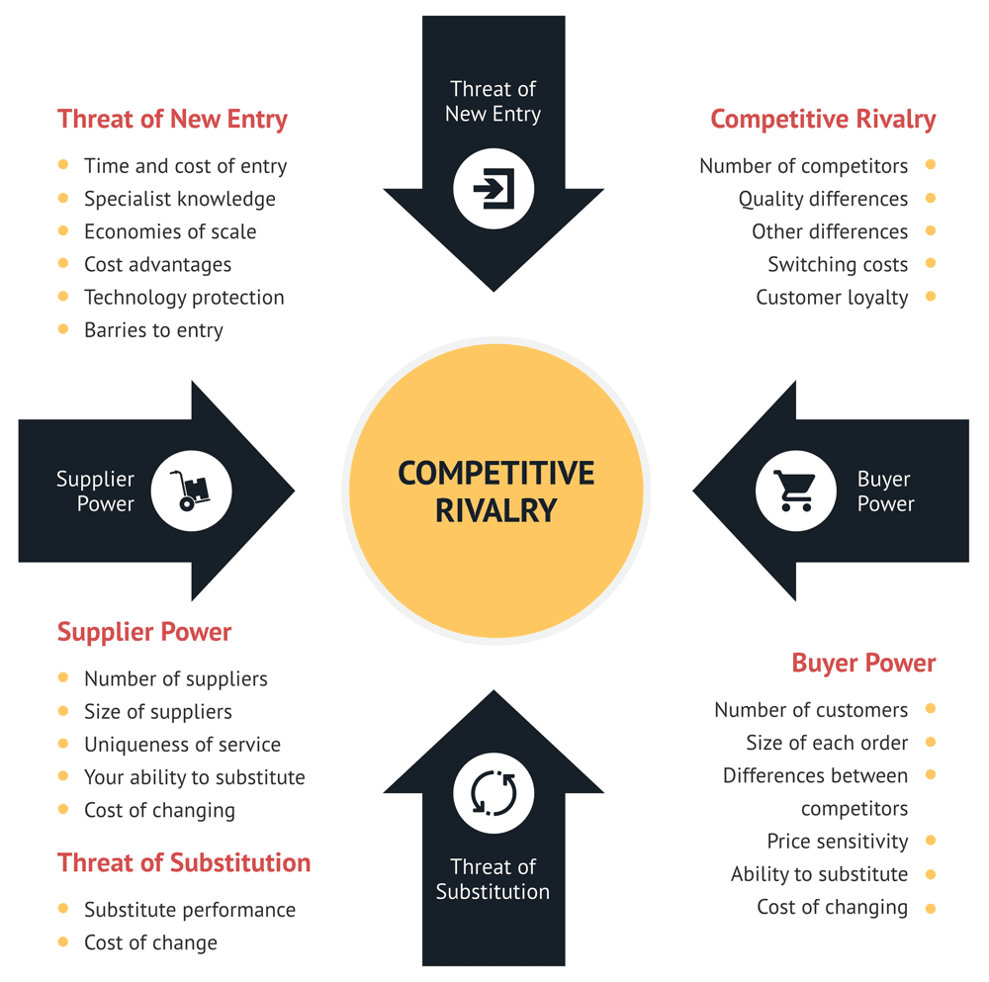
Figure 1 Porter 5 forces
(Source: Intachote, 2018)

Collaborators: Demonstrate an awareness of your organisations B2B Relationships, Partnerships, Franchises.
Climate: PESTLE (Macro analysis): PESTLE analysis is an acronym for political, economic, social, technological, legal, and Environmental (Christodoulou, and Cullinane, 2019). This analysis will show the current social and political setting of the case company and other factors that pose a concern to it.

Political- Holiday inn is highly dependent on the tourism and government regulations of the countries. The case company has to follow all the policies of present political party norms in the country (Youssef, 2022). | Economical- The Company must analyse the first economic fallouts of the country like inflations, recessions, etc. Holiday inn has a valuable position in different countries of the world and matched its budget according to the economic condition of the country. | Social-Holiday inn provides more affordable and luxurious rooms to the individual so that different class of people can be served with better services by the company. A case company also has a CSR policy to socially work in different countries of the world.
Technology- Holiday inn adopts new and updated technologies to perform better in the hotel market in different countries (Karmiathi, and Putra, 2022). The company uses trendy technologies like lifts, intercoms, Wi-Fi services, online booking, etc. to beat its local and renowned competitors globally. | Legal- Different country has different rules and regulations on the hotel industry and the case company also have to follow all those rules to smoothly run its business in various countries. Almost countries have discrimination laws to benefit the hotel industry. | Environmental-The case company is always ready to face any weather conditions in different countries. Holiday inn largely focuses on an eco-friendly environment in its all-hotel campus across the globe. The company is shifting to more biodegradable items to pledge the climate crisis.

Objectives
Marketing goals that are SMART are methods for setting goals which teams employ to devise a strategy for marketing that is actionable to support the long-term goals, such as the strategies to increase sales and engage customers. SMART's marketing objective functions more of a framework for success in goal setting of the Holiday inn. The objectives of the case company are categories under the time bound process which is specific, measurable attained, realistic, and time bound.

Strategy
In the hotel industry or even in Holiday inns, there are several different trends to be conscious of and the hotel trends are ambitious by a number of vital factors such as emerging technology, lifestyle changes, and corona virus. The huge change impacted by the corona virus in every field of business on Earth (Lai, and Wong, 2020). In hotel chain Management Companies, it is compulsory to emphasize hygiene and safety, and demand for contactless payments after the entry of COVID-19.
The most useful and effective plan to attract more new customers to the case company's services is discussed below:
Mobile trend- The case company can provide more useful and initial details of its services and booking slots on its website so that customers can open it on their phone also. As the customer visits the company's website, the company's employees should try to connect with the customers.
Unique selling points (USP) - Holiday inn may use many unique selling promotions on its website to retain customers and gain a competitive advantage over its competitors. The USP can be used for last-minute deals, attractive images, pop-ups, etc.
A strong presence on social media platforms- As young travellers widely uses the social media platforms like Instagram, Facebook, Twitter, etc. So, the company actively post its services, campaigns, or advertisement poster on these social media platforms to bring a huge customer base to the company.

Bowmans strategy clock will influence the cost and value proposition of the case company which can be easily understood through the help of the figure 2 below:
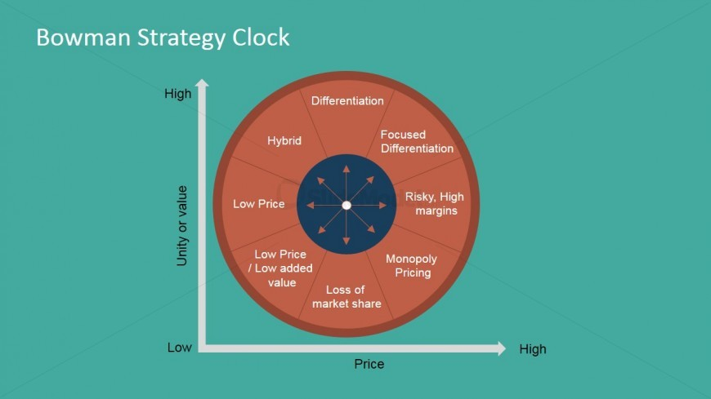
Figure 2 Bowman strategy for value proposition

Tactics
Marketing mix:
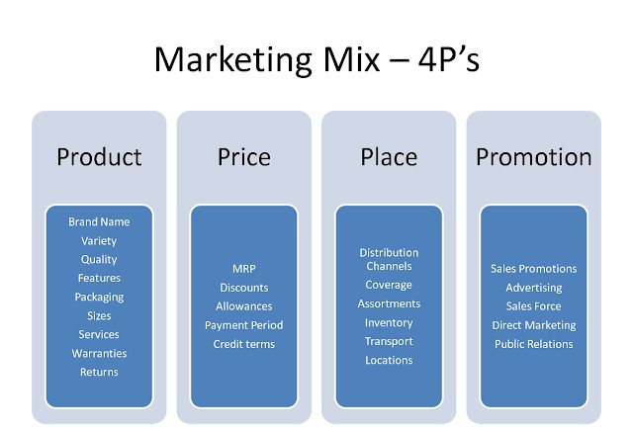
Figure 3 4Ps of the hotel marketing mix

(Source: Donotdont, 2015)

In the above figure, the case company is more affected by the primary 4ps of the marketing mix of the hotel industry (Susantini, et. al. 2018). Holiday inn already placed its effective position in the global market but also has to run its business with the above-mentioned marketing Ps to gain a competitive advantage on a primary basis.

Action plan

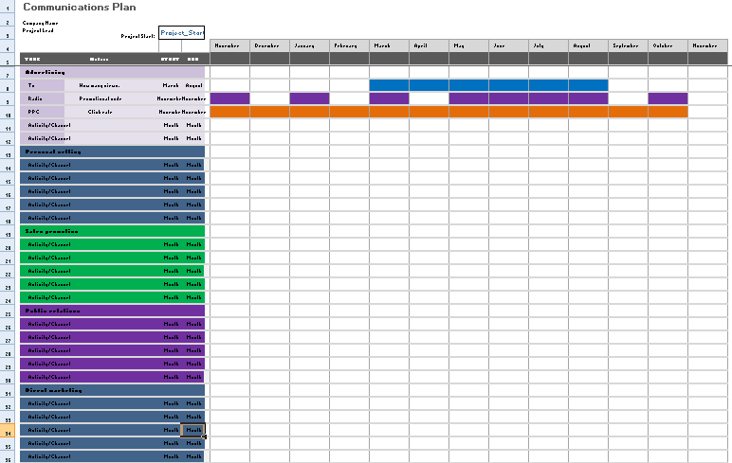

Control
The company should analyse different countries' hotel industry plans and then apply a suitable strategy that matches the country's environment and people. The more challenging phase for the case company was the corona virus pandemic. And the case company also get stable during the COVID-19 pandemic which shows the company's solidity in the global market. The case company has effective branding and positioning in the hotel industry as when the customer tries to search best hotel rooms the Holiday inn's hotel comes in front.

Conclusion
From the above-mentioned report, it is concluded that the case company has a large market reach in different countries of the world. An effective marketing strategy or plan is adopted by the company to enhance its market share in the global hotel chain market. Holiday inn also gains a competitive advantage over its different competitors on an international level with the adoption of new trends on a timely basis.

References

Bruijl, D. and Gerard, H.T., 2018. The relevance of Porter's five forces in today's innovative and changing business environment. Available at SSRN 3192207.
Christodoulou, A. and Cullinane, K., 2019. Identifying the main opportunities and challenges from the implementation of a port energy management system: A SWOT/PESTLE analysis. Sustainability, 11(21), p.6046.
Donotdont, 2015. Market of hotel 4Ps (online). <http://1.bp.blogspot.com/hr7kjI9cuJI/VXkC7qJJS6I/AAAAAAAAB9c/FAzwIRCK83E/s640/4ps-marketing.png> (accessed on 24 November 2022).
Holiday inn, 2022. WE ARE HERE FOR YOU - NOW AND LATER (online). <https://www.holidayinnexpress.com/hotels/us/en/reservation> (accessed on 24 November 2022).
Intachote, P., 2018. Discounted cash flow valuation of the Erawan group public company limited
Karmiathi, N.M. and Putra, I.K.A., 2022. Technical analysis of power factor improvement using ETAP 12.6 at Regent Resort & Holiday Inn Canggu. Matrix: JurnalManajemenTeknologidanInformatika, 12(1), pp.38-50.
Kencana, N.W.P.A., Arjana, I.W.B. and Sudiarta, M., 2018. OPPORTUNITIES AND THREATS TO INCREASE ROOM OCCUPANCY HOLIDAY INN RESORT BALI BENOA. Journal of Applied Sciences in Travel and Hospitality, 1(3), p.263.
Lai, I.K.W. and Wong, J.W.C., 2020. Comparing crisis management practices in the hotel industry between initial and pandemic stages of COVID-19. International Journal of Contemporary Hospitality Management.
Nalley, M. and Gregory, A.M., 2021. A Case for Change, Market Segmentation and Brand Management. In SAGE Business Cases. International CHRIE.
Slootweg, E. and Rowson, B., 2018. My generation: A review of marketing strategies on different age groups. Research in Hospitality Management, 8(2), pp.85-92.
Susantini, N.K.D., Sutarma, I.G.P. and Armoni, N.L.E., 2018. ANALYSIS OF IMPLEMENTATION OF PROMOTION MIX STRATEGY AT HOLIDAY INN EXPRESS BARUNA BALI TO MAINTAIN THE MARKET. Journal of Applied Sciences in Travel and Hospitality, 1(1), p.8.
Teoli, D., Sanvictores, T. and An, J., 2019. SWOT analysis.
Youssef, A., 2022. Meaning (A) Drift: The Movement in the Holiday Inn Beirut's Socio-Political Narrative (Doctoral dissertation, Carleton University).

https://www.ihg.com/holidayinnexpress/hotels/gb/en/newcastle-upon-tyne/ncljb/hoteldetail?cm_mmc=YextLocal-_-EX-_-GB-_-NCLJB

Appendices
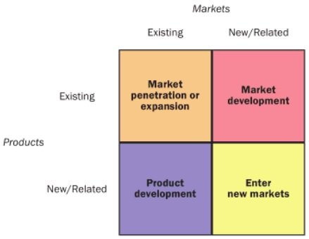

PowerPoint



