Juwayriyah Bibi
2315837
BA (Hons) Leadership and Management Skills for the Workplace. Level 6.
Strategic Management for Business LCLM6001
Yohan Mendis
Word count: 3141 (excluding references)

Contents

1) Executive Summary ............................................................. 3
2) Introduction ......................................................................... 4
3) Current Strategic Direction ............................................... 5-6
4) Environmental Scan and Competitive Positioning ............ 7
4.1 Value Chain Analysis......................................................... 6
4.2 SWOT Analysis..................................................... 7
4.3 PESTEL Analysis.............................................................. 9
4.4 Porter’s Five Forces.................................................. 10
5) Strategic Growth Options ..................................................11- 12
6) Stakeholder Analysis ......................................................... 13
6.1 Mendelow’s Matrix ..................................................... 14
7) Strategic Recommendations and Implementation ........... 15
7.1 Six-Month Implementation Plan (Gantt) ................. 16
8) Conclusion .......................................................................... 17
9) References .......................................................................... 18-19

- Executive summary
This report evaluated the strategic position of Arias, a Birmingham SME offering personalised hampers, flowers, balloons and bespoke gifting. External analysis identified inflationary pressure, price competition from supermarkets and seasonal demand volatility, but also growing consumer interest in customised, experiential gifts. Internal review highlighted strengths in agility, personalisation and social-media visibility, alongside capacity constraints and informal processes during peak periods.
SWOT, Value Chain and Porter’s Five Forces indicated opportunity to enhance differentiation and expand delivery reach. Using Ansoff’s Matrix, a focused differentiation strategy through product and market development is recommended. Stakeholder assessment via Mendelow’s Matrix showed suppliers, couriers and local customers hold high influence and require active engagement; a brief RACI clarified accountability.
Operational recommendations include supplier diversification, packaging improvements, seasonal workflow templates and multichannel marketing to reduce platform dependency. A phased, low-capital implementation plan, supported by a six-month Gantt schedule, improves feasibility within SME resource constraints. Overall, this strategy strengthens competitiveness, increases repeat purchasing and enhances resilience while retaining Arias’ core proposition of bespoke gifting.

- Introduction
Arias is an independent gift and personalisation shop located in the Cape Hill, Birmingham, jointly operated by two business partners. Established in 2020, the business offers customised gifting solutions including bespoke hampers, personalised balloons (with names/graphics), vinyl-printed gifts, and made-to-order fresh flower bouquets (Arias Sweets Shop, 2024). Operating from a physical storefront, Arias uses Instagram for product showcasing, promotions and order enquiries, a channel that is particularly effective for SMEs for other customers to see reviews and products for themselves (Hassan et al., 2023).
Customers can receive their orders in several different way to suit their needs. They can collect in-store if they are local, the owners personally offer delivery for balloon/event setups locally and for certain items or they can be shipped over longer distances via courier (Arias Sweets Shop, 2024). Bouquets are produced to order, enabling customisation and reducing floral waste, an important operational consideration given rising input costs (ONS, 2024; Kotler et al., 2022).
The shop competes in a price-sensitive local market shaped by large discounters such as Asda and Home Bargains, which benefit from economies of scale. These rivals can undercut on price and convenience, but struggle to imitate bespoke and personalised gifts at low cost. (Johnson et al., 2020; Coviello, 2020).
Demand is highly seasonal around cultural and life events—Valentine’s Day, Mother’s Day, Eid, Christmas and graduations, creating working-capital pressure and forecasting complexity typical of SME gifting (OECD, 2021; Arias Sweets Shop, 2024). Meanwhile, inflation and import-linked cost increases in flowers, balloons and packaging have compressed margins (ONS, 2024).
This report will critically evaluate Arias’ strategic direction and goals, conduct an environmental scan (SWOT, Value Chain, PESTEL, Porter’s Five Forces), develop and justify strategic growth choices (Ansoff, Porter’s Generic Strategies, Bowman’s Strategic Clock), analyse stakeholder expectations (Mendelow; RACI), and conclude with actionable, sustainable recommendations.

- Current strategic direction and goals (Vision, Mission and Objectives) of the Arias.
Arias does not currently have an official long-term plan or clearly written strategy. This is common for very small businesses because they often do not have enough time, money or specialist management skills (Hudson et al., 2021). However, without clear goals and direction, decisions can become unorganised, the message to customers may be confusing, and the business can slowly fall behind changes in the market (Johnson et al., 2020). With growing competition from low-cost retailers and increasing supply prices, Arias needs a stronger strategy to remain competitive.
Vision
“To become the leading local provider of personalised gifting solutions in Birmingham, recognised for creativity, quality and outstanding customer experience.”
A well-constructed vision delivers a desired future state and motivates internal stakeholders by providing direction (Kotler et al., 2022). It should be ambitious yet achievable, offering a long-term aspirational position (Bryson, 2018). This vision signals differentiation, which is crucial given competition.
Mission
“To design and deliver high-quality personalised hampers, balloons and floristry products that create meaningful gifting experiences, through exceptional craftsmanship, customer service and flexible delivery options.”
Effective mission statements communicate purpose, values and the strategic scope of operations (David et al., 2020). This mission emphasises experience for the customers, which is extremely important when gifting. (Mintel, 2024). It also acknowledges flexibility, a key expertise for SMEs.

Strategic Objectives (SMART)
To translate mission into action, Arias should adopt SMART (Specific, Measurable, Achievable, Realistic, Time-bound) objectives (Doran, 1981):
-Increase Instagram-driven sales conversions by 20% over the next 12 months through targeted content and promotional campaigns.
-Launch an e-commerce website within 9 months to expand the customer base beyond local footfall.
-Reduce product waste by 15% within 6 months by refining inventory ordering and enhancing made-to-order bouquet scheduling.
-Develop three corporate gift partnerships within one year to reduce seasonality pressure.
-Achieve a 10% growth in repeat customer purchases within 12 months through loyalty incentives.
These objectives support strategic alignment and operational control, which SMEs often lack (OECD, 2021). These objectives also help the business to deal with seasonal busy periods as well as the quieter months.

Arias demonstrates elements of a differentiation focus strategy, delivering personalised products (Porter, 1980). However, weaknesses include: Over-reliance on Instagram alone for digital outreach. Limited scalability due to manual production. Most gifts are hand made on the day or personalised upon request so Arias is limited to how much they can take in a day with only 2 workers. Another weakness is Arias busy periods during seasonal times such as valentines creates an unsteady amount of money. Additionally, If the suppliers that Arias uses start to charge more for the products, then the business will suffer from profit loss or then change prices.
The lack of formal strategic planning increases exposure to external shocks, as observed during inflationary periods (ONS, 2024). If the business doesn’t set clear goals, it will only respond to problems as they happen instead of planning ahead.

- Environmental scan. (Internal environment – SWOT, Value Chain / External environment – PESTEL, Porter’s five forces).
Internal analysis
Value Chain (Porter, 1985)
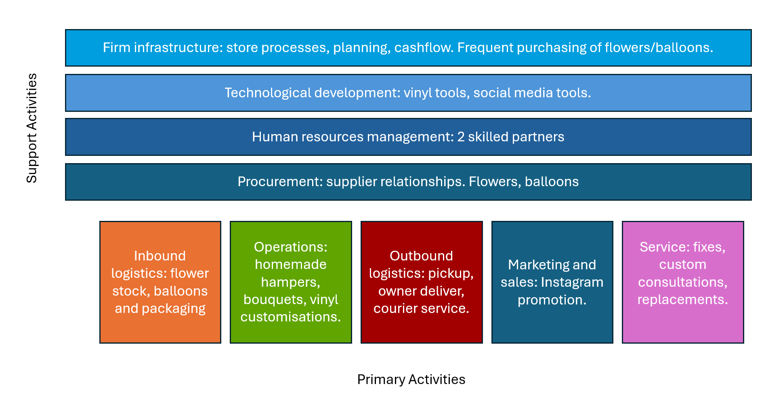
Figure 1) Value chain for Arias
The value chain analysis highlights that Arias’ primary value creation stems from operations, particularly the bespoke personalisation and design stages that differentiate the business from mass-market retailers. However, manual craftsmanship introduces a level of capacity, especially during seasonal peaks, while inbound logistics expose the business to supplier price instability. Outbound logistics are strengthened through flexible collection and delivery options, and Instagram enhances visibility despite platform dependency. Support activities such as procurement and technology are modest but functional, suggesting that standardising certain production tasks and diversifying suppliers could improve scalability without compromising customisation. However, the value chain model may oversimplify experiential and emotional value elements within personalised gifting, which are difficult to map to linear activities.
VRIO is a strategic tool used to assess whether a resource or capability gives a business a competitive advantage. (Barney, 1991). Applying the VRIO framework suggests that Arias’ personalisation capabilities and design expertise are valuable, rare, and difficult to imitate due to the tacit knowledge and creative skill involved. However, limited process formalisation means these capabilities are not yet fully organised to scale, resulting in a temporary rather than sustained competitive advantage.
The SWOT matrix below categorises Arias’ internal strengths and weaknesses alongside external market opportunities and threats. This structure enables strategic alignment between capabilities and environmental conditions.
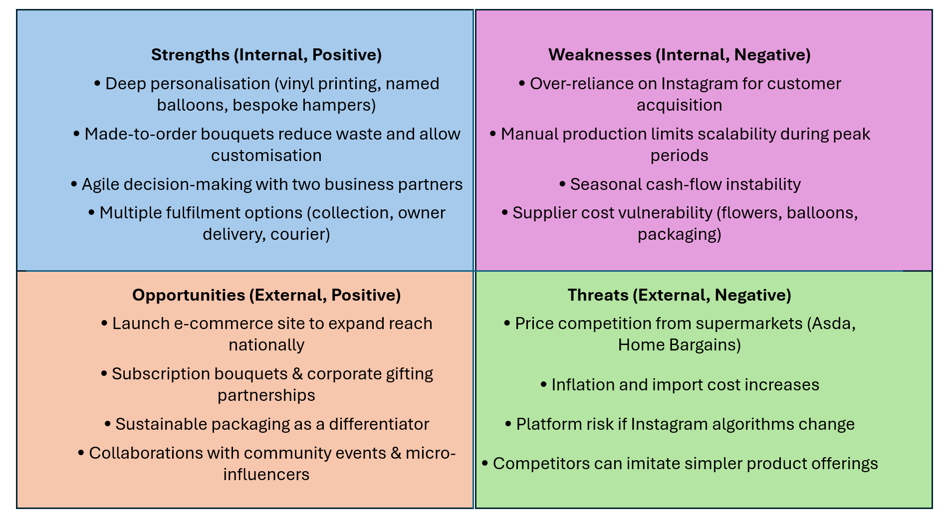
Figure 2) SWOT analysis
The SWOT matrix highlights that Arias’ competitive advantage is mainly driven by deep personalisation, made-to-order products and operational agility, which are difficult for large discounters to imitate. However, weaknesses such as seasonal cash-flow instability, supplier cost vulnerability and manual production capacity suggest scalability challenges during peak periods. Opportunities such as e-commerce expansion, corporate gifting partnerships and sustainable packaging can help reduce seasonality while differentiating the brand further. Threats including supermarket price competition and Instagram algorithm changes highlight the need to diversify marketing channels and strengthen brand loyalty.
SWOT analysis on its own is not enough to guide a business as it oversimplifies factors, therefore using other tools like Five Forces or PESTEL are useful to properly understand the full situation.

External analysis
PESTEL The PESTEL analysis highlights that economic inflation and fluctuating import costs represent the most immediate external risks to Arias, while social trends towards personalisation support growth opportunities. Regulatory requirements such as product safety and data protection remain manageable but require basic compliance controls. Technological dependency on social platforms enhances reach but increases platform risk, reinforcing the importance of diversifying marketing channels.
- Political/Legal: UK consumer protection, product safety (balloons/helium), GDPR for customer data; simple compliance checklists reduce risk.
- Economic: Inflation and exchange rates affect flower imports and packaging costs; maintain flexible pricing and tiered bundles.
- Social: Rising preference for personalised, meaningful gifts; diverse local celebrations (Eid, weddings, graduations) expand theme opportunities.
- Technological: Social commerce, low-cost e-commerce, print-and-cut vinyl tools; adopt automation for order taking and reminders.
- Environmental: Waste, plastics and packaging scrutiny; switch to recyclable/compostable options and disclose sourcing.
- Legal (retail operations): Trading standards, returns, courier liability; define T&Cs and courier legal agreements.
The PESTEL analysis highlights that Arias operates in a moderately stable but cost-sensitive environment. Politically, small businesses benefit from local entrepreneurship initiatives, yet face increasing regulatory requirements on waste management and packaging. Prices for products and supplies keep rising, so Arias earns less profit on each sale. Customers also spend money depending on the time of year, which makes sales unpredictable. Socially, gifting culture remains strong in Birmingham’s diverse community, especially around cultural celebrations such as Eid, Valentine’s Day and Mother’s Day, sustaining demand for personalised products. Technological change offers opportunity through affordable digital marketing and e-commerce integration, but Arias remains heavily reliant on Instagram, limiting exposure to wider audiences. Environmental expectations around sustainable packaging and floral sourcing are growing, requiring gradual adaptation to maintain brand trust. Legally, compliance with health, safety and trading standards is straightforward but non-negotiable. Overall, PESTEL factors indicate that while external instability challenges cost management, emerging consumer preferences and digital tools provide strategic growth potential for a small business like Arias.
Porter’s Five Forces (Porter, 2008) are applied to assess the competitive intensity of the personalised gifting market and Arias’ position within it. The chart below illustrates the relative strength of each force.
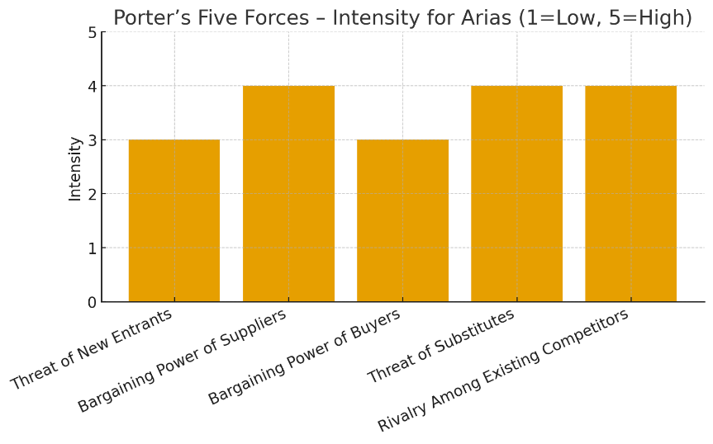
Figure 3) Intensity of 5 forces
High substitute and rivalry intensity suggest a need for continuous innovation and strong emotional branding to avoid price-based competition.
The Five Forces analysis indicates that Arias operates within a highly competitive environment, with strong substitute pressures from generic gifting alternatives and significant rivalry from supermarkets offering low-priced, mass-produced products. High supplier power resulting from fluctuating flower import costs further increases operational vulnerability. Although buyer power is moderate due to the unique nature of personalised gifts, the threat of new entrants remains present due to low start-up barriers. This suggests that Arias should continue emphasising differentiation through personalisation, emotional value, and service quality, while diversifying supplier relationships to reduce cost exposure. However, the Five Forces model assumes stable market structures and may not fully account for rapidly shifting consumer behaviours and digital platform dynamics within the personalised gifting industry.
Competitive positioning (Bowman’s Clock; Grant, 2019)
Arias competes in a differentiation-focus space: higher perceived value through bespoke design, personal service and flexible fulfilment, at moderate prices. To hold the position against discounters, sustain perceived value (design quality, speed, reliability, sustainability cues) and reduce Instagram dependence with owned channels (email/SMS, website).

- Strategic Growth Choices and Proposed Long-Term Strategy

SMEs typically have several strategic growth paths available through market and product decisions. According to the Ansoff Matrix (Ansoff, 1957), businesses can pursue growth through four main strategies: Market Penetration (selling existing products to existing markets), Product Development (creating new or improved products for current customers), Market Development (entering new markets with existing offerings), and Diversification (introducing new products to new markets). For Arias, a small partnership with limited resources, Focused Differentiation achieved through elements of Product Development and Market Development is the most suitable approach. This strategy builds on Arias’ strengths in personalisation, creativity, and customer intimacy, allowing it to offer unique, higher-value gifts that cannot be easily replicated by mass-market retailers. Unlike diversification, which carries high financial and operational risk, focused differentiation enables Arias to grow sustainably while preserving its distinctive identity as a bespoke gifting brand.
This focus on differentiation through creativity and personalisation supports long-term sustainability by deepening customer loyalty, enabling premium pricing, and strengthening Arias’ competitive resilience in a changing retail landscape.
Porter’s Generic Strategies (1985) indicate that Arias should pursue focused differentiation, strengthening its niche in bespoke gifting. Competing on cost is unsustainable against supermarkets with economies of scale. Arias instead differentiates through design creativity, personalisation vinyl, tailored consultations and one-off balloon setups, which are attributes that are difficult to imitate.
Bowman’s Strategic Clock further supports a shift towards Position 4 (Differentiation), emphasising perceived value rather than price sensitivity (Bowman, 1996). Attempting mixture of products (mid-price, mid-value) risks strategic strength. Therefore, the best long-term plan for Arias is to stand out from competitors by offering unique, personalised products.
This strategy is considered sustainable for reasons including there is a demand for bespoke gifting rather than mass-produced items (Deloitte, 2022). Differentiation reduces replacement threat. Focused differentiation coupled with product and market development offers a balanced growth path that maximises Arias’ creative capabilities, strengthens defensibility, and enhances long-term customer loyalty without exceeding resource constraints. The Ansoff Matrix simplifies market dynamics and assumes linear growth paths, which may overlook rapidly shifting consumer preferences in experiential gifting (Grant, 2019)

- Stakeholder analysis and critical evaluation of the different stakeholders and their relative power to identify the most suitable, feasible and acceptable strategic option/options (Mendelow’s Matrix)

Strategic change in SMEs can be highly sensitive to stakeholder dynamics due to concentrated resource dependence and informal governance structures (Ribeiro-Soriano, 2017). The recommended focused differentiation strategy, supported by product and market development, will therefore shift stakeholder expectations and power distributions. Identifying stakeholder responses is essential to ensure suitability, feasibility and acceptability (Johnson et al., 2020).
Key stakeholders relevant to Arias include owners/partners, local customers, regional delivery customers, local suppliers, courier partners, temporary seasonal labour, Instagram followers, the local council, and competitors.
Mendelow’s matrix:
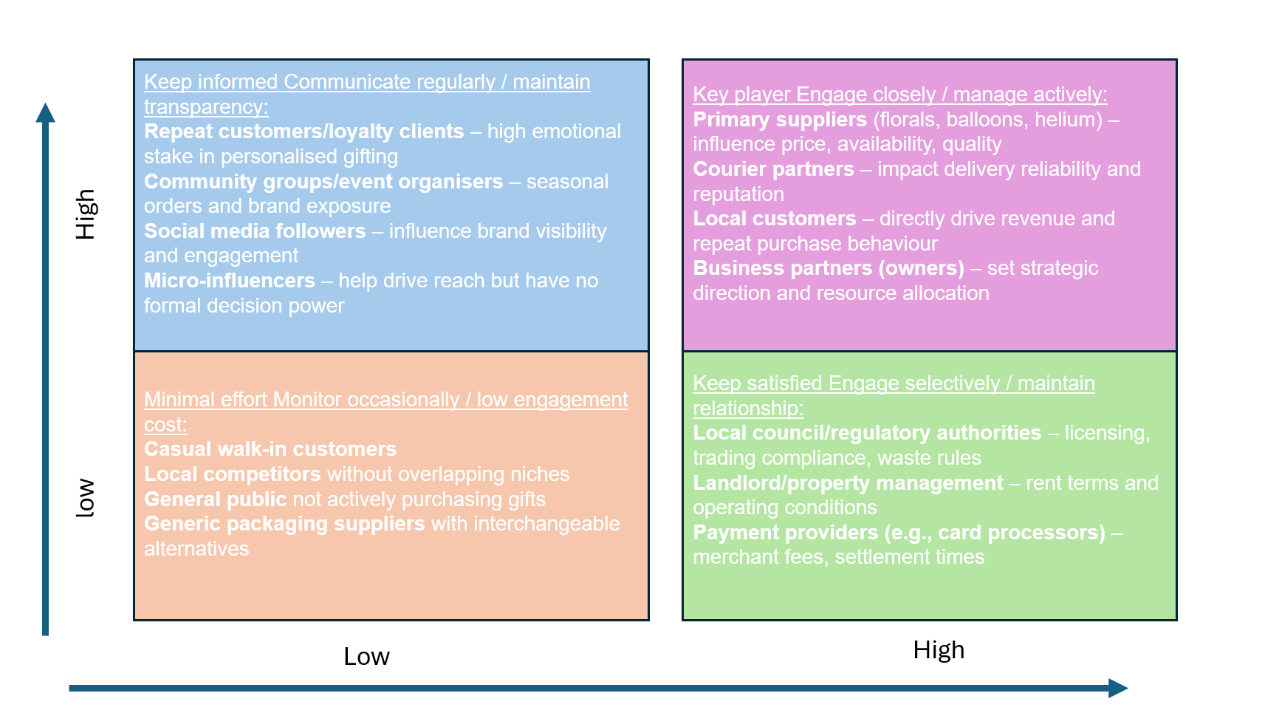
Figure 4) Mendelow’s matrix

High Power / High Interest (Manage Closely):
Owners hold financial control and strategic decision rights. Key suppliers influence cost instability, availability and quality, particularly important under product development. Local customers exert reputational pressure via reviews, increasing interest as the delivery radius expands.
High Power / Low Interest (Keep Satisfied):
Local council involvement is limited but critical for regulations around signage, waste disposal and helium canister safety. The commercial landlord retains power through lease terms but low emotional interest.
Low Power / High Interest (Keep Informed):
Instagram followers and regional customers care about product quality and delivery reliability but cannot directly influence strategic decisions. Seasonal temporary staff have high interest due to compensation and scheduling but low organisational power.
Low Power / Low Interest (Monitor):
The wider community and indirect competitors display minimal engagement unless public issues arise (e.g., waste, noise).
Mendelow’s Matrix can oversimplify dynamic power relations and assumes stakeholder interests remain stable, which may not hold in social-media-mediated retail environments (Freeman et al., 2020).
Strategic growth requires balancing customer quality expectations, supplier reliability needs and courier fulfilment constraints.
Suitability, Feasibility, Acceptability (SAF)
Suitability:
Aligned to market trends favouring personalisation and experiential gifting (Deloitte, 2022). Supports competitive differentiation identified in Five Forces and SWOT. Arias’ focus on custom hampers, balloon decor, and personalised gifts especially during events like Eid and Mother’s Day. This aligns with market trends toward personalisation and helps Arias stand out from supermarkets that sell generic gifts.
Acceptability:
Local customers value increased customisation; suppliers benefit from larger volumes; couriers gain consistent demand. Acceptability risk exists only if quality slips during peak demand. Customers appreciate the added personal touches, such as names printed on balloons and made-to-order bouquets, which improve satisfaction and repeat purchases. Suppliers benefit through larger, more predictable orders around key seasons, and couriers gain steady business from regular deliveries.
Feasibility:
Requires limited capital investment; scalable through packaging efficiencies, seasonal labour onboarding, and supplier diversification (Hudson et al., 2021). Arias can carry out this strategy with its current workspace and two partners, requiring only minor upgrades in packaging and temporary staff during peak times. By ordering materials in bulk and using a second supplier for helium and florals, it can scale sustainably without major investment.

- Strategic Recommendations and Implementation

To support long-term competitiveness, Arias should implement a focused differentiation strategy through product development and market development.
Recommendation 1: Standardise seasonal templates
Seasonal demand surges (Valentine’s Day, Mother’s Day, Eid) is hard to manage currently. Simple templates (e.g., pre-cut hamper fillers, standard balloon arch sizes) reduce cycle time and variance, improving throughout (Slack et al., 2020). This enables the business to convert more peak-season demand into revenue without adding full-time labour costs.
Recommendation 2: Dual-source key suppliers
Relying on just one supplier can be risky because prices can suddenly go up, items might go out of stock, and it can be harder to get materials when needed. By adding a second supplier, Arias has a backup source, can avoid running out of flowers, balloons, or helium and can keep prices more stable. This helps the shop keep operating smoothly, especially during busy seasons.
Recommendation 3: Packaging standardisation and courier agreements
As delivery radius expands, damage risk increases. Reinforced packaging (bubble containment, rigid boxing, deflated balloon shipping) and courier service level agreements (delivery window, compensation) protect perceived quality, maintaining differentiation (Bask et al., 2022).
Recommendation 4: Multichannel marketing expansion
Reliance on a single platform (Instagram) concentrates reputational and algorithmic risk. Adding TikTok short-form content and Google Business Profile improves discoverability (Chaffey and Ellis-Chadwick, 2019). This improves market access without requiring additional physical capacity.
Recommendation 5: Temporary labour for peak periods
Hiring part-time support during seasonality reduces cycle time delays and preserves service quality. Temporary onboarding documentation enables flexible scheduling without permanent payroll burden.
Implementation barriers include limited capital, founder dependency, informal processes, and digital skills constraints, which are common in micro-enterprises (Hudson et al., 2021). Addressing these challenges requires small, incremental improvements rather than transformational change.

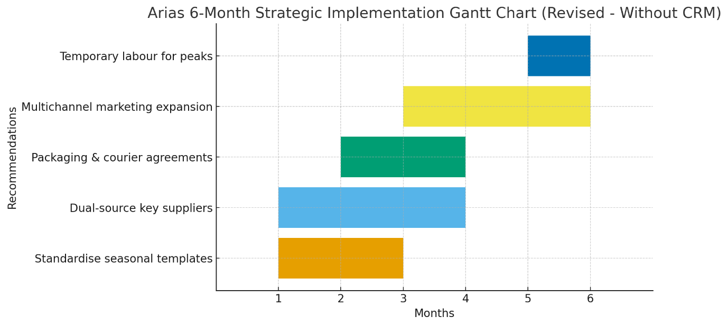
Figure 5) Gannt chart for 6 months

The recommended strategy is suitable, acceptable and feasible. It is suitable as it aligns with increasing demand for personalised gifting. It is feasible due to low capital requirements and incremental process improvements. It is acceptable to key stakeholders as suppliers gain volume consistency, customers gain product variety, and courier partners gain predictable demand.
Risks are managed through dual couriers, dual suppliers and use of packaging checklists. Key performance indicators include increased seasonal capacity, higher repeat purchase rates and reduced delivery complaints. These KPIs are SMART and measurable.
- Conclusion:
This report critically evaluated Arias’ strategic position as a SME operating within an increasingly competitive and price-sensitive gifting environment. Environmental analysis highlighted external pressures from inflation, supermarket substitution and seasonal demand variability, while internal assessment revealed strengths in personalisation, responsiveness and social media driven brand visibility. Applying growth frameworks indicated that focused differentiation, supported by product and market development, offers the most sustainable long-term path, allowing Arias to scale custom gifting without competing on price. Stakeholder analysis demonstrated that implementation requires active engagement with suppliers, couriers and local customers to manage expectations and protect service quality. Operational recommendations, including dual sourcing, packaging standardisation and seasonal workflow templates, address capacity constraints typical of SMEs. The proposed phased implementation plan is feasible within limited capital resources and strengthens resilience during seasonal peaks. Ultimately, this strategy enhances competitiveness, supports repeat purchasing and extends geographic reach while safeguarding Arias’ core value proposition of bespoke, memorable gifting.

- References
Ansoff, H.I. (1957) ‘Strategies for diversification’, Harvard Business Review, 35(5), pp.113-124.
Arias Sweets Shop (2024) Internal operational overview and business information. Birmingham: Arias Sweets Shop.
Arias Sweets Shop (2025a) Instagram page (@arias_sweets7). Available at: https://www.instagram.com/arias_sweets7/ (Accessed: 1 November 2025).
Bowman, C. and Faulkner, D. (1996) Competitive and Corporate Strategy. London: Pitman.
Bryson, J.M. (2018) Strategic Planning for Public and Nonprofit Organizations. 5th edn. Hoboken: Wiley.
Barney, J. (1991) ‘Firm resources and sustained competitive advantage’, Journal of Management, 17(1), pp. 99–120.
Coviello, N. (2020) ‘Integrating qualitative and quantitative research in B2C contexts’, Journal of Business Research, 116, pp. 454–465.
Deloitte (2022) Personalised Consumer Trends Report. Available at: https://www2.deloitte.com (Accessed: date).
David, F.R., David, F.R. and David, M.E. (2020) Strategic Management: Concepts and Cases. 17th edn. Harlow: Pearson.
Doran, G.T. (1981) ‘There’s a S.M.A.R.T. way to write management’s goals and objectives’, Management Review, 70(11), pp. 35–36.
Freeman, R.E. et al. (2020) Stakeholder Theory: The State of the Art. Cambridge: Cambridge University Press.
Grant, R.M. (2019) Contemporary Strategy Analysis. 10th edn. Hoboken: Wiley.
Hassan, L.M., Shiu, E.M. and Parry, S.C. (2023) ‘Social media engagement and micro-retail outcomes’, Journal of Retailing and Consumer Services, 72, 103216.
Hudson, M., Smart, A. and Bourne, M. (2021) ‘Understanding SME growth constraints’, Journal of Small Business Management, 59(3), pp.439-458.
Johnson, G., Whittington, R., Scholes, K., Angwin, D. and Regnér, P. (2020) Exploring Strategy. 12th edn. Harlow: Pearson.
Kotler, P., Keller, K.L. and Chernev, A. (2022) Marketing Management. Global edn. Harlow: Pearson.
Mintel (2024) Gifting in the UK. London: Mintel Group Ltd.
Mintel (2023) UK Gifting Market Report. Available at: https://www.mintel.com (Accessed: date).
OECD (2021) SME and Entrepreneurship Outlook 2021. Paris: OECD Publishing.
Office for National Statistics (ONS) (2024) Consumer price inflation, UK. Available at: https://www.ons.gov.uk (Accessed: 1 November 2025).
Porter, M.E. (1985) Competitive Advantage: Creating and Sustaining Superior Performance. New York: Free Press.
Porter, M.E. (1980) Competitive Strategy. New York: Free Press.
Porter, M.E. (2008) ‘The five competitive forces that shape strategy’, Harvard Business Review, 86(1), pp. 78–93.
Ribeiro-Soriano, D. (2017) ‘Small business and entrepreneurship: their role in economic and social development’, Entrepreneurship & Regional Development, 29(1-2), pp.1–3.
Tidd, J. and Bessant, J. (2021) Managing Innovation: Integrating Technological, Market and Organizational Change. 7th edn. Hoboken: Wiley.

