Business Report- Comparison of Two Hospitality Organisations

Financial Management for the Hotel Industry

(BMIH5007 )

Student name: Andreea-Florina Chiriac
Student ID: 2126260
Tutor name: Tristan Hawkins

Executive Summary

The following report has provided a critical analysis of the in-depth comparison between Premier Inn and the Mandarin Oriental Hotel Group. This examination identifies the entire revenue that both reputable hotel companies have produced throughout the last years. The identification of the market position of the business organisation has been addressed in order to comprehend the market share, consumer demographics, as well as brand perception. In addition, it has been determined that both company entities' CSR commitment and growth potential have been analysed.

Table of Contents
Introduction 4
Discussing the total revenues generated by the hotel business 5
Showing the total revenue of Mandarin Oriental Hotel Group 5
Total revenue of Premier Inn 7
Exploring the market position of both the hotel business 9
The market position of Mandarin Oriental Hotel Group 9
The market position of Premier Inn 9
Identifying the Growth potential of Mandarin Oriental Hotel Group and Premier Inn 11
Highlighting the expansion strategies 11
Evaluating the market’s potential 11
Conclusion 15
References 16

Introduction

The appropriate controlling as well as the management of the cash flow is to increase the capability as well as the efficiency of the oversight in the hotel industry. In addition to this, the main motive of the hospitality sector is to maximise profitability so as to stay in the competitive market. There are different types of business marketing methods that are implemented by the business sectors in order to promote capital for the sake of improving the pleasure of the visitors. Hence, considering and focusing on the basic concept of the hotel industry, the discussions will be made on two hotel companies that are the Mandarin Oriental Hotel Group and Premier Inn. Mandarin Oriental Hotel Group is a luxury group of hotels, resorts and residences that has a number of properties around the world (mandarinoriental, 2023). 20 of the properties are owned by this particular group only. On the other hand, the respective business entity Premier Inn is an economical hotel group that basically meets the expectations of the consumers. The business provides cheap and economical lodgings to customers throughout the UK (premierinn, 2023). Furthermore, the commitments related to the financial aspects of the business entities will be explained respectively.

Discussing the total revenues generated by the hotel business

Showing the total revenue of Mandarin Oriental Hotel Group
Stating the sources of revenues
There are different sources of finances that are applied and looked at by the mentioned business entities that as Mandarin Hotel Group in order to ensure a smoother workflow of the business. The respective business entity follows a number of ways for the sake of earning better profitability like hotel rooms, food, drinks and many others as well. One of the most demanded facilities that is provided by the business to its consumers is the spa and wellness assistance, meeting and event facilities. The business in order to improve the experience of the business travellers provides individualised services (Drury, 2021). For example, room dining services, personal butler services and many others respectively. According to research, it has been seen that the respective business entity Mandarin Hotel Group has well-demanded hotels in many different locations that include tourist hotspots and other industrial groups respectively. Below is the classification that has been made from where the Hotel earns a higher revenue:
Rooms- 34% of the profit
Foods and drinks- 30% of the revenues
Spa and wellness- 15% of the profit
Other miscellaneous expenses- 21% of the earnings.
Highlighting the revenue trends of Mandarin Hotel Groups
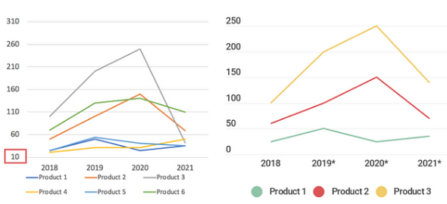
Figure: Displaying the revenue trends
Source: (statista, 2023)
The graphical representation that has been presented in the above part has basically shown the pattern of the different trends of revenues that have been earned by the respective business entity Mandarin Hotel Groups. The revenue trends basically assist the business entities in order to determining the increase as well as the decrease of the revenues that have been generated by the respective business entity considering the financial time period. The COVID-19 pandemic has caused a decline in revenue for the Mandarin Oriental Hotel Group in recent years (Drury, 2021). However, the company's earnings started to rise again in 2022 as travel restrictions started to soften. The revenue increased from 922.5 million to 1.05 billion in 2019, but it then decreased to 454.1 million in 2020 and 655.4 million in 2022. The main causes of this tendency include the COVID-19 outbreak, general economic issues, and competition from other upscale hotel chains. The income patterns of the Mandarin Oriental Hotel Group could be affected by a variety of factors. These include global occurrences like contagious diseases or shifts in the economy, tourism, advertising, and competitiveness (Seal, 2019). Excellent customer service, successful marketing campaigns, and market expansion may all contribute to revenue growth, whereas unfavourable market conditions or international crises may result in a decline.

Total revenue of Premier Inn
Explaining the sources of revenues
There are various sources of finance that are also followed by the respective business entity Premier Inn in order to ensure a smoother workflow for gaining a better competitive advantage. The mentioned business entity earns revenues by making a sale of hotel rooms in order to accommodate business travellers. The mentioned business entity in order to retain its customers provides the hotel services at reasonable and economical prices (Seal, 2019). There are different types of room services that are provided by the hotel such as deluxe rooms, family rooms, business rooms and many others. Other parts from which the business generates its revenues are the meals, drinks, houses, bars and lodging facilities respectively.
Explaining the revenue trends of the business entity Premier Inn
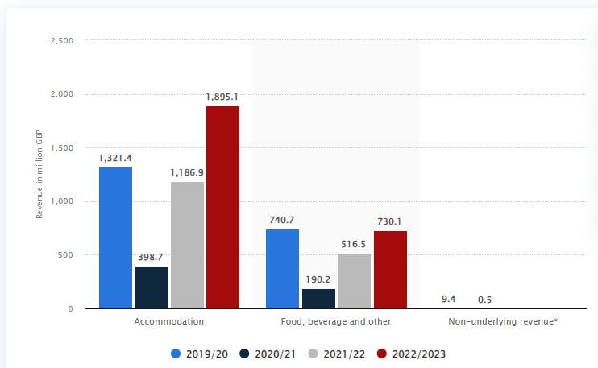
Figure: The revenue trends of Premier Inn
Source: (statista, 2023)
The graph that has been presented in the above part basically highlights the different types of services that are provided by the respective business entity Premier Inn. Here in the above graphs, it can be seen that the segmentations are divided into three years (Walker, 2021). In the year 2019/2020, it can be seen that the numbers generated from the accommodations are stated to be 1321.4 million. However, in the next part, it can be seen that from the foods, beverages and other facilities, the number that is generated was around 740.7 in million. Shifting to the other years that is 2020/2021 and 2022/2023, the numbers that are generated by the respective business entity Premier Inn is stated in the above graph that can be clearly seen (Walker, 2021). From accommodation in the mentioned years, the values show 398.7 1186.9 and 1895.1. Other than this, in terms of foods, beverages and others, the values are stated as 190.2, 516.5 and 730.1. Hence, from the graphs, it is clear that the business generates higher revenues from accommodation respectively.

Exploring the market position of both the hotel business

The market position of Mandarin Oriental Hotel Group
Market share
The market share of the respective business entity is considered the highest ranked amongst the premium hotels if compared to the other hotels as it is operated all over the globe. According to research, it can be seen that having a network of 32 hotels and resorts spread over 22 countries, the Mandarin Oriental Hotel Group has a market share of roughly 1.5% in the world's premium hotel market.
Customer demographics
Business travellers, affluent travellers, and nomads from throughout the world are just a few of the broad clientele that Mandarin Oriental Hotel Group serves. With an average age between 35 and 55, their clientele is primarily wealthy. The company is well-known for its upscale offerings and sumptuous lodgings and has a significant presence in Asia, particularly in China, Hong Kong, and Japan.
Brand perceptions
The respective business hotel is well known for providing premium services to its customers like opulent surroundings, and strategic positions (Atrill and McLaney 2021). In addition to this, the hotels are specialised for their better tourist spots as well as resort areas across the global sphere.

The market position of Premier Inn
Market share
The respective business entity Premier Inn is considered one of the largest chains of economic hotels in the United Kingdom (Atrill and McLaney 2021). The hotel business is estimated to cover a market share of around 15% which stands out in the low-fare price category. Some of the major competitors are Travelodge, Ibis and many others respectively.
Customer demographics
Business travellers ought to operate depending on the limited spending plan by seeking lodging to is clean, tidy and hygienic. The target market for Premier Inn is the budget-conscious visitor looking for comfortable, clean accommodation that is also competitively priced. The company frequently receives visits from families, couples, and business travellers. They probably have speed and cost considerations as top goals.
Brand perception
The reasonable rates, spotless, pleasant accommodations, and handy placement of Premier Inn are well renowned (Atrill and McLaney 2021). The hotel chain’s properties are frequently close to main thoroughfares and motorways, making finding them simple. The Premier Inn is renowned for its welcoming atmosphere for families as well as its dedication to offering tremendous value for investment.

Identifying the Growth potential of Mandarin Oriental Hotel Group and Premier Inn

Highlighting the expansion strategies
Expansion strategy of Mandarin Oriental Hotel Group
There are different types of strategies that are implemented by the respective business entity in order to enhance the overall performance (Tranter et al., 2014). In addition to this, the business can make certain types of initiatives that can help them to stay in the long competitive advantage so as to grab better opportunities in the future. The strategic alliances include purchases, development and management of the assets for the sake of expanding its footprint in significant international markets.
Expansion strategy of Premier Inn

Premier Inn, on the other hand, is following an ambitious expansion plan by extending its low-cost hotel network to various countries, with a specific emphasis on significant urban and tourist areas (Tranter et al., 2014). They place a focus on services that are uniform, reasonably priced, and client-centred in order to be attractive to a range of market sectors.

Evaluating the market’s potential
Opportunities for the Mandarin Oriental Hotel Group
The Mandarin Oriental Hotel Group has the chance to make money from the expanding desire for luxury experiences by concentrating on developing Asian nations like China and India (Tranter et al., 2014). In turn, they might become more prevalent in well-known hotspots for luxury travel. They could also search for chances in the environmentally friendly and healthcare sectors in order to react to changing customer needs.
Opportunities for Premier Inn
Budget-conscious travellers may be found all around the world, but they are particularly prevalent in Asia and Europe, where Premier Inn can entice them with its efficient and cost-effective business model (Torkington et al., 2020). In addition, research that has been conducted basically notes that partnerships with renowned travel companies and the use of digital marketing may boost brand awareness and foster customer loyalty in the extremely competitive low-cost hotel industry.
Exposing growth-related obstacles
Obstacles of Mandarin Oriental Hotel
The Mandarin Oriental Hotel Group faces difficulties in growing as a result of the fierce competition in the premium hotel industry, which restricts its growth opportunities (Torkington et al., 2020). They incur enormous expenses to maintain their extremely high standards and luxurious facilities, which might reduce their profitability. Geopolitical upheavals and adjustments to the economies of the industries they target may potentially pose a threat to them.
Obstacles of Premier Inn
Saturation of the market in some regions, particularly the UK, might limit Premier Inn’s development potential and raise competition (Torkington et al., 2020). Economic downturns could affect visitors who are on a tight budget, and it might be difficult to maintain a high standard of quality across a wide range of products. It may be more challenging for them to grow because of regulatory restrictions and shifting client lodging preferences.
Recognising the Financial Commitment to CSR
Mandarin Oriental Hotel Group’s dedication to community service
The Mandarin Oriental Hotel Group has proven to be strongly committed to Corporate Social Responsibility (CSR) programmes that address sustainability, community participation, and ethical business practices. They have put in place a comprehensive sustainability policy to remove single-usage plastics from all of the company’s hotels and promote responsible buying in significant areas including seafood, coffee, and cocoa (Moyle et al., 2020). In support of global environmental goals, these programmes demonstrate a large financial commitment to ecologically beneficial practices. Through a variety of activities, including feeding the poor, providing training opportunities for young people from disadvantaged backgrounds, and collaborating with organisations like City Harvest, Mandarin Oriental continuously encourages community engagement. Their commitment to enhancing the environment in which they function is seen by the considerable financial assistance provided to these efforts. The adoption of policies like the Modern Slavery Statement, Supplier Code of Conduct, and Human Rights further demonstrates their dedication to upholding ethical business practices (Moyle et al., 2020). These rules not only show that they provide funding for moral recruiting and sourcing practices, but they also ensure that their business operations adhere to the greatest ethical standards.
The Premier Inn’s CSR commitment
Premier Inn’s Earth Day promise, which emphasises its major commitment to CSR initiatives, is evidence of its unshakable dedication to environmental stewardship, community participation, and ethical business practices (Nikolskaya et al., 2020). Their initial financial commitment to sustainability is their promise to reduce carbon dioxide intensity by up to 88% by 2050 and by 50% by 2025. Significant operational changes, such as the use of alternative sources of energy, the purchase of environmentally friendly machinery, and the broad placement of solar energy systems throughout every one of their properties, are necessary to achieve this. Although these investments show a strong commitment to environmental responsibility, they also need substantial funding. Additionally, their efforts to stop using gas in new hotel constructions, switch to sustainable gas, and cut greenhouse gas emissions from their entire fleet of autos by changing to combination and electric substitutes show that they are financially supportive of lowering their carbon footprint. Utilising solar panels and switching to energy-efficient LED lighting are examples of cost- and sustainability-effective practices (Nikolskaya et al., 2020).

Conclusion
The Mandarin Oriental Hotel Group and Premier Inn, two reputable businesses in the UK, have been thoroughly compared in this research. It has emphasised numerous internal and external operational aspects of both firms in order to establish the comparison. By determining both companies’ historical ability to generate money, a first comparison between them has been produced. Based on the evidence acquired, it has been determined that the unexpected onset of the pandemic in 2020 caused a drop in the ability of both of the enterprises listed to generate money. Moving forward, the graphs and charts have been used to determine the place in the market that both firms occupy.

References
Atrill P, McLaney E (2021) Management Accounting for Decision Makers, FT Prentice Hall
Drury C (2021) (11th Ed) Management and Cost Accounting, London, Prentice Hall
mandarinoriental, (2023). Certain hotels get it.. [Online] Available at: https://www.mandarinoriental.com/en/ [Accessed 4 October 2023].
Moyle, C.L., Moyle, B. and Burgers, H., (2020). Entrepreneurial strategies and tourism industry growth. Tourism Management Perspectives, 35, p.100708.
Nikolskaya, E.Y., Romanova, M.M., Pasko, O.V., Uspenskaya, M.E. and Saadulaeva, T.A., (2020). Formulation of development strategy for tourism and hospitality industry. International Journal of Management (IJM), 11(3), pp.467-474.
premierinn, (2023). Premier Plus rooms. [Online] Available at: https://www.premierinn.com/gb/en/home.html [Accessed 5 October 2023].
Saner, R., Yiu, L. and Filadoro, M., (2019). Tourism development in least developed countries: Challenges and opportunities. Sustainable Tourism: Breakthroughs in Research and Practice, pp.94-120.
Seal W (2019) (6th Ed) Management Accounting, London, McGraw Hill
statista, (2023). Hotels - United Kingdom. [Online] Available at: https://www.statista.com/outlook/mmo/travel-tourism/hotels/united-kingdom#:~:text=Revenue%20in%20the%20Hotels%20market,US%2422.44bn%20by%202027. [Accessed 3 October 2023].
statista, (2023). Revenue of Whitbread worldwide from 2019/21 to 2022/23, by segment. [Online] Available at: https://www.statista.com/statistics/739891/revenue-whitbread-united-kingdom-uk-by-segment/ [Accessed 4 October 2023].
Torkington, K., Stanford, D. and Guiver, J., (2020). Discourse (s) of growth and sustainability in national tourism policy documents. Journal of Sustainable Tourism, 28(7), pp.1041-1062.
Tranter,K. Stuart-Hill,T. Parker,J. (2014) Introduction to Revenue Management for the Hospitality Industry, London, Pearson
Walker J (2021) Introduction to Hospitality, Harlow, Pearson

