University of Wales Trinity Saint David

OME level 6 degree apprenticeship



Systems Engineering: manufacturing a Shaped charge
Systems Engineering (ACDA5021)

Max Fisher

2113637

April 2024

Lecturers: David Holley Jenni Steen

Contents
Table of Figures 3
Table of Figures 3
1. Introduction 4
1.1. Aims and Objectives 4
1.2. What is systems engineering 4
1.3. Overview of tools 5
1.3.1. Requirements set: 5
1.3.2. Quality Function Deployments: 5
1.3.3. Function means analysis and pugh matrix: 6
1.3.4. P diagram/what why 6
1.3.5. Failure analysis 6
1.4. Item Selected 6
2. Requirements 7
2.1. Level 1 7
2.2. Level 2 7
2.3. Required functionality: 8
3. Design 9
3.1. Design QFD 9
4. Manufacturing 11
4.1. Manufacturing QFD 1 12
4.2. Process FMA/Process Pugh 13
4.3. QFD2 15
4.4. P diagram and what why 16
4.5. Manufacturing flow 20
4.6. Fault tree analysis 20
5. Conclusion 22
6. References 23
References 23

Table of Figures
Figure 1 US' DOD model. 4
Figure 2 Functional Importances graph. 10
Figure 3 Process importances chart 13
Figure 4 Means importance graph 16
Figure 5 Key noises 19
Figure 6 Key Controls 19
Figure 7 Manufacturing flowchart. 20
Figure 8 FTA symbols [7] 21
Figure 9 FTA diagram. 22

Table of Figures
Table 1Design QFD1 10
Table 2 Manufacturing QFD1 13
Table 3 Function means analysis. 14
Table 4 Process Pugh 15
Table 5 Manufacture QFD2 16
Table 6 What why 18

Introduction

Aims and Objectives
This report aims to detail the use and effectiveness of systems process and concepts. By evaluating customer requirements and mapping these to functions, a design will be generated. This design will then be interrogated though its production cycle, identifying possible methods and means. The critical features, steps and control measures will also be identified with explanations of how these decisions were made.

What is systems engineering
Systems engineering or systems thinking originated in the 1940’s from the Bell telephone laboratories [1] as a way of visualizing a system as whole. This has progressed since then to include many different tools and theories, and have been used all manner of organizations, including both military and civilian. While systems engineering does not provide the answers, it does cause the user to stop and think about the interrelationships between steps. It takes a holistic view of requirements, and inputs and translates them approximate numbers which can be compared, contrasted, and ranked.
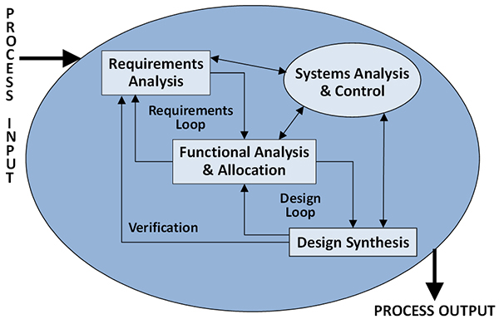
Figure 1 US' DOD model.

Overview of tools
Systems engineers utilise many different tools to complete a full analysis. This report will detail some of those used and why these were applied.

Requirements set:
Requirements set allows a user to identify the customer requirements. This is split between Level 1, 2 and sometimes 3. A level one is a simple requirement – ‘do this’ ‘do that’. The European Southern Observatory (ESO) describes this as ‘the highest level engineering requirements… they provide a link between the eventual user’s objectives and the project and engineering frameworks’ [2] Level 2 requirements are much more specific, these often come with numbers and break down the level 1 requirements into more manageable chunks. Instead of doing ‘this and that’ it becomes does ‘this to that extent’. This quantifies the problem in plain language.
Level 3 are not covered in this report, but further break this down into even smaller section. This is often required during large projects when the initial requirements have broader scopes. This task will not cover this.

Quality Function Deployments:
A quality function deployment or QFD is used to identify the critical requirements and design parameters. It can be used iteratively to expand the high-risk components of a design or manufacturing process. In a QFD 1, customer requirements are compared to a means, this will be expanded on later in this report. Initially an importance value 1-5 is assigned to each requirement, this allows a user to focus on what they deem an essential feature; this allows ‘delighters’ to be included but to not obscure the core properties. To determine the critical ‘how’, one of the following is assigned to each box: ‘1’, ‘3’,’9’ ‘-‘. This represents the strength of a relationship, with ‘1’ being the weakest relationship and ‘9’ being the strongest. The ‘-‘ is a blank space where there is no defined relationship. When all values are added, the ‘how’ with the highest number is therefore the most important part.

Function means analysis and pugh matrix:
FMA’s allow multiple options to be assessed. These maps functions to means, this is used both when identifying a design and when suggesting a manufacturing process. Multiple options are encouraged and different methods of achieving the same result can be explored. If multiple designs are deemed to be valid, they must be compared and contrasted. Requirements are introduced on the left along with a relative importance score of 1-5. Alternatives are then scored as either positive, negative or neutral. To see if a design if more affective than the other, the total must be reviewed; whichever has the highest score is the most effective solution.

P diagram/what why
A P diagram is used to investigate the key noises and controls in a system. This is done by first listing the noises such as external, unit-unit, deterioration. These are then countered by listing control factors, ideally there should be a control factor that can counter each noise. Each of these are then taken forwards into a what why diagram. This allows values to be assigned to each noise/ control. Again this uses the system of ‘1’,’3’,’9’,’-‘. This produces two charts: key controls and key noises. The highest value for each represents the most effective control measure and the most hazardous noise.

Failure analysis
A failure analysis can be completed at any stage of design or production and in many ways. Examples include a failure mode analysis; this can be regularly found in places like risk assessments, and include a failure, a consequence and the likelihood of this occurring. For DSTL any risk that is class as medium or higher requires senior leadership signoff [3]. Another method This in effect is a flowchart which explores the possible effects of a failure. These can diverge significantly and can grow large quickly. In large scale project’s fault trees can reference other fault trees; this allows a project to identify the cause and effects of a failure at a low level, while still accounting for its knock-on effects through the programme.

Item Selected
For this report a new design of a Rapid cratering kit has been examined. The purpose of the munition is to provide troops on the ground with an ability to rapidly entrench a position safely. This report will focus specifically on the shaped charge section of the munition. The shaped charge provides a ‘pilot’ hole for a larger main charge, as this is placed below ground level, it forces a large quantity of earth, sand or gravel, away from the point of initiation, providing a crater.
The following report will not use all systems engineering techniques and methods available but will provide a representative flow from two stages: firstly, initial requirements and 1st iteration of design. Secondly it will focus on the production stage, from manufacturing QFD 1 onwards.

Requirements

Level 1
Level one requirements are the basic top-level requirements. In the case of the whole Cratering charge kit, it has the following basic requirements:
- Make a hole,
- Do it safely,
- Do it quickly,
- Do it cheaply,
This sets out the raw information needed to begin a design and is supported by the level 2 requirements.

Level 2
Level two requirements build upon the level one and provide significantly more detail and direction.
Making a hole:
- At least the same size as the current in-service munition
- Adequate depth to provide cover from fragmentation and projectiles,
- Function in a desert (sandy) environment, ideally functional in all environments.
Do it safely:
- No unintentional initiation
- Reliable ignition
- Safe storage
- Safe transport through air (rotary and fixed wing) and land (wheeled and tracked)
Do it quickly:
- Man portable
- Easy to set up
- Minimal training

Do it cheaply:
- Simple to manufacture
- Compatible with current in-service equipment such as detonators

Required functionality:
The required functionality further refines the requirements and sets out a flow as to how the device would be used. In this case the following flow was developed.
- Identify target area,
- Unload kit,
- Unpackage munitions,
- Place shaped charge in position,
- Ensure standoff for shaped charge is suitable,
- Lay firing cable/lead/shocktube,
- Connect detonator,
- Connect firing pack,
- Fire shaped charge,
- Disconnect firing pack,
- Check firing cable (re-lay if necessary),
- Place main charge(s) in pilot hole,
- Place booster charge in contact with main charge,
- Place detonator in booster charge,
- Connect detonator,
- Fire main charge.
The above represents what the expected usage of the design will be. By identifying these usage functions, it allows the user to compare and contrast against the requirements in a logical way. This will be done in the design QFD.

Design

Design QFD
The Design QFD with use both level 2 and the required functionality already identified by doing this, the most important design elements can be identified. In this case this will be the functional importances. At this stage the author of the report would like to remind the reader that it is intended that this kit will not be supplied with a detonator or ignition kit. It is intended that the L1A2 or L2A2 (non)electric detonators will be used. These are 6.4x59mm [4] in size and are very widespread within the UK armed forces. Design QFD 1 can be seen below in Table 1.

How | Importance | unpackage kit | add standoff to SC | place SC in position | lay firing cable/lead/shocktube | connect detonator | connect firing pack | retreat to safe distance | firing Shaped charge | disconnect firing pack | observe soak time | proceed to target | check firing cable | place main charge(s) in hole | connect primary charge and det | place in contact with main charge | retreat to safe distance | fire main charge | observe soak time | use cover as required
Requirements |  |  |  |  |  |  |  |  |  |  |  |  |  |  | Add requirements detail and definition in here.
at least the same size as in service | 3 |  |  |  |  |  |  |  |  |  |  |  |  |  |  |  |  | 9 |  | 9
adequate depth to provide cover | 5 |  | 1 | 9 |  |  |  |  | 9 |  |  |  |  | 9 |  |  |  | 9 |  | 9
function in a desert environment (ideally all environments) | 5 |  | 1 | 1 | 9 | 3 | 1 | 1 | 3 |  |  |  |  | 3 | 1 | 9 |  | 9 |  | 9
no unintentional initiation | 5 | 1 |  |  | 9 | 9 | 9 |  | 9 | 9 |  |  | 1 | 1 | 9 | 3 |  | 3
reliable ignition | 5 |  |  |  | 9 | 3 | 3 |  | 9 |  |  |  | 3 | 3 | 9 | 9 |  | 3
safe storage | 5 | 9 |  |  | 3 | 9 | 1 |  |  |  |  |  |  |  | 9 |  |  | 3
safe transport air road and rail | 5 | 9 |  |  | 3 | 9 | 1 |  |  |  |  |  |  |  | 9 |  |  | 3
man portable | 3 | 3 | 3 |  | 9 | 9 | 3 |  |  |  |  |  |  |  | 1 | 1 |  | 3
easy to set up | 4 | 3 | 9 |  | 9 | 3 | 3 | 1 |  | 1 |  |  | 1 | 3 | 3 | 3 | 1 | 3 | 3
minimal training | 4 |  | 3 |  | 9 | 3 | 1 | 3 | 3 | 1 | 3 | 3 | 3 | 1 | 3 | 1 | 3 | 3 | 3
easy to manufacture | 3 |  |  |  | 1 | 1 |  |  |  |  |  |  |  |  | 1 |  |  | 3
compatible with in-service equipment | 5 |  |  |  | 3 | 3 | 9 |  | 3 | 3 |  |  | 3 |  | 1 |  |  | 1
bulk transportable air road and rail | 5 | 9 |  |  | 1 | 3 |  |  |  |  |  |  |  |  | 1 |  |  | 3
 |  | 1
 |  | 161 | 67 | 50 | 287 | 249 | 145 | 21 | 177 | 68 | 12 | 12 | 51 | 96 | 225 | 124 | 16 | 239 | 24 | 117
Table 1Design QFD1
This was then processed into the following Functional importance graph (Figure 2)
Figure 2 Functional Importances graph.
The most important function was found to be the firing cable followed by the detonator. However, as these will be standard off the shelf components, it was decided to focus on the next function down. This was the Firing of the shaped charge; this is because the shaped charge is interlinked with many of the requirements, especially performance and safety, such as reliable ignitions, unintended initiation, and depth of cover.

At this stage a design was created for the critical part; this was to maintain the geometry of the previous shaped charge but was to have a slightly smaller cone diameter. It was also intended to replace the fill with a theoretical novel fill ‘SWANS-EX’ which was a PBX based RDX/HMX (60:40) mix [5]. To aid with portability a carrying strap was introduced, allowing the munition to be slung over shoulder, and removable stand-off legs were added to ensure adequate space for the jet to form. Full details of design choices and methodology can be provided both as a report and/or presentation by request to the author. [5]

Manufacturing
Now that the critical part of the kit was identified, the shaped charge, it is now important to identify the potential issues and mitigations for the manufacture of the charge. This is done once again by identifying requirements for a QFD. In this case a standard set of requirements can be used [6]. These include:
Manufacturing costs:
- Labour,
- Equipment capital cost,
- Service/operating cost,
- Set up cost,
- Material cost-metals,
- Material cost -energetics,
- Material cost-other,
Manufacturing capacity:
- Target production rate per month,
Reliable manufacture:
- Repeatable performance,
- Effective maintenance,
- Low system outage,
Quality:
- Defect free,
- Effective test and inspection,
Safety
- Explosive,
- Non-explosive,

These are generic requirements for munitions production and in any future case can be replaced to suit the needs of the systems engineer.

Manufacturing QFD 1
Manufacturing QFD 1 takes those generic manufacturing requirements and compares them with manufacturing functionality. At this stage the manufacturing functions are extremely generic, this is by design as to not to suggest solutions at this stage. This exercise can be seen in Table 2.
Manufacturing Functionality | Importance | Form case | Form liner | form threads | secure standoff legs | secure carry straps | protect liner | attach liner | form booster | fill casing | attach booster
Manufacturing Requirements | 5
Manufacturing Costs | 5
Labour | 5 | 3 | 3 | 3 | 9
Equipment capital cost | 5 | 9 | 9 | 3 | 3 | 3 | 1 | 3 | 3 | 9 | 1
Service / Operating Cost | 5 | 3 | 3 | 1 | 1 | 1 | 9 | 1 | 3 | 9 | 1
Set up cost | 5 | 3 | 3 | 1 | 1 | 1 | 1 | 1 | 3 | 9 | 1
Material Cost - Metal Bits | 5 | 9 | 9 | 3 | 1 | 1
Material Cost - Energetic Bits | 5 |  |  |  |  |  |  |  | 9 | 9
Material Cost - other | 5 |  |  |  |  |  | 9
Maintenance Cost | 5 | 3 | 3 | 1 | 1 |  | 1 | 3 | 3 | 9 | 1
Manufacturing Capacity | 5
Target production rate XX per month | 5 | 9 | 9 | 3 | 1 | 1 | 1 | 1 | 3 | 9 | 1
Reliable Manufacture | 5
Repeatable performance | 5 | 9 | 9 |  | 3 |  | 1 | 3 |  | 9 | 3
Effective Maintenance | 5 | 3 | 9 | 1 | 1 | 1 | 1 | 3 | 1 | 9 | 1
Low system outage | 5 | 3 | 3 |  |  |  |  |  |  | 9
Quality | 5
Defect Free | 5 | 3 | 3 | 1 |  |  | 1 | 3 | 9 | 9
Effective test and inspection | 5
Safety | 5
Explosive | 5 |  |  |  |  |  |  |  | 9 | 9 | 9
Non-Explosive | 5 | 3 | 3 |  |  |  | 3 | 1
 | 5
 | 5
 | 5
 | 5
 |  | 300 | 330 | 85 | 105 | 40 | 140 | 95 | 215 | 495 | 90
Table 2 Manufacturing QFD1
The output from the Manufacturing QFD1 is then translated once again into graph form, this clearly shows which process is the most important. This can be seen in Figure 3, and clearly shows that filling the casing is the most important process. This is then lead into a process function means analysis to suggest methods in achieving each of these steps.
Figure 3 Process importances chart

Process FMA/Process Pugh
The process Function means analysis compares the functions to various means. These are then selected as design options. Design 1 and design 2 are very similar here, with the only difference being mixing in case and mixing out of case. This is detailed in Table 3, with the design highlighted by the colour of the boxes.

Function | Means
form case | press aluminium sheet | spin against blank | cast
form liner | cast copper | press sheet | spin sheet
form threads | drill and tap | cast | insert thread
secure standoff legs | drill and rivet | weld | screw | press fit
secure carry straps | drill and rivet | weld | screw | press fit
protect liner | lacquer | paint | electroplate | varnish
attach liner | glue | weld | screw | roll edge
form booster | stamp | cast | cut
fill casing | mix in case | pour under vacuum | vibration table | granulated fill
attach booster | press fit | glue | cap off
Table 3 Function means analysis.
Now two competing designs are suggested, they can be interrogated. In this case a process pugh will be undertaken, however, if this task was to be completed in reality additional clarification would need to be understood, especially in regard to budget, time scales and most importantly in this instance volume required. This would allow the relative importances of each requirement to be assessed and production method with the better fit the to the customers requirements can be selected. Table 4 shows this comparison and highlights that method 2 mixing out of case will be a better solution (again in reality this will be influenced more directly by customer requirements). Now that method 2 has been selected this can be taken forwards to a QFD 2, where the manufacturing design features are compared to the original functionality.
 | Relative Importance Equal | Benchmark |  | method 1.  Mix in case |  | method 2 mix out of case
WHATs - Customer Requirements
Labour | 5 | 0 |  | 2 |  | -1
Equipment / Capital Costs | 5 | 0 |  | 1 |  | -1
Service Operating Costs | 5 | 0 |  | 0 |  | 0
Material Cost | 5 | 0 |  | 0 |  | 0
Maintenance Cost | 5 | 0 |  | -2 |  | 0
Surge Capacity | 5 | 0 |  | -5 |  | 5
Reliable manufacture | 5 | 0 |  | 1 |  | 3
Effective Maintenance | 5 | 0 |  | 1 |  | 1
Defect Free | 5 | 0 |  | 1 |  | -1
Effective Test and Inspect | 5 | 0 |  | 0 |  | 0
Explosive Regs Safety | 5 | 0 |  | -1 |  | 1
Non-Explosive Regs Safety | 5 | 0 |  | 1 |  | -1
setup cost | 5 | 0 |  | 5 |  | -3
production rate | 5 | 0 |  | -3 |  | 6
 | 5
 | 0 |  | 5 |  | 45
 | 0 |  | 0 |  | 0
Ranking | 100 | 0 |  | 5 |  | 45
Table 4 Process Pugh

QFD2
Manufacturing QFD2 was then completed as follows (Table 5)
Design feature | Importance | spin metal on lathe | drill holes | tap holes | rivet parts | roll edge | lacquer part | pour material | press/stamp material
Functionality
Form case | 30 | 9 | 3 | 3 | 3 | 3
Form liner | 33 | 9 |  |  |  |  | 9 |  | 1
form threads | 8.5 |  | 9 | 9
secure standoff legs | 10.5 |  | 3 |  | 9 |  |  |  | 3
secure carry straps | 4 |  | 3 |  | 9 |  |  |  | 3
protect liner | 14 | 1 |  |  |  | 1 | 9
attach liner | 9.5 | 1 |  |  |  | 9 |  |  | 3
form booster | 21.5 |  |  |  |  |  |  | 9 | 9
fill casing | 49.5 | 1 |  |  |  |  | 1 | 9
attach booster | 9 | 1 |  |  |  |  |  | 3 | 3
 | 0
 |  | 649 | 210 | 167 | 221 | 190 | 473 | 666 | 326
Table 5 Manufacture QFD2
Which then produced Figure 4. This once again suggests that pouring the fill is the most important stage of production. This further reinforces the need to interrogate this process, and its potential issues.

Figure 4 Means importance graph

P diagram and what why
The previous tools have consistently identified that the shaped charge is the most critical part of the cratering charge kit, the manufacturing tools have then identified both through QFD 1 and 2, that the filling of the shells is critical to the function of the munition and its ability to meet the customer’s requirements. As such it is important to identify potential issues or noises that may arise as well as the control measures that can be taken to reduce this. A p-diagram maps these in a clear way, before they are processed in a what why.

Noise factors identified:
External
- Humidity
- Temperature
- Electrical power supply
Unit to unit
- Casing variation
- Contamination of fill
- Viscosity of fill
Deterioration
- Filling blockage
- Valves/pipework malfunction
- Erosion of filling nozzles/extruder
- Calibration of scales

Control factors:
- Humidity control
- Temperature control
- Backup power supply
- Manufacturing tolerances
- Dust free environment/cleaning.
- Scrutinising suppliers
- Cleaning of pipework
- Regular maintenance of machinery
- Cut off time for filling.
These were then compared against each other with relative importances applied. At this stage all bar the availability of a backup power supply (3) were given an importance of 5. This can be seen in Table 6.
 |  |  |  |  |  |  |  |  |  |  |  |  | Relative Importance of noise in meeting performance via control factor
Design control parameters | Weighting of design control parameter. | Unit to Unit Variation |  |  | Deterioration |  |  |  | External
Design control parameters | Weighting of design control parameter. | Mfg |  |  |  |  |  |  | Environment |  | Human | Total
Design control parameters |  | casing variation | contamination of fill | viscosity of fill | filling blockage | valves stuck | erosion of filling nozles. | calibration of scales | humiditiy | temperature | electrical power supply
humidity controls | 5 |  | 3 | 3 | 3 | 3 | 1 | 3 | 9 | 1 | 3 | 29 | 145
temperature controls | 5 | 3 |  | 9 | 3 | 3 | 1 | 3 | 1 | 9 | 1 | 33 | 165
backup power supplies | 3 |  |  |  | 9 | 1 | 1 | 9 | 3 | 3 | 9 | 35 | 105
casing manufacture tollerances | 5 | 9 | 1 | 1 |  |  |  | 1 |  |  |  | 12 | 60
dust free environement | 5 | 1 | 9 | 3 | 3 | 3 | 1 | 3 |  |  | 1 | 24 | 120
scruitinising suppliers | 5 | 9 | 9 | 9 | 1 | 1 | 1 | 9 |  |  | 1 | 40 | 200
cleaning of pipework | 5 |  | 9 | 9 | 9 | 9 | 3 | 1 | 3 | 3 |  | 46 | 230
regular maintence of machinery | 5 | 9 | 9 | 3 | 9 | 9 | 3 | 9 | 3 | 3 | 9 | 66 | 330
cut off time for filling (post mixing) | 5 | 1 |  | 9 | 9 | 9 | 9 |  | 9 | 9 |  | 55 | 275
Relative importance of noise factor: |  | 160 | 200 | 230 | 212 | 188 | 98 | 172 | 134 | 134 | 102
Table 6 What why
This provides two sets of results: the key controls and the key noises.
The key noises can be seen in Figure 5, and the key controls in Figure 6. The most critical noise is the viscosity of the fill. Once the mixing has begun the fill starts to set, this is a problem when making bulk quantities as it may be some time between the first and last shell of a batch. If SWANS-EX cures within the pipework, it would likely be expensive and difficult to remove, this would negatively impact production to a great extent. An equally important concern with the viscosity of the fill, is that the more viscous it becomes the more likely air bubbles will be trapped within the shaped charge, this can be reduced through vibration tables and pouring under vacuum but still remains a significant challenge. Unsurprisingly, control measures design to ensure the rapid flow of the fill rank highly, with a cut-off time for filling being the second most important measure. However, the most important control is to regular maintenance of the machinery. By maintaining equipment there will be a reduced failure rate, this both reduces cost and downtime; in turn reducing the likelihood of fill being stuck in the pipework, it would also mean a much more consistent fill.

Figure 5 Key noises

Figure 6 Key Controls

Manufacturing flow
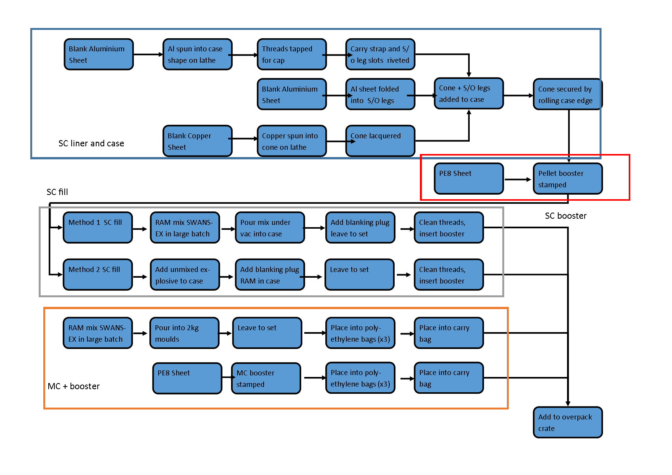
To summarise the manufacturing processes a flowchart has been created (Figure 7). This includes both methods highlighted in the process FMA, as providing both options to a customer would likely be beneficial; again, cost and quantity would be much more important factors in a real-world situation.
Figure 7 Manufacturing flowchart.

Fault tree analysis
A fault tree analysis investigates failures, what can happen further along the line if an issue occurs at a low level. An example study was conducted using this tool on potential causes of unintended initiation of the shaped charge. This is conducted using the following logic gates (Figure 8):

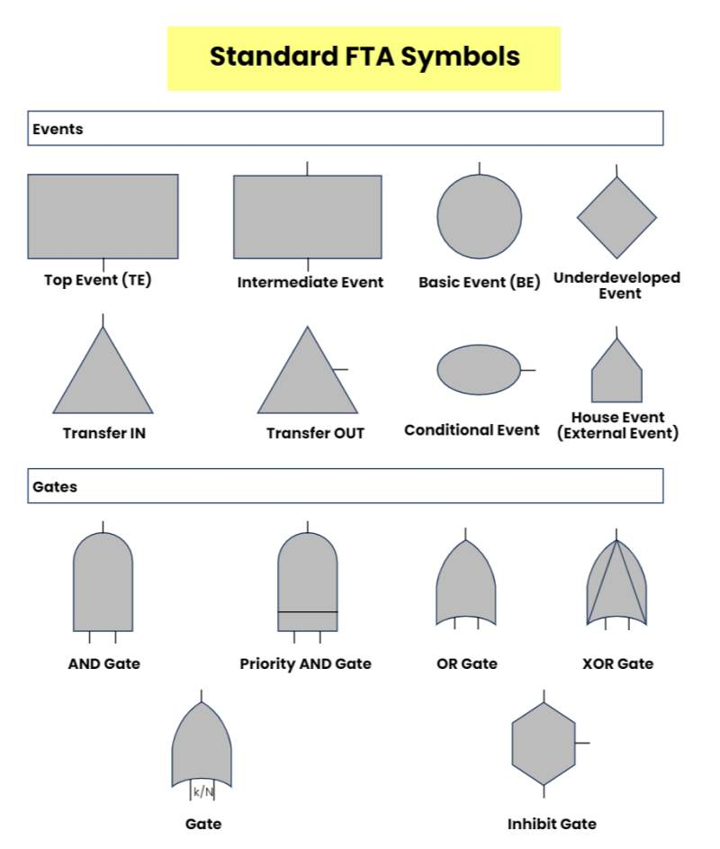
Figure 8 FTA symbols [7]

These symbols represent a range of events have the following meanings:
- Basic event; a fault that has no direct causes – a base level issue.
- Conditional event; a fault that has causes.
- Undeveloped event; an event that is further broken down in a separate fault tree analysis
- And gate; requires all inputs to have happened to fail.
- OR gate; requires one or more of its inputs to fail
There are many more symbols as seen above, however only these listed were used in the fault tree analysis conducted below (Figure 9). As the design of the munition is to be an ‘Insensitive munition’ it is unlikely for the munition to initiate without significant stimulus and or fault with the munition. As such it is important to investigate what could cause issues; if the shaped charge were to initiate it is likely to come from one of three parts; the main fill, the booster or the detonator, these are then further broken down into causes of ignition for each. The main fill was examined in the most detail as this has been the focus of the report thus far. The SWANS-EX main fill, is an IM explosive, as such it is unlikely to initiate unless there is a fault with the fill, such as aging or incorrect energetic components (e.g. binder/stabiliser). This then broken down even further into a filling issue, a mixing issue or fill contamination. To avoid overpopulating one fault tree analysis, these are not broken down, instead they are linked to a separate FTA, where the causes of each can be explored in more detail (this time with the issue now at the top of the tree).
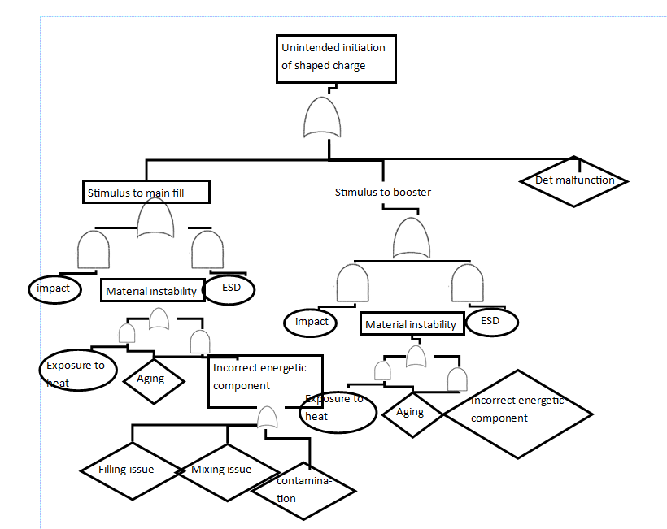
Figure 9 FTA diagram.

Conclusion
This report has detailed a variety of systems engineering techniques including, QFD’s, FMA’s, what why tables and many more. Each of these tools can be used as and when required, and do not have be used in a rigid order. The flexibility of systems engineering tool are their main virtue allowing them to be applied everywhere from energetics to computing. Evaluating customer requirements effectively is the most important part of this process; without identify what is required you can design something brilliant; yet absolutely useless; this is both expensive, time consuming and harmful to a user’s (or their organization’s) reputation.
This report also showcases the use of these tool through the design of a cratering charge kit. It has proved to be extremely effective, initially ensuring that the design ethos was correct, and that the munition would meet the requirements provided by the customer. By highlighting this early on, costly redesigns were avoided, and a higher design inertia could be maintained. The QFD analysis were especially useful when determining the ‘critical’ parts; both in the kit overall, and then specifically the design feature (the fill) and the manufacturing steps. This reduced the chance of oversights, while increasing the safety, efficiency and performance of the design presented.
This report in tandem with the Cratering charge portfolio, provide a comprehensive and credible design. This design and supporting evidence could be taken forwards to maturity in the event an energetic fill similar to the fictional Polymer bonded explosive ‘SWANS-EX’ is developed.
At this stage the author would like to remind the reader that the above work while a sample piece could be applied in a real scenario, either in small scale, project to project or as an entire organisation. Systems engineering has proliferated around the world because of its ability to convert concepts into comparable numbers in almost any setting; helping guide decisions with facts not feelings.

References

References

[1] | K. J. Schlager, “Systems Engineering-Key to Modern Development,” IRE Transactions on Engineering Management, vol. EM3, no. 3, pp. 64-66, 1956.
[2] | European Southern Laboratories, “Systems engineering,” in OWL Blue Book Issue 2, Garching, European Souther Laboratories.
[3] | DSTL, Dstl Risk assessment process, Salisbury: DSTL, 2024.
[4] | Chemring, “Detonator electric L2a2,” [Online]. Available: https://www.chemring.com/~/media/Files/C/Chemring-V3/documents/energetics/heds/det-elec-apr22.pdf. [Accessed 1 5 24].
[5] | M. Fisher, “Design Process of a New Cratering Charge,” unpublished, Swansea, 2024.
[6] | D. Holley, “L5 - Systems Engineering (Sept 2021 Cohort) (Sem 2) (ACDA5021),” 2024. [Online]. Available: https://moodle.uwtsd.ac.uk/course/view.php?id=12137. [Accessed 4 2024].
[7] | Wondershare edraw, “A Complete List of Fault Tree Analysis Symbols,” [Online]. Available: https://www.edrawmax.com/article/fault-tree-analysis-symbols.html. [Accessed 2024 5 3].

