
Software Solutions For business
Andre Moura Dos Santos


university of wales trinity saint david

Table of Contents
Introduction 1
Task 1. e-Commerce Website builders or software solutions 1
1.1 WooCommerce 1
1.2 Wix 1
Task 2. Mind-map of contemporary software applications 1
a. Mind mapping and explain the benefits of using mind mapping in business operations 1
b. Create a mind map of contemporary software applications 1
Task 3. Office Applications 1
a. Four office software solutions for business operations 1
MS Word 1
MS PowerPoint 1
MS Excel 1
MS Access 2
b. Practical demonstration of Two Office Features 2
Mail Merge 2
If Statement 2
Task 4. Communication and Collaboration applications 2
a. One contemporary Communication and one Online Collaboration applications/tools 2
MS Outlook 2
MS Teams 2
b. One feature of a freely available Communication (1) and one feature of a Collaboration (1) application 2
MS Outlook 2
Ms Teams 2
Conclusion 2
References 3

Introduction
<Insert Information Here>

Task 1. e-Commerce Website builders or software solutions

Shopify

Shopify is the most the used e-commerce website for beginners, and it is best for fast advancement, no time wasting and start selling immediately. There plans are extremely cheap and efficient. Shopify is great for bringing your ideas to life, it implements buttons in your website sample such as, “Add Product” This such an amazing feature it makes adding products effortless this is perfect for selling any of your products. This feature is perfect not only for beginners but also for professionals, when the user presses “Add Product” it takes the user to the add products page and lets the user easily submit their product, add a name/title for their product, add a description and also change the format and colour of the product description (Extra, Engaging feature), add an image for your product, select your price and also input how much stock you have in your inventory and many extra features. These features are extremely useful and easy to navigate this is why Shopify is the #1 platform for starting one's business according to INC.com and Forbes.com and I agree. From your main menu/sidebar you can easily navigate through important business features for example, you store analytics, your previous customers, you can preview your actual online store, your orders, products, and more features that are important for businesses and owners. Another beautiful feature Shopify uses are the implementation of Ai to help you design the layout and aesthetic of your store; many users are good with ideas and the business side of e-commerce but not with actual website/store designs therefore this feature solves this problem for business start-ups and owners that struggle with the actual website development and designs. [1]

1.2 Wix

In my opinion “Wix” is the best website builder for beginners I have found. My reasoning behind this is because it is easy to use and navigate, everything is displayed clearly and you can freely switch your website view from desktop to tablet to smartphone view with ease. Wix has many free and paid templates that you can use to jump start your e-commerce journey, most websites only give you a handful of free templates that do not do not help beginners, the samples are very minimal they seem to do this to force new users and beginners to pay for better templates even though they are new to they’re website designs and layouts. Wix has amazing drag and drop functionalities for example, when using a template that already has images you can easily click the image and a drop-down menu with buttons will appear. One of the buttons that appear is “Change Image” this makes it extremely easy to add your any image/video of your choice with effortless navigation. Another feature that I like about Wix is the mainframe does not have a lot of confusing buttons; the sidebar has a simple buttons navigation menu that you can hover over to see the button name to see what the buttons are for. Such as if you hover over image icon the word “media” appears to let you know this button will take you to “Choose media files” page that lets you upload your own images/videos. [2]

Task 2. Mind-map of contemporary software applications

Mind mapping and explain the benefits of using mind mapping in business operations.
Sometimes people may struggle to plan their ideas therefore a good strategy to preplanning is Mind mapping. Instead of writing an endless amount of notes/bullet points mind mapping allows you to visualize your plans in an organised structure it allows you to add images and key words that link to other parts of ideas and key words. For most people it is easier to view ideas visually rather than read a lot of information at once. Mind mapping makes it easier to navigate from one idea to another without getting overwhelmed and confused. There are multiple techniques people use when mind mapping, one technique that is used regularly is the “Rich in picture” technique. This technique is used to provide a visual presentation of an entire business situation. This is used because instead of words and notation images make it easier to reflect/portray situations that are harder to understand or analyse with words such as software issues that people that are not as fluent in technical language may not understand. [3]
Mind maps are used to organise and unravel issues and ideas, confusing concepts/work schemes. They clarify communication issues especially when using images instead of words. They build connections between different work-based departments and teams such as workflow team and project teams.
Mind mapping are branches connected different ideas and concepts to one another, aligning related themes, sub-themes, and ideas that stem from the core concept. Most of the time people will use colours to clearly visualise to present clearly that an idea stems from another key point.
Everything starts from one core theme/centre making sure this is the main focus; to keep everything well-structured and organized you use keywords or short phrases to keep the idea simple and easy to easy to read fast.
These are the core benefits of mind mapping, Enhances creativity and problem-solving. [4]
In recent years, implementing mind mapping has become important as it is recognised as an effective communication tool that is used effectively for collaborations sessions. Mind mapping increases productivity, simplify request for proposals (RFP), Optimize project management, Improve collaboration and communication and many more.
Business and technology are constantly evolving day by day sometimes gathering information can be overwhelming, using mind mapping can make absorbing information less difficult and carefree making your workload a lot more organised and structured. Using visual mapping techniques allow you to analyse complex ideas, plan projects and think much more creatively. When used effectively mind mapping can be a very effective tool for businesses, entrepreneurs, team leaders etc… to clarify their views and ideas. It can create connections between different teams.
Furthermore, mind maps can be extremely helpful when learning something new or working through unfamiliar topics for busy professionals. Mind mapping converts abstract information into an uncomplicated visual layout that is easy to digest. Helping many people absorb and remember the information given more effectively than long list of text alone, this will make it easier for professionals to apply the information they have just acquired to their daily tasks as they have understood the information given to them effortlessly. [5]

Create a mind map of contemporary software applications.
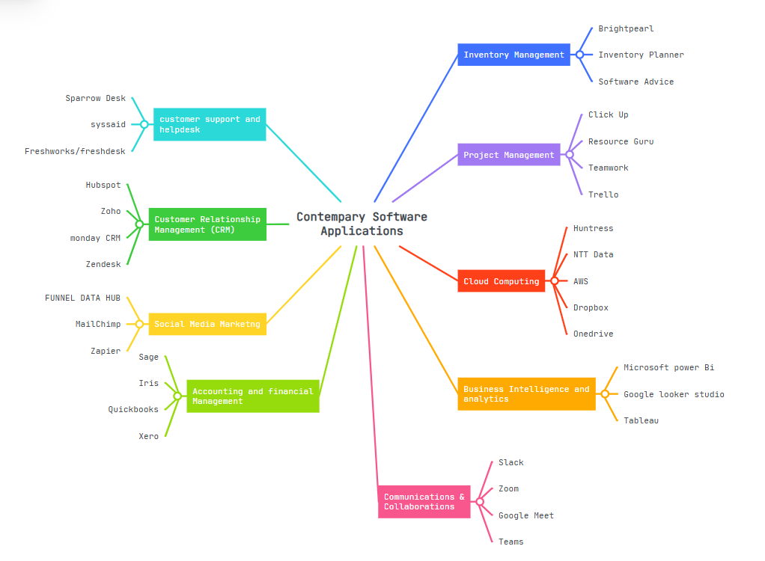

Task 3. Office Applications

Four office software solutions for business operations

 MS Word
In the early years of technology and computing, there we’re a vast variety of word processing software’s, Microsoft Word was released on 25 October 1983 but from the early 2000’s onwards Microsoft Word became the became the standard writing tool. MS Word persuaded the public to make convert from using their traditional devices/hardware such as, typewriters to make a huge jump into technological advancement and use computers for their built-in writing software’s. For traditional writers this was a major change from going from physical typewriting and pen to paper writing to effortless computer software writing. [6]
There are many key differences between the traditional way of writing and the new ear of writing. In today’s era you can not only write text, but you can also add images, videos, tables and charts for documents with ease, with these features you can effortlessly create letter, resumes and reports. These features make your tasks a lot more engaging and easier to understand as well as to create. For easier start ups MS Word provides various templates to make document creation easier. This is commonly utilised by users, organisations, and schools because of its ease of use and multiple useful features. The use of images/videos make it a better visual experience making the workload better for people who rely more on visual representations rather than just text.
These are some of the key features that I have found from my deep research into Microsoft Word.
“User-friendly interface” MS Word has and easy to read and easy to use layout. Making it very simple for beginners to use and become familiar with, they can navigate through the software environment easily, find tools and options.
“Formatting” Before computer writing software’s the writer could only write in the text format that they were taught or accustomed to whereas, using MS word you can now use a vast array of text sizes, formatting style, text colour changes text underlining an many more features that you can use to make your documents unique to your own style of work.
“Templates” MS Word has many free, ready-made templates that users can navigate and choose from depending on their liking. There are many styles depending on the document that the user is working on. This is perfect for users who want to save a lot of time and want to focus on their clear goal/task without worrying about the actually aesthetic of their work. This makes life easier, saves time and also allows users to give their work a much more professional and aesthetically pleasing look.
“Spelling and grammar check” Everyone is human and humans make mistakes, when writing or creating documents it is easy to make small mistakes that you may not notice until later. Traditionally, typewriting or just writing pen to paper you could make a mistake and have to cross the text out. Whereas with MS Word you do not need to worry about this anymore the software detects any mistakes that you may not have noticed and tells you what to fix and gives you recommendations if needed, in addition in many cases it finishes your words and even sentences before your even done typing. [7]

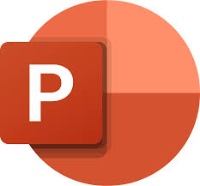 MS PowerPoint
Microsoft PowerPoint is presentation software that businesses use to share information clearly using slides. It is often used in meetings, staff training, project updates, sales pitches and business reports. PowerPoint helps users put information into a visual format instead of writing everything in long paragraphs. A presentation can include text, images, graphs, tables, audio, video and design themes, which makes it easier for an audience to stay focused and understand the main points. Reports and training guides on PowerPoint also show that it includes tools for templates, slide layouts, transitions, animations and presenter features, which makes it useful in day-to-day business communication.
One of the main features of PowerPoint is that it lets users break information into separate slides, which makes content easier to follow. It also includes templates, themes and layout tools that help presentations look more professional. This is useful in business because workers often need to produce clear presentations quickly, even if they are not design experts. A recent PowerPoint book explains that users can plan content, prepare slide master’s and use built-in features to create stronger presentations, while current accessibility guidance also shows that PowerPoint is widely used for teaching, training and events.
Another important feature is the use of visual tools such as charts, images, diagrams, SmartArt, transitions and animations. These features can help explain ideas step by step and keep the audience interested. For example, a manager giving a sales update can use charts to show progress more clearly than just reading numbers from a page. Recent research also shows that audiences often respond better when slides are well organised and supported by strong visual elements instead of being overloaded with text. [8]
There are several benefits of using PowerPoint in business operations. First, it helps businesses communicate information clearly. A presentation can summarise the main points of a topic in a way that is easier to understand than a long report. This is helpful when speaking to staff, clients or managers because it allows the speaker to focus attention on the key information. Recent presentation guidance also explains that effective presentations should support engagement, knowledge transfer and audience understanding, which shows why PowerPoint is so widely used.
Another benefit is that PowerPoint can make information look more professional. Businesses often need to create a good impression when presenting ideas, pitching to clients or delivering training. Templates, themes and design tools can help users create a polished presentation without starting from zero every time. A 2023 book on PowerPoint best practice explains that the software includes tools for planning content, building attractive slides and improving delivery, which is a big reason why it is useful in professional environments. [9]
Teams and company groups and school teachers use MS PowerPoint a lot when it comes to presenting ideas and getting feedback from their groups and students, they do this because while presenting they can also edit and make changes in real time, they can also share/send the document/presentation to various people effortlessly for them to also make changes in real time. [10]

 MS Excel
Microsoft Ecxel was originally built for financial analysis, implementing tables into your spreadsheets. Excel is mainly used in the workplace due to their tools that allow users to organize data, calculate risk, and track progress. Excel was originally created for financial analysis, but it has now become a frequently used software in most businesses, HR teams and IT teams.
Excel is used a lot for financial modelling, especially for things like budgets and profit and loss statements. Finance teams use formulas and different linked sheets to test scenarios quickly and see how changes affect the numbers. This is good because it gives businesses flexibility and lets them make decisions without needing complicated software’s. The downside is that when the spreadsheet gets too big, it can become overwhelming harder to check properly and easier for mistakes to happen.
Excel is also used in HR management. HR teams can use employee performance review templates to track goals, ratings and review periods. This is useful because it can be customised to match whatever scoring system or review style the company wants. It works well when the process is simple and the team is small. But as the business grows, it can become harder to keep everything consistent and there can also be issues around privacy and keeping staff data secure.
Another use is inventory tracking. Small and medium-sized businesses often use Excel to keep track of stock levels and supplier information. It is a simple way to see what products are coming in and going out, and it works well when stock levels are not too complicated. The problem is that a lot of it depends on manual updates, so once the business grows or has more products, the chance of errors becomes much higher.
Excel is also useful for IT audits. IT teams can use it to record user access reviews, including usernames, roles and whether access has been approved or not. This makes it easy to set up quickly and keep everything in one place. However, when it comes to security and being fully audit-ready, Excel is not always the strongest option because it can be harder to control access properly and make sure nothing important gets missed.
In project management, managers often use Excel for task lists, timelines and even Gantt-style charts. One of the good things about Excel is that it is basically a blank canvas, so teams can set it up however they want and change it as priorities/tasks change. This makes it useful for internal projects and quick planning. But when lots of people need to work on the same file, collaboration can get messy, confusing and overwhelming.
Even though there are now lots of specialised software tools, Excel is still one of the first choices for managers because it is quick, flexible and easy to customise. A lot of people like it because they can build a tracker straight away without waiting for IT or learning a whole new system.
At the centre of Excel is its calculation system, which gives users many built-in functions to analyse data. This allows the software to handle both simple and more advanced calculations. For example, in HR, Excel can automatically work out averages, rankings and overall scores, which saves time and reduces mistakes. However, when spreadsheets become too complex and formulas are linked across many sheets, it becomes harder to track calculations and spot errors. [11]

 MS Access
Microsoft Access is a database software that is used to create, store, organise and manage large amounts of data in one system. It is part of Microsoft 365 in some versions, and it is more advanced than Excel when it comes to handling lots of related information. Even though it can look a bit complicated at first, Microsoft Access has a clear interface that helps users build and manage databases more easily.
The main job of Microsoft Access is to help users create databases using tables, queries, forms and reports. This means businesses can store information properly, find it quickly, update records and keep data more organised. Access can also analyse data, automate certain tasks and create forms for entering information and reports for showing results clearly.
Furthermore, Access is different from Excel because Excel is mainly used for spreadsheets, calculations and charts, while Access is built for managing bigger sets of data in a more structured way. Excel is easier to learn and better for quick analysis, but Access is stronger when a business needs to store large amounts of information, control data more carefully and allow multiple users to work with records.
Microsoft Access has a variety of key features that make it useful for managing business data. One important feature is that it allows users to create, change and delete database objects such as tables, indexes and views. This helps businesses set up databases in a structured way and adjust them when needed. Access also lets users add, update, remove and retrieve data, which makes it useful for keeping records organised and easy to manage.
Another major feature is query design. This allows users to search through data and pull-out specific information from the database. This is very useful for businesses because it helps them find exactly what they need without going through every record manually. Access also includes form design, which makes it easier to enter, view and edit data through user-friendly forms instead of working directly in tables. On top of that, report design helps users create clear reports with summaries, charts and graphs, making the information easier to present and understand.
Access also has tools for automation. For example, the Macro Builder allows users to automate tasks through a visual system, while VBA support gives more advanced users the chance to customise the database further and automate more complex processes. These features can save time and improve efficiency, especially when the same tasks need to be repeated regularly.
Microsoft Access can be used in many different situations. In inventory management, it can track stock levels, orders and product movement. In customer relationship management, it can store customer details, sales leads and interactions. In project management, it can help monitor progress, tasks and resources. It is also useful in human resources for employee records, attendance and payroll information. Other uses include financial management, where it can track expenses and budgets, research and development, where it can store findings and experiments, and education, where it can manage student records, grades and class schedules. Overall, Access is a flexible database tool that can support many different business operations.[12]

Practical demonstration of Two Office Features

Pivot Table
Screenshot 1 >
This screenshot shows the original sales dataset used to create the Pivot Table in Microsoft Excel.
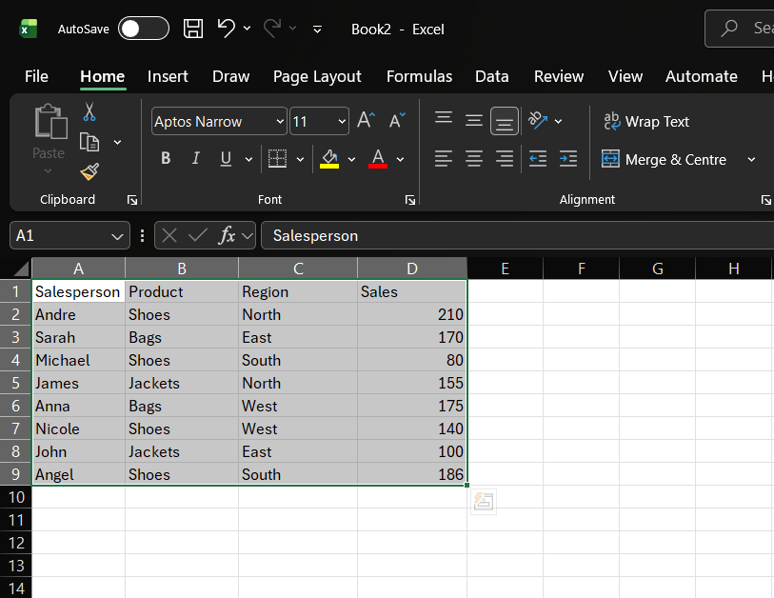
Screenshot 2 >
This screenshot shows the PivotTable feature being selected from the Insert tab in Excel.
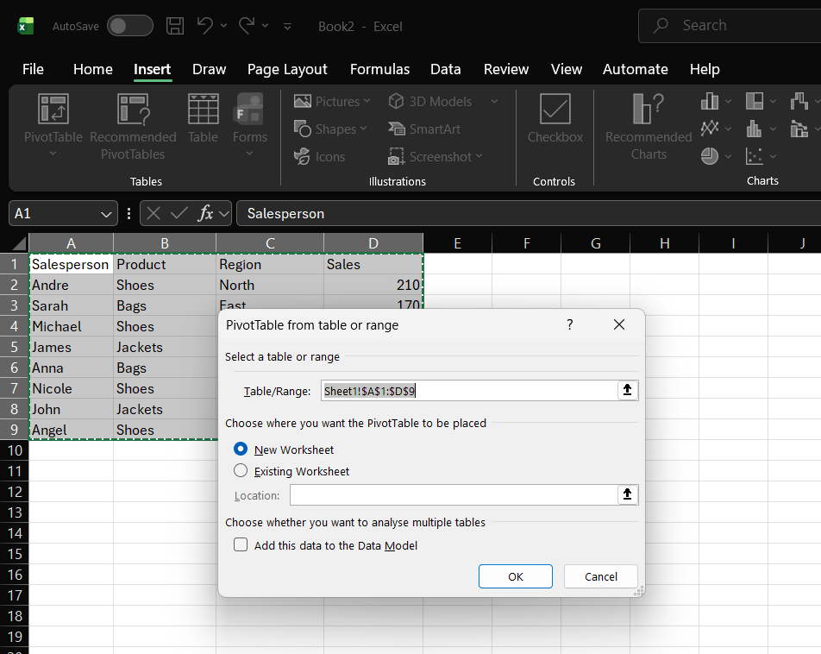
Screenshot 3 >
This screenshot shows the PivotTable Fields pane. The Salesperson field was placed in the Rows area, and the Sales field was placed in the Values area.
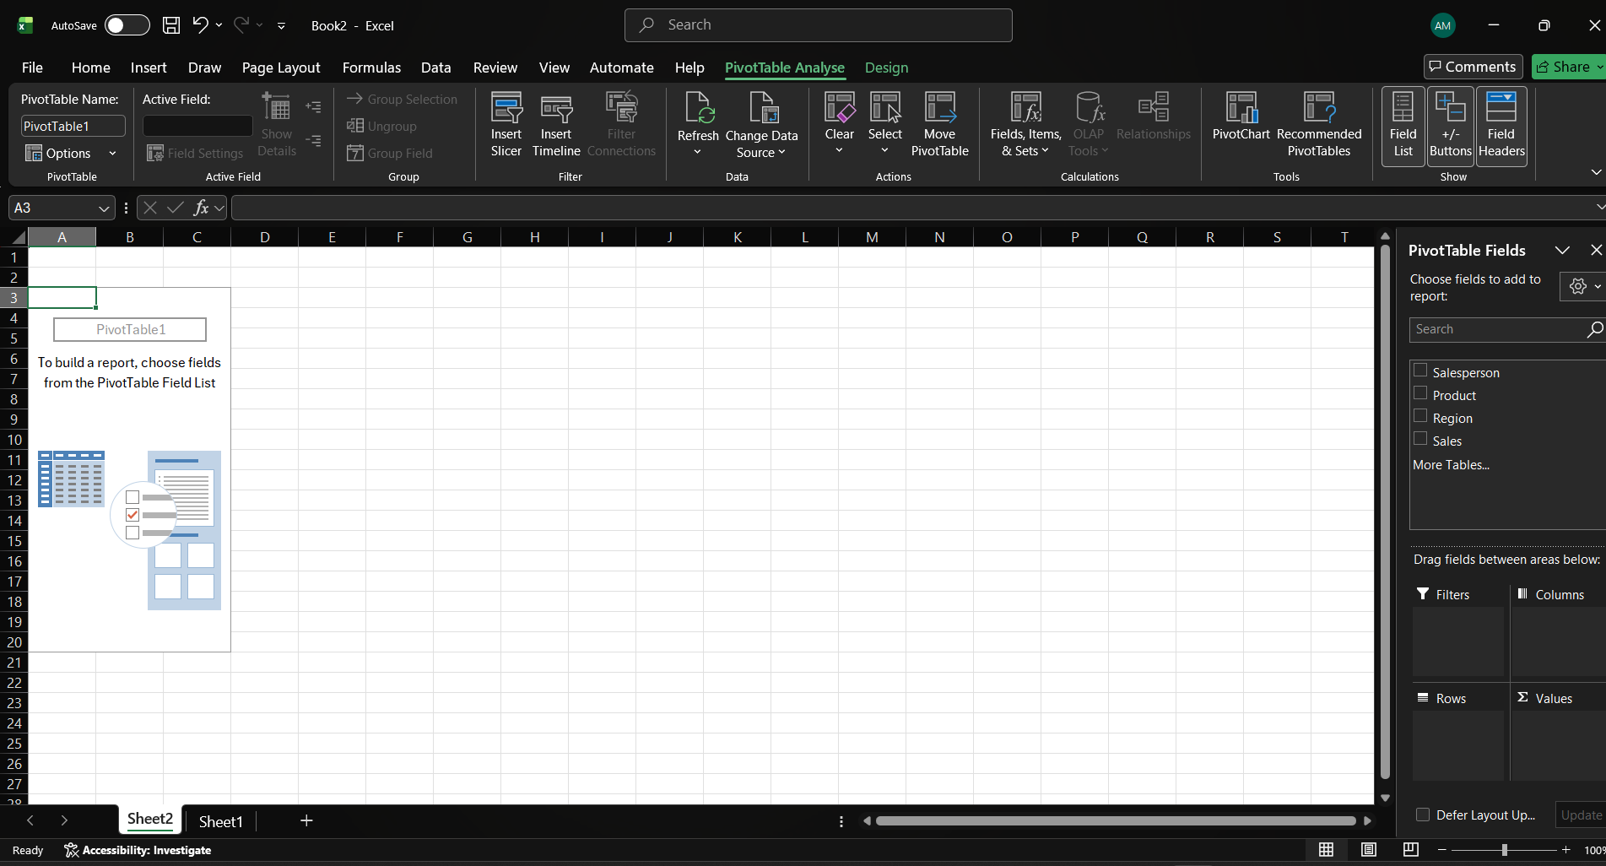

Screenshot 4 >
This screenshot shows the completed Pivot Table. It summarises the sales data and calculates the total sales for each salesperson automatically. 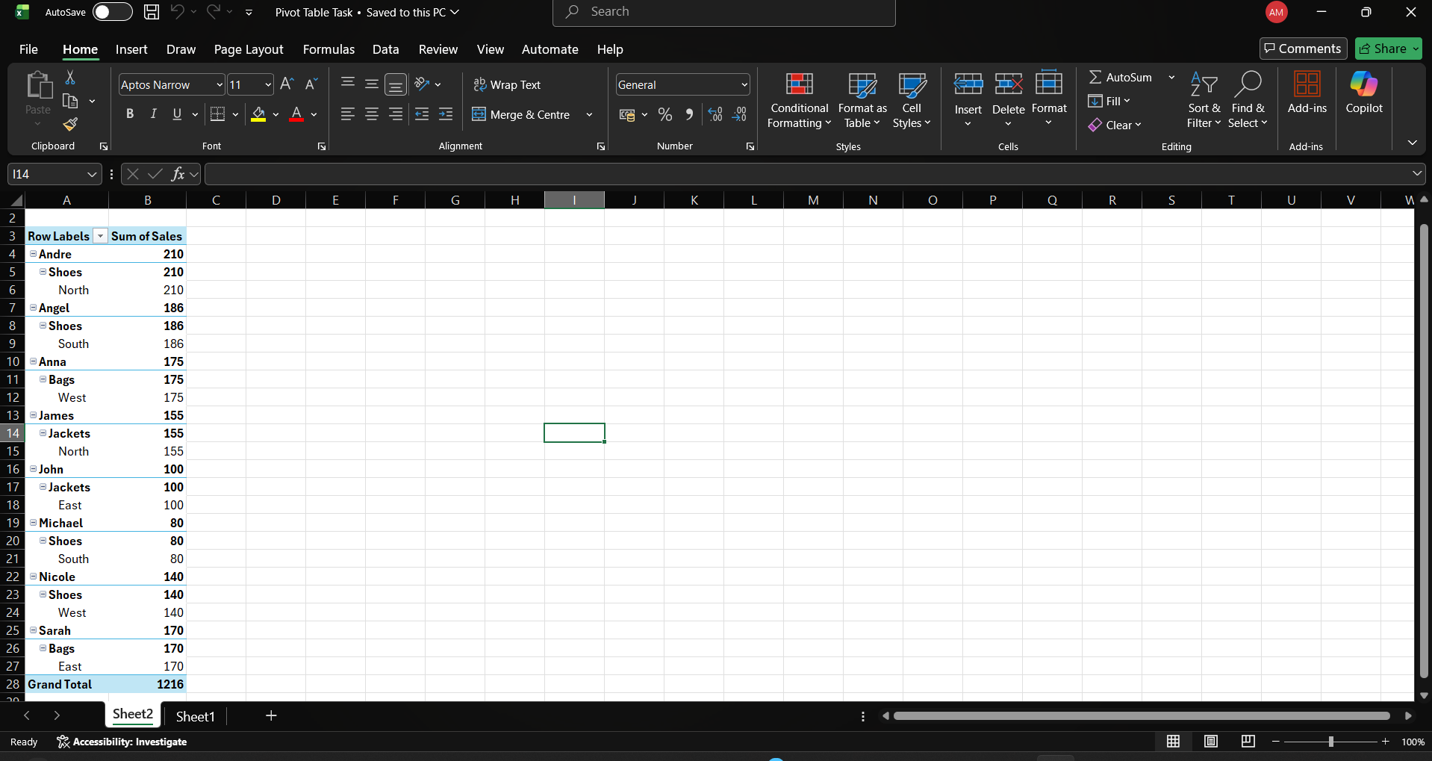

If Statement
Screenshot 1 >
This screenshot shows the original student score table created in Microsoft Excel before the IF function was applied.
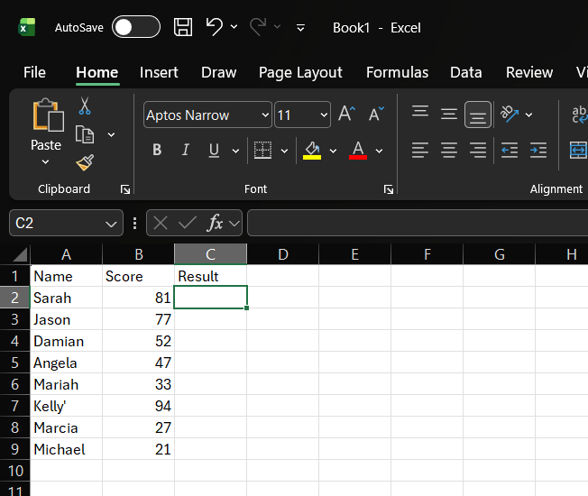
Screenshot 2 >
This screenshot shows the IF formula entered into the Result column. The formula checks whether the score is 50 or higher. If true, Excel returns “Pass”; if false, it returns “Fail”.
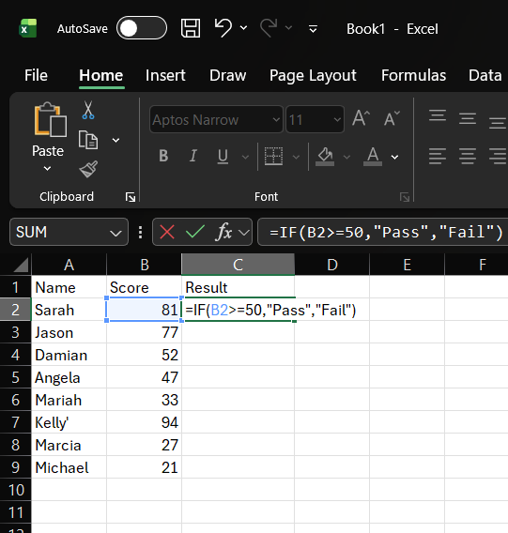

Screenshot 3 >
This screenshot shows the completed results after applying the IF function. Excel automatically displays Pass or Fail based on each student’s score.
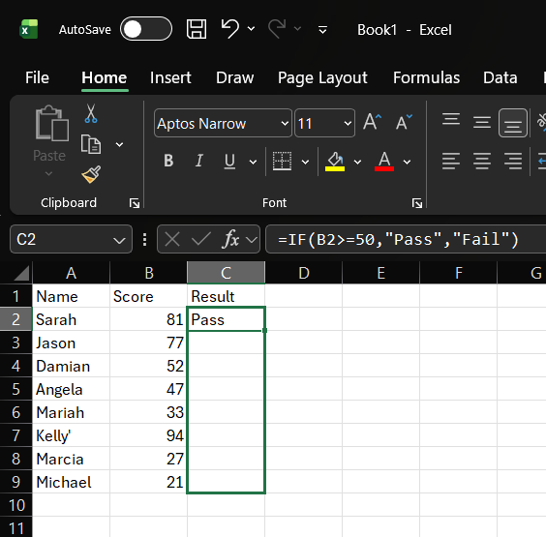

Screenshot 4 >
This screenshot shows the IF formula copied down the column using AutoFill, allowing the same logic to be applied to all rows quickly.
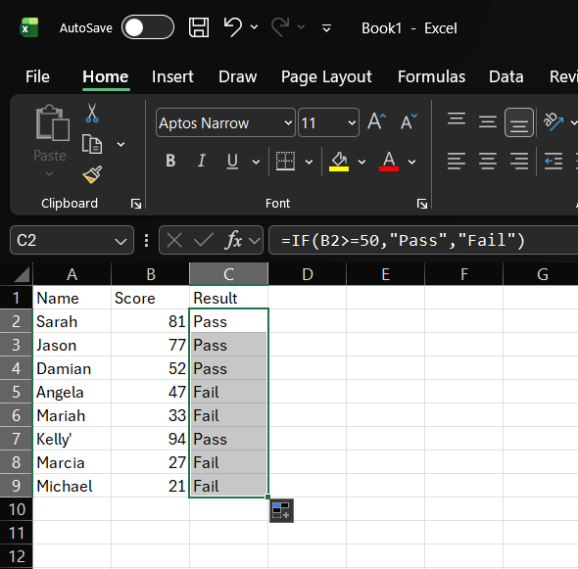

Task 4. Communication and Collaboration applications

One contemporary Communication and one Online Collaboration applications/tools

MS Outlook
Microsoft Outlook is a communication and personal information management application developed by Microsoft. It is widely used in both academic and business environments because it combines email, calendar, contacts, and task management in one platform. This integrated design helps users organise communication, schedule meetings, manage deadlines, and keep important contact information all in one place rather than across multiple separate applications. “TechTarget” describes Outlook as a platform whose core features include email, search, flagging, colour coding, preview-pane options, calendaring, calendar sharing, contacts, and task tools, showing that it functions as a broader productivity system rather than only an email client. [13]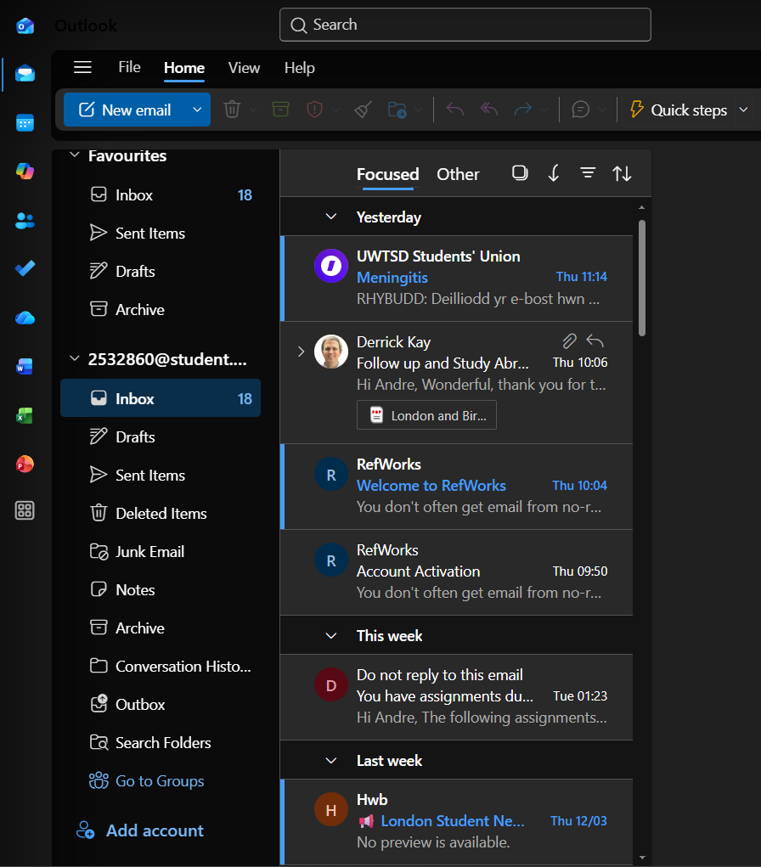
One of Outlook’s main strengths is its email management system. Users can send, receive, organise, and search emails efficiently and effectively. Features such as folders, categories, search tools, and message previews help people manage large volumes of communication more effectively. This is particularly important in modern workplaces where email overload can reduce efficiency and increase stress. Recent research on email management strategies found that structured approaches to handling emails can improve email-management performance, which supports the value of tools like Outlook that helps users prioritise, sort/organise, and monitor messages more effectively. Outlook therefore, supports productivity not only by allowing communication but also by helping users control the flow of information in busy work environments.

Another important feature is the calendar feature. The Outlook Calendar allows users to create appointments, schedule events, organize meetings, set reminders, and share calendars with colleagues and teams. This is especially useful in workplaces where teamwork, time management, and availability tracking are essential. Shared calendars help users find meetings more easily and reduce scheduling conflicts. In addition, Outlook’s relationship with other Microsoft workplace tools strengthens its usefulness in hybrid and office-based work, where digital scheduling and communication are the main focus for collaboration. 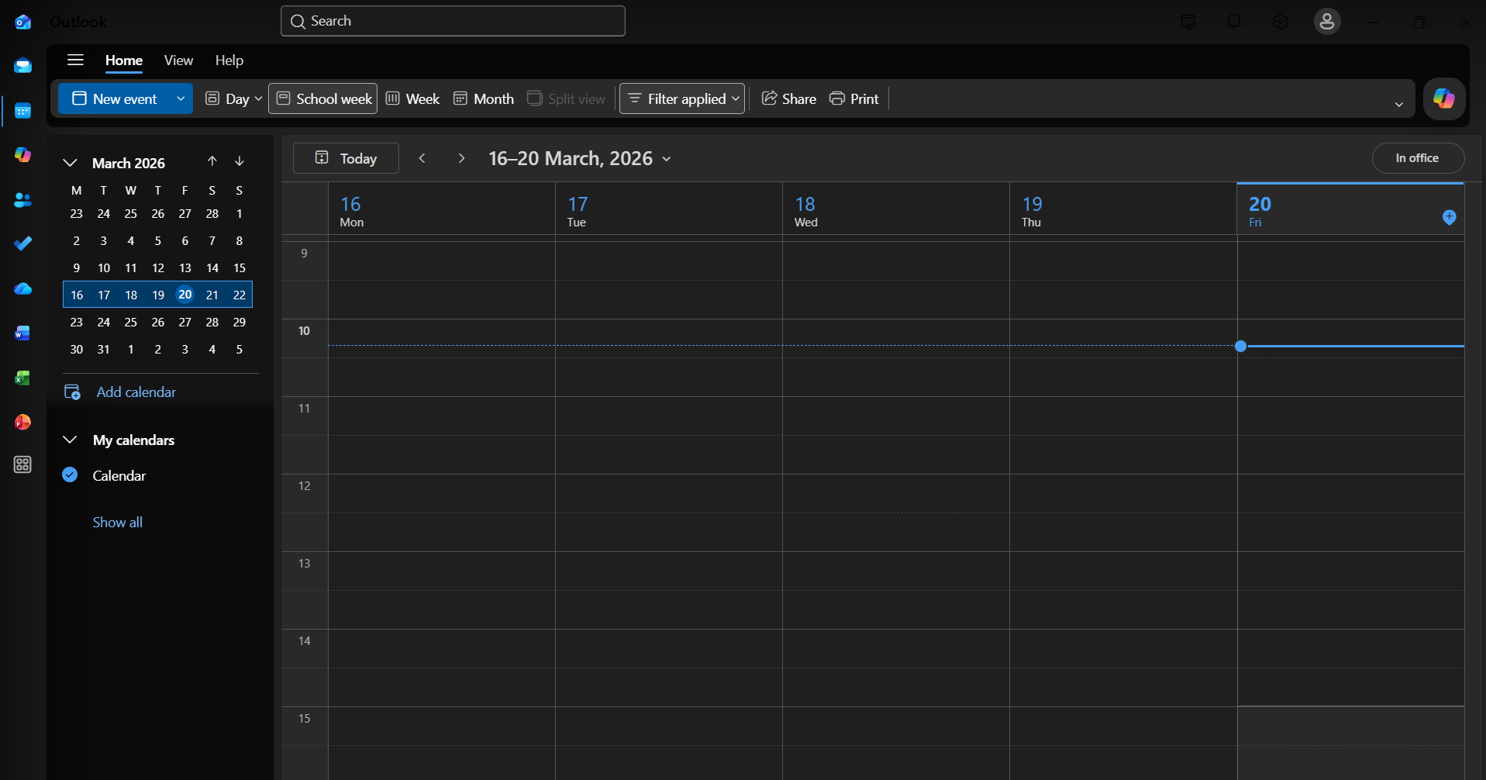
Outlook also includes contacts and task-management features, making it useful for broader personal and professional organization. Users can store contact details, flag(save) emails for follow-up, and manage to-do activities linked to communication and scheduling. This makes Outlook valuable for students, administrators, and professionals who need a single interface for everyday work/productivity. Research on workplace email habits also shows that expectations around fast email responses can create pressure in professional settings, so a system that helps users organize, prioritize, and respond more deliberately is increasingly important.
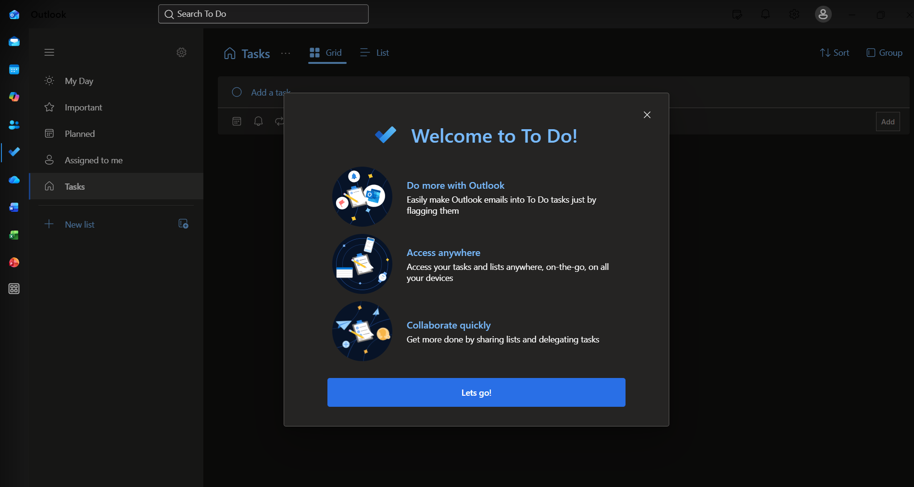

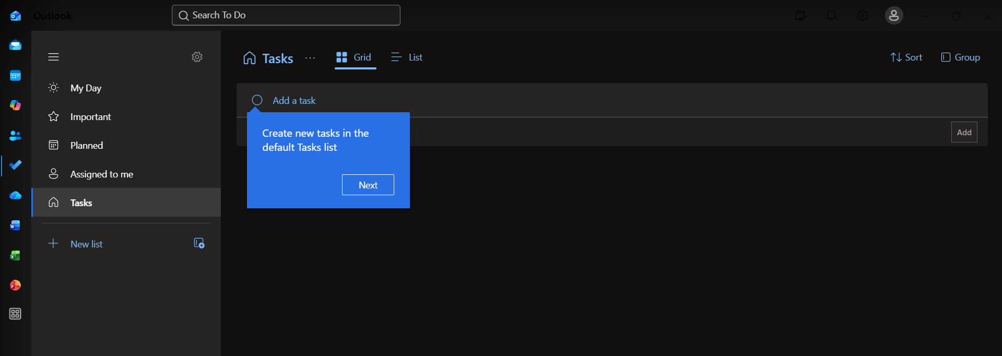Overall, Microsoft Outlook is an effective communication and productivity tool because it integrates several essential office functions into one system. Its combination of email management, scheduling, contact organisation, task tracking and saving makes it highly valuable for study and work environments, especially where digital coordination and efficiency are important.

MS Teams
Microsoft Teams is a digital communication and collaboration platform developed by Microsoft. It is widely used in education and business because it brings together chat, meetings, calling, file sharing, and app integration all in one workspace. Microsoft describes Teams as a collaboration app built for hybrid work, helping users stay informed, organised, and connected in one place. This all-in-one design software is one of its main strengths, as users do not need to switch constantly between separate tools for messaging, meetings, and document sharing. [14]
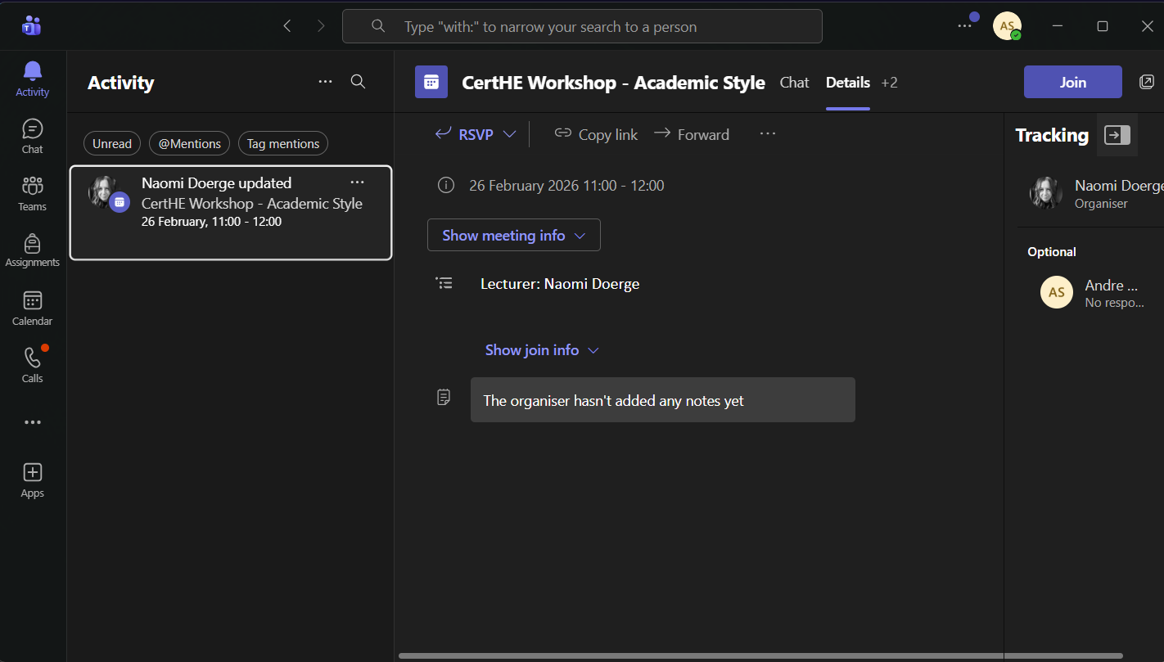
One of the most important features of Microsoft Teams is chat and messaging. Users can create one-to-one chats, group chats, and channel-based conversations. This makes it suitable for both quick and direct communication, and larger team discussions. Teams also supports threaded(direct) replies in channels, which helps keep conversations structured and easier to follow. In addition, users can send files, links, emojis, stickers, and other content directly within chats, making communication more interactive and efficient, in my opinion this creates a fun intriguing way of communicating rather than the normal bland text only communication. These features are useful in modern workplaces because they improve speed of communication and reduce dependence on very long email chain. Navigating through chains of emails can become very confusing, stressful and time consuming, some users may lose train of thought when navigating through them also.
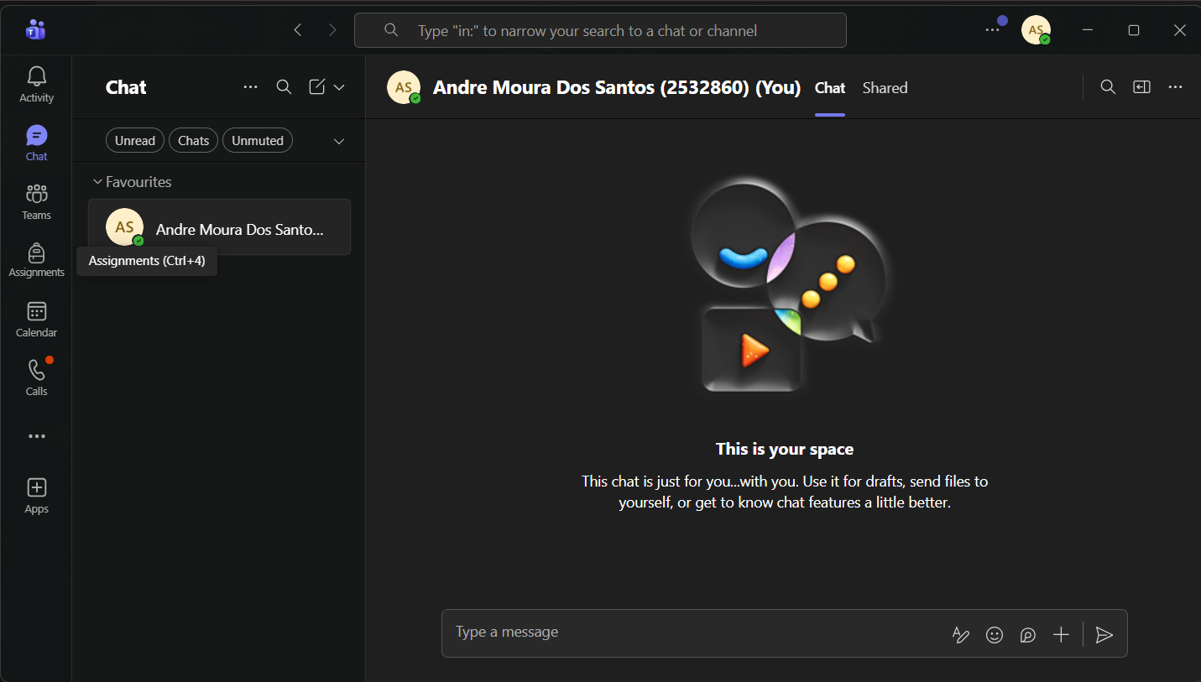
Another major feature is teams and channels. A team is created for a group of people, such as a department, project team, or class, even interviews. While channels are used to organize discussions and resources around specific topics. Microsoft explains that channels are the place where users can hold meetings, have conversations, and work on files together as a team. Tabs at the top of channels can also link to frequently used files, apps, and services, which improves workflow and keeps collaboration resources in a central location. This structure is especially valuable for project management because it helps users separate workstreams clearly and reduces confusion and stress. [14]
Microsoft Teams is also well known for its meeting and video conferencing tools. Teams widely used for this feature because it makes group interviews and online classes very effortless and simple. Users can schedule or join online meetings, chat during meetings, share content, and use cloud-based communication features to support remote and hybrid work. Meeting chat is especially useful because participants can share information without interrupting the speaker or disrupting the flow of the meeting. Teams have continued to develop their meeting capabilities through updates to the new Teams app, including improvements to content sharing and collaboration experiences. These features make the platform highly effective for virtual teamwork, staff meetings, online classes, and client communication.
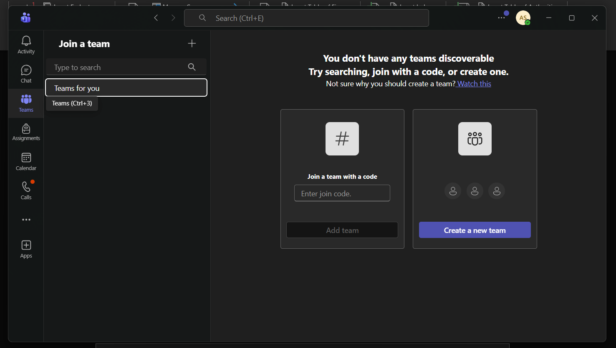
A further strength of Teams is its integration with Microsoft 365 apps and files. Microsoft documentation notes that Teams relies heavily on services such as Exchange and SharePoint for core productivity scenarios including meetings, calendars, chats, and file sharing. This means users can collaborate on files and access important resources without leaving the platform. In practical terms, this creates a more connected digital workspace and supports efficient teamwork. Research on digital workplaces also supports the wider value of collaboration technologies in improving communication and coordination among teams.
Overall, Microsoft Teams is an effective modern communication and collaboration tool because it combines messaging, channels, meetings, and document collaboration in one application. Its features are particularly valuable in hybrid working environments where employees need fast communication, organized teamwork, and easy access to shared information. [14]

One feature of a freely available Communication (1) and one feature of a Collaboration (1) application

MS Outlook
Sending an email.
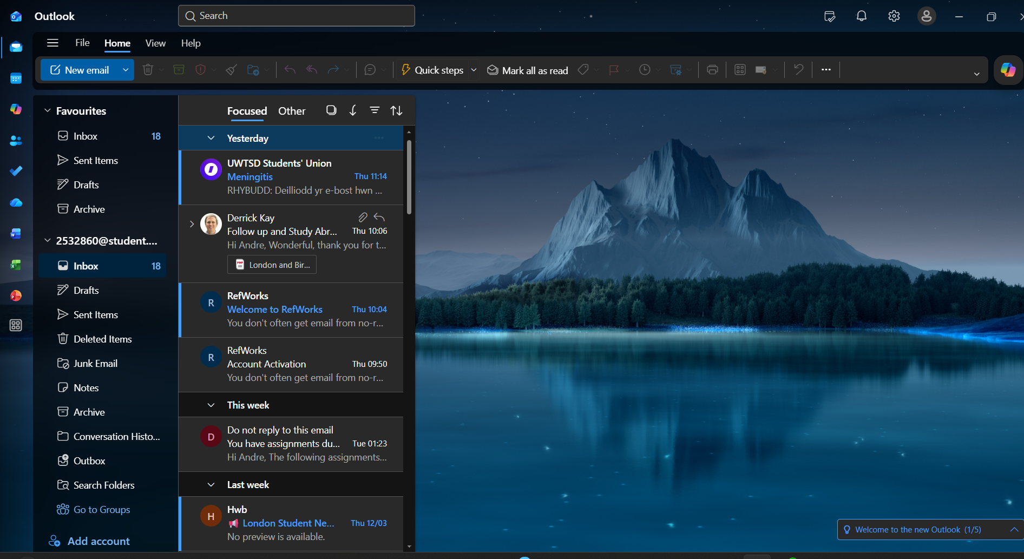
Screenshot 1 shows the main Microsoft Outlook interface used to access email communication features.
New email message being composed
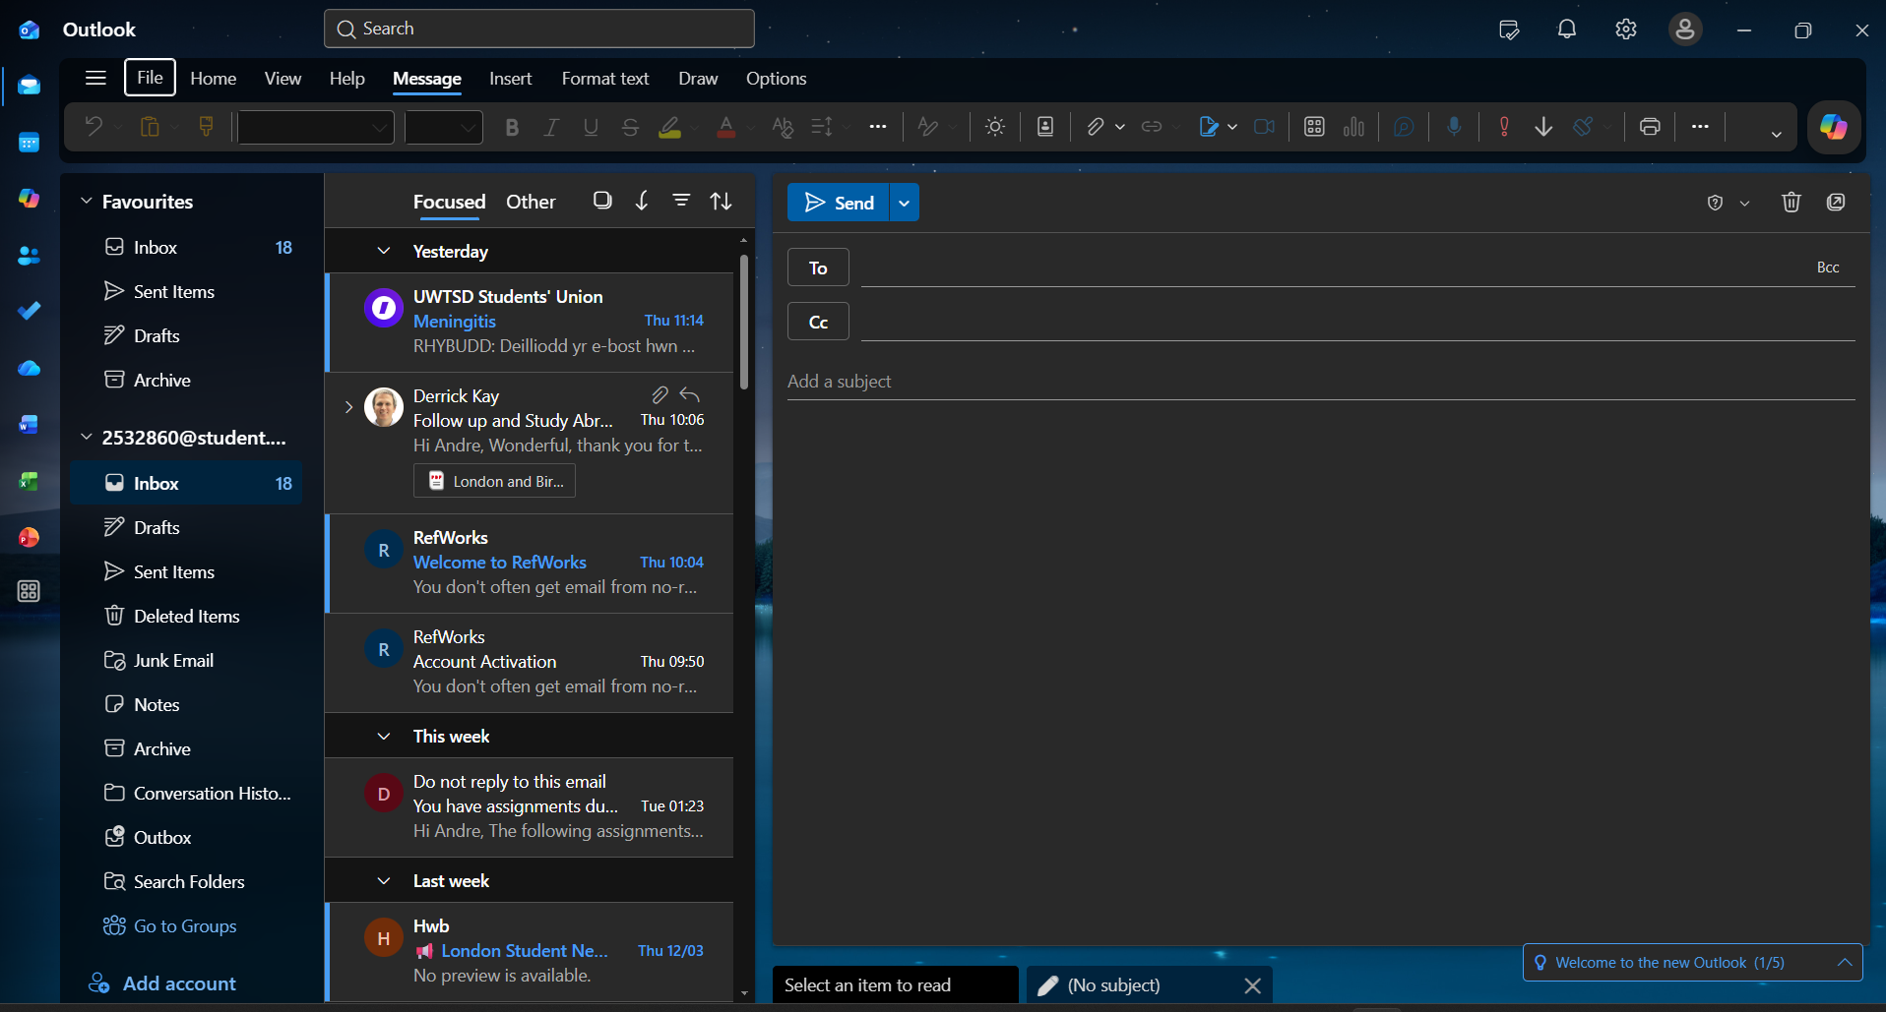
Screenshot 2 shows a new email being created in Outlook, including the recipient, subject, and message body. This demonstrates practical use of Outlook’s email communication feature.

Sent email or message in Sent Items
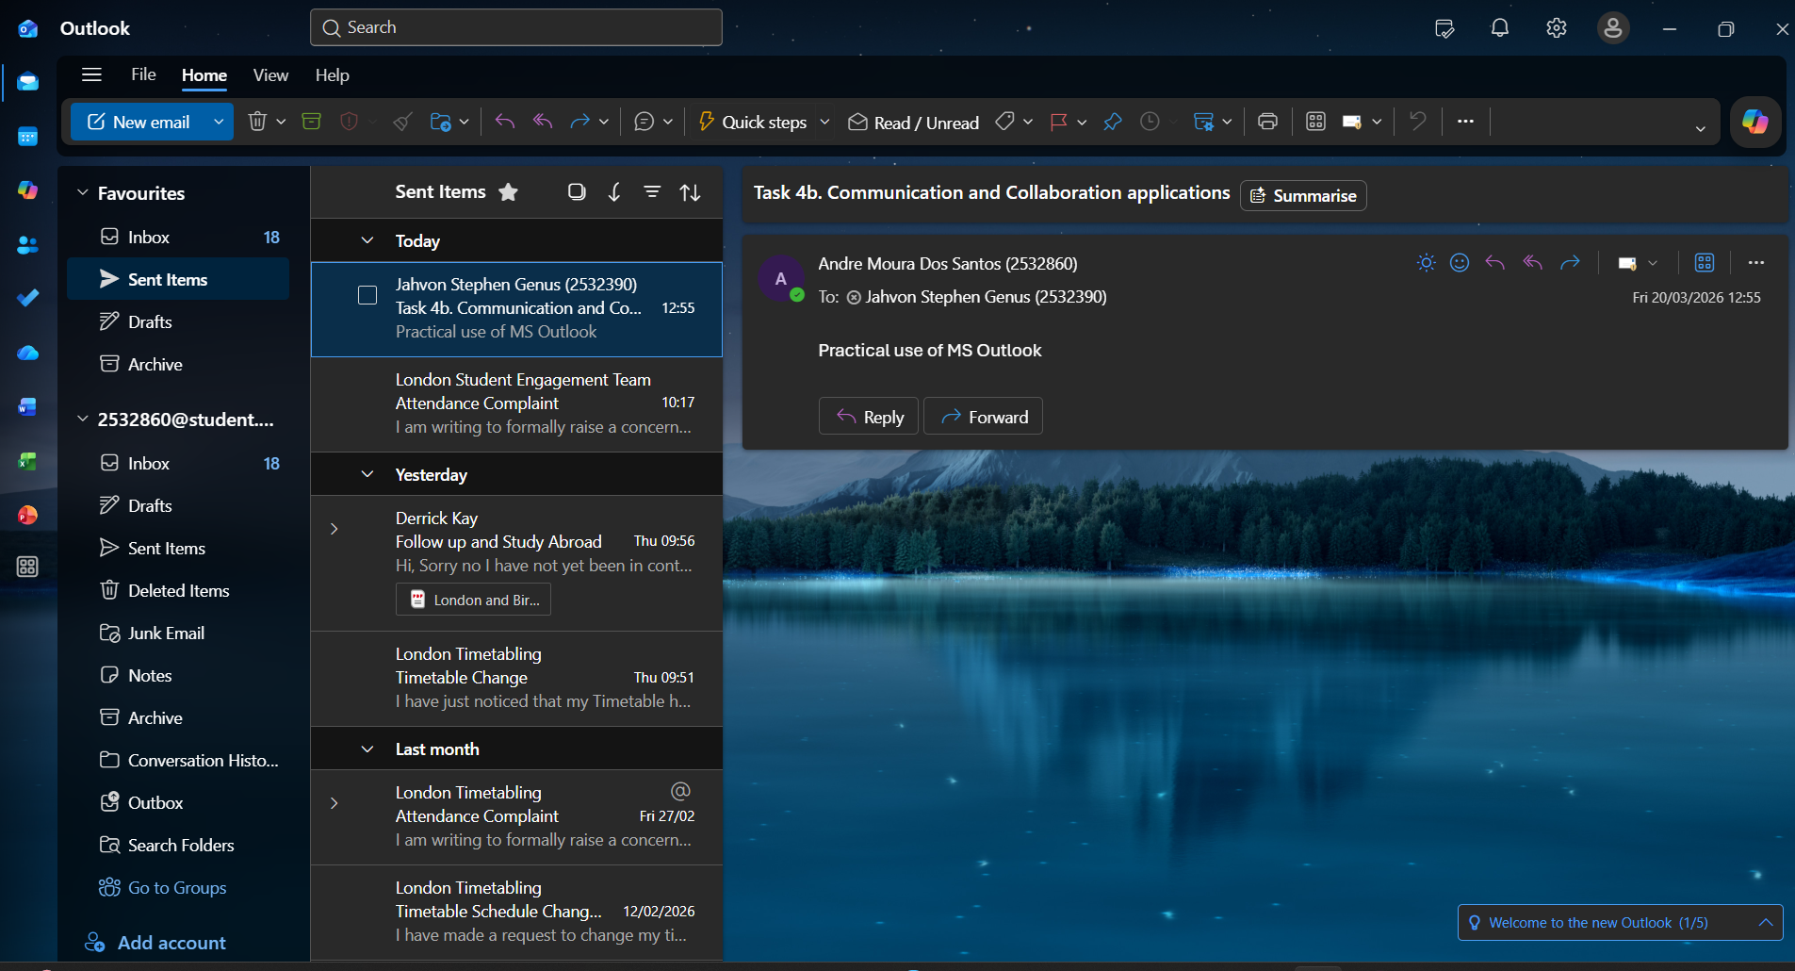
Screenshot 3 shows the email after it was sent successfully. This provides evidence of practical use of Outlook as a communication application.

Ms Teams
Creating a team/channel chat or sharing a file in Teams

Screenshot 4 shows the Microsoft Teams workspace with a team and channel open, demonstrating the collaboration environment.
File being uploaded/shared in the channel chat
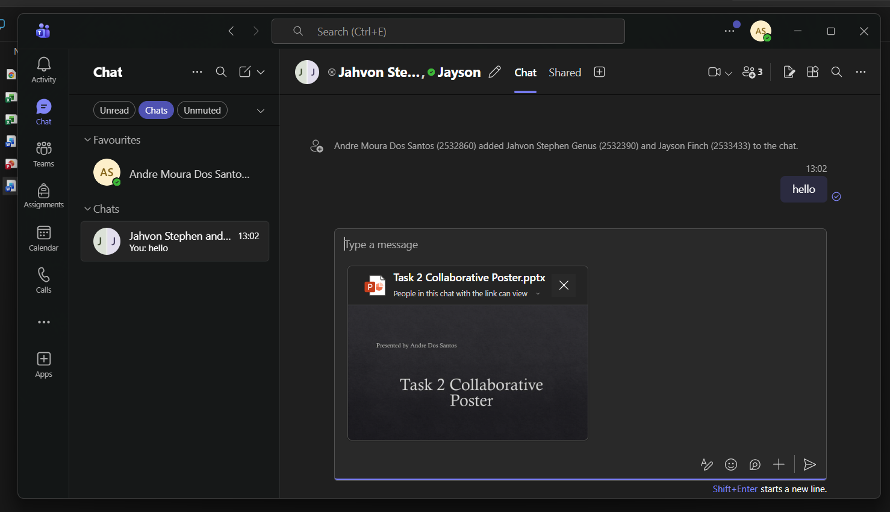
Screenshot 5 shows a file being shared in Microsoft Teams. This demonstrates the collaboration feature that allows team members to exchange documents in one shared space.
Shared file visible in the conversation or Files tab
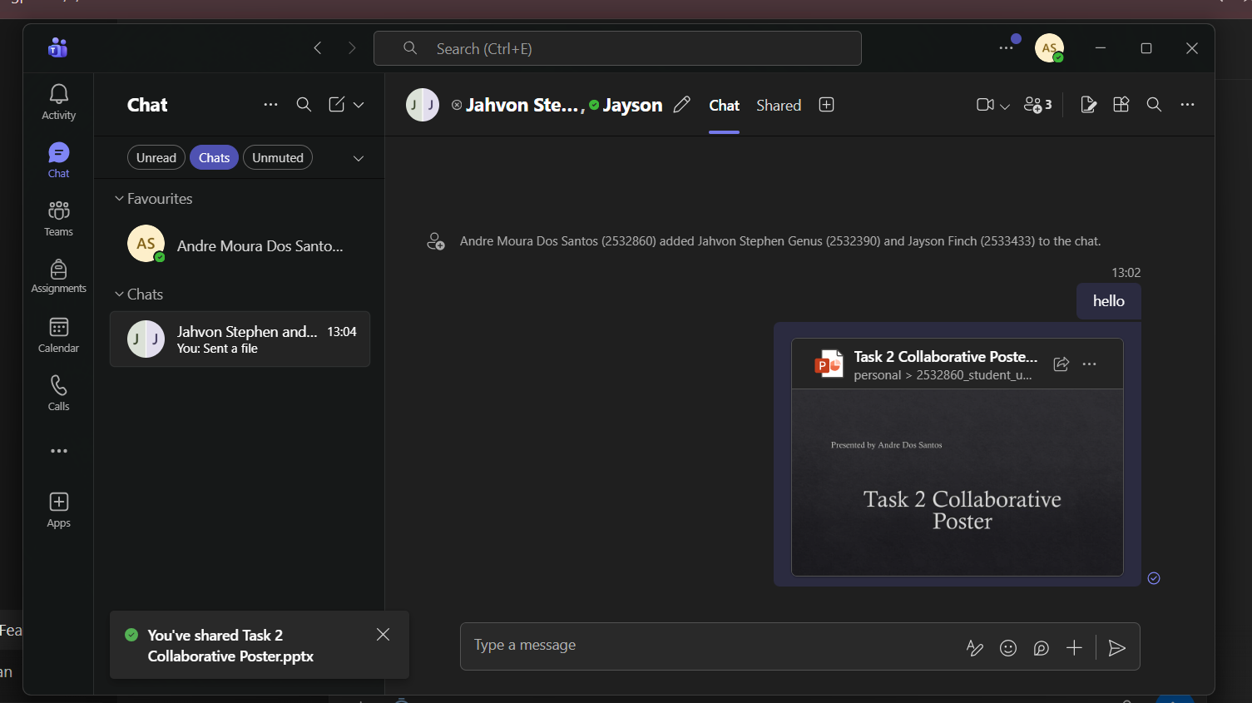
Screenshot 6 shows the uploaded file available within Teams, providing evidence of practical use of the file-sharing and collaboration feature.

Conclusion
In conclusion, this assignment helped me understand how important different software applications are in modern business and day-to-day life. Looking at all four tasks together, businesses depend a lot on digital tools to stay organized, communicate properly, analyze information, and work more efficiently. Each task showed a different side of how technology supports businesses and why these applications are now such a big part of the business world.
In Task 1, I looked at two e-commerce website builders/software solutions, and this showed me how important these platforms are for businesses that want to sell online and grow their business and clientele. They make it much easier to build a website, manage products, and handle online sales without needing advanced technical skills. In Task 2, I explained mind mapping and its benefits, and this showed how useful it can be for organizing ideas, planning tasks, and understanding how different software applications connect to business activities.
Task 3 focused on office applications such as Microsoft Word, PowerPoint, Excel, and Access. This part of the assignment showed that these tools are essential for creating documents, presenting information clearly, analyzing data, and storing business records. Testing Excel features also made the task more practical because it showed how these functions can be used in real situations rather than just being explained. During this task I had to use my own intellect and learn to use these formulas/features and physically demonstrate and present what I have learnt. It also made it easier to understand the strengths and limitations of these applications.
In Task 4, I looked at communication and collaboration tools used in business. This showed how important these applications are for teamwork, sharing information, and helping people work together, especially in modern workplaces where remote communication is common. The practical testing also helped show how these tools are used in everyday business settings.
Overall, this assignment gave me a better understanding of how a wide range of software applications support businesses in different ways. It showed that using the right tools can improve productivity, communication, organization, and decision-making. I also feel like the assignment helped me connect theory with practical use, which made the topic easier to understand.

References

[1] | M. Rukki, “Design and Implementation of a Shopify Online Store,” 2025. [Online]. Available: https://www.theseus.fi/handle/10024/895718.
[2] | H. Chahal, “Development of a Scalable E-Commerce Website for Small Businesses,” 2025. [Online]. Available: https://www.theseus.fi/handle/10024/893948.
[3] | “Mind Mapping,” [Online]. Available: https://www.improvementservice.org.uk/business-analysis-framework/investigate-situation/mind-mapping.
[4] | B. t. t. a. Slack, “How to Create a Mind Map: Examples, Benefits, and Uses,” 19th September 2025. [Online]. Available: https://slack.com/intl/en-gb/blog/collaboration/how-to-create-a-mind-map-examples-benefits-and-uses#:~:text=Mind%20maps%20help%20us%20untangle,workflows%2C%20teams%2C%20or%20projects..
[5] | S. Peek, “The Benefits of Mind Mapping for Busy Professionals,” 12 January 2026. [Online]. Available: https://www.business.com/articles/benefits-of-mind-mapping-for-professionals/.
[6] | O. Kruse, “Word Processing Software: The Rise of MS Word,” in Word Processing Software: The Rise of MS Word, Springer, Cham, 2023, p. pp 15–32.
[7] | T. K. Academy, “What is Microsoft Word: Everything You Need to Know,” 20 December 2025. [Online]. Available: https://www.theknowledgeacademy.com/blog/what-is-microsoft-word/#:~:text=Microsoft%20Word%20provides%20essential%20formatting,sharing%20and%20editing%20among%20collaborators..
[8] | “Mastering PowerPoint: Advantages, Disadvantages, and Expert Tips,” 2026.
[9] | M. T. Ltd, “How Microsoft Powerpoint Can Benefit Your Business”.
[10] | C. f. I. T. a. Learning, “Teaching with PowerPoint,” 2020.
[11] | R. Tanner, “Excel Review: Breakdowns of Features, Benefits, and Limits,” 2025.
[12] | R. Jones, “What is Microsoft Access? Its Uses and Benefits (Guide for 2026),” 2026.
[13] | G. Wright, “What is Microsoft Outlook?,” Microsoft messaging and collaborations, 2025.
[14] | Y. J. Wu, “Information sharing in a hybrid workplace,” understanding the role of ease-of-use perceptions of communication technologies in advice-seeking relationship maintenance, 2023.
[15] | A.-A. Deschenes, “Digital literacy, the use of collaborative technologies, and perceived social proximity in a hybrid work environment: Technology as a social binder,” computing in human behaviour reports, 2024.
[16] | “Mind Mapping in Business,” [Online]. Available: https://www.mindmapping.com/mind-mapping-in-business.
[17] | R. E. Cummings, “Generative AI in first-year writing: An early analysis of affordances, limitations, and a framework for the future,” Science Direct, 2024.

