Integrating Project (M4X01506)
Group One

Introduction
The task given was to design and build a soapbox racer to meet the regulations outlined for Richard’s Castle soapbox derby. An overview of the track has outlined various requirements for the racer that had to be factored into the design for success, otherwise the car wouldn’t be able to make it to the end of the course.

The team was split up with the intention of having certain people be able to focus more closely on certain areas of the design. The team breakdown goes as follows:

Chassis – Joseph Lockyear & Thomas Unwin
Suspension and Brakes - Lee Stewart
Steering and Wheels – Alexander Penny
Body and Aerodynamics – Daniel Morgan & Hannah White
Materials and Costing – Claudia Marques-Andre

The original group was broken down into the smaller categories upon the first meeting, with each smaller group or individual choosing the topic that they felt they’d be best at researching. Before anybody went to work individually, the group created a number of diagrams and potential rough designs before settling on a finalised idea that everyone was happy with.

It was also decided which member of the team would be racing the car when it was done. This decision was based on general attitude and personal confidence after watching the footage of the specific track the car would be racing. The car was designed around the rider that was chosen and was essentially made-to-measure. Certain decisions in the design of the racer, such as the hand-held braking mechanisms were decided based on the racer’s personal preference and experience of motorcycles over cars.

Chassis

The chassis for the racer must meet several requirements before it’s fit to race.
Firstly, the chassis must be strong. It has to hold and support the weight of the driver and his seat, and also the roll cage and bodywork that will be fitted. Beyond this, it also has to be strong enough to support the attached suspension. Because of these stated reasons, the chassis will be made from 30mm tubular steel with a thickness of 2.0mm for the main body, and 2.5mm for the axles (Azuma, 2013). These thicknesses were selected because it will be strong enough to meet the requirements outlined above without sacrificing the lightness that the racer needs. Ideally, carbon fibre would have been chosen for its strength and lightness, but the cost and difficulty of manufacture proved to be too much.

The shape of the chassis designed is as pictured below. This will add strength and rigidity without being so long or wide as to break the regulations for the competition or to sacrifice the nimble turning demanded by the track it will be racing. A roll cage is featured that will measure inches above the driver’s head to maximise his safety whilst also minimising the impact on aerodynamics that the extra height would cause. The chassis has been designed with a double tier around the base in such a way as to allow for the chosen method of suspension, allowing enough room and strength to support it. The chassis will measure close to 1600mm x 800mm as this will allow for a smaller wheelbase to allow the racer to turn quicker, will still fit the racer comfortably and will allow for bodywork to be added to it without exceeding the maximum dimensions stated in the regulations. Four mounting points will also be factored in to the design to accommodate the suspension setup.
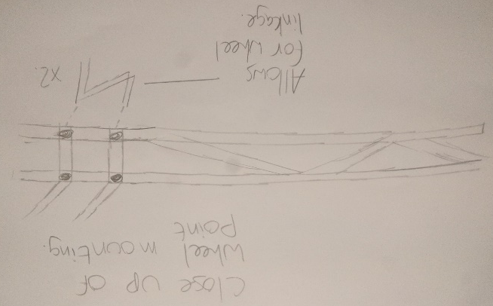
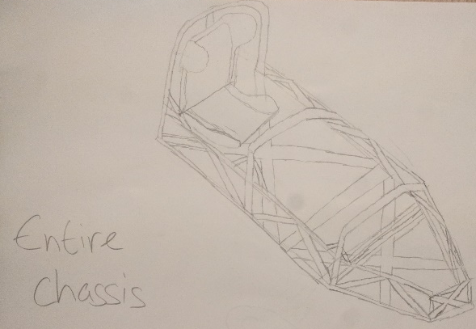

Suspension
During the process of deciding on the suspension system for the soap box racer we had many factors to consider and decisions to make. Some crucial decision had to be made before we could decide which suspension system we would use, such as the shape of the chassis and the steering method we would use. Once these vital decisions had been made we proceeded to look at varying suspensions styles and design.
To be able to make an informed decision about the approach we would take, firstly we examined the track in which the race would take place and the specific regulations attached to it. Upon this we decided for our application and budgetary restrictions we would use ‘320mm Rear Suspension Air Shock Absorbers from a Yamaha RD350 on all four corners of the racer.’ These would fit nicely into the unequal length double wishbone suspensions setup we have chosen. The rationale behind this is there is several quite severe corners on the track which would require a lot of steering input from the driver, therefore we knew we needed to isolate the driver from the input of the road, this was also due to the terrain of the track being gravel, loose mud and occasional large stones (Thede & Parks, 2010). More reasoning behind this decision is the shocks we have chosen are readily available on eBay and a relatively cheap at £55.63. Also, this suspension system would fit perfectly in with the chassis and steering method decided upon, as which previously mentioned where huge deciding factors in this choice.
Here we have an example of the core components of a double wishbone suspensions system. Figure 1
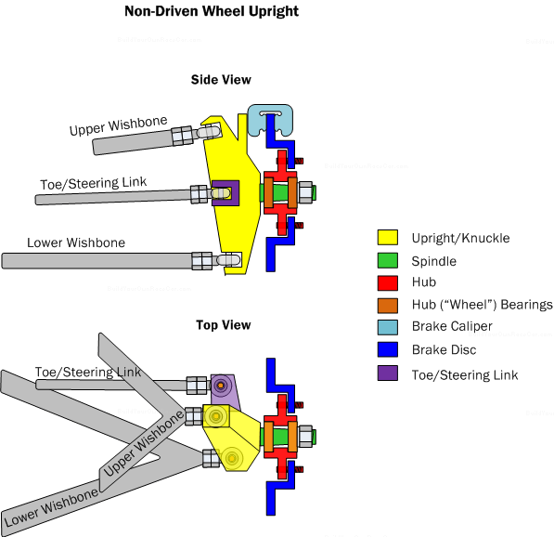
This is an image of an uneven length suspension system fitted to dual layer trellis frame. Figure 2
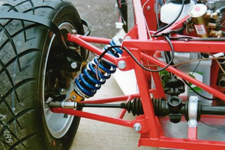

Steering
During the course of research and testing we looked at 3 core designs for steering when an uneven double wishbone suspension system is used.
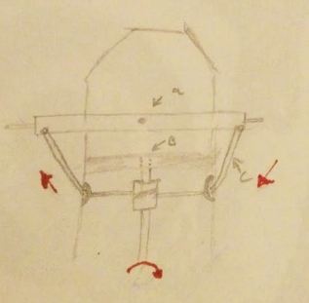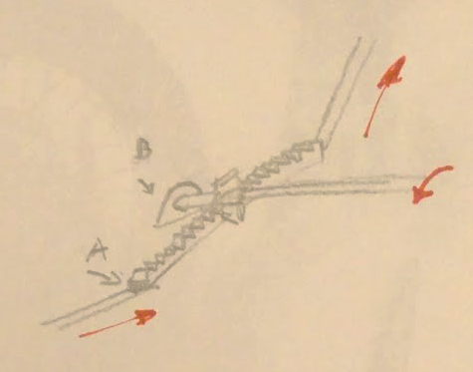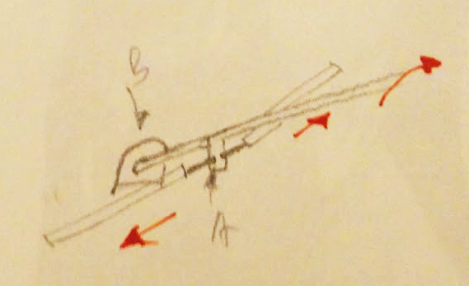
These designs are based on prior knowledge, the above diagrams demonstrate the principles of three key designs. Firstly we have a pulley based system which although simple, it relies on a solid axel roataing aroung a central pivot. Although it is feasible with the suspension system and frame we have decided it is sub optiumum as it would decrease the regidity of the gravity racer. A rack and pinion would allow for variable gearing so that it can be tuned for the ideal input to steering ratio for our racer. It was decided that a shaft with a simple protrusion would be ideal for our short manufaturing period as it can be easily manufactured and would not suffer too greatly due to any imperfections in manufacturing. The deisgn is very simple requiring minimal welding from low priced materials. The two bearings required to support the mechinism can be obtained easily in many availlble variations.
An F1 style go-cart steering wheel was decided upon since it most suits the desired areodynamic profile for our racer. This can be bought for less than £20.

Wheels
Through investigation, it was found that a very common cause of mid-race failures was wheels buckling due to side loads. Since this was discovered, more rugged bicycle wheel set ups were looked at, such as bmx and downhill mtb, since the concerns could never be eliminated focus shifted over to wheels of similar dimensions amongst heavier applications. Wheel barrow wheels were considered but later discounted due to the complication of mounting any form of brakes to it. The next progression was to small motorcycle wheels. Since the track is majority gravel dirt bikes wheels were looked at, this resulted in the knowledge that for £80 wheels already fit with off road tire and disk brakes could be purchased. Due to the simplicity of purchasing a full package it was decided 14” pitbike wheels would be designed around for this project.

Brakes
Whilst choosing the system we would use for braking on the racer we came across two main options we thought would be suitable for the application. Firstly, we looked at was drum brakes, the main reason for looking at this type of braking system is because it can generate more breaking force than a brake disc of equal diameter (Haynes, 2018) and with the racer running small wheels this was an attractive concept. Once we had established the pros and cons of using drum brakes, we then looked at how brake discs perform in contrast to drum brakes. On further research, we discovered that the drum brake system is far more complex to implement than a disc brake system. However, the main reason we decided to use disc brakes is because a decision was made on the type of wheel we should use on the racer already comes with a disc rotor and a single piston hydraulic brake calliper already fitted. These will be actuated using hydraulic levers mounted to the steering wheel. Using this system, the front and rear brakes can be actuated separately allowing the driver to better control and loss of traction that may occur on the gravel track we will be racing upon.

Body and Aerodynamics
The body of a soap box racer plays a vital part of the structural integrity that affects both stability and the aerodynamics of the racer. To achieve an even balance of the body it must have a low coefficient of air resistance, be structurally secure to allow knocks to the racer without catastrophic consequences, and above all needs to be able to be manufactured at a respectable price and in a university workshop with minimal weight.
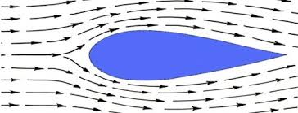
The first step was to research the most aerodynamic shape. When looking at purely aerodynamics, a teardrop shell would have been the most desirable. Figure 1 is an example of what a teardrop shell is. The arrows in figure 1 are demonstrating that the shape is very streamlined, when an object is streamlined it will glide through the air with very little air resistance.
Figure 1
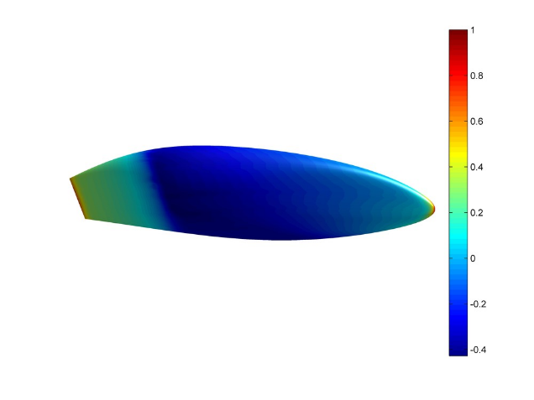
Though figure 1 is the best aerodynamic shape, looking at the structural and manufactural aspects of the body, it was decided that this would not be the best shape for a soap box racer. Through further research a suitable shape was found. As can be seen in figure 2.
After discussing the shape in figure 2 with the team, it was decided that a less curved bottom would be best to accommodate chassis and would allow the 5cm ground clearance that is specified in the restrictions.
Figure 2
Once a rough idea of the shape of the racer was decided on, it was also decided that the width, length and height of the racer would be based on the size of driver, so the most suitable member of the team was picked to drive the soap box racer, to determine who was the most suitable driver, the height, weight, size and of course confidence in driving the racer was taken into consideration. By doing this there will not be any excess material, and so the racer in theory will be cheaper to build and also the driver will have maximum available comfort.
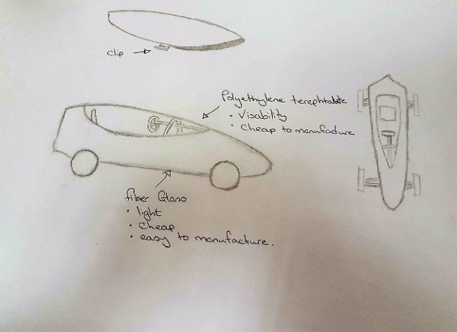
Figure 3 shows the final shape that was decided on which met all of the requirements needed to make a suitable soap box racer body. You can also see from figure 3 that there is a clear detachable roof with a clip on the side of the roof, which can be operated by the driver, so they can get out of the soap box racer without any assistance. It was important that the body allowed for plenty of visibility whilst maintaining the stability of the body.
Figure 3
As stated in figure 3, the body will be made from fiberglass. The reasons we chose fibre glass are that fibre glass is very strong, durable, and light. Pound for pound it is stronger than sheet metal and will never rust. It is also resistant to corrosion. Fiberglass is also very cheap and easy to manufacture and can be moulded into nearly any shape you want.
Polyethylene terephthalate will be used for the roof. Similarly, to fiberglass, it’s very cheap and extremely light weight. It is also strong, has no chance of shattering, and it has nearly glass like transparency, so it will give near perfect visibility for the driver.
Materials and costs
What are materials?
Materials are the matter from which a thing can be made, there are various types of materials and they can be divided into one of the four groups of materials: Metal, composite, ceramic and polymers. Different materials can be combined to create a composite material. Within each of these classifications, materials are often further organized into groups based on their chemical composition or certain physical or mechanical properties (National Science Foundation, 2018).
This table is showing the amount of money and material invested to produce the soap box.
Material, Descriptions | price | Company
polyethylene terephthalate | £0.29 Per Kg | Plasticker (Anon., 2018)
Chassis- steel tubing (Anon., n.d.) | £55.80 30mm*2.0mm 316L body | Nero
Brakes | Odyssey Springfield Brake Kit £36.09 | (Anon., 2018) Sourcebmx
Axle plank
pivot
Suspension ( motorcycle) (Anon., 2018) | £31.65(2) | eBay
Steering & wheels, Mini Moto Dirt Bike Rear Wheel 10 X 2.5 Complete With Disc, Sprocket, (Anon., n.d.) | £119.96(4) | eBay
Fibre glass | 50m x 0.95m (£1.20 per LM): £60.00 | MB fibre glass (Anon., 2018)

This project provided us an opportunity to design a soap box and it also gave us a choice of materials that can affect the performance, quality, and economic manufacture of the racer, so it was important to consider a range of materials properties before the material is chosen.
performance – behaviour of the material in the finished product;
processing – behaviour of the material during manufacture;
economic – cost and availability of material;
aesthetic – appearance and texture of processed material.
Material utilisation – the amount of waste material generated during processing, (Anon., 2018).
Increasingly environmental impacts are playing a part in the choice of materials. These impacts include the energy consumed and pollution produced in the extraction and pre-processing of raw materials as well as their final processing into a product; and the effect of chosen materials on the life of the product; the potential for recycling and environmentally sound disposal at the end of the product's life.
It was decided to use fibreglass for the body, since it can be recycled and easily found. It is also resistant to heat, fire and the fibres in fiberglass are capable of transmitting light around curves which is very useful for the driver visibility. Polyethylene terephthalate (PET) is a hard, stiff, strong and dimensionally stable material that absorbs very little water. It has good gas barrier properties and good chemical resistance.
Chassis - steel tubing for the base of the car because is cheap and reusable, we also thought about buying the chassis instead of manufacturing it ourselves as it would cut costs and give us more time. In the end the group will manufacture the chassis themselves as there are specific requirements that have to be considered.

Conclusion
The racer we have designed will be well equipped to deal with the rider, track conditions and layout. It has been designed in such a way as to maximise aerodynamics and strength, while also saving on weight and cost. It has also been designed to maximise comfort, familiarity and ease-of-use for the chosen rider. Had both the budget and the regulations been slightly different, the racer would have been designed differently, featuring materials like carbon-fibre.

Works Cited
Anon., 2018. Plasticker. [Online]
Available at: http://plasticker.de/preise/pms_en.php?show=ok&make=ok&aog=A&kat=Mahlgut
Anon., 2018. [Online]
Available at: http://www.mbfg.co.uk/chopped-strand-mat/2445.html?gclid=EAIaIQobChMIvaal_IDz2AIV5pXtCh2zMAEDEAQYBSABEgKAuvD_BwE
Anon., 2018. GOOGLE. [Online]
Available at: https://www.google.co.uk/search?q=11:300mm+motorcycle+suspension+cheap+price&dcr=0&tbm=shop&source=lnms&sa=X&sqi=2&pjf=1&ved=0ahUKEwixkq6s37TXAhVNI1AKHfmHAcwQ_AUICigB&biw=1366&bih=613&dpr=1#spd=16149062077384972155
Anon., 2018. sourcebmx. [Online]
Available at: https://www.sourcebmx.com/en/gb/Odyssey-Springfield-Brake-Kit/m-26595.aspx?PartnerID=1237&utm_source=google&utm_medium=shopping&utm_campaign=UnitedKingdom&gclid=EAIaIQobChMIwpHstfjy2AIVbrXtCh1G7g2gEAQYAiABEgIEA_D_BwE
Anon., 2018. the open university. [Online]
Available at: http://www.open.edu/openlearn/science-maths-technology/engineering-and-technology/design-and-innovation/invention-and-innovation-introduction/content-section-15.3
Anon., n.d. [Online]
Available at: http://www.nero.co.uk/catalogue/product.aspx?node_id=a4d21131-56df-4959-9340-0065e475fe3a
Anon., n.d. [Online]
Available at: https://www.ebay.co.uk/i/192248078993?chn=ps&dispctrl=1&adgroupid=46343423714&rlsatarget=pla-380128119520&abcId=1128926&adtype=pla&merchantid=7459844&googleloc=9045406&device=c&campaignid=856845593&crdt=0&var=492175299307
Azuma, 2013. Scottish Cartie Association. [Online]
Available at: http://scottishcarties.org.uk/node/326
[Accessed 20 November 2017].
Haynes, 2018. The pros and cons of disc brakes. [Online]
Available at: https://haynes.com/en-gb/tips-tutorials/pros-and-cons-cars-drum-brakes
National Science Foundation, 2018. NDT resource center. [Online]
Available at: https://www.nde-ed.org/EducationResources/CommunityCollege/Materials/Introduction/classifications.htm
Thede, P. & Parks, L., 2010. Race Tech's motorcycle suspension bible. Minneapolis: Motorbooks.

