Transitioning

How school staff can support this milestone.

Contents

Introduction 3
Aim and purpose
Needs of the child 4
Transition
John Bowlby
Urie Bronfenbrenner
UNCRC
Security
Role of the adult 8
Early Years Foundation Phase (EYFP)
Effective transitions
Supporting children with additional needs
Play
Observation
Partnership with parents 11
Interventions 11
Proposed outcomes 12
Resources 14
Non verbal communication
Reference list 16

Introduction
The aim of this handbook is to support key workers and support staff that are working with young children aged 3 to 4 years old transitioning from nurseries to school. These are guidelines that may prove effective when used correctly within settings. It is important to ensure the transition period is not only a positive one for the children but also conducted appropriately for children with additional needs. Ensuring the process is planned effectively will enable staff to support the children through their journey into full time education.

It is equally important that settings work in partnership with the family and gather as much information to ensure they have a positive experience at school that enables them to plan for any situations that may arise during the transition. Also, settings must ensure that they work alongside other professionals if this is appropriate. This would ensure interventions can take place and staff can further investigate the child’s needs.

Also, the handbook will investigate the neurological development of children as they transition and how professionals are able to support children in these areas as well as physically, intellectually, emotionally and socially.

Needs of the child

Transitions
Children transitioning from nurseries or home environments can experience high levels of emotion and become overwhelmed as their regular routine changes. As children have not bonded with all staff It must be approached and dealt with appropriately and sensitively. Children should feel comfortable in their new environment thus building a positive relationship with their teacher and support staff. Therefore supporting children’s emotional well being, promotes a more positive experiences.
Stability and routine is paramount to help children settle into the setting. By developing routine, children will become accustomed to the setting which will then give stability. NurseryWorld, 2003 state “Three- and four-year-olds, while showing their independence and their ability to enjoy each other's company, still want to have reliable and consistent adults around them.”
Transitions for children with additional needs will have an Individual Education Plan (IEP) before attending the setting this is made by SENCO and the key worker. Meeting all staff prior to starting school will help the child familiarise themselves with this new environment.

John Bowlby
The attachment theory originator John Bowlby believed that from birth, children need to attach themselves to a primary caregiver. Cherry, K. (2018) state “children are born with a biologically-programmed tendency to seek and remain close to attachment figures.” If the child does not form an attachment it can have negative psychological effects in the future.
Although Bowlby also believed a child can attach themselves to other caregivers who are not their primary carer, staff must ensure they are able to bond with all children within the class as they may not have developed a strong bond at home.
If it is apparent that a child is withdrawn and does not socialise with children or adults that staff begin to create a positive relationship with the child and build trust. Also, by slowly introducing one child at a time to the withdrawn child, this helps with the socialisation process. Diagnosing the child’s needs at an early stage will enable staff to intervene earlier to ensure they thrive. Child Protection Resource (2014) state
“If adults are seriously inconsistent or unresponsive in their behaviour to the child, he may become very anxious as he is not able to predict how the adults around him will act; the child may even give up trying to get his needs met.”
Practitioners must ensure that all children’s needs are met to help children develop.
Although attachment shows in many ways such as attachment disorders but also separation anxiety. A child may display signs of separation anxiety for many different reasons such as a recent event of bereavement. This could impact a child to separate from their primary caregivers, therefore it is important to form a relationship with parents to share concerns. Ensuring the child has trust and a bond could prove effective at this time.

Urie Bronfenbrenner
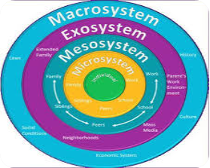
Urie Bronfenbrenner’s theory is based on microsystem, mesosystem, exosystem and macrosystem. The circle was created to demonstrate the influences that have the greatest effect on a child. The child is central to all and it is important to consider all factors to ensure a child is able to reach their full potential through positive experiences. Bronfenbrenner believed different environments children are exposed to can have an impact on the child’s development. School is underpinned in the microsystem and mesosystem, therefore positive environments and relationships within the setting will help them grow and develop. Sincero, S.M. (n.d) states “if a child is neglected by his parents, he may have a low chance of developing positive attitude towards his teachers.” As a professional, it is important that the child‘s needs are met and that they are able to build a positive relationship with the child to ensure they are supported in all areas.
Bronfenbrenner’s theory can be widely used in practice as it can help practitioners understand the importance of the relationships formed and also what is central to children’s development. School should have a positive impact on the child and ensure they develop healthy and thriving relationships. Working with the children’s close family will also help practitioners form relationships with the parents/carers and establish a trust.
(Wangdi, n.d).

The United Nations Convention on the Right of the Child (UNCRC)
A treaty was signed in 1989 to which 192 countries have signed including the UK. The treaty declares that all children have the right to basic human rights and should be promoted and respected by all working with children. There are 54 articles, articles 1-42 are based on the child while articles 43-54 are how countries implement them.
The role of the children’s commissioner for Wales is to ensure the UNCRC is implemented and also ensuring children’s voices are heard. Also, it was adopted by the Welsh government in 2004.
The Early Years Foundation Phase (EYFP) is statutory curriculum for children aged 3-7 years old and is heavily based on the UNCRC. It is important to ensure all children's rights are identified and adhered to within the setting. All children have the right to life and also the right to develop. This must be implemented in the setting and to ensure that all children are equal. UNICEF (n.d) states “The Convention must be understood as a whole: all rights are linked and no right is more important than another.” All articles relating to the UNCRC ensure that children develop
- Physically
- Intellectually
- Emotionally
- Socially

Security
A child must feel physically and emotionally secure whilst at the setting. The setting must be safe before children enter the classroom by ensuring all supplies are correctly stored. This also includes areas that are open such as outdoor areas. They must be secured to ensure children aren’t exposed to danger outside the setting.
Equally children must feel safe whilst at the setting and have no fear that they will be harmed by others. Children who do not have a positive environment or a bond with a member of staff can struggle later in life to socialise with others. It is also likely that they may experience mental or physical issues as they mature to adulthood (Croner-i, 2012).

Abraham Maslow supports security in his hierarchy triangle as he believes it is part of a child’s basic need.. For the triangle to prove effective all segments of the triangle must be present. If a child’s safety needs are not met the child is unable to progress to the next level. McLeod, S. (2018) states “Individuals must satisfy lower level deficit needs before progressing on to meet higher level growth needs.” Practitioners must ensure that they identify children’s needs to ensure they can support growth.



(McLeod, 2018).

The role of the adult

Early Years Foundation Phase (EYFP) Holistic development is supported within the Early Years Foundation Phase (EYFP). Children develop holistically through many play activities set out throughout the class, each task is set to develop individual skills. The key worker will plan activities that will encourage children to develop and explore their environment whilst also sharing ideas with support staff.
Play has an influence on a child’s development as they are developing skills such as; social, emotional, physical, gross and fine motor, cognitive, language and self-help. Through the activities of the EYFP children are able to explore the world around them and also question themselves and their learning. It is important that all staff are supporting their curiosity and also enabling them to experience activities that will help develop these holistic needs. Key Workers and also staff working alongside children must cater for their needs and ensure all activities set are enjoyable and also developing their individual skills.
As the EYFP promotes the use of many toys that develop skills and colourful classrooms children transitioning may find it a happy place. Also, as they engage with other children and in play they settle and become more comfortable and confident in the setting.

Effective transitions
Children transitioning from nurseries and other settings prior to school may find school formidable, therefore it is the role of the practitioner and key worker to ensure it is a positive experience. Prior to starting school, the teacher will liaise with families to discuss the development of the child and any concerns the parents may have. Also, children will have a ‘play date’ which consists of a morning session with the teacher and staff, enabling them to familiarise themselves with the class, staff and other pupils.
Children may feel positive about attending school although there will be some who may feel overwhelmed, therefore staff must ensure they have techniques to reconcile and to make the child feel safe whilst they are in their care. This could be by having one to one time with the child and finding an interest in an activity that they enjoy. Although, children with additional needs which have been identified through multi agencies, parents or prior settings will ensure teacher and staff plan for a successful transition.
As children are all individuals, it is important to ensure staff identify their individual needs and ensure they are supported throughout this process. There may be children who struggle with separation anxiety from their primary carer/carers therefore identifying these early, enables settings to put in place strategies that will help the child emotionally.
Strategies that have proven effective in such circumstances are social stories. Social stories can be implemented within school and also at home. Through observations conducted at school, staff have identified that some children benefit from social stories. Social stories are short stories or flash-cards that enable children to interact using pictures which prepare children for events such as first day at school. They are adaptable for children with individual needs to ensure positive experience for all. Also, individual educational plan (IEP) may prove effective.

Supporting children with additional needs
Transitioning from a setting where a child has experienced routine can still be stressful for children with additional needs. It is therefore important to engage with parents and previous carers of the child to ensure a smooth transition. By discussing with parents the child’s interests and hobbies, the key worker can use this information to help engage the child’s attention. Also, children with additional needs may benefit from visits to the setting to familiarise themselves with the new environment and to interact with their teacher and support staff.
Transition books will also help children understand what will be happening when they attend the new setting. The transition book could include a picture of the school, the classroom and also pictures of the staff. This could be reinforced at home therefore it is important to have a positive relationship with the parents or carers of the child. Also, visual cards may be shown throughout the day to indicate what is happening next and able to associate the picture with the task ahead and also to inform the child what is happening next.

Play
The Welsh Government established the play policy in 2002 to implement in school as play is significant in a child’s development. School set activities that can further progress them in their learning journey. The Early Years Foundation Phase (EYFP) is based on learning through play. They ensure children can develop in 7 areas of development through play. According to Gov.uk (n.d) the 7 areas include

- “communication and language
- physical development
- personal, social and emotional development
- literacy
- mathematics
- understanding the world
- expressive arts and design”
Learning through play has many benefits for children such as emotional, social and physical. If the learning environment is planned effectively, children will experience stimulating experiences ensuring all tasks are planned for children to succeed.
Many theorists believe children learn through play. Maria Montessori founded the Montessori schools that are still available. Maria would make most of her materials for children to engage and play with. According the Theories of Childhood (2000) “to be comfortable, young children need furnishings their own size and tools that fit their small hands.” Many settings have adopted Montessori’s teachings. She also believed children should direct their play thus meaning all supplies should be accessible for them. Ensuring children are able to see all resources available to them to create and lead their exploration. Using Maria’s theory it promotes independence and to explore or use their environment to the fullest.
Observation
Through observations staff are able to identify the child’s needs. Also, it enables practitioners to understand what developmental stage they are currently at. When children first arrive at the setting, observations will be carried out. Staff conduct these to gain a greater understanding of the children’s capabilities and plan appropriate activities. Observations should be carried out regularly to ensure children are developing holistically. (Riddall-Leech, 2005, p.7) “You will be in a stronger position from which to make assessments about their needs; and will be more able to suggest and plan activities and experiences that will enable them to progress.” It also enables intervention if needed, to support children in the areas needed for their development.
Whilst children engage in play, they are developing and using skills that they have learned. Children may feel pressured when asked questions whilst observing, therefore observing them play independently may give a greater understanding. Also, children who engage in play with others are using their social skills and also learning to share. These skills are equally important and must encourage children to use these skills also.

Ensuring practitioners have a positive relationship with parents is crucial within the setting. By having a partnership with parents, it builds trust. If a situation arises, a parent may feel more comfortable notifying a staff member and thus be reassured it will be dealt with appropriately.

Partnership with parents
Children will also see their parent and teacher coercing and may help the child build a relationship with staff and begin to trust and feel secure in their care. Hobart and Frankel, 2009, p.45 states “The child will benefit most when the triangle of parent, child and child-care practitioner works together.”
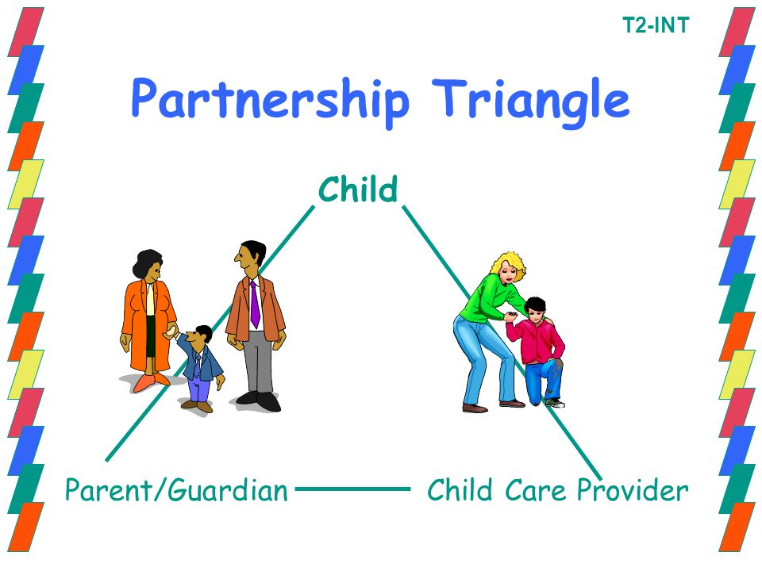
Although, before a child attends school there will be several opportunities for parents to meet the key worker and staff. This will give the parents or carers the opportunity to relay information they believe is important. Also, ensuring information disclosed by the parents is used for an effective transition. If a parent believes their child will find the transition difficult the key worker will plan appropriately for the child.
Whilst at the meeting they are able to discuss the child to ensure an effective transition or any concerns they have about this milestone.
Also, the child to be invited for a ‘play date’ to familiarise themselves with the new environment. This is also an opportunity to meet their teachers and begin building a relationship. Through placing activities that they can engage in, will enable interaction with other children also.

(Bryant, n.d).

Interventions
Intervention teams are involved in the setting to ensure children have all their needs met. Invertantions at the setting include
- Special Educational Needs Coordinator (SENCO)
- Emotional Literacy Support Assistant (ELSA)
- Speech Link
- Looked After Children (LAC)
- Home and School books
- Home visits
- ‘Play dates’
- Parents evening

Prior to starting school children will be invited for a ‘play date’ to familiarise themselves with the setting and also practitioners are able to interact with children. Also, if the key worker has a need to discuss the child’s ‘play date’ or have concerns, they can express this with the parents and offer support and activities that they can discuss at home with the child. If appropriate, Key workers can also offer home visits. Home and school books may also prove effective during the transition as parents and staff are able to communicate how the child is performing and maybe explain why the child is upset or distressed that day because of something that happened at home. Also, parents evening is offered to parents to ensure they are included in their child’s learning and able to discuss what children need more encouragement with and how they can implement it at home. It also offers parents the opportunity to share concerns or to feel included in their child’s learning process.

Intervention teams such as ELSA, SENCO and Speech Link may prove effective if children transitioning take longer to settle. They aim to support children who are struggling and to identify their needs for appropriate intervention. ELSA would be implemented if a child is struggling emotionally. SENCO will be effective if they believe intervention is needed in strategising for a child and also if they need to be assessed by the coordinator for extra support. Speech Link will help children develop their language skills and communicate with others.
Not only do schools have interventions to help children emotionally and physically they also have a responsibility to support Looked After Children (LAC). Children under LAC have a Personal Education Plan (PEP) set by the Local Authority and it is reviewed regularly. Child Law advice states “it is of paramount importance that a school place is found that meets the child’s educational needs as soon as possible.” Ensuring the setting can support LAC and ensure they have equal opportunities to others to thrive.

Proposed outcomes
Promoting a good relationship between staff and parents will help to ensure that parents feel included in their child’s education. Through witnessing this continued relationship between staff and parent, children will more readily replicate this, thus ensuring a trusting relationship also.
Establishing a positive attachment with key workers and support staff will help children feel reassured in the setting. Integrating with other children and forming friendships will also help with a successful integration. Through research conducted by John Bowlby and Abraham Maslow staff are enable to identify children’s needs and ensure children have a positive transition. As children enjoy playing, it distracts them from the transition and also promotes their learning through play and socialising with other children. By promoting a positive environment for children to learn in, will ensure they explore and question their learning.
All children need to be included in all activities regardless of ability. Children with additional needs must have support to help them progress further, thus providing all with a safe and comfortable environment in which to learn and develop.

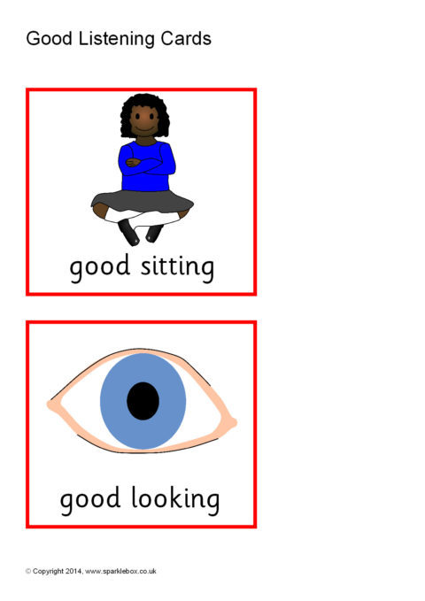
Resources - Non-verbal communication
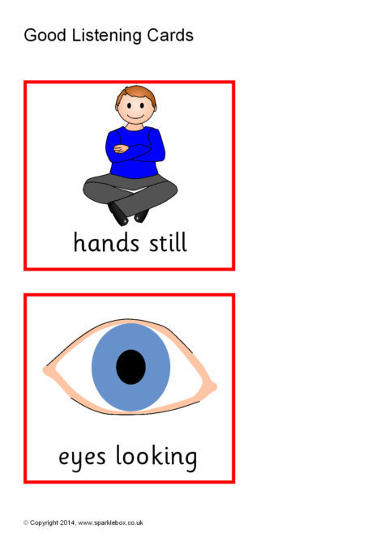
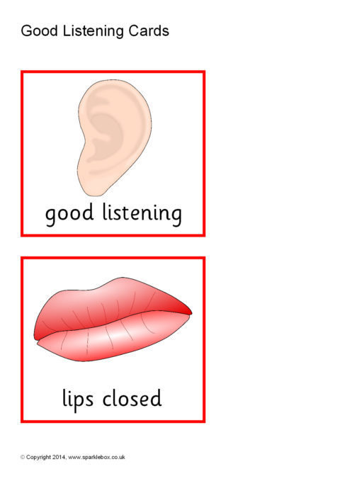

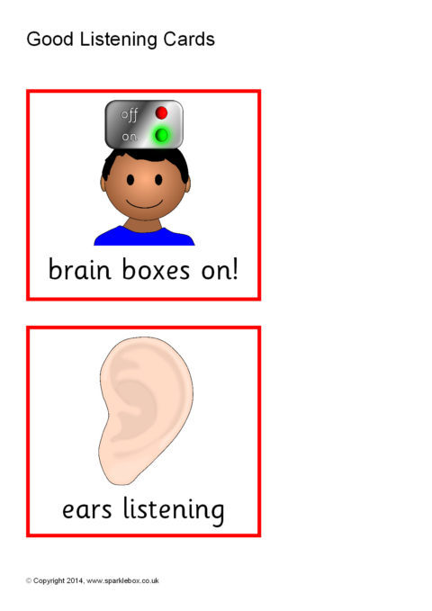

(Sparklebox, n.d)

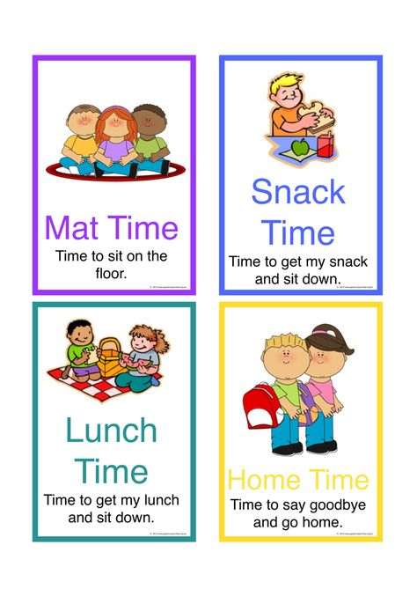

(Pinterest, n.d)

Reference List

Bryant, J. (n.d) First Aid for Child Day Care Personnel T1-INT. Partnership Triangle Child Parent/GuardianChild Care Provider T2-INT [Diagram]. Available at:
https://slideplayer.com/slide/5801455/ (Accessed 12th December 2018).

Cherry, K. (2018) John Bowlby Biography (1907-1990). Available at:
https://www.verywellmind.com/john-bowlby-biography-1907-1990-2795514 (Accessed: 15th of January 2019).

Child Law Advice (n.d) Education for looked after children. Available at:
https://childlawadvice.org.uk/information-pages/education-for-looked-after-children/ (Accessed: 17th of January 2019).

Child Protection Resource (2014) What is Attachment Theory? Why is it important?. Available at: http://childprotectionresource.online/what-is-attachment-theory-why-is-it-important/ (Accessed: 15th of January 2019).

Croner-i (2012) The emotional environment. Available at: https://app.croneri.co.uk/feature-articles/emotional-environment (Accessed: 9th of January 2019).

Gov.uk (n.d) Early years foundation stage. https://www.gov.uk/early-years-foundation-stage (Accessed: 16th of January 2019).

Hobart, C. and Frankel, J. (2009) A practical Guide to Working with Parents. 2nd Ed. Cheltenham: Nelson Thornes Ltd.

Jones, K. (2018) HOW IMPORTANT IS DIVERSITY AND INCLUSION FOR YOUR DEALERSHIP? [Image]. Available at:https://www.clickdealer.co.uk/important-diversity-inclusion-dealership/ (Accessed 27th of November 2018).

McLeod,S. (2018) Maslow's Hierarchy of Needs [Diagram]. Available at:
https://www.simplypsychology.org/maslow.html (Accessed 9th of January 2019).

McLeod, S. (2018) Maslow’s Hierarchy of Needs. Available at: https://www.simplypsychology.org/maslow.html (Accessed: 9th of January 2019).

Mooney, C. (2000) Theories of Childhood An Introduction to Dewey Montessori Erikson Piaget & Vygotsky. St. Paul: Redleaf Press.

Pinterest (n.d) Discover ideas about Behavior Support [image]. Available at:
https://www.pinterest.co.uk/pin/469359592387139963/ (Accessed 18th of January 2019).

Riddall-Leech, S. (2005) How to Observe Children. Oxford: Heinemann Educational Publishers.

Sincero, S.M. (n.d) The Five Environmental Systems. Available at: https://explorable.com/ecological-systems-theory (Accessed: 24th of November 2018).

SparkleBox (n.d) Good Listening Cards [image]. Available at: https://www.sparklebox.co.uk/th1001-1005/sb1002-good-listening-prompt-cards.html (Accessed 18th of January 2019).

Tassoni, P. (2003) ‘Ready steady: stability’, NurseryWorld, 20th May. Available at: https://www.nurseryworld.co.uk/nursery-world/news/1103602/ready-steady-stability (Accessed 14th of January 2019).

UNICEF (n.d) INTRODUCING THE UNITED NATIONS CONVENTION ON THE RIGHTS OF THE CHILD. Available at: https://www.unicef.org.uk/rights-respecting-schools/the-rrsa/introducing-the-crc/ (Accessed: 12th of December 2018).

Wangdi, D. (2015) Bronfenbrenner’s Ecological Model [Diagram]. Available at:
http://dumchowangdi.blogspot.com/2015/02/bronfenbrenners-ecological-model.html (Accessed 12th of December 2018).

