Questions and Guidelines for Assessment Component 1


Changemakers: Creativity and Value Creation
Professions (BMHP5014)

Component 1: Online portfolio of set exercises

Student name: Amina Mustapha
Student number:2418937
Lecturer’s name: Brian Mashumba

Table of contents
Introduction .............................................................................. ……………..1
Task 1: Creative Thinking and Reflection .................................................... 2
Task 2: Group Activity and Reflection ........................................................... 3
Task 3: Thinking Styles and Reflective Practice ..................... ………………4
Task 4: Case Study Analysis of a UK Innovation .......................................... 5
Task 5: Research Task ....................................................................................... 6
Task 6: Exploring Digital Innovation in Health and Social Care ………………7
Task 7: Understanding the NHS health care leadership model…………………8
Task 8: Self-reflection journal entry………………………………………………….9
Conclusion ............................................................................................................. 10
Reference List ......................................................................................................... 11

Task 1: Defining Key Concepts in Practical
Innovation refers to introducing and implementing a new or significantly improved idea, service, process or technology that creates benefit. In health and social care, innovation is not simply having an original idea; it involves applying that idea successfully to improve outcomes. Rogers (2003) explains that innovation spreads when people perceive it as useful, compatible with existing practice and relatively easy to use. For example, virtual wards allow suitable patients to receive monitoring and treatment in their own home rather than remaining in hospital. This can improve patient comfort while releasing hospital capacity.
Creativity is the ability to generate original and useful ideas. Amabile (1996) argues that creativity depends on expertise, creative-thinking skills and motivation. In care settings, creativity may involve staff identifying a new way to communicate with people who have dementia, redesigning an appointment system, or adapting care plans to suit an individual’s needs. Creativity is particularly valuable because frontline staff understand the everyday barriers experienced by patients and can identify realistic solutions.
Value creation concerns improving outcomes in relation to the resources used. Porter (2010) defines value in healthcare as health outcomes achieved per unit of cost. However, value should also include dignity, independence, experience and fairness. For example, digital appointment reminders may reduce missed appointments, improve attendance and prevent wasted clinical time. The value created is not only financial: patients may receive care more promptly and experience less uncertainty.
Change is the process through which organisations move from existing ways of working to improved practice. Lewin’s model identifies unfreezing, changing and refreezing as key stages. Staff may first need to understand why current practice is inadequate, then receive training and support during implementation, before the new approach becomes routine. In health and social care, change must be carefully managed because poor implementation can affect safety and staff confidence. Together, creativity produces ideas, innovation applies them, value creation assesses their benefit, and change management embeds them into practice.
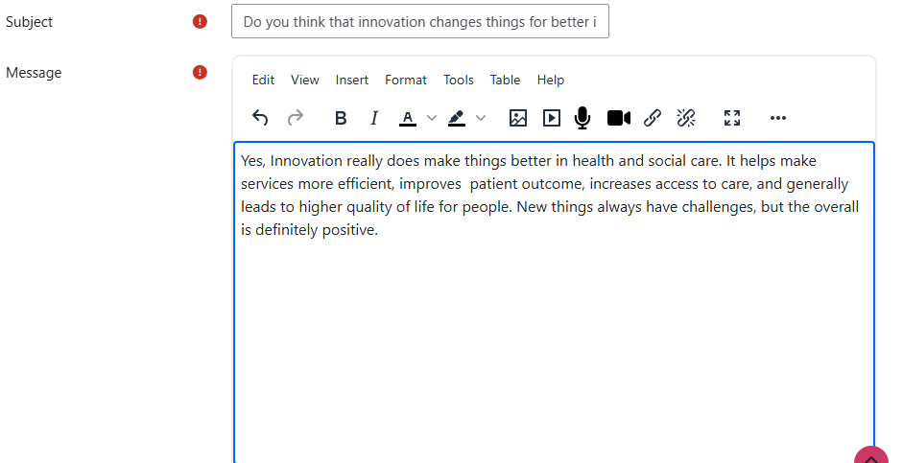

Task 2: Mind Map: Staff Burnout in Health and Social Care
The central problem is staff burnout in health and social care. Its causes include high workload, staff shortages, emotional labour, long shifts, inadequate supervision and limited control over work. These factors interact: staff shortages increase workload, while increased workload leads to sickness absence and further shortages. Burnout may result in emotional exhaustion, reduced motivation, lower job satisfaction and staff leaving the profession. This can affect patients through poorer continuity of care, delayed treatment and increased risk of errors.
Possible solutions include safe staffing levels, flexible routes, access to psychological support, effective supervision and opportunities for staff involvement in service improvement. Digital systems may reduce administrative workload, but only where staff are trained and technology is reliable. A systems-thinking approach is useful because burnout is not caused by one individual weakness; it develops through interconnected organizational pressures. If the issue is not addressed, services may experience worsening retention, poorer patient experience and increased costs from agency staffing.
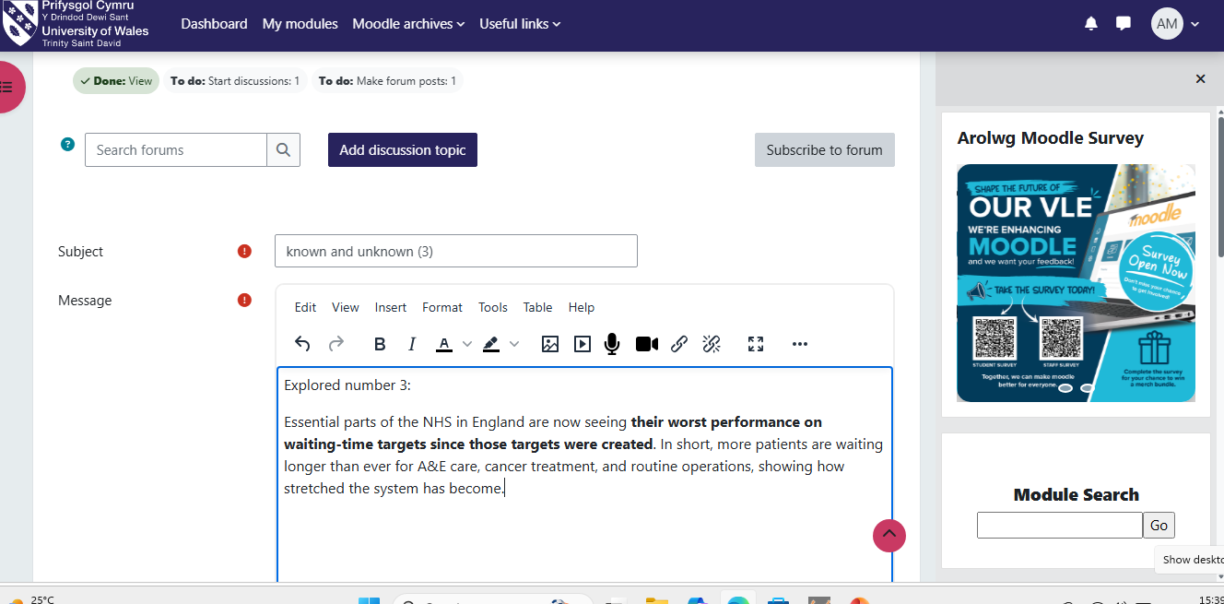

Task 3: Self-Reflection of Group Activity
During the group activity, divergent thinking involved generating many possible solutions without immediately judging them, whereas convergent thinking involved evaluating those ideas and selecting the most appropriate option. Our group initially used divergent thinking to identify ways to reduce missed appointments, including text reminders, telephone follow-up, transport support and flexible booking systems. We then used convergent thinking to decide which ideas were practical, affordable and likely to benefit patients.
Using Gibbs’ (1988) reflective cycle, I felt engaged during idea generation but noticed that I sometimes focused too quickly on whether an idea was realistic. This limited my contribution during the creative stage. However, listening to other group members showed me that unusual ideas can be adapted into workable solutions. I learned that teamwork benefits from different thinking styles: some members generated imaginative suggestions, while others considered risks and implementation.
In future, I would allow more time for ideas to develop before evaluating them. I would also encourage quieter members to contribute, as their perspectives may identify barriers that others have missed. This activity improved my understanding that creativity in health and social care is collaborative rather than individual. It also demonstrated that innovation requires both open thinking and structured decision-making.
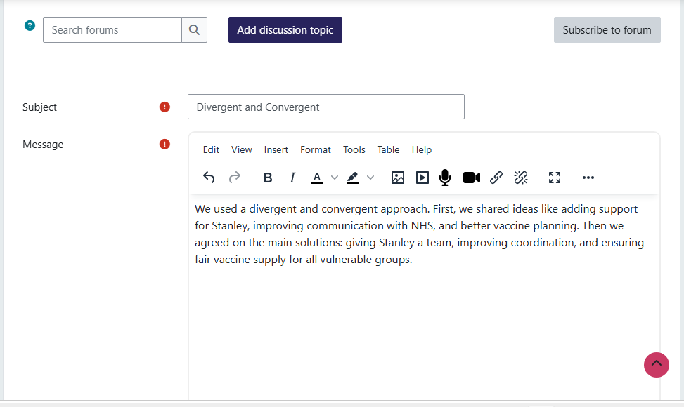

Task 4: Case Study Analysis of UK Innovation: Virtual Wards
Virtual wards are an important NHS innovation that supports people who would otherwise require hospital admission to receive treatment and monitoring at home. They may be used for conditions such as respiratory illness, frailty and heart failure. Patients can use devices to record observations, while multidisciplinary teams review information remotely and respond if deterioration is identified.
The problem addressed is pressure on hospital beds and the risk that unnecessary hospital stays can reduce independence, particularly for older people. Virtual wards create value by enabling appropriate patients to remain in familiar surroundings while receiving clinical oversight. They may also support hospitals to focus beds on people requiring acute care. NHS England Digital (2026) states that virtual wards allow people to receive care safely and conveniently in their usual place of residence.
Rogers’ (2003) Diffusion of Innovations Theory helps explain adoption. Virtual wards have relative advantages because they can reduce hospital use and improve convenience. However, adoption depends on compatibility with staff workflows, confidence in remote monitoring and access to digital devices. Staff training and clear, Staff training and clear escalation pathways are therefore essential.
The approach is creative because it redesigns the location of care rather than simply increasing hospital capacity. Patients, carers, hospitals and community teams may benefit. However, virtual wards should not replace face-to-face care where people have complex needs, poor digital access or unsafe home circumstances. The model could be used more widely, provided services address digital exclusion, consent, information governance and clinical safety. 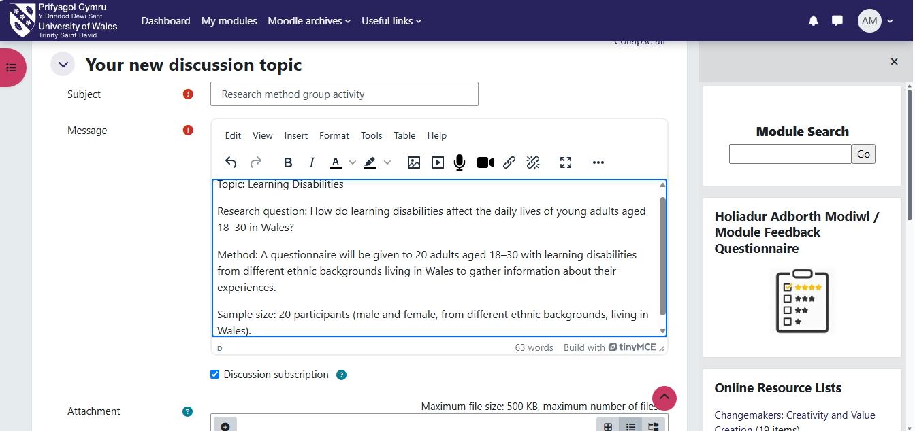

Task 5: Research Task: Staff Stress and Burnout
Staff stress is a major issue because it affects employee wellbeing, retention and quality of care. Maslach and Leiter (2016) identify burnout as a response to chronic workplace stress, commonly involving exhaustion, cynicism and reduced professional effectiveness. Their work highlights organizational causes, including excessive workload, lack of control, insufficient rewards and poor workplace community. This is useful because it shows that burnout should not be treated solely as an individual resilience problem.
West et al. (2016) similarly argue that healthcare staff wellbeing is closely linked to patient safety and compassionate care. They identify workload, poor teamwork, bullying and inadequate leadership as significant contributors to stress. Their analysis is particularly relevant to NHS services because it connects staff experience with patient outcomes.
The articles broadly agree that burnout is shaped by working conditions rather than personal weakness. However, Maslach and Leiter focus more on the psychological dimensions of burnout, while West et al. place greater emphasis on organizational culture and leadership. Maslach Burnout Theory supports this analysis because it explains how prolonged demands can lead to emotional exhaustion and disengagement.
A systems approach is necessary. Improving well-being requires safe staffing, supportive leadership, manageable workloads and opportunities for staff to influence decisions. Individual support services are valuable, but they cannot compensate for unsafe or unsustainable working conditions. 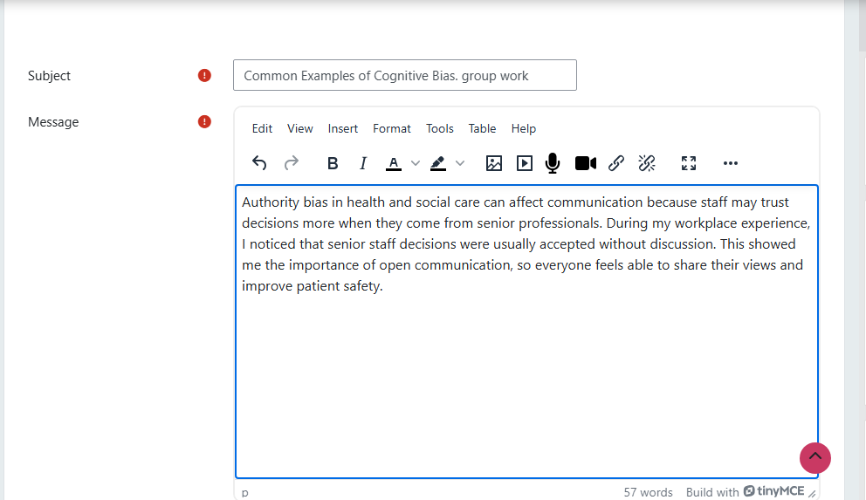

Task 6: Exploring Digital Innovation in Health and Social Care
Wearable Health Technology
Wearable technology, such as smartwatches and activity trackers, can support self-management of long-term conditions by helping people monitor physical activity, heart rate, sleep patterns or symptoms. For example, a person with heart failure may use a connected device to record daily observations, allowing healthcare professionals to identify deterioration earlier. This may help prevent avoidable hospital admission.
The main benefit is that patients can become more involved in their own care. Regular feedback may encourage healthier behavior and improve awareness of changes in health. However, technology should support rather than replace professional judgement. Some people may lack digital confidence, internet access or the ability to interpret information safely.
Davis’s (1989) Technology Acceptance Model suggests that people are more likely to use technology when they believe it is useful and easy to use. Therefore, staff should provide clear instructions, accessible design and alternatives for people who cannot use wearable devices. Digital health must be inclusive so that it does not widen health inequalities.
For example, when a patient is discharged from hospital, shared electronic records can protection requirements. Digital systems must also be reliable and interoperable; otherwise, staff may need to enter the same information repeatedly. NHS England Digital (2026) emphasizes the importance of lawful and secure information governance for virtual ward services. Technology is most effective when it supports professional communication rather than creating additional administrative burden.
Personalized Care and Self-Management
Digital technology can support personalized care by allowing people to access information, monitor symptoms and communicate preferences. The NHS App is an example of a digital tool that can help users access services, order repeat prescriptions and view aspects of their health information. This may give people greater control and reduce unnecessary contact with services.
For someone with diabetes, a digital app may help record blood glucose readings, food intake and medication use. The information can support discussions with healthcare professionals and help the person recognized patterns in their condition. Personalization is important because people have different goals, levels of confidence and support networks. 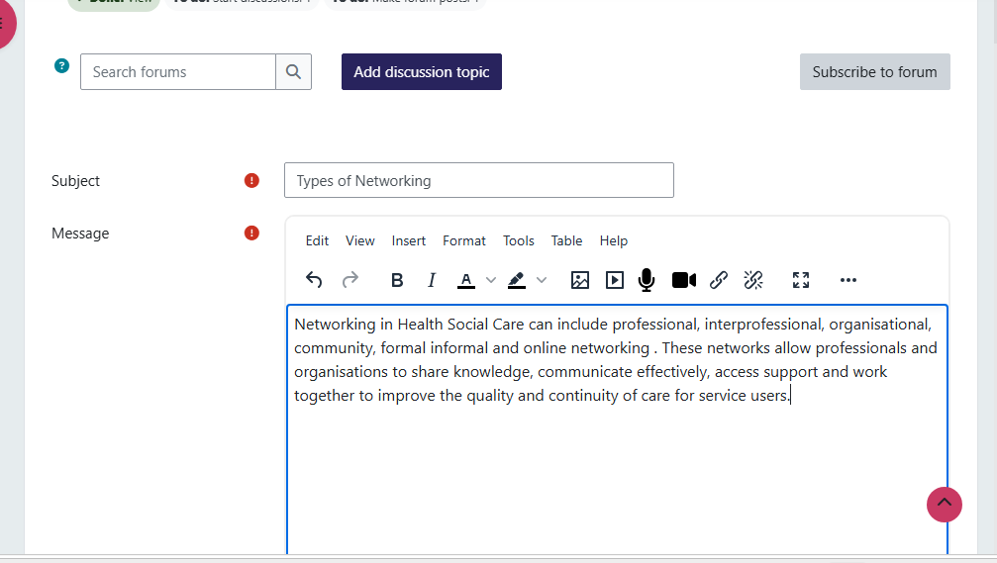

Task 7: Understanding the NHS Leadership Framework
The NHS Healthcare Leadership Model contains nine dimensions: inspiring shared purpose, leading with care, evaluating information, connecting our service, sharing the vision, engaging the team, holding account, developing capability and influencing results. The model is relevant to both clinical and non-clinical staff because leadership behavior affects workplace culture, staff wellbeing and patient experience.
Inspiring shared purpose Inspiring shared purpose is particularly important. It involves connecting everyday work to NHS values and the wider purpose of improving patient care. When staff understand why a change is necessary, they may be more willing to participate and identify practical solutions. For example, a manager introducing a new digital triage system should explain how it may improve access and safety rather than presenting it only as an efficiency target.
This behavior links to transformational leadership. Bass and Avolio (1994) argue that transformational leaders motivate others through vision, encouragement and shared commitment. In health and social care, this can improve patient care by creating a culture where staff feel valued and confident to raise concerns. The NHS Leadership Academy (2026) explains that the model is designed to help leaders understand their behaviors and development needs. Effective leadership is therefore not limited to senior managers; all staff can influence care quality through communication, teamwork and accountability.
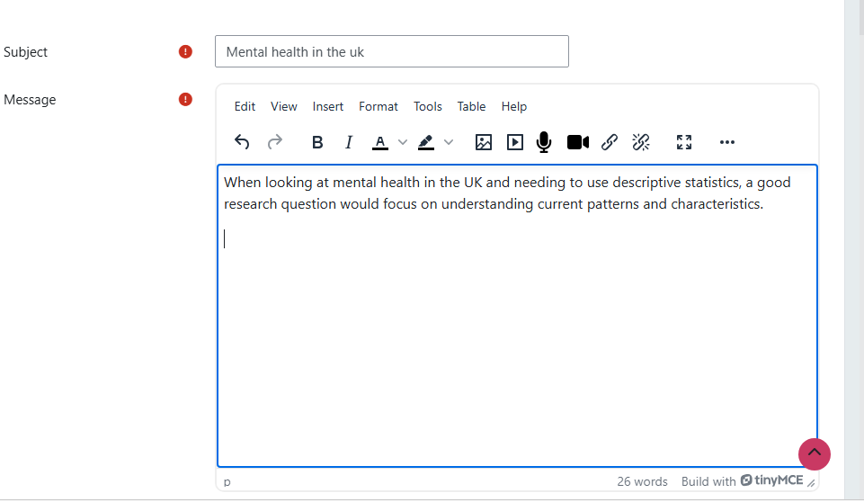

Task 8: Self-Reflection Journal Entry
This module changed my understanding of innovation. Previously, I associated innovation mainly with technology, such as apps or digital records. I now understand that innovation can also involve changing communication, teamwork or service design.
The virtual wards case study was particularly useful because it showed how value can be created by moving appropriate care from hospital into people’s homes.
Using Gibbs’ (1988) reflective model, I recognize that I initially focused on whether an innovation was new rather than whether it improved outcomes. I now understand that value creation should include patient dignity, independence, safety and staff experience, not simply financial savings.
In my future professional role, I will be more willing to suggest improvements and listen to service users’ experiences. I will also consider whether proposed changes are accessible to people with different digital skills and circumstances. The key concept I will carry forward is that successful innovation requires collaboration, evaluation and careful implementation.

Conclusion
Mind Connect UK represents an innovative approach to improving mental health care for young adults. By combining artificial intelligence with professional healthcare expertise, the service enables earlier intervention, faster access to support and improved patient outcomes while reducing pressure on NHS services. Through secure technology, evidence-based practice and collaborative working, Mind Connect UK has the potential to create lasting value for individuals, healthcare providers and society.

Reference List

Amabile, T.M. (1996) Creativity in Context. Boulder: Westview Press Bass, B.M. and Avolio, B.J. (1994) Improving Organizational Effectiveness Through Transformational Leadership. Thousand Oaks: Sage.

Davis, F.D. (1989) ‘Perceived usefulness, perceived ease of use, and user acceptance of information technology’, MIS Quarterly, 13(3), pp. 319–340.
Gibbs, G. (1988) Learning by Doing: A Guide to Teaching and Learning Methods. Oxford: Oxford Polytechnic.

Lewin, K. (1951) Field Theory in Social Science. New York: Harper and Row.
Maslach, C. and Leiter, M.P. (2016) ‘Understanding the burnout experience: recent research and its implications for psychiatry’, World Psychiatry, 15(2), pp. 103–111.

NHS England Digital (2026) Virtual Wards. Available at: NHS England Digital virtual wards guidance⁠� (Accessed: 5 July 2026).

NHS Leadership Academy (2026) Explore the Healthcare Leadership Model. Available at: NHS Healthcare NHS England Digital (2026) Virtual Wards. Available at: NHS England Digital virtual wards guidance⁠� (Accessed: 5 July 2026).

Porter, M.E. (2010) ‘What is value in health care?’, New England Journal of Medicine, 363(26), pp. 2477–2481.

Rogers, E.M. (2003) Diffusion of Innovations. 5th edn. New York: Free Press.
West, M., Dawson, J., Admasachew, L. and Topeka’s, A. (2016) NHS Staff Management and Health Service Quality. London: Department of Health

