

University of Wales Trinity Saint David
Wales Institute of Science and Art

To Clearly Explain What a Ride Height Device is and Outline the Pros and Cons
Academic Skills ACHA4005

Jake Davies
2205290
11/2022

Contents Page

1. Introduction

2. Main Body

3. Advantages and Disadvantages of RHD

4. Conclusion

5. References

Introduction

This report will be explaining what a ride height device is on a MotoGP bike and what the pros and cons of this device are. This will include how it has changed the performance of the bikes, The first Manufacturer to bring this new development into the sport and who’s idea it was to add this device to the bikes.

Main Body

The ride height device is a further development from what was known and the “whole shot device” and this was an electronic switch which could only be activated once and was used at the start of the race, the device earnt its name from its drastic improvement to the acceleration of the MotoGP bikes upon race start. The “whole shot device” was activated by compressing the front forks on the warmup lap and pressing a switch that engaged a hook that locked them in place and to deactivate this all they had to do is brake for the first corner which would unlock the spring-loaded hook and allow the front forks to decompress.

The ride height device is switch that the rider can activate but it will only deactivate once the rider applies a large amount of brake pressure. What this switch does is it lowers the rear end of the bike which overall will lower the bikes centre of gravity. In 2019 Ducati brought this new device to the first race and it was not long after that there was a race amongst manufacturers to develop one of their own devices as it was clear to see the improvement to acceleration taking place.

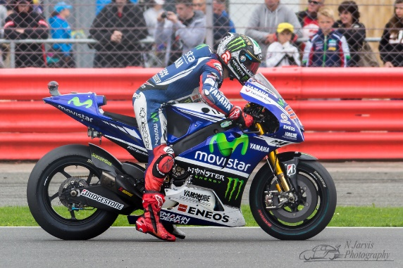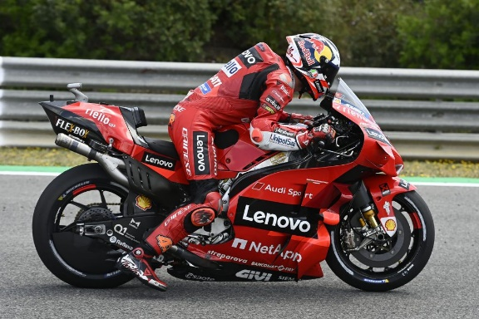

This is a side-by-side comparison of the device being deactivated and the device being active

Advantages and Disadvantages

Advantages

The biggest advantage of this device is in a race start situation they lower the centre of gravity of the bike which means the bike will not wheelie as much when applying substantial amounts of power to the back wheel.
On a motorbike there is something called a “wheelie phase” which this device helps drastically with as having a lower centre of gravity when accelerating in a low gear means that the front of the bike wont lift as much.
This device also helps the rear tyre to grip to the tarmac causing less wheel spin allowing the bikes to accelerate quicker as they are not spinning.

Disadvantages

With the addition of this device u also must consider the addition of weight to the machine.
This device changes the geometry of the bike until you brake hard enough to disengage the device. This means that the moment you grab the brakes the bikes attitude will be different to normal which could lead to you having to alter your body position to suit how the new attitude of the bike needs, some riders have said that they have needed to change the way they brake to keep the bike calm and steady as their normal way of braking would cause the bike to shake a lot.

Conclusion

In conclusion, it is clear to see that the bike has made significant improvement since the addition of this device as the role of this device was to allow the bike to accelerate quicker. This device offered a fast solution to the problem engineers were facing and was a tremendous change that caused a race against teams to perfect one of their own so they can outperform others.

References

MotoGP Rear Ride Height Device explained - 44Teeth | Motorcycle Lifestyle
44teeth are an organisation of 2 people, Alastair Fagan who is a ex British superbike racer and ex Isle of man TT racer. Chris Eades is the second man in charge who is a social media star and an ex British superstock Championship racer

MotoGP Ride Height Devices Explained - intentsGP
These are a family run business with 2 sons who are ex racers, and the family are motorcycle enthusiasts.

Some information was researched through MotoGP.com where you can find interviews with chief engineers and team managers.

