​4 Site Location
​4.1 Location Description
​The Address: Bethany Square Car Park, Bethany Square, 87 Station Rd, Port Talbot SA13 1PQ
​Description: Bethany Square Car park is a 166-parking spaced car park situated at Bethany square in port talbot
​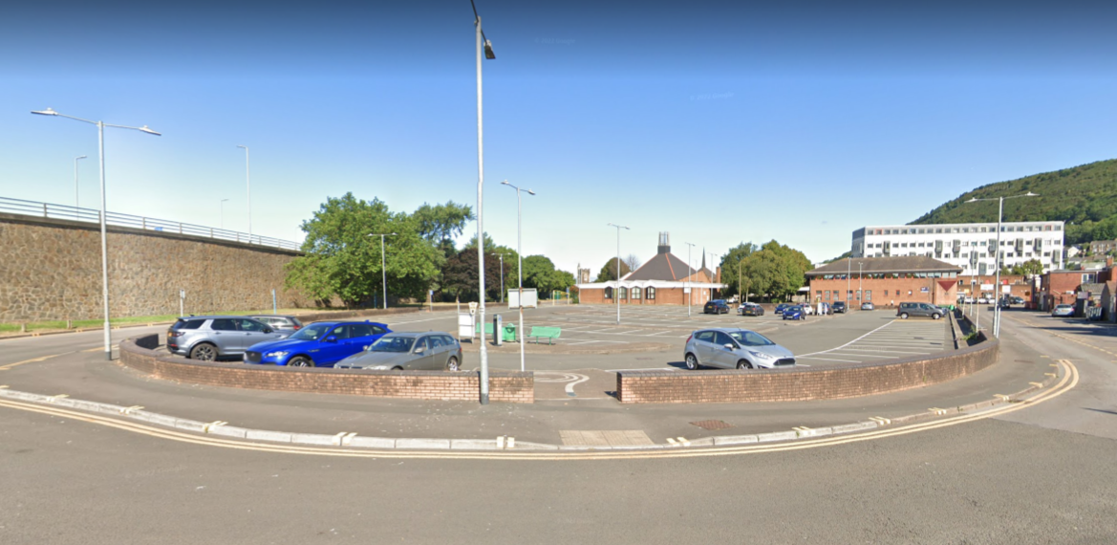
​4.2 Ownership
​The Site is owned and operated by NPT Council and is used daily for parking for the many facilities of station road and other surrounding areas
​
​4.3 Site Investigation
​Borehole record title: Redevelopment of port talbot town centre bridges no26
​Reference Number: SS78NE243
​Date: 09/09/1969
​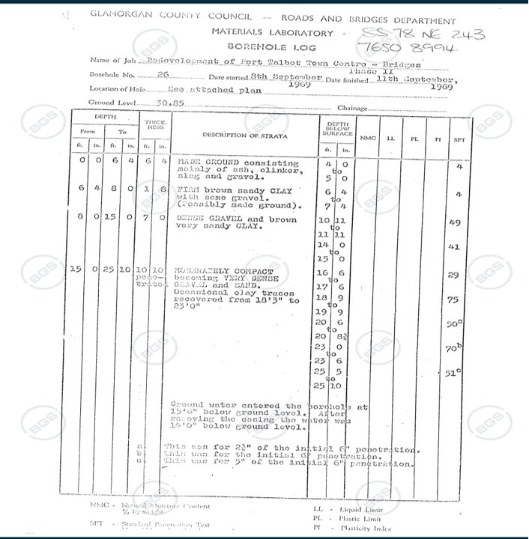
​
​0ft-6ft4in consists of Made Ground: Ash, Clinker, Sand and Gravel
​6ft 4in-8ft 0 in: Firm brown sand clay with some gravel. Possibly made ground
​8ft 0 in- 15ft 0 in: Dense gravel with brown and sandy clay
​15ft 0 in- 25ft 10 in: moderately compact to very dense gravel with occasional traces of clay
​Ground water entered the Borehole at 15ft 5inches below ground level after removing the casing the water was 14ft 0inches below ground level
​
​Recommendation: With the data being 54 years old this could pose a problem going forward along with it being roughly 100m away from the proposed site, newer equipment could also provide more accurate results.
​4.4 Contaminated Land
​Port Talbot has a history of heavy industry, including steelmaking. Industrial processes often involve the use of various chemicals and materials that can lead to soil and groundwater contamination if not managed properly
​Improper disposal of industrial waste, including hazardous materials, in the past will have resulted in soil contamination. Dumping of waste products into the environment may could have potentially caused long-term contamination in the groundworks
​A more specific report of our site will be acquired from the Neath Port Talbot Council Civic Centre

​4.6 Services Adequacy

​To achieve service adequacy in constructing the Jayne Pierson school of fashion, art and design, the project should prioritize meeting the unique requirements of a modern educational facility within the constraints of construction and budgetary considerations. This involves detailed planning to create functional and aesthetically pleasing spaces, such as design studios, laboratories, and lecture halls.

​Adherence to regulations is crucial, and safety standards must be strictly followed. Efficient project management, skilled labor, and effective communication with architects, builders, and the educational institution contribute to the successful construction of the school. Integrating technology, ensuring sustainability in construction materials, and providing flexibility in spaces to accommodate the dynamic nature of fashion education are additional considerations.

​The construction project should reflect the industry's aesthetic while creating an environment conducive to learning and innovation. Continuous evaluation and adjustments during the construction process contribute to the overall service adequacy of the project.

​5 Development Constraints
​5.1 Planning
​When working around Bethany Chapel which is a grade II listed building, we will consult with NPT planning to grasp the intricacies of its designation. We will also engage with professionals experienced in the preservation of historic structures, such as architects and conservation specialists.
​We will also obtain the necessary planning permissions and Listed Building Consent for any proposed alterations, ensuring compliance with local regulations. Design considerations should prioritize the preservation of Bethany Chapel. Developing a conservation plan specific to Bethany Chapel will ensure the preservation and any proposed changes.
​Open communication with NPT Council, including regular updates and consultations, is crucial throughout the project. Implementing protective measures during construction, such as dust control, is essential to safeguard the chapel. Thorough record-keeping, documenting existing conditions and alterations made, ensures a comprehensive historical record.
​Lastly, establish a post-completion maintenance plan to ensure the continued preservation of Bethany Chapel will be needed.
​No tree preservation orders will interfere on site as there are none nearby along with there being no CADW listed areas nearby also. Hedgerow will also not need to be considered, but we will need planning permission from NPTC council to undertake any construction works
​
​
​5.2 Flood consequence assessment (FCA) report required?
​A flood consequence report will be required. We will also conduct a thorough site assessment. We will also raise the elevation of structures to reduce vulnerability to flooding. Another method is grading the site to direct water away from buildings and toward drainage systems. We can also implement effective stormwater management practices, such as installing retention and detention basins to control water runoff. Installation of well-designed and properly sized drainage systems, including gutters, downspouts, and storm drains will be required and we will ensure that drainage systems are regularly inspected and maintained.
​5.3 Environmental Protection requirements
​When dealing with contaminated land in Port Talbot, specific measures should be taken to address local conditions and regulatory requirements. Initiating a thorough site assessment, including soil and water sampling, is crucial to understanding the extent of contamination. Compliance with Neath Port Talbot County Borough Council, is paramount, necessitating the acquisition of necessary permits and approvals. Implementing containment measures, employing proper personal protective equipment, and employing remediation techniques suitable for the specific contaminants found are essential steps. Regular monitoring and community communication are critical, ensuring transparency and adherence to local environmental standards throughout the process.
​
​
​
​
​5.4 Highways implications of development
​Addressing the highway implications of our build requires a thoughtful and tailored planning approach. Pedestrian and Vehicle Access must be maintained as part of the brief. The construction activities are likely to contribute to increased traffic congestion along Station Road, impacting the regular flow of vehicles and potentially causing delays for commuters so to solve this, traffic management systems will need to be put into place to allow the proposed construction to take place, these systems will be placed in accordance with Traffic Management Regulations like implementing traffic management plans that optimize the flow of vehicles, potentially through the introduction of temporary traffic signals or alternative routes, could mitigate congestion. Providing alternative parking solutions during construction, such as utilizing nearby vacant lots or establishing temporary parking areas, would alleviate the impact on local parking availability. Moreover, implementing clear signage and designated pedestrian walkways can enhance safety for pedestrians navigating around the construction site. Lastly, proactive communication with the community to inform them of construction plans, potential disruptions, and alternative transportation options would foster understanding and cooperation. In taking these measures, a comprehensive planning approach can not only anticipate and address highway implications but also ensure the smooth progression of construction activities while minimizing inconveniences for the local community.
​5.5 Services adequacy
​To achieve service adequacy in constructing the Jayne Pierson school of fashion, art and design, the project should prioritize meeting the unique requirements of a modern educational facility within the constraints of construction and budgetary considerations. This involves detailed planning to create functional and aesthetically pleasing spaces, such as design studios, laboratories, and lecture halls. Adherence to regulations is crucial, and safety standards must be strictly followed. Efficient project management, skilled labor, and effective communication with architects, builders, and the educational institution contribute to the successful construction of the school. Integrating technology, ensuring sustainability in construction materials, and providing flexibility in spaces to accommodate the dynamic nature of fashion education are additional considerations. The construction project should reflect the industry's aesthetic while creating an environment conducive to learning and innovation. Continuous evaluation and adjustments during the construction process contribute to the overall service adequacy of the project.
​
​5.6 Uses of surrounding development
​The proposed construction site within the Bethany Square car park necessitates a comprehensive understanding of the existing uses of surrounding development to ensure integration and minimize disruptions. Station Road currently serves as a vital public transportation artery, hosting a mix of commercial establishments, including shops, banks, restaurants, and churches. Adjacent to the car park, there are residential properties and public amenities contributing to the dynamic character of the area. Understanding these existing uses is crucial for anticipating potential impacts on vehicular and pedestrian traffic, as well as the availability of parking spaces for local businesses and residents. Moreover, the proximity to public transport stops adds another layer to the uses of the surrounding development, requiring careful consideration to avoid disruptions to the existing transportation infrastructure.
​5.7 Phasing arising from nature of works
​Site Preparation (Phase 1):
- ​Clearing and preparing the construction site on the car park.
​Foundation and Infrastructure (Phase 2):
- ​Pouring concrete foundations.
- ​Installation of necessary utility infrastructure, including water, electricity, and sewage systems.
​Structural Framework (Phase 3):
- ​Construction of the steel or concrete framework for the fashion school.
- ​Erection of floor slabs and vertical supports.
​Exterior Facade and Windows (Phase 4):
- ​Installation of the exterior facade, showcasing a design reflecting the identity of the fashion school.
- ​Fitting windows and glass elements for natural light
​Interior Fit-Out and Studio Spaces (Phase 5):
- ​ Partitioning and layout of interior spaces, including classrooms, studios, and administrative areas.
- ​Installation of specialized features for fashion design studios.
​Mechanical, Electrical, and Plumbing (MEP) Systems (Phase 6):
- ​ Installation of MEP systems to support the functionality of the fashion school.
- ​Integration of state-of-the-art technology for lighting, climate control, and design equipment.
​Interior Finishes and Branding (Phase 7):
- ​ Application of interior finishes that align with the aesthetic and functional requirements of a fashion school.
- ​Branding elements integrated into the interior design to reflect the school's identity.
​Exterior Design (Phase 8):
- ​ Design and implementation of outdoor spaces like the garden sculpture area, considering aesthetics and functionality.

​5.8 Contractors site compound
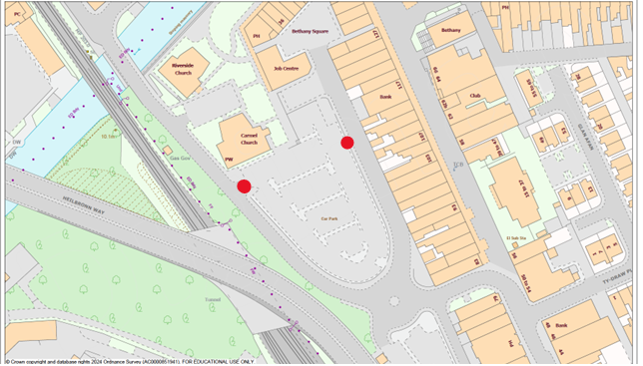
​
​
​ ​A site compound will need be installed to allow safe access for pedestrians around the site and that all demolitions works are conducted within a safe area. The compound will have to include boundaries, adjacent land usage, access, and security measures. The compound would utilise existing access points to the site I've marked these access points on the OS Map above, Minor Road works may need to be implemented to accommodate the access points but should be done quickly to avoid disruption to pedestrians and traffic.
​
​5.9 Party Wall Act
The Party Wall Act 1996 will be applicable. This legislation requires that we serve notice to the owners of adjoining properties, giving them the opportunity to consent or dissent to the proposed works. If disputes arise, Party Wall Surveyors may be appointed to prepare a Party Wall Award outlining the rights and responsibilities of both parties. Adherence to the Act is crucial to ensure that construction activities are carried out with proper consideration for the structural integrity of neighbouring properties and to avoid legal complications. Seeking professional advice from a Party Wall Surveyor early in the planning stages is recommended to ensure compliance and maintain positive relationships with adjoining property owners.
​
​

