

Danielle Humphries
1910878

Module ACBA4001

Fundamentals of Construction Technology

Contents Page
Introduction……………………………………………………………………………………..Page 3
Building plans……………………………………………………………………………….….Page 4
Ground floor construction……………………………………………………………….Page 5 & 6
The first floor construction………………………………………………………………Page 7
Openings, lintels, sills and jambs……………………………………………………..Page 7
Eaves and roof coverings………………………………………………………………..Page 7
Main roof structure………………………………………………………………………….Page 8
Reference…………………………………………………………………………………….…..Page 9 & 10
Bibliography……………………………………………………………………………….….…Page 10, 11 & 12
Appendices……………………………………………………………………………………….Page 11

Introduction
Planning consent has been granted for a single, two storeys detached domestic building with a loft room.
Details of the build:
- Build on level greenfield site that has 400mm of topsoil above a firm subsoil with low clay content that is above the water table.
- The building is of standard cavity wall construction, block brick with partial fill cavity insulation and a smooth render externally, plinths, solider courses over all openings and porch pillars are to be natural sandstone.
- There is a suspended timber ground floor and upper floors are to be traditional solid timber with tongue and groove softwood flooring.
- Windows and external doors are to be light oak wood effect uPVC with sealed Double-glazing units.
- Roof structure to be trussed rafters at a 40⁰ pitch with a natural slate covering and closed eaves.
I will document the following construction details:
- Ground floor. Construction detailing and junctions with external walls
- First floor. Construction detailing junctions with external walls and restraints
- Openings. Lintels, sills and jambs
- Eaves and roof coverings. Indicating appropriate weathering, fixing and laps
- Main roof structure. Construction detailing and fixing.
Sketches will show the element’s detailed above with step by step descriptions.
Attached below are the proposed drawings of the dwelling.
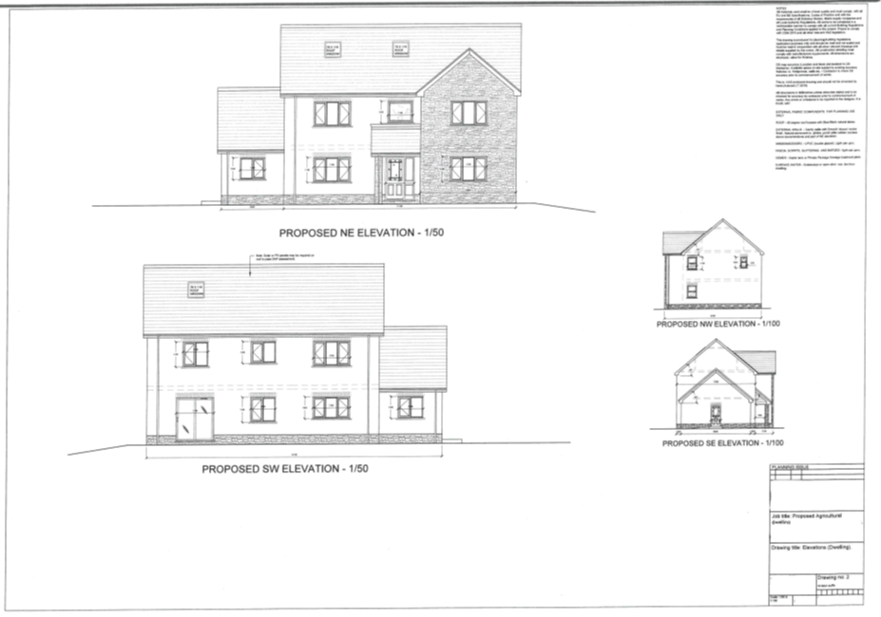
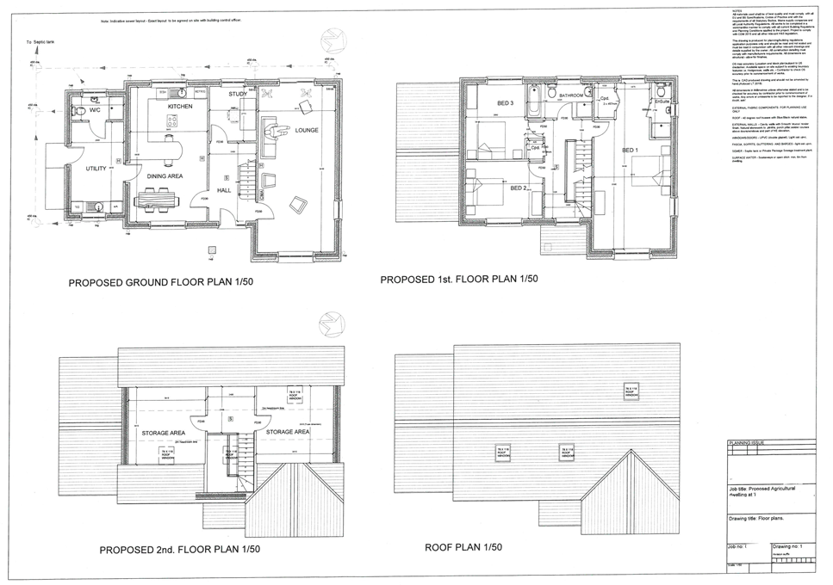
- Ground floor construction
1.1 External walls will be constructed with a traditional stretcher bond layout. Stretcher bond is a common technique that is easy to construct, little waste and set in stretcher rows. The stretcher bond pattern consists of a row of stretchers with each stretcher centred above the stretcher below, all joints run vertically down the wall. This wall will be a load bearing wall supporting the upper external walls. The requirements for an external wall are:
- Weather protection
- Fire resistant
- Durability
- Noise insulation
- Buildability
- Thermal resistance
- Strength & stability
Building Regulations A 2.1 (figure A)
1.2 Along side the external stretcher bond wall we have a standard block on block internal wall with partial fill cavity insulation. Thermal insulation requirements are set under Part L of the building regulations to be compliant with an overall energy and carbon performance. Partial fill cavity requires 102.5mm fair-faced brickwork on the pouter leaf, 50mm clear cavity, 50mm foiled-faced polyurethane foam (λ = 0.023 W/m K), 100mm lightweight blocks (λ = 0.15 W/m K) and 12.5mm plasterboard on dabs (λ = 0.16 W/m K). (Lyons, 2007). Building Regulations Part L.
Wall ties are an essential part of a cavity wall construction this helps to keep the structure save and stable. Building Regulations Part A. (figure B)
1.3 Weep holes are installed to serve two purposes one to reduce moisture and humidity within the cavity and the other to release any excess water that may build up in the cavity and act as ventilation to deduce the risk of mildew build up, damp and dry rot. BS 5628 (figure C)
1.4 Damp Proof Course will be laid above the foundations of the entire property as a barrier to stop water rising from the ground through the foundations and into the property. Horizontal DPC is usually around 6inches above ground level. Approved building regulations for damp proof course are set under C. Damp can damage a property internally causing black mould walls, deterioration of plaster and timber and could also create health problem’s to the occupant. Building Regulations Part C. (Figure D)
1.5 Vapour Barrier will be installed between the insulation and the block work wall. The vapour barrier is designed to absorb any vapour that maybe produced from inside the property it also acts as a drain plane for any excess water the drain towards the weep holes. Building Regulations Part L. (Figure E)
1.6 Suspended timber flooring is to be fitted throughout the ground floor of the property. The timber flooring is to be secured using joist hanger and will also have insulation fitted between the joists. (Figure F & G) Suspended timber floors is a good solution for levelling floors, cheap and easy to install and adaptable. Building Regulations Part A, BS 8004:1986/BS EN 206-1/BS 8500-2 (strip foundations).
Legislation for suspended timber flooring is as follows:
- Building regs A
- BS 8103-3:2009 Structural design of low-rise buildings. Code of practice for timber floors and roofs for housing
- BS EN 1995-1-1:2004+A2:2014:2019 UK National Annex to Eurocode 5. Design of Timber Structures
- Eurocode 5 Span tables for solid timber members in floors, ceilings and roofs for dwellings. 4th edition (2014) (Parts 1 to 7)
- PD 6693-1:2019 Recommendations for the design of timber structures to Eurocode 5: Design of timber structures. General - common rules and rules for building
1.7 Sleeper walls are internal loadbearing walls, these are constructed with gaps in-between the bricks to act as ventilation as air is able to flow under the floor stopping the build up of condensation. There will be 3 main internal walls on the ground floor that will be fitted with sleeper walls. Internal wall adjoining into the kitchen / dinner, kitchen / dinner adjoining study and hallway and study hall way adjoining the lounge. Legislation as above.(Figure H)
1.8 Struts to be installed between the joists to provide extra support as the joist can move, twist and creak, the strut should prevent this from happening. The struts are to be laid staggered between the joists.

2. First Floor Construction
2.1 Using the same style as the suspended timber flooring for the upper level in this dwelling. The suspended timber flooring will once again be constructed using timber joist attached to the block working using the joist hanger, struts installed staggered between joists and insulation installed between ceiling, joist and tongue and groove boards. (figure F, G & I)
2.2 Partition walls will be constructed throughout the property. Partition walls are a quick and easy way to separate one room into two and are non load bearing walls. In the building of this property there will be numerous partition walls such as the on suit bathroom in the main bedroom, wall between bathroom and landing and between the bedroom 2 & 3. BS EN 336. Once the partition wall structure is build it will need rockwool acoustic insulation installed, then plasterboard can be fixed and the wall be finished with a coat of plaster. Building Regulations Part E 1-E2. (figure J)
3. Openings, lintels, sills and jambs.
3.1 The type of lintel that will be metal, this lintel is designed to work alongside the cavity wall. This style of lintel will have two weep holes just above the window in the brickwork this is so any excess water or moisture will train down the tray and into the weep hole. Building Regulations Part M. EN 845-2:2013 + A1:2016. BS EN 1996-2:2006 (figure K)
3.2 Window sills will be constructed using stone external sill, flashing and insulation. A expansion joint will be put in place under the sill these will be fitted with each window through the property. Building Regulations Part L & N. BS 5642-1:1978+A1:2014. (figure K)
3.3 Jambs are the vertical upright component’s that for the frame of a window. Building Regulations Part L & N. BS 8213-4:2016. (figure L)
3.4 Door jamb is the frame to the sides of the door frame. Building Regulations Part L & N. BS 8213-4:2016. (figure L)
3.5 Soldier course brickwork will be installed above each door and window. (figure M)
4. Eaves and roof covering
4.1 Closed eaves to be constructed at the property. Building Regulations Part E BS 5250:2002 (ventilation) (figure N)
4.2 Roof covering will be natural slate tiles with a double lapped, fixed with double nails. Building regulations Part C. BS 5534 BS 5534:2014+A2:2018 BS 1202-3 or BS 1202-2(figure O)
4.3 Guttering valley will be installed on the front elevation this will channel water down into the main guttering. Building Regulations Part H. BS EN 12056 (figure O).
5. Main roof Structure
5.1 Queens Post Truss will be the structure for the main roof Structure Queens Post Truss will be constructed in the roof space. Queens Post Truss is a wooden frame with two principal rafters and two vertical Queen posts with a tie beam at the bottom. Wall plates and nail plates will be used to secure the main roof structure together and to the walls of the property. The Queens Post Truss can be span over a greater distance. Building regulations BS EN 14250:2010 Timber Structure BS EN 1995-1-1:2004+A2:2014 Eurocode 5: Design of timber structure.(figure P)

References
BUILD. 2020. Door Frame Types. [online] Available at: <https://build.com.au/door-frame-types> [Accessed 23 April 2020].

Builderbill-diy-help.com. 2020. Soldier Course. [online] Available at: <http://www.builderbill-diy-help.com/soldier-course.html> [Accessed 23 April 2020].

Builderbill-diy-help.com. 2020. Queen Post Truss. [online] Available at: <http://www.builderbill-diy-help.com/queen-post-truss.html> [Accessed 24 April 2020].

Designingbuildings.co.uk. 2018. Weep Hole. [online] Available at: <https://www.designingbuildings.co.uk/wiki/Weep_hole> [Accessed 18 April 2020].

Edwards, M., 2020. DIY Damp Proof Injection | How To Install A Damp Proof Course | DIY Doctor. [online] DIY Doctor. Available at: <https://www.diydoctor.org.uk/projects/dpc.htm> [Accessed 18 April 2020].

Edwards, M., 2020. How To Build A Suspended Timber Floor. [online] Diydoctor.org.uk. Available at: <https://www.diydoctor.org.uk/projects/hollowfloor.htm> [Accessed 20 April 2020].

Forterra.co.uk. 2020. Brick Bond Patterns - Forterra. [online] Available at: <https://www.forterra.co.uk/resources/design-advice/brickwork-details/brick-bond-patterns> [Accessed 16 April 2020].

Lyons, A., 2007. Materials For Architects & Builders. 3rd ed. Butterworth Heinemann, p.35.

Lstiburek, J., 2018. BSD-106: Understanding Vapor Barriers. [online] Building Science Corporation. Available at: <https://www.buildingscience.com/documents/digests/bsd-106-understanding-vapor-barriers> [Accessed 19 April 2020].

Nhbccampaigns.co.uk. 2020. NHBC Standards 2011. [online] Available at: <http://nhbccampaigns.co.uk/landingpages/techzone/previous_versions/2011/Part7/section2/sitework.htm> [Accessed 24 April 2020].

Nzdl.org. 2020. Self - Help Construction Of 1-Story Buildings: Directions For Construction: Construction Of Walls, Windows, And Doors: Block And Brick Walls: Framing Windows And Doors. [online] Available at: <http://www.nzdl.org/gsdlmod?e=d-00000-00---off-0hdl--00-0----0-10-0---0---0direct-10---4-------0-1l--11-en-50---20-about---00-0-1-00-0--4----0-0-11-10-0utfZz-8-10&a=d&cl=CL1.16&d=HASH0120e3be1fcef504939676c2.5.5.1.3> [Accessed 23 April 2020].

Standardsdevelopment.bsigroup.com. 2020. British Standards Institution - Search. [online] Available at: <https://standardsdevelopment.bsigroup.com/search/Standards?Term=Ceilings.%20Floors.%20Stairs&Source=category#5> [Accessed 27 April 2020].

British Standards Institution. 2020. [online] Available at: <https://standardsdevelopment.bsigroup.com/search?Term=new+dwelling> [Accessed 27 62April 2020].

Bibliography
BUILD. 2020. Door Frame Types. [online] Available at: <https://build.com.au/door-frame-types> [Accessed 23 April 2020].

Builderbill-diy-help.com. 2020. Soldier Course. [online] Available at: <http://www.builderbill-diy-help.com/soldier-course.html> [Accessed 23 April 2020].

Builderbill-diy-help.com. 2020. Queen Post Truss. [online] Available at: <http://www.builderbill-diy-help.com/queen-post-truss.html> [Accessed 24 April 2020].

Designingbuildings.co.uk. 2018. Weep Hole. [online] Available at: <https://www.designingbuildings.co.uk/wiki/Weep_hole> [Accessed 18 April 2020].

Edwards, M., 2020. DIY Damp Proof Injection | How To Install A Damp Proof Course | DIY Doctor. [online] DIY Doctor. Available at: <https://www.diydoctor.org.uk/projects/dpc.htm> [Accessed 18 April 2020].
Edwards, M., 2020. How To Build A Suspended Timber Floor. [online] Diydoctor.org.uk. Available at: <https://www.diydoctor.org.uk/projects/hollowfloor.htm> [Accessed 20 April 2020].
Ferriz-Papi, J., 2020. External Walls.
Ferriz-Papi, J., 2020. Openings.
Ferriz-Papi, J., 2020. Suspended Timber Floors.
Ferriz-Papi, J., 2020. Pitched Roofs.

Forterra.co.uk. 2020. Brick Bond Patterns - Forterra. [online] Available at: <https://www.forterra.co.uk/resources/design-advice/brickwork-details/brick-bond-patterns> [Accessed 16 April 2020].

Lyons, A., 2007. Materials For Architects & Builders. 3rd ed. Butterworth Heinemann, p.35.

Lstiburek, J., 2018. BSD-106: Understanding Vapor Barriers. [online] Building Science Corporation. Available at: <https://www.buildingscience.com/documents/digests/bsd-106-understanding-vapor-barriers> [Accessed 19 April 2020].

Nhbccampaigns.co.uk. 2020. NHBC Standards 2011. [online] Available at: <http://nhbccampaigns.co.uk/landingpages/techzone/previous_versions/2011/Part7/section2/sitework.htm> [Accessed 24 April 2020].

Nzdl.org. 2020. Self - Help Construction Of 1-Story Buildings: Directions For Construction: Construction Of Walls, Windows, And Doors: Block And Brick Walls: Framing Windows And Doors. [online] Available at: <http://www.nzdl.org/gsdlmod?e=d-00000-00---off-0hdl--00-0----0-10-0---0---0direct-10---4-------0-1l--11-en-50---20-about---00-0-1-00-0--4----0-0-11-10-0utfZz-8-10&a=d&cl=CL1.16&d=HASH0120e3be1fcef504939676c2.5.5.1.3> [Accessed 23 April 2020].

Standardsdevelopment.bsigroup.com. 2020. British Standards Institution - Search. [online] Available at: <https://standardsdevelopment.bsigroup.com/search/Standards?Term=Ceilings.%20Floors.%20Stairs&Source=category#5> [Accessed 27 April 2020].

British Standards Institution. 2020. [online] Available at: <https://standardsdevelopment.bsigroup.com/search?Term=new+dwelling> [Accessed 27 April 2020].

Appendix
Figure A: Stretcher bond wall for then external of the property
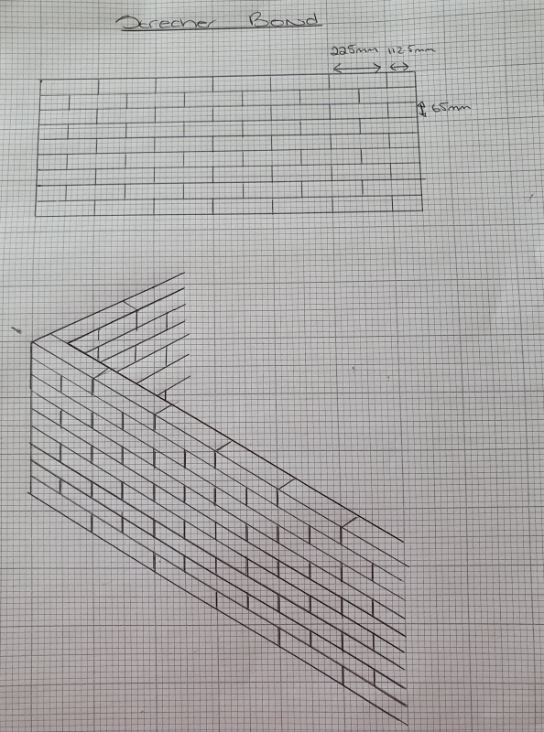
Figure B: Partial fill cavity wall, with wall ties and insulation.
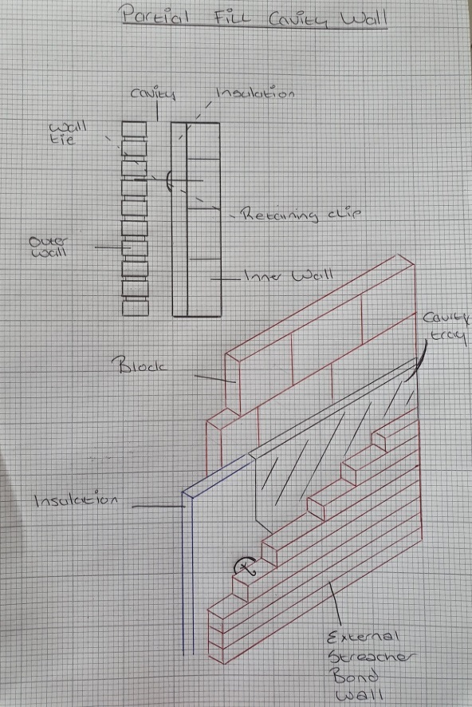

Figure C: Weep hole in the stretcher bond wall and shown from inside the cavity
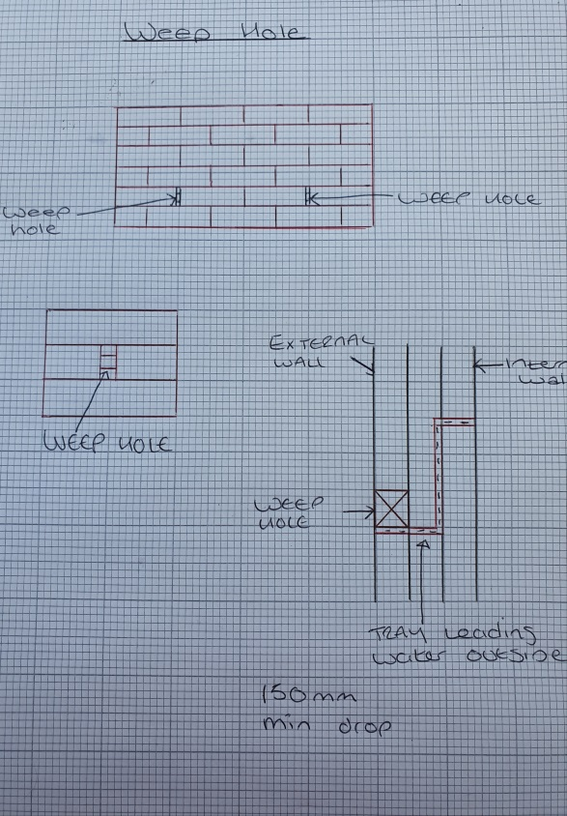
Figure D: Damp proof course detailing from the direction of the cavity.
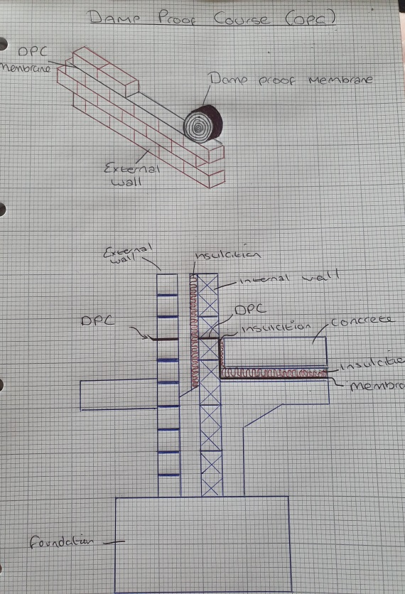

Figure E: Vapour control barrier detailing
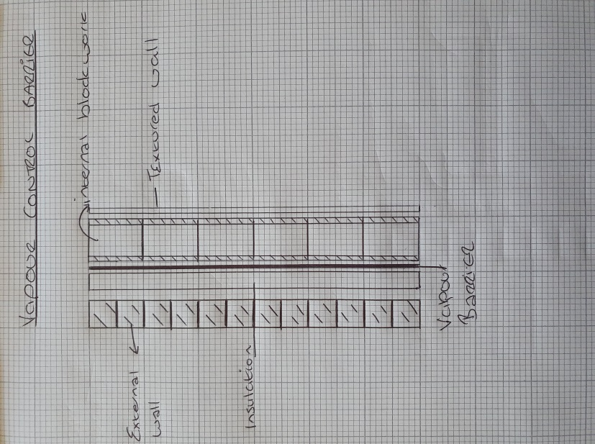
Figure F: Joist hanger alone them detailed using the timber frame.
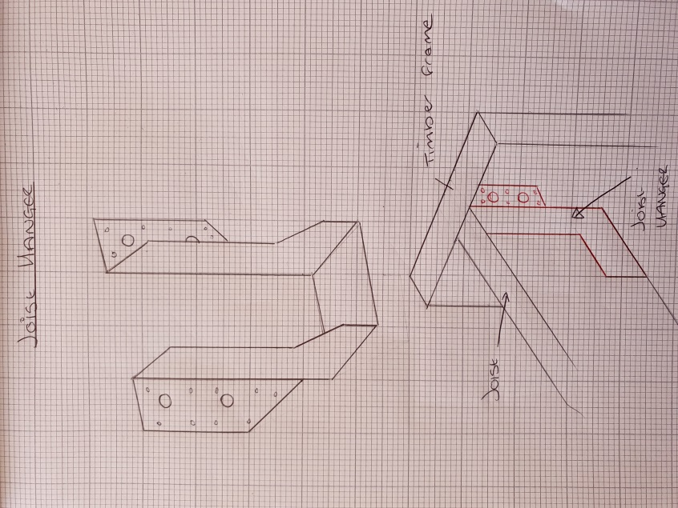

Figure G: Suspended timber floor (ground floor) detailing distance between ground floor and timber floor. Also detailing insulation.
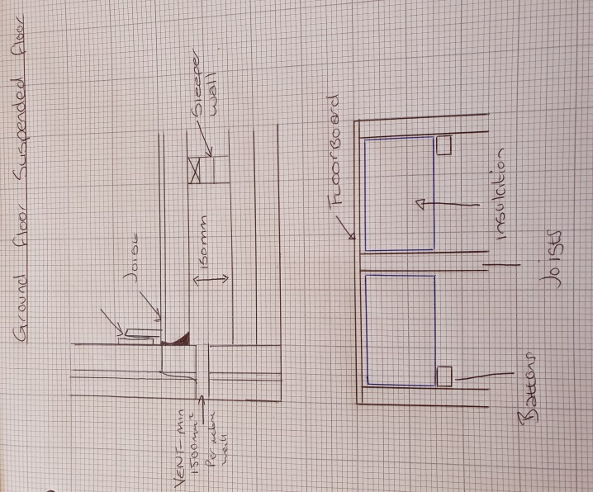
Figure H: Sleeper walls
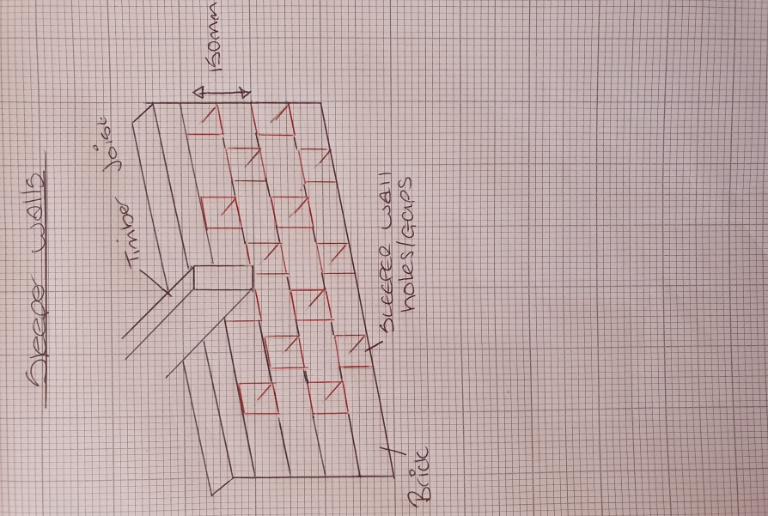

Figure I: Strutting within the span of the suspended timber flooring.
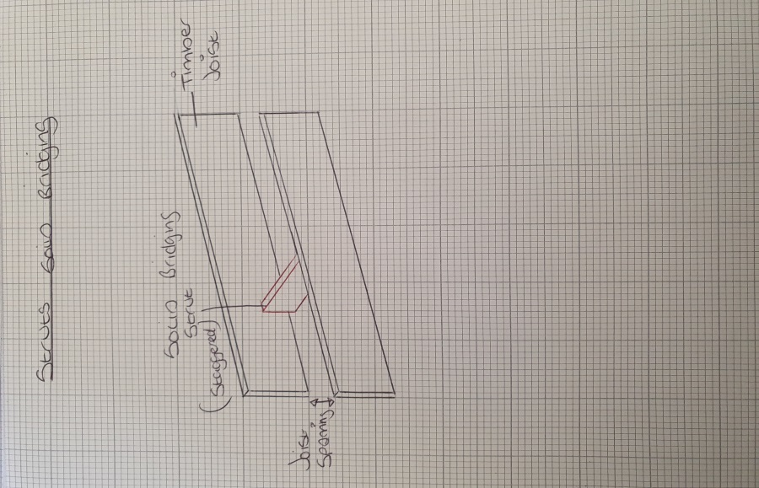
Figure J: Partition walls (timber frame) with insulation installed between the struts and plasterboard
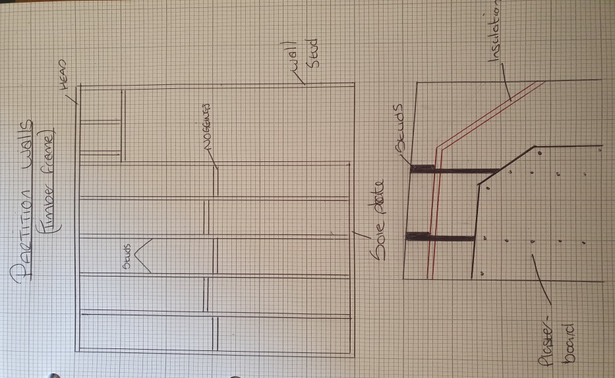
Figure K: Steel Lintel to be installed above all openings throughout the property. External sills for each window in the property.
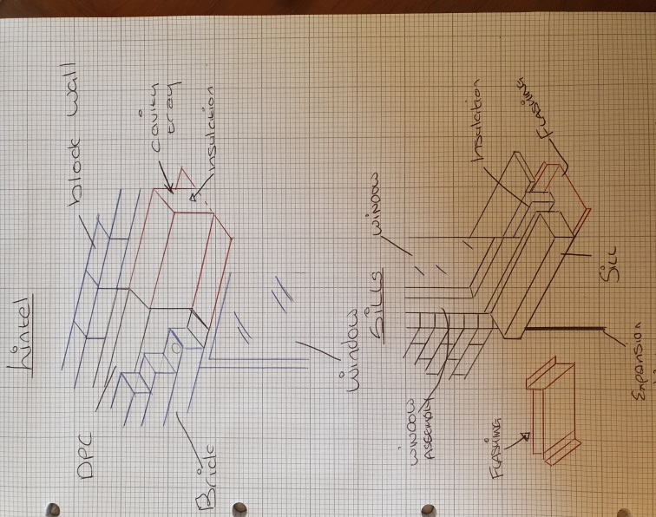
Figure L: Window and door jambs.
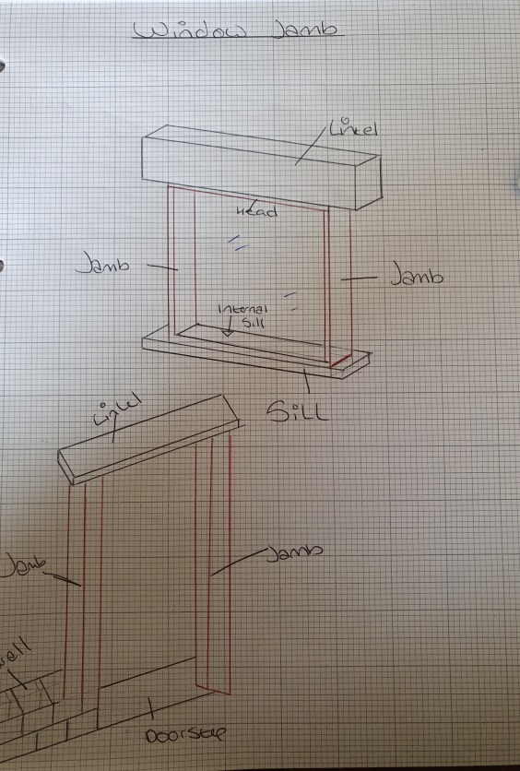

Figure M: Soldier Course.
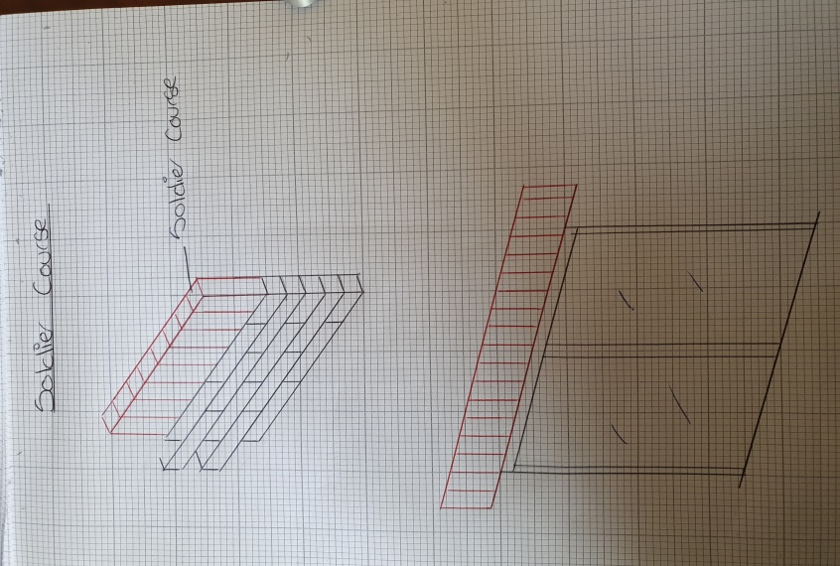

Figure N: Closed eaves
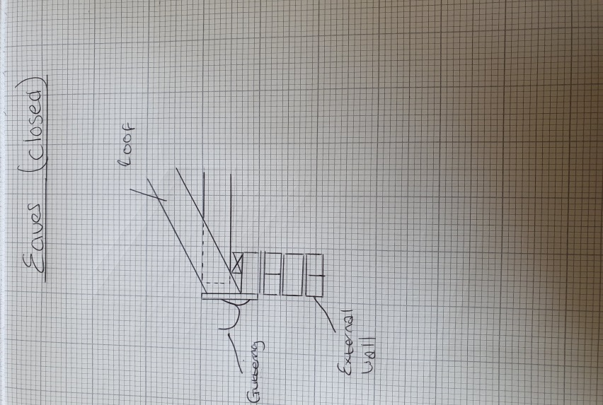
Figure O: Natural Slate Tiles & Valley gully
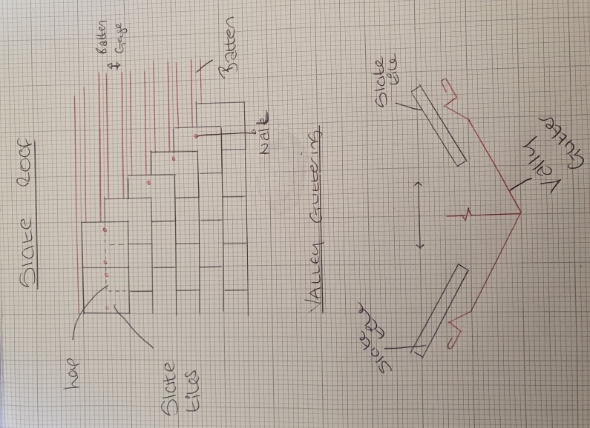
Figure P: Queens Post Truss with walls plates for main structure of the roof


