

 |  | Traffic Light System
 |  |  |  | Oliver Atkinson
 |  |  |  | 26/02/2025  Jenifer Prince Devaraj  ACDB5002 | 
Contents
Aims of the project 4
What makes a traffic light legal? 4
Signal Box Quantity 4
Signal Light Order 4
Signal Timings 5
Pedestrian Timings 5
Traffic Light Control Methods 5
Fixed timings 5
Traffic Sensors 5
Specification 6
Hardware Requirements 6
The System Design 7
Deep Dive 8
Traffic Light Module 8
Seven-Segment Displays 8
Pedestrian Crossing Signal LEDs 9
PIC Microcontroller 9
Flowcharts/pseudocode 10
Software Development 11
The Countdown 11
The traffic light cycle 12
Pedestrian Crossing LEDs 14
Screenshots of the system and Testing 15
First Traffic Light cycle. 15
Second Traffic light turned on 16
Third Traffic light turned on 17
Pedestrian Crossing turned on 18
Testing 19
References 20
Appendix A 21

Figure 1 - Traffic Light Cycle 4
Figure 2 - T junction from the assignment 7
Figure 3 - T junction schematic 7
Figure 4 - Traffic light from schematic 8
Figure 5 - counter from schematic 8
Figure 6 - pedestrian LEDs 9
Figure 7 - PIC18F45K50 from schematic 9
Figure 8 - flowchart design 10
Figure 9 - countdown code 11
Figure 10 - the main loop code 11
Figure 11 - main loop code 12
Figure 12 - traffic light arrays 12
Figure 13 - first traffic light subroutine 13
Figure 14 - third traffic light subroutine 13
Figure 15 - second traffic light subroutine 13
Figure 16 - pedestrian crossing if statement 14
Figure 17 - main function 14
Figure 18 -second traffic light state 15
Figure 19 – first state 15
Figure 20 - fourth state 15
Figure 21 - third state 15
Figure 22 - first state 16
Figure 23 - second state 16
Figure 24 - third state 16
Figure 25 - fourth state 16
Figure 27 - second state 17
Figure 26 - first state 17
Figure 28 - third state 17
Figure 29 - fourth state 17
Figure 30 - first state 18
Figure 31 - second state 18
Figure 32 - fourth state 18
Figure 33 - third state 18

Aims of the project

The aim of this project is to produce a reliable and efficient traffic solution, by engineering a traffic light system that manages the flow of traffic and allows pedestrians to cross the carriageways. The system should operate on precise timings that are predictable for vehicles manoeuvring in and around the junction.

The junction in question will be a T junction based on current UK roads. It should have 2 traffic lights on each junction exit as well as red and green “men” for pedestrian signals. A seven-segment display will display the timing structure on each junction.

What makes a traffic light legal?

This section will include background research into the real-life laws and regulations the ministry of transport (MoT) has put into place. With these in mind, both an assignment accurate traffic light system and a system that meets the rules and regs of the MoT will be provided in this report.

Signal Box Quantity

Each approaching carriageway must have at least two visible traffic signal boxes. The nature of the traffic light means it is more visible than a static sign. This means a primary signal should be on the left side of the road and a secondary signal box should be on the left to increase visibility. [1]

In specific occasions extra signal boxes will be required (where large heavy goods vehicles or buses are frequent) they can be added but special consideration must take place. The aim is to use the minimum amount of signal boxes to get the desired result and still have the junction function safely. [1]

Signal Light Order

Typical UK traffic signals are red, red and amber, green, amber then red (shown below). The assignment brief only specifies to include separate red, amber and green. In that case to be more realistic the code shown below will include the states set by the MoT. [2]
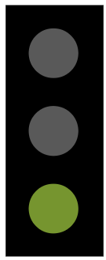


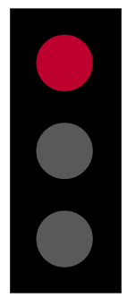
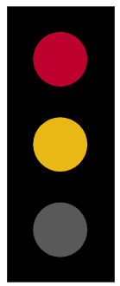
Figure 1 - Traffic Light Cycle

Signal Timings

The timing for each coloured light to be turned on is not a fixed time period for the majority of signals however the amber signal is fixed at 3 seconds and the red/amber signal is fixed at 2 seconds with a 0.25 second tolerance either way.

The green signal is determined site to site based on a number of variables and usually matched to demand. In general, smaller intervals for the green cycle perform better in traffic management. A green cycle longer than 120s is not recommended for optimal traffic flow. [3]

Pedestrian Timings
The usual time to cross in the UK is 6 seconds. With this being said there is the possibility for slow walkers and elderly people. Therefore, a blackout zone was created, where the red man lights up but traffic doesn’t start moving. The green man is only an invitation to leave the curb, it is the blackout period which is the safe to cross period. [4]

Traffic Light Control Methods

There are many ways to control traffic lights. These include fixed timings and using sensors.

Fixed timings
This is the most based form of traffic control, where each phase has a set period of time. With this system the road with the highest amount of traffic flow is given the most green light time and the side roads have minimal time on green. This system is then repeated throughout the day to service the junction correctly. [5]

Traffic Sensors
The most common type of sensor in traffic lights is the induction loop. An induction loop is a copper wire coil embedded in the road surface that detects changes in the inductance of the road when a car drives over it. When a change of inductance is detected a signal is sent through the copper wire to the sensor circuitry where a signal is then sent to the traffic lights. [6]

Another sensor type that is used frequently are microwave radar detectors. These are usually placed on top of the signal boxes and can detect cars travelling to and from them as long as the vehicle is travelling above 2 mph.

In cases where slow moving traffic occurs if is often recommend to use both a microwave radar detector and an induction loop at the stop line. [7]

Specification

- Six traditional UK traffic lights (two per road)
- Two pedestrian signals per road
- Six seven-segment displays for timing (two per two-digit counter)
- 40 second cycles for traffic management
- 10 second intervals per traffic light phase
- With the last ten seconds reserved for pedestrians

Hardware Requirements

- At least 23 output ports on a PIC microprocessor
- Various LED requirements
- Various seven-segment displays

The System Design

The assignment brief was to produce a traffic light system for a junction similar to that shown below. This meant each entrance of the junction would have had one traffic signal box. In the UK traditional T junction like the one shown below would not have traffic lights and instead have a give way system.
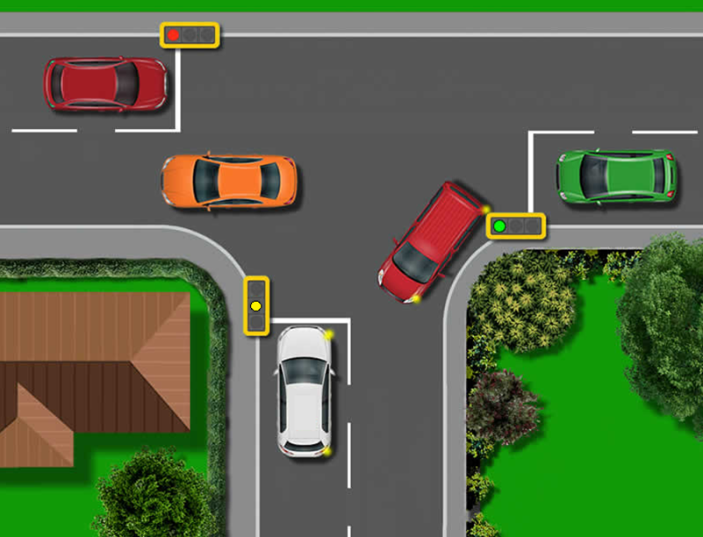
Figure 2 - T junction from the assignment

Along with the specification for a pedestrian crossing, this allowed a liberal view on how the lights should operate and how many traffic lights each entrance road has.
Due to the pedestrian crossing, 6 traffic signal boxes have used as well as 6 pedestrian crossing signal boxes have been utilized. This allows for every road entrance in the T junction to have 2 traffic lights and 2 pedestrian crossing boxes.
Figure 3 - T junction schematic
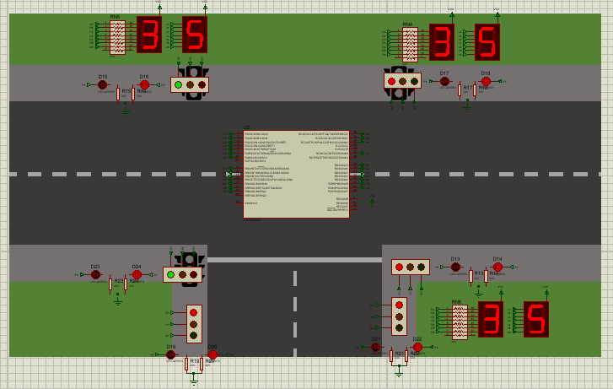

Deep Dive

This section will look further into the subsystems of the T junction system. Four main subsystems are used to form a T junction: a traffic light module, a seven-segment display module, pedestrian crossing LEDs and the PIC chip itself.

Traffic Light Module
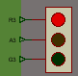

Figure 4 - Traffic light from schematic

The traffic light module uses the pre-made traffic light blocks from the proteus libraries. These are connected to three pins on various ports on the pic microcontroller. Each road has its own 3 pins because each traffic light should be independent. Each light is a separate LED, one green, one amber and one red.

Seven-Segment Displays

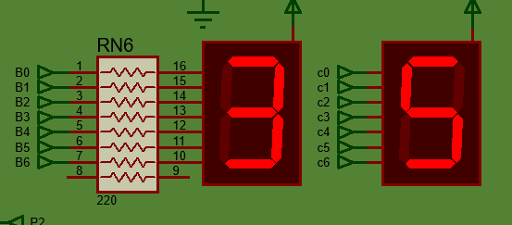
Each seven-segment display is connected to a different port on the PIC chip (ports b and c). This is so the various digits can be displayed correctly. All of the seven-segment displays in the system are pulled high by the VCC supply. This means in order to display a value on the displays the PIC must sink current. So, the pins connected to the displays must be dropped low in order to light a led.
Figure 5 - counter from schematic

Pedestrian Crossing Signal LEDs

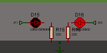
These serve as a theoretical red and green man for pedestrian crossing. When the pin on the PIC go high the respective LED will light signalling the pedestrians to cross or not. The resistor values are set to 220 ohms in order to limit the current entering the LEDS and stop the LEDS from blowing up.
Figure 6 - pedestrian LEDs

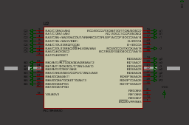
PIC Microcontroller
Figure 7 - PIC18F45K50 from schematic

This PIC was chosen because it has 32 endpoints which is enough to have every device attached separately as planned with surplus endpoints leaving room for upgradability. Also, this PIC has a clock speed up to 48MHz which again allows for upgradability.

This PIC is also relative cheap to purchase making it ideal for mass traffic light systems across a town or village. Along with this, the chip can be used off of a 12V power supply if a voltage regulator is applied. The voltage operating range of this chip is 2.3V to 5.5V. [8]

Flowcharts/pseudocode

The flowchart shown below is a basic representation of the process that the traffic light system runs. The main part is a for loop that iterates though 40 times. This acts as the main timing loop that the traffic lights run off.

Each time the FOR loop iterates both the countdown decrements and the traffic light colour will change. This works because both of these boxes in the flowchart will have separate arrays with values relevant to the countdown and the traffic lights respectively. So as the for loop works through the arrays a value for both countdown and traffic lights will be selected.

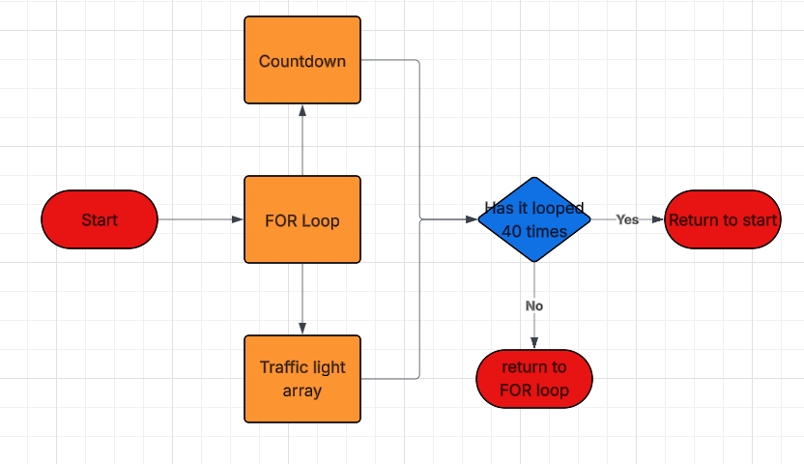
Figure 8 - flowchart design

Software Development

This section will breakdown the software that gives the desired results given in the specification. The code will be broken into the different function groups which allow each part the traffic light system to function correctly.

The Countdown

In order to display on the correct value on the seven-segment certain hex values must be outputted onto each port associated with a seven-segment display. This means an array with the values to display 0-9 on a display is needed. Shown below.

9 | 8 | 7 | 6 | 5 | 4 | 3 | 2 | 1 | 0
0x79 | 0x24 | 0x30 | 0x19 | 0x12 | 0x02 | 0x78 | 0x00 | 0x10 | 0x40

The array in the code starts at 0 then counts from 9-1. This is so the system can wrap around and be used independently.

Figure 9 - countdown code

A FOR loop is used to cycle through this array 40 times (shown below). Inside the FOR loop 2 instructions are given to output the value in the array onto two different ports.

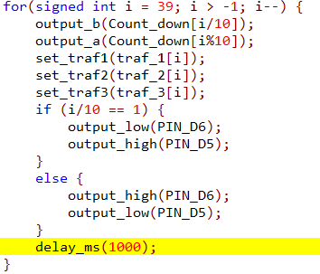
Figure 10 - the main loop code

The value outputted onto port B is ‘i/10’. When using the ‘/10’ operand the result of the operation is very much similar to primary school maths. 23/10 is 2 remainder 3. That two is then output onto port B. The value outputted onto port A is ‘i%10’, the modulo 10 of ‘i’. In this operation it is the remainder value that is output onto port A. So, for 23%10 the remainder would be 3 and that is output to port A. Using these two values, the count_down array is indexed into and the corresponding hex value is sent to the output ports. This is how the two separate digits are displayed onto the seven-segment displays.

The traffic light cycle

The traffic light cycle uses arrays as well, however in a very different way. Each approaching carriageway has its own array which stores the rotation of coloured lights for each signal box.

Figure 11 - main loop code

The set_traf subroutines are where this comes into play. Each of these functions has a value from an array input into it. The array in question can either have a value of 1,2,3 or 4 representing the four different states of a traffic light. As the main FOR loop iterates, the value input into these functions’ changes, changing the state of the traffic light. The first value in the FOR loop is 39 meaning the array shown below will be decremented through, 40 values/states in the array, one index per second. If ‘i’ is equal to 35 then the value for the first traffic light will be 3 and the traffic light will be green.

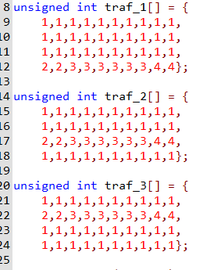
Figure 12 - traffic light arrays
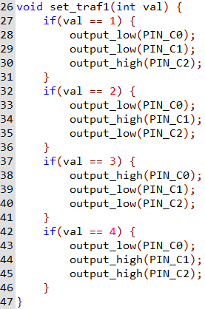
The first of the traffic lights is being told which LED to power by the function below. Each if statement is testing to find which value from the arrays has been inputted. Depending on which state the function has been given, the PIC can power various pins giving the desired result. For example, if the function is given the third state (val ==3) then PIN_C0 is output to high giving the green light on the traffic light.
Figure 13 - first traffic light subroutine

This then repeats for each approaching carriageway but with different output pins associated with each section.
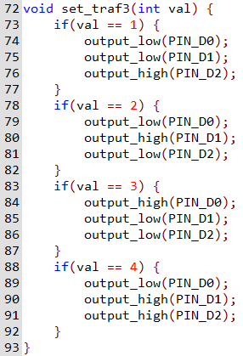
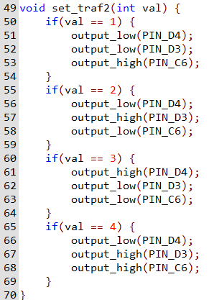
Figure 14 - third traffic light subroutine
Figure 15 - second traffic light subroutine

Pedestrian Crossing LEDs

The pedestrian crossing LEDs are attached to the main counter. When the counter reaches 9 seconds remaining the green LED (representing the green man) is turned on. Until this requirement is met the red LED is switched on.

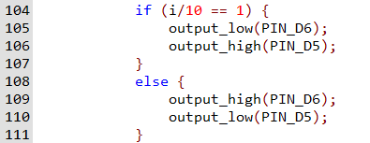
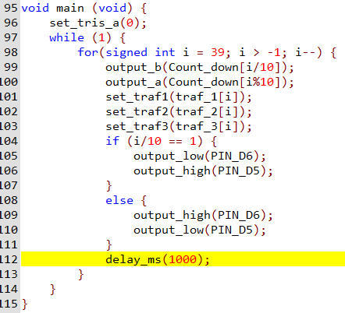
Figure 16 - pedestrian crossing if statement
Figure 17 - main function

Screenshots of the system and Testing

First Traffic Light cycle.
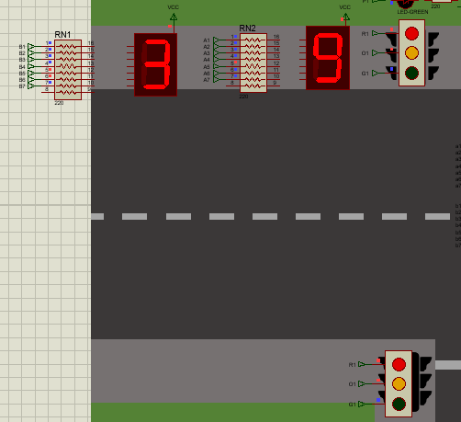
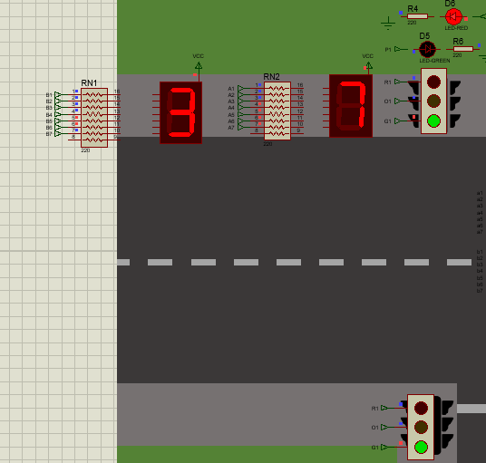
Figure 19 – first state
Figure 18 -second traffic light state

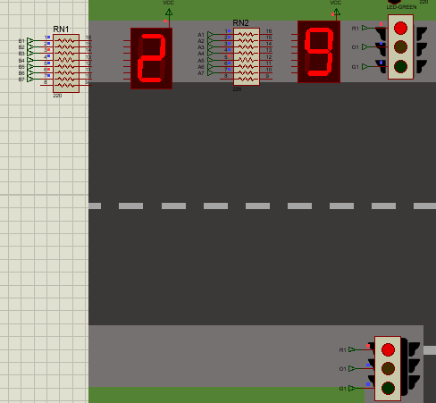
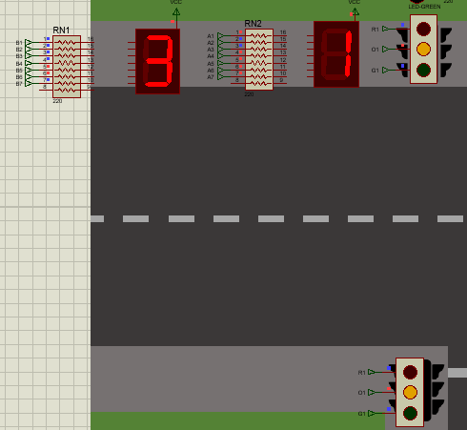
Figure 20 - fourth state
Figure 21 - third state

Shown above is the different stages of traffic light for the first approaching carriageway. As the first ten seconds passes the traffic cycles through the various states of a realistic traffic light. Throughout the remaining 30 seconds of the cycle these lights remain on red.

Second Traffic light turned on

Figure 22 - first state

Figure 23 - second state

Figure 24 - third state

Figure 25 - fourth state

Above is the cycle of the second set of lights and the timings between them.

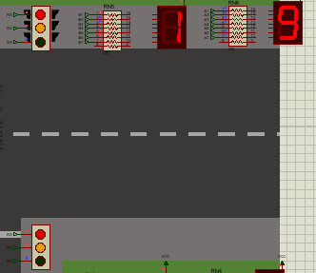
Third Traffic light turned on
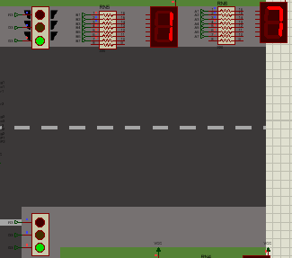
Figure 27 - second state
Figure 26 - first state

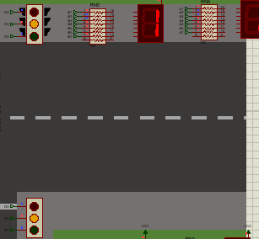
Figure 28 - third state
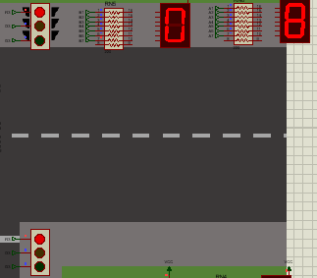
Figure 29 - fourth state
Shown above is the third traffic light unit and the cycle/timings associated with it.

Pedestrian Crossing turned on
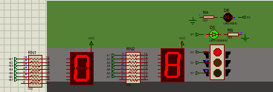
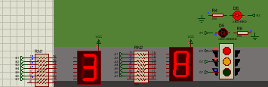
Figure 30 - first state
Figure 31 - second state

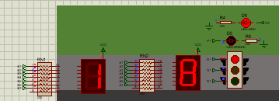
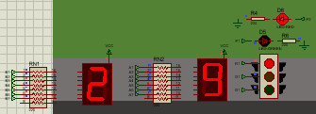
Figure 32 - fourth state
Figure 33 - third state

Above are the different stages of the pedestrian crossing LEDs.

Testing
As shown by the screenshots above, the system functions as intended. Below is a table showing how well each spec point was met if at all. The system has 10 seconds per traffic light cycle and then 10 seconds for pedestrians.

Spec Point | What was is? | Was it met?
1 | - Six traditional UK traffic lights (two per road) | Yes
2 | - Two pedestrian signals per road | Yes
3 | - Six seven-segment displays for timing (two per two-digit counter) | Yes
4 | - 40 second cycles for traffic management | Yes
5 | - 10 second intervals per traffic light phase | Yes
6 | - With the last ten seconds reserved for pedestrians | Yes

Overall this system is a success however with extended time, a more seamless system could be produced. This would include a filter lane for turning traffic as well as a more realistic timing system.

References

[1] | Department for transport, "Traffic Signs Manual Chapter 6," HMS Stationary office, UK, 2019.
[2] | DFT, "Traffic Signals," Department for transport, 05 11 2023. [Online]. Available: https://www.gov.uk/government/publications/know-your-traffic-signs/traffic-signals#:~:text=RED%20and%20AMBER%20also%20means,to%20pedestrians%20who%20are%20crossing.. [Accessed 20 04 2025].
[3] | DFT, "Traffic signs manual," HMS Stationary office, UK, 2025.
[4] | Transport for london, "Time to Cross," Transport for london, 29 01 2014. [Online]. Available: https://www.london.gov.uk/who-we-are/what-london-assembly-does/questions-mayor/find-an-answer/time-cross. [Accessed 20 04 2025].
[5] | Shropshire council, "Dynamic traffic controls," Shropshire Council, 2023. [Online]. Available: https://next.shropshire.gov.uk/roads-and-highways/traffic-management/traffic-signals/dynamic-traffic-controls/. [Accessed 21 04 2025].
[6] | Automate systems, "How do traffic light sensors work?," Automate systems, 2025. [Online]. Available: https://www.automatesystems.co.uk/how-traffic-light-sensors-work/. [Accessed 21 04 2025].
[7] | Traffic signal designs, "How are Vehicles Detected at Traffic Signals?," Traffic Signal Design, 2025. [Online]. Available: https://www.traffic-signal-design.com/vehicles-detected.htm. [Accessed 21 04 2025].
[8] | Microchip, "PIC18F45K50," Microchip, USA, 2012.

Appendix A

Full working code:

//Traffic Light system

#include <18F45K50.h>
#use delay (clock=4000000)

unsigned int Count_down[] = {0x40, 0x79, 0x24, 0x30, 0x19, 0x12, 0x02, 0x78, 0x00, 0x10}; //This array counts down from 9 to 0

unsigned int traf_1[] = { //The following arrays are the cycle in which each traffic light performs
1,1,1,1,1,1,1,1,1,1, //1 symbolizes the red traffic light
1,1,1,1,1,1,1,1,1,1, //2 symbolizes the amber light
1,1,1,1,1,1,1,1,1,1, //3 symbolizes the green light
2,2,3,3,3,3,3,3,4,4}; //4 symbolizes the red and amber light together

unsigned int traf_2[] = { //the numbering repeats in these arrays as well
1,1,1,1,1,1,1,1,1,1,
1,1,1,1,1,1,1,1,1,1,
2,2,3,3,3,3,3,3,4,4,
1,1,1,1,1,1,1,1,1,1};

unsigned int traf_3[] = {
1,1,1,1,1,1,1,1,1,1,
2,2,3,3,3,3,3,3,4,4,
1,1,1,1,1,1,1,1,1,1,
1,1,1,1,1,1,1,1,1,1};

void set_traf1(int val) { //set_traf1 is the subroutine which assigns a value to the first of the traffic lights
if(val == 1) { //if the value input into this function is 1 then the red led is turned on
output_low(PIN_C0);
output_low(PIN_C1);
output_high(PIN_C2);
}
if(val == 2) { //if the value input into this function is 2 then the amber led is turned on
output_low(PIN_C0);
output_high(PIN_C1);
output_low(PIN_C2);
}
if(val == 3) { //if the value input into this function is 3 then the green led is turned on
output_high(PIN_C0);
output_low(PIN_C1);
output_low(PIN_C2);
}
if(val == 4) { //if the value input into this function is 4 then the red and amber led is turned on
output_low(PIN_C0);
output_high(PIN_C1);
output_high(PIN_C2);
}
}

void set_traf2(int val) { //set_traf2 is the subroutine which assigns a value to the seonc of the traffic lights
if(val == 1) { //the assigned numbers from set_traf1 repeats here
output_low(PIN_D4);
output_low(PIN_D3);
output_high(PIN_C6);
}
if(val == 2) {
output_low(PIN_D4);
output_high(PIN_D3);
output_low(PIN_C6);
}
if(val == 3) {
output_high(PIN_D4);
output_low(PIN_D3);
output_low(PIN_C6);
}
if(val == 4) {
output_low(PIN_D4);
output_high(PIN_D3);
output_high(PIN_C6);
}
}

void set_traf3(int val) { //set_traf3 is the subroutine which assigns a value to the third of the traffic lights
if(val == 1) { //the assigned values share the pattern from the previous functions
output_low(PIN_D0);
output_low(PIN_D1);
output_high(PIN_D2);
}
if(val == 2) {
output_low(PIN_D0);
output_high(PIN_D1);
output_low(PIN_D2);
}
if(val == 3) {
output_high(PIN_D0);
output_low(PIN_D1);
output_low(PIN_D2);
}
if(val == 4) {
output_low(PIN_D0);
output_high(PIN_D1);
output_high(PIN_D2);
}
}

void main (void) {
set_tris_a(0); //sets port A as outputs
while (1) { //when the simulation starts this while loop runs continuously
for(signed int i = 39; i > -1; i--) { //main for loop which iterates 40 times
output_b(Count_down[i/10]); //outputs the value of the countdown array after it has been divided by ten onto port B
output_a(Count_down[i%10]); //outputs the value of the countdown array after being modulo'd by 10 onto port A
set_traf1(traf_1[i]); // runs the set_traf functions
set_traf2(traf_2[i]);
set_traf3(traf_3[i]);
if (i/10 == 1) { //if the tens digits is less than ten then the pedestrian crossing lights turn on
output_low(PIN_D6);
output_high(PIN_D5);
}
else { //any other time the red man is turned on
output_high(PIN_D6);
output_low(PIN_D5);
}
delay_ms(1000); //1 second delay
}
}
}

