Common Assessment Criteria Applied
Common Assessment Criteria Applied | REFER |  | D |  | C |  | B | A
 | OUTRIGHT FAIL | UNSATISFACTORY | SATISFACTORY | GOOD |  | VERY GOOD |  | EXCELLENT
1. Subject Knowledge and Understanding (which includes using research-informed literature and knowledge and understanding of the subject)
 |  |  |  |  |  | X
2. Intellectual Skills (Analysis) |  |  |  | X
3. Pedagogic and Professional Applications (Practical Application and Deployment)
 |  |  |  | X
4. Key Transferable Skills |  |  |  |  |  | X
PLEASE COMMENT ON AREAS IN WHICH YOU FEEL THAT YOU HAVE PERFORMED WELL | PLEASE COMMENT ON AREAS you feel that you need TO DEVELOP
Student Self Evaluation Form

Supporting pupil progress: A detailed analysis of one child’s holistic development, with justification for the next steps in learning.

Word count: 3735 words.

Introduction
This assignment is centred on a female, seven-year-old child, in year three, who attends a mainstream school on the outskirts of Swansea. This child (Child A) is an overall mid ability child in her class and has some anxiety issues. She is a quiet child but has a lot of friends and communicates well with other children in her class. The assignment will explore Child A’s learning, progress in her subjects in school, holistic development and provide detailed next steps, to move her development and learning on in the most effective manner.

The school has approximately three hundred and fifty children on roll and is neither a particularly financially prosperous or disadvantaged school as it only has 7.5% of it’s children receiving free school meals and 93% of the children coming from English speaking homes. The school that this child, Child A, attends has eleven mainstream classes which are two split year classes, as well as two STF classes for children with autism. Each class in the school has under thirty children, which allows children to get more attention through the smaller class sizes. The STF classes can have a maximum of nine children each.

Data collection
The data on Child A’s educational progress has been collected through observations, RAG tracking, copies of her work and her reading record. These methods of collecting data on Child A’s progress were chosen because they have been used so far in the placement portfolio, are informative and when combined are able to give a holistic insight into Child A’s educational and developmental progress. The use of several types of data collection have led to a holistic approach of Child A being achieved in this assignment, because together these methods of data collection have triangulated to increase the validity of my findings. Thurmond (2004:253) supports this statement of triangulation as she suggests that triangulation is used to “decrease, negate, or counterbalance the deficiency of a single strategy”. I additionally have used KWL grids, self-check success criterion and exit cards. These three extra pieces of work allow me to see how much information on the topic the children are retaining.

Observations are important as they allow the teacher or researcher to view the children’s behaviour, learning and development in a variety of contexts within the daily school routines. The Welsh Assembly Government (2008) support this as they assert that observations mean practitioners are able to gain knowledge and understanding on skills children are developing, what they understand and their personal preferences. It is further noted that observations allow the adult to gather more raw and authentic data than other methods of data collection (Turrin, 2015). Yet, Cohen, Manion and Morrison (2011:474) assert that observations “can be costly in time and effort” for the researcher as they can be difficult to interpret. RAG tracking children’s work is helpful when monitoring pupil progress because it allows the teacher to comment, assess and provide realistic next steps for each individual child in their class. The need to track children’s learning is supported by Greiner, Finch and Vollans (2017:7) who suggest that teachers cannot “help a child to learn if you are not thinking all of the time about assessment. MacNaughton (2003) notes that alike observations, tracking is very time consuming, due to writing up your conclusions of the work and each child’s next steps for their learning experiences.

Copies of Child A’s work have been included as they support the reasoning for her current levels in her subjects and show how much understanding she has of the topics and subjects I have covered whilst teaching in her class. Tyrer and Taylor (2013) explain that evidence of children’s work provides teachers, parents and schools with a visual resource of their children’s progression in their writing and understanding of various topics. On top of this, a weekly reading record has also been included, showing her reading ability, understanding and strengths and weaknesses of reading. This reading record is short, as it only dates back to the week my teaching practice in this school began. Harris, Turbill, Fitzsimmons and McKenzie (2006) state that reading records are important because they allow the teacher to track and support the reading development and progress of each individual child in their class. Prough (2012) adds that reading records ensure that the books are appropriate to the reading levels for each child. On the other hand, Harris et al (2006) note that reading records are time consuming and require the teacher to have good classroom management as the rest of the class need to be engaged in an activity when reading with individual children.

In addition to the observations, copies of work and tracking of learning I felt it would be beneficial to gain feedback from the children for a variety of lessons taught, similarly note that assessment for learning is crucial in effective teaching and learning. I did this through the use of exit cards, self-check success criteria and KWL grids. These assessment for learning strategies showed me what the children had learnt, which methods of learning they enjoyed, how their learning has progressed and, finally whether they are confident with their understanding of the material they have been taught in my lessons. Sadler (1989) states that children are only able to reach their learning potential if they can understand and know how to achieve it. Self-assessment for learning strategies are beneficial to children’s learning because they are visual and can provide detailed responses from the children. Yet, Mitchell (2014) notes that children may copy their friends’ responses or may not understand the objective of the activity, leading to the aim not being achieved.

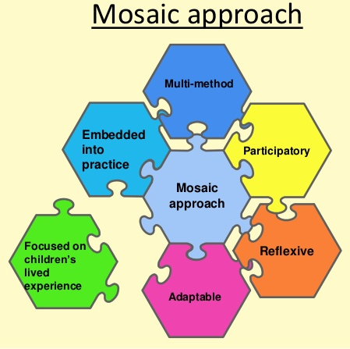
The mosaic approach was created by Clark (2011:13) to learn about child development and progress because it “combines the traditional methodology of observation and interviewing with the introduction of participatory tools”. This approach allows a holistic view of a child to be explored. The mosaic approach provides children with the opportunity “to create a living picture of their lives” (Clark and Moss, 2005:13). This approach is essential in examining children’s progress and development because it puts children’s views and opinions at the core of discussions, relating to their care, learning and development, between adults (Clark and Moss, 2005).
Mosaic Model. Retrieved from Zorica (2016).

Due to the council’s now stricter rules on data protection, in relation to the GDPR, I have ensured that no names are shown in this work and received permission from the school ^{[1]}. I additionally decided to not use photographs of Child A working or carrying out activities in school to ensure anonymity, confidentiality and reduce the risk of data protection issues. This is supported by the UNCRC’s rights of the child with article 16 – the right to privacy (Children’s Commissioner for Wales, 2018). However, this has still allowed me to collect information and data on her educational progression. This has been done through weekly reading, tracking her learning within all the lessons I have taught, weekly observations and photocopies of her work from my lessons.

Analysis of learner
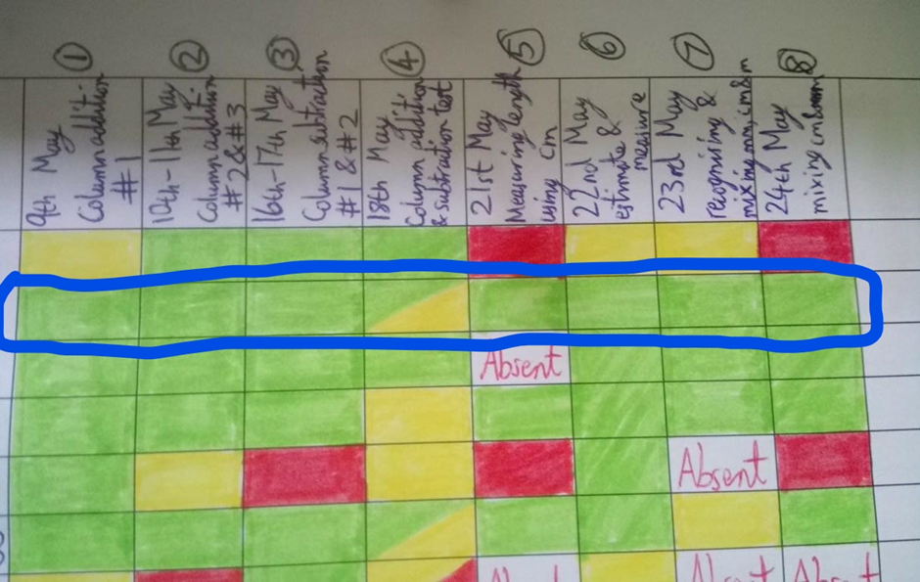
The data collected from Child A’s mathematical learning shows that she tries very hard in each lesson, generally has a very good understanding with both column method addition and subtraction sums ^{[2-4]} and measuring length in cm and mm ^{[5-8]}. However, it is evident that she needs to take more care when reading the signs (addition and subtraction) of each individual question. Child A’s individual tracking ^{[9]} observations two and three ^{[10]} and her overall mathematics tracking shows that she has done very well with using the column method to add two and three-digit numbers, and to subtract. However, on the fourth lesson, a column method assessment was done to check the children’s understanding. During this lesson Child A started to struggle due to the mixture of addition, subtraction and two-part word problem sums in the questions. This was proven by Child A’s answers as she had not read the signs or questions correctly (added for subtraction sums and took away for addition sums). The children’s marks from that lesson led to me initiating a class discussion to check the children’s understanding and see how they would like to improve their understanding and knowledge. It was decided unanimously that the children wanted more practice of column addition, subtraction and word problem sums in the morning of the following week during morning registration. Child A’s understanding and care of her work and reading of questions greatly improved with these additional sums to practice each day ^{[4]}.
Child A’s overall maths tracking highlighted in blue.

Due to the way the lessons panned out, I have unfortunately only taught one English lesson so far in this class ^{[11-12]}. This has meant that the data collected will not display Child A’s progression in this subject ^{[13]}. However, due to the inclusion of Child A’s reading record ^{[14]} and work from her topic book ^{[15-21]}, it is clear to see her literacy development from reading and handwriting to sentence structures, understanding and content. Within all of Child A’s written work, both individual and group, she has taken the care to ensure her handwriting is neat and legible, her spelling is generally very good and her presentation of all her work is well ordered. These skills are all requirements for a child to obtain a level three in the national curriculum. Despite some areas of Child A’s educational development reaching a level four, it is not yet consistent enough in her work to move her up to that level within the national curriculum’s progression of learning for children.

During many topic lessons (art, design and technology, and science) I incorporated several group work activities. This gave Child A ample opportunity to develop her verbal communication, team work, listening skills and resilience of compromising as she works with children that she did not used to talk to frequently. The KWL grid ^{[22]} allowed me to see how much Child A had learnt about the Wild Wood topic, woodland areas in the United Kingdom, and the wildlife that lives within them, over the past three weeks. Although I do not teach P.E lessons I know from celebration assemblies that Child A plays rugby for sevens and under in a local team. Child A is evidently proud of her rugby achievements and enjoys celebrating her team’s progress with her friends and peers in school. This shows that Child A has confidence in her sports, plays well with other children and is able to take pride in work and her skills that she is doing well in.

As the success criteria sheets and exit cards ^{[23]} were not kept long term, until half term, I do not have Child A’s responses to lessons and work via these assessment for learning strategies. In spite of this, the data that has been discussed does produce a well-rounded, holistic picture of Child A’s development and educational progress over the past three weeks. Child A’s completion of her self-check success criterium show that she is able to check her work, understand what the success criteria for each lesson is and what she needs to do to achieve this. The exit cards allow Child A to tell me what she has learnt (what stood out to her), what she enjoyed and help me to evaluate my teaching and lessons to make them more engaging and supportive for the children in the class.

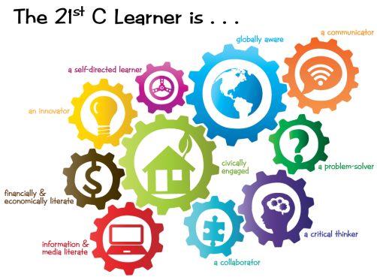
Child A takes a lot of pride in her work, she tries hard with her spellings and is keen to ask for support if she is unsure. Her handwriting and layout of her work in all her subjects is well presented, even and legible. She is engaged in all her lessons, participates in introductions and plenaries within the lessons and interacts well in group discussions. Her confidence in herself and ability is growing, whilst still remaining supportive and compassionate to her peers in her class. Child A does well in all subjects and is levelled at a 3a across the board. This means that she is above the national average of 2a to 3b for a child in year three (Dimbylow, 2018). This shows that Child A is competent and is being challenged appropriately in all subjects, in relation to her ability level. From the evidence shown it is evident that Child A is developing appropriately in all aspects of learning and development for a child within this generation. This is supported by Conklin (2012) who notes that twenty-first century learners are more inquisitive in their learning, have greater problem solving and communicating skills, and are more aware of the outcomes and creative with their own learning.
21st Century Learner. Retrieved from Foskett and Blackhall (2015).

I feel that the weekly observations were the least helpful form of data collection for this study. This is because they were very time consuming and do not always provide usable evidence for what you are researching. This is supported by Cohen, Manion and Morrison (2011) who assert that naturalistic observations require a lot of the researcher’s time. Despite being none intrusive to the child’s learning, participant observations can be messy and don’t provide a clear picture of the events occurring (Palaiologou, 2008).

The tracking was extremely helpful in promoting the learning progress of Child A because I was able to use my tracking to observe who had achieved the activity and who needed more support or interventions. I was then able to address this with differentiated work and using the additional staff in my classroom to support small groups who need further reinforcement. Tracking the children’s learning in each lesson within a variety of subjects helps teachers and practitioners to “provide appropriate support” both socially and physically to enhance the learning of each child (Sancisi and Edgington, 2015:100). Additionally, the assessment for learning strategies helped me to plan my future lessons with how I taught the children, what environments I should use more of and how much they enjoy particular aspects. These strategies worked well with my tracking sheets because they demonstrated Child A’s understanding of the success criteria and built upon her knowledge of leading her learning through self-marking and evaluation.

Child A’s reading record was beneficial because it showed me what type of books Child A enjoyed reading, how well she read or where she struggled, her understanding of words and of the story being told. The copies of Child A’s work from her various lessons that I have taught are a visual support to me for what she understands, where she begins to struggle with work and how much she focusses on the presentation of her work in each lesson from handwriting and spelling to sentence structures, grammar and layout of work in various activities.

Next steps
Child A is doing well in school and she is doing better in school than the national average for a child in year three. This means that I need to ensure that I am challenging Child A at a level of learning that is suitable for her ability. From this, I have come to the conclusion that my lessons at the beginning of a topic should be suitable for the average abilities of year three children. I should ensure all children have an understanding before moving on to challenge the children with more problem-solving tasks, independent learning opportunities and extend the learning of the children as the lessons on each topic develop. This will help individual children to take more responsibility in their learning, think more critically and develop their understanding of a topic at a higher level than before. Dweck (2017) states that children who take more responsibility in their learning “dig deep and do what it takes” to ensure their learning progresses. I believe that Child A is one of the learners Dweck describes as having a growth mindset because she will regularly take charge of her learning and try hard, even if she is struggling. This means that Child A will not just sit back and not ask for support or try with her work at the risk of failing.

To move Child A on with her mathematics I need to follow the next steps of her final tracking sheet - to practice measuring weight using gram and kilograms. This will introduce Child A to another type of measurements using new units. Measuring weight next will progress Child A’s understanding and learning of measurements because where the biggest unit for length practiced was a metre, the biggest unit for weight will be a kilogram, which will take her place values up to four-digit numbers. This can additionally reinforce Child A’s progress with column addition and subtraction because there will be larger sums to complete, more word problems and the necessity to include units within her answers. Similarly, Gray and MacBlain (2012) note that the Montessori method embeds the importance of repetition in learning, to enable children to use more abstract reasoning throughout their life. The continued use of concrete visual representation will additionally support Child A’s understanding of mathematical topics because she will be able to see how it can be used in real life experiences. This is supported by Mercer and Miller (1992) who note that concrete visual representation should be used in the early stages of learning a topic to ensure a basic understanding is reached by the learners. Furthermore, Codding, Volpe and Poncy (2017) assert that visual representation that is specific to the topic is more beneficial to children’s learning than the use of general objects.

The next steps for Child A’s literacy development is to practice slowing down her reading, so to not miss words out. This could be done with more regular guided reading sessions as she will then be reading to her group and will have to ensure her reading is correct, her speech is clear and she uses an appropriate volume level. This is supported by Vygotsky’s opinion that language is a result of and a key component within social interactions (Pound 2014). Continued spelling and handwriting practice will prevent Child A from losing her lovely, neat and orderly presentation with her work. Child A’s imagination and vocabulary can be extended through reading a variety of texts, researching various topics and communicating with her peers in a range of environments, both in and out of school. Bruner supports this as he believed that children who spend more time learning to read and write will achieve higher levels of understanding and cognitive development than their peers in literacy and verbal language communication (Gray and MacBlain, 2012).

The subjects covered in the topic book are not core subjects. However, they are still crucial in extending the learning of children’s emotional and cognitive development. Music lessons help Child A explore different techniques of using instruments, repeating patterns and rhythms, as demonstrated in the first observation of Child A ^{[10]}. This can in turn help Child A’s memory as a more engaging way to remember information. This is supported by Gray and MacBlain (2012) who assert that Steiner education views music, both learning and playing of, are essential in developing emotional, social and the academic progress of children. Science, art, humanities and design technology lessons can extend Child A’s progress as they promote independent learning, researching topics that interest the children and give children the freedom to express themselves in these less structured activities. This freedom is important as it promotes views on education, school and the health and wellbeing of all children.

Child A’s wellbeing can be furthered by challenging her through a variety of activities. This will give her the chance to try, persevere and build confidence in her own abilities, with less support required. Vygotsky discusses the need for scaffolding to assist children to reach their potential through the zone of proximal development (Pound, 2014). By challenging Child A with harder and more complex activities and questions I, as the teacher, will be able to guide and support Child A as she extends her own knowledge, pushes her boundaries of known capability and extends her own self-efficacy. The social development of Child A can be extended through more group work activities and presenting work to the class. This will also help reduce Child A’s anxiety levels as her self-esteem, confidence and social skills develop even further.

For Child A’s development and education to be holistically developed all of these next steps need to be carried out well. This includes making the lessons enjoyable and using a variety of teaching techniques to reduce disinterest in learning. Lavin (2008) similarly notes that “imaginative approaches are important to engage, challenge and inspire pupils”. This shows that the way I teach Child A and her peers, the classroom atmosphere and what I plan the children to do will directly impact their concentration, engagement and enjoyment in the learning of all subjects. This is further supported by Comenius who asserted that education must be a holistic approach as an individual’s knowledge, spirituality and emotional development are entwined with one another (Pound, 2014).

Conclusion
In conclusion this assignment has discussed that Child A is an average seven-year-old child with some anxiety issues. The evidence provided shows why Child A is achieving level 3a, and although there are some aspects of her learning and work that display a level 4 achievement, these aspects are not consistent enough throughout Child A’s learning and developmental progression to achieve this national curriculum level yet.

It is important to use a variety of methods to monitor children’s academic, social and developmental progress. This is so you as an educator, and a core person in the life of children in your class, for a year, are able to guide, support and understand each child in your class more effectively. Teh and Choy (2017:21) support this as they suggest that “assessment truly dictates how our learners understand their role” in their own learning, how they can extend their knowledge acquisition through various activities, group work activities and begin to critically reflect and evaluate on their learning experiences. From this I believe that the tracking, copies of work, reading record and assessment for learning strategies have been the most effective ways to monitor Child A’s progress. I shall continue to use them as best as possible, as well as working on the use of weekly observations so they are more useful in assessing and monitoring Child A and the rest of the class.

References

Children’s Commissioner for Wales. (2018) UNCRC – Children’s Rights. Available at: https://www.childcomwales.org.uk/uncrc-childrens-rights/. Accessed on 27th May 2018.

Clark, A. & Moss, P. (2005) Spaces to play: More listening to young children using the mosaic approach. London: National Children’s Bureau.

Clark, A. (2011) Ways of seeing: using the Mosaic approach to listen to young children’s perspectives. In Listening to young children: The mosaic approach. (A. Clark and P. Moss, eds.). London: National Children’s Bureau.

Codding, R. S., Volpe, R. J. and Poncy, B. C. (2017) Effective Math Interventions: A guide to improving whole number knowledge. New York: The Guildford Press.

Cohen, L., Manion, L. and Morrison, K. (2007) Research Methods in Education (6th ed.). Oxon, Routledge.

Cohen, L., Manion, L. and Morrison, K. (2011) Research Methods in Education (7th ed.). Oxon: Routledge.

Conklin, W. (2012) Higher-order Thinking Skills to Develop 21st Century Learners. California: Shell Education.

Dimbylow, L. (2018) What are National Curriculum Levels? Available at https://www.theschoolrun.com/what-are-national-curriculum-levels Accessed on 27th May 2018.

Dweck, C. (2017) Mindset: Changing the way you think to fulfil your potential. New York: Robinson.

Foskett, G. and Blackhall, C. (2015) Important Ofsted changes: Personal development, behaviour and welfare. 3D Eye. Available at: https://3diassociates.wordpress.com/2015/09/17/important-ofsted-changes-personal-development-behaviour-and-welfare/ Accessed on 25th May 2018.

Gray, C. and MacBlain, S. (2012) Learning Theories in Childhood. London: Sage.

Grenier, J., Finch, S. and Vollans. C. (2017) Celebrating Children’s Learning: Assessment beyond levels in the early years. London: David Fulton Books.

Harris, P., Turbill, J., Fitzsimmons, P. and McKenzie, B. (2006) Reading in the Primary School Years (2nd ed.). Victoria: Social Science Press.

Lavin, J. (2008) Creative Approaches to Physical Education. London: Routledge.

MacNaughton, G. (2003) Shaping Early Childhood: Learners, curriculum and contexts. Maidenhead: Open University Press.

Mercer, C, D. and Miller, S, P. (1992) Teaching students with learning problems in math to acquire, understand, and apply basic math facts. Remedial and Special Education, 13 (3), 19-35.

Mitchell, G. (2014) Using self-assessment in the primary classroom. Available at https://prezi.com/56ioi9s6sode/using-self-assessment-in-the-primary-classroom/ Accessed on 27th May 2018.

Nottingham, J. (2011) Develop ASK. Available at: https://www.slideshare.net/jabulani4/develop-ask. Accessed on 25th May 2018.

Palaiologou, I. (2008) Childhood Observation. Exeter: Learning Matters.

Pound, L. (2014) How Children Learn: Educational theories and approaches – from Comenius the father of modern education to giants such as Piaget, Vygotsky and Malaguzzi. London: Practical Pre-School.

Prough, C. (2012) Time for Kids Nonfiction Readers: Advanced plus teacher’s guide. California: Teacher Created Materials.

Sadler, D. R. (1989) Formative assessment and the design of instructional systems. Instructional Science, 18 (2), 119-144.

Sancisi, L. and Edgington, M. (2015) Developing High Quality Observation, Assessment and Planning in the Early Years: Made to measure. Oxon: Routledge.

Teh, G. B. and Choy, S, C. (2017) Empowering 21st Century Learners through Holistic and Enterprising Learning. Selected papers for Tunku Abdul Rahman University College International Conference 2016. Singapore: Springer.

Thurmond, V, A. (2004) The point of triangulation. Journal of Nursing Scholarship, 33 (3), 253-258.

Turrin, M. (2015) A day in the field. Science Teacher, 82 (5), 35-42.

Tyrer, G. and Taylor, P. (2013) The Literacy Leader’s Toolkit: Raising standards across the curriculum 11-19. London: Bloomsbury Education.

Welsh Assembly Government. (2008) Observing Children. Available at: file:///C:/Users/evil_/Downloads/140828-observing-children-en.pdf Accessed on 20th May 2018.

Zorica, M. (2016) Strong voices - Greener kindergarten. Available at: https://www.slideshare.net/MilosZorica/za-istraivake1eng Accessed on 25th May 2018.

Appendices

Appendix 1 – Signed and blacked out consent form

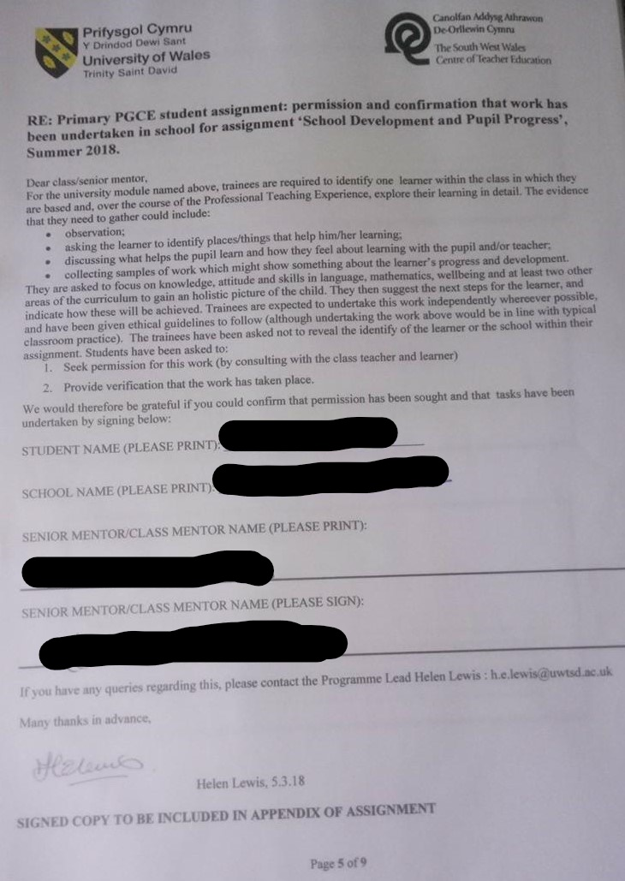

Appendix 2 – Column addition.

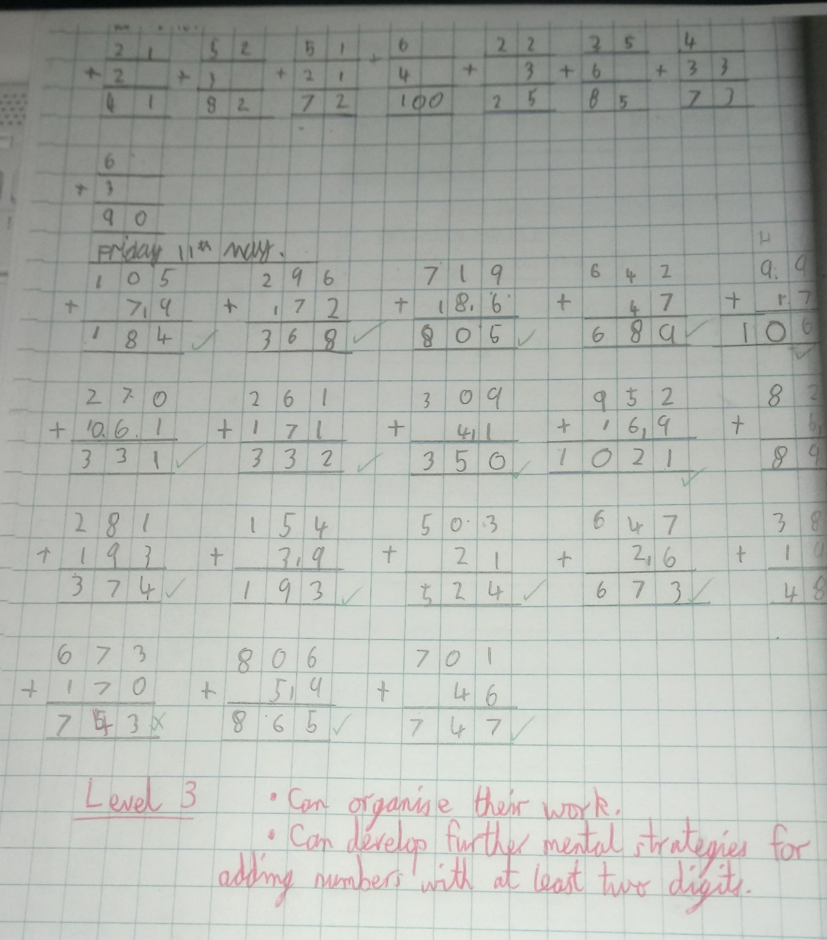

Appendix 3 – Column subtraction.

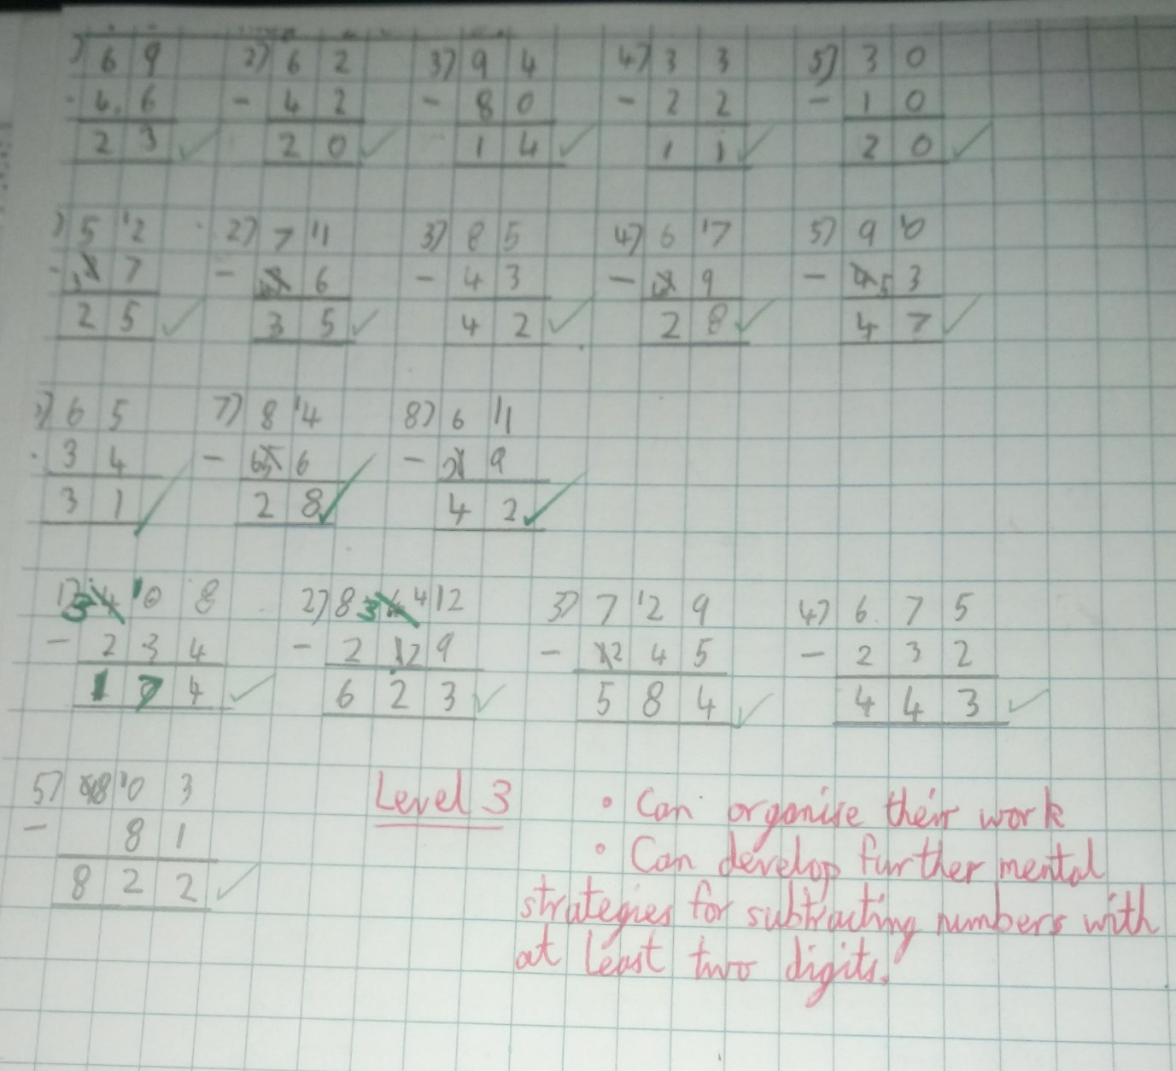

Appendix 4 – Column addition and subtraction extra practice.

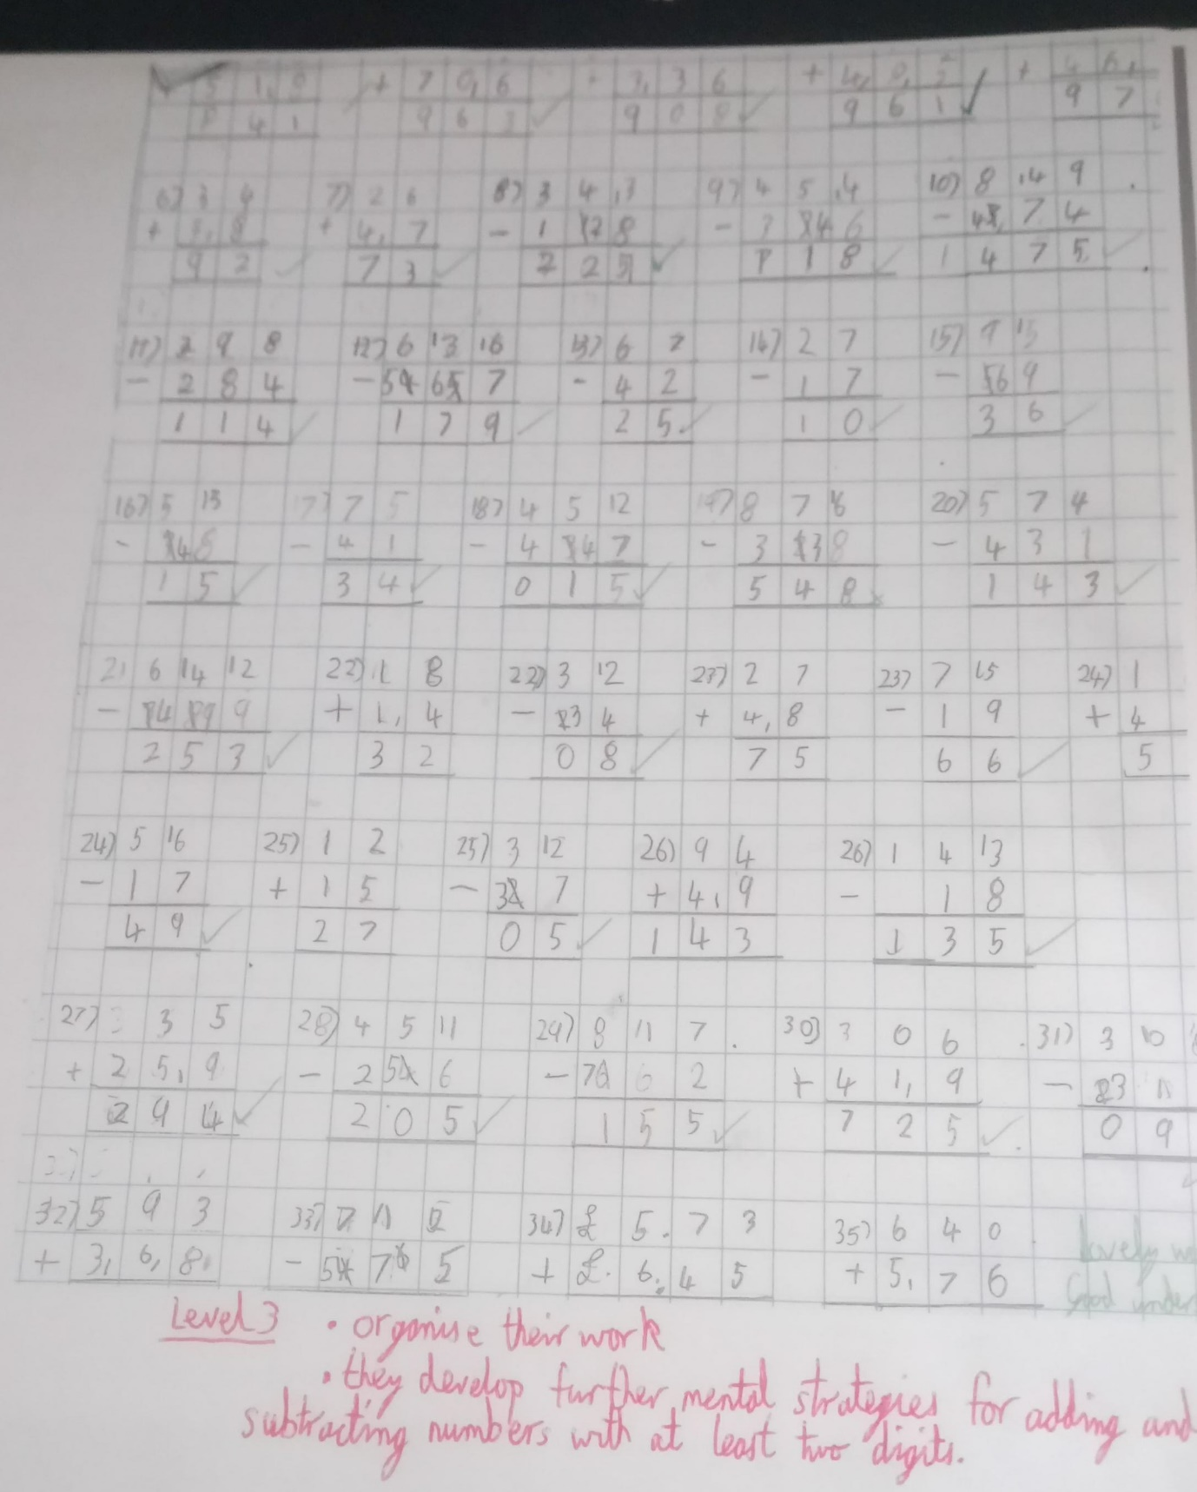

Appendix 5 – Measuring length, area and perimeter in cm.

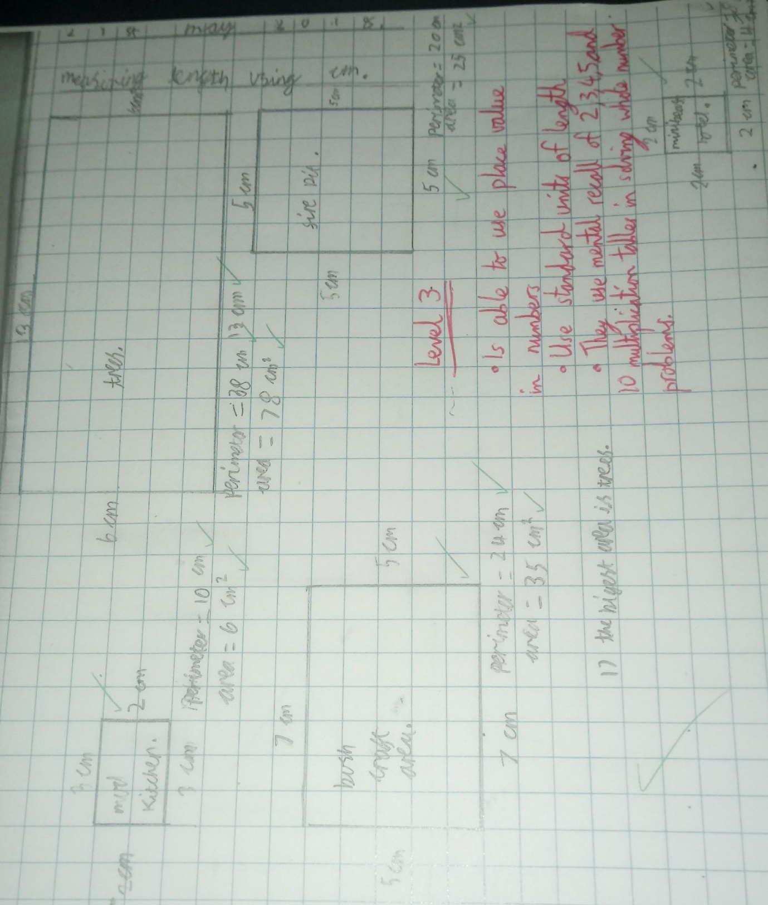

Appendix 6 – Measuring length using cm of various shapes.

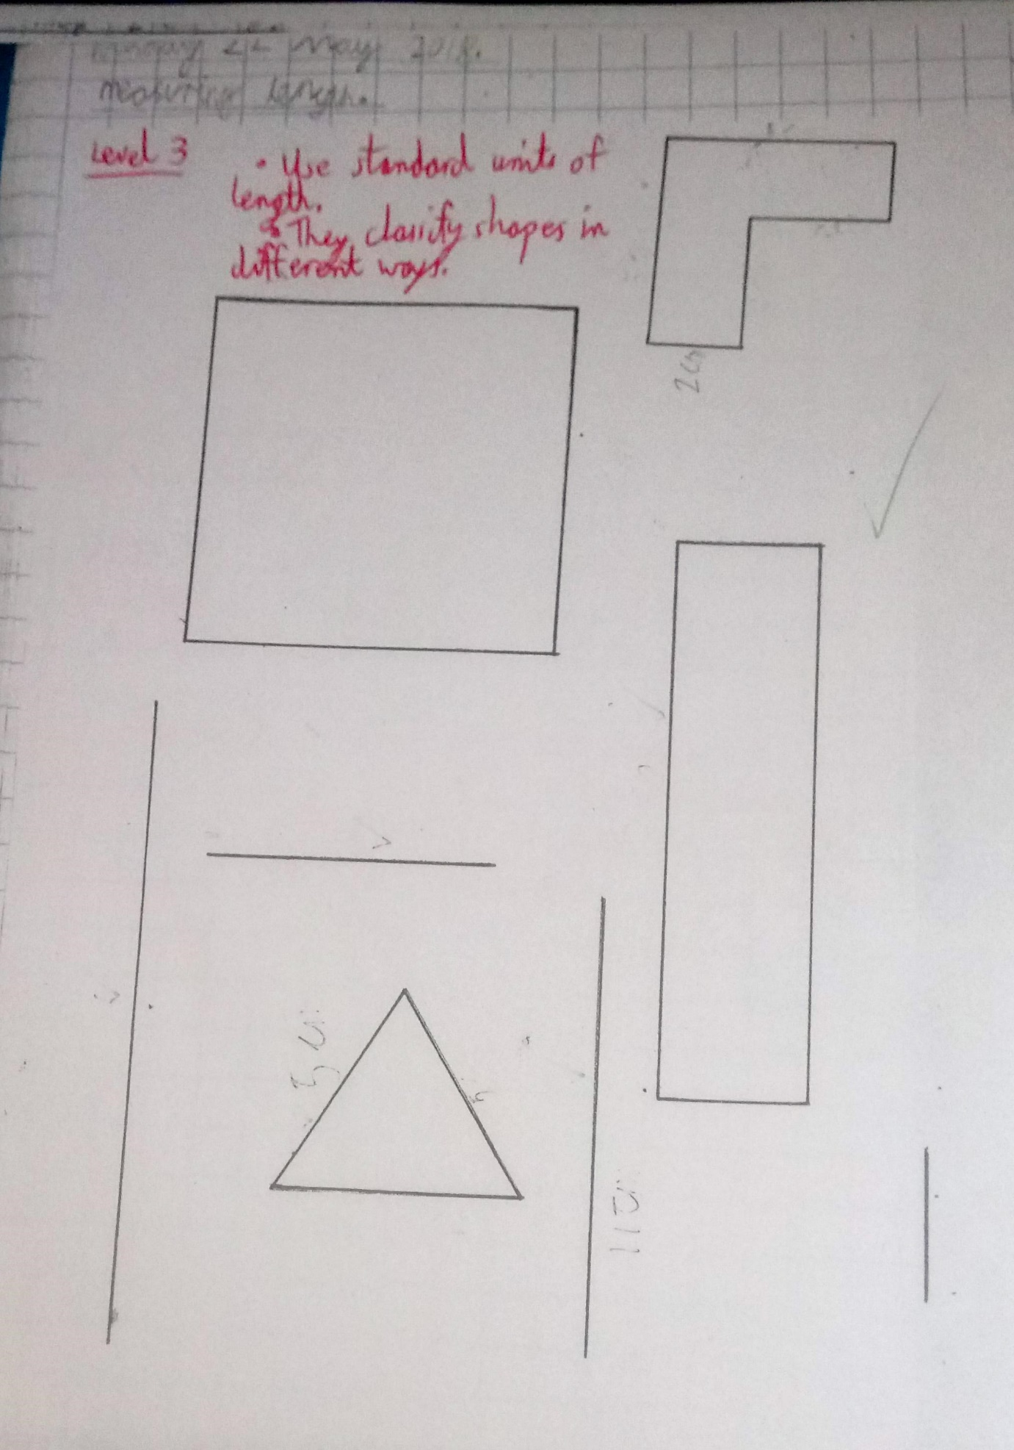

Appendix 7 – Ordering lengths of different units (cm, mm and m).

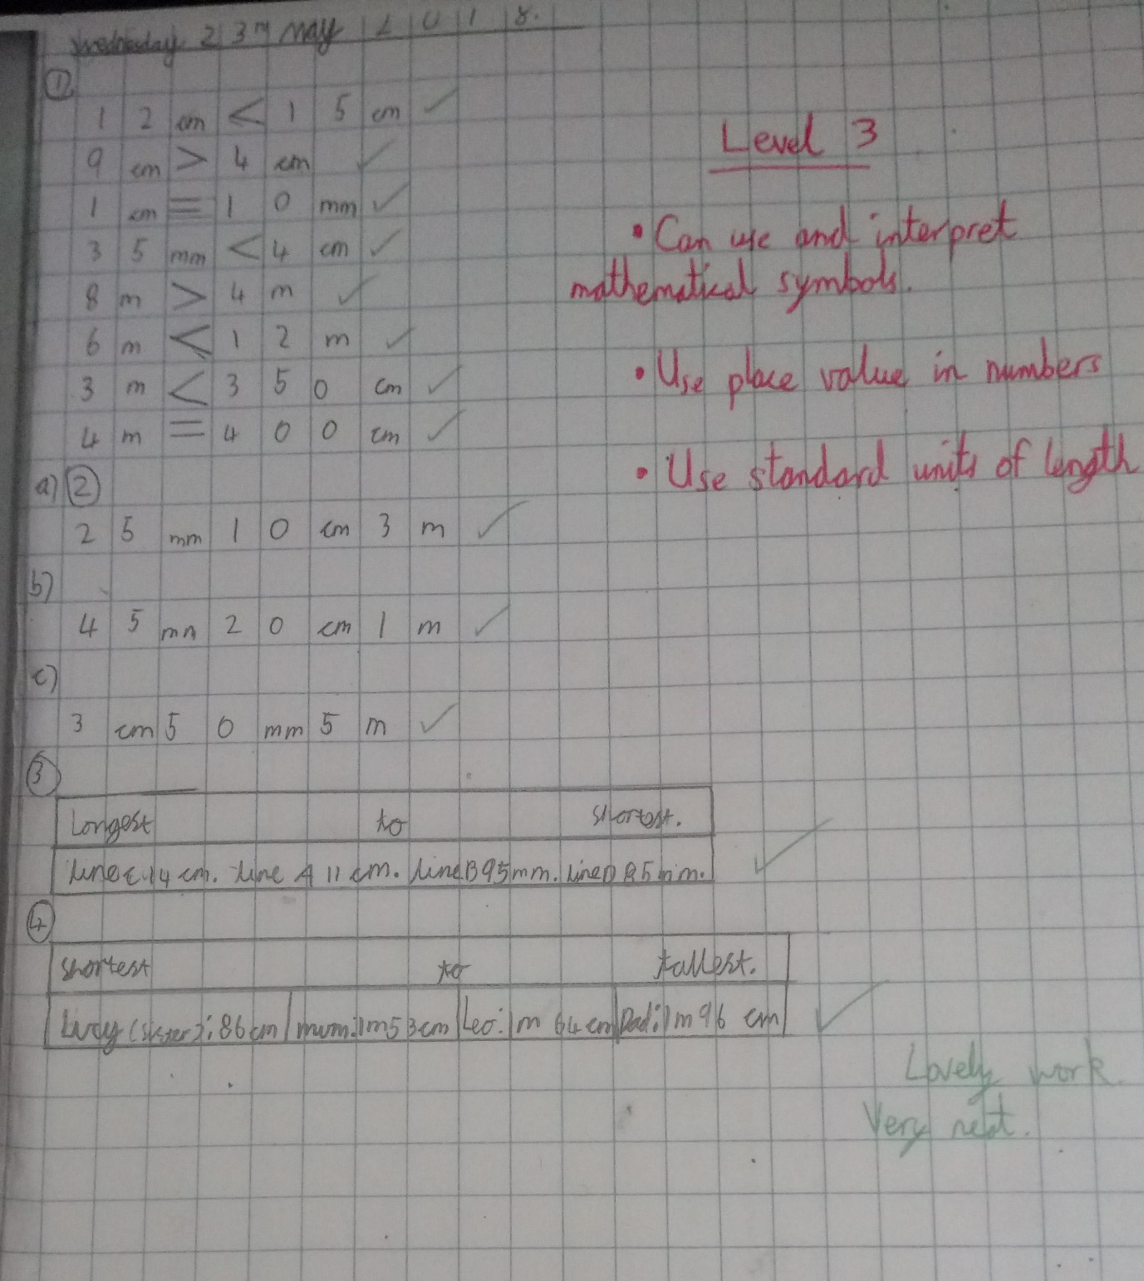

Appendix 8 – Measuring and plotting different lengths in cm and mm.

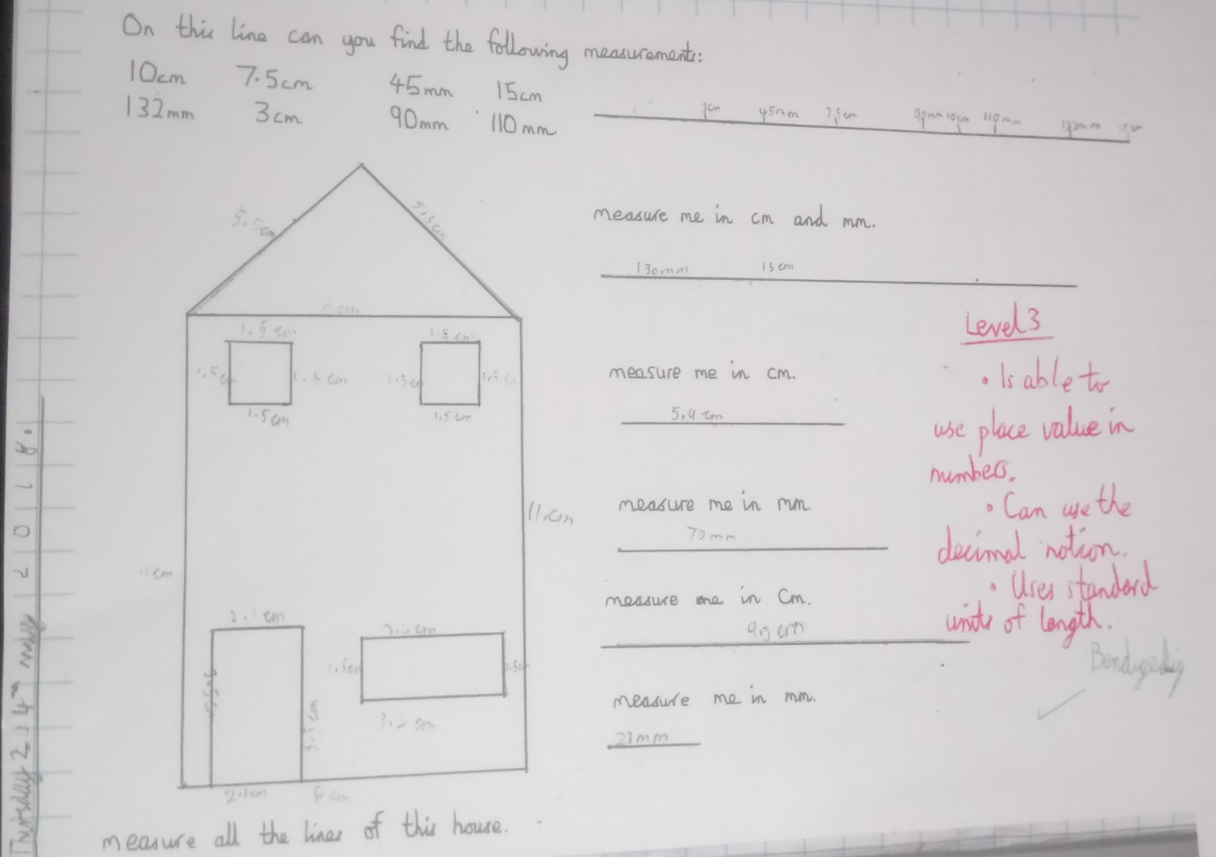

Appendix 9 – Maths tracking (lessons 1 – 8).
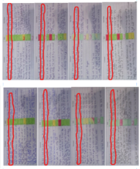

Appendix 10 - Weekly observations (1, 2 and 3).

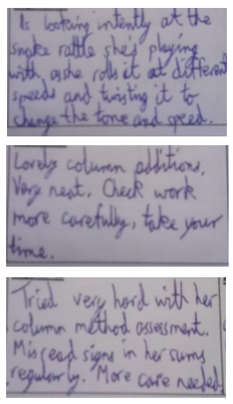

Appendix 11 – English irregular verbs activity 1.

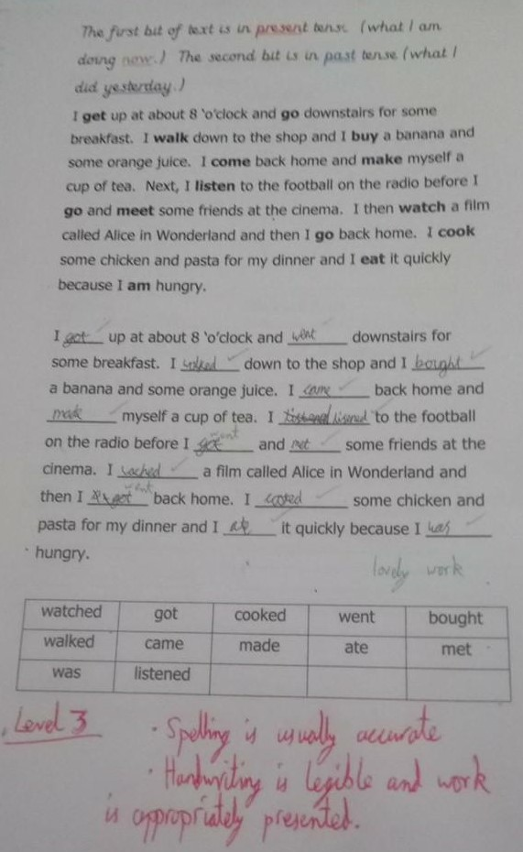
Appendix 12 – English irregular verbs activity 2.
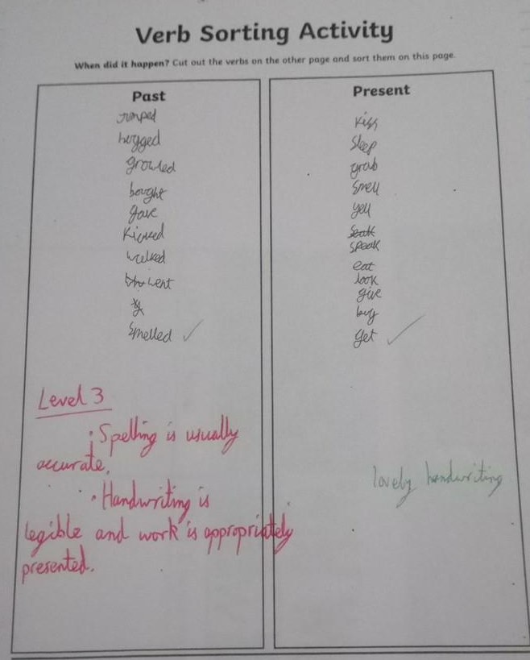

Appendix 13 – English lesson 1 tracking.

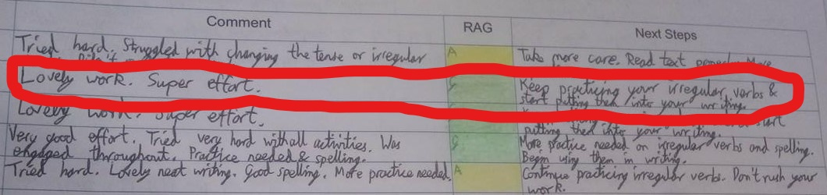
Appendix 14 - Reading record.

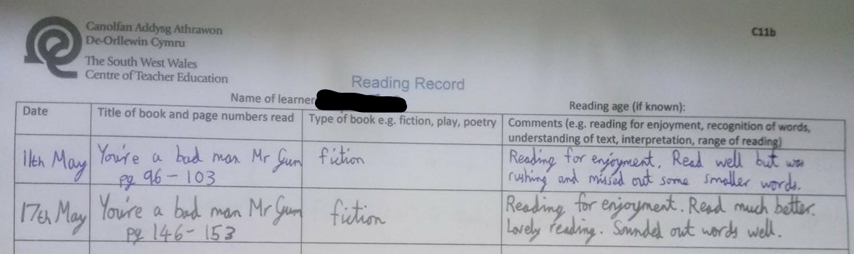

Appendix 15 – Minibeast hunt.

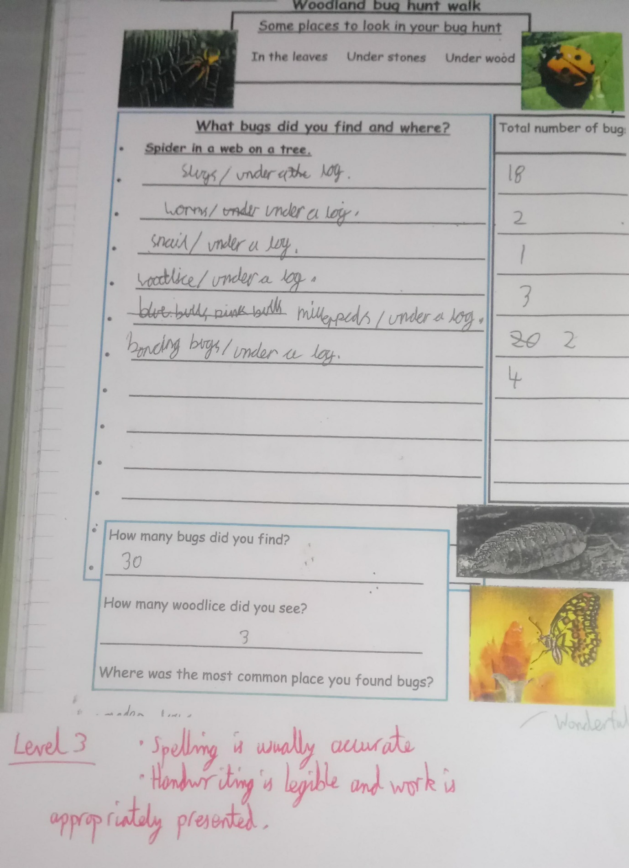

Appendix 16 – Minibeast bar chart.

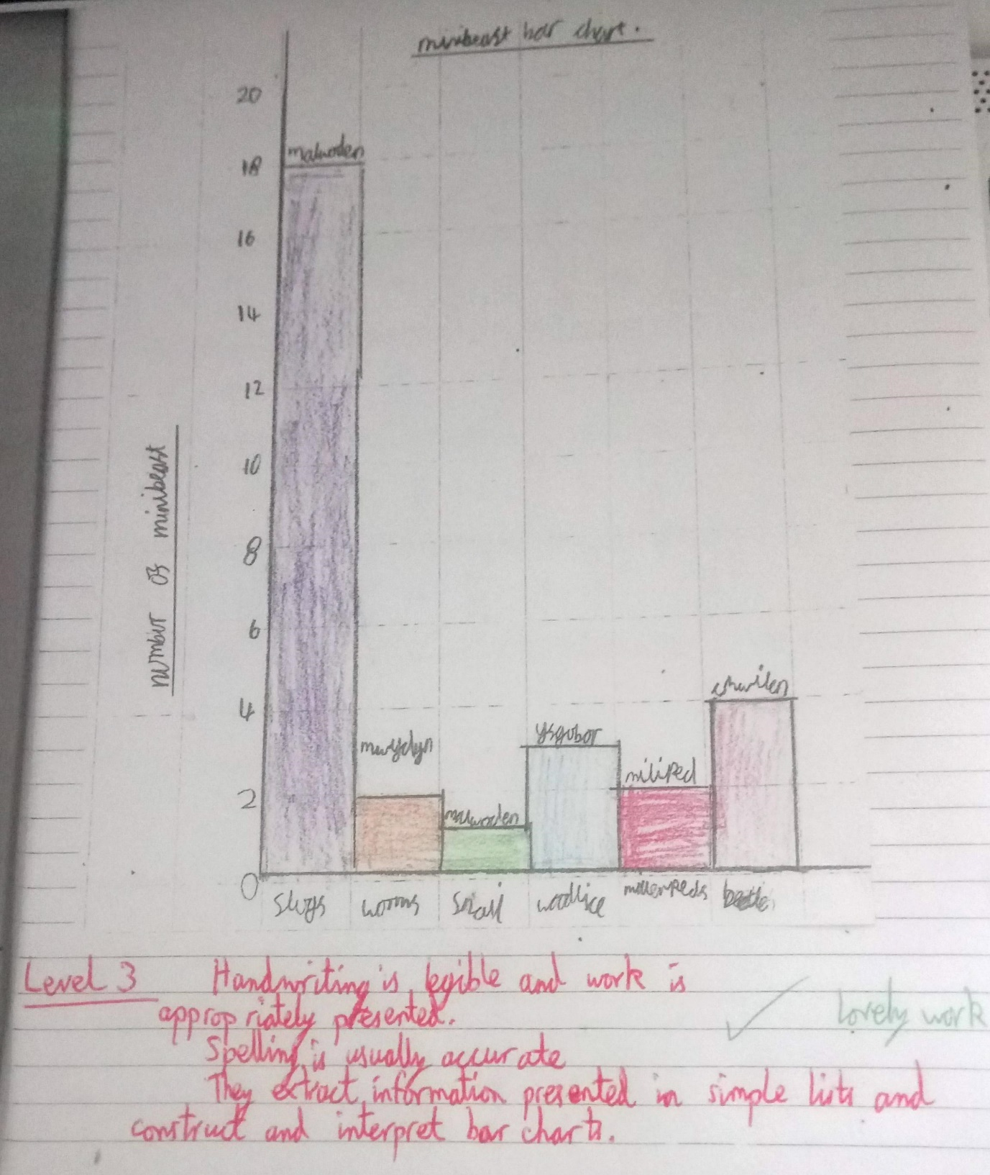

Appendix 17 – Animal fact file.

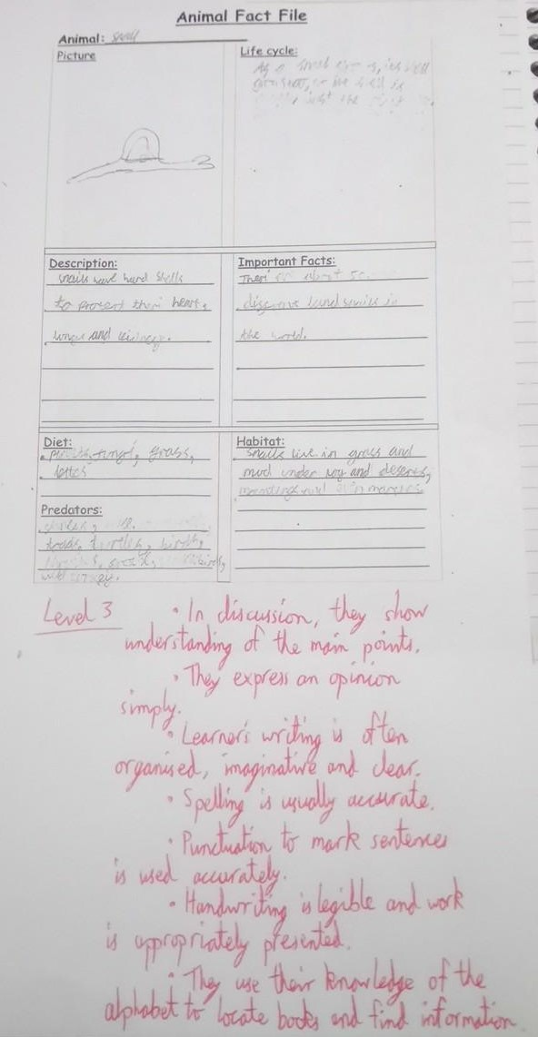

Appendix 18 – Environmental artist research.

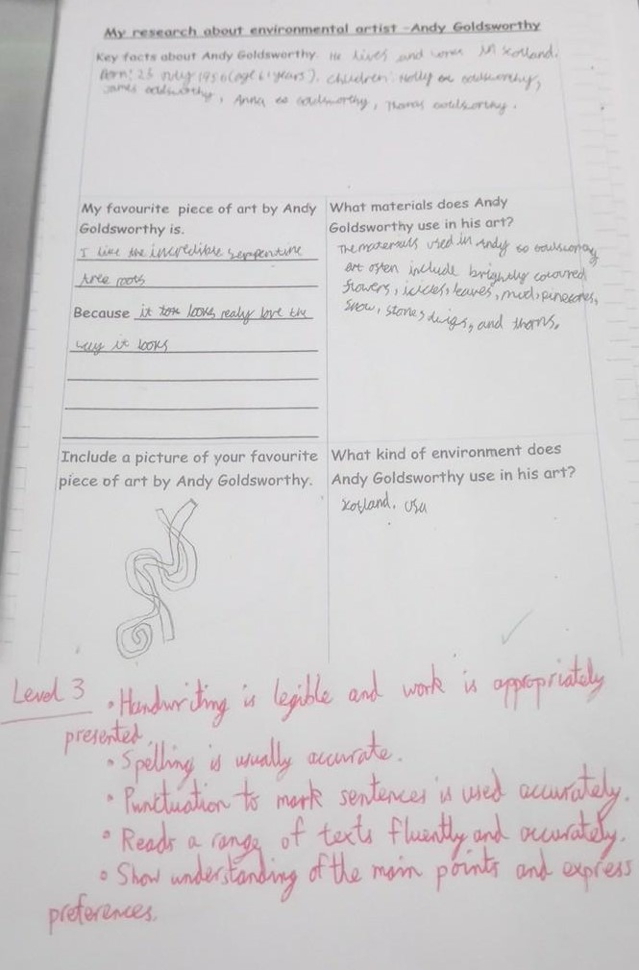

Appendix 19 – Environmental artist venn diagram.

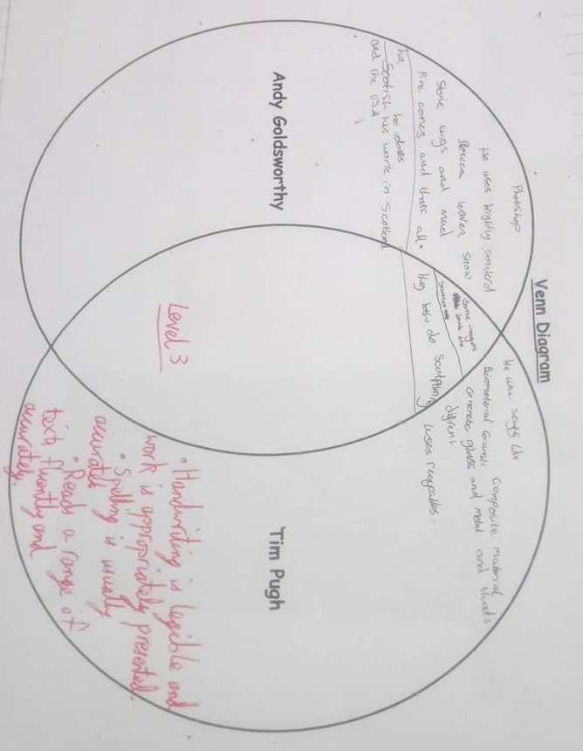

Appendix 20 – Environmental art.

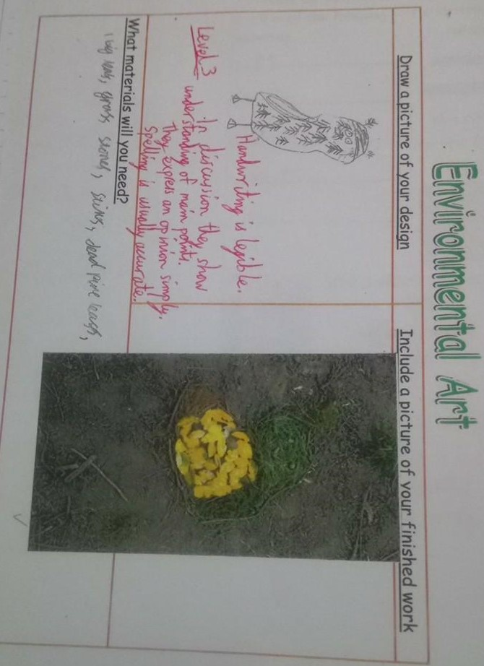

Appendix 21 – Birdfeeder design.
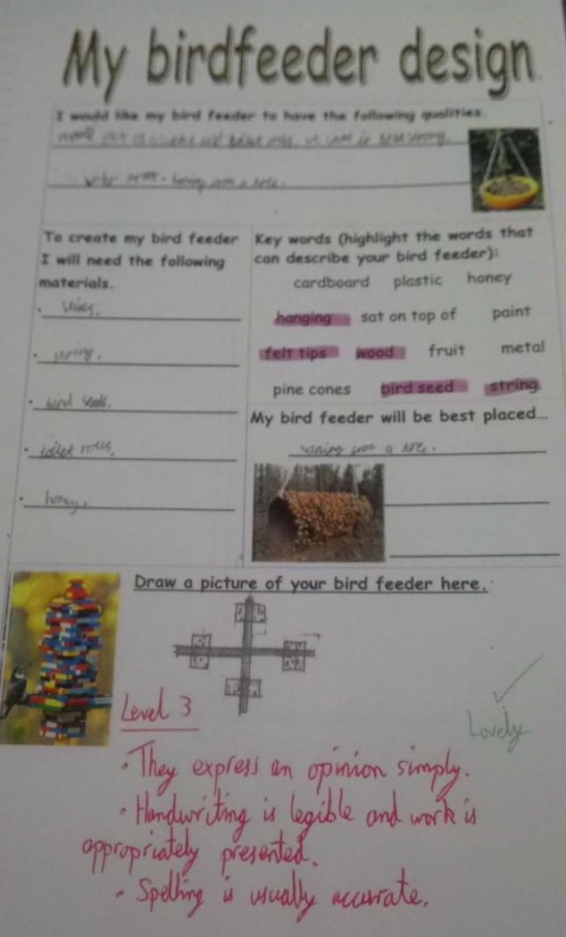
Appendix 22 – KWL grid for Wild Wood topic.

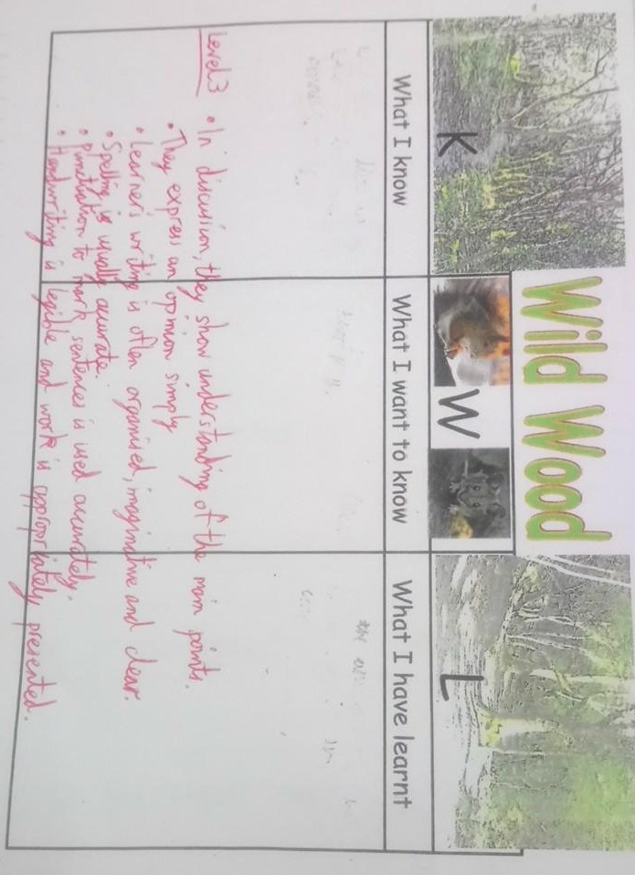

Appendix 23 - Assessment for Learning strategies (Self check success criteria and Exit cards).



