MATLAB Assessment – Callum Wallis-Evans (2426155)

- >> x=2.0
x =
2

>> y=3.0
y =
3

(i). >> 3*x^2-2*y^3
ans =
-42

(ii). >> log(x*y)
ans =
1.7918

(iii). >> sqrt(x/y)
ans =
0.8165

(iv). >> exp(y)
ans =
20.0855

(v). >> exp(-x)+log10(y)
ans =
0.6125

- >> clear all
>> fplot('exp(-x)',[0,4])
>> hold
>> fplot('0.75*x',[0,4])

x=0.677 y=0.508 (3d.p)

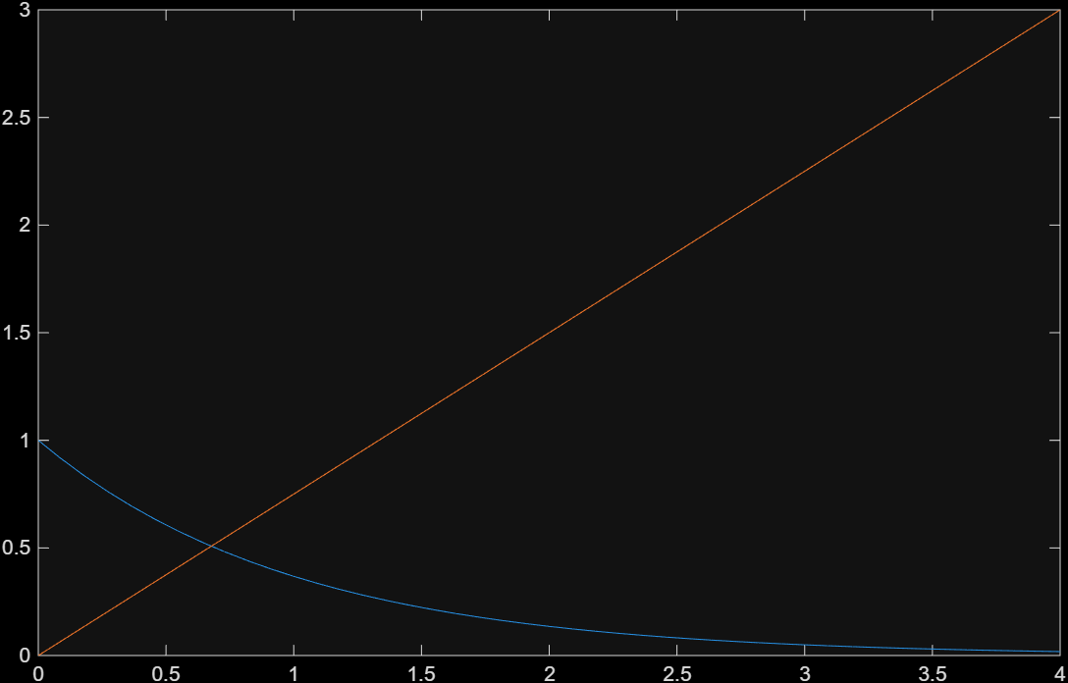

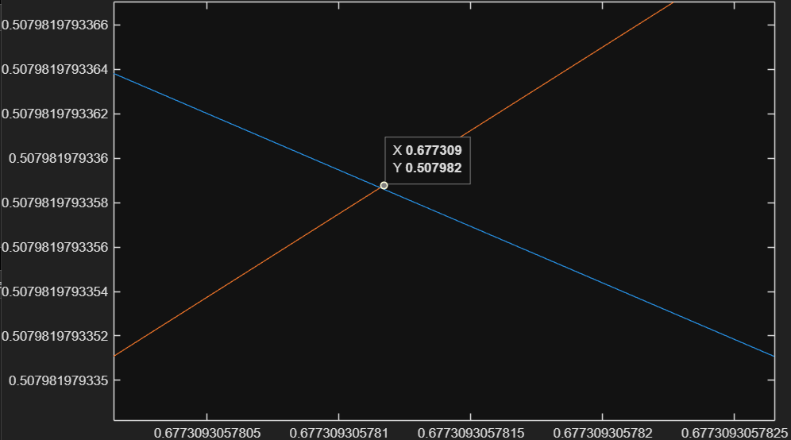

- >> clear all
>> syms x
>> solve(x^3-6*x^2+11*x-6)
ans =
1
2
3

either x = 1 or x = 2 or x = 3

- >> clear all
>> x=[1.0 2.0 3.0 4.0 5.0 6.0]
x =
1 2 3 4 5 6

>> y=[4.1 6.7 9.9 13.3 16.4 19.3]
y =
4.1000 6.7000 9.9000 13.3000 16.4000 19.3000

>> p=polyfit(x,y,1)
p =
3.1000 0.7667

>> y1=polyval(p,4.5)
y1 =
14.7167

- >> clear all
>> syms x
>> y=sin(6*x)
y =
sin(6*x)
>> y2=diff(y,2)
y2 =
-36*sin(6*x)
>> y2+36*y
ans =
0

- >> clear all
>> a=[2 -2 3]
a =
2 -2 3

>> b=[2 -3 2]
b =
2 -3 2

>> dot(a,b)
ans =
16

>> cross(a,b)
ans =
5 2 -2

- >> clear all
>> A=[1 1 2;1 2 1;3 -1 -1]

A =

1 1 2
1 2 1
3 -1 -1

>> det(A)

ans =

-11.0000

>> inv(A)

ans =

0.0909 0.0909 0.2727
-0.3636 0.6364 -0.0909
0.6364 -0.3636 -0.0909

- >> B=[4;4;1]
B =
4
4
1

>> inv(A)*B
ans =
1.0000
1.0000
1.0000

