Developing Professional Practice

Name: Agnieszka Grabowska-Phillips

CIPD Membership Number: 48812683

Date: 14/11/2017

Word count (approx.: 2600 words)

I declare that this assignment is my own work and that any information obtained from books and other sources have been appropriately referenced.

Signed......................................................... Date...............................................

Contents

1 Introduction 3
1.1 HR Professional 3
1.2 The CIPD Profession Map 3
1.3 The Core of the Profession Map 5
1.4 Code of Personal Conduct 6
2 Group Dynamics 7
2.1 Conflict Resolution 8
2.2 Negotiating 9
2.3 Influencing 10
3 Project Management 11
4 Problem Solving 12
4.1 Brainstorming 12
4.2 Persuading 13
5 Personal Development Plan 14
5.1 Learning Styles 14
5.2 Reflective Practice 15
References 17

1 Introduction

1.1 HR Professional

The role of HR manager is no longer limited to administrative tasks. Today, HR managers and practitioners are expected to perform value adding activities like continuous improvement and change management (Johns & Perkins, 2016). What’s more, they are there to ensure that the human side of lean management creates lasting value for the organisation (Frackleton, et al., 2014).
To achieve this, HR professionals need to become the ‘thinking performers’. This means taking a holistic approach, continuous learning, being adaptable and not being afraid to challenge the status quo in search for solutions (Johns & Perkins, 2016).
I am currently employed in a HR support role by Highland Spring. The company was formed in 1979 in Blackford, Perthshire. In 2009, following the purchase of the Speyside Glenlivet and two further water businesses from Greencore Group, it became the biggest producer and supplier of naturally sourced bottled water in the UK (HSG, 2017).

1.2 The CIPD Profession Map

CIPD describes HR professionalism as an indication of an individual’s commitment to raising standards of knowledge, capability and ethical practice (CIPD, 2017a).
The HR Profession Map outlines the technical knowledge, skills, behaviours and experience, that all members must aim to demonstrate (CIPD, 2017c). It consists of ten professional areas describing the experience and knowledge required for effective role performance and eight behaviours i.e. characteristics required to carry out HR activities (Fig.1).
Professional areas and behaviours have been collated in four bands of professional competence, each defined by the relationship with the customer and focus of activity (Fig.2).

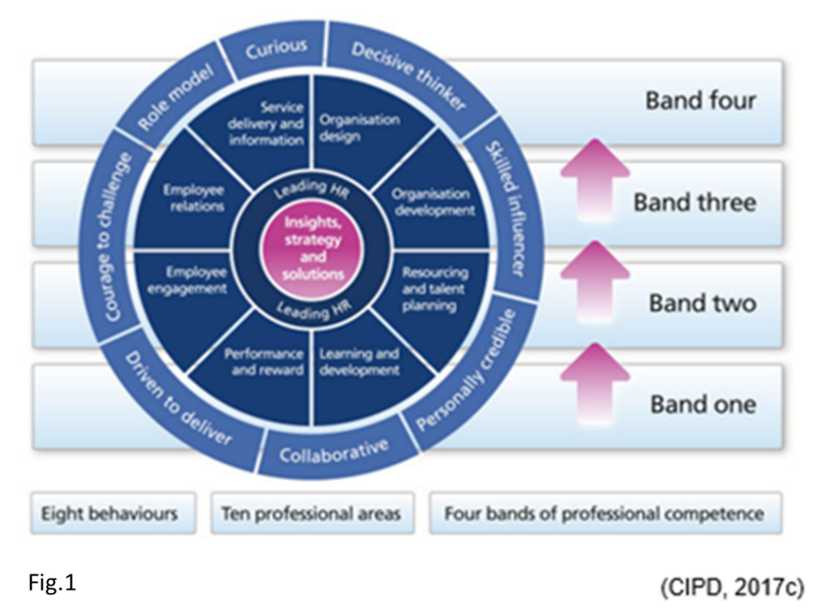

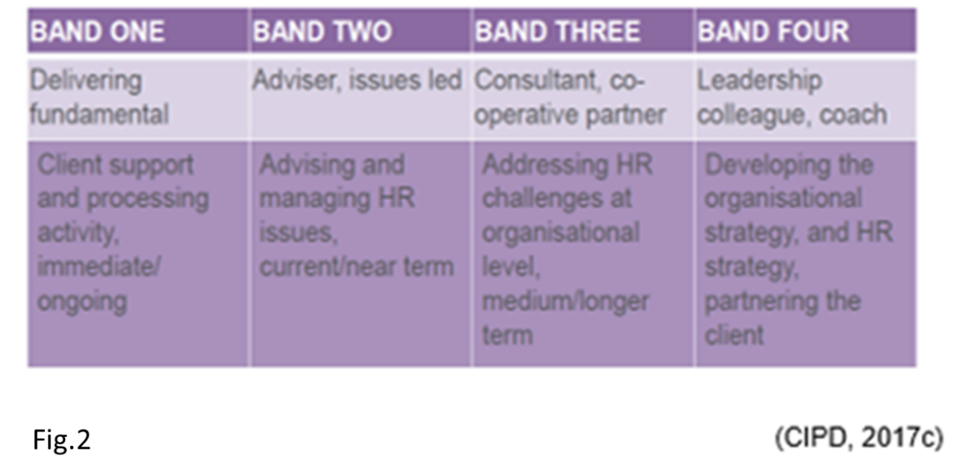
My current role fits within Band 1 (Technician) of The CIPD Profession Map as it mainly involves day-to-day employment relations, attendance management, recruitment and payroll, maintaining employees’ personal records and managing access rights.
My intention is to move to Band 2 (Adviser) as the next step of my career. I have started to become involved in employee engagement surveys and performance management, including disciplinary proceedings. Furthermore, I am a member of the support team for the Marks & Spencer’s Code of Practice for Ethical Trading.

1.3 The Core of the Profession Map

At the core of the CIPD Profession Map are the two most prominent skills required by a HR professional. These are ‘Insights, Strategy and Solutions’ and ‘Leading HR’ (Fig.3). These two elements make the foundation of a great HR capability regardless of role, location or stage of career, and are to be reviewed in conjunction with the remaining relevant technical professional areas (CIPD, 2017d).
According to CIPD (2017c), it is critical to develop these two areas first, as without them it is impossible to advance from ‘Technician’ level.
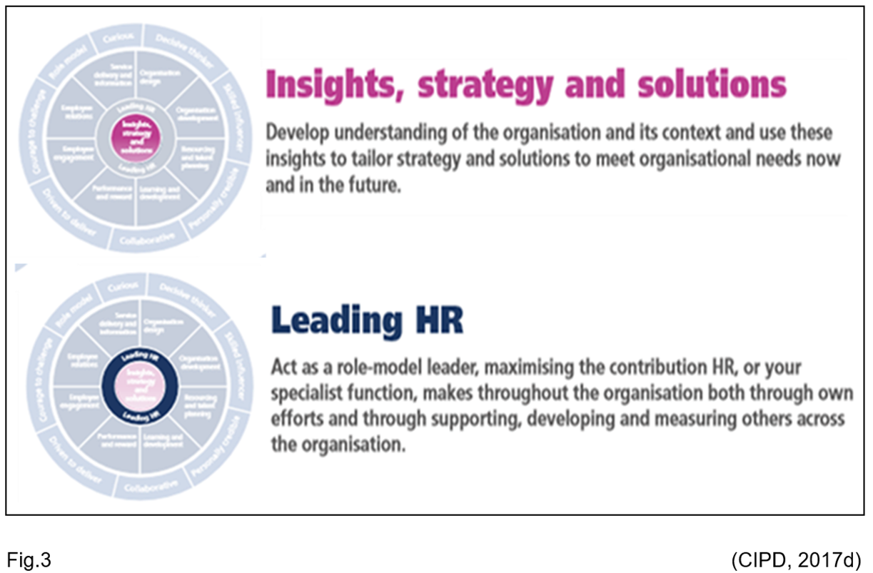

‘My CPD Map’ is a tool developed by CIPD to support HR practitioners in their career, development and learning. It includes a series of self-assessments relevant to the current role, future development and areas of interest (CIPD, 2017e).
I used ‘My CPD Map’ to identify my current position and to establish the elements required for my transition to the next level (see evidence 1). I also used this tool to identify the areas of HR I am most interested in. It allowed me to focus on the most important parts of my development (see evidence 2).

1.4 Code of Personal Conduct

HR professionalism can be defined as a body of knowledge, supported by appropriate expertise, which is underpinned by a code of conduct or ethics (Johns & Perkins, 2016).
There are a strict set of rules that all members of CIPD are required to adhere to (Fig.4). These obligations form a Code of Personal Conduct (CIPD, 2017b).
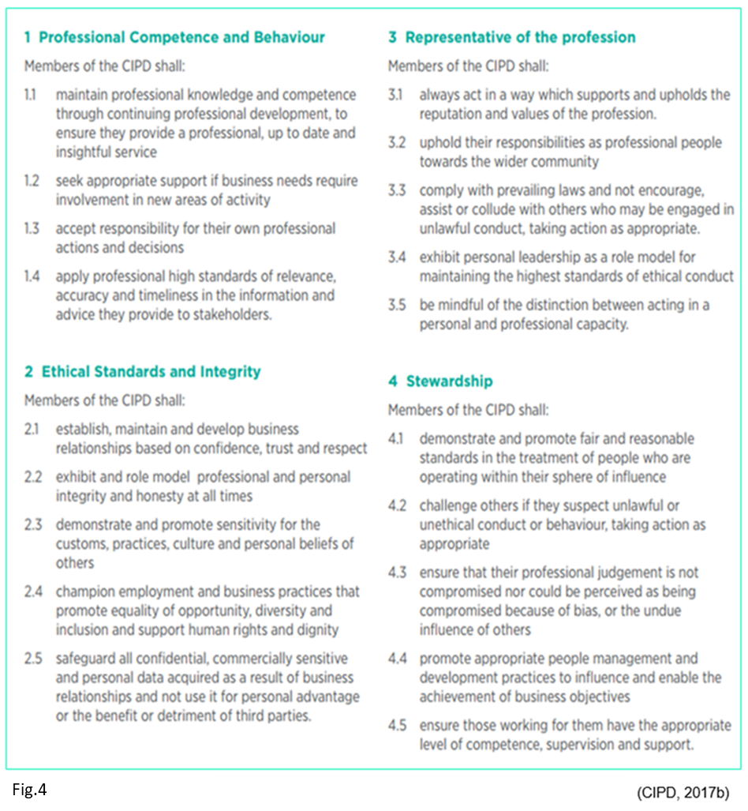

2 Group Dynamics

Teamworking is a crucial part of working within an organisation. Its effectiveness is often considered a major component in the success of a project (Muller & Judgev, 2012). The first step to optimise teamwork is to understand the stages of team development. Created in 1965, and amended in 1977, ‘Tuckman's Model of Small-group Development’ (Tuckman & Jenson, 1977) is the most frequently referenced model in academic and professional literature (Bonebright, 2010). It introduces the four stages of group development (Fig.5).
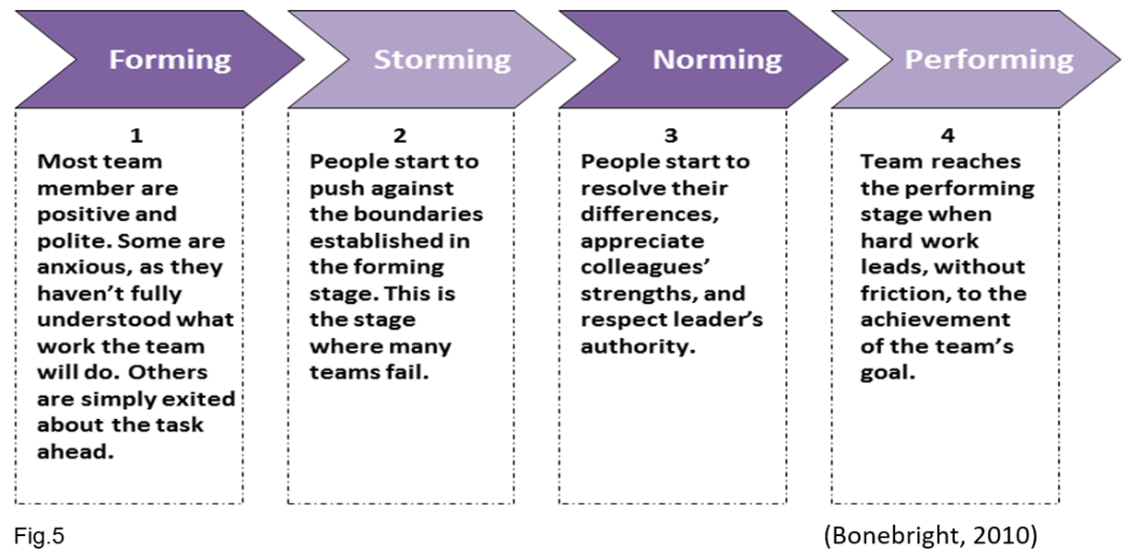

The interactions between group members, otherwise known as group dynamics, can be affected by a number of factors. Johns and Perkins (2016) lists the following elements:
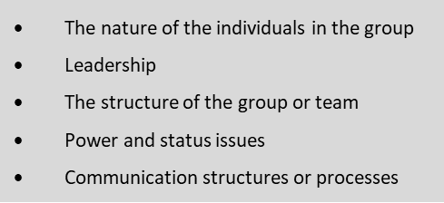
All HR professionals at some point will be expected to work in a team. The participation may involve leading it or contributing as a member. More often than not, HR professionals will become part of different teams moving across the department and working with individuals or groups from different backgrounds (Johns & Perkins, 2016).
Within my current role I tend to work on my own initiative. However, on occasions I am required, or I find it beneficial, to become a part of a team. One example is my membership of the group supporting Marks & Spencer’s Code of Practice for Ethical Trading. The Code obliges all suppliers to ensure their products meets minimum labour standards, the national law and the Global Sourcing Principles (M&S, 2016). The team consists of HR and H&S advisers. All participants have a strong knowledge of the subject, long working experience and are customer and quality focused. ‘The structure of the group’ and the ‘nature of the individuals’ seem to have an especially positive influence on teamwork, resulting in a strong performance: earlier this year, The Beacons site achieved the highest Gold Award.

2.1 Conflict Resolution

“Conflict management refers to techniques and ideas designed to reduce the negative effects of conflict and enhance the positive outcomes for all parties involved” (HRZone, 2017).
‘Conflict Mode Instrument’ is a model developed by (Kilman & Thomas, 1977) that demonstrates how people deal with conflict (Fig.6).

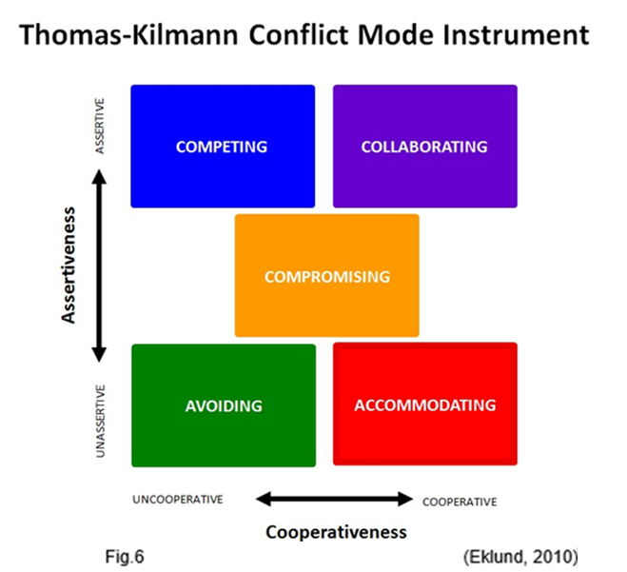

This model is based on the assumption that, in any conflict situation, there are always two choices; one needs to decide how assertive or how cooperative they want to be. Assertiveness emphases satisfying a person’s own needs, while cooperativeness focuses on the needs of others (Eklund, 2010).
The biggest mistake often made by HR personnel is dealing with conflict through formal procedures, grievance and employment tribunals and not properly addressing the low-level conflicts often lurking in the side-lines (Simms, 2017). In fact, the ability to identify conflict in the workplace and knowing how to quickly and effectively resolve the underlying issues, in a positive way, is a paramount skill for a HR professional.
There are five steps to conflict resolution: ‘set the scene’, ‘gather information’, ‘agree to the problem’, ‘brainstorm possible solutions’ and ‘negotiate a solution’ (Bisk, 2017). Negotiating, influencing and persuading skills are the best tools to reach agreements with less complications and stress (Gillen, 2008).

2.2 Negotiating

According to Johns and Perkins (2016), negotiating is useful when the need or desire of one party clashes with those of the other. The best outcome of negotiation is the so called ‘win-win’ situation, with both parties achieving a satisfying outcome.
During the eight years preceding my employment in Highland Spring, I worked as a Project Engineer for a 2nd tier supplier in the automotive industry. A significant part of my role involved the interpretation of customer drawings and negotiating with customer guest engineers to assess and influence the wiring system design for manufacture. The ‘win-win’ situation was achieved when the product still fulfilled the customer’s fitting requirements, but at the same time was easier and cheaper to produce.
Now I often utilise this experience. For example, when negotiating a new completion date for a monthly overtime report. A conflict occurred due to the employees on a rotating shift pattern handing in their paperwork late while the HQ based payroll team were demanding faster processing times. I managed to negotiate a slight delay, still within required limits, but gained enough time to correlate the monthly reports of all shifts, hence resulting in a ‘win-win’ situation for both sides.

2.3 Influencing

HR professionals aiming to influence others must most of all show a superb knowledge of the subject. Furthermore, they need to have good communication skills and be friendly, but assertive (Johns & Perkins, 2016). The aim is to positively influence people so that they follow and act willingly rather than because of the authority factor (Horowitz, 2013).
Horowitz (2013) lists the following steps to achieve it:
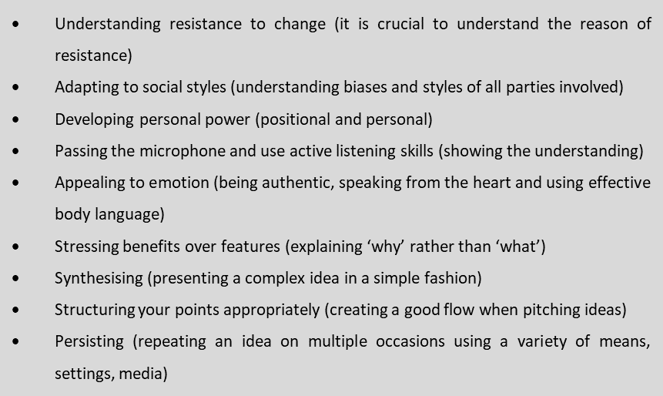
I have used the influencing method on many occasions. Most recently, when redesigning the Holiday & Flexi-time Database. I was responsible for introducing a new format of the document, but had to influence numerous employees who resisted this change. I had to stress the benefits of the change and presented my idea in the simplest possible fashion. I also made a point of repeating my idea on multiple occasions and used a variety of means to do so, including one to one meetings and e-mail notifications.

3 Project Management

Today’s organisations are increasingly using project management as a tool to improve their productivity (Frame, 1995). It is a method of managing complex tasks, performed under demanding constraints such as time pressure, and often requiring cooperation between different departments (McLain, 2009). Project management can be used to plan and manage change in an organisation; hence it is often applied in change management (Gareis, 2010).
HR related projects may vary in size or time scale, having knowledge of project management tools and techniques is highly advantageous for HR professionals. Each project can be divided into five stages (Fig.7)
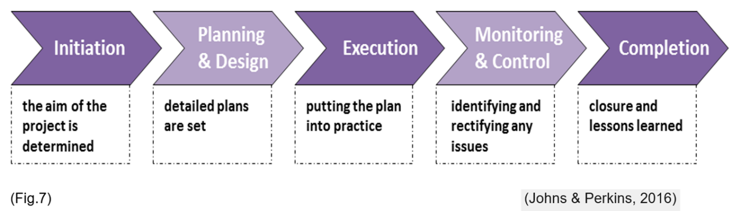
The number of HR projects I was involved in during my employment at Highland Spring is limited. Yet, I was still able to make use of my past project management experience:
One of my more recent engagements was the introduction of a new clocking in system in The Becons site. The aim of the project was to replace the outdated hardware and software with the latest version (Initiation). The model chosen as a replacement introduced a fingerprint reader, as opposed to the card reading machine used in the past. The project budget was assigned (Planning & Design). The new clocking machine was purchased and IT support has visited the site to set up the equipment and software (Execution). The new clocking machine was set and ran as a trial for two months. A number of connection issues were found and fixed. In addition, numerous employees experienced difficulties with having their finger prints read and were issued with an optional password (Monitoring & Control). The project has now been closed. Lessons learned from the project include: 1) The priorities for data transfer via the satellite Internet connection must be reassessed and remodelled. 2) The return to a card reader instead of finger print reader has been recommended (Completion).

4 Problem Solving

Problem solving is the foundation of effective management for the Human Resource department. Problem-solving skills mean being able to identify issues, obstacles, and opportunities and then develop and implement effective solutions (Skillings, 2017). There are four basic steps in solving problems: ‘defining the problem’, ‘generating alternatives’, ‘evaluating and selecting alternatives’ and ‘implementing solutions’ (MindTools, 2017).

4.1 Brainstorming

Brainstorming is considered to be one of the most beneficial tools for generating powerful and useful ideas in a group or team environment (Baxter, 2016). It involves generating large amounts of ideas to solve the problem (Morrison, 2016) and therefore can be used in the second step of the problem-solving process i.e. ‘generating alternatives’ (Fig.8).
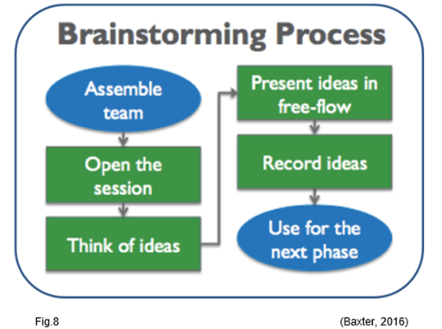
The idea of returning to a card reader instead of a finger print reader (see Project Management section) was generated during a brainstorming session. After the introduction of the new clocking in system, it became obvious, that the new hardware did not perform as efficiently as expected. A cross-functional team of participants included: a deputy factory manager, an engineer who fitted the hardware, IT support team member who installed the software, the team leaders (the main stakeholders of the new process) and myself as a HR representative.
I opened the session by facilitating an introduction and reviewing the brainstorming topic. I reminded the team the reasons why this particular model was fitted and the concerns over the clocking data not being registered. The participants were then given time to think about ideas. In a free-flowing setting, I invited the participants to share their ideas. At this stage, there were no discussions or evaluation of the ideas. I recorded each idea exactly as presented on a flip chart. The group then discussed each solution on its merits. In conclusion, the majority of participants agreed to go back to the card reader.

4.2 Persuading

The third stage in the problem-solving process i.e. ‘selecting alternatives’ is the most difficult stage, as it often leads to further conflict, thus extending existing problems. CIPD created the ‘Persuasive Funnel Technique’ that helps HR professionals to make others use their own logic to persuade themselves (CIPD, 2012). The aim is to make the other party think by asking them questions set within a four-stage framework (Fig.9).
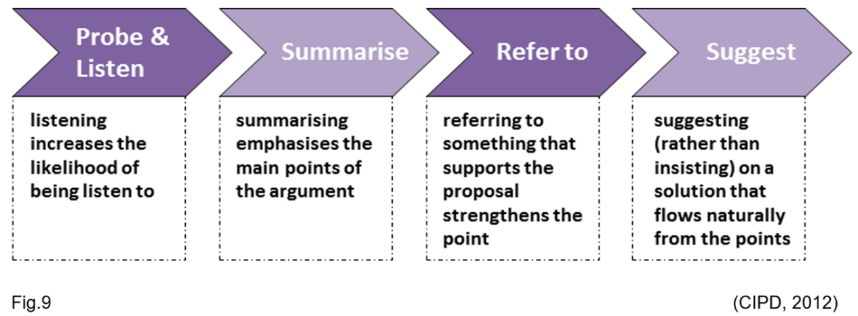
The brainstorming session resulted in the idea of replacing the finger print reader on the new clocking in system with the card reader (see Brainstorming section). I could persuade the deputy factory manager, who was opposed to that change, by following CIPD’s Persuasive Funnel technique:
I listened to the arguments for the finger print reader benefiting security, but emphasised the point that the hardware does not recognise all the prints and a great deal of information is getting missed. Furthermore, I referred to past incidents when missed clocking led to issues with payments being delayed. Finally, I suggested adopting the exact same model of clocking system that is being used in other Highland Spring sites, and this solution has been accepted.

5 Personal Development Plan

I used ‘My CPD Map’ tool (CIPD, 2017e) to generate a detailed Development Plan in support of my transition strategy. The self-assessment confirmed that my current role is in Band 1 (see evidence 1) and helped me to identify the areas of HR I’m most interested in (see evidence 2). Since ‘Insights, Strategy and Solutions’ and ‘Leading HR’ are critical to develop, as without them it is impossible to advance from Band 1, I chose to focus on these two areas first. What’s more, my self-assessment also highlighted the gaps in skills required for further development (see evidence 3). This allowed me to generate a list of aims and objectives for my development (see evidence 4).

5.1 Learning Styles

There are seven types of learning styles (Shanks, 2013). They include visual, aural/auditory, logical, social, solitary, verbal, physical/kinaesthetic (Fig.10). I like learning alone using self-study and therefore I concluded my preferred style of learning is ‘solitary’.

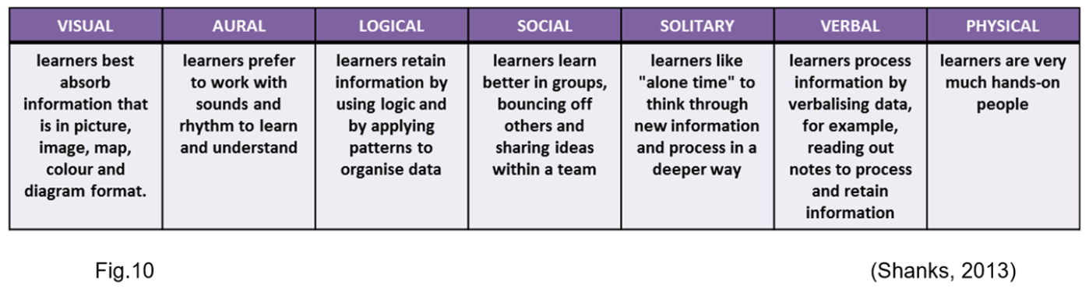
Different learning preferences will fit different learning content, thus allowing a more focused and accurate choice of learning materials and teaching techniques (Fig.11).
Taking into account my preferred learning style, I intend to focus on reading books, researching academic and professional journals and listening to podcasts. However, judging from my previous learning experience, I believe I am flexible enough to extend my learning style, and will include additional learning sources whenever possible to maximise the learning output, for instance online webinars and one-to-one interviews.

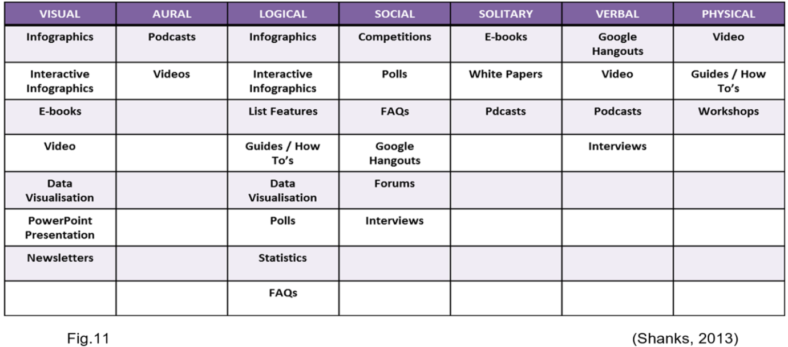

5.2 Reflective Practice

Reflective Practice is the foundation of professional development. It is a way of recognising and articulating everything that was learned on a moment by moment basis, as opposed to reading books or attending courses.
Reflective Practice allows individuals to reflect on their experience presuming the notion that people learn all the time; from everything they do to every conversation they have. It involves: learning to pay attention (listening to ourselves), coming face to face with our assumptions, noticing patterns, changing what we see and changing the way we see (CIPD, 2017f).
The model I use in my reflective practice is Gibbs Reflective Cycle (Fig.12). It relates strongly to idea of empathy (Gibbs, 1988).
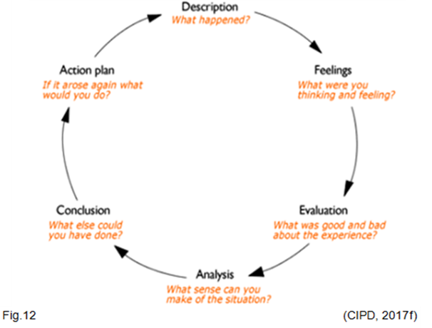
Gibbs (1988) recognises that personal feelings always influence the situation. At the same time, having empathy can help to see beyond one’s own actions, feelings and motivation to imagine how another person might be feeling.
I apply all stages of Gibbs Reflective Cycle in my work and throughout my learning and development process. I use it to evaluate my actions and examine how I dealt with situations, so I can understand what I did well and identify opportunities for further improvement.

References
Adeyemi, M., 2010. Managing Conflict In Organisation-An Overview. Academic Leadership: The Online Journal, 8(4).
Baxter, R., 2016. Generating Value by Conducting Brainstorming. [Online]
Available at: https://www.linkedin.com/pulse/generating-value-conducting-brainstorming-rod-baxter
[Accessed 11 11 2017].
Bisk, 2017. Effective Conflict Resolution Techniques. [Online]
Available at: https://essentialsofbusiness.ufexec.ufl.edu/resources/human-resources/the-conflict-resolution-process/#.WgY1fGi0OUm
[Accessed 11 11 2017].
Bonebright, D. A., 2010. 40 years of storming: A historical review of Tuckman's model of small group development. Human Resource Development International, Volume 13, pp. 111-120.
CIPD, 2012. The persuasive funnel. [Online]
Available at: https://www2.cipd.co.uk/toolclicks/interpersonalskills/training-tools/persuading-skills/persuasive-funnel/default.aspx
[Accessed 11 11 2017].
CIPD, 2017a. Professional identity may hold the key to rebuilding trust in organisations. [Online]
Available at: https://www.cipd.co.uk/news-views/news-articles/professional-identity-rebuilds-trust
[Accessed 09 11 2017].
CIPD, 2017b. Code of Professional Conduct. [Online]
Available at: https://www.cipd.co.uk/about/what-we-do/professional-standards/code
[Accessed 09 11 2017].
CIPD, 2017c. The CIPD Profession Map. [Online]
Available at: https://www.cipd.co.uk/learn/career/profession-map
[Accessed 10 11 2017].
CIPD, 2017d. The Core of the Profession Map. [Online]
Available at: https://www.cipd.co.uk/learn/career/profession-map/core-areas
[Accessed 11 11 2017].
CIPD, 2017e. My CPD Map. [Online]
Available at: https://www.cipd.co.uk/learn/cpd/map
[Accessed 11 11 2017].
CIPD, 2017f. Reflective Practice Guide. [Online]
Available at: https://www.cipd.co.uk/Images/reflective-practice-guide_tcm18-12524.pdf
[Accessed 13 11 2017].
Eklund, A., 2010. Managing Conflict. [Online]
Available at: http://www.andyeklund.com/managing-conflict/
[Accessed 10 11 2017].
El-Saboni, M., Aouad, G. & Sabouni, A., 2009. Electronic communication systems effects on the success of construction projects in United Arab Emirates. Advanced Engineering Informatics, Volume 23, pp. 130-138.
Frackleton, E., Girbig, R., Jacquemont, D. & Singh, A., 2014. Guiding the people transformation: The role of HR in lean management. The Lean Management Enterprise, pp. 7-88.
Frame, D., 1995. Managing Projects in Organization. 2 ed. New York: Jossey-Bass.
Gareis, R., 2010. Changes of organizations by projects. International Project Management, 28(4), pp. 314-327.
Gibbs, G., 1988. Learning by doing : a guide to teaching and learning methods. 1 ed. London: Further Education Unit.
Gillen, T., 2008. Negotiating, Influencing and Perduading. 2 ed. London: CIPD.
Horowitz, R., 2013. 9 Ways to Influence Without Authority. [Online]
Available at: https://www.hrvoice.org/9-ways-to-influence-without-authority/
[Accessed 12 11 2017].
HRZone, 2017. What is Conflict Management?. [Online]
Available at: https://www.hrzone.com/hr-glossary/what-is-conflict-management
[Accessed 11 11 2017].
HSG, 2017. Highland Spring Group. [Online]
Available at: http://www.highlandspringgroup.com/
[Accessed 20 10 2017].
Johns, T. & Perkins, G., 2016. Developing professional practice. In: S. Taylor & C. Woodhams, eds. Studying Human Resource Management. London: CIPD, pp. 67-88.
Kilman, R. H. & Thomas, K. W., 1977. Developing a forced-choice measure of conflict-handling behaviour: the'Mode' instrument. Educational and Psychological Measurement, Volume 37, pp. 309-325.
M&S, 2016. Marks and Spencer Code of Practice - Ethical Trading. [Online]
Available at: https://corporate.marksandspencer.com/file.axd?pointerid=22e10bb0c7ea4457858fdd030ab6f5d5
[Accessed 11 11 2017].
McLain, D., 2009. Quantifying project characteristics related to uncertainty. Project Management, 40(4), pp. 60-73.
MindTools, 2017. What Is Problem Solving?. [Online]
Available at: https://www.mindtools.com/pages/article/newTMC_00.htm
[Accessed 11 11 2017].
Morrison, M., 2016. Brainstorming technique for innovation, creativity and problem solving – a business strategy. [Online]
Available at: https://rapidbi.com/brainstorming-technique-innovation-creativity-problem-solving/
[Accessed 11 11 2017].
Muller, R. & Judgev, K., 2012. Critical success factors in projects: Pinto, Slevin and Prescott - The evaluation of project success. International Journal of Project Management, 5(4), pp. 757-775.
Shanks, L., 2013. The Importance of Content Types in Content Strategy. [Online]
Available at: https://www.zazzlemedia.co.uk/blog/content-types/#gref
[Accessed 12 11 2017].
Simms, J., 2017. There's more than one way to solve a dispute: Resolving workplace differences is a fine art - and many businesses have been getting it dramatically wrong.. People Management, Volume 4, pp. 32-35.
Skillings, P., 2017. Answering Behavioral Questions: Problem Solving. [Online]
Available at: https://biginterview.com/blog/2014/02/behavioral-interview-question-problem-solving.html
[Accessed 12 11 2017].
Tuckman, B. W. & Jenson, M. A., 1977. Stages of small-group development revisited. Group and Organization Studies, Volume 2, pp. 419-427.

