Assignment Title. Engineering Design (External pipe climber project)

Module code. M4X01160

Christian Parry:

I have Developed my ideas found during my research and have come to the decision about what components to use.

I have decided that to increase the durability of the design and to reduce the weight that either a chain or belt drive would be sufficient in this task. This way there will just be a chain or belt coming directly off the motor onto the drive wheel at whatever ratio works best when we start experimenting with ratios in the workshop.

I have drawn an example of the way in which the ratio could be changed from the motor to the drive wheel:

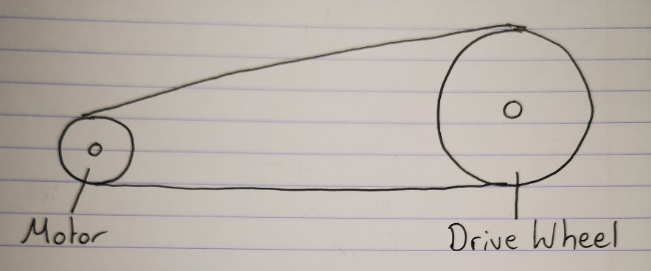
Motor Radius = 4mm
Drive wheel Radius = 16mm
Ratio =4:1

I have also come up with a drawing of how I would like the pipe climber to be packaged:
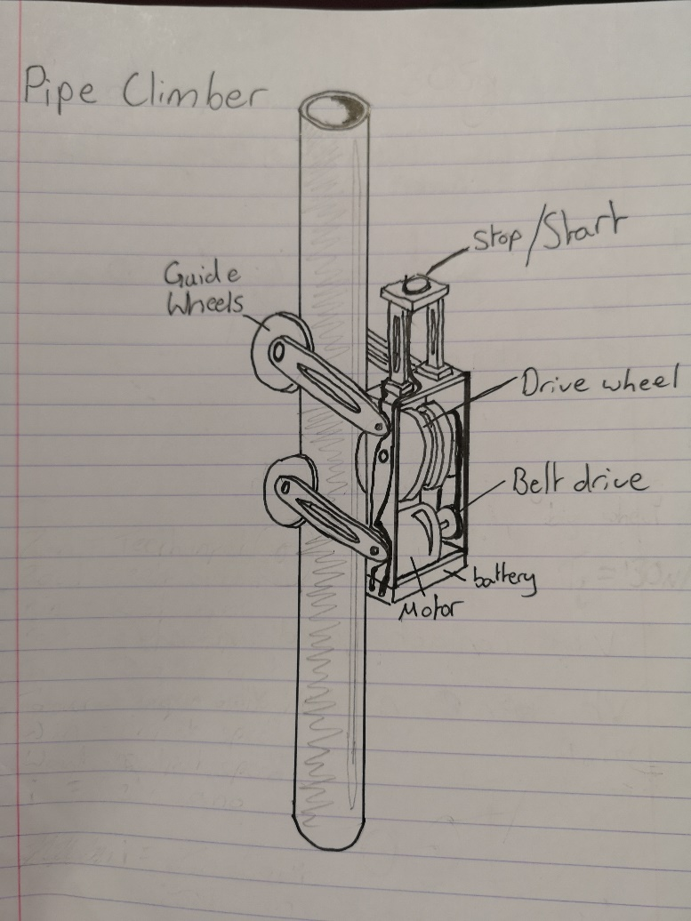
I think the way that the design is packaged is very neat and will allow parts to be changed if they were to fail. With a majority of the weight at the bottom the wheel is pulling the weight up the pipe rather than pushing it up so it should be more efficient. I have also added 2 guide wheels to the back which will support the device enabling it to climb the pipe quicker.
The stop start button will be on a raised section above to fulfil the maximum 300mm height brief to hopefully make the time it takes to reach the top and press the button shorter.
The motor will be fixed to the chassis of the device whilst the drive wheel will run freely on a spindle, the tension on the drive wheel will be kept by adjusting the guide wheels on the back.
The battery will be attached to the bottom of the devices chassis ideally by double sided tape if it will hold the weight of the battery as this would be the lightest way of doing it, however if it doesn’t work when we come to make it then we will have to make a little cradle to fit it in.
I decided in the design research phase that I wanted the chain to be hung off the opposite side to the drive wheel, however with the design I have produced I feel that we can experiment a bit and choose which side we want to hang it off as due to the guide wheels I think either side will now be able to support the additional weight of the chain.
I would like to make the chassis out of mild steel as although it is heavier than aluminium it is also a lot cheaper and more available to us, I would also like to experiment with some plastics potentially for the strut part holding the on/off switch as that part doesn’t have to be particularly strong, and it would benefit the device if that was as light as possible. The same goes for the arms holding the guide wheels if we have to make them out of mild steel then I will machine the slots out of the centres of them to save a bit of weight, as I think for this project getting the design to be as light and strong as possible whilst not being flimsy will produce a winning device.
To increase the durability of the device a high impact foam could be attached to the bottom of the battery to soak up the impact from it dropping, I haven’t included it on the drawing as I think as a group we will experiment to see which way of protecting the device is best as there are lots of ways in which we could do it ie, springs or foam…

