Medi Catrin Evans (2103136)

BMNS4005 – Introduction to Health Research
Module lead – Gareth Morgan

The effects on ITP in young children.

Contents
Introduction 2
What is ITP? 2
How is ITP treated? 3
Conclusion 6
Reference list 7

Introduction
The Platelet Disorder Support Association (PDSA, 2022a) describes ITP is a rare auto immune disease that can be as difficult to pronounce as it is to live with. This report aims to define and demonstrate an understanding on the effects of ITP in young children and how the research-based evidence is undertaken and how it impacts upon health promotion.

What is ITP?
According to the ITP Support Association (2022a) Immune Thrombocytopenic Purpura (ITP) is a medical term for a condition that causes severe bruising and bleeding (purpura) because there are significantly less platelets in the blood than usual (thrombocytopenic), this is usually caused by a problem with the immune system (the body's defence against infection) or an allergic reaction. Chronic ITP refers to ITP that has not resolved on its own accord after a 6-month period. One out of every four children with ITP will develop chronic ITP. Even if the ITP is still present at 6 months, most children with chronic ITP will have some platelet count recovery later, and most younger children will completely recover from the condition after a few years. Norfolk and Norwich University Hospitals (2022) explain further that ITP is not a genetic condition. Every year, approximately 4 out of every 100,000 children and adults can develop ITP. It can happen at any age but affects more females than males. When the platelet count in the blood falls below 50 × 109/l, and below 20 ×109/l, bruising and petechiae (pinpoint blood spots under the skin) can occur. Common bleeding of the nose and gums may also occur while older female patients may suffer with heavy periods. Serious bleeding tends to occur in patients with a platelet count of <10 × 109/l. Like any medical condition, ITP can affect the quality of life of young children. For example, studies show that a third of those with ITP report fatigue symptoms and are most likely worried about how bleeding might affect everyday life, school life, work and social activities. For most Children with ITP, the impact on their quality of life seems to reduce after a short period of time, especially in those who are responding well to treatment. The impact of ITP will vary from child to child and the reasons for their symptoms will differ. The ITP Support Association (2022b) discusses the important adaptations and support measures in place to safeguard their pupils who suffer from ITP. Some primary schools who feel they do not have adequate staff to supervise pupils who suffer from ITP on school yard allow those pupils to stay indoors and use a computer or play board games with a friend. Contact sports are not advised for anyone who suffers from ITP. This means that the sports department will need to provide alternative activities for their pupils to take part. A child suffering with ITP is worrying for parents as their child is in the care of others during the school day and will rely on the headteacher and teachers to be vigilant. It is advisable for the headteacher or class teacher to meet with the parents of the pupil to understand the severity of their ITP and the health and wellbeing of the child understanding the care requirements as well as the limitations if any whilst at school. In addition to this, The ITP support association (2015) suggest that by providing correct training to all staff members of the school and supplying a fact sheet and pinning it up in visible areas, such as the staff room to inform the staff of the pupils ITP. It is critical that all teachers or office personnel in charge of First Aid are aware with ITP and what it entails. When the child is likely to show symptoms, and when the parents or the emergency services should be called, and the pupil will need to be taken to A&E.

How is ITP treated?
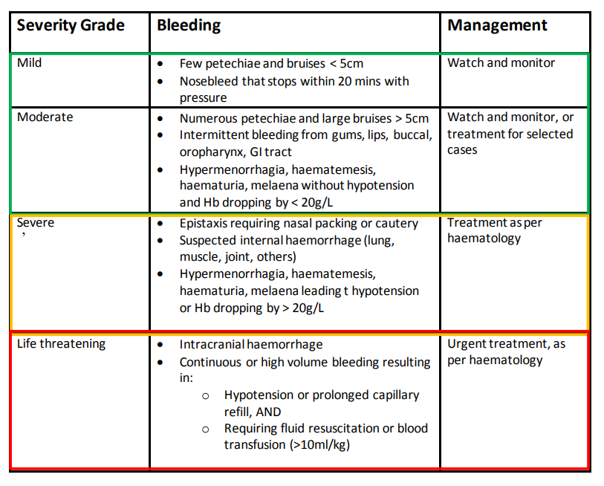
Arnold and Kelton (2007) documents that the goal of treatment for patients with ITP is to increase the platelet count to high enough levels to prevent bleeding while employing the least hazardous medicine possible, acknowledging the illness's largely benign character. From analysing the research within the article, it is evident that corticosteroids, intravenous immune globulin, and splenectomy are main sources of treatment. Although there are newer therapies including rituximab and the thrombopoietin receptor agonists. Immune suppressant medications and cytotoxic drugs continue to be used in patients with severe and chronic ITP with some success rate. However, there are estimates of the effect of these and other treatments are limited by the lack of randomized trials. This article highlights that the treatments for ITP are reviewed focusing on their mechanism of action and the best available evidence from previous clinical studies. Rodeghiero (2008) argues that many medications can carry dangers that may be worse than the actual ITP itself. It is widely acknowledged that the rationale for treatment should be targeted based on the severity of the bleeding rather than platelet count. Despite the lack of prospective on the controlled studies, there is consensus that bleeding risks are significantly higher in children with a platelet count of 20 x 10(9)-30 x 10(9)/L. Therefore, treatment would be considered a priority for these patients. To raise platelet counts, the recommended first-line treatment for ITP is oral corticosteroids. Intravenous immunoglobulin or anti-D immunoglobulin can help boost platelet counts and are especially useful for boosting platelet counts quickly before planned treatments. Splenectomy, which causes a long-term response in the majority of patients, is still widely employed for those who do not respond to steroid therapy and should be considered the gold standard therapy. However, splenectomy is an intrusive procedure, and some patients relapse even after years of treatment. Very rare occurrences of life-threatening or lethal infections may also arise at any time following splenectomy, and as a result, clinicians and patients are becoming increasingly hesitant to advise or consent to this treatment technique. Other therapies, such as high-dose dexamethasone, intermittent anti-D immunoglobulin infusions, and rituximab, have been studied to prevent or postpone splenectomy. There have been few randomised, placebo-controlled studies of these techniques, and their efficacy and safety are still unknown. Thrombopoietin receptor agonists are now being studied in clinical trials for the treatment of ITP and could be an alternative therapy option in the future. The criteria for treating ITP, as well as the benefits and hazards of therapy, are covered in this section. Ongoing and future research will aid in determining the optimal ways for boosting platelet counts and lowering the risk of bleeding in ITP patients. To add to this research study, Patrick (2020) provides a guideline on management of acute ITP in children by focusing treatment on severity of bleeding.

The table categorises bleeding under mild, moderate, severe and life threatening, including the management and treatment strategy accordingly. If the child had been assessed and is suitable for the watch and monitor strategy then guidelines are set out to ensure that the patient has open access to the local hospital, often directly to the paediatric ward. Parents and carers are given clear guidelines as to expectations and best practice, such as avoiding any contact sports and to avoid the use of medications like ibuprofen. It is imperative that parents/carers understand the importance of potential risks associated with head injuries. The administration of tranexamic acid for children with nose bleeds is common practice. Under the watch and monitor process, patients would be required to have a repeat full blood count test on a weekly appointment basis. Children can attend school as normal but should avoid high risk activities to prevent any injuries that may cause excessive bleeding. Furthermore, parents are advised to consider any dental treatment that may cause bleeding and is advised to consult with their child’s dental practitioner to seek further guidance. Moreover, and with modern therapies widely available many people suffering with ITP are looking into holistic herbal therapies that have been used for centuries within the traditional Chinese and Indian medicines. The PDSA (2022b) presents the alternative use of Herbal remedies. Compounds derived from plant leaves, stems, bark, flowers, seeds, and roots which are frequently utilised as the foundation of therapies in these traditional medical systems, as well as in other healing systems. As pharmaceutical corporations identified active compounds, trademarked them, and marketed them as pharmaceuticals, several herbal cures have become conventional Western medicines. Aspirin, for example, was developed from the bark and leaves of the willow tree, while vincristine, a chemotherapeutic treatment used to treat some chronic instances of ITP, was derived from the rosy periwinkle. Although people seek these alternative treatment methods it is not a replacement for the conventional Western treatments, merely that is a compliment of the conventional treatment plan. Herbs, like other plants, can vary based on their growing conditions, handling, and processing, therefore they may contain contaminants and toxins, as well as interact with conventional pharmaceuticals in unexpected ways. There have been few studies to date that illustrate the impact of combining herbal remedies with conventional drugs. If there are problems, determining the cause can be difficult, and certain herbs may have adverse effects that might create problems for persons with ITP, such as damaging the bone marrow. Other herbs have also been linked to thrombocytopenia. As with all ITP therapies, it is critical to consult with the child’s health care practitioner or an herbal medicine expert who is familiar with the disease and the herbs given. Chinese medicine practitioners treat ITP based on many main elements they believe are involved with the ailment, categorising ITP into three distinct categories: heat (inflammation-related), Qi deficiency (production-related), and blood stagnation (circulation-related). Whereas practitioners specialising in Indian medicine use substances are to cleanse the body of pollutants that may be linked to sickness. The cleansing process, known as panchakarma, is thought to help restore the equilibrium between mind, body, and spirit, which is necessary for optimal health. Each person is said to have a unique combination of life forces known as doshas that control the body's functioning, and treatment regimens for diseases and disorders must be personalised in order to re-establish a healthy balance between these energies. In addition to this the PDSA (2022c) promotes the power of leading a healthy lifestyle, although no specific diet or regime will completely treat and relive ITP symptoms. Making better and healthier lifestyle choices can support the immune system by eating right and feeling better.

Conclusion
Following the analysis of the research behind ITP, this report highlights the severity on how ITP impacts the lives of young children. It has been made clear that ITP is a condition that causes severe bruising and bleeding because there are significantly less platelets in the blood than usual. Which is usually caused by a problem with the immune system or an allergic reaction. It effects approximately 4 out of every 100,000 children and tends to affect more females than males. It is evidenced that the impact on the children’s quality of life seems to reduce after a short period of time, especially in those who are responding well to treatment. The impact of ITP will vary from child to child and the reasons for their symptoms will differ. This means that making suitable adjustments in familiarised settings such as the child’s home or school environment will help prevent excessive bleeding which can be life threatening. By adhering to the guideline on management of acute ITP parents, carers and those responsible of the child during school hours will understand the precautions they need to take while receiving ITP treatment. Studies show that the aim of treatment is to increase the platelet count to high enough levels to prevent bleeding while employing the least hazardous medicine possible. It is discussed that there are some treatments such as, corticosteroids, intravenous immune globulin, and splenectomy are main sources of treatment. Although there are newer therapies including rituximab and the thrombopoietin receptor agonists. Immune suppressant medications and cytotoxic drugs continue to be used in patients with severe and chronic ITP with some success rate. However, there are estimates of the effect of these and other treatments are limited by the lack of randomized trials. All the while other evidence argues that many medications can carry dangers that may be worse than the actual ITP itself. It is widely acknowledged that the rationale for treatment should be targeted based on the severity of the bleeding rather than platelet count. Despite the lack of prospective on the controlled studies. Furthermore, the research behind the natural herbal treatments for ITP has been discovered effective but isn’t a reliable treatment form that should replace traditional medicines.

Reference list
Arnold, D. M., & Kelton, J. G. (2007). Current options for the treatment of idiopathic thrombocytopenic purpura. Seminars in hematology, 44(4 Suppl 5), S12–S23. DOI: https://doi.org/10.1053/j.seminhematol.2007.11.003
Dr. Katharine Patrick. (2020). Management of Acute Immune Thrombocytopenic Purpura (ITP). Available at: 336_Management_of_Suspected_Immune_Thrombocytopenic_Purpura.pdf (Accessed on 16th of March 2022)
Norfolk and Norwich University Hospitals. (2022). Immune Thrombocytopenia. Available at: Norfolk and Norwich University Hospitals NHS Foundation Trust » Immune thrombocytopenia (nnuh.nhs.uk) (Accessed on 14th of March 2022).
PDSA. (2022a). What is it ITP? Available at: Platelet Disorder Support Association - for People with ITP - What is ITP? (pdsa.org) (Accessed on 14th of March 2022)
PDSA. (2022b) Herbal remedies. Available at Platelet Disorder Support Association - for People with ITP - Herbal Remedies (pdsa.org) (Accessed on 16th of March 2022)
PDSA. (2022c) Diet& lifestyle. Available at: Platelet Disorder Support Association - for People with ITP - Eating for Health (pdsa.org) (Accessed on 16th of March 2022)
Rodeghiero F. (2008). First-line therapies for immune thrombocytopenic purpura: re-evaluating the need to treat. European journal of haematology. Supplementum, (69), 19–26. DOI: https://doi.org/10.1111/j.1600-0609.2007.01000.x
The ITP Support Association. (2015) Guidelines for school’s clubs playground’s. Available at: School Guidelines (itpsupport.org.uk) (Accessed on 14th of March 2022).
The ITP Support Association. (2022a). What is childhood ITP. Available at: The ITP Support Association - ITP in Children (Accessed on 14th of March 2022).
The ITP Support Association. (2022b). The school pupil with ITP. Available at: The ITP Support Association - Info for Schools (Accessed on 14th of March 2022).

