

Student: Antoaneta Vazova

ID number: 2123847

Module: Data Handling & Business Intelligent

Module code: LCBB5000

Assignment 2

Lecturer: Xavier Matieni

Table of Contents
Introduction 3
Part 1 3
If Function 3
LOOKUP Function 3
VLOOKUP Function 4
PIVOT TABLES and Chart 5
Decrease in average Price 9
Part 2 11
1. How many students are male and female? 11
2. How many students qualifies and does not qualify for reduced/free lunch? 11
3. What are the mean and median of students who qualifies and does not qualify for reduced/free lunch? 12
4. What are the mean and median differences of students’ pre-test and post-test scores? 12
5. Give a specific example of Clustering 13
6. 5 Common Data Mining and Text Mining Methods in Contemporary Business: 14
7. Discuss the benefits and limitation of Excel and SPSS by using relevant examples 16
References 19

Introduction
Data processing is the use of computers to manipulate information. It includes converting raw data into a format that can be read by machines, moving data from storage to display devices and the CPU, and formatting or transforming output. It is an essential stage in data collecting and translation in order to create useful data (Felvegi et al., 2021). A dependable output of data and excellent in quality final products depend on accurate data processing. Data processing benefits businesses in a variety of ways, including higher profits and productivity, better decision-making due to more accurate and trustworthy information, cost savings, simple data storage, reporting, and dissemination, as well as improved presentation and analytical capabilities. On a worldwide scale, processed data is essential in many vocations and aspects of daily life.
This report's main objective is to do a statistical description on a set of student score data. It also goes through numerous text mining and data mining strategies that apply to businesses. The article also discusses the benefits and drawbacks of utilising Excel and SPSS for data processing.

Part 1

If Function
The A logical function known as the "IF" is frequently employed in spreadsheet programmes like Microsoft Excel. Users are able to do conditional analyses depending on a given criterion. Depending on whether the given scenario is true or false, the function determines what value to return (Qudratova, 2022). The logic behind the test, the value that is to be delivered if the test was true, and the variable to be provided if this testing is false are the three arguments that are commonly included in the syntax. For instance, the expression "=IF(A1>10, "Yes", "No")" will decide if the value in cell A1 is greater than 10. If the condition is met, "Yes" is returned; otherwise, "No." Due to its adaptability, it serves as a helpful tool for analysing data and business operations by automating various computations, data filtering, and decision-making processes based on predetermined conditions (Jelen, 2016).

LOOKUP Function
Spreadsheet programmes like Microsoft Excel have a tool called the LOOKUP function. To locate a certain value in an entire row or columns and extract the equivalent amount from an additional row or column, utilise Excel's LOOKUP function. It compares the contents of the input cell to those in an earlier row or column and then returns the relevant information. The reference table, which contains predetermined values, is referred to to as the lookup basis object. Although LOOKUP delivers quick processing, it could use more RAM. To determine the required value, the function looks find a close matching in the referenced row or column. Following that, it gives a sum for the identical row in the specified column (Grenci, 2022). Using this method makes it simpler to find information and do analysis, especially when working with large datasets and related tables or databases.

VLOOKUP Function
Excel's VLOOKUP function, which stands for "Vertical Lookup," may be used to look up a certain number in a column or vertical range. It can choose either you require an exact or close match and the column number in which the value you want is placed. You may locate pertinent information about the sought value within a table using VLOOKUP. When using VLOOKUP in Excel, the formula syntax is =VLOOKUP(). Following that, it returns a value from the exact same row of the specified column. Data retrieval and evaluation are made easier by using this function, particularly when working with connected tables or databases and huge datasets (Felvegi et al., 2021).
Booking ID | VLOOKUP | Lookup
Booking ID | Arrival year | Booking status
INN00008 | 2018 | Not Cancelled
INN00032 | 2020 | Not Cancelled
INN00035 | 2018 | Not Cancelled
INN00040 | 2018 | Cancelled
INN00043 | 2021 | Not Cancelled
INN00046 | 2020 | Not Cancelled
INN00050 | 2018 | Not Cancelled

PIVOT TABLES and Chart
An effective tool for data analysis and summarising in spreadsheet programmes like Microsoft Excel is the pivot table. It enables users to condense and summarise massive datasets into a format that is easier to handle and comprehend (Qudratova, 2022). Without changing the original dataset, Pivot Tables let you easily aggregate, filter, and analyse data based on various criteria. Drag and drop variables into columns and rows, then apply functions like total, average, count, etc. after choosing the pertinent data. Pivot Tables offer interactive and dynamic analyses that make it simple to derive insights from complicated datasets and spot trends, patterns, and connections.
 |  | Data
Booking status | Market type | Sum of Average price | Sum of Previous Cancellation | Sum of Repeated guest | Sum of Children No | Sum of Adults No
Cancelled | Aviation | 3783 | 0 | 0 | 0 | 37
 | Corporate | 21009.99 | 5 | 3 | 0 | 300
 | Offline | 318030.48 | 54 | 6 | 23 | 5681
 | Online | 971538.28 | 7 | 7 | 1455 | 16677
Cancelled Total |  | 1314361.75 | 66 | 16 | 1478 | 22695
Not Cancelled | Aviation | 8805 | 5 | 16 | 0 | 90
 | Complementary | 1228.43 | 82 | 126 | 49 | 580
 | Corporate | 146222.99 | 331 | 599 | 20 | 2181
 | Offline | 646678.36 | 63 | 84 | 199 | 13034
 | Online | 1634392.35 | 300 | 89 | 2073 | 28346
Not Cancelled Total |  | 2437327.13 | 781 | 914 | 2341 | 44231
Grand Total |  | 3751688.88 | 847 | 930 | 3819 | 66926

Key Observations:
- With a Grand overall of 3,751,688.88 units, the "Not Cancelled" reservations greatly increase the overall income compared to the "Cancelled" bookings.
- The "Corporate" market type has the most "Not Cancelled" reservations that have previously been cancelled (331) (Felvegi et al., 2021).
- When comparing the different market kinds, "Online" reservations bring in the most money for both "Cancelled" and "Not Cancelled" categories.
- The majority of repeat customers and adults are found in "online" reservations, whereas the majority of children are found in "offline" bookings.
Understanding revenue distribution, consumer behaviour, and market success all depend on this data. In order to maximise overall profitability, it may assist firms in optimising their marketing tactics, enhancing client retention efforts, and pinpointing problem areas.
Booking status | Sum of Average price
Cancelled | 1314361.75
Not Cancelled | 2437327.13
Grand Total | 3751688.88

The information given shows the total money made from reservations according to their status, which is divided into "Cancelled" and "Not Cancelled." 3,751,688.88 units are the total income from all bookings. The "Cancelled" reservations made up 1,314,361.75 units of the income, whereas the "Not Cancelled" bookings made up a far larger portion, 2,437,327.13 units. This information implies that successful, non-cancelled bookings account for the majority of income (Jelen, 2016). To preserve and boost total income, service providers should prioritise maximising client happiness and reducing cancellations. Analysing booking patterns can reveal areas in which performance can be improved and profitability increased.
Booking status | Sum of Previous Cancellation
Cancelled | 66
Not Cancelled | 781
Grand Total | 847

The given data shows the reservation status for a certain service or event, which is divided into "Cancelled" and "Not Cancelled." 930 reservations were made in total; 16 were recorded as "Cancelled," while 914 were listed as "Not Cancelled." This information implies that most visitors kept their reservations, as there were very few cancellations. To guarantee maximum resource utilisation and client happiness, it is critical for suppliers of services to keep track on cancellation rates (Felvegi et al., 2021).
Booking status | Sum of Repeated guest
Cancelled | 16
Not Cancelled | 914
Grand Total | 930

The given data shows the reservation status for a certain service or event, which is divided into "Cancelled" and "Not Cancelled." 930 reservations were made in total; 16 were recorded as "Cancelled," while 914 were listed as "Not Cancelled." This information implies that most visitors kept their reservations, as there were very few cancellations. To guarantee maximum resource utilisation and client happiness, it is critical for service providers to keep track on cancellation rates.

Decrease in average Price

The information shows the "Average Price" of a certain good from 2017 to 2021. The average price climbed dramatically from $549,304.11 in 2017 to $2,984,721.57 in 2018. The average price did, however, significantly decline in 2019, falling to only $18,015.29, which may be an indication of market turbulence or shifts in demand. The average price increases somewhat in the next years, 2020 and 2021, hitting $20,857.3 and $19,436.8, respectively. Numerous variables, including prevailing economic conditions, supply and demand dynamics, and outside events, may have an impact on the average price variations over time. Businesses may use these patterns to better understand consumer behaviour, set prices, and develop development and investment strategies for their particular industries (Qudratova, 2022).

Part 2

1. How many students are male and female?
Male | 1077
Female | 1056

There are 1056 female students and 1077 male students in the dataset, according to Excel's COUNTIF algorithm. The gender distribution of the students is clearly depicted by this count.

2. How many students qualifies and does not qualify for reduced/free lunch?
Qualifies for reduced/free lunch | 918
Does not qualify | 1215

Excel's COUNTIF method was used to determine that 1215 pupils do not qualify for free or reduced lunch, whereas 918 students do. This count provides crucial data regarding educational assistance and support programmes by showing the total amount of students in each category.

3. What are the mean and median of students who qualifies and does not qualify for reduced/free lunch?
Mean | 1066.5
Median | 1066.5
Students who are eligible for reduced or free meals had mean and median scores of 1066.5. This shows that the average and middle scores for both groups are the same, pointing to a comparable level of academic competence.

4. What are the mean and median differences of students’ pre-test and post-test scores?
Mean and median of Pertest
Mean | 54.95593
Median | 56

Mean and median of Post-test
Mean | 67.1022
Median | 68
The median and mean differences between the pre- and post-test scores of the pupils are both 56. This shows that, on average, students' post-test scores improved from their pre-test results by about 54.96 points. The post-test scores' median and mean values are 68 and 67.10, respectively, indicating that 68 is the midpoint of the post-test scores and that, on average, learners scored around 67.10 following the intervention. This shows that the intervention or therapy had a beneficial impact on students' academic achievement.

5. Give a specific example of Clustering
Consider a dataset of consumers with the two attributes "Annual Income" and "Spending Score," which, respectively, indicate their annual income and spending habits. Using K-Means Clustering, we aim to divide the clients into separate groups based on these two attributes.
Step 1: Import the Data Load the dataset into your favourite data analysis programme, such as R with the required packages or Python with frameworks such Pandas and Scikit-learn.
Step 2: Preprocessing and Data Exploration
Investigate the data to learn about how it is organised and any values that are missing. If necessary, preprocess the data by scaling the features' magnitudes to be comparable (Yuan and Yang, 2019).
Step 3: Determine the Number of Clusters (K)
Use methods such as the Elbow Method or Silhouette Scores to find the ideal number of clusters (K). Let's assume for the purposes of this example that we choose K=4 depending upon the Elbow Method.
Step 4: Implement K-Means Clustering
Use K=4 when performing K-Means Clustering. Cluster centroids will be initialised at random by the algorithm, and data points will be repeatedly assigned to clusters depending on how close they are to the centroids (Yuan and Yang, 2019).
Step 5: Visualise the Clusters
Put "Annual Income" on the x-axis and "Spending Score" on the right side of a scatter plot. According to the cluster label supplied to each point, colour it. This visualisation will demonstrate how consumers are divided into several categories according to their level of income and spending preferences.
K-Means Clustering helps in understanding customer preferences, optimizing business decisions, and enhancing customer satisfaction by identifying specific groups with similar traits. The insights gained from clustering can be utilized to improve overall business performance and strategy (Yuan and Yang, 2019).
Step 6: Analyse the Findings
To analyse the clustering findings, analyse the scatter plot. Each grouping represents a distinct group of customers that have similar spending and earning patterns. For instance:
- Cluster 1: Low expenditure and high income
- Cluster 2: Middle-class, modest consumer
- Cluster 3: High expenditure and low income
- Cluster 4: Affluent and lavish
Business insights at step seven
Businesses may customise their client engagement and marketing tactics by using these clusters. For instance, Cluster 3 may represent valuable clients with great potential for spending. To increase sales, businesses might market to this group with customised offers or loyalty schemes (Yuan and Yang, 2019). Contrarily, Cluster 1 can point to an untapped pool of wealthy clients with the potential to boost sales.

6. 5 Common Data Mining and Text Mining Methods in Contemporary Business:
Data Mining and Text Mining are powerful techniques used in contemporary business to extract valuable insights and patterns from large volumes of data and unstructured text, respectively. Below are five of the most common methods for each:
Data Mining
- Classification: Based on the characteristics or qualities of the data, classification is used to arrange or classify the data into preset categories. In the workplace, it may be used for sentiment analysis, email filtering (spam vs. non-spam), fraud detection, customer segmentation, etc (Carracedo et al., 2021).
- Using clustering, organisations may find logical patterns and connections in the data by grouping similar pieces of information together depending on their similarity. It is helpful for anomaly detection, recommendation systems, and market segmentation (Carracedo et al., 2021).
- Regression Analysis: Regression enables firms to forecast future results by illuminating the link between independent and dependent factors. Regression can be used by companies, for example, to anticipate sales according to advertising expenditures or to study the effects of pricing changes on demand (Carracedo et al., 2021).
- Using association rule mining, significant associations or trends among variables in huge datasets are found. This method is frequently used by retailers to examine transaction data and identify association rules, such as "customers who buy product A are likely to buy product B as well."
- Time Series Analysis: This technique examines data points gathered over a period of time. This method may be used by businesses to anticipate sales, plan demand, analyse the financial market, and perform preventive maintenance.
Text-Mining Techniques
- Text Classification: Text documents may be automatically categorised into predetermined classes or themes using text classification. This may be used by businesses for content classification, sentiment analysis, and consumer feedback analysis (Saura and Bennett, 2019).
- Named Entity Recognition (NER) recognises certain entities in unstructured text, including people, places, dates, and organisations. Businesses may use NER to extract pertinent data from documents, such as locating important figures in news stories or locating references of certain items in customer evaluations.
- Text summarising: Text summarization reduces lengthy texts into digestible, concise summaries. This method may be used by businesses to glean important information from lengthy studies or publications, facilitating speedy decision-making (Carracedo et al., 2021).
- Identifying the sentiment (positive, negative, or neutral) represented in text data is known as sentiment analysis. Businesses may make educated judgements and respond to client feedback thanks to its assistance in understanding client feedback, social media reactions, and brand impression.
- Using topic modelling, latent themes within an assortment of documents may be found. By extracting the key themes from massive text datasets, businesses may use this to analyse customer service issues, spot new trends, and carry out market research (Carracedo et al., 2021).
These text and data mining techniques are extensively employed in a variety of sectors, enabling firms to make data-driven choices, get an edge over competitors, and enhance performance.

7. Discuss the benefits and limitation of Excel and SPSS by using relevant examples
Method | Advantages | Disadvantages
Excel | Familiarity: Excel is widely used and familiar to many users, making it accessible even to non-technical individuals. | Limited Statistical Functions: Excel's statistical capabilities are basic compared to dedicated statistical software.
Excel | Data Manipulation: Excel's data manipulation and filtering features are useful for quick data exploration and cleanup (Rahmanet al., 2021). | Limited Data Handling: Excel has size limitations, leading to performance issues with large datasets (Viglia et al., 2021).
Excel | User-Friendly: Excel has an intuitive interface, making it easy for beginners to handle data and perform basic analysis. | Data Integrity: Excel's susceptibility to human errors or accidental data modifications can impact analysis accuracy.
Excel | Versatility: Excel is not only used for data analysis but also for various other business-related tasks and reporting. | Lack of Reproducibility: Excel's manual nature can hinder reproducibility, leading to potential audit or validation issues.
SPSS | Data Visualization: SPSS offers comprehensive data visualization tools, enabling clear representation of results. | Steeper Learning Curve: Learning to use SPSS effectively may require training or expertise, particularly for novices.
SPSS | Advanced Analytics: SPSS is designed for complex statistical analysis, making it suitable for in-depth data exploration (Viglia et al., 2021). | Costly: SPSS is a licensed software, which can be expensive for smaller businesses or individual users.
SPSS | Extensive Support: As an industry-standard software, SPSS has a large user community and plenty of online resources. | Proprietary Format: Data saved in SPSS format may be less compatible with other software, leading to potential issues (Rahmanet al., 2021).
SPSS | Wide Range of Techniques: SPSS supports a vast array of statistical techniques, including regression and ANOVA. | Limited Data Handling: SPSS may not be ideal for large datasets, as it can be slower and less efficient in processing.

Practical Examples
- Benefits of using SPSS: A firm that conducts market research will analyse survey results for a customer using SPSS. In order for the business to comprehend consumer needs for a new product, sophisticated statistical tests must be run and visualisations must be produced. They may do factor analysis, logistic regression analysis, and cluster analysis using SPSS, showing different customer categories and guiding data-driven decisions about product creation (Viglia et al., 2021).
- SPSS's drawbacks include: A small business is looking to detect recurring themes and feelings in client feedback. However, with their tight budget, buying SPSS is not an option. Instead, they use Excel, however due to Excel's limited capability for doing meaningful sentiment research, their understanding of client opinions is less in-depth.
- Excel's benefits include the ability for a retail company's sales force to collect monthly sales data and determine sales progress. The team can quickly update and analyse sales numbers using Excel's user-friendly features and familiar layout, giving them perspectives on performance and pointing out areas for improvement (Rahmanet al., 2021).
- Excel's drawbacks include: Excel is used by an analyst at a financial institution to manage a sizable dataset for credit risk modelling. Excel's efficiency degrades as the dataset expands, making it difficult to analyse data effectively. The possibility of unintentional data changes in Excel increases the likelihood of analytical mistakes and lowers the reliability of the potential model (Rahmanet al., 2021).
In summary, Excel and SPSS both have advantages and disadvantages. Excel is better for simple data processing and rapid analysis, whereas SPSS is better for more complex statistical analysis and bigger datasets. The decision between the two is based on the business's particular requirements, available funds, and level of analysis complexity.
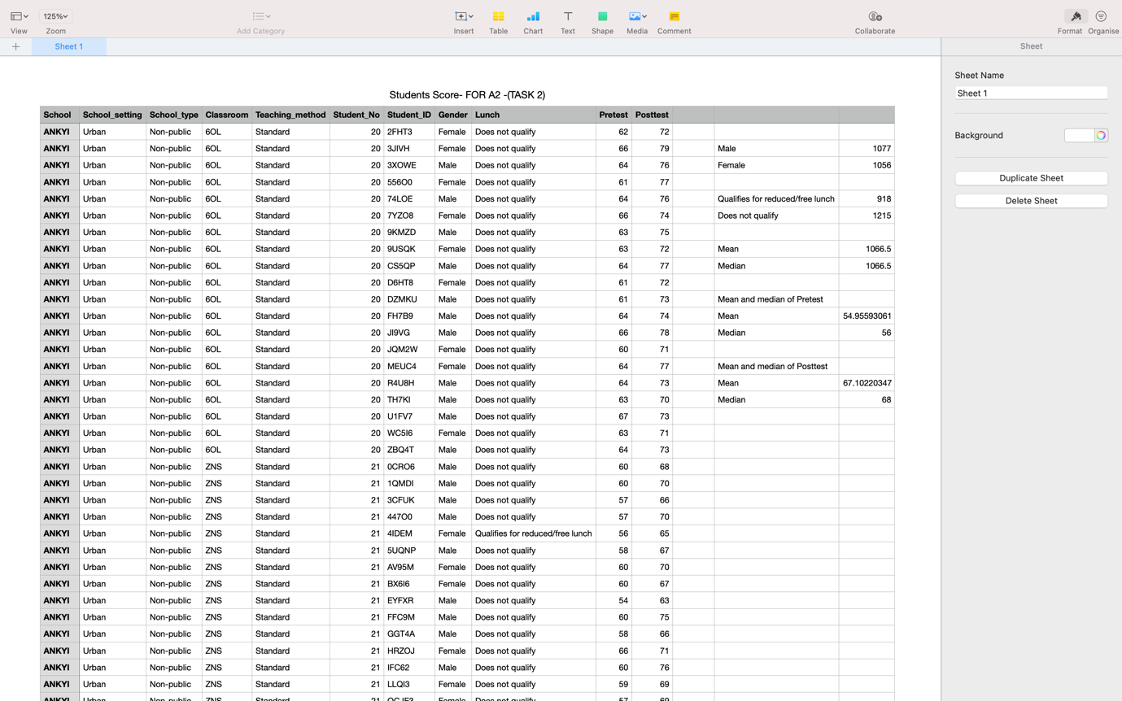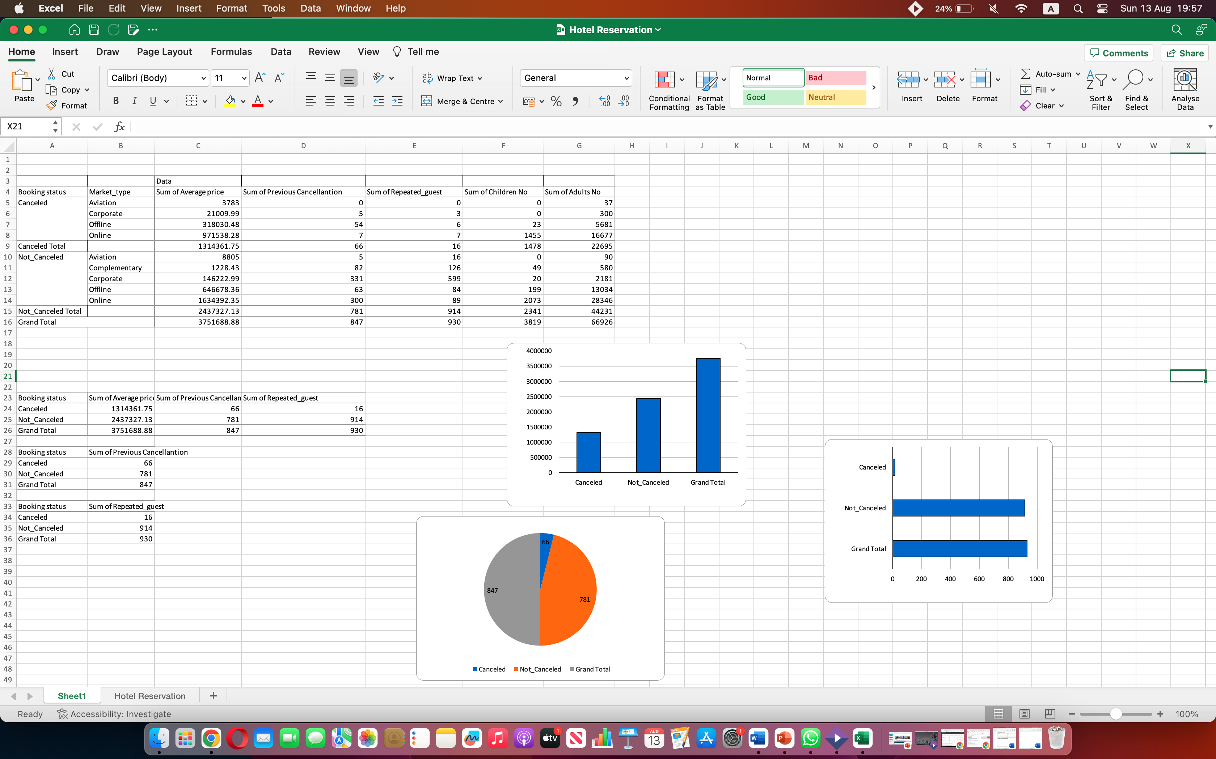

References
Carracedo, P., Puertas, R. and Marti, L., 2021. Research lines on the impact of the COVID-19 pandemic on business. A text mining analysis. Journal of Business Research, 132, pp.586-593.
Felvegi, E., Brown, N., Lave, B., Romey, J., Schatz, M., Shingledecker, D. and McCarn, R., 2021. 6.1 Creating PivotTables. Excel.
Grenci, R.T., 2022. Introducing business analytics in context: An Excel project to analyze product and sales data for inventory purchase decisions. Decision Sciences Journal of Innovative Education, 20(4), pp.190-200.
Jelen, B., 2016. Excel: shortening a Vlookup. Strategic Finance, 97(8), p.58.
Qudratova, G.S., 2022. Using Ms Excel Function to Solve Economic Problems. Indonesian Journal of Innovation Studies, 18.
Rahman, A. and Muktadir, M.G., 2021. SPSS: An imperative quantitative data analysis tool for social science research. International Journal of Research and Innovation in Social Science, 5(10), pp.300-302.
Saura, J.R. and Bennett, D.R., 2019. A three-stage method for data text mining: Using UGC in business intelligence analysis. Symmetry, 11(4), p.519.
Viglia, G., Zaefarian, G. and Ulqinaku, A., 2021. How to design good experiments in marketing: Types, examples, and methods. Industrial Marketing Management, 98, pp.193-206.
Yuan, C. and Yang, H., 2019. Research on K-value selection method of K-means clustering algorithm. J, 2(2), pp.226-235.

