MARKETIGN ESSENTIALS
MODULE CODE: M4X01916
STUDENT: RAZVAN RADU JOITA
STUDENT CODE :1905612
LECTURER: DALE CLARKE


TABLE OF CONTENTS

- INTRODUCTION………………………………………………...P.3
- MARKETING WITHIN MIS…………………………………...P.3
- COMMUNICATION WITHIN MIS……………………………...P.4
- GATHERING INFORMATION…………………………………. P.5
- EFFECTIVENESS OF MIS………………………………………P.5
- CONCLUSION……………………………………………………P.6
- REFERENCES……………………………………………………P.6



Introduction Marketing Information System is the subject of the assignment. It must be represented as a toll for marketing and its effectiveness should be described as well through the paragraphs of the assignment. Next to the MIS, which is the base that will contour the assignment, aspects about it such as gathering, communication, marketing and a conclusion will be mentioned as well. Thinking at the definitions, after Kotler’s mentioning’s, it is a continuous organisation of people equipment and procedures to collect, process, analyse, evaluate and share pertinent, timely and exact information about the importance of marketing decision makers to improve their marketing structures, involving and control. This quote shows that the MIS has an important role in developing new decisions in light of the collected information.
Within the following titles the relevance of a chosen hotel which is The Santorini Princess Hotel from Greece, within each subtitle. The chosen hotel is a luxury hotel which is a very popular one in relation to its facilities and its many options as well. MIS in the hotel is used overall to collect the information from the guests, partners, competitors and staff as well to be able to initiate new rules, services or just simply changes in the products or some adjustments in the facilities or prices.
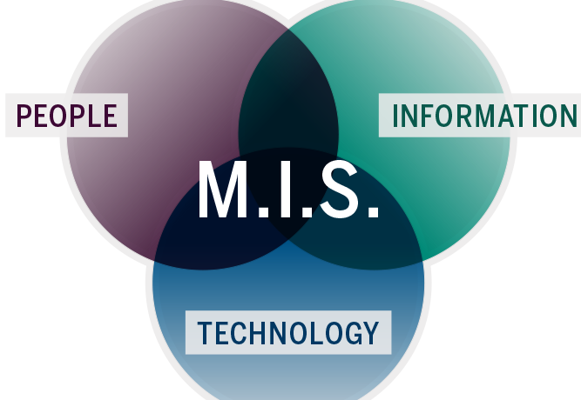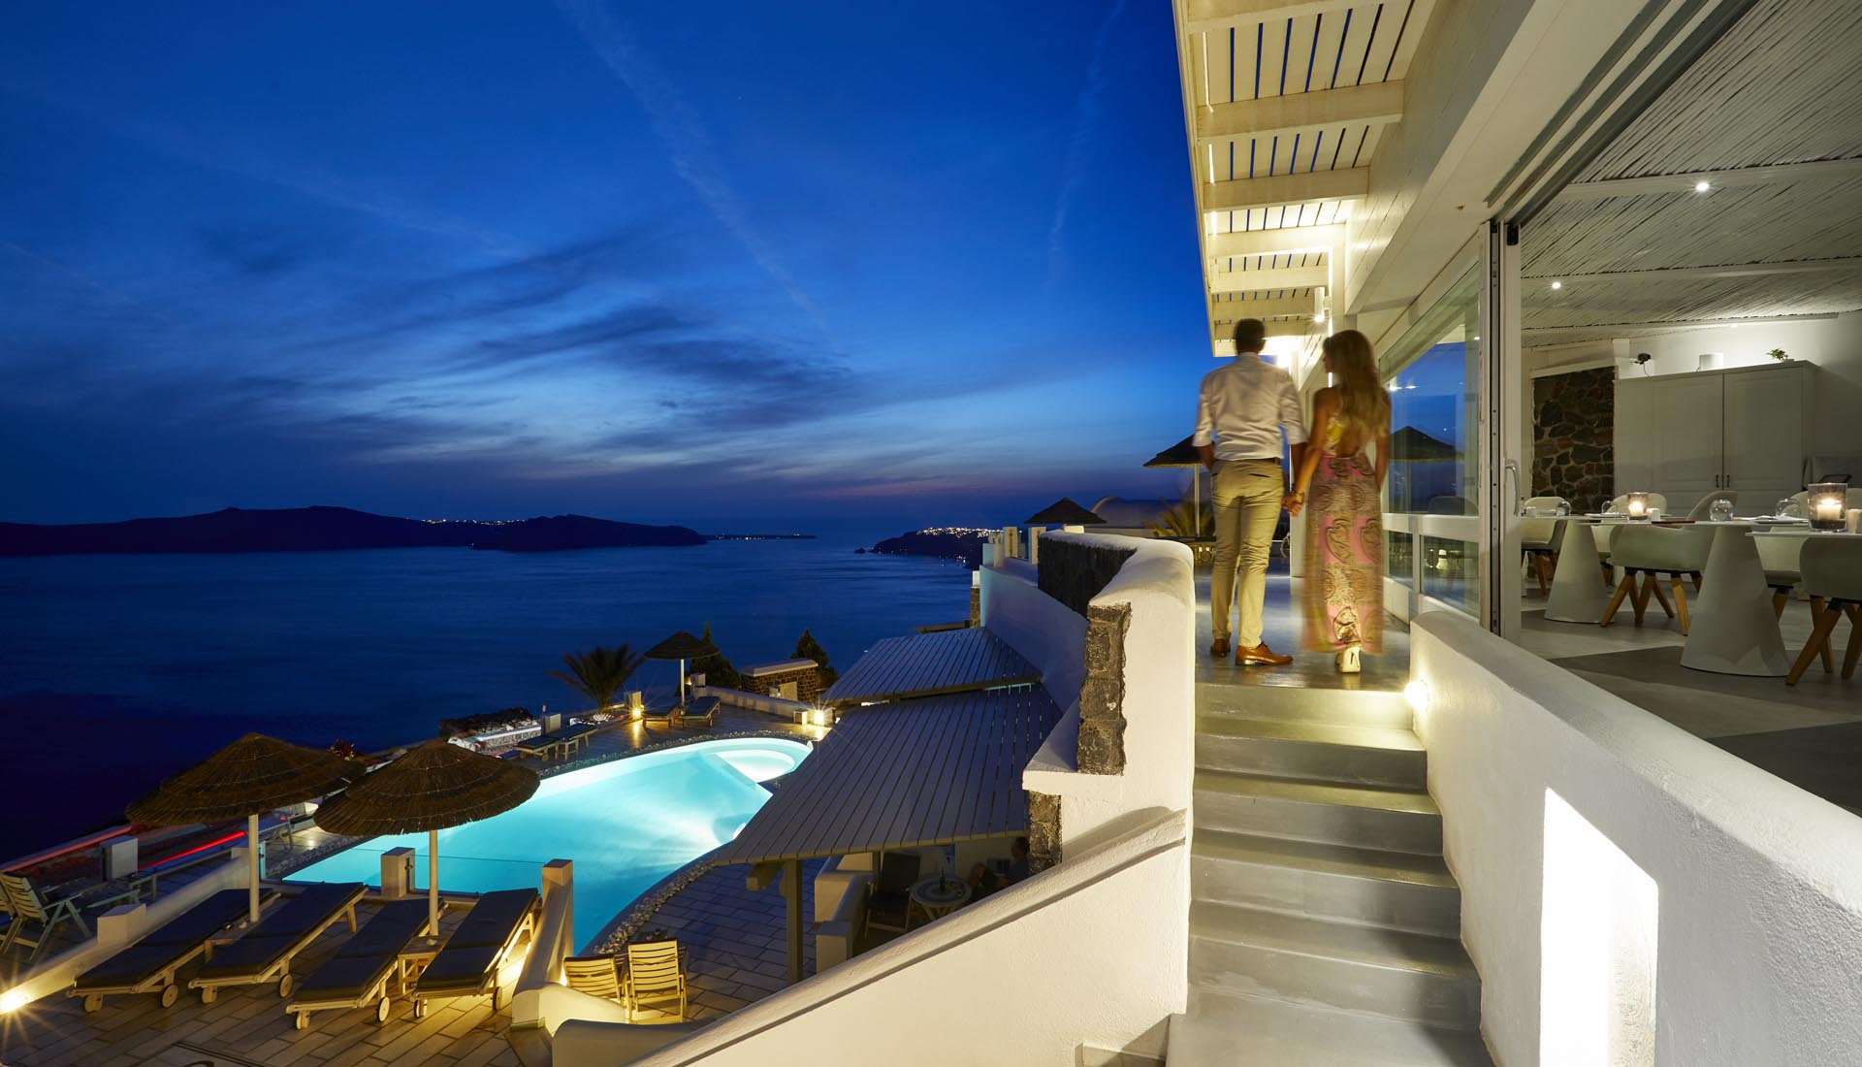
Marketing (within MIS)
As described in the Principles of Marketing (Philip Kotler),” Marketing is mostly based on dealing with customers and this because its goal is to bring the guest at the highest level of satisfaction”. Therefore, MIS is using its subsystems to can take the right decisions. Anyway, the decision making can be spread in three types; strategic, management control and operations control and they all have a common point, this being that they are all working in the company’s advantage, even if they have different roles still linked with the marketing. Also, marketing is not always good and this because sometimes, because of the excess of theoretic information collected, the managers could mostly focus more on the products and services rather that prioritising the guests and its thoughts. This issue is called the MARKETING MYOPIA, and this is a massive risk because if it occurs than the hotel could lose guests for a time, think that will affect the hotel’s economy and reputation as well.
In consideration of the Santorini Princess Hotel, the management of the hotel is very well-structured, and the appearance of MIS is very easy to identify because of the high number of services, facilities and products. The idea of structuring the hotel in a way that will make everyone thankful is in advantage of the hotel as well because automatically there are lots of people coming and paying to have all the wanted services as possible. Linking the situation to MIS, it is good to considerate the fact that everything that the hotel has now it because of the information they did collect from the outside. Looking at what the hotel offers, very easily can be identified the fact that the hotel is trying to listen each customer’s needs and that through the facilities and the location the hotel is increasing its economy and profit more than surely.
Communication within MIS
When it comes to communication such aspects cannot be missed because there are million aspects that must be communicated either with the partners, member of staff, guests or competitors. Knowing that the technology became many times better and modern it is very basic to transfer information from a person to another, to groups or to an entire department. As mentioned about the evolution of the software systems, “the internet allows the customers specially to communicate in a direct way to access the accommodation facilities, prices, availability. (Stockdale, 2007). Otherwise, the managers can access with ease the guest’s data as well and this will be automatically once they get signed onto the website or anywhere. The most important thing out of communication in a hotel is linked to the fact that it must be up to date to make sure that all the news is transferred to everybody that needs to be in touch. There are such internal systems that are running to share all the information. Anyway, considering that now we are in a very modern society, manager don’t even have to distribute the information personally to everyone that needs to know something as the specific piece of information can be updated on a website that can be accesses any time and from any location.
Keeping an eye on our hotel, remarkable is that they are using social media very much to communicate firstly with customers. Another thing which is easy to observe is that on their website they are having a live chat and contact options as well, thing that is a plus for them especially when a person has a burning question or interest for the hotel. Now, thinking about the internal communication, making a bit of research, it will be noticed the fact that they have an internal system through they can contact each department, mostly through email and through telephonic calls.

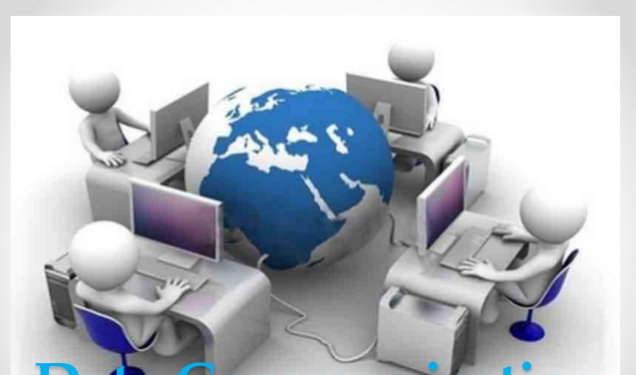

Gathering information
When it comes to collecting information that should be helping with the decision making in the hotel, it is to be mentioned that the collection is made by following few processes and these are “used interfaces, application software, databases and system support” (Robert Harmon 2003). After the mentioned aspects are followed there is the Marketing Decision Support System which is supporting in analysing the collected data to make sure that the decisions that are going to be made are the ones that will help in running the business. Next to the supportive systems, we need to consider where the information and the data is mostly collected from and surely, there are specific resources that are supporting with this. Some of the resources that are “feeding” the MIS with information are the newspapers, government economic reports, computer systems, bibliographies and one of the most important ones, from the customer’s feedback. The subsystem that is collecting information everyday is the Marketing Intelligence system which is then followed by the Market Research which is then accumulating relevant information to a specific marketing issue that must be dealt by the environment.
The Santorini Princess Hotel is one of the best hotels when it comes about gathering information and this because it has loads of resources to use. Things such as mass media, newspapers, questionnaires and feedback sections are just some of the very many sources that are keeping the necessary information safe and then it is giving it out to be generated and brought to decisions and new rules. It is clear that they are inspiring from the information because the people in charge of the hotel are using their experience to rise the standards of the hotel as high as possible and then they are making sure that the taken decisions are the best ones to satisfy the customer and to maintain or even increase the hotel’s place. To make sure that the taken decision is good, they are giving some time to it to check the impact of it. Aspects such as the customer’s reaction to the change and the number of requests for the product must be followed.
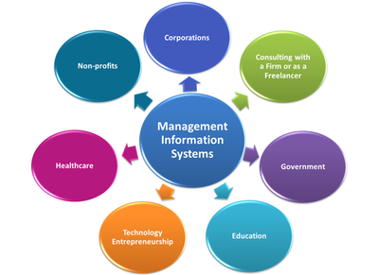

Effectiveness of MIS
MIS as a tool for marketing is very effective, no doubt about it because it is using is strategies and its subsystems to make sure that the hotel’s place is in the most advantageous way. Referring for a bit to the historical side of MIS, it did evaluate a lot more than expected over the years as before the information and the decision used to be taken through written hypothesis where now is automatically collected and generated by the new technology and modern life. Therefore, it is effective because when the information is collected the person in charge of it has a easier job to do. Anyway, the most important thing linked to its effectiveness is that the collected information and data is the one that is supporting in initiating new rules, services and products.
Conclusion
As a conclusion the perfect thing to say is that MIS has an important role while it is a tool for Marketing into the hospitality industry and therefore it is making such a great job, especially knowing the evolution of the technology and the way it has been used to introduce MIS to it as well. MIS and its subsystems were mentioned through the assignment very clearly and this is why it is very evident that MIS is playing a vital when running a hotel, especially a very popular one.
As a conclusion when it comes to the hotel, we can say that MIS maintains a continuous wealth of the hotel regarding to the multiple decisions that are taken everyday in the hotel’s advantage.


References
Robert R. Harmon. (2003). Marketing Information Systems. Encyclopaedia of Information Systems, Vol. 3. Elsevier Science (USA), 137-151
http://www.fao.org/3/w3241e/w3241e0a.htm
R. Stockdale Managing customer relationships in the self-service environment of e-tourism
Journal of Vacation Marketing, 13 (3) (2007), pp. 205-219,

Principles of Marketing- Global Edition, Philip Kotler, Gary Armstrong- Pearson 2014

