Calah Riley-Lamb
2121869
BMSW4004
Professional Career Development
Charles Nimoh

Context page
- Title page
- Context page
- Introduction/Start of report
- Main body of report
- Reference

Case study report
What are the five social impacts of mental illness on people who suffer from the condition? To what extent do you agree or disagree?
Introduction
We will be going over how mental health within the workplace can affect service providers. Will we be talking about five social impacts that a mental illness can have on someone who suffers with a mental health condition. I agree with the points that have been made within this report, the reasons why will be explained in more dept within this report. While there will be reasons as to why I could disagree with some points made by employers in relation to their employees. I will have points on both sides as it creates more of a stronger argument. Throughout learning about problem solving and decision-making part of working with mental health problems is every single day decision making.
Main body of report
Mental health can affect anyone weather you within the younger generation, middle class or the older generation. This can affect your day-to-day life by the littlest and most simple activities can make it feel like you have the world on your shoulders felling heavy all day every day. This can make simple day to day activities to what may seem to be the case within yourself vertically impossible. With the feelings starting out as a depression system might then turn into an increasing mental health problem for example anxiety. Some of the other mental health illnesses can be caused from trauma and does not always stay the same this can vary from going to having good mental health days to mental health days that are set out to be worse in some cases being suicidal.
One of the five social impacts could be feeling distressed, down, or frightened. I agree with this because a mental illness does not always show physically and in this day & age it has become the normal to hide this away, but mental health is getting spoken about more but unfortunately its still nit enough. A mental illness can show in your work as you might become sloppier, not taking care of your appearance as much as before or simply just not talking to anyone as you do not have the energy to do this.
The second one is relationship breakdowns due to your mental illness. It could affect your family relationships, friends, your love life, or sex life. Getting help for this might include going to counselling and working through these problems to have gained a better mindset for yourself to be able to deal with these problems now and ongoing throughout the rest of life. This can also cause you to have relationship breakdowns with your child/children which would then take a lot of work getting back to a good place in your relationship with your child/children.
The third one would be having an eating disorder as a mental illness will also affect your social life as you might feel uncomfortable going to family meals or out with your friends to eat. It could affect the lunch breaks with work collages.
The fourth one would be this may have not officially arisen by a doctor for years, so you might have seemed ‘difficult’ to deal with during your school years and never really understood why. Your education in the past has been affected by your mental illness. This would have an effect of your outcome of gcse’s or college work or university work. In which would then be added pressure to your brain and body causing your illness to increase because of your body and brain not knowing how to deal with this newly added pressure.
The finally social impact it could have been your home life, you might become less motivated to clean your house. Sometimes you might turn to drinking as this will become a conditioned response to your brain telling you that this natural reaction of feeling depressed or your anxiety or ptsd (post-traumatic stress disorder) or eating disorder.
Its scope and impact
The problem is worldwide with mental health affecting individuals especially during covid-19. People had to learn a whole new world while learning how to work from home with a massive lack of support from the government within the mental health area. The lack of support could have been better in areas to help employers deal supporting their employee’s, having a free course of training provided. This is and has been a long-term problem, a problem can be defined as a circumstance where there is a gap in the situation that you be believe should not be there. The decision making is the act of choosing between what should happen. Problem solving is the process of taking action to fix the problem the decision-making part of the output is made when you are facing the problem and deciding what to do to be able to fix the problem. This is one of the prime skills that will be used in business & lifelong term. Mental health can have a massive budgetary impact on your household or yourself, this is because your mental health can affect your day to day living, you might not be able to complete daily tasks that you would normally be able to do this may include going to work as it might be to much for you to handle. Not only your mental state affects your financial, but it can affect you wanting to socialize with your friends, family, partner etc. Especially having a mental health problem that you don’t yet know how to deal with, not being able to talk to anyone about it because you simply don’t know how to. It could be that you think the problems in your head isn’t real and don’t realise yet that it could be mental have related can be difficult, this can feel very lonely. You are not alone in this.
Analysis of the organisation and problem
To analyse the organisation of the problem, the problem within supporting your co workers or dealing with mental health within the workplace started from a while back even though mental health is talked about more in this modern day and age it is not enough! Mental health is not talked about enough, the percentage of men’s suicide is higher than women as because they are men they must be seen as the ‘big man’, staying strong or they would be considered as weak or have individuals look down on them. Women’s mental health is more spoken about than men’s although nhs services have waiting lists that you may be on for up to 12 months sometimes longer.
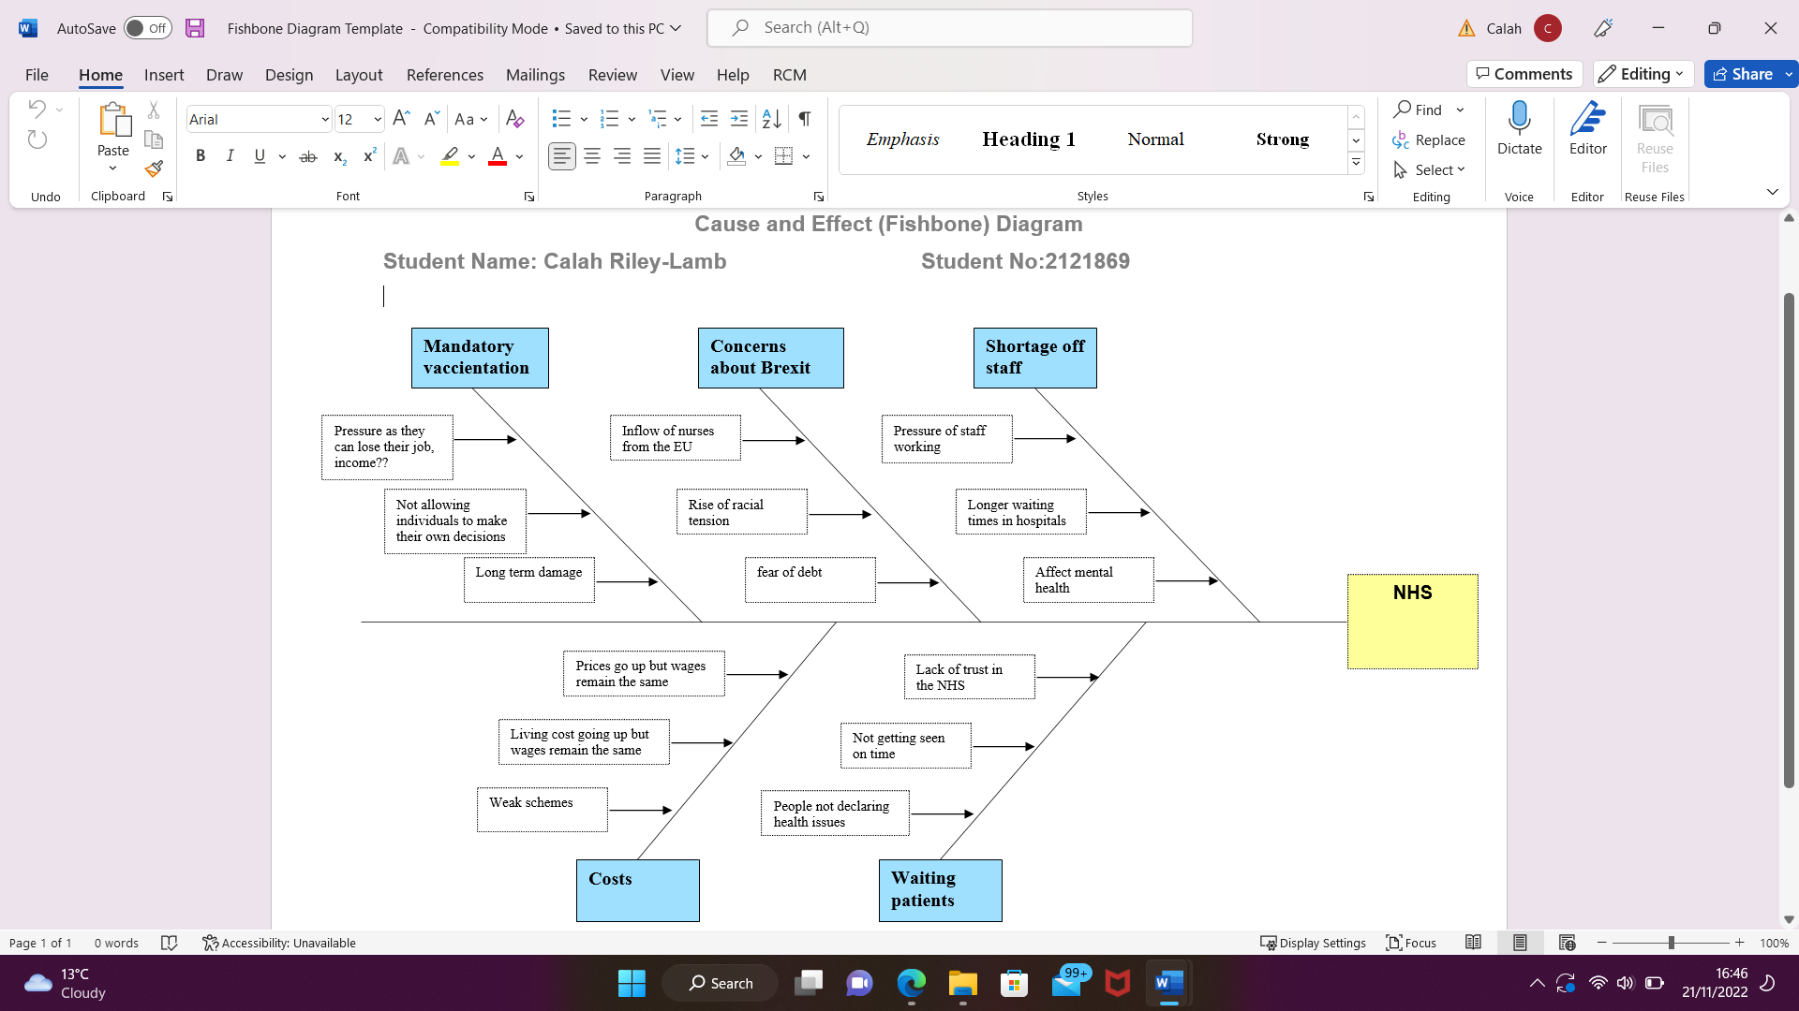

Propose alternative solutions
- Increasing the emotional support within the workplace beyond just seeing your employees there do work, have an open-door policy about speaking openly about their mental health.
- Employees supporting each other not talking behind others backs to not lower one another self-esteem and not knocking confidence.
- Have a secret deposit box for workers to leave comments to the manager if they do not feel comfortable enough talking about it out loud but still able to receive the support they need.
- NHS services having a wider free range of mental health support other than ones that are currently running to lower the amount of waiting lists times
- Care home staff to have higher pay
- More funding being put into mental health services so service users can receive the correct help they need.
- Mental health training within workplaces
Plan for Implementing Solution, Monitoring and Review Process/System:
Being able to monitor the system and solutions to mental health within the workplace would be a difficult job for anyone and that is completely understandable. To be able to sit down and have a plan in order to put certain measurement in place for workplaces wanting more support to be able to deal with mental health. The consequences to this are people committing suicide not being able to deal to want to deal with it no more and wanting all the noise in their head and pain to stop. Suicide is never the answer. This would be a high-risk factor and there is always the question how will people or loved one react? This may cause loved ones to be deeply affected by the horrible action this person has chosen to take the effecting their mental health. Many unknown factors are always just the case of simply not knowing. Being able to have a service within the workplace that not only offers mental health support but has 24/7 availability would be a great thing to consider.

Conclusion
Throughout this report we have learnt the impact mental health can have in the workplace. We have learnt through the working with mental health conditions within the workplace that there is a massive lack of support. We have found different things wrong with what people refer to as ‘the system’ and its corrupt ways of dealing with mental health patients, to the long waiting listing, being able to not have trust within the NHS or mental health services that turn service users away due to a few reasons. We have proposed ways that could be solutions to this problem but in my opinion, I don’t think it would ever be the standard that the world needs. This is a worldwide problem people all over the world suffer with many different mental health issues, many that is not fully diagnosed due the long process of either being turned away or having to wait for years for their diagnosis to be medically issued to receive the correct help.

