Assignment – Integrating Project

Student Name: Magdy Bkheet
Student Number: 2007446
Module: Integrating Project
Lecturer: David Williams- Sue Maw

Table of contents

- Introduction …………………………………………………………………………………………………………1

- Conduct research into the tools and techniques used to solve the challenge of the problem………………………………………………………………………………………………………………2.

- Creating website and designed application………………………………………………………….3

- Date Base…………………………………………………………………………………………….......4

- Beyond Mobile and Web……………………………………………………………………………………….5

6 -Microsoft Project ………………………………………………………………………………………………………………6

- Conclusion…………………………………………………………………………………………………………………….7

- References…………………………………………………………………………………………………………8

- Introduction

The integration project is processes and activities required to ensure that the various project activities are properly coordinated by identifying and defining, compiling and coordinating the various project operations and activities (Investisdigital, 2021). However, we designed and developed a prototype system for the active travel application of our choice which as Cardio with friends that it allows friend to meet very easy and simply, CWF are broken down or including three sections which are Design Builder, Date Baes and Beyond mobile and WEB.
it is encountered many problems when designed the application, which are Time, Location, transport and what three words (WTW). However, some are more complex and more difficult than others. In both cases, it must possess special skills to ensure that reach the right solutions at the right time. This is known as Problem Solving Skills, so what are these skills and how can you develop them. Problem-solving skills, as their name indicates, express the ability to find effective solutions to the various problems that we face in application, and in a timely manner that ensures that losses are avoided or minimized as much as possible.

- Conduct research into the tools and techniques used to solve the challenge of the problem.
What is meant by problem solving skills?
Problem-solving skills, as their name indicates, express the ability to find effective solutions to the various problems that we face in WEB, and in a timely manner that ensures that losses are avoided or minimized as much as possible. This includes several major steps that must be followed (Indeed, 2012). However, the problem-solving process includes the following steps:
Define and define the problem.

Find alternative solutions.

Evaluate and choose appropriate solutions to solve the problem.

The Tools we used to solve the challenge of this problem in the Cardio with friends which are:

- Windows 10
- Google Chrome
- Choosing the platform
- Selected the Template.
- Analysed and improve.

- Creating website and designed application.

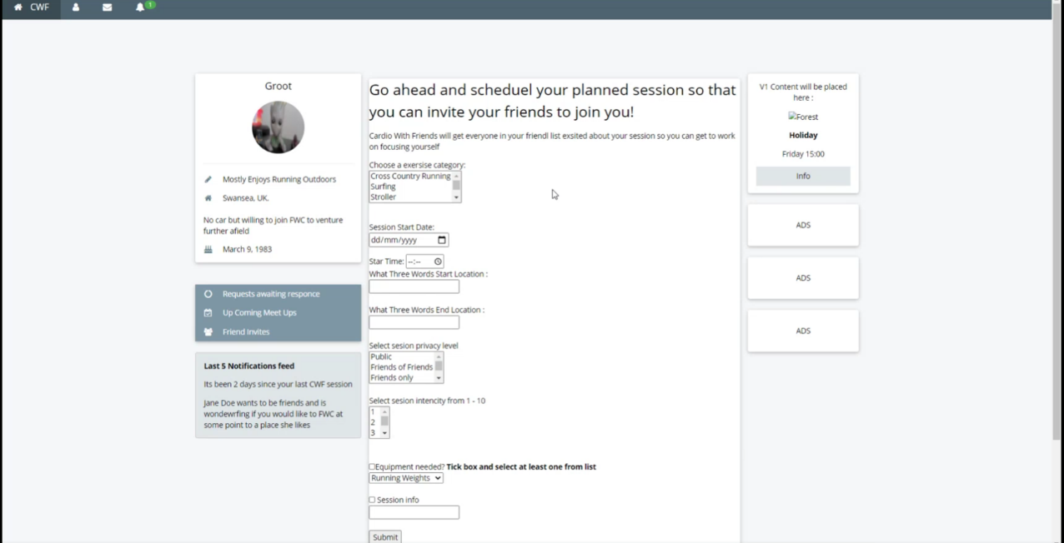

In this regard we suggest new ides to create the website in order to solve the problems. However, the website is a reserved electronic space on the Internet through which you can upload and display all the services or products that you provide to our target audience, through which any plans are supported evidence and facts. The ideas and plan of the website is the electronic space that is designated for Cardio with friends to store and display information about us and to provide our services (Wix, 2012).
Also, on the website we used App which is what three words to help identify the location for cardio with friends. One of the most problems that most people suffer from is identifying addresses correctly, as many rely on oral description or sending the location via maps, but unfortunately, it is highly inaccurate, and causes many errors due to the inability to determine the exact location.
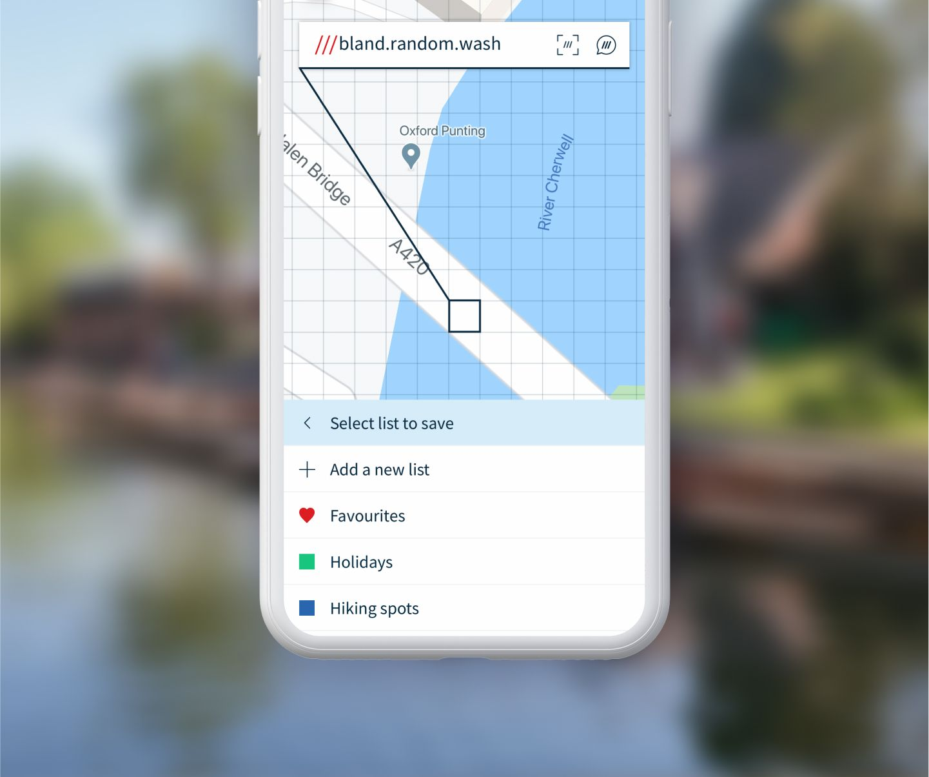
The matter is not limited to individuals only, but also to companies, such as shipping companies, who struggle a lot in determining the addresses of customers to deliver shipments to them, but what3words application contributes greatly to solving this problem in Cardio with friends (What3words, 2021).

- Date Base

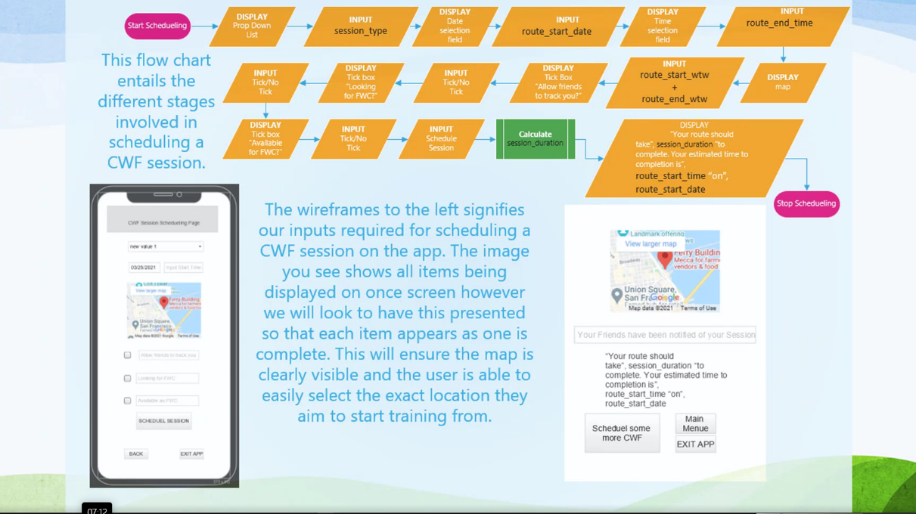

However, we used a Database to collect the information and organized it in a way that allows it to be accessed, modified, and easily managed. Databases are used by Cardio with friends to store, retrieve, and manage information with the development of databases.
A new way was invented to facilitate database management CWF, through special software called Database Management Systems (DBMS) (Caspio, 2021).
In his regard we suggest, database for program and login a session after calculate sub process and calculate the session duration and the session schedule for the users and in this case, it will show to CWF when it submits and will tell them how many hours need to do the session. Also, the database includes what3words tell when, where and how to start and end the session.

- Beyond Mobile and Web.
This app for those who want to lose weight, build muscle, or keep fit from home as it offers a wide range of exercises that help with that. This app gives you over 700 exercise videos with simple equipment and supports all fitness levels.
it can also design your own exercises through the user interface that depends on drag and drop, and the exercises in the application are distinctive as they were designed by the most famous fitness trainers in the world, and you can choose between different exercise methods such as 7-minute exercise, cardio exercises to burn fat or focused exercises on weightlifting and much more (Linked in, 2021).
Technogym app offers you a lot of features to help you follow a healthier and more active diet and is slightly different from other apps.
This application allows you to measure and analyse the intensity of your activities through the indicator, an innovative indicator that allows you to know how active you are at every moment of your daily life, and this includes every individual activity you do such as running outdoors, cycling with friends or doing some exercise (Garnacho-Castaño, Manuel V ; Faundez-Zanuy, Marcos ; Serra-Payá, Noemí ; Maté-Muñoz, José L ; López-Xarbau, Josep ; Vila-Blanch, Moisés, 2021).
Through the exercise section, the application will suggest you a specific exercise every day for you, and if you want to change, you can simply click on “Choose an exercise” and discover all the exercises organized according to the needs and levels. You can also monitor all the activities that you do and the results you have reached through the section Results. however, this app integrates with the Apple Health app and other apps and devices including Fitbit, Garmin, Run keeper, Strava and Withing’s. In additional also this App it can count steps distance, colorise heart rate puke, sleep and some even go beyond this to calculate other metrices.

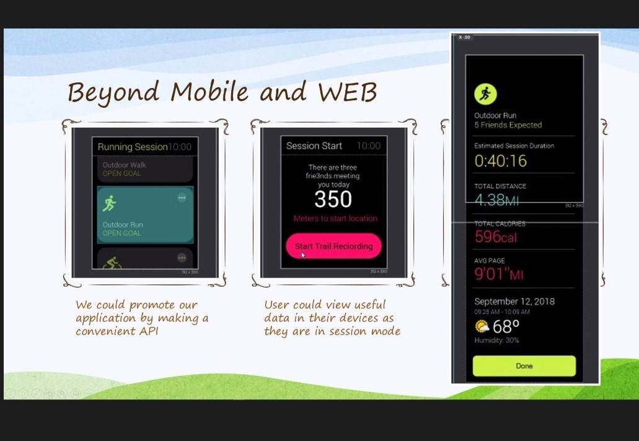

This would mean that convenience would be brought to the user. However, they would no longer have to get the mobiles out of their pouch when out exercising when they wanted to check their stats. The wearable tech would display all the session related data it holds in a confidently accessible location such as on the wrist for smart watches and on face for smart glasses.
Some examples of the information which would be made available could be distance to session start location with even an arrow to guide direction. Along the product development roadmap, we would even look to allow the user to hold session relevant data such as route taken (Contentful, 2021). this would make a great addition down the line when the user would want to maybe create a race for their mates, so they use their previous route and have directions displayed on the wearable tech giving them the ability to split up and go at their own pace as a form of race.

- Microsoft Project
After installing the program, it can open it and then you will find some menus at the top that are very similar to Word, where through the File menu you can add a project, create a new project, or save the current project. Also, through the same menu, by clicking on the info option, which displays the project information, where you can add a name for the project and other information about the project if you want.
It will also find other information such as the start date of the project and the end date of the project, and there are some other data that you can add to the project (ProWorkflow, 2021).
At the top there is a list containing some of the fields that you use during your work for the project, the box next to the file field, which is the task field, through this list you will start creating the project.
Also, will enter the name of the task that you will do in the task name box, after entering the tasks, can list some tasks under one task, that is, the main task contains sub-tasks that are under it, by selecting these sub-tasks and then clicking on the green arrow at the top located on the right.
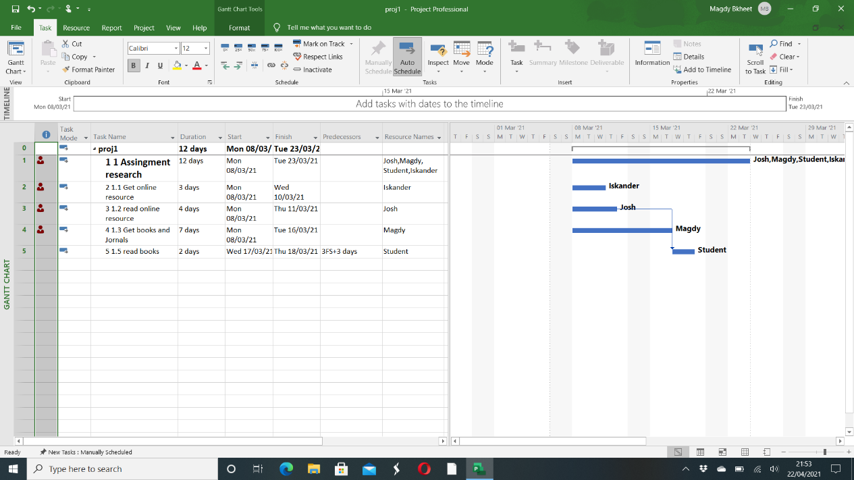

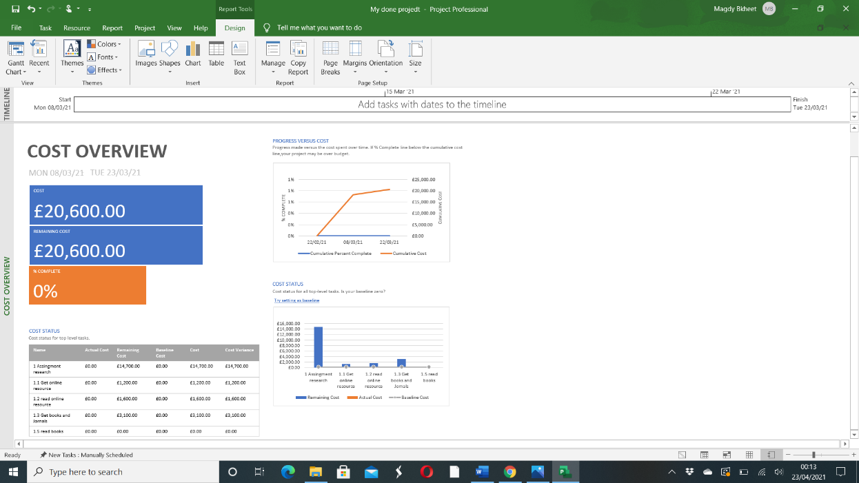

This assignment research mads it as group including. Myself Magdy, Josh and Iskander.
- Open project file in project desktop right clicks, then named my filed and chose custom filed.
- Select task of the filed to be available in resource filed views.
- Select the type of filed and customize form the type of list.
The first step made label in my timeline used new bar label button in the format ribbon of the timeline it names each timeline individually. Also included adjust the timescale labels and the click on the start and finish date on my timeline and then clicked date range in the format ribbon. however, used timeline dares dialogue, establish custom dates for my timeline. Also added additional timeline into my project schedule used the add timeline bar button in the format ribbon of the timeline.
It customizes the various text filed within a timeline and the clicked on the task style button in the format ribbon in the timeline, then change the font, colour and the size of various object of the timeline. Its view the progress of task with my timeline.

- Conclusion
It is concluded that this report as integration project is processes and activities required to ensure that the various project activities are properly coordinated by identifying and defining, compiling and coordinating the various project operations application and activities.

References
Caspio, 2021. Best Online Database Builder, All-in-One Solution. [Online]
Available at: https://go.caspio.com/build-online-databases-without-coding-082020-eu?utm_source=adwords&utm_medium=ppc&utm_term=best+database&utm_campaign=Commonwealth+-+Search&gclid=Cj0KCQjwse-DBhC7ARIsAI8YcWLeDOJjAjMDr5xLxP_tqZ0SCq8XOY7AReLNJO_U0hg_-c52EFiq-w0aAnkbEAL
[Accessed 19 April 2021].
Contentful, 2021. Building blocks for your digital experience platform. [Online]
Available at: https://www.contentful.com/app-framework/?utm_source=google&utm_medium=search-paid&utm_campaign=&utm_content=&gclid=Cj0KCQjwvYSEBhDjARIsAJMn0lgPRSTjGtD_a4VyrxFQFwZvSIuuKTxWYWa7Ff2_tY3HuynFnrnkcmwaAu_jEALw_wcB
[Accessed 20121 April 2021].
Garnacho-Castaño, Manuel V ; Faundez-Zanuy, Marcos ; Serra-Payá, Noemí ; Maté-Muñoz, José L ; López-Xarbau, Josep ; Vila-Blanch, Moisés, 2021. Reliability and Validity of the Polar V800 Sports Watch for Estimating Vertical Jump Height. Journal of sports science & medicine, Vol.20 (1)( 1303-2968), pp. p.149-157.
Indeed, 2012. Problem-Solving Skills: Definitions and Examples. [Online]
Available at: https://uk.indeed.com/career-advice/career-development/problem-solving-skills
[Accessed 17 April 2021].
Investisdigital, 2021. WEB DESIGN AND DEVELOPMENT. [Online]
Available at: https://www.investisdigital.com/blog/web-design-and-development/steps-for-a-successful-integration-project
[Accessed 17 April 202].
Linked in, 2021. Beyond Mobile. [Online]
Available at: https://www.linkedin.com/company/beyond-mobile-business
[Accessed 22 April 2021].
ProWorkflow, 2021. Unite your Team, Remote collaboration made easy. [Online]
Available at: https://www.proworkflow.com/?utm_medium=cpc&utm_source=google&utm_campaign=brand-usa&utm_term=project%20management%20software&gclid=Cj0KCQjwvYSEBhDjARIsAJMn0ljt9GDCtvqykP-pLuc6F0_Xq-mlNPTsZvZov7utlJivnWcpV0aVox8aArD0EALw_wcB
[Accessed 23 April 2021].
What3words, 2021. How to use the what3words app. [Online]
Available at: https://what3words.com/how-to-use-the-what3words-app/
[Accessed 18 April 2021].
Wix, 2012. The Leader in Website Creation. [Online]
Available at: https://www.wix.com/html5uk/hiker-create?utm_source=google&utm_medium=cpc&utm_campaign=398247495^28263881415&experiment_id=create%20your%20own%20website%20app^e^396095817788^&cq_src=google_ads&cq_cmp=398247495&cq_con=28263881415&cq_term=create%20your%20ow
[Accessed 18 April 2021].

