North or south, East or west. When you’re cruising, any way is best

What is cruise tourism?
“Cruise tourism is a luxurious form of travelling, often involving an all-inclusive holiday on a cruise ship that lasts at least 48 hours, following a specific itinerary, in which the ship is calling a number of ports or cities” (Research Centre for Coastal Tourism, 2012)

I. ‘You like big ships and you cannot lie’

Florida-Caribbean Cruise Association (2016) reported that a record-breaking 24.7 million passengers cruised globally in 2016.
The cruise industry is currently the fastest-growing industry in the tourism industry. The number of cruise ship passengers have increased from 17.8 million in 2009 to an estimate of 25.8 million in 2018. (FCCA, 2016) Goertz (2018) debated that the main thing attracting people on a cruise ship rather than booking a flight and go to a destination on their own is the food, entertainment and one-stop-shopping. Goertz (2018) stated that most cruise lines run several full-scale production shows, have live bands and other entertainment for kids. Recently, the major cruise lines have added features such as Ice Skating Rinks, Zip Lining and a Surfing simulator to their ships.


The Ice Skating Rink on board Mariner of the Seas, 17/12/17. Photo: Caoimhe McNulty
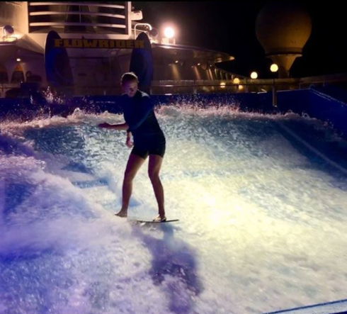
Surf Simulator / Flowrider
Photo: Rebecca Staff, Cruise Ship Crew Member (2018)
Cruise Lines International Association’s (2017) report showed that there was 7,196 Asian cruise calls in 2017, which is seen as an increase of 29% from 2016’s 5,574 calls. CLIA (2017) reported that between 2012 and 2016, the total passenger number increased from 775,000 to 3.1 million passengers. It can be argued that China is the main driver of passenger growth in Asia as they accounted for two-thirds of the passenger number in 2016. (CLIA, 2017). As of 2017, 35 cruise lines are active in Asian waters, deploying a total of 66 ships. CLIA’s report (2017) stated that this is a major growth compared to their 2015 report where it was reported that 26 cruise lines were positioned in the region with 52 ships deployed. In 2015 there was one mega ship*, whereas in 2017 this increased to 5 mega ships. (CLIA, 2015; CLIA, 2017)
*Mega ships can hold more than 3,500 passengers.
Sailings through Asia had a solid growth with an increase of 142% from 861 cruises and voyages to over 2,000 in 2017, according to CLIA (2017).
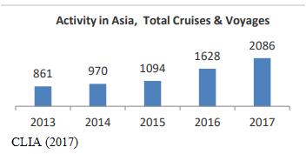
Macmillan (2016) said there is a “wealth of exciting destinations” to discover in the Asian region, and this include Malaysia. It can be argued that the reasons for the increased number of passengers cruising around Southeast Asia is because this is the ideal way to visit several countries in one package, and if the passengers are looking for cultural experiences, good food, urbane cities, laid-back beaches, unspoiled dive sites or just a relaxed vacation in the sun, they will find it all on an Asian cruise.
Whilst the cruise tourism in Malaysia, and the rest of Asia, is facing a major cruise-boost, the Caribbean is suffering from a decline in many of their most famous port of calls. Caribbean Tourism Organization (2016) reported that there was recorded declines ranging between -1.9 per cent in the US Virgin Islands and -22.6 per cent in Saint Lucia. CTO (2016) also reported major declines in Puerto Rico with -11.3 per cent and St.Maarten with -17.7 per cent.
It can be debated that the destination itself is of less appealing nature to the more adventure-seeking Gen Y/Millennials. Wagner (2018) said that people may have the impression that the Caribbean region was distressed due to series of hurricanes that occurs in this region. Wooldridge (2017) reported that twelve cruise ship passengers on an excursion in Mexico’s Yucutan region died after their tour bus flipped on a two-lane highway. Wooldridge (2017) and Royal Caribbean Cruises ltd (2017) reported that there was a total of 27 passengers on this tour bus, and they were traveling to the Mayan Ruins on a on board booked shore excursion through Celebrity Equinox and Serenade of the Seas, both owned by Royal Caribbean Cruises ltd. It has also been recently reported by Walker (2018) that several cruise lines warn their guests about taking ferry excursions between Cozumel and Playa del Carmen in Mexico due to narco-terrorism and bombs. 12 days ago, there was reported an explosion on board a ferry in Carmen del Playa and a planted explosive device of another ferry on February 1st. Walker (2018) stated that Princess Cruises have cancelled all their ferry excursions in the area, and Royal Caribbean, through their press release, reported that they have also cancelled all shore excursions requiring a ferry in the same area. (Royal Caribbean, 2018). Due to above said issues, the overall decline in passenger numbers going to the Caribbean can arguably be caused by safety and security on shore and natural disasters. On the contrary, in Malaysia these types of incidents are of the rare type and the area are seen to be safer to visit than the Caribbean, yet Southeast Asia has been marked as a “red-light” area due to maritime crime and piracy (Beeson, 2016).

II. Not all who wander are lost

29 per cent of all cruisers are under the age of 40, whilst 52 per cent are aged between 40 and 59 and only 20 per cent is aged over 60. It can therefore be argued that the myth of “only old people go cruising” have been punctured (Rances, 2016). Statista (2018) conducted a research to determine the main nationalities that regularly goes on a cruise vacation, and they reported that the United States accounted for 11.51 million passengers worldwide, with China at 2.1 million passengers and Germany with 2.02 million.
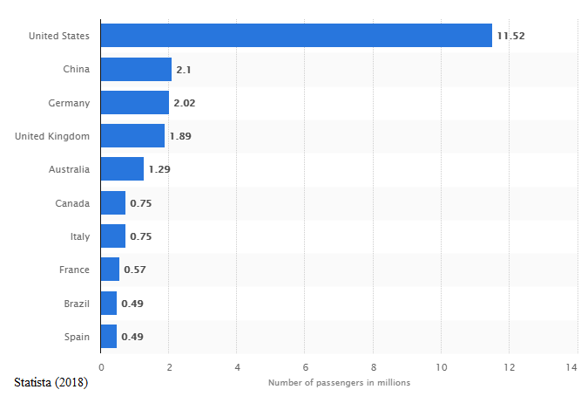
It can be debated that most Americans travel to the Caribbean instead of Malaysia as this is closer to their own backyard and more convenient, conversely, the Chinese market are more attracted to the Southeast Asian market due to its relative proximity of the main cruise hubs in Southeast Asia (Macmillan, 2016).
A cruise allows you to see many different asian destinations without the hassles of jetlag, negotiating through airports, train stations, transfers, and checking in and out of various hotels. – Adam Goldstein, managing director of royal caribbean international, celebrity cruises and azamara club cruises (Macmillan, 2016)

III. It is not the going out of port, but the coming in, that determines the success of a voyage

With the developing cruise market in Malaysia, the Malaysian Government has thrown its support behind new port developments, infrastructure improvements and cultivating coastal towns and cities to make them more attractive as a cruise destination (Ooi, 2015). The largest renovation to date in Malaysia will be the $40 million project they have named Melaka Gateway, which will include the new Malacca International Cruise Terminal to be finished by 2025, reported by Ooi (2015). Cruise lines are also ready to give Malaysia the attention it deserves as Royal Caribbean Cruises ltd has signed on as partner and consultant for the cruise terminal project (Royal Caribbean, 2014). Royal Caribbean C.P., Commercial and New Business Development, John Tereck, said in Royal Caribbean (2014) that the new cruise terminal can “grow and boost the cruise market for Melaka and the region in years to come.”
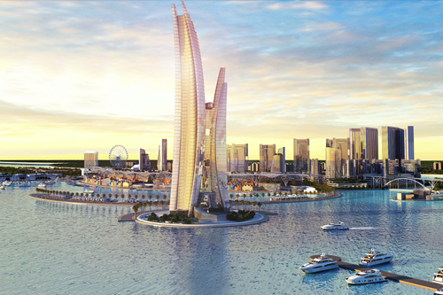
Melaka Gateway Project
Photo: Royal Caribbean Blog (2014)
Cruise Industry News reported in 2014 that the new Melaka Gateway will encompass Southeast Asia’s largest collection of islands whereas one is natural and two are man-made islands, however, it has not been confirmed whether any of these will be owned by any cruise lines. Similarly, Abu Dhabi launched Sir Bani Yas Island Cruise Beach in 2016, which was the first dedicated beach stop over (Khaleej Times, 2017). On the contrary, Abu Dhabi’s Sir Bani Yas Island Beach is privately owned by MSC Cruises (Goldfarb, 2016), whilst the islands in Melaka has not been confirmed to be owned by any cruise lines.
Malaysia and Abu Dhabi are not the only destination with these types of islands. The most famous ones are located in the Caribbean, and this region was arguably the first destination with privately owned cruise line islands. Royal Caribbean Cruises ltd owns two private islands in this region, which is exclusively for Royal Caribbean International and Celebrity Cruises passengers. Specifically Labadee in Haiti and CocoCay in the Bahamas (Royal Caribbean, 2017)
Newsdesk (2017) reported that cruise experts at CruiseCompete would rank privately owned islands as number one on a cruisers’ to-do list, and these are the reasons why;
- Unique opportunity for relaxation
- The chance to live like royalty
- Ramp up adrenaline
- The makings of an epic travel story
- Paradise on Earth.
It seems like destinations such as the Caribbean and Abu Dhabi has been successful in promoting cruises going to their private islands, so the question is; would any of the man-made islands in Malacca be privately owned by a cruise line in the future to boost the cruise industry in the region? It is a difficult question to answer without any evidence that this may or may not be the case, however, if Royal Caribbean Cruises ltd is a partner and consultant on this project there may debatably be a chance they wish to privately own one of the man-made islands, if not now maybe in the future.

IV. EXPERIENCE THE MAGIC ON BOARD

I. Language is wine upon the lips
The most common nationalities for cruising includes; United States, China, Germany, Italy, France and Spain. Due to the wide cultural differences on a cruise ship, it is vital to accommodate each nationality. Therefore, most of the information on board a cruise ship is in English, but also translated into other languages. It often depends on how many guests there are per nationality, and as there are a vast amount of Chinese passengers on a cruise through Southeast Asia, it is important to have all the information in Chinese as well. Information that would be in multiple languages include; restaurant menus, shore excursion brochures, daily compass and announcements over the PA system. It is also emphasized upon the languages spoken by tour guide on shore excursions, whereas in this region most of the tour guides will speak in Chinese, Japanese and Malay. Leslie and Russel (2006) emphasized on the importance of language in the industry, and the easier it is made for guests to access information and services and the more welcome they are made to fell, the more likely is their return.

II. Vacation calories don’t count
Macmillan (2016) stated that several cruise ships have been designed specifically for the Chinese market, with tweaks such as Cantonese and regional Chinese cuisine, however, it has been noted that the same restaurants are available in any region where the cruise ship is located. Royal Caribbean International added Jade Sushi to several of their ships, including the ones that is located in Asian waters, for example Mariner of the Seas. Yet, this buffet is also available on ships that are not cruising in this region, for example on Adventure of the Seas and Navigator of the Seas (Royal Caribbean, 2015). Brown (2018) stated that Jade is Mariner of the Seas’ Asian-influenced buffet area, representing Chinese, Indian and Japanese cuisine. Arguably, there may be some differences in what the chefs’ prepare in the complimentary buffets and specialty restaurants across the cruise lines that have ships deployed in Southeast Asia, however, some evidence that this is the case has not been found. There has been reported by Royal Caribbean (2018) that Mariner of the Seas will undergo a 32-day dry dock to improve facilities offered on board, and this included a Polynesian-themes bar with tiki-chic décor, Izumi Hibaci and Sushi restaurant.

V. EXCURSIONS – IT LEAVES YOU SPEECHLESS, THEN TURNS YOU INTO A STORYTELLER
Marine Insight (2015) defined Shore Excursions as “one does not have to make arrangements for sightseeing on one’s own. The cruise company takes care of all details”.
A ports’ tour and attraction base are the strengths that offers chances for cruise ship passengers to develop their travel experience and learn about the community’s history, culture and lifestyle. The city, history, lifestyle and climate all add to Malaysia’s mix when establishing itself as a desirable location for cruise passengers and subsequently cruise lines.
Shore Excursions all over the world would in theory focus on the same things; culture, food, history and shopping. There is however a few differences depending on where the ship is deployed and what those places has to offer. It can be argued that Shore Excursions in Malaysia would include more history and culture than the Caribbean where snorkeling and sea-based excursions are seen to be more popular (Menikefs, 2018). Gazelidis (2018) stated that the most popular excursions in Malaysia include;
- Batu Caves and the city experiences
- Craft and local discovery
- Temple tours and visits to historical sites
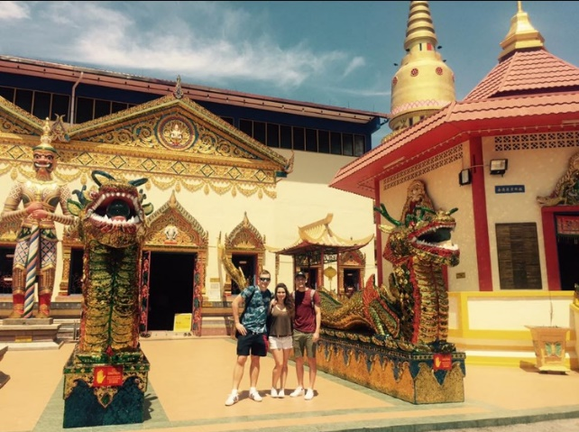
Crew Members of Mariner of the Seas at Reclining Buddha Wat Chaiyamangalaram in Penang, Malaysia
Photo: Christina Gazelidis (2018)
All of the above mentioned excursions include religion, culture and history, whilst the most popular Caribbean excursions may include;
- Dolphin and Whale watching safari’s
- Scuba diving and snorkeling
- Zip lining and other adventure excursions

Crew Member of Celebrity Eclipse in Willemstad, Curacao. Photo: Nok Karnsang (2018)

There are quite significant differences in what popular excursions include in the two different regions, however, the Caribbean is often seen as American’s second home, and it can be argued that they are escaping for a beach break rather than historic and religious adventures. Looking at the different excursions offered in the Middle East compared to Malaysia and the Caribbean, it is noted that they have encompassed a mix of the excursions mentioned above, but they have also emphasized on the fact that they have a landscape that is different to other places, for example excursions going to the dunes (Royal Caribbean, 2018).
What does connect them is that all these excursions bring new understanding to those who travel. They connect people together in a way that arguably would not be possible otherwise and they create friendship amongst fellow travelers, crew members and the locals.

references
Beeson, C., 2016. Is Piracy still a threat to ocean cruisers?. [Online]
Available at: http://www.yachtingmonthly.com/cruising-guides/piracy-still-threat-ocean-cruisers-52973
[Accessed 18.02.2018].
Brown, C. S., 2018. Mariner of the Seas dining. [Online]
Available at: https://www.cruisecritic.co.uk/reviews/review.cfm?ShipID=274&pgtype=dining
[Accessed 26.02.2018].
Bundhun, R., 2011. Gulf cruises under threat from pirates. [Online]
Available at: https://www.thenational.ae/business/travel-and-tourism/gulf-cruises-under-threat-from-pirates-1.430623
[Accessed 06.02.2018].
Butler, M., 2003. Worldwide Cruise Ship Activity. Madrid: World Tourism Organisation.
Chong, K., 2015. Cruise Tourism in Malaysia: A SWOT Analysis, Petaling Jaya: Centre for Tourism, Hospitality and Culinary University.
Clarke, J., 1999. Cruise lines just say no. [Online]
Available at: http://articles.baltimoresun.com/1999-07-25/travel/9907290375_1_smoking-carnival-cruise-line-passengers
[Accessed 06.02.2018].
Cruise Industry News, 2014. KAJ Development Breaks New Ground with Malacca Gateway. [Online]
Available at: https://www.cruiseindustrynews.com/cruise-news/10641-kaj-development-breaks-new-ground-with-malacca-gateway.html
[Accessed 27 02 2018].
Cruise Lines International Association, 2017. 2017 Asia Cruise Trends, Washington: CLIA.
Cruise Lines International Association, 2017. Cruise Travel Report: January 2017, s.l.: CLIA.
Dowling, R., 2014. Cruise Ship Tourism. India: CABI.
Dowling, R. & Weeden, C., 2017. Cruise Ship Tourism. 2nd ed. Wallingford: CABI.
Dowling, R. & Weeden, C., 2017. Cruise Ship Tourism. 2nd ed. Wallingford: CAB International.
Florida-Caribbean Cruise Association, 2016. Cruise Industry Overview - 2017, Florida: FCCA.
Frey, T., 2011. The Future of the Cruise Industry. [Online]
Available at: http://www.futuristspeaker.com/business-trends/the-future-of-the-cruise-industry/
[Accessed 18.02.2018].
Gazelidis, C., 2018. What are the most popular excursions in Malaysia? [Interview] (25 02 2018).
Gilbert, J., 2017. Royal Caribbean Cruises looks forward to cruise port development in Malaysia. [Online]
Available at: https://www.nst.com.my/business/2017/11/302656/royal-caribbean-cruises-looks-forward-cruise-port-development-malaysia
[Accessed 19.02.2018].
Goertz, J., 2018. Reasons Why People Choose To Cruise Travel. [Online]
Available at: http://www.traveldir.org/articles/misc/cruise/reasons_why_people_choose_to_cruise_travel.html
[Accessed 27.02.2018].
Goldfarb, A., 2016. MSC Cruises Launches Sir Bani Yas Island 'Beach Oasis' Destination For Its Winter 2016/2017 Cruise Itineraries. [Online]
Available at: https://www.prnewswire.com/news-releases/msc-cruises-launches-sir-bani-yas-island-beach-oasis-destination-for-its-winter-20162017-cruise-itineraries-300277472.html
[Accessed 19.02.2018].
Greenwood, A. B. & Barron, P., 2018. Issues determining the development of cruise itineraries: A focus on the luxury market , Queensland: School of Tourism and Leisure Management.
Hamdi, R., 2017. Southeast Asian Cruising Positioned to Reap Big Benefits from China and Australia. [Online]
Available at: https://skift.com/2017/02/14/southeast-asian-cruising-positioned-to-reap-big-benefits-from-china-and-australia/
[Accessed 18.01.2018].
Kalosh, A., 2018. Penang, RCL team on $35m terminal upgrade to host larger ships. [Online]
Available at: http://www.seatrade-cruise.com/news/news-headlines/penang-rcl-team-on-35m-terminal-upgrade-to-host-larger-ships.html
[Accessed 20.02.2018].
Khaleej Times, 2017. Record Cruise Season for Abu Dhabi. [Online]
Available at: https://www.khaleejtimes.com/business/economy/record-cruise-season-for-abu-dhabi
[Accessed 19.02.2018].
Leslie, D. & Russell, H., 2006. The importance of foreign language skills in the tourism sector: A comparative study of student perceptions in the UK and continental Europe. Tourism Management, 27(1), pp. 1397-1407.
Levin, M., 2018. What's New in Cruising. [Online]
Available at: http://www.neverstoptraveling.com/whats-new-in-cruising
[Accessed 19.02.2018].
Lipsey, S., 2015. The Caribbean's Most Dangerous Cruise Stops Will Surprise You. [Online]
Available at: https://www.yahoo.com/lifestyle/the-caribbeans-most-dangerous-cruise-stops-will-073043253.html
[Accessed 18.02.2018].
London, W., 2011. Economic Risk in the Cruise Sector, s.l.: Etudes Caribeennes.
Macmillan, S., 2016. Why now is the best time to cruise in Asia. [Online]
Available at: http://www.traveller.com.au/cruise-asia-gr9n2i
[Accessed 27.02.2018].
Marine Insight, 2017. New Study Reveals 9 Important Trends In Asia’s Growing Cruise Industry. [Online]
Available at: https://www.marineinsight.com/shipping-news/new-study-reveals-9-important-trends-in-asias-growing-cruise-industry/
[Accessed 17.02.2018].
McLean, J., 2018. Carry on Cruising in Asia. [Online]
Available at: http://www.smarttravelasia.com/cruises.htm
[Accessed 19.02.2018].
Menikefs, J., 2018. What are the most popular excursions in the Caribbean? [Interview] (25.02.2018).
Morgan, S., 2014. Cruise visitors set to boost Welsh economy. [Online]
Available at: https://www.walesonline.co.uk/news/wales-news/cruise-visitors-set-boost-welsh-6807971
[Accessed 06.02.2018].
Ooi, T., 2015. Malaysia: The cruise tourism playground of the east. [Online]
Available at: http://www.aseancruising.com/malaysia-the-cruise-tourism-playground-of-the-east/
[Accessed 17.02.2018].
Oxford Business Group, 2015. The Report: Abu Dhabi 2015. Abu Dhabi: Oxford Business Group.
Ptaszycka-Jackowska, D., 2012. Sea Cruises as a new branch of the tourism industry, Cracow: Jagellonian University.
Royal Caribbean Cruises ltd, 2018. Royal Caribbean cancels shore excursions requiring ferries in Mexico. [Online] Available at: http://www.royalcaribbeanblog.com/2018/03/02/royal-caribbean-cancels-shore-excursions-requiring-ferry-mexico [Accessed 04.03.18]
Royal Caribbean Cruises ltd, 2016. Royal Caribbean investing in new cruise terminal in Malaysia. [Online]
Available at: https://www.royalcaribbeanblog.com/2014/02/07/royal-caribbean-investing-new-cruise-terminal-malaysia
[Accessed 27.02.2018].
Royal Caribbean International, 2015. Sushi on Royal Caribbean: Everything you need to know. [Online]
Available at: https://www.royalcaribbeanblog.com/2015/09/04/sushi-royal-caribbean-everything-you-need-know
[Accessed 26.02.2018].
Royal Caribbean International, 2018. Shore Excursions - Dubai, United Arab Emirates. [Online]
Available at: http://www.royalcaribbean.com/findacruise/destinations/shoreExcursions/subGateWayByPort/search.do?LocationCode=DXB
[Accessed 26.02.2018].
Royal Caribbean, 2018. Royal Caribbean announces new features coming to Mariner of the Seas. [Online]
Available at: https://www.royalcaribbeanblog.com/category/category/mariner-seas
[Accessed 28.02.2018].
Statista, 2018. Number of cruise passengers by source market worldwide, s.l.: Statista.
Statista, 2018. Number of passengers of the cruise industry worldwide between 2009 and 2017, s.l.: Statista.
The Cruise Web, 2018. Cruising Southeast Asia. [Online]
Available at: https://cruiseweb.com/destinations/cruise-southeast-asia
[Accessed 06.02.2018].
The National, 2016. Sir Bani Yas Cruise Beach opens. [Online]
Available at: https://www.thenational.ae/business/travel-and-tourism/sir-bani-yas-cruise-beach-opens-1.183219
[Accessed 19.02.2018].
Toh, R., Rivers, M. & Ling, T., 2005. Room occupancies: cruise lines out-do the hotels. International Journal of Hospitality Management, 24(1), pp. 121-135.
Tourism Research Centre for Coastal, 2012. Cruise Tourism: From a broad perspective to a focus on Zeeland, Zudwest-Nederland: Research Centre for Coastal Tourism.
Tourism Western Australia, 2012. Western Australia: Cruise Shipping Strategic Plan 2012-2020, s.l.: Tourism Western Australia.
Travel Agent Central, 2017. 5 Reasons the Cruise Lines’ Private Islands Are Travelers' Favorite Ports. [Online]
Available at: https://www.travelagentcentral.com/cruises/5-reasons-cruise-lines-private-island-are-most-favorite-port
[Accessed 19.02.2018].
Visit Singapore, 2013. Navigating the next phase of Asia's Tourism, Singapore: YourSingapore.
Wagner, R., 2018. Report on the State of Cruising in the Caribbean 2017. [Online]
Available at: http://www.beyondships2.com/caribbean-report-2017.html
[Accessed 19.02.2018].
Walker, J, 2018. Narco-terrorism and bombs on ferries - Cruise Lines warn about excursions between Cozumel and Playa Del Carmen, Mexico. [Online] Available at: http://wwww.cruiselawnews.com/2018/03/articles/terrorism-1/narcoterrorism-an-bombs-on-ferries-cruise-lines-warn-about-excursions-between-cozumel-and-playa-del-carmen-mexico/index.html [Accessed 04.03.2018]

WorldOMeters, 2018. Malaysia Population. [Online]
Available at: http://www.worldometers.info/world-population/malaysia-population/
[Accessed 20.02.2018].

