
Certificate of Higher Education
Employability Skills
Module: Managing Enterprise
Module code: BMSW4011
Lecturer: Melanie Squire
Student: Florina Tutuiu (2409707)

Assignment Title: Business Plan and Reflection - Glow to Go Aesthetics

I confirm that I have not presented any AI generated materials as my own work.
I confirm that I have copies of my drafts, notes, and other resources I used, which I may be asked to provide in evidence.

Table of Contents
Business Plan 3
1. Service Proposition and Business Name 3
2. The Story Behind the Idea 3
3. Business Ownership Structure 3
4. Mission, Aims, Objectives, and USP 4
5. Physical Setup and Location 4
6. Human Resources 5
7. Marketing and Promotion 5
8. Market Research 6
9. Financial Resources 7
10. SWOT Analysis 8
Individual Reflection 8
Reference List 11

Business Plan

1. Service Proposition and Business Name
Glow to Go Aesthetics by F.T is a mobile aesthetic clinic offering premium non-invasive beauty treatments, including anti-wrinkle injections, skin boosters, vitamin infusions, and dermal fillers, delivered directly to clients’ homes, offices, or event locations. Operating from a converted luxury van designed to feel like a high-end spa, the mobile clinic interior exudes a tranquil ambiance, with a soothing atmosphere created by subtle but elegant design and an air of refined comfort. Treatments are administered by certified professionals using cruelty free, specialized products. Our offering combines professionalism, luxury, and convenience, providing accessible aesthetic care without compromising quality or safety.

2. The Story Behind the Idea
Modern life is fast paced, often leaving people feeling exhausted and with little time for themselves. With the growing pressures of work and family life, many individuals find it hard to prioritise personal care. That frustration, of never having the time or flexibility to focus on self-care, inspired the Glow to Go concept (Sandhu, 2020). Traditional clinics require appointments during limited hours, long waits, and travel. Glow to Go was created to break these barriers, supporting the growing trend of personalised wellness on demand (Pinto and Guarda, 2020). It delivers trusted aesthetic care where and when it suits the client. It sends a powerful message: confidence shouldn’t wait for a gap in your schedule; it should meet you where you are. Because confidence should come to you.

3. Business Ownership Structure
Glow to Go Aesthetics by F.T will operate as a private limited company, with the founder as the majority shareholder. This setup protects personal assets by limiting liability and enhances credibility among clients and suppliers (Barringer and Ireland, 2022). It also opens pathways to funding through grants or business loans (Williams, 2022). On the downside, a limited company brings more administrative responsibility, including annual reporting and legal compliance (Young, 2022). However, considering the business's professional nature, this structure appears to be the most strategic.

4. Mission, Aims, Objectives, and USP
Our mission is to empower individuals by offering professional, flexible aesthetic treatments in luxurious, safe environments, wherever they may be. We aim to become the leading mobile aesthetics provider in South Wales within three years (Armstrong, Kotler and Opresnik, 2023).
We plan to launch in late 2025, secure at least 100 bookings within the first three months, and retain 80% of those clients with tailored loyalty initiatives. Our social media presence is set to grow to over 5,000 followers in the first year, and we aim for a minimum £60,000 net profit by the end of the year.
Glow to Go's Unique Selling Proposition lies in its name and philosophy. It brings specialized beauty treatments to people's doors, supported by elegant branding, high hygiene standards, and a luxury mobile clinic experience. We don’t just offer aesthetics; we deliver empowerment.

5. Physical Setup and Location
Glow to Go Aesthetics is a fully mobile business headquartered at the founder’s home in South Wales (Fig.1).
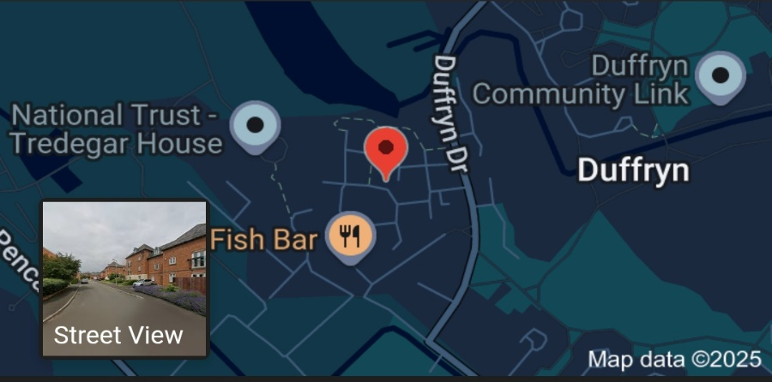
Figure 1. Google Maps screenshot of Glow to Go Aesthetics headquarters location.
The business primarily serves clients across the South Wales region, including Cardiff, Newport, and Swansea. However, for corporate events, bridal parties, or special bookings that guarantee a minimum number of clients, Glow to Go is prepared to travel further to meet demand. This flexible setup reduces overhead costs and allows for a more personalised and responsive service.

6. Human Resources
The business will launch with a small, agile team. The founder will handle service delivery and operations, with plans to bring onboard an extra part time nurse practitioner when demand increases.
A remote assistant will support marketing, social media, and bookings an external accountant will be engaged on a monthly basis for compliance and financial planning (Fig. 2).
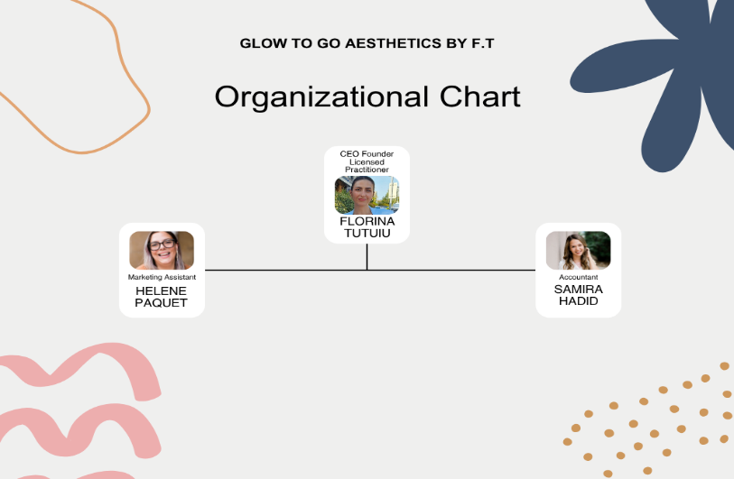
Figure 2. Organisational chart Glow to Go Aesthetics by F.T: Tutuiu,F. 2025.

7. Marketing and Promotion
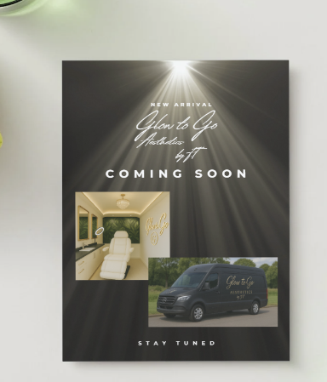
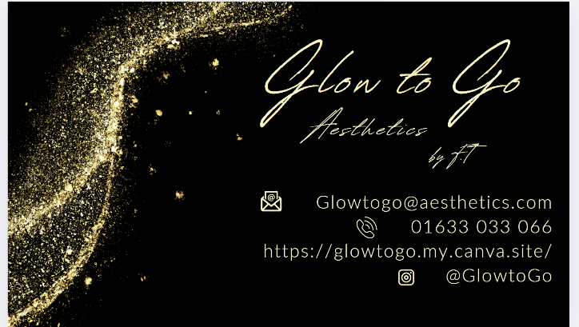
All promotional decisions were shaped by insights from our questionnaire (Tutuiu, 2025; Byrd, 2021). Offline materials, such as flyers and business cards (Fig. 3-4), will be placed in high traffic locations like gyms, salons, and coworking spaces.
Figure 3. Glow to Go business card: Tutuiu, F. (2025). Figure 4. Glow to Go promotional flyer: Tutuiu, F. (2025).
Online marketing will use targeted Facebook and Instagram ads aimed at South Wales professionals, with content that highlights trust, convenience, and luxury.
Collaborations with influencers and behind the scenes videos will build transparency and trust. An engaging newsletter will offer tips, updates, and loyalty discounts to keep clients connected.

8. Market Research
Our primary research, based on 112 responses, highlighted key consumer expectations: 68% prioritised flexibility and convenience, over 50% preferred mobile over traditional clinics, and top treatments included anti-wrinkle and vitamin boosters (Fig.5-6). Trust in hygiene, licensing, and professionalism was also a consistent theme (Fig.7).

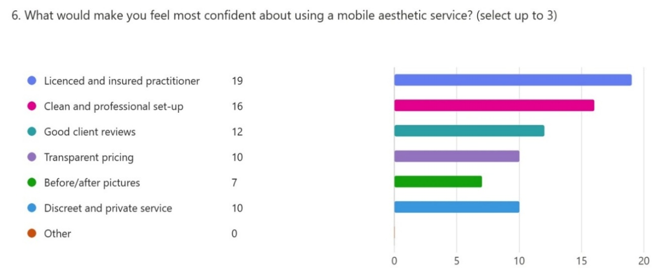
Figure 5. Screenshot of questionnaire responses: Tutuiu, F. (2025).
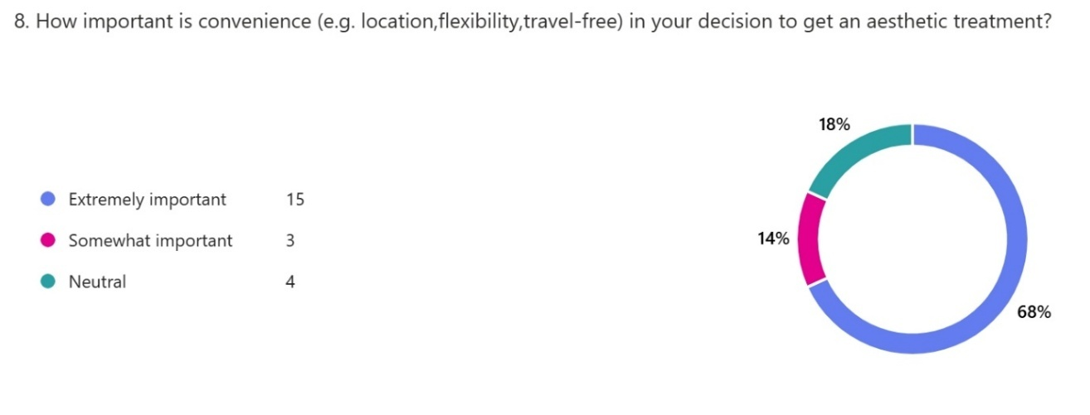
Figure 6. Screenshot of questionnaire responses: Tutuiu, F. (2025).
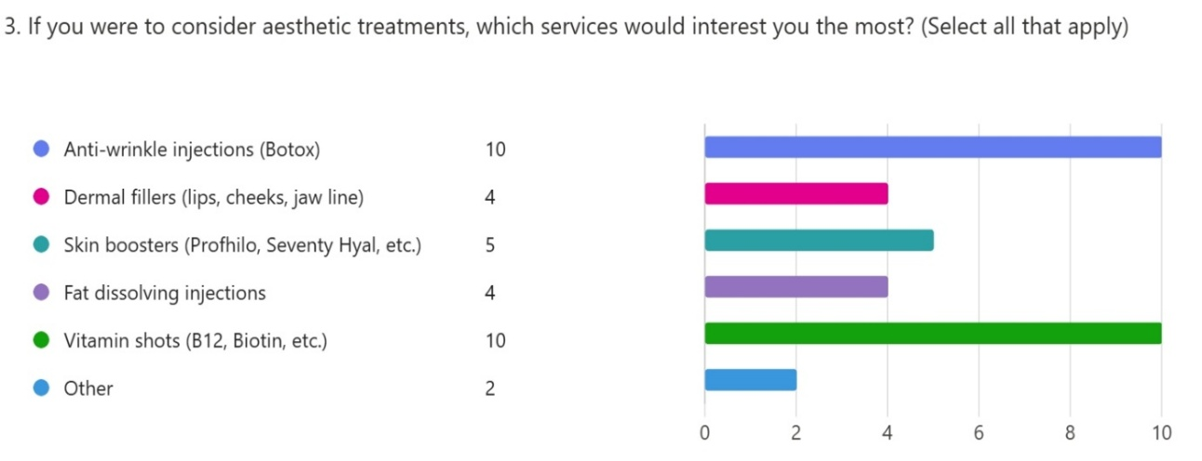
Figure 7. Screenshot of questionnaire responses: Tutuiu, F. (2025).
Secondary sources supported our findings (MarketLine, 2023; Barringer and Ireland, 2022; Pinto and Guarda, 2020). MarketLine (2023) projects a 7.8% average annual growth for the UK aesthetic sector. Post pandemic, mobile wellness services are on the rise (Barringer & Ireland, 2022), and consumers place greater importance on clear digital reassurance (Pinto & Guarda, 2020).
Together, this research shaped everything, from our service menu and pricing to brand tone and social media strategy (Dadwal, 2020; Reedy and Parker, 2017).

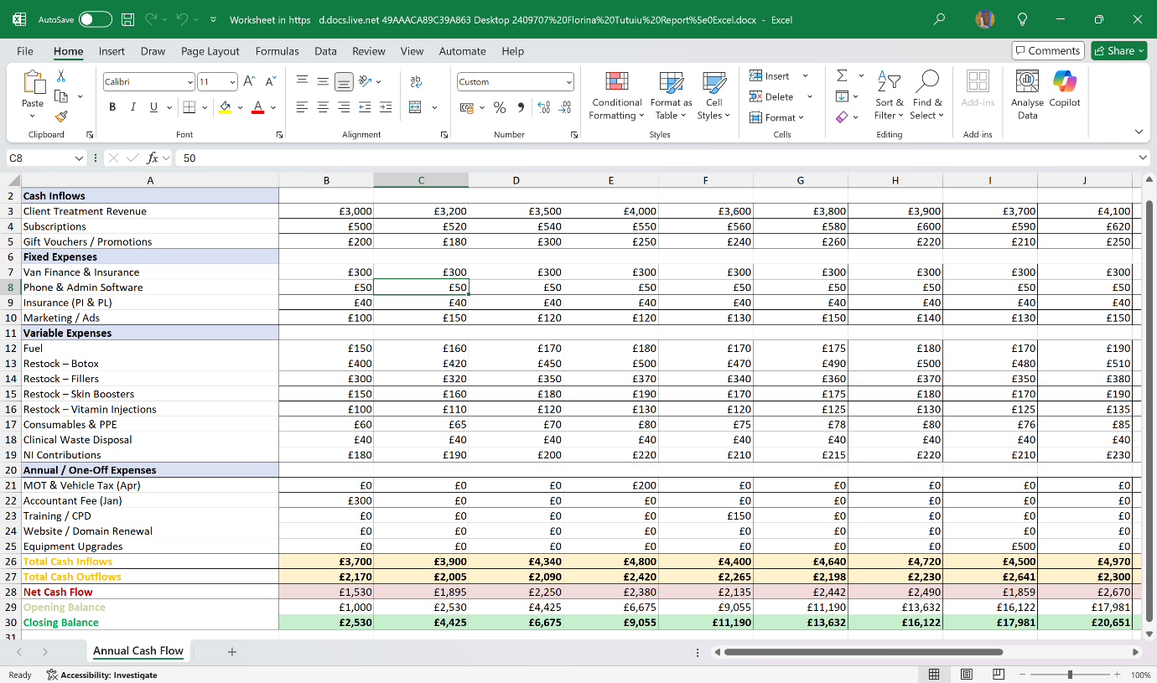
9. Financial Resources
Figure 8. Glow to Go twelve months Excel forecast: Tutuiu, F. (2025).
Initial setup costs include £9,000 for van conversion, £4,500 for equipment, and £5,200 for insurance, licensing, and branding. These will be covered through a mix of personal savings (£10,000), a government grant (£7,000), and a startup loan (£5,000).
Based on the Excel forecast, total income for the first year is projected at £56,840, with operating expenses at £14,475. This results in a strong forecasted profit of £42,365 for year one. Monthly income is expected to peak at £5,000 in the winter season, with steady growth throughout the year (Fig.8). Key cost areas include marketing, fuel, restocking, insurance, and software (Kumar and Zhmke, 2023).

10. SWOT Analysis
Glow to Go’s strengths include a flexible mobile format, strong brand identity, and high perceived value. Weaknesses include the absence of reviews at launch and dependency on vehicle reliability. However, we plan to address this by gathering early testimonials, showcasing hygiene certifications, documenting results, and encouraging reviews through QR-linked incentives. Opportunities include seasonal campaigns and corporate partnerships. Threats such as competitor pricing and regulation shifts will be monitored continuously (Barrow, Barrow and Brown, 2021).

Individual Reflection
Developing this business plan has helped me gain practical experience in aligning an idea with real-world feasibility. I have learned how to use both qualitative and quantitative data to shape a business model. My questionnaire highlighted what people value most: trust, flexibility, and professionalism. That feedback directly influenced everything, from van design and licensing visibility to pricing and content tone.
Another skill I acquired was financial forecasting. Previously, Excel felt intimidating. Now I can build, test, and refine cash flow projections using tools like conditional formatting.
I have also learned to simulate seasonal spikes and variable costs to better prepare for uncertainty, especially in a market influenced by fluctuating trends and economic pressures.
This process also taught me the value of customer focused branding. Rather than building a service I like, I built one that solves real problems. The marketing materials, including flyers, website, and social media content, were tailored to different audience segments. This shift in approach helped me better understand the emotional and psychological motivations behind customer decisions, particularly in a field like aesthetics where trust and comfort are crucial.
Beyond branding, I have become more comfortable with taking feedback and adjusting according to customer demands. The questionnaire helped me move away from assumptions and toward evidence backed decisions. I used insights not only to prioritise service offerings but to refine messaging, pricing, and even the tone of our visuals. I now realise that planning is not a one off task, but an ongoing loop of testing, evaluating, and improving.
An entrepreneurial trait I would like to develop further is confidence in self-promotion. I am skilled at operations and behind the scenes organisation but tend to hesitate when it comes to putting myself forward in a public facing way. I understand now that building a brand is not just about what you deliver, it is about how you communicate, show up, and stay consistent.
To improve, I plan to take a short video content course, follow influencers and aesthetic entrepreneurs who manage this well, and begin practicing through Instagram stories or casual behind the scenes content.
If I were an angel investor, I would cautiously back this venture. It has a clear market need, low overheads, strong branding, and a realistic path to profitability. The idea is supported by actual consumer research, not just intuition. However, I would expect early evidence of traction, such as reviews, digital engagement, and bookings, before increasing any level of funding.
With achievable Key Performance Indicators like 100 bookings, 4.5-star ratings, and strong retention, Glow to Go has room to grow organically and sustainably.
This assignment changed my mindset. I used to think entrepreneurship was about a good idea, work and passion. Now I know that those things are just the beginning. What truly matters is the discipline to research, plan, structure, and adapt. I now feel more equipped to face business challenges, not just with creativity, but with strategy and clarity.

Reference List

- Adams, J. (2022) ‘80% of jobs require Excel’, European Journal of Educational Research, May.
- Armstrong, G., Kotler, P. and Opresnik, M.O. (2023) Marketing: An Introduction. 15th edn. Harlow: Pearson Education.
- Barrow, C., Barrow, P. and Brown, R. (2021) The Business Plan Workbook: A Step-by-Step Guide to Creating and Developing a Successful Business. 10th edn. London: Kogan Page.
- Barringer, B.R. and Ireland, R.D. (2022) Entrepreneurship: Successfully Launching New Ventures. Updated 6th edn. Harlow: Pearson.
- Byrd, L.S. (2021) Cultivating Entrepreneurial Changemakers Through Digital Media Education. Hershey: IGI Global. Available at: http://doi.org/10.4018/978-1-7998-5808-9
- Dadwal, S.S. (2020) Handbook of Research on Innovations in Technology and Marketing for the Connected Consumer. Hershey: IGI Global. Available at: http://doi.org/10.4018/978-1-7998-0131-3
- Google Maps (2025) Figure 1. Screenshot of Glow to Go Aesthetics headquarters location. [online image] Available at: https://www.google.com/maps (Accessed: 02.07.2025).
- Kumar, D. and Zhmke, A. (2023) ‘Excel: Transforming Digital Landscapes’, LinkedIn [online]. Available at: https://www.linkedin.com (Accessed: 20 June 2025).
- MarketLine (2023) UK Beauty Industry Report. [online] MarketLine. Available at: https://www.marketline.com (Accessed: 24 June 2025).
- Mohammadi, A., Riahi, M. and Benali, A. (2024) ‘Dynamic Cash Flow Management Under Uncertainty’, International Journal of Applied Research in Management Economics and Accounting, 2(1), pp. 23–34.
- Pinto, F.M. and Guarda, T. (2020) Digital Marketing Strategies and Models for Competitive Business. Hershey: IGI Global. Available at: http://doi.org/10.4018/978-1-7998-2963-8
- Reedy, K. and Parker, J. (2017) Digital Literacy Unpacked. London: Facet Publishing. Available via ProQuest Ebook Central: https://ebookcentral.proquest.com/lib/trinity/detail.action?docID=5490897
- Sandhu, K. (2020) Digital Transformation and Innovative Services for Business and Learning. Hershey: IGI Global. Available at: http://doi.org/10.4018/978-1-7998-5175-2

- Tutuiu, F. (2025) Figure 3. Business card, Glow to Go Aesthetics by F.T. Unpublished design, Cardiff: Higher Education Wales.
- Tutuiu, F. (2025) Figure 8. Monthly Cash Flow Spreadsheet, Glow to Go Aesthetics by F.T. Unpublished Excel spreadsheet. Cardiff: Higher Education Wales.
- Tutuiu, F. (2025) Figure 2. Organisational chart, Glow to Go Aesthetics by F.T. Unpublished graphic, Cardiff: Higher Education Wales.
- Tutuiu, F. (2025) Figure 4. Promotional flyer, Glow to Go Aesthetics by F.T. Unpublished design, Cardiff: Higher Education Wales.
- Tutuiu, F. (2025) Figure 5-7. Screenshot of Questionnaire Responses. Unpublished student report. Cardiff: Higher Education Wales.
- Williams, S. (2022) The Financial Times Guide to Business Start Up 2021/2023. 32nd edn. Harlow: Pearson Education.
- Young, P. (2022) Business Plan. [online] Global Media Publications.

