Student Name: Thomas Ingell
Student Number: 1900087
Course Title: Automotive and Transport Design (BA)
Module: ADAD4019
Tutors: Julia Lockheart and Gwen Beynon
Word Count: 1560

‘Aero’
Automobiles involved in motorsport have evolved to their dynamic environment throughout the years in a whole host of ways. In Formula One, the most noticeable and notable would be the changes to the form of the car’s bodies, constantly morphing over time in order to reach what is believed to be the pinnacle of aerodynamic efficiency for their task at hand; winning (CNBC International, 2014). It is the competitive pressures and nature of automotive innovation that drives newfound methods to quench the thirst for success. To me, I am fascinated at the drastic increase in the level of scrutiny undertaken in the design elements of modern Formula One cars in comparison to their predecessors during the mid-20th Century; the cars back then could be described as ‘Cigar shaped’ (McKenzie, 2018). I think it paints a wonderous picture of the human drive for greatness and has produced the most beautiful outcome.
My exhibition will be titled ‘Aero’ to give context to the focus of what is displayed. It will feature The Mercedes W196 from 1954 driven by Juan Manuel Fangio (Hill, 2001, p.41) looking into the eyes of its iteration in 2019, the Mercedes W11 which competed 65 years later (Mercedes AMG F1, 2020). The exhibition will be held at Hangar-7 in Salzburg, Austria – less than a four hours’ drive from the heart of Mercedes in Stuttgart (Google, 2020). This venue is highly appropriate for ‘Aero’ to take place in due to its architecture, as Hangar-7 itself, displays a flowing, aerodynamic shape, like that of an aeroplane’s wing (Hangar-7, 2020).
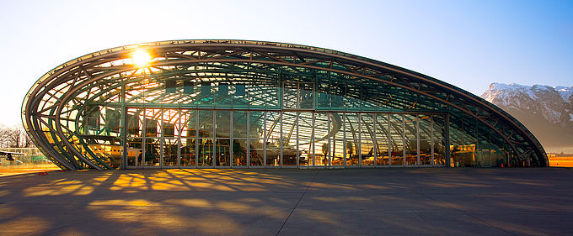
Fig. 1: Hangar-7 in Salzburg.

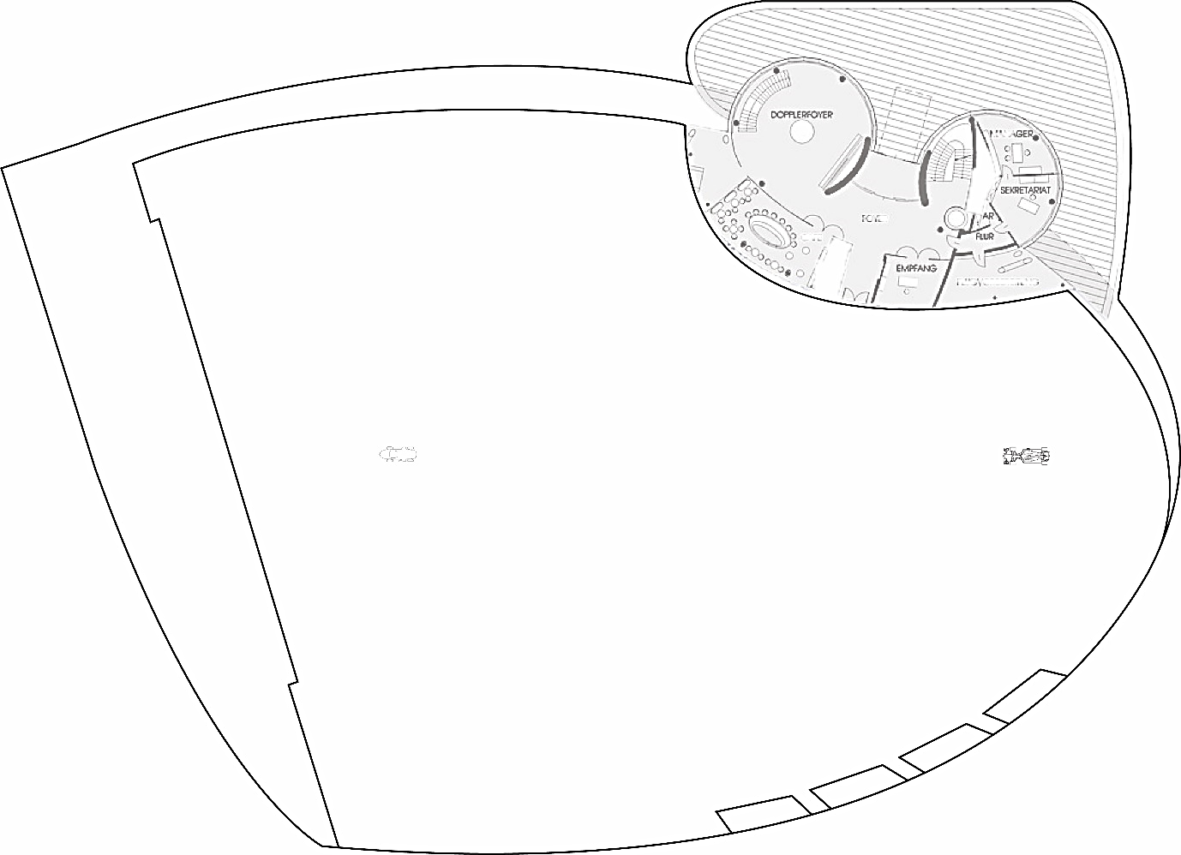
65 meters
Fig. 2: My plan of the exhibition: ‘Aero’.

The cars will sit in near emptiness, alone with one another with 65 metres of floor space between them, representing the number of years separating their introduction to grand prix racing.
A key spatial aspect of this curated space will be the void between the subjects, and the unmistakeable sense of power that each of them hold. The space is large, much like the great achievements of each vehicle yet the distance parting them highlights how far the car itself has evolved to grasp its success. The lack of sound in the enclosed, yet seemingly open glass structure of Hangar-7, will only draw more attention to the atmosphere surrounding the vehicles, allowing the viewer to hone in on aerodynamic features, elegantly displayed in a new form on the Mercedes W10 to that of the W196, whose shapes and curves whilst not as advanced, display beauty in classy manor.
Inspiring the abundance of space in the hangar is not only the period in history between the two vehicles, but also the ideas presented in the installation work of British artist Sir Anthony Gormley. The desolate scene of Cosby beach, home to ‘Another Place’ depicts the exact same ambiance I want to achieve in my exhibition. After visiting the beach in 2018, I ca safely say the eerily silent, sparse area intrigues you to go up close to the subjects within and inspect them intently- this is what I aim to achieve for my exhibition. There will be no need for an explanation as to what they symbolise, the cars themselves do the talking.
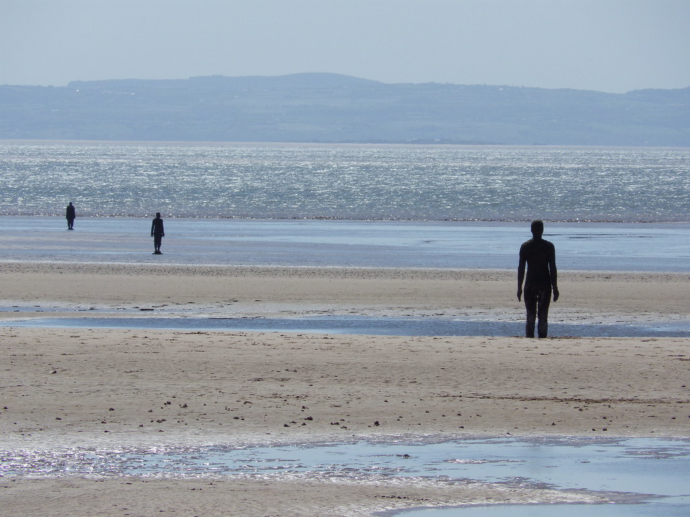
Fig. 3: ‘Another Place’ By Sir Anthony Gormley.
The goal of this is to put into perspective the power and success that fuelled these cars in their time, and the significance of the aerodynamic advancements over the years that have led to ground-breaking innovations. This, in turn, saw the success in motorsport that all drivers and team members dream of, dominance of a consecutive 6th world title in Formula One for Mercedes (Formula 1, 2020). To create a space that feels loud, full of history and evolution yet in complete silence would do the vehicles justice giving them the appreciation they have earnt. I think by separating these two cars by such a distance, it offers a chance for the viewer to reflect on what they have just seen and give context to what they are about to see.
One of the most important features of the exhibition is the venue itself. Hangar-7 at Salzburg is a beautiful space for which to display these cars, it is no stranger to showcasing machinery alike such as “the historical Flying Bulls aircraft fleet and a collection of Formula 1 race cars”. The key aspect of the venue, and what it does most for ‘Aero’ is the form of the building itself. From the entrance, Hangar-7 can be seen shaped like the form of the cross-section of an aeroplane’s wing. Volkmar Burgstaller, the architect behind such a design “enriched the entire city” of Salzburg, creating a design that “radiates extraordinary dynamism and weightlessness” (Hangar-7, 2020). I believe this makes it the perfect place to hold the exhibition because the its focus is embodied in the venue’s structure, aerodynamics.
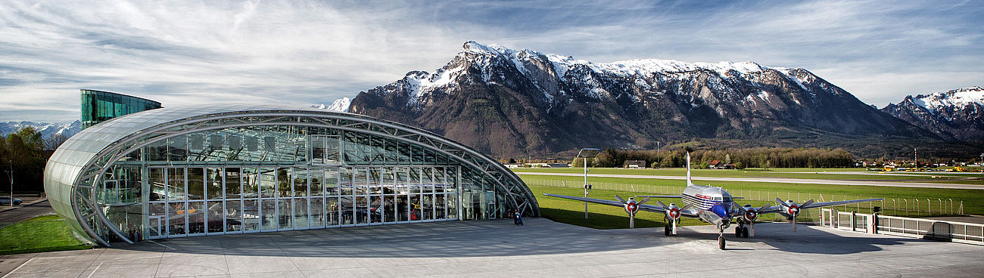
Fig. 4: Hangar-7 in Salzburg.
There is DNA of Mercedes in this venue, not far from the home of the brand and in a German-speaking country. It feels only right that these German masterpieces stray no further than 380 kilometres of where they were born (Google, 2020). Despite Mercedes Formula One now operating in Brackley, UK, the 2019 iteration (the W10) is still part of a larger organization that resides firmly in Stuttgart, Germany (Wikipedia, 2020).
The large proportion of glass making up Hangar-7 provides second to none natural lighting, capturing the aerodynamic features of the cars in only their finest versions. The relationship between the contours of each vehicle and the unmistakable beaming lights from all around should tell a story of ingenuity, progression and a desire to win. The shadows cast being a vector in telling the story of how hunger for success drove aerodynamic advancements. In a venue used to giving a home to innovative and successful machinery, I can see no more appropriate place to stage this exhibition in.
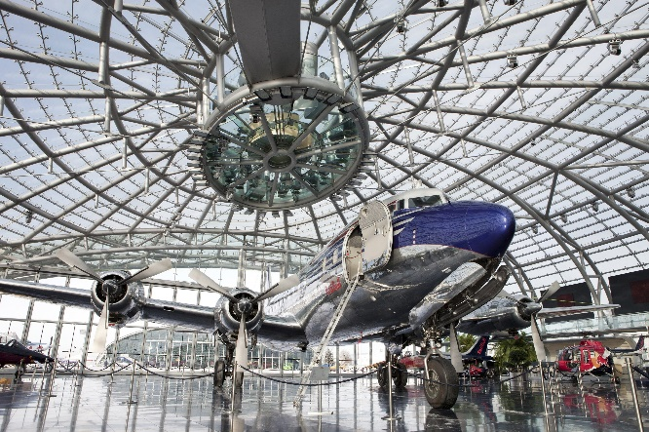
Fig. 5: Hangar-7 in Salzburg.
A large focus of my exhibition will be of course the subjects displayed, the Mercedes W196 raced in 1954, and its modern counterpart, the W10 from 2019. The bond shared between these two motor cars will be unmistakably powerful as they are seen staring at each other from a far in an indefinite face off. I believe the heavy contrast between the cars, mainly visually, adds to the sense of importance that a viewer would experience upon stepping into the wide-open space housing them.
Formula One, as most things have, has progressed incredibly far throughout the decades, and it is my belief that we owe an appreciation to the work of aerodynamicists and technical innovators alike that have slowly shaped their knowledge into automobiles such as the W10, capable of producing 740 Brake Horse Power giving a power-to-weight ratio of almost 1 mile an hour to the kilogram (Ultimatecarpage.com, 2020). Quite possibly the most well-known engineer and aerodynamicist, if not certainly in Formula One would be Adrian Newey. Responsible for the design of all of team Red Bull Racing’s success in the sport, Newey’s work can be considered as an art form; carefully pencilling out drawings that make it all the way to the track. He has given live to cars that have been dominant in multiple eras (Newey, 2017). The cars he has helped produce, cars just like the Mercedes W10, are almost now a new machine compared to that of the mid nineteen-fifties with few elements of the vehicles looking similar.
Modern day Racing cars of all pedigrees now have so many various ways of creating downforce, (A force providing grip to the road surface), that were incomprehensible decades ago. From endplates and bargeboards, even wings of any sort, the difference is huge and begs the question: What will the cars 65 years from now look like? Is it possible for a twofold increase in aerodynamic knowledge and development?
Within the large open space of this exhibition, I hope that the experience can yet feel absolutely crowded with remnants of history, the art of aerodynamic evolution and above all greatness that has sparked from such a hunger to win in one of the most competitive, high-risk and generally dangerous sports in existence (Planet F1, 2018). I believe that the venue chosen is well suited, with architect Volkmar Burgstaller creating art in the form of Hangar-7. The very nature of the building’s elegant design manifests the characteristics of the performance vehicles that will be displayed inside. I think by taking inspiration from Sir Anthony Gormley in the layout of the display, the eerily empty floor will work effectively in conveying the historical story that spans almost seven decades by creating a sense of mystery, and igniting an interest in the viewer for what is displayed in the exhibition.
After designing this curated space, I have found that I am more aware of the significance of making decisions about what surrounds the main focus of an exhibition, and that these choices are in actual fact equally as important as the displayed subjects as they can both limit and enhance such subjects. It is important to choose carefully about certain elements that contribute to the meaning of what is being exhibited as creating a space that’s well thought through in every aspect will only add to the desired effect and meaning that is to be conveyed as part of the exhibition.
Bibliography
CNBC International (2014) F1 History of Aerodynamics | One Second in... F1 | CNBC International: Accessed from: https://www.youtube.com/watch?v=Cq8dgCShRsI [Accessed on 28th April 2020].
McKenzie, C. (2018) A SHORT HISTORY OF FORMULA 1, USING LEGO CARS: Accessed from: https://drivetribe.com/p/a-short-history-of-formula-1-using-dRfgSnLXSGGGNCMfmHiqSQ?iid=X9sE2T1ASeC1L_8ukCOgXA [Accessed on 28th April 2020].
Hill, T. (2001) Formula One Unseen Archives. Bath: Parragon.
Mercedes AMG F1 (2020) Mercedes-Benz W196 R: Accessed from: https://www.mercedesamgf1.com/en/heritage/silver-arrows/mercedes-benz-w-196-r-1954-1955/ [Accessed on 28th April 2020]. And Mercedes W10 EQ Power+: Accessed from: https://www.mercedesamgf1.com/en/car/f1-w10-eq-power/ [Accessed on 28th April 2020].
Google (2020) Map data: Accessed from: https://www.google.co.uk/maps/dir/Salzburg,+Austria/Stuttgart,+Germany/@48.2491369,8.8611743,7z/data=!3m1!4b1!4m14!4m13!1m5!1m1!1s0x47769adda908d4b1:0xc1e183a1412af73d!2m2!1d13.05501!2d47.80949!1m5!1m1!1s0x4799db34c1ad8fd3:0x79d5c11c7791cfe4!2m2!1d9.1829321!2d48.7758459!3e0?hl=en [Accessed on 28th April 2020].
Hangar-7 (2020) Concept: Accessed from: https://www.hangar-7.com/en/hangar-7/concept/ [Accessed on 28th April 2020].
Formula 1 (2020) 2019 Constructor Standings: Accessed from: https://www.formula1.com/en/results.html/2019/team.html [Accessed on 8th May 2020].
Wikipedia (2020) Mercedes-Benz: Accessed from: https://en.wikipedia.org/wiki/Mercedes-Benz [Accessed on 8th May 2020].
Ultimatecarpage.com (2020) Mercedes-Benz W10 EQ Power+: Accessed from: https://www.ultimatecarpage.com/spec/7544/Mercedes-Benz-W10-EQ-Power-.html [Accessed on 8th May 2020].
Newey, A. (2017) How to Build a Car. London: HarperCollins.
Planet F1 (2018) The Dangers at a Formula 1 Race: Accessed from: https://www.planetf1.com/news/the-dangers-at-a-formula-1-race/ [Accessed on 8th May 2020].
List of Figures
Figure 1: Hangar-7 in Salzburg. Accessed from: https://www.hangar-7.com/en/hangar-7/opening-hours/ [Accessed on 8th May 2020].
Figure 3: ‘Another Place’ By Sir Anthony Gormley. Accessed from: https://www.flickr.com/photos/nigelhomer/34453263585 [Accessed on 8th May 2020].
Figure 4: Hangar-7 in Salzburg. Accessed from: https://www.hangar-7.com/en/ [Accessed on 8th May 2020].
Figure 5: Hangar-7 in Salzburg. Accessed from: https://kongres-magazine.eu/2018/05/hangar-7-home-of-the-flying-bulls/ [Accessed on 8th May 2020].

