

Tittle Page

Assignment Tittle: Individual report on how Emirates as a company and their customer relationship management (CRM)

Student name: Petko Petkov
Student number: 2125440
Module lecturer: Abdi Rahman
Module name: Understanding and Engaging in the customer experience
Module code: BMSW5103_BIRM

Contents Page

Table of Contents
- Introduction……………………………………………………………………………………………………………3
  - Ethical and sustainability polices…………………………………………………………………………….3
- Deming’s Plan-Do-Check-Act Cycle within Emirates…………………………………..4
- Trilogy of quality marketing – Joseph M. Juran…………………………………………5
- TQM 8 Principles of total quality managing……………………………………….….....6
- Corby’s Cost of Quality philosophy…………………………………………………….7-8
- Conclusion…………………………………………………………………………………..8
- References list…………………………………………………………………………..9-10

- Introduction:
Emirates is a company with very well established ethical and sustainability polices, it gives the customers one of the best experiences. The CRM of Emirates is well carried out and has been for years since its establishment in 1985. In this report we will go through a few of the companies’ best features and company ethics, engaging with their customers as well as assuring the comfort and reliability they offer to their customers. We will understand what the values of customer service are, how customer engagement is in the airline and evaluate the implementation of CRM into Emirates. Exploring the theories, concepts and philosophies of Deming, Juran and Crosby about quality managing and customer relation managing and see which one fits with our chosen company - Emirates.

1.1 Ethical and sustainability polices:
Some ethical polices that have really made a significant boost in terms of the companies’ development throughout the years are anti-slavery and human trafficking, antitrust and competition law, anti-bribery and corruption. These are some of the most important features of the ethical build-up of Emirates, it is crucial for them to not tolerate any illegal and dehumanising activities on their flights and their airports. Furthermore, as it quotes in the official website of the airline, company values play a massive role in the companies’ success with customer engagement and management. Excellence, Agility, Innovation, Leadership and Reliability are the 5 brand values with which Emirates wins and continues to win loads of its customers support and prosper as a business. Sustainability is one of the main priorities for the company sharing some practices they embrace in their own management and establishment: environmentally friendly practices – recycling with a system called “closed loop recycling programme” see Figure 1.
Figure 1:
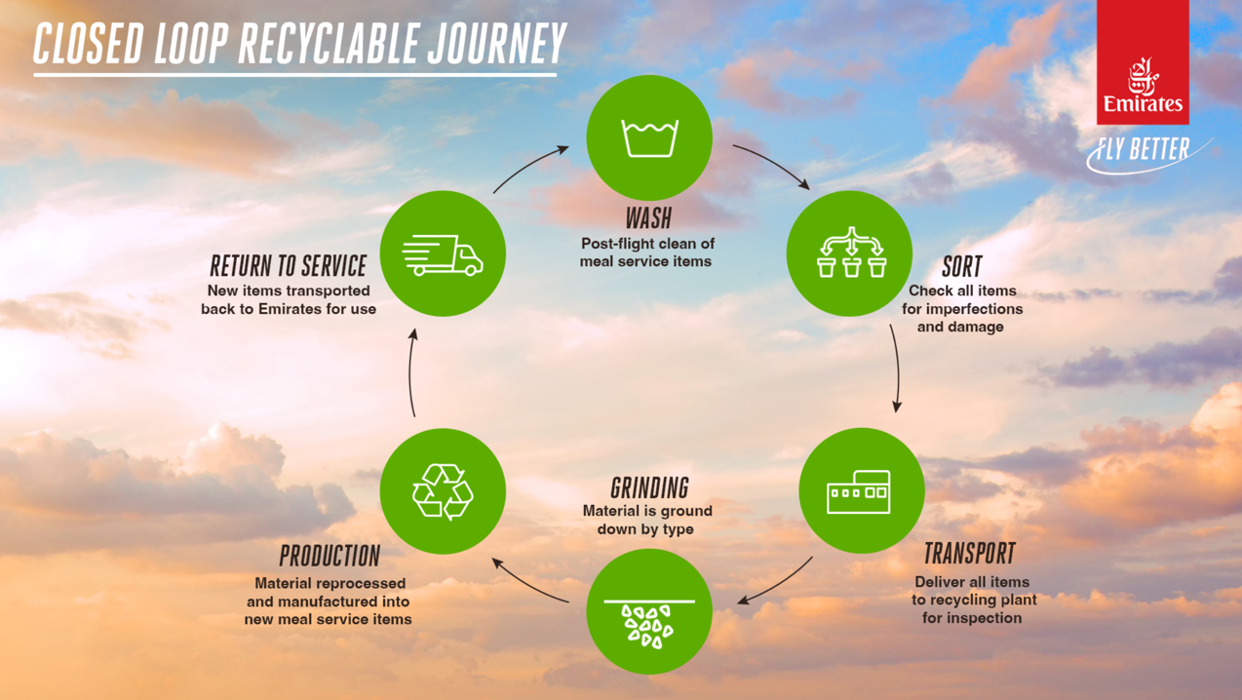

Emirates Flight Catering is one of the world's largest airline catering companies and has a recycling program that scales with its business. Their program removes a wide range of materials from landfills, including paper and cardboard, aluminium foil and cans, plastic bottles and containers, many of which are collected from aircraft upon arrival in Dubai.

- Deming’s Plan-Do-Check-Act Cycle within Emirates
Sustainable marketing applies to Emirates as one of their sustainable and customer friendly features and although some people might disagree, the company offers comfort, assures bio usage of oils and electricity as well as recyclable materials on board in exchange of a reasonable price for journeys. This way of approaching existential appliances and effective practices resembles the Deming Cycle: The concept of the Deming cycle is based on four main categories of management that can appear in different interpretations.
It is considered both an administrative function and a basic administrative procedure.
Company; product manufacturing (including sales) product quality assurance and monitoring (Ma, 2018).
Manufacturing and marketing, including handling consumer complaints (Baranenko et al., 2013). Emirates have honoured tourists with an efficient cycle which really resembles the Deming Cycle with the repetition and consistency of their service. See Figure 2.

Figure 2:
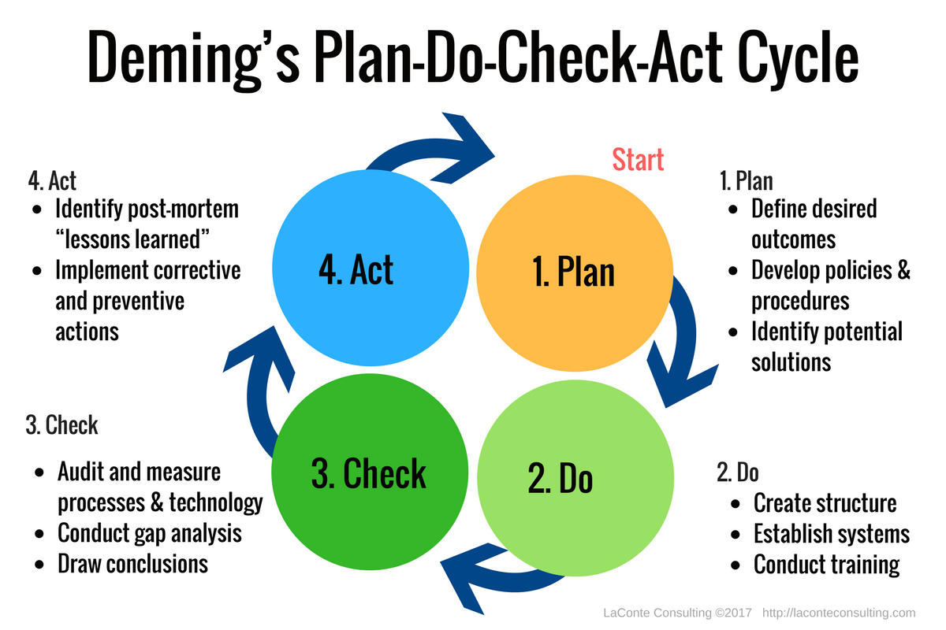
The Deming cycle is a concept of quality managing which fits perfectly with the ethical and sustainability polices of the chosen topic for this report – Emirates. This theory that the quality management is essentially a 4-step process is only the presentation for the audience, behind the scenes as mentioned previously, establishments such as Emirates airlines are a large, well stringed and productive branch which is dedicated at targeting the comfort of their subscribers. One example of a feature which Emirates has improved is their refund policy. This is an option which was not customer friendly in the years of the company’s start. Now this feature is available as well as a few other features such as keeping your ticket/boarding pass and flying with it later instead of getting a refund (as it says on the official website in 10-14 days) on it if one chooses to cancel their flight. This has changed the way the company proceeds with their customer relationship management simply because it gives the customer more comfort about their purchases of flights and offers flexibility in terms of planning and arranging travels with Emirates.

Sustainable and ethical marketing has been thoroughly enhanced throughout all the departments of Emirates airlines. Marketing of airlines typically could be carried out in many ways; however, Emirates choose to market their journeys by offering an amazing comfort for their customers which on most occasions fulfils the needs of all. People have evidently complained throughout the years about the high pricing of flights but essentially if the company is keeping a good environmental and global status (which it does), the pricing is reasonable! Destinations such as Dubai which could reach 14 million visitors overnight does require a higher pricing as Emirates is one of the higher budget flying companies out there.

Complaints and social criticisms have always played a global part in the airline industry because of the high demand from the world’s population to travel. Tourism in Dubai (the UAE) especially has jumped from 7 million arrivals overnight in 2021 to 14.6 million overnight visitors in 2022. This goes to show how tourism is becoming increasingly common across the world especially in UAE where Emirates is a main aviation hub and still able to adapt flawlessly to the tourist demand (Al Dhabbah, 2017)

- Trilogy of quality marketing – Joseph M. Juran
Another theory and concept which this report will touch on is the concept of Joseph M. Juran. This theorist is a model to appreciate and learn a lot from, he has a book on the topic of quality of managing and reaching the “peak” of consumer needs and how customer engagement with a certain product contributes towards its success. “Be a customer to know the needs of one” (Juran, 1992). In order to evaluate and conclude what the customers’ needs are we all need to be customers of the service we are trying to market promote and distribute as a business. The aviation industry is extremely oversaturated and so the pricing of some flights is unreasonably high, however nowadays with all the marketing available in the eyes of platforms such as booking.com and many more of this sort, customers and users especially of this service can easily find a cheaper option than visiting the official websites and booking platforms of aviation companies such as Emirates.

Juran’s models of quality managing is very strategic in a sense as it evaluates the needs of consumers from a business point of view as well as focusing on the opposite side by placing all his concepts through the prism and shoes of the customer themselves. Therefore, it provides a more realistic approach and design of quality managing. Juran’s quality trilogy is a concept which is also seen in many aviation brands, the trilogy consists of:
- Quality planning,
- Quality control, and,
- Quality improvement.

Factually, this specific concept is applied in almost every business there is out there, however it effectively suits Emirates because it is an aviation company and as mentioned before, billions of people are consumers of this service therefore, the Aveo companies such as Emirates do tend to “feel the grounds” of planning, controlling and eventually improving their service according to the voice of the public. If they get a large backlash for a feature they included into their service, they tend to improve and advance their performance immediately. Adhering to Emirates' policy of investing in the latest eco-efficient technology means they have one of the youngest fleets in the industry. The environmental benefits of operating modern widebody vehicles include both reduced noise and reduced engine emissions. The aircrafts are fully compliant with International Civil Aviation Organization (ICAO) Chapter 4 noise standards (apart from a few wet-lease freighters) and comply with applicable ICAO engine emission standards. The Airbus A380 is one of the quietest large aircraft on the market and is designed to meet the stringent requirements of the world's most noise-sensitive airports. The company has offered an amazing experience to all people who are willing to fly with it and it is evident from all the video material and comments out there from people giving the service amazing feedback in all their platforms because traveling by air has become more and more important and cherished nowadays (Smatana).

4.TQM 8 Principles of Total Quality Managing:

To accomplish such an honour, Emirates aircrafts had embraced the apparatuses of Value Control Circle and complete quality administration as the groundwork of its drive. Additionally, the company was motivated by the belief that individuals are the driving force behind quality procedures. Emirates' foray into the tourism and resort industry is another outstanding strategy. This has been accomplished through acquisitions, the construction of numerous spas and resorts, and a focus on quality control. The company has received a lot of praise for this, and it has also opened more business opportunities. Plus, the organization has gained by this open door by building a travel industry business, which causes the organization to develop significantly further (Rababah & Mohd, 2011)

To accomplish this, Emirates Aircrafts perceive that every movement and every individual effects and is thusly impacted by others. TQM is, thusly, picked as a system to further develop competences, by improving the viability across all cycles and works (Ambroz 2004). In any case, as enterprises extend, the opposition keeps on uplifting while, simultaneously, the requirement for quality improvement is turning out to be more basic. According to (Godfrey, 1997), businesses that operate in numerous nations adhere to the TQM principle in order to guarantee long-term expansion and market competitiveness. Emirates Carriers has found a way multiple ways to accomplish high portion of the overall industry and to confront the market contest (Kuntonthong, 2008), (Silver Associates Inc.)

- Crosby’s Cost of Quality philosophy:
Cost of quality is a widely interpreted topic, in terms of aviation industry the cost is usually many benefits over many sacrifices. Many of the flight attendants who work for Emirates have complained and left the company because they have been losing over a month of sleep in a work year according to their own words on their social media platforms. This concept unravels the insights of a good quality service over an internal failure cost (Crosby, 1979). See figure 3.
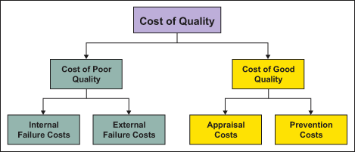
Figure 3:

Cost of quality has been paid by Emirates itself as well as the crew members and all the people who work for the company in customer service in order to provide an amazing experience for its consumers. “Cost” can be interpreted in many ways when it comes to large business groups such as Emirates. Emirates has an amazing internal structure judging by the high budget advertisement and marketing they use, however the internal situation is not as colourful as it looks on the outside.

This is not however how the Cost of Quality concept works. It works in a way in which the company which implements it into their services such as Emirates. As mentioned before, the company has one of the most sustainable low emission programmes. This allows the company to prosper for longer, saving energy and incorporating biofuels into their flying machinery. The cost of quality in this case we can say has been determined by a largely sustainable and ethically enhanced service construction within and outside the aircraft (Curran, 2004).

Customer service at airports has been shown to not be so thorough and welcoming. An online backlash was happening in 2020 against Emirates. They were accused online that they do not provide a good customer service face to face with the customers flying with the airline. This is history now; however, the internet is a very powerful tool for sharing opinions and on some occasions harassing businesses which have done so much throughout the years to stay relevant and productive within their spheres of work. This could have resulted differently for the aviation company and brought it to losing a lot of its money.

- Conclusion:
As a conclusion for this report on Emirates, their CRM and the quality of the companies’ customer service, ethical and sustainability polices as well as the quality of management I would like to say that the airline itself has managed to stay sustainable and ethically working with amazing professionals inside the aircrafts and outside also behind the scenes where all the flights are prepared for take-off and arrival. The company’s ways of recycling, keeping on top of the game with covid regulations as well as all the new advancements they have added to their luxurious aircrafts really resemble a quality model of Crosby as it invests a lot into their service and provide it to the public in the best way possible!

Researching about this airline has engrained a sense of research and awareness of every company I travel with, and I wish all people are searching for and to find whatever suit their own comfort. I recommend traveling with Emirates as it is a very well-established airline.

- Reference List

Al Dhabbah, M., 2017. The Seven Public-Government Relationship Typlogies: Apply CRM in United Arab Emirates (UAE) Government (Doctoral dissertation, Virginia Tech).

Ambroz, M 2004, ‘Quality system as a product of the empowered corporate culture. The TQM Magazine.vol. 16 no. 2, pp. 93-104.

Ang. L, Davies, M & Finlay, P 2000, ‘Measures to assess the impact of information technology on quality management’, International Journal of Quality and Reliability Management, vol. 17, no.1, pp.42-65.

Baranenko, S. P., Dudin, M. N., Ljasnikov, N. V., & Busygin, К. D. (2013). Using environmental approach to innovation-oriented development of industrial enterprises. American Journal of Applied Sciences, 11(2), 189-194.

Crosby, P.B. (1979). Quality Is Free, McGraw-Hill, New York, NY.

Crosby, P.B. (1979). Quality Is Free, McGraw-Hill, New York, NY.
Hitt, M. A., Ireland, R. D., & Hoskisson, R. E. (2004). Strategic management, 6th ed. Thomson/South-Western, United States.

Curran, R., Raghunathan, S., Price, M., Kundu, A., Benard, E., Castagne, S., Mawhinney, P., Crosby, S. and Early, J., 2004, September. A methodology for integrated cost engineered systems within aerospace. In AIAA 4th Aviation Technology, Integration and Operations (ATIO) Forum (p. 6207).

Global. (2016). Environmental policy | Our planet | About us | Emirates. [online] Available at: https://www.emirates.com/english/about-us/our-planet/environmental-policy/.

https://www.youtube.com/watch?v=wRedikRAbbU

Juran, J.M. (1992). Juran on Quality by Design: The New Steps for Planning Quality Into Goods and Services. [online] Google Books. Simon and Schuster. Available at: https://books.google.co.uk/books?hl=en&lr=&id=KPUXbZ2Hw1EC&oi=fnd&pg=PR5&dq=Joseph+M.+Juran&ots=xM_h1CI8kO&sig=Xns1RhQSBbebFm_QRL25sbWPqxY#v=onepage&q&f=false

Kantardjieva, M., 2015. The relationship between total quality management (TQM) and strategic management. Journal of economics, business and management, 3(5), pp.537-541.

Kuntonthong, W., 2008. Passengers' perception of quality of Emirates Airline.

Ma, J., Sun, L. and Zhang, T., 2021, May. Thoughts on Online Teaching of Employment Guidance Course for Civil Aviation Majors under the COVID-19 Epidemic--Based on the teaching practice of college students enrolled in 2018 in the Civil Aviation Management Institute of China. In Journal of Physics: Conference Series (Vol. 1931, No. 1, p. 012001). IOP Publishing.

Rababah, K., Mohd, H. and Ibrahim, H., 2011. Customer relationship management (CRM) processes from theory to practice: The pre-implementation plan of CRM system. International Journal of e-Education, e-Business, e-Management and e-Learning, 1(1), pp.22-27.

Silver Associates Inc. n.d., Emirates – Program Planning and Strategy, Web.

Smatana, D., CUSTOMER RELATIONSHIP MANAGEMENT IN THE AIRLINE INDUSTRY.

