University of Wales Trinity Saint David

Dissertation –(LCBB6000)
BA(Hons) Business Management

Title: An analysis of the influence of leadership style on HRM practices in the entrepreneurial environment.

Student’s name: Svetlomira Nedyalkova
Student’s number: 2010796

Professor’s name: Dr. Anupam Mazumbar
Supervisor: Dr. Asad Abbas Jaffari

31.08.2023

Declaration

Name of student: Svetlomira Nedyalkova
Student number: 2010796

I declare that the dissertation titled ‘’ An analysis of the influence of leadership style on HRM practices in the entrepreneurial environment.’’ is my original work and was carried out by me under the supervision of Dr. Asad Abbas Jaffari. The dissertation has not formed the basis for the award of any degree, associateship, fellowship, or any other.

Date:31.08.2023 Signature of the student:

Acknowledgments

I would like to acknowledge and give my warmest thanks to my supervisor Dr. Asad Abbas Jaffari who made this work possible. His guidance and advice carried me through all the stages of writing my project. I also want to thank Dr. Anupam Mazumbar for all the guidance and support I received throughout this stage.

Abstract
The importance of understanding how leadership and the styles gained through it impact the process of entrepreneurship is emphasized by the fact that leadership can be understood in the widest possible range of contexts or situations, not just in relation to work or tasks and their execution. This fact further emphasizes the need to know how leadership affects the habits picked up along the way. This research has emphasized the facts and influence of leadership styles and approaches on HRM practices.
Contents
Abstract 4
1. Chapter 1: Introduction 7
1.1 Introduction 7
1.2: Background of the study 7
1.3: Problem Statement 9
1.4: Aims, Objectives, and Research Questions 9
1.5: Rationale 10
1.6: Methodology 10
1.7: Scope of the Study 10
1.8: Structure of the Dissertation 11
1.9: Summary of Chapter 1 11
Chapter 2: Literature Review 12
2.1 Various theories of leadership that may be used in business situations 12
2.2 Impact of a Company's Leadership Style on its HRM Practices 13
2.3 HRM tactics that work best in varied company environments 14
2.4 Literature gap 15
Chapter 3: Research Methods and Methodologies 16
3.1: Research Philosophies 16
3.2: Research Technique 16
3.3: Data collection method 16
3.4: Data 17
3.5: Data analysis 17
3.6: Time Horizons of research 17
3.7: Sampling of research 18
3.8: Ethical considerations for research 18
Chapter 4: Data Analysis and Discussions 19
4.1: Introduction 19
4.2: Data collection 19
4.3: Analysis and Discussions 25
4.4: Summary of Chapter 4 27
Chapter 5: Conclusions, Limitations and Recommendations 28
5.1: Introduction 28
5.2: Conclusions on each research objectives 28
5.3: Conclusions on the research problem 29
5.4: Summary of the research findings and outcomes 30
5.5: Original Contribution of the Research 30
5.6: Limitations of the Research 31
5.7: Recommendations 31
5.8: Summary of Chapter 5 32
References 33
Appendix 35

1. Chapter 1: Introduction

1.1 Introduction

Leaders in today's businesses must be adept at navigating the uncertainties inherent in a dynamic global environment. Therefore, leadership and the various leadership styles are crucial to a company's development and success. Since a company's survival and prosperity are directly tied to the actions of its executives, studies on leadership have received a lot of attention. There are two main types of leadership studies: those that attempt to define leadership in terms of certain traits and behaviors, and those that examine the traits and behaviors of persons who have outsized influence within a group but cannot be classified as leaders. Leadership is also defined as a collection of actions, some of which change with the leader's status in the eyes of his or her subordinates.

This research looks at the impacts of different leadership styles on HRM, as well as the effects of HRM on educator satisfaction and the achievement of the Sustainable Development Goals (SDGs). The purpose of this research is to examine the effects of gender, leadership style, team communication, human resource management, and leadership style on educators' psychological and physiological health. The research hypotheses below illustrate potential connections between the many areas of inquiry. To test these hypotheses, a linear regression analysis was conducted. Many sources of published literature were consulted in the creation of the scales used for measurement. Convenience sampling, which is not random, was used to collect the data.

1.2: Background of the study
There is still a general lack of understanding regarding leadership in the corporate sector, despite the abundance of written literature on the issue. Leaders' actions, or their use of different leadership styles, may have consequences for others around them. In order to steer companies towards their ideal future states, leaders must strike a delicate balance. Therefore, leadership plays a crucial role in determining how effectively employees understand and carry out their responsibilities. Leadership and the impact it may have in an entrepreneurial setting are crucial to the success and public perception of businesses (Ababneh, 2021)

Strategical and practical contribution
Strategic human resource management has the potential to aid an organisation in realizing its vision, sustaining its fundamental values, and accomplishing its goals. This has helped employees better understand their role in the company and the significance of their efforts.
Reasons for the significance of strategic leadership include Successful organisations, whether formally established or not, are those that have developed a consistent set of competences that have allowed them to maintain their stakeholders' competitive edge over time. Several options are highlighted for closer inspection. A leader with an entrepreneurial attitude is one who can organize and inspire their team to experiment, take chances, grasp opportunities, and adjust to a constantly shifting business climate. Always keeping the focus on the organisation’s stated goals. Establishing a unified hub for employee education and development to boost output.
Major contributions: Human resource managers are responsible for fostering open lines of communication between the business and its staff. But behind the scenes, there is a lot more happening in this sector than meets the eye. Human resource managers are in charge of developing the policies and processes necessary for the company to accomplish its goals, as well as the overall people strategy. From a human resource management perspective, harmony is essential for a successful launch.

1.3: Problem Statement

A person becomes an entrepreneur when a series of circumstances come together to inspire the development of an original business proposition. For a business to generate value and maintain financial viability, there is a predetermined order in which tasks must be completed. Leadership research has shown that more study of the entrepreneurial process is needed to fill gaps in our understanding of the field and aid leaders and businesses in rethinking their approaches to better accommodate the different phases of innovation (Moustaghfir et.al, 2020). Doing so is crucial because it will help leaders and companies rethink their plans considering the many facets of the entrepreneurial journey.

1.4: Aims, Objectives and Research Questions
Aim: The goal of this research is to assess, from an entrepreneurial standpoint, the impact that various leadership philosophies have on the tactics used for controlling human capital.
Objectives:
- To research the various theories of leadership that may be used in business situations.
- To carry out a study of the impact that a company's leadership style has on its HRM practices.
- To identify the HRM tactics that work best in varied company environments.
Research Questions:
- What can be the best possible leadership strategy which can assist in the development of entrepreneurial venture?
- How does the business environmental changes impose impact on the business performance?
- How does leadership impose impact on the human resource practices and what can be the best HRM tactics to handle leadership styles?

1.5: Rationale

Managers and executives in businesses might adopt a variety of stances. Previous research has demonstrated that transformational, transactional, participative, and relational leadership styles are most suitable to the entrepreneurial process and the context of Entrepreneurial ventures, hence these are the only four types that will be examined in this study (Moustaghfir et.al, 2020). The literature acknowledges many different styles of leadership, but this study will only examine a handful. It is common practice to use the words entrepreneurship and leadership interchangeably within the relevant literature. Therefore, the purpose of this research is to examine the effect of various leadership styles on the entrepreneurial process as it occurs in small and medium-sized enterprises.

1.6: Methodology
This method was required due to the exploratory nature of the data. The raw data shown here mostly focuses on the study participants. Scientists may have access to accurate demographic profiles provided they consult the right data sets. The testimony of eyewitnesses is crucial to solving this case. If the study is going to rely on raw data, then first-hand experience is essential. A total of 100 participants will be chosen at random from the general population. It was decided that a sample size of 100 would be sufficient to adequately reflect the population as a whole with minimal sampling bias (Ahmad et.al, 2021). Secondary data analysis will be used to explore into additional areas of coverage alongside the original research's conclusions, which may shed some light on such regions. Primary and secondary data will come from surveys and academic publications, respectively, in this investigation. For instance, combining the two approaches might lead to the discovery of novel and productive research areas.

1.7: Scope of the Study
To do this, a qualitative exploratory study was conducted to examine the cases of four This study focused on Entrepreneurial ventures because of the widespread assumption that they are the engine that propels economic growth (Danilwan & Dirhamsyah, 2022). Despite the country's Entrepreneurial ventures' amazing success and achievements, the difficulties they face have grown considerably over the last several years. Technology, resources, management, staffing, and the industry's organisational structure all play a role in contributing to these difficulties. In times of economic hardship, it is sometimes argued that small and medium-sized firms serve as the "backbone" of national economies. Its contributions to economic growth, new product creation, market competitiveness, and future expansion are substantial and far-reaching.
A company's development and prosperity are directly tied to the quality of its human resources management. A human resources manager who is dedicated to the success of the business will use innovative methods of management to drive the company forward. The human resources director's role is to represent the employees' best interests to both upper management and the rest of the firm. Increased staff engagement, a stronger ability to address talent pipeline limitations, and reduced difficulties and costs associated with employee churn are all potential benefits of investing in leadership development. Those leaders who can entice and enlist followers while inspiring them to give their all stand out from the crowd. The capacity to inspire and encourage people to achieve at their best is a necessary skill in both human resource management and leadership. Successful leadership and human resource management (HRM) ideas will, without a doubt, pave the way to unprecedented achievement.

1.8: Structure of the Dissertation
Chapter 1: Introduction
Chapter 2: Literature Review
Chapter 3: Research Methods and Methodologies
Chapter 4: Data Analysis and Discussions
Chapter 5: Conclusion, Limitation and Recommendations

1.9: Summary of Chapter 1
Given the dearth of research examining the interplay between leadership and entrepreneurship in the setting of Entrepreneurial ventures, this study hopes to fill a gap in the literature. The goal of this research was to delve more into the interplay between intrinsic drive, persuasive speech, strategic planning, and character traits (Mazurchenko & Maršíková, 2019). The purpose of this research is to learn more about the relationship between various types of leadership and the various stages of an entrepreneur's work process.

Chapter 2: Literature review

2.1 Various theories of leadership that may be used in business situations
Different theories have emerged throughout time to explain and support good leadership practises, since they are seen as a crucial component of successful corporate management. Leaders may get essential insight into the many strategies and personality traits they can use to guide their teams and organisations to success from these ideas (Gallardo-Gallardo et al., 2020). The trait theory of leadership proposes that people with certain personality traits tend to excel in leadership roles. At first, researchers tried to pin down the specific characteristics—like IQ, self-assurance, charisma, and decisiveness—that set apart leaders from followers.
Behavioral theories propose that good leadership may be learnt and developed via certain behaviors, shifting the focus away from an individual's intrinsic features and onto the actions and behaviors of leaders. Research conducted at Ohio State University (consideration and starting structure) and the University of Michigan (employee-centered and job-centered) are two examples of well-known behavioral techniques (Atrizka et.al, 2020). According to the Situational Leadership Theory developed by Hersey and Blanchard, an effective leader will switch between a more directive and a more supportive style of leadership depending on the level of preparedness of his or her followers.
According to this theory, effective leaders can switch gears depending on the circumstances (Saeed et.al, 2019). Charismatic and visionary leaders who attempt to empower and develop team members and establish an environment of shared purpose inside organisations are the backbone of transformational leadership, which aims to inspire and drive followers toward remarkable achievements. Using incentives and penalties to steer team members towards desired outcomes, transactional leadership is based on an exchange relationship between leader and followers. The focus of this method is on achieving outlined goals and achieving established levels of performance (Anwar et.al, 2020).
On the other hand, servant leaders put the needs of their followers above their own, focusing on their own growth and development while working to create a welcoming work environment for all employees. Leaders that are genuine to who they are and what they stand for exhibit openness and integrity in their leadership. The capacity to inspire and motivate people with one's vision and ideas via one's own charismatic personality and communication style is the hallmark of a charismatic leader. Highly persuadable and able to mobilize followers behind their cause, charismatic leaders are the norm (Harsch & Festing, 2020).
The LMX framework analyses how leaders interact with their teams. A leader's interactions with each member of the team are unique, resulting in a "in-group" and a "out-group." Members of the in-group have better chances of getting what they need from the group's leader because of the better rapport they have with that person. According to the Path-Goal Theory, leaders should remove roadblocks, provide enough resources, and lay out specific targets for their teams to achieve. Both the work requirements and the wants and traits of their followers should inform their actions. Considerations such as issue complexity, time restrictions, and team expertise are included into the Leader-Participation Model (also known as Vroom-Yetton-Jago), which provides a decision-making framework for leaders. According to the outstanding Man Theory, outstanding people are innately predisposed to positions of leadership. In this opinion, outstanding leaders are not developed but rather are born (Collings et.al, 2019).

2.2 Impact of a company's leadership style has on its HRM practices
The HRM practices of an organisation are profoundly impacted by the leadership style of its senior management. Human resource management (HRM) involves monitoring an organisation's staff to make sure they have the right set of abilities to help the company achieve its objectives (Pham et.al, 2020). The management team's leadership style has a significant impact on HRM's ability to manage and develop its staff. For instance, an autocratic leadership style is characterized by a reliance on top-down, command-and-control decision-making. Companies that make HR choices from on high may fail to adapt their policies and processes to the changing demands of their workforce (Stewart & Brown , 2019)
To add insult to injury, this method may hinder innovation and creativity by making workers feel they have no say in the matter. Workers are more likely to feel that their voices are being heard and their opinions matter when led in a democratic fashion. Human resource management (HRM) practices that encourage employee participation in the formulation of policies and other organisational decisions are more likely to be adopted by organisations with a democratic style of leadership (Harsch & Festing, 2020). Human resource management practises should create an atmosphere where workers feel like they have a voice and can make decisions, which will boost their motivation and pleasure at work.
Organisations that use transformational leadership are more likely to focus on employee learning and advancement (HRM) (Whysall et.al, 2019). A highly competent and engaged staff is the result of a transformational leader's investment in training and development programs that increase employee skills and capabilities. Many HRM strategies aim to create a welcoming environment that inspires workers to think outside the box and work together effectively. To motivate their followers, transactional leaders may use financial incentives and financial penalties. Employees' intrinsic desire to do well and make significant contributions to the workplace may be dampened if just monetary incentives are considered (Stahl et.al, 2020).
Human resource management practices should focus on making expectations clear and offering enough resources to help workers succeed. Servant leaders prioritize the health and growth of their staff (Yusliza et.al, 2019). Human resource management (HRM) practises may place an emphasis on employee wellness and work-life balance if servant leadership is used. To boost job happiness and retention, HR policy may prioritize things like telecommuting or other forms of work-life balance. To foster a productive work environment, servant leaders may fund training and mentoring initiatives.

2.3 HRM tactics that work best in varied company environments
Human resource management (HRM) departments that provide a solid groundwork for expansion play a crucial role in the success of startups and small enterprises. Human resources places a premium on hiring individuals who can think on their feet and juggle several tasks efficiently. To help new hires feel comfortable in their positions and contribute right away, the HR department designs and implements thorough training and orientation programs. Additionally, they adopt HR practises that are adaptable to the ever-changing needs of startups and small firms (Stone et.al, 2020).
Here, the HR group's primary emphasis within talent management strategies is on talent discovery programs. Human resource management teams of multi-national corporations (MNCs) are urged to use leadership style systems to evaluate and compensate workers based on their contributions to the company's success in achieving its objectives (Yong et.al, 2020). Furthermore, HRM teams are typically tasked with managing a workforce that is spread across many countries, which poses its own set of issues to both HR and management. Human resource management practises, such as cross-cultural training, are used by these businesses (Yusoff et.al, 2020) to foster mutual respect and collaboration among personnel of different cultural backgrounds.
Human resource management (HRM) may be very helpful in family-owned enterprises in balancing personal and professional obligations (Shahi et.al, 2020). To guarantee that the next generation of family members is ready to take important leadership roles, the HRM team plays a crucial role in succession planning. Human resource management techniques in IT companies should reflect their dynamic and fast-paced workplace, and conflict resolution practises should be in place to prevent interpersonal conflicts inside the company. The HR department's primary priority is attracting and retaining the industry's best and brightest minds in technology by providing them with lucrative compensation, adaptable scheduling options, and educational and professional development resources (Roscoe et.al, 2019). Furthermore, they want to encourage innovation and teamwork by promoting a welcoming work environment that prizes these qualities.
Programs that recognize and reward employees for going above and beyond in customer service are another tool used by HR departments to inspire and retain top performers (Fenech et.al, 2019). Human resource management (HRM) aligns with these ideals when an organisation has robust commitments to sustainability and corporate social responsibility. Human resource management experts are essential in a sustainable business because they recruit and retain workers who share the company's commitment to sustainability and advocate for green policies and procedures inside the organisation (Stewart & Brown, 2019).

2.4 Literature gap
There has probably been a lot of study done on the best leadership style practises in human resource management. More specific research into the factors that vary this link between industries and institutional structures is required. Additional research is probably necessary to thoroughly understand the effects of leadership style practises on a business's sustainability.

Chapter 3: Research Methods and Methodologies

3.1: Research philosophies
Many philosophers consider positivism to be the best strategy for achieving philosophical aims. This approach is theoretically grounded on an analysis of many theoretical applications with potential research applications. Interpretivism is a philosophical and methodological approach that looks at past and present social events via the context of their time and location. Positivism will serve as the theoretical foundation for our investigation. In the positivist approach to data collection, only reliable market data can be accepted as reality. When it comes to data, Aldi will only provide what has been well researched and is suitable for the purpose. In this research, positivist methods will be used, for instance, to analyze the data. The technique is justified due to its significant potential for delivering useful information on a regular basis.

3.2: Research technique
Given the current state of research, it is crucial to formulate a workable strategy for this investigation. Information collecting for the study as a whole will be governed by this strategy. After obtaining the necessary information and making a determination, the investigation will proceed. Therefore, the deductive method is appropriate for the scope of this research. Deductive methods include a series of steps that, when contrasted to the inductive technique, help establish a conclusion. The strategy will be chosen since it is effective in accomplishing this aim while also reducing expenses. Therefore, we shall rely entirely on the deductive method. For instance, in the next research, hypotheses will be created before data collection begins.

3.3: Data collection method
With a large enough sample of raw data, the study might be replicated. Since it is possible to guarantee a great deal of different components all at once, it will also be put into exercise to use secondary data which probably just provides the bare minimum of the research. Data collection methods include surveys and literature research for secondary data. Both of these tactics are ones that we plan to use. Another important choice that will aid in the development of a strategy is the approach to be used while conducting surveys. Information on the local population is a must for every research endeavor. It is possible to obtain both primary data and raw data in the form of insight by utilizing this method of data collection through questionnaires. This method is useful for answering the question since it provides the most reliable information available. Because it allows for and promotes suitable involvement, the survey approach will be utilized to choose participants for the research. For that, I will hand out surveys containing seven questions.

3.4: Data
Information that can be counted, measured, or otherwise defined numerically is called quantitative data. Qualitative data, in contrast to numerical data, is often presented in narrative form. The very effective quantitative method might potentially coexist with other approaches to study. It's possible that this strategy will help the research become more proactive. Providing the necessary data might help the organisation, especially if many methods are utilized. Numerical data gathering is crucial to the success of this study. The quantitative data will be checked and verified with the use of qualitative methods. Since it is crucial that all participants in the study understand the findings, a wide range of research methods will be used. This research will employ a qualitative methodology to collect theoretical knowledge and data. Applying the quantitative process in this manner, and disclosing the underlying theoretical facts, is planned. Making choices from a more nuanced stance will be helpful. Descriptive statistics will be shown using a theme analysis example.

3.5: Data analysis
We will use both descriptive and statistical methods to analyze the data. Using descriptive analysis, the most salient features, trends, and patterns of the data will be outlined. Afterward, researchers may use quantitative methods from statistics to derive useful findings and make accurate evaluations of the external world. The multidisciplinary approach enhances the study's scope and depth.

3.6: Time Horizons of research
Due to scheduling constraints, a cross-sectional study was conducted. Such cross-sectional restrictions might be useful for quick decision-making. It is common practice for researchers using cross-sectional analysis to choose studies from a wide range of time periods. Aldi will use information gathered over the last five years.

3.7: Sampling of research
Using a simple random sampling procedure, we will survey all 100 of the company's workers. A sample size of 100 workers will be sufficient to accurately reflect the population, simplifying data collection. If the sample size is too large or too little, the research may be more challenging than expected, or the results may not be generalizable. The inquiry needed raw data, hence this approach was opted upon. Each raw data file in this set contains identifiers for each individual who participated in the research. Accordingly, a research may get access to the suitable population roles by thoroughly studying the sources. As a consequence, Aldi's primary data collecting tool will be online questionnaires.

3.8: Ethical considerations for research
Informed consent is required before studying the correlation between effective leadership style and a successful business. Coercion should be avoided, and participants' privacy should be safeguarded. Participants will freely provide their consent after being fully informed of the study's aims, methods, possible benefits, and risks. Aldi is committed to the well-being of all research participants and will take all necessary measures to that end. The research for this project will be conducted openly and honestly in accordance with all applicable laws and regulations.

Chapter 4: Data Analysis and Discussions

4.1: Introduction
Researcher has just recently begun working with anybody else, yet they have already shown an eagerness to compensate that individual for their efforts. Compensation for followers based on their contributions to the leader's "idea bank" or on performance, and other related practises, are symptomatic of a transactional style of leadership. This quality is typical of a transactional leader who inspires their followers by appealing to their own and their followers' best interests after a period of exceptional performance. Employees are just working with one other individual now, but they have already shown an interest in paying them for their work.

4.2: Data collection
Info 1: Do employees agree that Aldi's leadership practises contributed to the company's success?
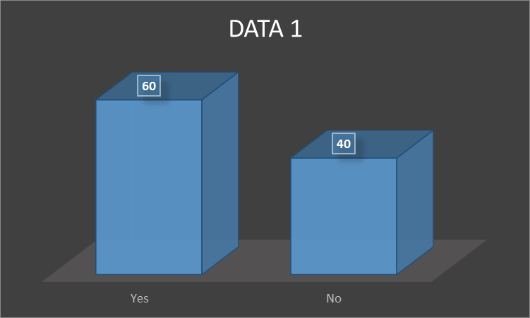
Results from a survey of 100 people found that 60% agreed that Aldi's leadership practises contributed to the company's success. Forty percent of respondents think the impact is very significant, out of a total of one hundred. This demonstrates that most respondents think Aldi may benefit from using some of these leadership strategies. It is telling that not a single person reported feeling anything.

Info 2: Do employees regularly get feedback on their performance from Aldi leadership?

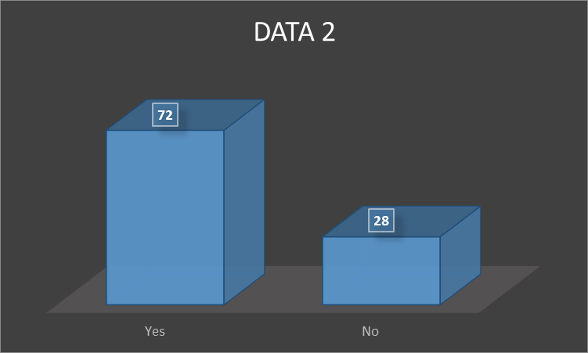

Seventy-two percent of respondents stated they regularly get feedback on their performance from Aldi management. Furthermore, 28% of the whole cohort (n=100) reported having such encounters often. That's why it's so important for Aldi to keep its employees apprised of how their work affects the business as a whole. In the meanwhile, just a minority of respondents reported regularly learning about the company's leadership style aims and aspirations. Also, only those who said they regularly get such information were included in the analysis.

Info 3: Do employees think that Aldi have enough room for leadership development and education?

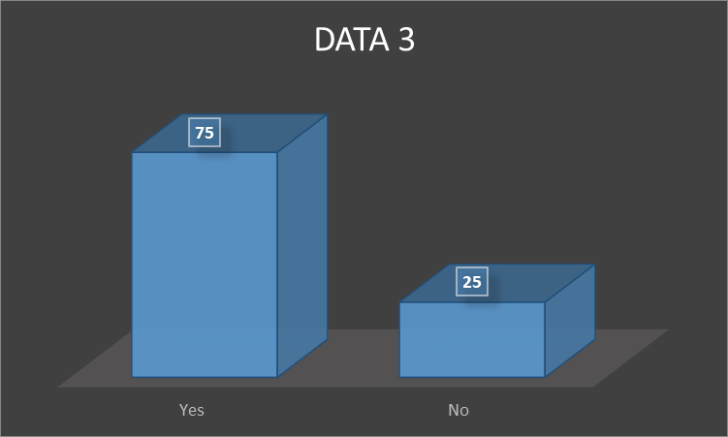

Seventy-five percent out of a hundred respondents think Aldi offers enough room for leadership development and education. Just 25% of respondents (a negligible fraction) fully agree with this assertion. A substantial percentage of Aldi workers feel they have enough opportunities for training and advancement to help them maximize production. Only one-quarter of those polled felt confident that Aldi offers sufficient training and development opportunities to foster the growth of more effective leadership skills among its employees.

Info 4: Do employees think there is significance of guidance from superiors in the Aldi leadership style surveys?
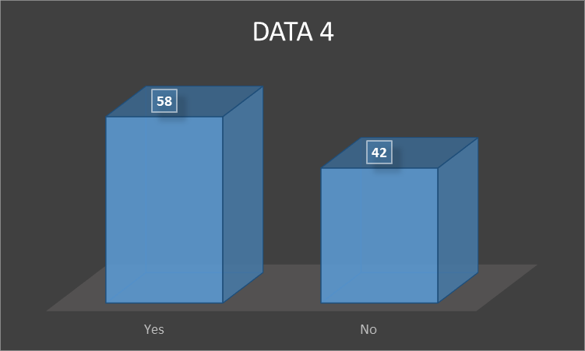

There was a wide range of responses on the significance of guidance from superiors in the Aldi leadership style surveys. Only 58% felt that the criticism they received improved their leadership skills, while 42% felt the opposite. Furthermore, 58 of those who took the leadership style test said that the feedback they received was helpful. Some people found the feedback useful, despite the fact that the vast majority dismissed it as irrelevant. Twenty-three individuals found the remarks to be at least somewhat helpful, and seventeen people found them to be very helpful. Nineteen individuals found the remark to be at least somewhat useful. The findings as a whole indicate that Aldi has to make major changes to the way it gives feedback to its top executives. It is critical to address an employee's issues if they believe they are not making any progress.

Info 5: Do employees think that outstanding leadership is taken seriously at varying levels within the Aldi organisation?

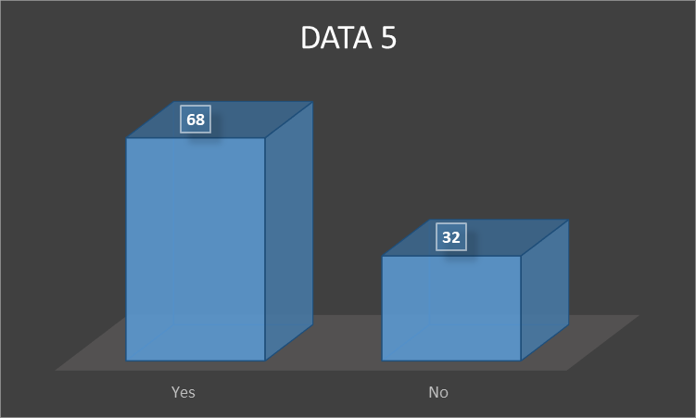

The findings indicate that public recognition of outstanding leadership is taken seriously at varying levels within the Aldi organisation. Sixty-eight percent of respondents felt that because of the company's leadership, Aldi made extra measures to notice or reward outstanding achievements. This shows that a lot of people working at Aldi are unhappy with the current methods of reward and recognition that are in place. Another third of respondents felt that Aldi might have done more to acknowledge their efforts. There is evidence of success in the company's recognition and reward practises if there is room for expansion in this area. Most respondents, meanwhile, did concede that Aldi does recognize and reward its top brass. Just 10% of poll takers said they felt Aldi did enough to recognize and reward staff for their efforts. To calm the nerves of the employees who feel their efforts are seldom, if ever, recognized, Aldi must adjust the ways in which it rewards and recognizes its employees, as shown by the statistics.

Info 6: Do employees think company's current leadership style practises are beneficial and compatible with the company's main aims?

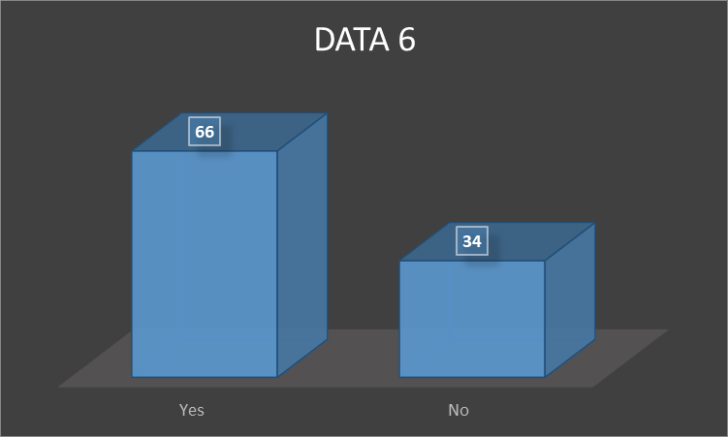

Sixty-six percent of Aldi employees think that the company's current leadership style practises are beneficial and compatible with the company's main aims, indicating that most respondents feel the current practises are efficient and consistent with Aldi's ultimate goals. It's possible that respondents overestimated the degree of congruence between business goals and leadership practises, even if many gave the alignment a very high or excellent grade. Reviews have been uniformly favorable, demonstrating the alignment's universal approval. However, there is room for advancement since 34 percent of respondents (out of a total of 100) regarded the alignment as really poor.

Info 7: What do employees feel about the leadership style of the company on HRM?
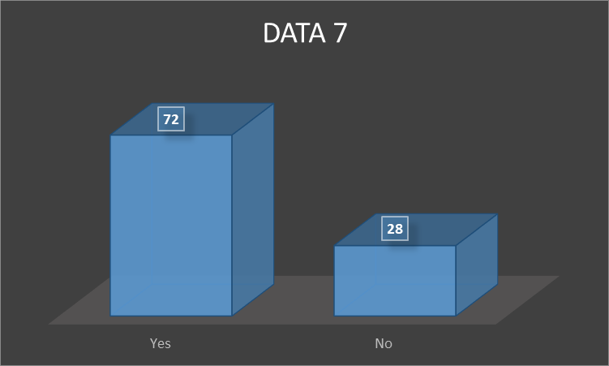
According to the data, Aldi employees are divided about the leadership style of the company. Since 28 persons (28 percent) out of a total of 100 are unhappy with the existing leadership practises, there is opportunity for change. Further, several of those polled reported feeling "very low" satisfaction with their life, indicating they were far less content than the typical person. Despite this, many workers have demonstrated only mild to neutral support for the administration's policies. Seventy-two people said they were happy with Aldi's procedures and appreciated the company's work. Furthermore, when asked how satisfied they were with the leadership style techniques. These workers lacked conviction in their judgement, as seen by their lack of demonstrable enthusiasm for or aversion to their work.

4.3: Analysis and Discussions
After discussing what the leader wants to accomplish and what the future collaborators want to receive of the characteristics indicated in the first phase of the entrepreneurial process, this leader is presenting transactional leadership, which is based on an exchange transaction between the parties, the leader and future collaborators. Exchange between the leader and any potential future team members is the foundation of transactional leadership (Javed et.al, 2020). Employees emphasize the necessity for incentives and assistance in the process of entrepreneurship, as well as the importance of traits like the eagerness to seize opportunities as they arise and the ability to create. The implementation phase of entrepreneurship corresponds to the transactional style of leadership that was shown to be most successful. Collaborators in this context get perks and pay as well. It is important to have control over the actions being taken and participation in fixing problems as they arise. The CEO of this small business openly admits that in return for financial incentives, he promotes the company's interests and aims among collaborators, helping them understand what must be done to attain the goals (Sulich et.al, 2021).
If everyone is pulling in the same direction, the leader cares about their employees and does everything they can to make them feel welcome on the job. This kind of CEO may inspire his or her staff to work towards the company's goals, which in turn leads to structural and behavioral changes that boost the effectiveness of the management team. The company's founder has a stellar reputation as an inspiring boss who encourages and backs his staff as they strive to do their best. Their concept of transformational leadership is consistent with and revitalizes the model because of his emphasis on role distinction for his followers and on social ties (Bhatti et.al, 2019). Two distinct varieties of leadership emerged from these transactions, participative and relational leadership. A great illustration of the participatory technique at work is when a leader shows genuine interest in his team members' input and participation in the decision-making process of the company, which in turn improves their loyalty to the business. 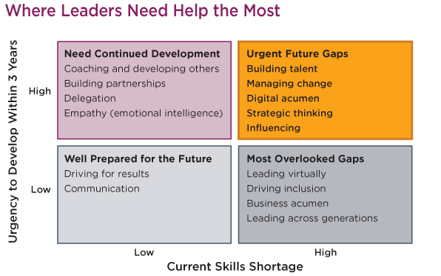
Figure: Leadership skills analysis (Rasool, et al., 2019)
Strong leader is an example of a participatory leader, who encourages open dialogue and never reprimands employees. In this case, the leader not only creates personal bonds with their subordinates, but also builds professional ties with them. Some of the variables that affect becoming an entrepreneur are also shown. These include presenting a well-defined business strategy and a well-established organisational culture and structure; being a competent leader and manager of the firm; building and maintaining favorable connections with the company's vendors, rivals, and customers; and so on. It seems from the data that entrepreneurial ventures are mostly led by transactional leaders. Indeed, this is true for both businesses (Javed et.al, 2020).

4.4: Summary of Chapter 4
Although the CEOs of these companies have been reported as stating they do not discipline employees based on performance, they have also warned employees that they risk losing their jobs if they continue to underperform (Alikaj, et al., 2021). The followers of business leader were the only ones who openly declared their support for the leader and the business, which is notable despite the fact that all of the leaders who were questioned said that their employees were happy with their employment. Workers have been there for less than a year, which may explain why they are more satisfied with their positions than those.

Chapter 5: Conclusions, Limitations and Recommendations

5.1: Introduction
The interviews were used to learn more about the leaders and the people who worked under them. Leadership styles suited for each stage of the entrepreneur's process were then determined based on the traits of the leaders and their direct reports. Leadership styles such as transformational, transactional, participatory, and relational models were discussed at length. When a leader inspires and uplifts their people, they are said to be practicing transformational leadership.

5.2: Conclusions on each research objectives

Objective 1
A transformative leader is one who can unite their followers around an ambitious objective. The first goals were to investigate several leadership theories that may be applied to the commercial world. When the success of an organisation is highly dependent on the quality of its leadership, situational leadership is a must. Whether these skills are used narrowly or broadly, three basic methods emerge: focus, uniqueness, and a cost leadership strategy. Cost leadership is a business strategy in which a firm offers a product or service of a specific quality to customers at the lowest possible price. If a business can create or provide a product at a lower cost, it may be able to maintain profitability for a longer length of time.

Objective 2
The leader in this case inspires the group by appealing to their self-interest and then uses the group's performance to either punish or reward the members. The second purpose was to analyze the effects of different leadership philosophies on HRM procedures inside an organisation. The quality of an organisation's leadership greatly affects how productive it is. The morale, decision-making ability, and output of a team are all affected by the leader's choices. There are numerous facets to being a great HR leader, and one of them is being an HR specialist in an organisation's company. Human resources (HR) departments may have an influence when they work with the company as strategic partners and advisors.

Objective 3

Research shows that followers consider leaders who use relational leadership to be positive influences. The third objective was to learn what kinds of human resource management strategies are effective in various types of businesses. It's become an essential resource for companies that want to foster environments where employees can thrive in terms of satisfaction, innovation, and output. An organisation's dedication to diversity is a major factor in candidate evaluation. If management is serious about managing diversity successfully, they need to try new approaches.

.5.3: Conclusions on the research problem
The purpose of this research was to learn more about the management and leadership styles used by entrepreneurial venture’s owners and managers throughout the whole venture creation process which contributes in the business environment. But research problems get created due to some lacking of leadership knowledge and practices. However, communication skills are needed, and the absence of this skill creates issues (Hamadamin &Atan, 2019). By using a case study approach, we can draw the conclusion that there is not a unique leadership style shared by the CEOs of the analyzed Entrepreneurial ventures. As a result, we may say that there is more than one kind of leadership.

5.4: Summary of the research findings and outcomes

By delving into the link between organisational leaders' styles of management and the entrepreneurial endeavors taking place within their companies, this study hopes to help fill a gap in the current body of knowledge. Building a diversified company is a lengthy process. Make sure employers interviewing people from all walks of life by double-checking organisation’s recruiting practices. To show that employees are committed to developing a more diverse organisation, employees should examine the processes employees use to assess and choose people from varied backgrounds. It's important to stress, nevertheless, that every leader really wants the best for the teams they manage.

5.5: Original Contribution of the Research
The findings of our study have important theoretical and practical implications. The findings may provide a theoretical basis for effective leadership in the entrepreneurial sector (Hamadamin, et.al, 2019). Therefore, the surviving workers are more likely to see the value in variety. The company's culture is set by the top executives. This research contributes to what is already known about entrepreneurship and leadership. This is the first step towards include business environment and entrepreneurial venture leadership in the broader entrepreneurship framework. Without these benefits, parents often find themselves at a professional disadvantage.

5.6: Limitations of the Research

Another way this is helpful is that it suggests a novel model for describing the qualities and leadership styles of entrepreneurs as they go through the many stages of starting a business. Therefore, it is crucial for owners and managers of Entrepreneurial ventures to evaluate the numerous facets of being an entrepreneur, including how their management style affects the organisation and its employees (Ardi, et.al, 2020). These benefits, however, won't become apparent until state-of-the-art technology is implemented, and employees have been given proper training and orientation. Technology and innovation are often utilized in a continuous manner in most organisational contexts. Therefore, the health of the economy, which in turn supports the functionality of the technical infrastructure, is crucial to a company's capacity for growth and the attraction and retention of top employees. The key to management success is a focus on the future and the ability to anticipate trends. The results have the potential to fill in gaps and point to intriguing areas of convergence in the literature on leadership, entrepreneurship, and collective action. The poor ROI on employee training and development is one of the main challenges preventing HR departments from expanding. Organisational growth is affected by the economy, labor legislation, and other major external elements. Strategic decision-making must be flexible in order to counteract the economic uncertainty caused by technological changes. Think about the external factors, like the state of the economy, and the internal factors, like the organisation’s goals for the return on investment in training and development. Verify that the organisation’s personnel strategy supports the larger goals of the organisation’s company. Plans for the people management process should be aligned with the company's broader strategy if a disruptive workforce is to be managed successfully. The vitality of a business is measured by its success in retaining, growing, and training its workforce.

5.7: Recommendations

The transactional leadership style was seen in two of the examples, although it was not linked to any one stage of the entrepreneurs' work. Since it reveals the kind of business strategies and leadership styles that should be adopted at each step of the entrepreneur's journey, this research has vital practical repercussions. The expansion of the understanding of leadership dynamics relies on research that shows how various leadership styles impact and influence not just the entrepreneurial process but also the behavior and attitudes of followers. This is because the findings show that a leader's approach to their role affects not just the entrepreneurial process but also the followers' actions and mindsets. The recommendation is to maintain a good relation and right leadership approach will be appropriate to maintain good business environment.

5.8: Summary of Chapter 5
A leader that employs a participatory approach listens to their team and takes their input into account. This top executive routinely polls those who report to them for their thoughts on crucial business decisions (Ardi, et al., 2020). Whether or whether they agree with a choice, followers are always given a voice and treated as full members of the organisation. Hence good leadership will lead the business environment in a good way and through this the organisation will be able to make up their losses along with some progress in their performance which will be done with the help of HRM practices.
In the future, researchers may look at the relationships between organisational culture, leadership styles, and HRM policies and procedures in entrepreneurial settings. The purpose of this research is to shed light on complex dynamics by investigating how cultural values, norms, and beliefs shape leadership styles and, in turn, HRM techniques.

References
Ababneh, O. M. A. (2021). How do green HRM practices affect employees’ green behaviors? The role of employee engagement and personality attributes. Journal of Environmental Planning and Management, 64(7), 1204-1226.
Ahmad, I., and Umrani, W. A. (2019). The impact of ethical leadership style on job satisfaction: Mediating role of perception of Green HRM and psychological safety. Leadership and Organisation Development Journal.
Ahmad, S., Islam, T., Sadiq, M., and Kaleem, A. (2021). Promoting green behavior through ethical leadership: a model of green human resource management and environmental knowledge. Leadership and Organisation Development Journal.
Alikaj, A., Ning, W., and Wu, B. (2021). Proactive personality and creative behavior: examining the role of thriving at work and high-involvement HR practices. Journal of Business and Psychology, 36, 857-869.
Ardi, A., Djati, S. P., Bernarto, I., Sudibjo, N., Yulianeu, A., Nanda, H. A., and Nanda, K. A. (2020). The relationship between digital transformational leadership styles and knowledge-based empowering interaction for increasing organisational innovativeness. International Journal of Innovation, Creativity and Change, 11(3), 259-277.
Bhatti, M. A., Alshagawi, M., Zakariya, A., and Juhari, A. S. (2019). Do multicultural faculty members perform well in higher educational institutions? Examining the roles of psychological diversity climate, HRM practices and personality traits (big five). European Journal of Training and Development, 43(1/2), 166-187.
Danilwan, Y., and Dirhamsyah, I. P. (2022). The Impact of The Human Resource Practices on The Organisational Performance: Does Ethical Climate Matter?. Journal of Positive School Psychology, 6(3), 1-16.
Hamadamin, H. H., and Atan, T. (2019). The impact of strategic human resource management practices on competitive advantage sustainability: The mediation of human capital development and employee commitment. Sustainability, 11(20), 5782.
Hameed, Z., Khan, I. U., Islam, T., Sheikh, Z., and Naeem, R. M. (2020). Do green HRM practices influence employees' environmental performance?. International Journal of Manpower.
Heilmann, P., Forsten-Astikainen, R., and Kultalahti, S. (2020). Agile HRM practices of SMEs. Journal of Small Business Management, 58(6), 1291-1306.
Ichsan, R. N., Nasution, L., Sinaga, S., and Marwan, D. (2021). The influence of leadership styles, organisational changes on employee performance with an environment work as an intervening variable at pt. Bank sumut binjai branch. Journal of Contemporary Issues in Business and Government, 27(2).
Javed, S., Malik, A., and Alharbi, M. M. H. (2020). The relevance of leadership styles and Islamic work ethics in managerial effectiveness. PSU Research Review, 4(3), 189-207.
Mazurchenko, A., and Maršíková, K. (2019). Digitally-powered human resource management: Skills and roles in the digital era. Acta Informatica Pragensia, 8(2), 72-87.
Moustaghfir, K., El Fatihi, S., and Benouarrek, M. (2020). Human resource management practices, entrepreneurial orientation and firm performance: what is the link?. Measuring Business Excellence.
Muisyo, P. K., Qin, S., Ho, T. H., and Julius, M. M. (2022). The effect of green HRM practices on green competitive advantage of manufacturing firms. Journal of Manufacturing Technology Management, 33(1), 22-40.
Rasool, S. F., Samma, M., Wang, M., Zhao, Y., and Zhang, Y. (2019). How human resource management practices translate into sustainable organisational performance: the mediating role of product, process and knowledge innovation. Psychology research and behavior management, 1009-1025.
Sulich, A., Sołoducho-Pelc, L., and Ferasso, M. (2021). Management styles and decision-making: Pro-ecological strategy approach. Sustainability, 13(4), 1604.
Waheed, A., Miao, X., Waheed, S., Ahmad, N., and Majeed, A. (2019). How new HRM practices, organisational innovation, and innovative climate affect the innovation performance in the IT industry: A moderated-mediation analysis. Sustainability, 11(3), 621.

Appendix
1 | Do employees agree that Aldi's leadership practises contributed to the company's success?
2 | Do employees regularly get feedback on their performance from Aldi leadership?
3 | Do employees think that Aldi have enough room for leadership development and education?
4 | Do employees think there is significance of guidance from superiors in the Aldi leadership style surveys?
5 | Do employees think that outstanding leadership is taken seriously at varying levels within the Aldi organisation?
6 | Do employees think company's current leadership style practises are beneficial and compatible with the company's main aims?
7 | What do employees feel about the leadership style of the company on HRM?

